Supplementary Figures
Precisely constrained 134-ka strong monsoon event in the Penultimate Deglaciation by an annually laminated speleothem from the Asian monsoon domain

Jiahui Cui¹, Jingyao Zhao¹*, Xiyu Dong¹, Carlos Pérez-Mejías¹, Jing Lu¹, Ye Tian¹, Jian Wang¹, Liangkang Pan¹, Hai Cheng^{1,2,3}*

¹ Institute of Global Environmental Change, Xi’an Jiaotong University, Xi’an 710049, China
² State Key Laboratory of Loess and Quaternary Geology, Institute of Earth Environment, Chinese Academy of Sciences, Xi’an 710061, China
³ Universal Scientific Education and Research Network (USERN), Xi'an, China
Figure
Fig. S1. The cave site, meteorology station, and cave monitoring.
Fig. S2. Oxygen isotope simulations of isoGSM (A-C) and iCESM (D-F)
Fig. S3. Comparison of stalagmite records from north and south China
Fig. S4. Global paleo-records comparison from 20 to 5 ka

Correspondence and requests for materials should be addressed to J.Z. and H.C.
(*E-mail: zjy1230@xjtu.edu.cn and cheng021@xjtu.edu.cn )
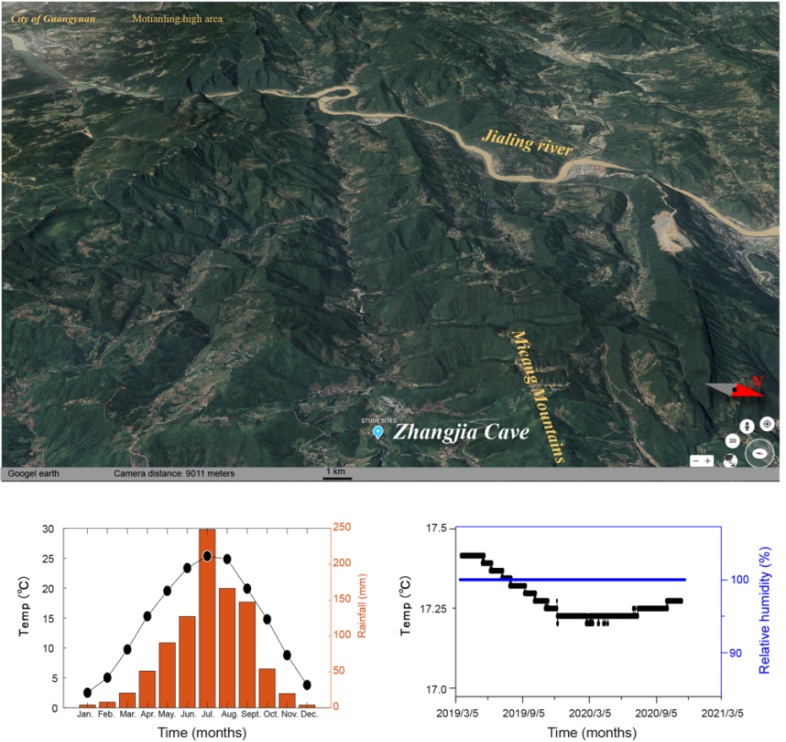
Fig S1. The cave site, meteorology station, and cave monitoring.
The figure above shows the location of the Zhangjiadong Cave, the figure on the lower left shows the local average monthly temperature and precipitation, and the figure on the lower right shows the changes in temperature and relative humidity monitored in the cave from March 5, 2019 to March 5, 2021.

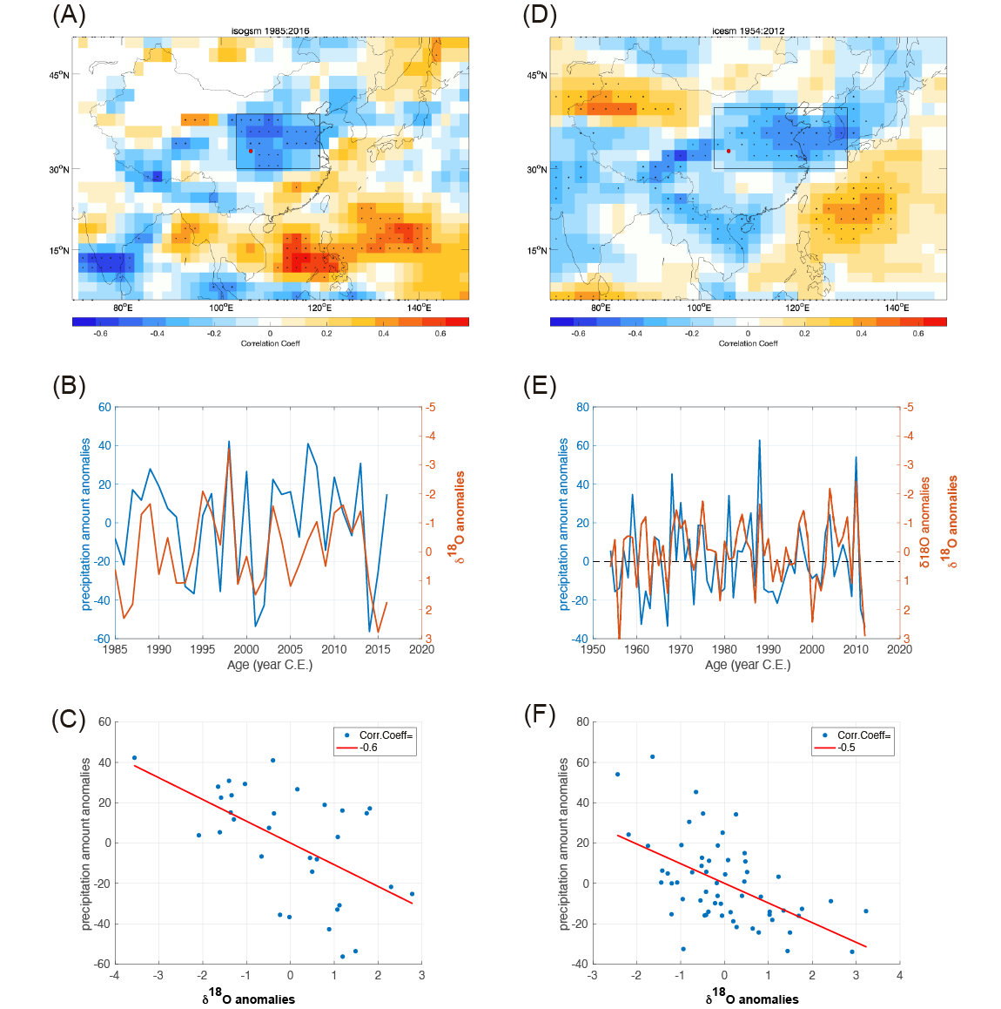
Fig S2. Oxygen isotope simulations between precipitation (mm) and δ¹⁸O in isoGSM (Yoshimura et al., 2008)(A-C) and iCESM (Hurrell et al., 2013)(D-F). (A-C): (A) Correlations between June and September (JJAS) IsoGSM simulated δ¹⁸O and precipitation amount at each grid cell. The black rectangle demarcates the region from where precipitation amount was extracted for time-series comparisons in panel (B). (B) Z-score transformed time-series comparisons between the JJAS precipitation amount (black), δ¹⁸Op (red) for 1985–2016. Timeseries for all two variables represent averaged values extracted from a rectangular-shaped region over the China marked in panels (A). (C) Correlation between the IsoGSM simulated δ¹⁸O and precipitation amount. (D-F): (D) Same as (A) but by the iCESM for 1954–2012. (E) Z-score transformed time-series comparisons between the JJAS precipitation amount (black), δ¹⁸Op (red). Timeseries for all two variables represent averaged values extracted from a rectangular-shaped region over the China marked by rectangles in panels (D). (F) Correlation between the iCESM simulated δ¹⁸O and precipitation amount.
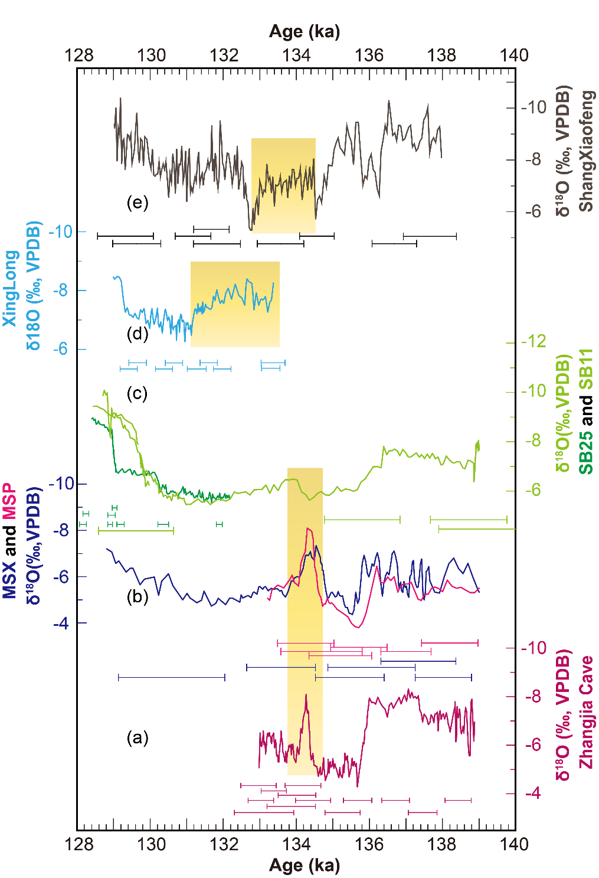
Figure S3. Comparison of stalagmite records from north and south China. From bottom to top: (a) The speleothem δ¹⁸O record from Zhangjia Cave (this study). (b) The speleothem MSP (pink), and MSP (navy blue) δ¹⁸O records from Hulu Cave (Cheng et al., 2006; Wang et al.,2018). (c) The speleothem SB-25(dark green) and SB-11(light green) δ¹⁸O records from Sanbao Cave (Cheng et al., 2009). (d) The speleothem δ¹⁸O record from Xinglong Cave (Duan et al., 2019). (e) The speleothem δ¹⁸O record from Shangxiaofeng Cave (Xue et al., 2020). The ²³⁰Th dates with uncertainties (±2σ) is shown in each error bars. The yellow bars indicate 134ka-event.
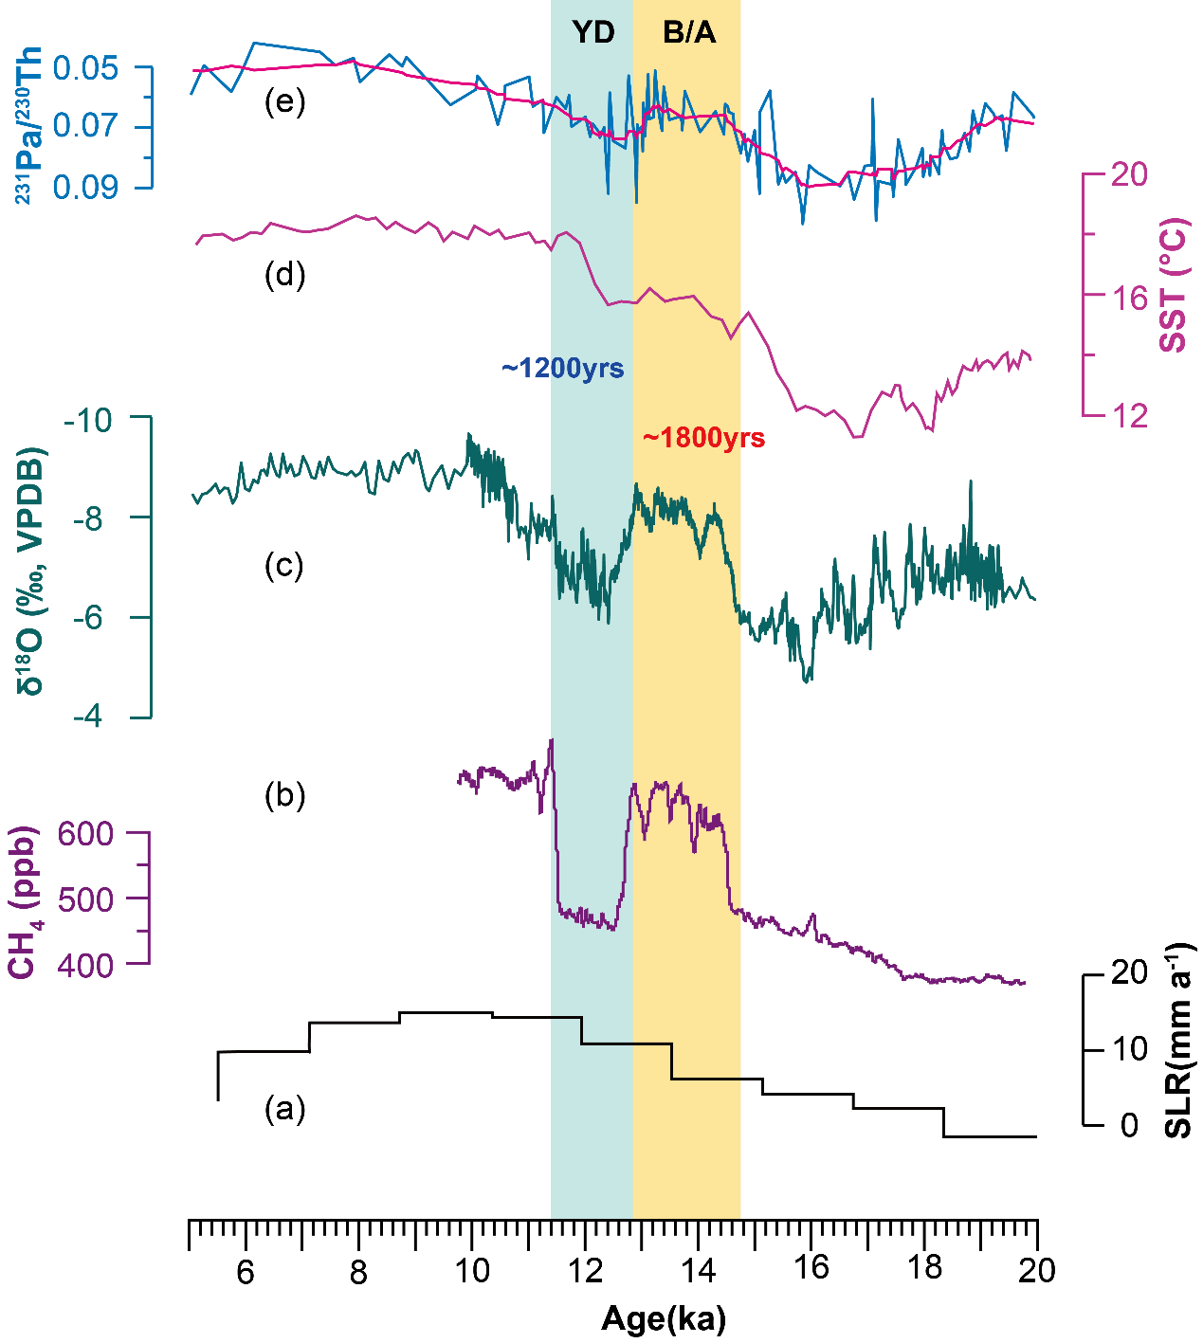
Figure S4. Global paleo-records comparison from 20 to 5 ka. From bottom to top: (a) Global sea level rates from benthic (Stoll et al., 2022). (b) WAIS Divide ice core methane concentrations (Rhodes et al., 2015). (c) East Asian monsoon intensity speleothem-derived record (Cheng et al., 2016). (d) Iberian margin SST reconstructions at sediment cores MD01-2444 (Martrat ef al., 2007). (e) North Atlantic marine sedimeni ²³¹Pa/²³⁰Th ratios reflecting AMOC intensity (red line: 9-point moving average) (Henry et al., 2016; Ng et al.,2018). The yellow bars indicate B/A event.

Reference:
Cheng, H., Edwards, R.L., Broecker, W.S., Denton, G.H., Kong, X., Wang, Y., Zhang, R., Wang, X., 2009. Ice age terminations. Science 326, 248-252.
Cheng, H., Edwards, R.L., Sinha, A., Spotl, C., Yi, L., Chen, S., Kelly, M., Kathayat, G., Wang, X., Li, X., Kong, X., Wang, Y., Ning, Y., Zhang, H., 2016. The Asian monsoon over the past 640,000 years and ice age terminations. Nature 534, 640-646.
Cheng, H., Edwards, R.L., Wang, Y., Kong, X., Ming, Y., Kelly, M.J., Wang, X., Gallup, C.D., Liu, W., 2006. A penultimate glacial monsoon record from Hulu Cave and two-phase glacial terminations. Geology 34, 217-220.
Duan, W., Cheng, H., Tan, M., Li, X., Edwards, R.L., 2019. Timing and structure of Termination II in north China constrained by a precisely dated stalagmite record. Earth and Planetary Science Letters 512, 1-7.
Henry L G, McManus J F, Curry W B, et al. North Atlantic ocean circulation and abrupt climate change during the last glaciation[J]. Science, 2016, 353(6298): 470-474.
Hurrell, J.W., Holland, M.M., Gent, P.R., Ghan, S., Kay, J.E., Kushner, P.J., Lamarque, J.-F., Large, W.G., Lawrence, D., Lindsay, K., 2013. The community earth system model: a framework for collaborative research. Bulletin of the American Meteorological Society 94, 1339-1360.
Martrat, B., Grimalt, J.O., Shackleton, N.J., de Abreu, L., Hutterli, M.A., Stocker, T.F., 2007. Four climate cycles of recurring deep and surface water destabilizations on the Iberian margin. Science 317, 502-507.
Ng, H.C., Robinson, L.F., McManus, J.F., Mohamed, K.J., Jacobel, A.W., Ivanovic, R.F., Gregoire, L.J., Chen, T., 2018. Coherent deglacial changes in western Atlantic Ocean circulation. Nature communications, 9(1): 2947.
Rhodes R H, Brook E J, Chiang J C H, et al. Enhanced tropical methane production in response to iceberg discharge in the North Atlantic[J]. Science, 2015, 348(6238): 1016-1019.
Stoll H M, Cacho I, Gasson E, et al. Rapid northern hemisphere ice sheet melting during the penultimate deglaciation. Nature communications, 2022, 13(1): 1-16.
Xue G, Cai Y, Ma L, et al. A new speleothem record of the penultimate deglacial: Insights into spatial variability and centennial-scale instabilities of East Asian monsoon. Quaternary Science Reviews, 2019, 210: 113-124.
Wang, Q., Wang, Y., Shao, Q., Liang, Y., Zhang, Z., Kong, X., 2018. Millennial-scale Asian monsoon variability during the late Marine Isotope Stage 6 from Hulu Cave, China. Quaternary Research 90, 394-405.
Yoshimura, K., Kanamitsu, M., Noone, D., Oki, T., 2008. Historical isotope simulation using Reanalysis atmospheric data. Journal of Geophysical Research 113.

