SUPPLEMENTARY MATERIAL
Table S1. List of tropical cyclones in Gulf of Thailand during 1951-2020 (Thai Meteorological Department, 2020).
NO. | Name | Year | Intensity | Landfall location
1 | Shirley | 1952 | Tropical depression | Chanthaburi
2 | Vae | 1952 | Tropical storm + depression | Trat
3 | Harriet | 1962 | Tropical depression + storm | Nakhon Si Thammarat
4 | Lucy | 1962 | Tropical depression | Chumphon
5 | Kate | 1964 | Tropical depression | Prachuap Khiri Khan
6 | Gloria | 1965 | Tropical depression | Songkhla
7 | Hester | 1968 | Tropical depression | -
8 | Nina | 1968 | Tropical depression | -
9 | Nora | 1970 | Tropical depression | -
10 | Louise | 1970 | Tropical depression | -
11 | Ruth | 1970 | Tropical storm | Surat Thani
12 | Sally | 1972 | Typhoon + tropical storm | Surat Thani
13 | Sarah | 1973 | Tropical depression | -
14 | Thelma | 1973 | Tropical depression | Prachuap Khiri Khan
15 | Gay | 1989 | Tropical storm + typhoon | Chumphon
16 | Angela | 1992 | Tropical depression | -
17 | Forrest | 1992 | Tropical storm | Nakhon Si Thammarat
18 | Manny | 1993 | Tropical depression | Songkhla
19 | Ernie | 1996 | Tropical depression | Chumphon
20 | Linda | 1997 | Typhoon | Prachuap Khiri Khan
21 | Gil | 1998 | Tropical depression + storm | Songkhla
22 | Unnamed | 1998 | Tropical depression | Chumphon
23 | Unnamed | 1999 | Tropical depression | Chumphon
24 | Unnamed | 2003 | Tropical depression | Prachuap Khiri Khan
25 | Muifa | 2004 | Tropical storm | -
26 | Durian | 2006 | Tropical depression | Surat Thani
27 | Jal | 2010 | Tropical depression | Songkhla
28 | Wukong | 2012 | Tropical depression | -
29 | Unnamed | 2013 | Tropical depression | Prachuap Khiri Khan
30 | Lehar | 2013 | Tropical depression | Narathiwat
31 | Kai-tak | 2017 | Tropical storm | -
32 | Tembin | 2017 | Typhoon | -
33 | Unnamed | 2017 | Tropical depression | Narathiwat
34 | Toraji | 2018 | Tropical depression | -
35 | Pabuk | 2019 | Tropical storm | Nakhon Si Thammarat
36 | Krovanh | 2020 | Tropical storm | Surat Thani
Table S2. Summary of grain size analysis parameters and LOI based organic matter and carbonate contents.
Sample | Exposure | Mean (phi) | Sorting (phi) | Skewness (phi) | Kurtosis (phi) | Organic matter content (%) | Carbonate content (%)
CHA-1 | A1 | 1.529 | 0.901 | -0.079 | 0.903 | 0.456 | 1.746
CHA-2 | A1 | 1.775 | 0.92 | -0.08 | 0.897 | 0.363 | 1.215
CHA-3 | A1 | 1.394 | 0.896 | 0.042 | 0.915 | 0.385 | 1.723
CHA-4 | C3 | 2.877 | 1.835 | 0.425 | 0.838 | 0.915 | 0.344
CHA-5 | C3 | 1.519 | 0.927 | 0.27 | 1.575 | 0.206 | 0.095
CHA-6 | C2 | 2.417 | 0.649 | 0.042 | 0.968 | 0.530 | 0.141
CHA-7 | C2 | 2.454 | 1.004 | 0.301 | 1.574 | 0.450 | 0.151
CHA-8 | D2 | 1.882 | 1.039 | 0.305 | 1.914 | 0.736 | 0.210
CHA-9 | D2 | 2.199 | 0.853 | 0.261 | 1.65 | 0.484 | 0.144
CHA-10 | D3 | 2.657 | 1.056 | 0.371 | 1.693 | 0.969 | 0.316
CHA-11 | D3 | 2.37 | 0.9 | 0.244 | 1.636 | 1.081 | 0.224
CHA-12 | E1 | 2.75 | 1.042 | 0.222 | 1.602 | 0.607 | 0.206
CHA-13 | E1 | 3.174 | 1.328 | 0.341 | 1.369 | 1.235 | 0.296
CHA-14 | E2 | 4.033 | 1.589 | -0.268 | 1.038 | 1.529 | 0.423
CHA-15 | E2 | 2.433 | 0.775 | 0.161 | 1.252 | 0.127 | 0.052
CHA-16 | A2 | 2.408 | 0.59 | -0.012 | 0.945 | 0.781 | 0.389
CHA-17 | A2 | 1.417 | 0.848 | 0.038 | 0.905 | 0.409 | 1.897
CHA-18 | A2 | 1.724 | 0.69 | -0.038 | 0.945 | 0.700 | 1.351
GS1-1.2 | F1 | 2.43 | 1.12 | -1.07 | 6.49 | - | -
GS1-1.3 | F1 | 2.61 | 0.97 | -1.2 | 7.94 | - | -
GS1-2.2 | F2 | 2.7 | 0.96 | -0.73 | 4.44 | - | -
GS4-1.1 | B1 | 1.5 | 1.16 | 0.01 | 2.89 | - | -
GS4-1.2 | B1 | 1.2 | 1.11 | -0.01 | 2.54 | - | -
GS4-1.3 | B1 | 1.56 | 1.07 | -0.12 | 2.7 | - | -

Table S3. Summary data of luminescence dating with measure sediment moisture and average water content estimate use for dose rate calculation, measure concentration of radioactive elements (K, Th, U) and dose rate. n = number of aliquots passing the rejection criteria, od. = observed overdispersion, MAM = Minimum Age Model, CAM = Central Age Model, D_{e} = Equivalent dose.

Sample | Exposure | Depth  (cm) | Moisture  (%) | Water  (%) | K  (%) | Th  (ppm) | U  (ppm) | D  (Gy ka⁻¹) | n | od. | Method | D_{e}  (Gy) | Age  (Yr)
CHA1Q | A1 | 75 | 3.8 | 4±2 | 0.36±0.03 | 2.44±0.18 | 0.83±0.05 | 0.87±0.07 | 30 | 0.59 | MAM | 0.028±0.004 | 32±3
CHA2Q | A1 | 35 | 3.2 | 4±2 | 0.28±0.02 | 1.48±0.12 | 0.49±0.04 | 0.68±0.08 | 30 | 0.44 | MAM | 0.029±0.003 | 43±5
CHA3Q | A1 | 25 | 2.1 | 4±2 | 0.38±0.03 | 1.72±0.13 | 0.62±0.05 | 0.81±0.07 | 30 | 0.00 | CAM | 0.026±0.002 | 32±3
CHA4Q | C3 | 55 | 13.8 | 20±5 | 0.22±0.02 | 3.39±0.22 | 0.88±0.06 | 0.73 ±0.05 | 24 | 0.30 | MAM | 1.40±0.07 | 1910±120
CHA5Q | C3 | 30 | 5.2 | 10±5 | 0.08±0.01 | 1.01±0.07 | 0.60±0.04 | 0.47±0.03 | 24 | 0.29 | MAM | 0.78±0.04 | 1670±120
CHA6Q | C2 | 110 | 18.4 | 20±5 | 0.31±0.03 | 3.59±0.25 | 2.04±0.13 | 1.03±0.07 | 24 | 0.16 | MAM | 1.27±0.07 | 1230±80
CHA7Q | C2 | 50 | 6.4 | 10±5 | 0.36±0.04 | 4.70±0.30 | 1.91±0.11 | 1.24±0.05 | 24 | 0.08 | CAM | 1.58±0.03 | 1240±60
CHA8Q | D2 | 110 | 17.3 | 20±5 | 0.15±0.02 | 2.45±0.17 | 0.57±0.04 | 0.54±0.03 | 24 | 0.43 | MAM | 1.10±0.03 | 2030±100
CHA9Q | D2 | 50 | 3.1 | 10±5 | 0.083±0.01 | 2.04±0.14 | 0.53±0.04 | 0.51±0.04 | 24 | 0.11 | MAM | 1.14±0.06 | 2240±160
CHA10Q | D3 | 100 | 20.3 | 25±5 | 0.38±0.04 | 4.09±0.27 | 2.49±0.15 | 1.16±0.50 | 24 | 0.14 | MAM | 1.84±0.05 | 1590±70
CHA11Q | D3 | 40 | 9.4 | 10±5 | 0.31±0.025 | 4.60±0.30 | 0.74±0.06 | 0.93±0.07 | 24 | 0.14 | MAM | 1.55±0.09 | 1670±120
CHA12Q | E1 | 50 | 18.3 | 20±5 | 0.68±0.07 | 4.11±0.27 | 1.88±0.20 | 1.34±0.07 | 24 | 0.09 | CAM | 5.55±0.11 | 4140±210
CHA13Q | E1 | 30 | 16.3 | 20±5 | 0.71±0.05 | 7.00±0.50 | 2.32±0.15 | 1.64±0.80 | 24 | 0.23 | MAM | 5.66±0.17 | 3450±160
CHA14Q | E2 | 205 | 19.2 | 25±5 | 0.78±0.08 | 8.50±0.50 | 3.00±0.17 | 1.79±0.08 | 24 | 0.20 | MAM | 6.77±0.17 | 3790±170
CHA15Q | E2 | 165 | 8.8 | 15±5 | 0.41±0.04 | 2.19±0.16 | 1.91±0.21 | 1.03±0.05 | 24 | 0.07 | CAM | 3.76±0.06 | 3630±190
CHA16Q | A2 | 75 | 16.2 | 20±5 | 0.44±0.04 | 3.64±0.25 | 1.77±0.11 | 1.12±0.14 | 30 | 0.00 | CAM | 0.026±0.003 | 23±2
CHA17Q | A2 | 50 | 2.4 | 4±2 | 0.40±0.04 | 1.63±0.12 | 0.55±0.04 | 0.81±0.08 | 30 | 0.00 | CAM | 0.025±0.002 | 31±3
CHA18Q | A2 | 20 | 2.4 | 4±2 | 0.25±0.021 | 1.80±0.13 | 0.64±0.05 | 0.73±0.06 | 27 | 0.00 | CAM | 0.027±0.004 | 37±3
CHA21Q | B1 | 37 | 11.8 | 15±5 | 0.22±0.03 | 1.62±0.13 | 0.48±0.13 | 0.57±0.04 | 23 | 0.36 | MAM | 0.65±0.03 | 1130±90
CHA22Q | B1 | 52 | 20.9 | 25±5 | 0.23±0.02 | 1.59±0.11 | 0.64±0.10 | 0.57±0.05 | 19 | 0.17 | MAM | 0.75±0.06 | 1330±120
CHA23Q | C1 | 32 | 24.2 | 25±5 | 0.30±0.03 | 2.85±0.21 | 1.23±0.19 | 0.81±0.07 | 24 | 0.18 | MAM | 1.56±0.11 | 1910±160
CHA24Q | D1 | 32 | 10.6 | 15±5 | 0.09±0.01 | 1.54±0.12 | 0.60±0.11 | 0.49±0.09 | 24 | 0.49 | MAM | 0.18±0.03 | 370±60
CHA25Q | D1 | 57 | 22.3 | 25±5 | 0.07±0.01 | 2.01±0.14 | 0.71±0.15 | 0.48±0.06 | 24 | 0.34 | MAM | 0.49±0.05 | 1020±120
CHA26Q | F2 | 32 | 21.7 | 25±5 | 0.90±0.09 | 8.10±0.50 | 4.06±0.37 | 2.10±0.16 | 24 | 0.16 | MAM | 5.32±0.35 | 3540±160
CHA27Q | F1 | 42 | 20.7 | 25±5 | 0.67±0.07 | 4.20±0.28 | 2.42±0.26 | 1.39±0.12 | 24 | 0.21 | MAM | 4.46±0.33 | 3220±280
CHA28Q | F1 | 62 | 25.2 | 25±5 | 0.74±0.08 | 6.74±0.42 | 3.88±0.37 | 1.85±0.09 | 24 | 0.09 | CAM | 6.19±0.13 | 3340±160
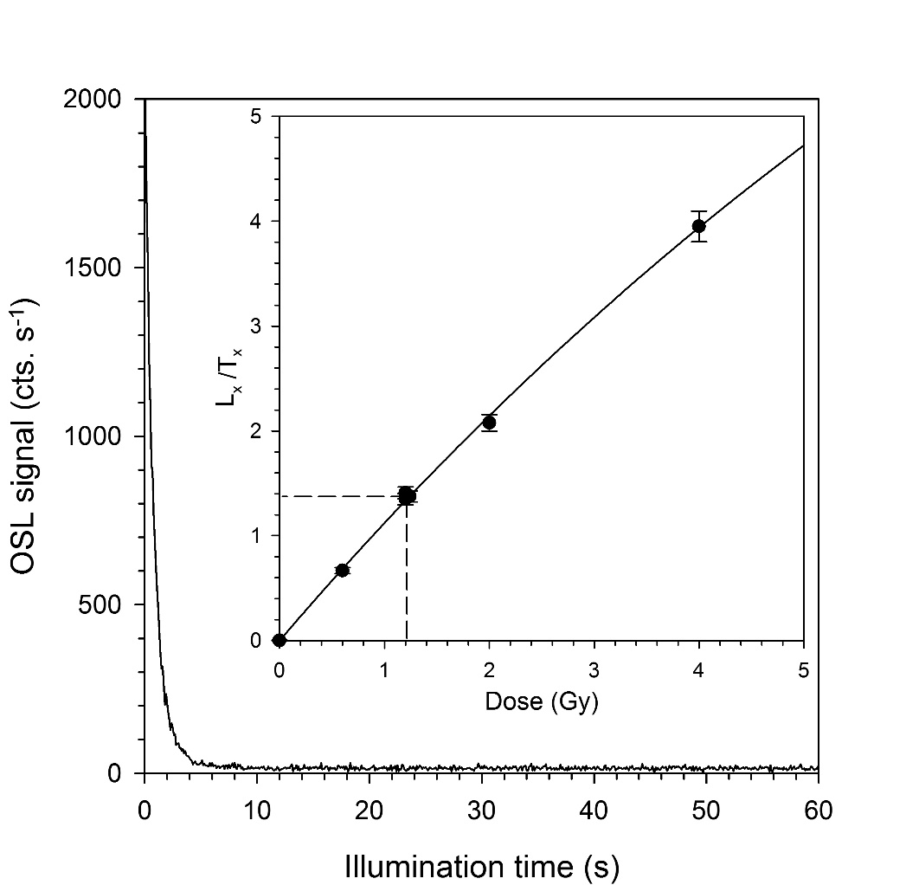
Figure S1. Example OSL decay and growth curve of sample CHU4Q.

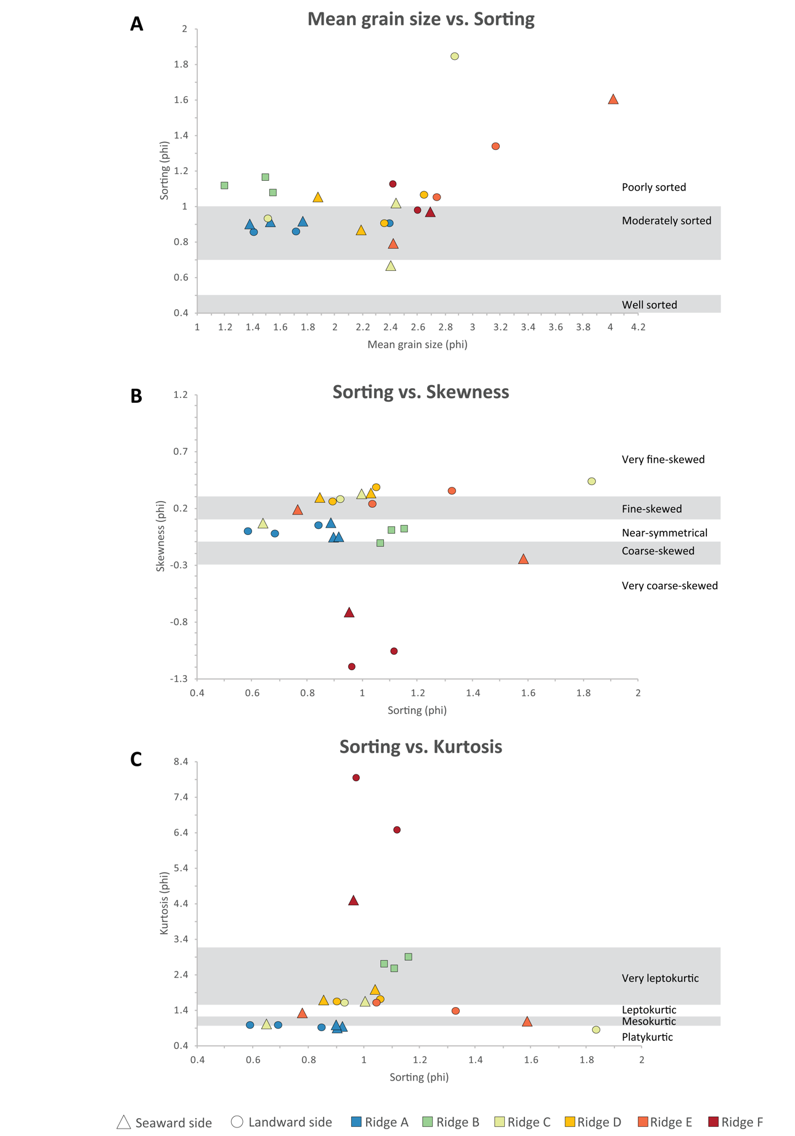
Figure S2. Plotting statistical values of (A) mean grain size vs. sorting, (B) sorting vs. skewness and (C) sorting vs. kurtosis.

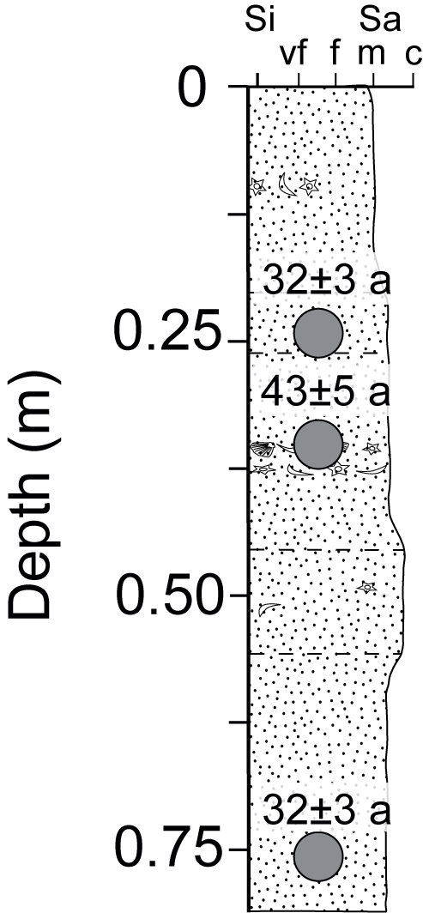
Figure S3. Sediment log of A1 (modern foreshore).
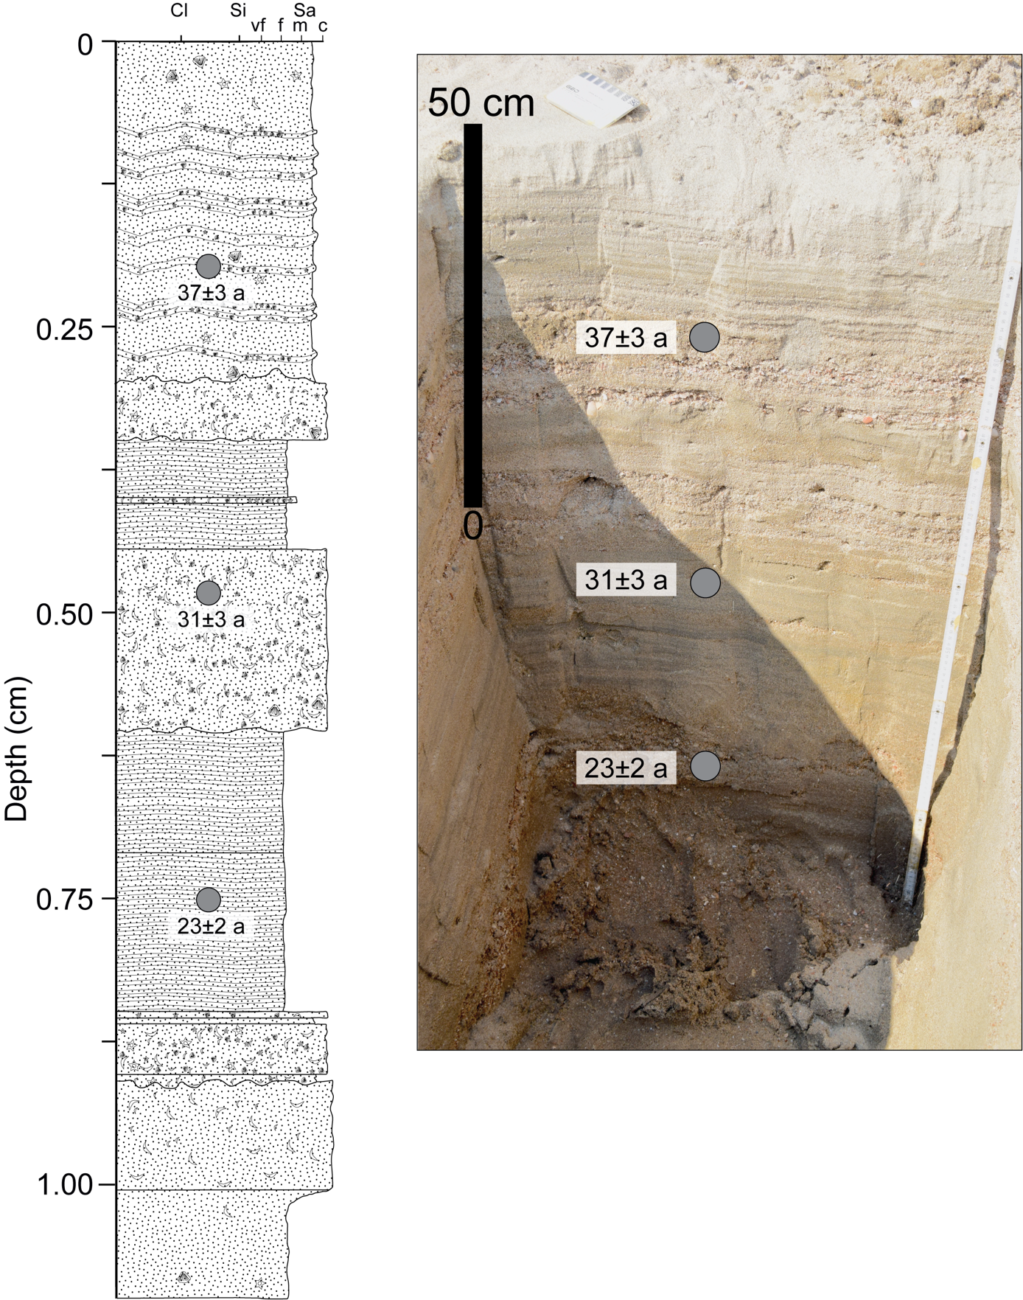
Figure S4. Sediment log and picture of A2 (modern backshore).
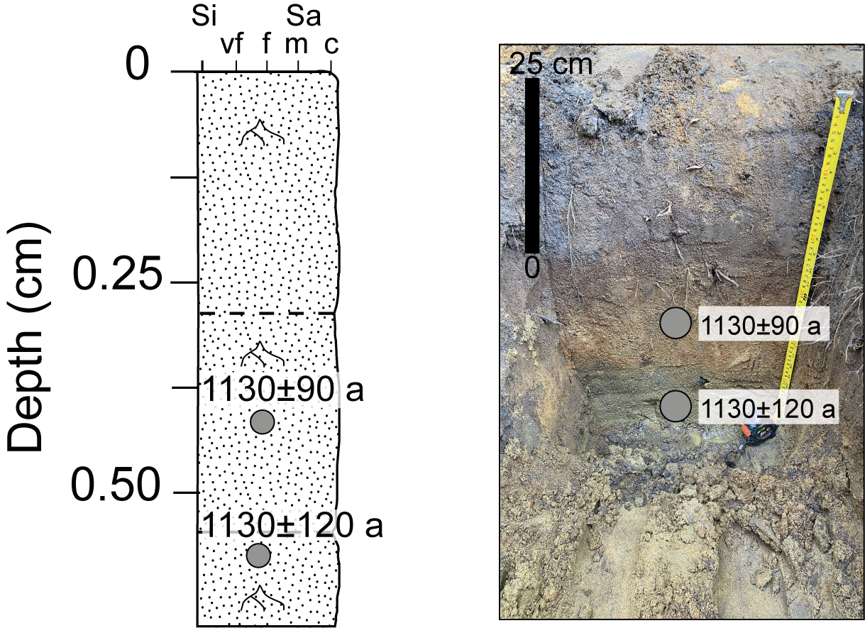
Figure S5. Sediment log and picture of B1.
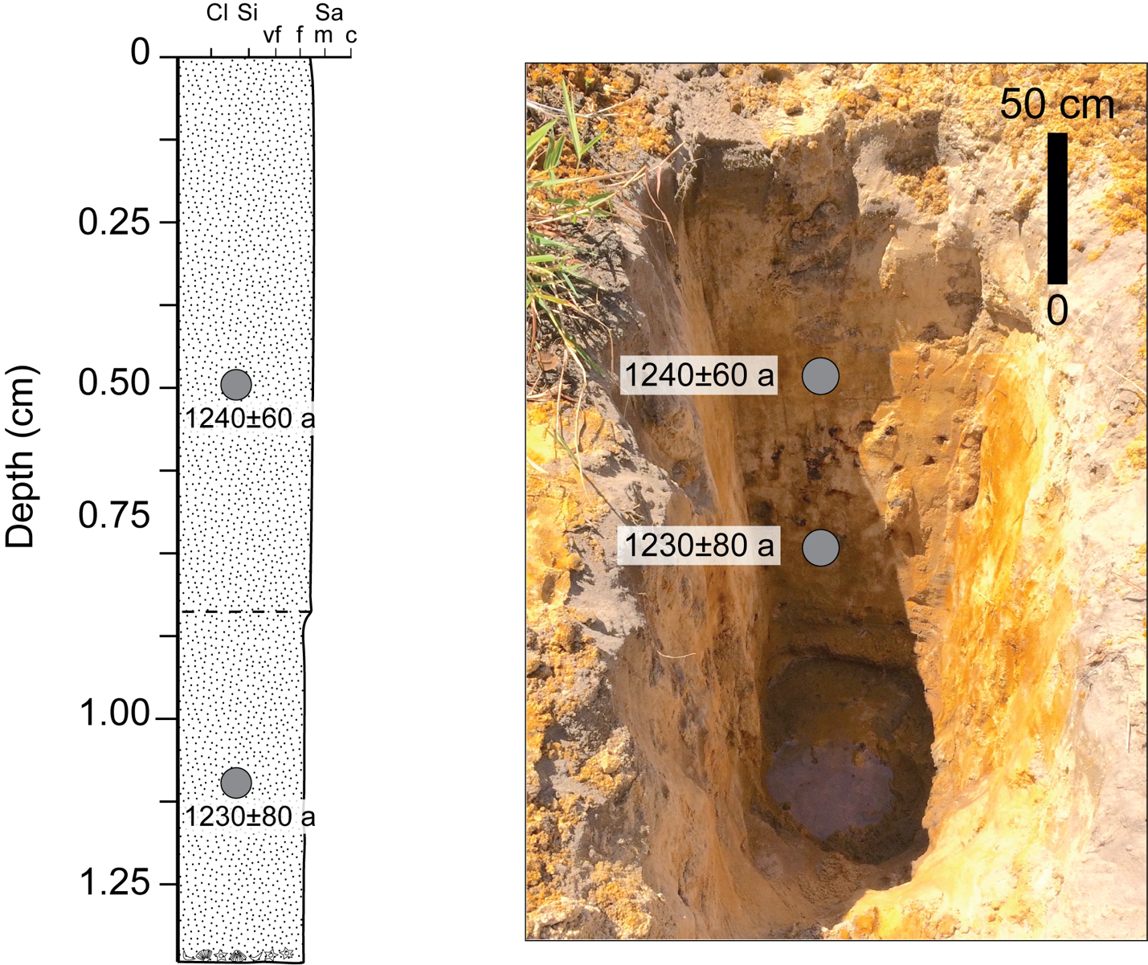

Figure S6. Sediment log and picture of C2, seaward side of ridge C.

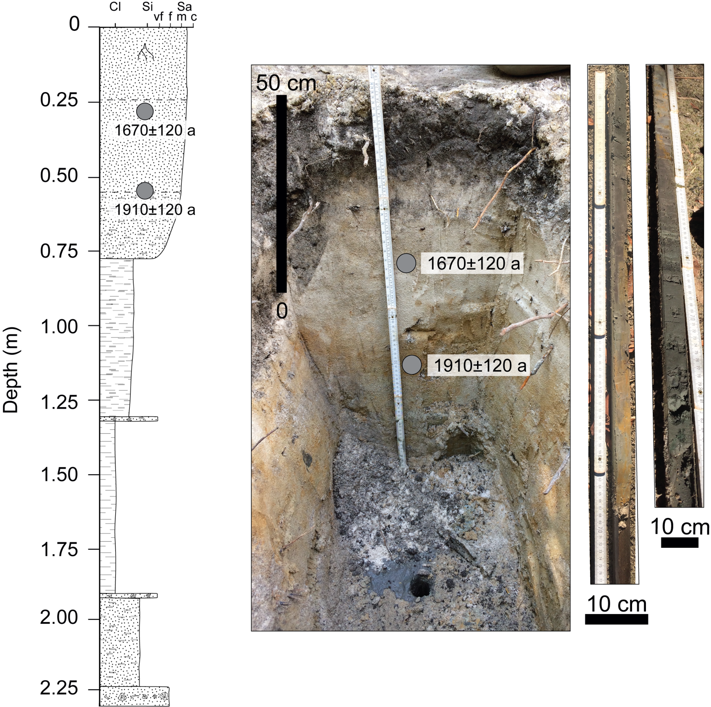

Figure S7. Sediment log and picture of C3, landward side of ridge C.

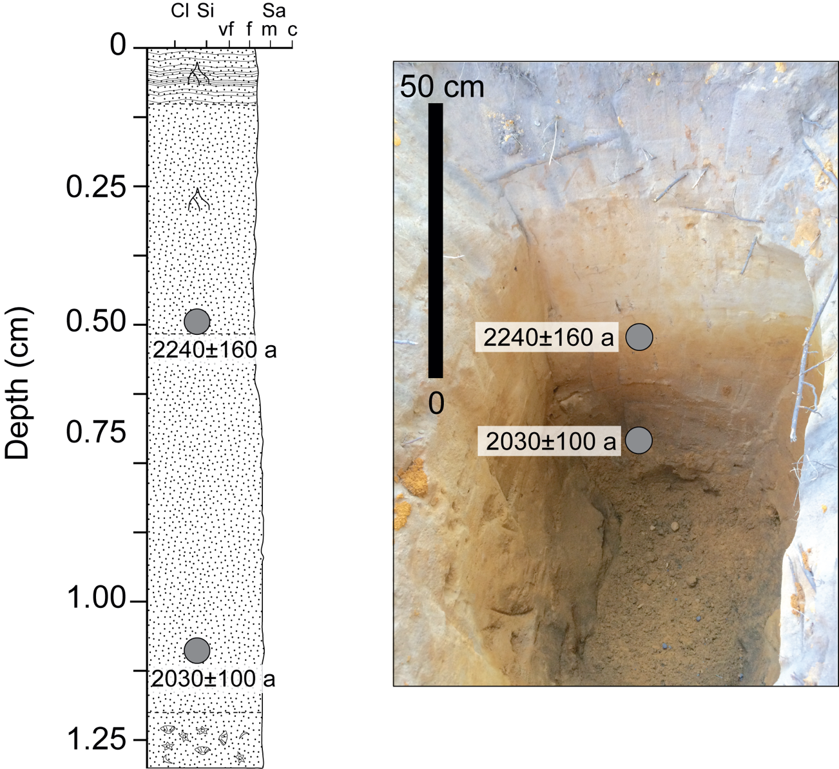

Figure S8. Sediment log and picture of D2, seaward side of ridge D.

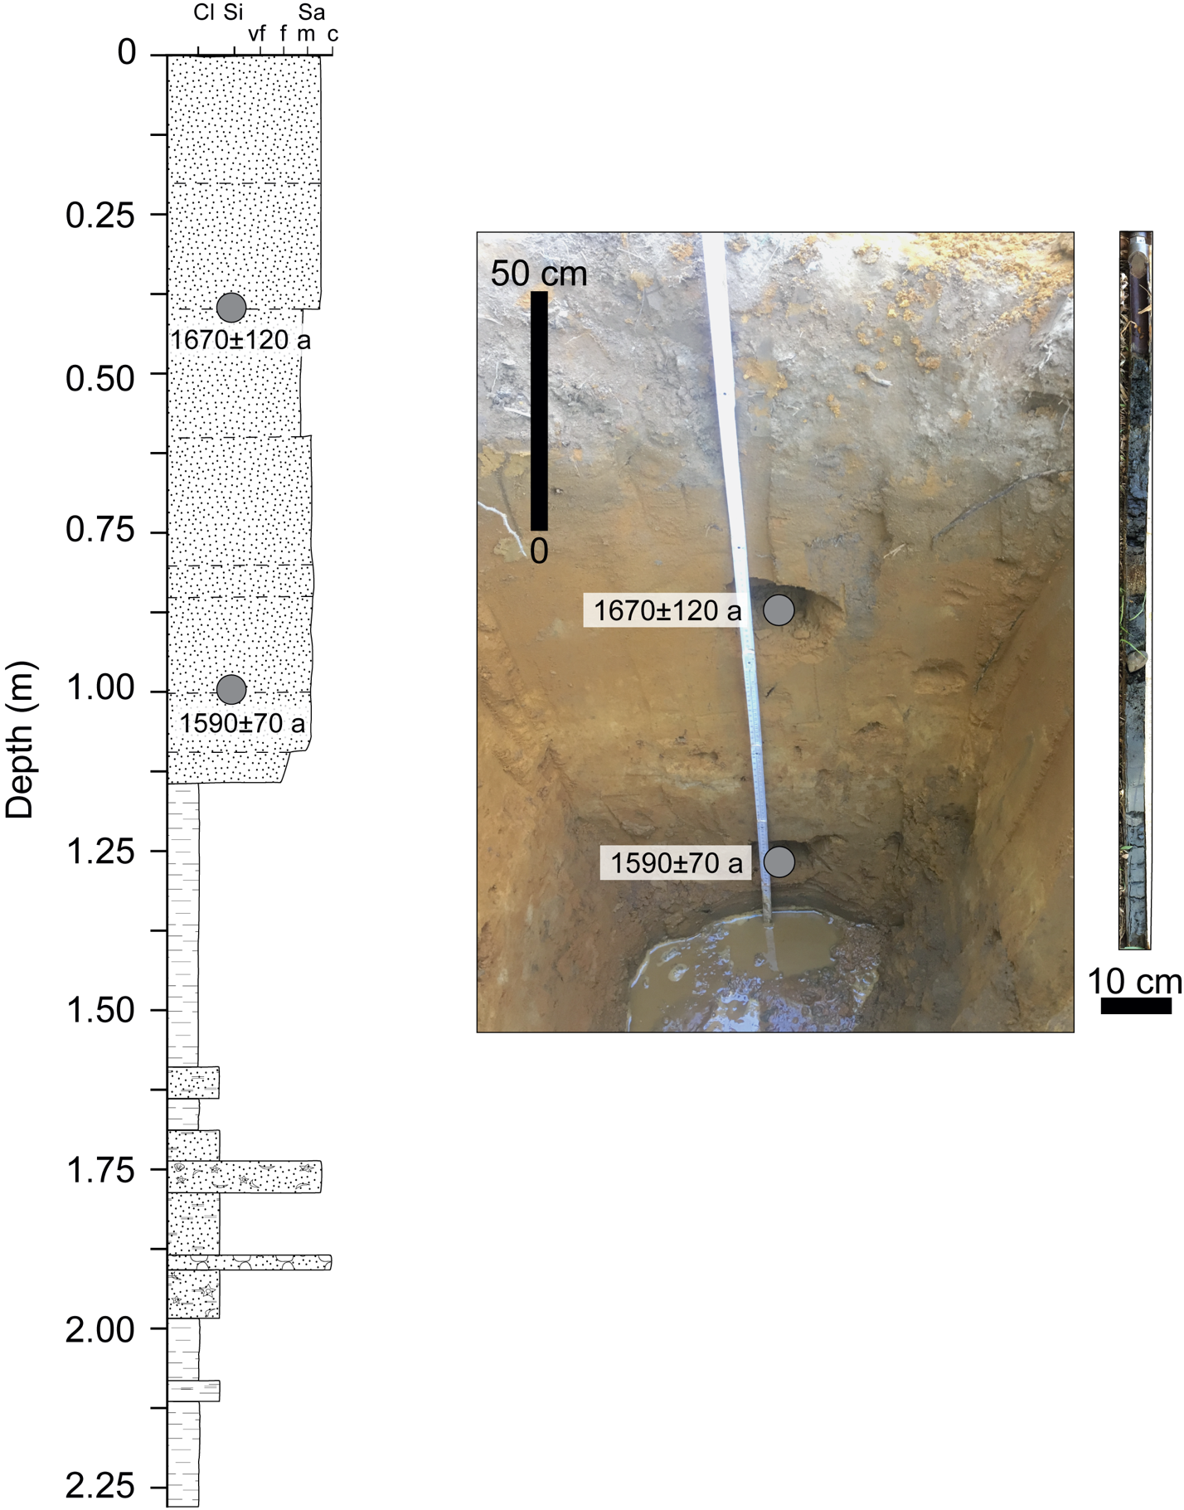

Figure S9. Sediment log and picture of D3, landward side of ridge D.

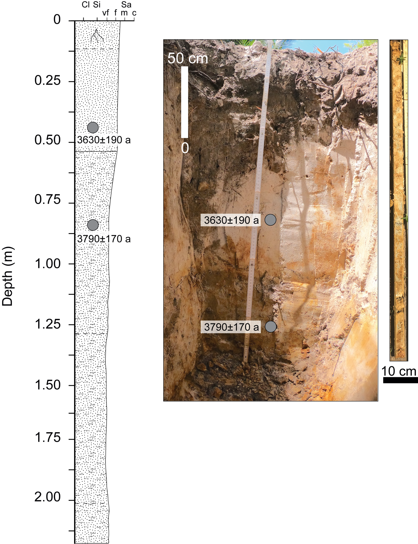

Figure S10. Sediment log and picture of E2, seaward side of ridge E.
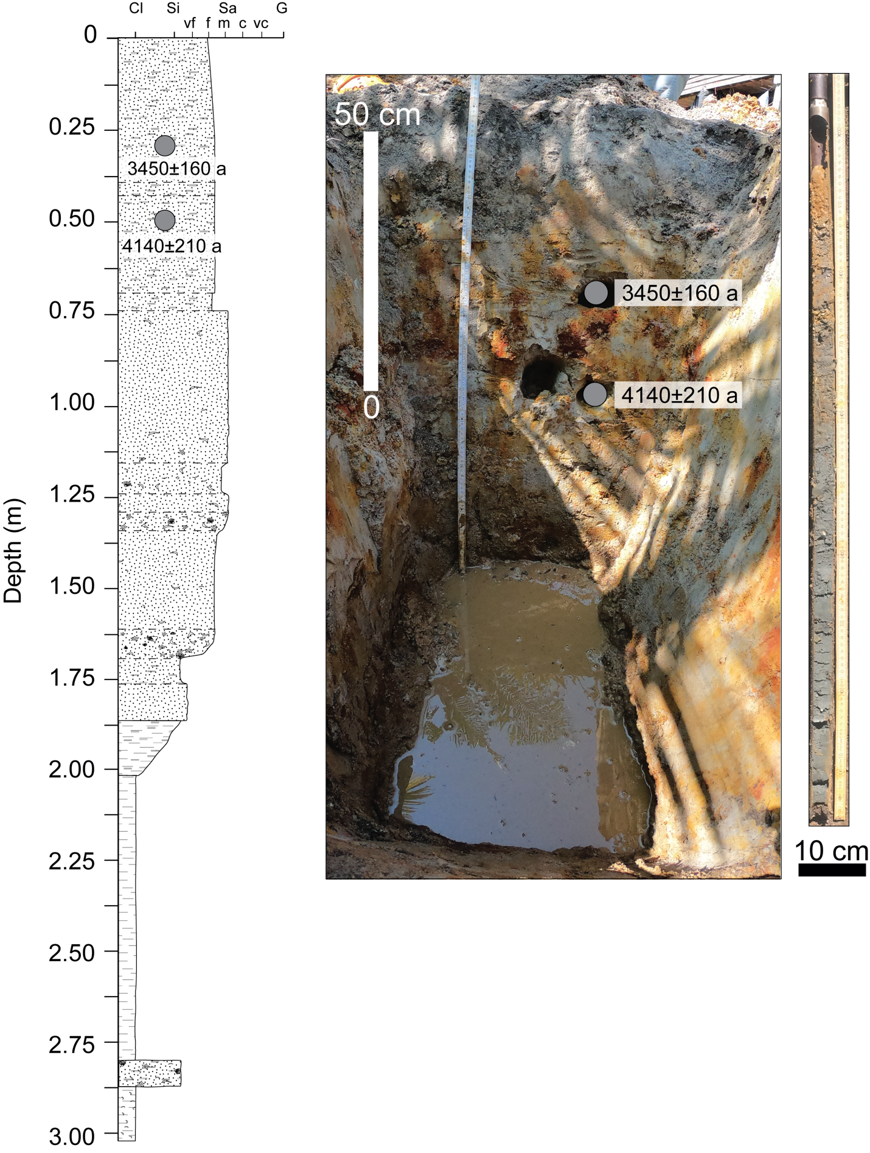
Figure S11. Sediment log and picture of E1, landward side of ridge E.

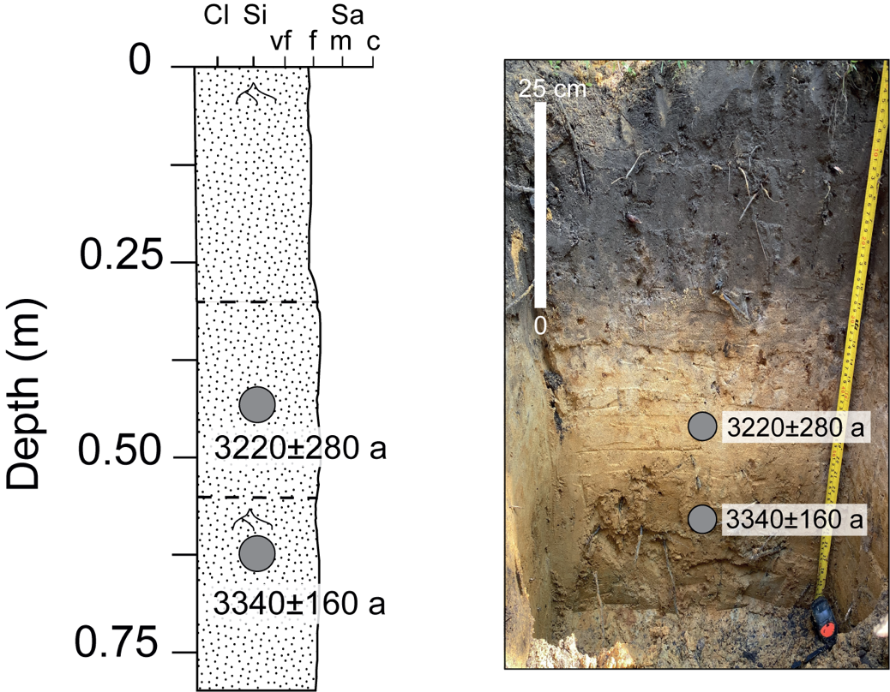

Figure S12. Sediment log and picture of F1, seaward side of ridge F.

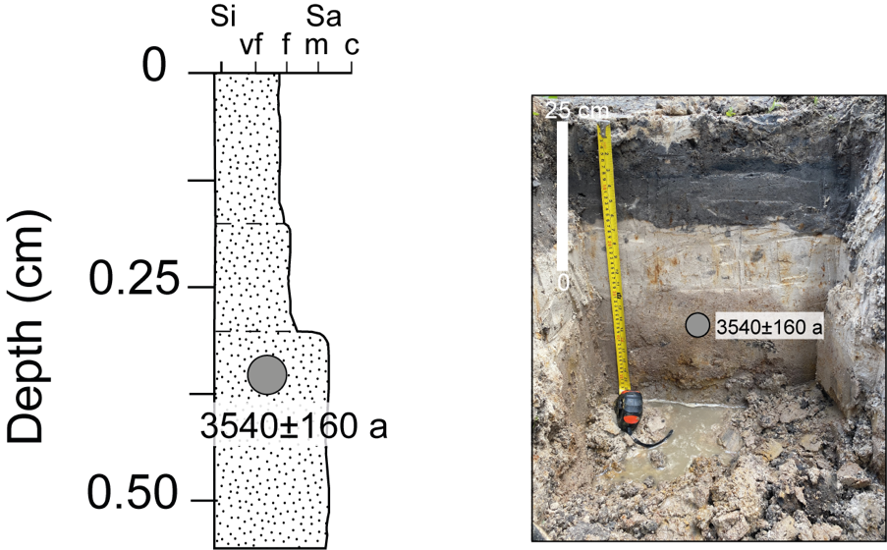

Figure S13. Sediment log and picture of F2, landward side of ridge F.

