Supporting Information

Protein click chemistry and its potential for medical applications
Ahmad Amiri,ª Sedigheh Abedanzadeh,^{b} Bagher Davaeil,ª Ahmad Shaabani,^{c} Ali A. Moosavi Movahediª*

ªInstitute of Biochemistry and Biophysics (IBB), University of Tehran, Tehran, Iran
^{b}Faculty of Chemistry, Kharazmi University, Tehran 15719-14911, Iran
^{c}Department of Chemistry, Shahid Beheshti University, Tehran, Iran

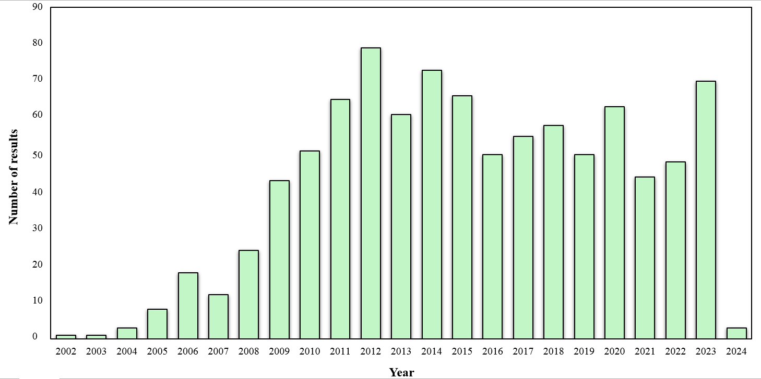
Figure 1. The number of published papers in the field of protein click chemistry with biological applications.

To obtain the number of results on click protein chemistry with biological applications, we used the advanced search motor of Scopus. Using keywords “click” in the title and “protein or peptide or enzyme” in the title, abstract, and keywords, 1584 articles with the subject of biological applications, including chemistry, biochemistry, genetics and molecular biology, pharmacology, toxicology and pharmaceutics, medicine, immunology, and microbiology have been found. Among them, through one-by-one checking, we separated and sorted 946 articles that were related to click protein chemistry with biological applications. Based on this information, Figure 1 is plotted by authors.

