Table S1. GSMS Participants followed up at each age
 | N (%)
Original Sample | 1420 (100)
Age
19 | 1072 (75.5%)
21 | 1060 (74.6%)
25 | 1109 (78.1%)
30 | 1154 (81.2%)

Table S2. Basic information about the Great Smoky Mountains Study
Total # of participants | 1,420
Sampling strategy | Community, representative with oversampling for children at risk for mental health problems
Design | Accelerated longitudinal with 3 cohorts
Observations | 11,233 (Median=8 per participant; Interquartile range 7-10)
Informant | Ages 9-16: Parent and Self-Report;  Ages 19-25: Self-report only  Age 30: Self-Report only
Age | Cohorts aged 9 (N=508), 11 (n=497), and 13 (N=415) at baseline;  Average age at last adult assessment: 30.9 (SD=1.7; range 26-35)
Sex | 49.2% female
Race and Ethnicity | 89.8% White; 6.4% African-American; 3.8% American Indian
Interview | Ages 9-16: Child and Adolescent Psychiatric Assessment  Ages 19-25: Young Adult Psychiatric Assessment  Age 30: Young Adult Psychiatric Assessment

Table S3: Effect size of positive transition in adulthood by race/ethnicity
 | American Indian Participants |  |  | Non-American Indian participants
 | Effect Size | Standard Error | 95% CI | Effect Size | Standard Error | 95% CI
Symptoms
Emotional | -0.01 | 0.10 | -0.22, 0.20 | -0.33 | 0.15 | -0.63, -0.03
Substance-related | 0.01 | 0.06 | -0.11, 0.14 | -0.05 | 0.06 | -0.17, 0.07
ASPD | -0.06 | 0.04 | -0.13, 0.01 | -0.08 | 0.03 | -0.14, -0.02

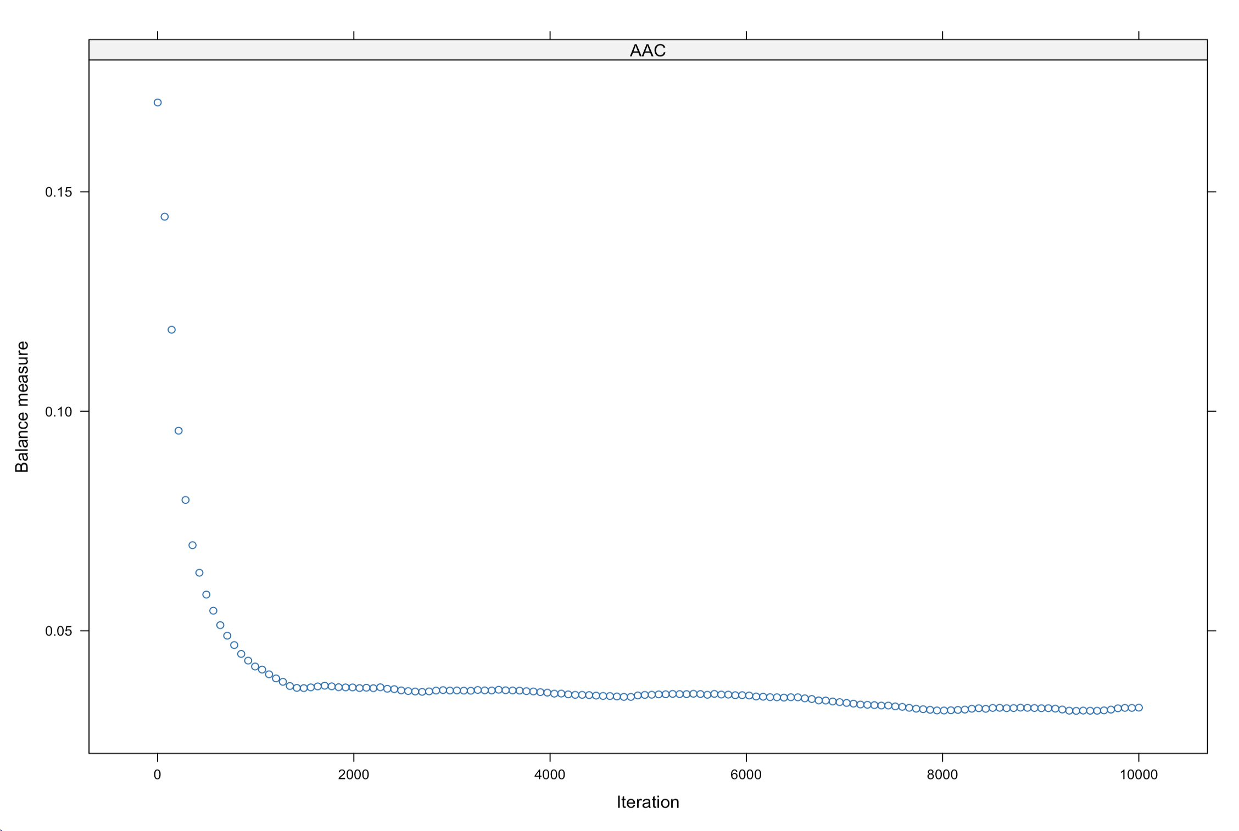

Figure S1. The average balance of covariates in absolute Spearman’s correlations is over 10,000 iterations of the generalized propensity score model using the generalized boosting method.

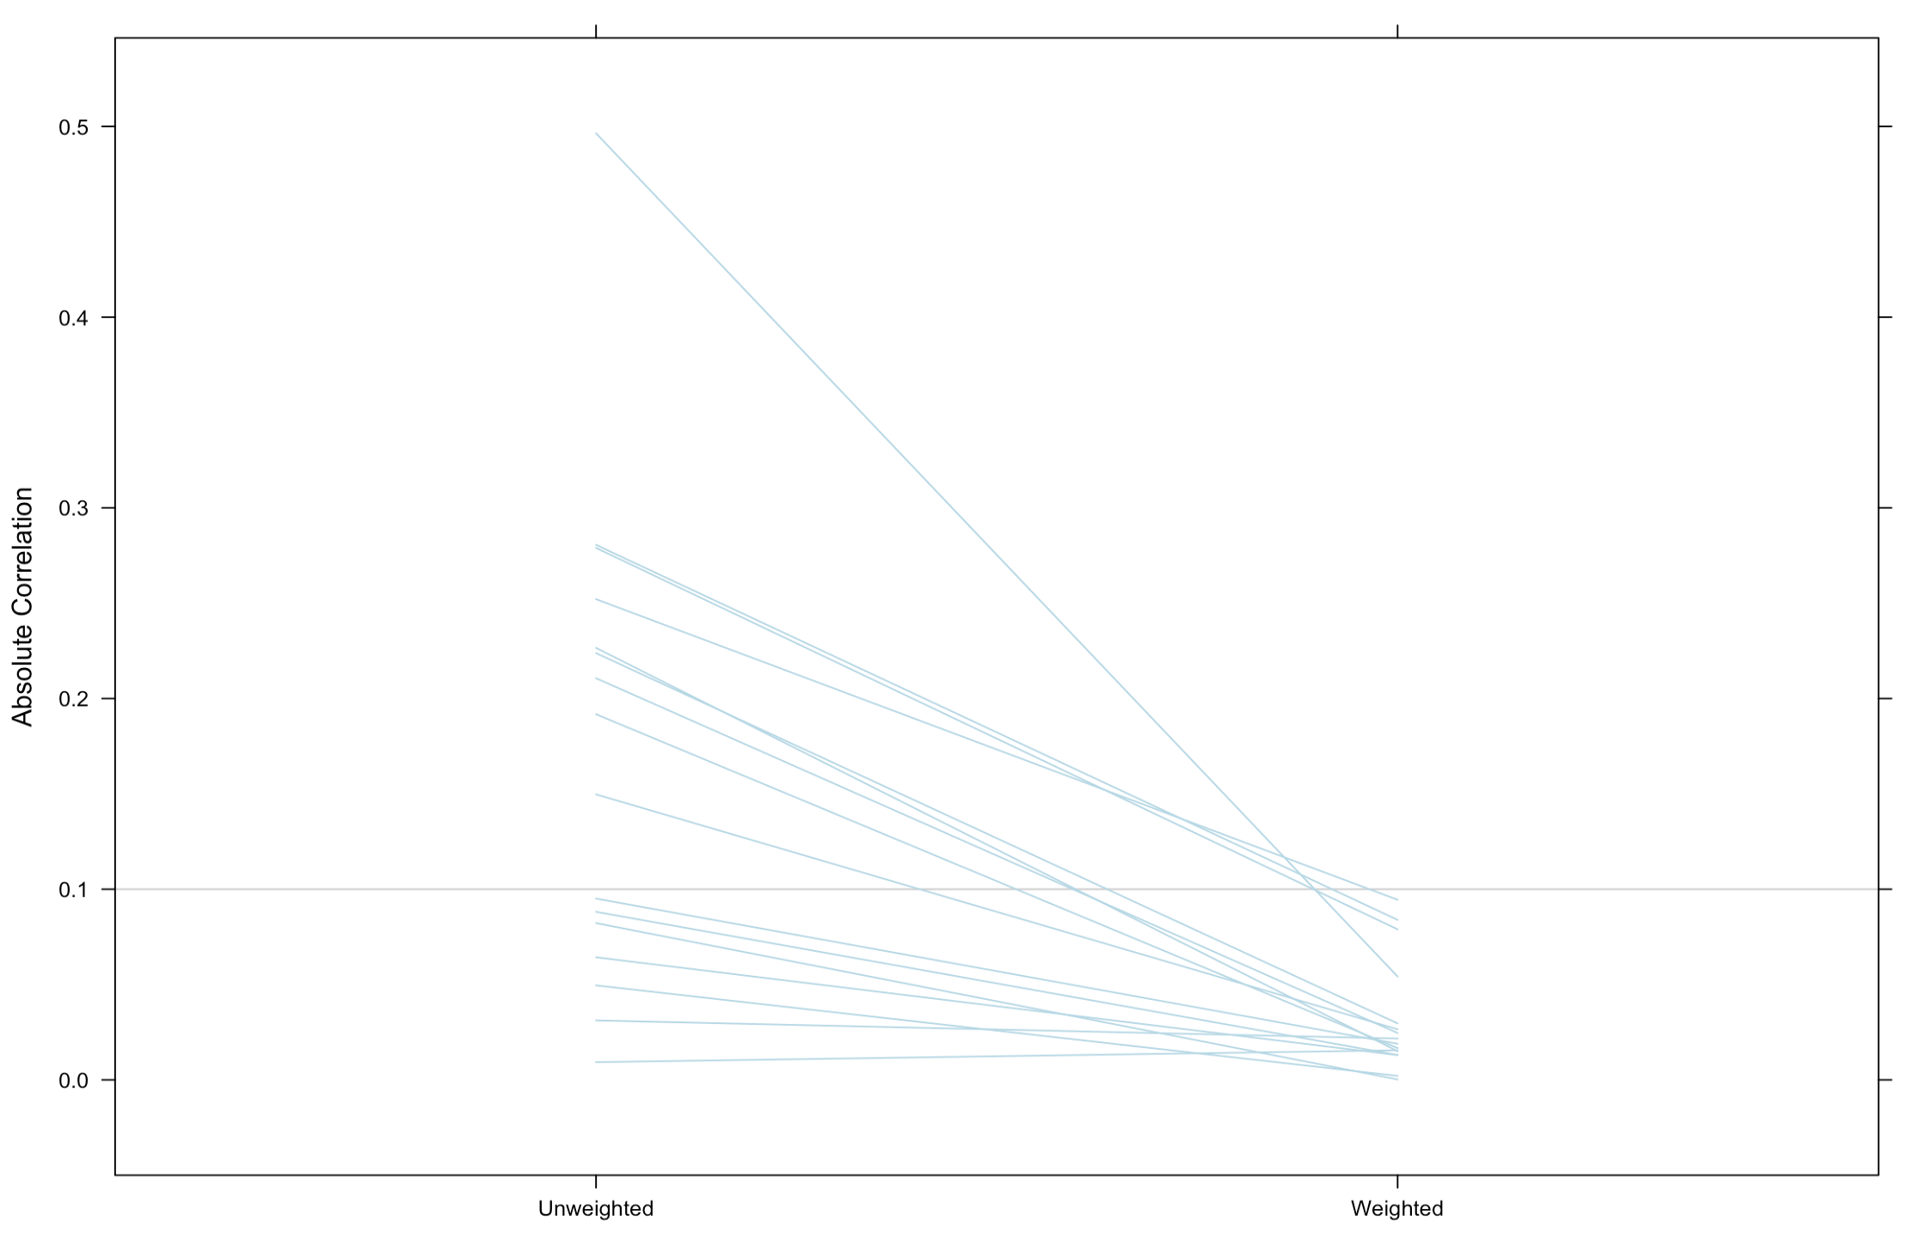

Figure S2. Absolute Spearman’s correlations of covariates with the transition before and after applying the weights obtained from the propensity score model using the generalized boosting method.

