Supplementary Materials
Measures:

Social and Occupational Functioning Assessment Scale (SOFAS)
The SOFAS (Saraswat et al., 2006) measures participant functioning on a scale of 0 (grossly impaired) to 100 (excellent functioning), with 9 anchor points in-between for guidance. Participants can be scored on any number within this range (e.g., 63). The scale was completed by a trained research assistant based on their knowledge of the individual and discussions with their care team. Unlike the Global Assessment of Functioning (GAF), the SOFAS does not rate the severity of clinical symptoms, but instead focusses solely on social and occupational functioning.

Goal Attainment Scale (GAS)
The GAS is a personalised measure, used to capture clinical change in goal attainment resulting from intervention. The GAS has been shown to be a suitable measure for multidimensional health problems which warrant a personalised approach to treatment and outcome measurement, and has been successfully used to measure cognitive rehabilitation (Rockwood et al., 1997). The GAS was scored based on the participant’s achievement of apriori determined goals, over the course of the trial. Participants were rated based on 3 goals set at baseline their assessment, with each goal rated on a 5-point scale (-2 to +2). Goals were then weighted based on relative importance and anticipated difficulty of achieving the goal, with a T-score for change calculated to allow statistical comparisons.
This was the primary outcome in the main trial however, as the GAS is used to measure change from the same baseline point (i.e., no variance) (Kiresuk & Sherman, 1968), it has limited usefulness cross-sectionally and was therefore only included in a change-network.

Positive and Negative Syndrome Scale (PANSS)
The PANSS (Kay et al., 1987) is a validated scale used to assess symptom severity in patients with schizophrenia. It has been shown to be valid, reliable, sensitive to change, with a lack of ceiling effects. The PANNS consists of 30-items originally adapted from the Brief Psychiatric Rating Scale (BPRS) and Psychopathology Rating Scale (PRS). The trained interviewer administers the PANSS by conducting a semi-structured interview (SCI-PANSS) covering each of the items on the scale. Each item is then rated between 1 (absent) to 7 (extreme), according to detailed guidance in the measure’s guide. The PANSS consists of three sub-scales, positive (7-items), negative (7-items), and general symptoms (16-items), with a summed total given for each. In this study, only the positive and negative symptoms scales were used.

The Clinical Assessment Interview for Negative Symptoms (CAINS)
A further semi-structured measure of negative symptoms, the CAINS (Kring et al., 2013), was also included. Unlike the PANSS Negative Scale, which provides a broader clinical evaluation, the CAINS focusses on experiential and expressive deficits. The separation of expressivity and motivation was informed by the current literature which emphasises these as distinct constructs within the negative symptom domain (Strauss et al., 2018). For example, motivation deficits are primarily associated with functional outcomes and cognitive domains, while expressivity is linked to social interaction and communication. This separation aligns with evidence suggesting differential treatment responsiveness and neurobiological underpinnings for these factors. Including both the PANSS Negative and CAINS subscales allowed for a more nuanced exploration of the negative symptom domain and their potential distinct relationships with cognition and functioning outcomes.

The CAINS is a second-generation measure of negative symptoms, shown to be valid in separating different aspects of negative symptoms (motivation and pleasure vs experiential) and to have good reliability and internal consistency. Participants are rated on 13 different items, composing the two 2 sub-scales: a 9-item motivation and pleasure scale and a 4-item experiential scale. Each item is rated on (0-4) as per guidance in the handbook, on a scale ranging from absent (0) to severe (4).

Digit Span Backwards (DS-B)
The DS-B is a measure of working memory in which the subject is read aloud a sequence of numbers starting with 2 numbers, progressing up to 8 items in the length. On hearing them, the participant is asked to repeat them in exactly reversed order. After two items are each sequence length, the items increase in length. The task is discontinued if the participant gets two items in a row, at the same sequence length, incorrect. This task differs from digit-span forwards, in requiring more effortful activity involving mental double-tracking and manipulation simultaneously.

Rey Auditory Verbal Learning Test (AVLT)
The REY AVLT (Schmidt, 1996) is a test to auditory verbal learning and memory. The participant is read aloud a list of 15 words (one word per second) by the examiner. They are then asked to recall the words, in no particular order. This is then repeated a further four times (five trials in total), with each trial scores based on the number of words correctly recalled. The outcome measure used is the total number of words recalled correctly across the five trials.

The Cambridge Automated Neuropsychological Cognitive Test Battery (CANTAB)
The CANTAB connect for the i-Pad (CANTAB®, 2017) is computerised touch-screen assessment tool for cognitive functioning, which is highly sensitive and has become the gold standard for measurement of cognition in clinical trials. All tests are non-linguistic and all instructions are standardised.

Motor Screening Task (MOT)
The MOT screens for motor speed and was the first CANTAB task completed by participants. The MOT measures sensorimotor speed and comprehension and serves to also ensure participants are able to use the touchscreen format of the CANTAB connect. In this task, participants are presented with one coloured crosses on the screen, in changing locations. The participant is asked to respond to the cross by touching on it as quickly and as accurately as possible. This was used to as a screening tool to ensure participants were able to complete the tasks included in the study.

Rapid Visual Information Processing (RVP)
The RVP task is used to record sustained attention. In this task, the participant is shown a box in the middle of the screen, within which digits between 2 and 9 appear at a rate of 100 digits a minute. Participants are given the instruction to respond by pressing a touch-screen button at the bottom of the screen when seeing the consecutive sequence of numbers “3-5-7”. The task starts by highlighting the number sequence in red to ensure the participant is following the instructions correctly, with this gradually fading away completely as the task progresses. The outcome used was the sensitivity to the target sequence regardless of response tendency.

Reaction Time (RTI)
The RTI task measures is thought to measure reaction time and accuracy, motor and mental response speed, and impulsivity. Participants were shown a touch screen button at the bottom of the screen and instructed to press and hold this using their index finger, before the start of each trial. Once a circle at the top of the screen turns yellow, participants are required to press this as soon as possible using their index finger of the same hand. The task has two modes – “simple” in which only one circle is shown at the top of the screen, and “five-choice”, in which 5 circles are present in different positions across the screen, with only one lighting up at the time.

One Touch Stockings of Cambridge (OTSC)
The OTSC task is computerised adaptation of the Towers of Hanoi task. The Stockings of Cambridge task measures working memory and spatial planning, with the one-touch version asking participants to calculate the minimum number of moves required to complete a solution, which they must then select as a response (1 – 7).
Participants are shown a split-screen image depicting coloured balls suspended in “stockings” and are asked to select the minimum number of moves required for the lower image to be “moved” to be identical to the upper image, whilst obeying a number of rules: that no ball can be suspended in “mid-air” that and no ball can be moved from underneath another without first moving the ball on top. The primary outcome is the number of solutions solved on the first attempt.

Attention-Switching Task (AST)
The AST (since renamed to multi-tasking test) assesses one’s ability to switch attention and manage incongruent information. In this task, two buttons are displayed at the bottom of the screen and arrows are shown directly above either of the two boxes. In the first instance, the participant is asked to select the box on the side of the screen the arrow shown. As the task progresses, participants are asked to press the box on the side of the screen that the arrow is pointing to and ignore which side of the screen the arrow is presented on. The participants will then be directed on which rule to follow with the word “side” or “direction written in the middle of the screen. The participant is given both congruent (where the direction of the arrow matches the side of the screen it is presented on) and incongruent (e.g., where the arrow presents on the left but points to the right). The primary outcome for this measure was the number of correct responses.

Paired Associates Learning (PAL)
The PAL measures visual memory and new learning. Boxes “open” around the edges of the screen, one at a time, in an apparently random order, with one of the boxes containing a patterned image (see Figure S5). After all boxes have opened, a patterned image is displayed in the middle of the screen, and the participant is asked to touch the box on the outside of the screen, which the image had appeared in. This is then repeated for each of the images which were shown. If the participant makes any error, the boxes are then re-opened again in the same order as in the initial trial, for another attempt. Only once the participant has completed the sequence correctly, they move on to the next trial, with an increasing number of patterns/boxes (maximum 8). The outcome measure was the number of times the participant chose the incorrect box for a stimulus on assessment problems, plus an adjustment for the estimated number of errors they would have made on any problems, attempts, and recalls they did not reach.

Spatial Working Memory (SWM)
A measure of spatial working memory, executive functions and strategy use, participants are shown coloured boxes in varying formations across the screen (see Figure S6). They are then asked to locate a box containing a yellow token, and once found, to select and “store” it in a slot to the right of the screen. Each trial has only one token, and participants are informed that tokens will not appear in the same box twice, such that they must remember which boxes they have already checked. As the task progresses, the number of boxes increases, until there are 8 boxes in total. The outcome measure was the number of times the participant incorrectly revisits a box in which a token has previously been found.

Emotion Recognition Task Short-Form (ERT)
The ERT task assesses the speed and accuracy with which participants can recognise emotions. The ERT was developed by deriving morphed images from real individuals showing one of 6 emotions (happiness, surprise, sadness, anger, fear or disgust). Images are displayed one at a time, for 200ms and then immediately hidden. At this point, the participant is asked to select the emotion the face most closely resembled, from the 6 options. In the short-form version of this task, there are a total of 48 trials, pertaining to 8 of each emotion. Outcome measure is the total number of correct responses (emotion selection) the subject made across all assessed trials

Supplementary Table 1 (S1): Mean scores on each measure
Variable | Pre-CR* (n - 165)  Mean (SD) | Post-CR* (n – 165)  Mean (SD) | Comparison  Pre vs post-CR
SOFAS | 64.41 (14.92) | 67.40 (18.53) | t = 2.47, p = 0.02
GAS | 32.92 (4.79) | 51.48 (11.55) | t = 20.09, p = <0.001
PANSS Positive | 12.84 (5.07) | 11.32 (4.66) | t = -5.38, p - <0.001
PANSS Negative | 14.39 (6.35) | 13.28 (5.23) | t = -2.54, p = 0.01
CAINS EXP | 3.86 (4.37) | 3.49 (3.99) | t = -1.27, p = 0.21
CAINS MAP | 14.61 (7.50) | 13.47 (7.41) | t = -2.22, p = 0.03
MIC-SR | 19.43 (9.69) | 16.44 (9.14) | t = -4.36. p = <0.001
DS-B | 5.73 (2.21) | 5.93 (2.26) | t = 1.43, p = 0.16
AVLT | 43.77 (11.45) | 45.55 (12.26) | t = 2.00, p = 0.05
AST | 143.58 (16.40) | 145.33 (17.16) | t = 1.61, p = 0.11
ERT | 27.14 (6.12) | 26.87 (6.87) | t = -0.58, p = 0.55
OTSC | 9.30 (3.21) | 9.46 (3.38) | t = 0.70, p = 0.49
PAL (errors) | 19.68 (16.35) | 17.67 (16.84) | t = -1.98, p = 0.05
RT | 409.94 (56.28) | 406.33 (54.32) | t = -0.95, p = 0.34
RVP | .95 (.06) | .96 (.05) | t = 1.38, p = 0.17
SWM (Errors) | 13.70 (9.81) | 11.33 (10.19) | t = -3.44, p = <.001

SD = standard deviation, N = number of participants, *following imputation. PANSS = Positive and Negative Syndrome Scale, SOFAS = Social and Occupational Functioning Scale, CAINS EXP = Clinical Assessment Interview for Negative Symptoms, EXP = experiential, MAP = Motivation and Pleasure. MIC-SR = Measure of Insight into Cognition – Self-report, DS-B =Digit-Span – Backwards, AVLT = Rey Auditory Verbal Learning Test, AST = Attention Switching Task, ERT = Emotion Recognition Test, OTSC = One-Touch Stockings of Cambridge, PAL = Paired Associates Learning, RT = Reaction Time, RVPA = Rapid Visual Processing, SWM = Spatial Working Memory

Network Stability
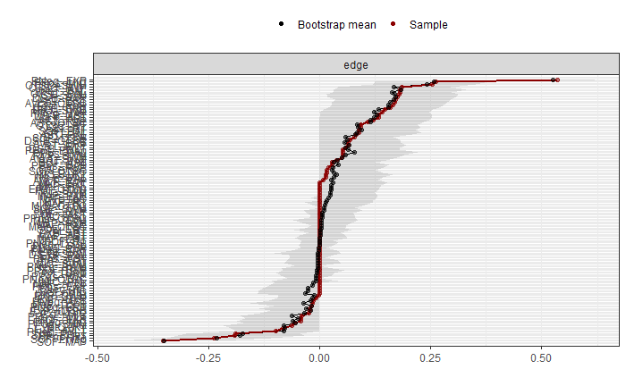
Figure S8: Bootstrapped 95% confidence intervals (CI) for the estimated edge weights in the pre-CR network.

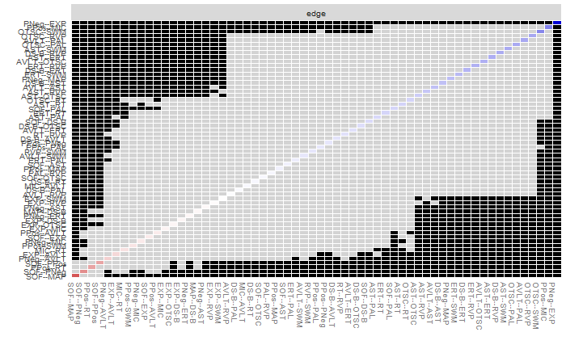
Figure S9. Bootstrapped difference tests of edge weights in the pre-CR network.
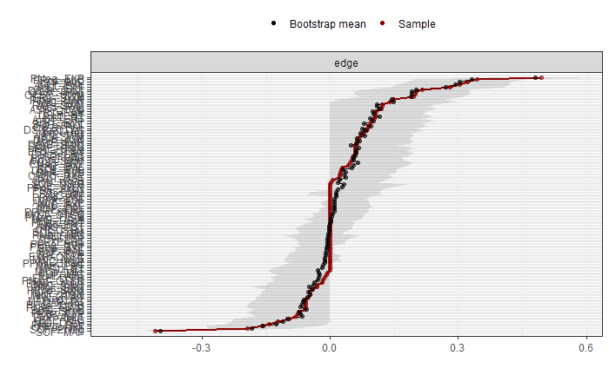
Figure S10. Bootstrapped 95% confidence intervals (CI) for the estimated edge weights in the post-CR network
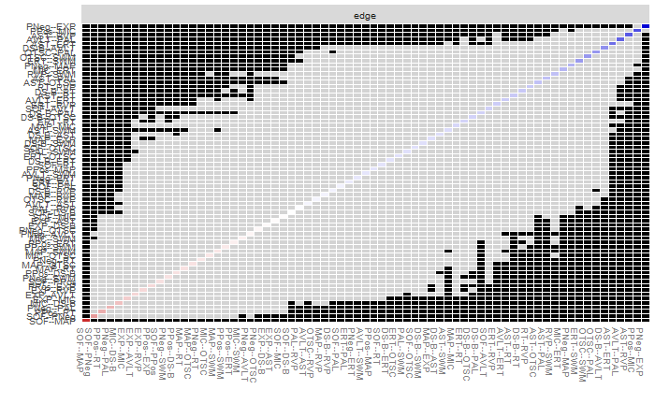
Figure S11. Bootstrapped difference tests of edge weights in the post-CR network.

Sensitivity Analysis
Table S2: Table of imputed vs non-imputed mean scores

Table of imputed vs non-imputed mean scores
Variable | Pre-CR non-imputed (n = 96) Mean (SD) | Pre-CR imputed (n = 165)  Mean (SD) | Post-CR non-imputed (n = 96) Mean (SD) | Post-CR Imputed (n = 165)  Mean (SD)
SOFAS | 64.24 (13.98) | 64.41 (14.92) | 67.57 (16.02) | 67.40 (18.53)
PANSS Positive | 12.91 (5.27) | 12.84 (5.07) | 11.33 (4.76) | 11.32 (4.66)
PANSS Negative | 14.53 (6.15) | 14.39 (6.35) | 13.14 (4.88) | 13.28 (5.23)
CAINS EXP | 4.02 (4.25) | 3.86 (4.37) | 3.53 (4.17) | 3.49 (3.99)
CAINS MAP | 14.54 (7.41) | 14.61 (7.50) | 13.07 (7.36) | 13.47 (7.41)
MIC-SR | 18.78 (9.90) | 19.43 (9.69) | 16.19 (9.13) | 16.44 (9.14)
DS-B | 5.90 (2.19( | 5.73 (2.21) | 6.10 (2.38) | 5.93 (2.26)
AVLT | 43.70 (10.59) | 43.77 (11.45) | 46.04 (11.66) | 45.55 (12.26)
AST | 145.25 (15.18) | 143.58 (16.40) | 147.84 (13.73) | 145.33 (17.16)
ERT | 27.27 (6.05) | 27.14 (6.12) | 27.29 (6.36) | 26.87 (6.87)
OTSC | 9.40 (3.02) | 9.30 (3.21) | 9.97 (3.04) | 9.46 (3.38)
PAL (errors) | 19.93 (15.54) | 19.68 (16.35) | 16.68 (15.91) | 17.67 (16.84)
RT | 408.39 (52.87) | 409.94 (56.28) | 398.99 (46.86) | 406.33 (54.32)
RVP | 95 (.06) | .95 (.06) | .96 (.07) | .96 (.05)
SWM (Errors) | 14.01 (9.81) | 13.70 (9.81) | 10.65 (9.95) | 11.33 (10.19)

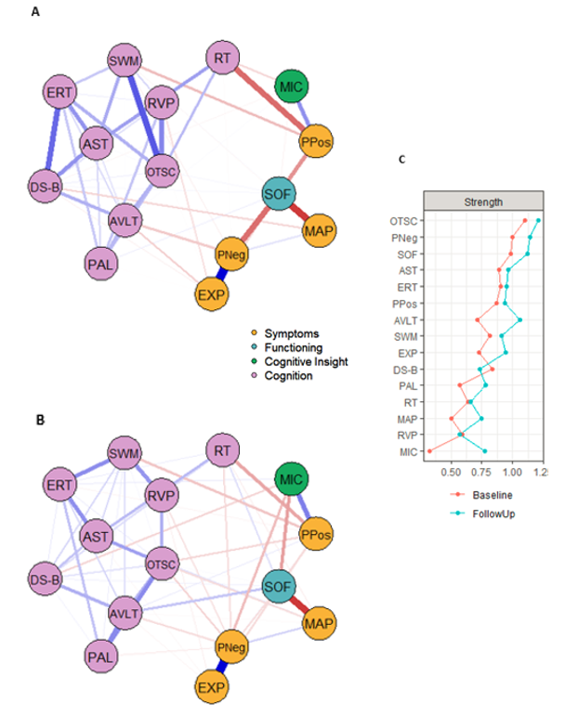
Figure S5: Network estimation for the CR networks using complete data pre-CR (A) and post-CR (B) and their strength centrality scores (C). Nodes (circles) represent cognitive (purpose), clinical (yellow), cognitive insight (green) and functioning (blue) scores. Higher scores for cognitive and functioning nodes represents better performance, whilst higher scores for metacognition and symptoms represents worse performance. Edge weights (lines) represent associations between nodes, with denser lines indicating stronger associations. Blue edges depict positive associations and red edges depict negative associations. AST = Attention Switching Task; AVLT = Auditory Verbal Learning Task, DS-B = Digit Span Backward, ERT = Emotion Recognition Test; EXP = CAINS Expressive Score; MAP = CAINS Motivation and Pleasure Score; MIC = Measure ofe Insight into Cognition – Self Report; OTSC = One-Touch Stockings of Cambridge; PAL = Paired Associates Learning; PNeg = PANSS Negative; PPos = PANSS Positive; RT = Reaction Time; RVP = Rapid Visual Processing; SOF = Social and Occupational Functioning Assessment Scale; SWM = Spatial Working Memory

Table S3: Table of centrality indices for complete-cases sensitivity analysis
Network | Edge | Strength
Pre-CR | 0.53 | 0.28
Post-CR | 0.59 | 0.28

Supplementary References
CANTAB®. (2017). [Cognitive assessment software]. All rights reserved. www.cantab.com [Online]. Cambridge Cognition.
Kay, S. R., Fiszbein, A., & Opler, L. A. (1987). The positive and negative syndrome scale (PANSS) for schizophrenia. Schizophrenia Bulletin, 13(2), 261–276. https://doi.org/10.1093/schbul/13.2.261
Kiresuk, T. J., & Sherman, R. E. (1968). Goal attainment scaling: A general method for evaluating comprehensive community mental health programs. Community Mental Health Journal, 4(6), 443–453. https://doi.org/10.1007/BF01530764
Kring, A. M., Gur, R. E., Blanchard, J. J., Horan, W. P., & Reise, S. P. (2013). The Clinical Assessment Interview for Negative Symptoms (CAINS): Final Development and Validation. The American Journal of Psychiatry, 170(2), 165–172. https://doi.org/10.1176/appi.ajp.2012.12010109
Rockwood, K., Joyce, B., & Stolee, P. (1997). Use of goal attainment scaling in measuring clinically important change in cognitive rehabilitation patients. Journal of Clinical Epidemiology, 50(5), 581–588. https://doi.org/10.1016/s0895-4356(97)00014-0
Saraswat, N., Rao, K., Subbakrishna, D. K., & Gangadhar, B. N. (2006). The Social Occupational Functioning Scale (SOFS): A brief measure of functional status in persons with schizophrenia. Schizophrenia Research, 81(2), 301–309. https://doi.org/10.1016/j.schres.2005.09.008
Schmidt, M. (1996). Rey Auditory and Verbal Learning Test. A handbook, Los Angeles, Western Psychological Association.
Strauss, G. P., Nuñez, A., Ahmed, A. O., Barchard, K. A., Granholm, E., Kirkpatrick, B., … Allen, D. N. (2018). The Latent Structure of Negative Symptoms in Schizophrenia. JAMA Psychiatry, 75(12), 1271–1279. https://doi.org/10.1001/jamapsychiatry.2018.2475

