Appendix 1: Assessment of safety
The likelihood of adverse events (AE) occurring during this trial was low. Previous studies have shown that daytime sleepiness, tiredness and vigilance impairment may increase during sleep restriction therapy (SRT), which is one of the behavioural components of CBT-I (Kyle et al., 2014). For the full procedure on how AE and Serious AE (SAE) were reported, see trial protocol (Moukhtarian et al., 2022). AE and SAE during the study period that may or may not have been due to the intervention were recorded by the research team to check for any patterns or trends in events.
The table below summarises the adverse event reports received during the trial. None were judged serious or related to the treatment.
Table 1 Reports of Adverse Events
Adverse Event Description | Related/Unrelated | Outcome*
Employee signed off work with mental health burnout | Unrelated | Withdrew from the trial
Head injury sustained during the trial | Unrelated | Continued in the trial
Signed off work, suspected vitamin deficiency | Unrelated | Continued in the trial
Signed off work due to stress after first therapy appointment | Unrelated | Withdrew from the trial
Rash from wearing the sleep tracker | Unrelated | Continued in the trial
*None of the participants withdrew consent, and their data was therefore not deleted.

Appendix 2: Variable distributions
Normality of all variables in the study were examined both graphically through histograms and Q-Q plots, and analytically reporting on the Shapiro-Wilk test.
Primary outcomes
GAD-7
W (159) = .96, p < .01
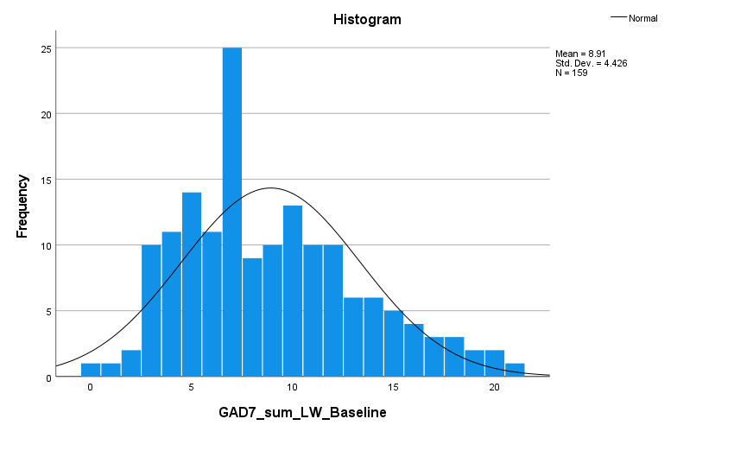
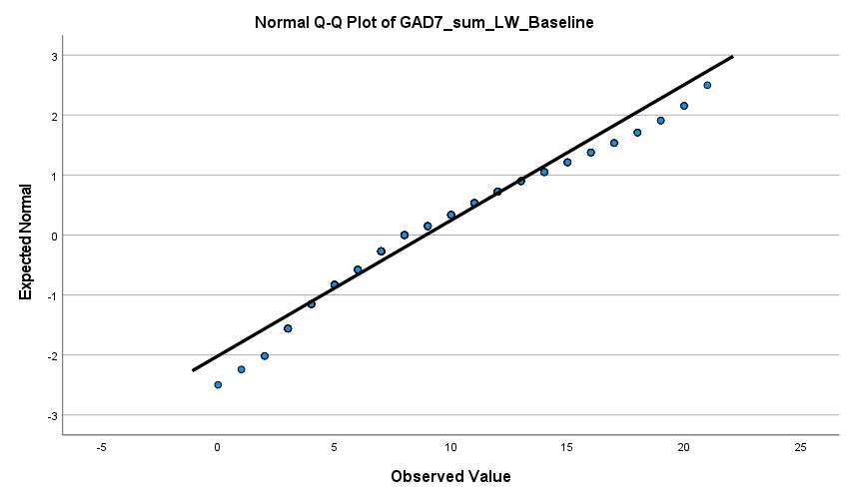

PHQ-9
W (159) = .97, p < .001
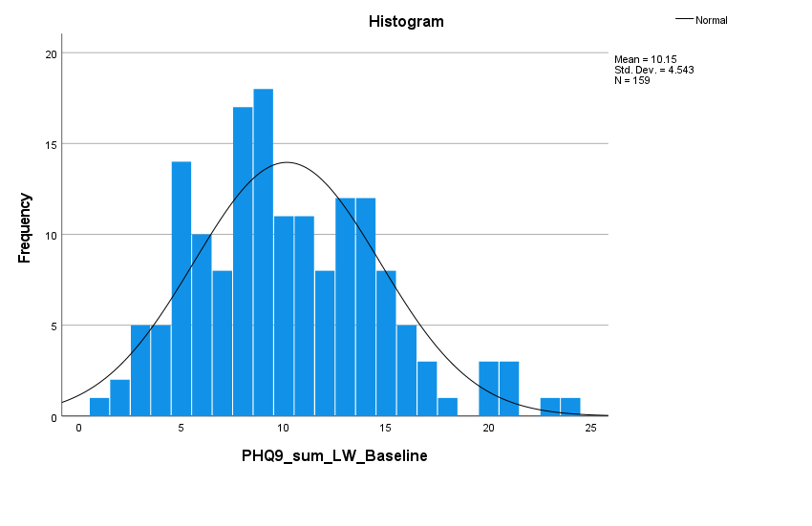
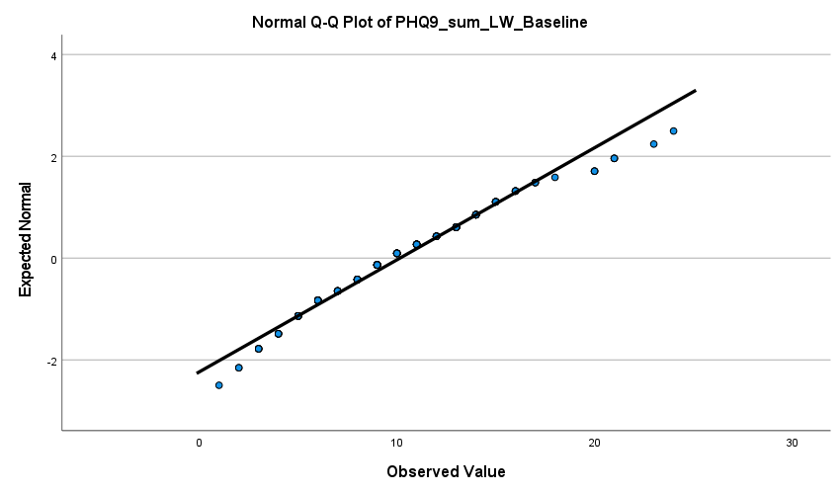

ISI
W (159) = .99, p = .29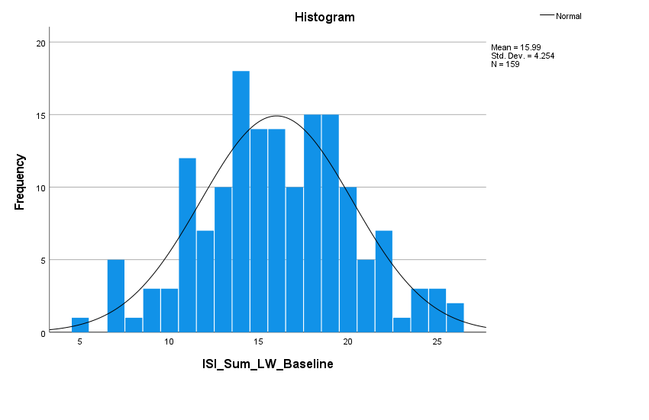
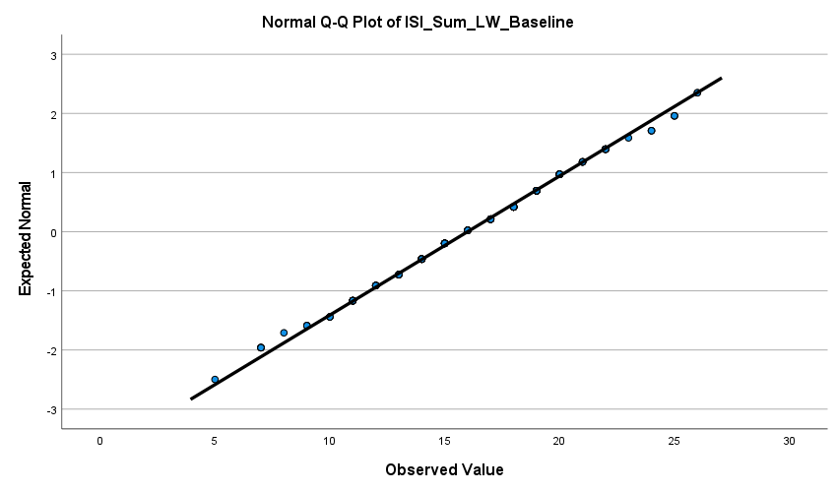

Secondary questionnaire outcomes
IJSS
W (159) = .99, p = .12
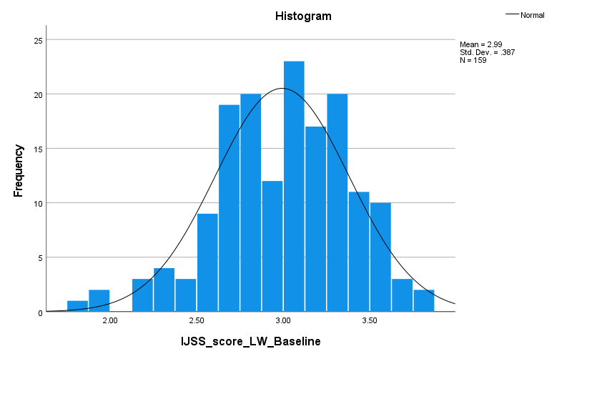
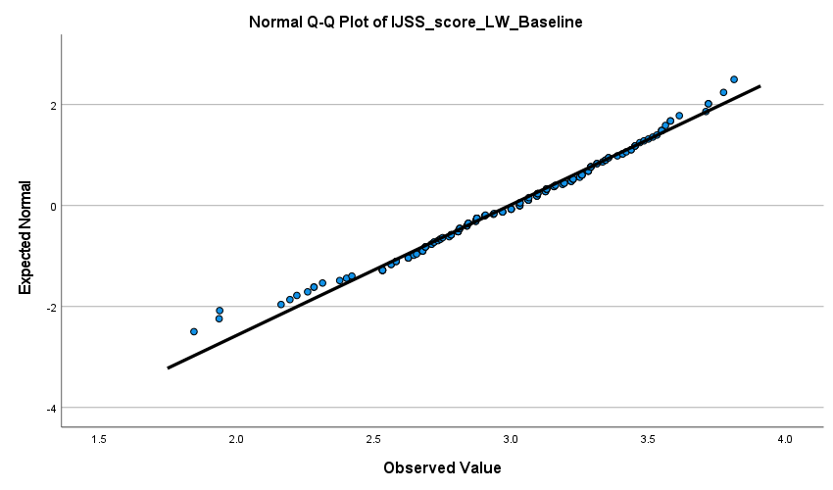

WEMWBS
W (156) = .98, p = .05
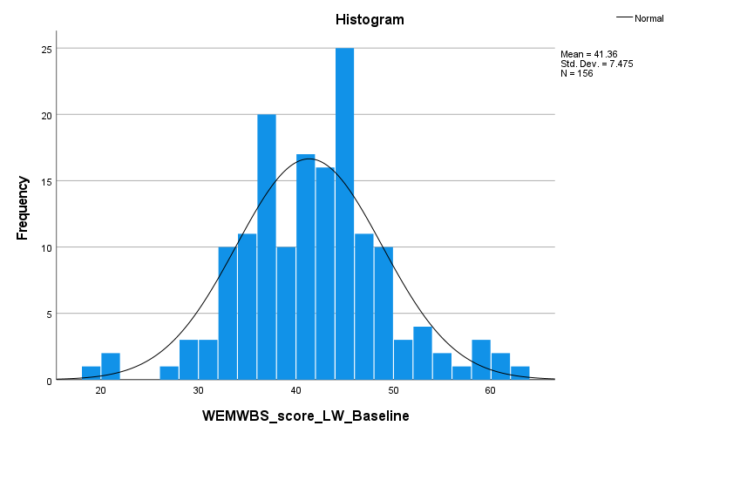
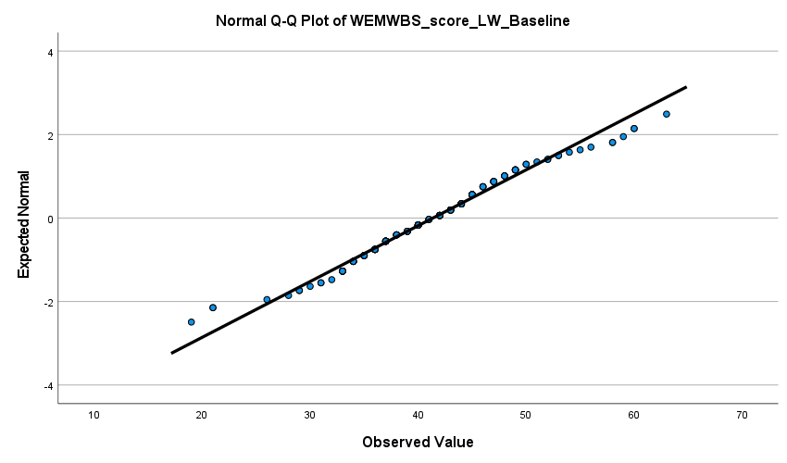

WPAI1-WTM
W (158) = .29, p < .001
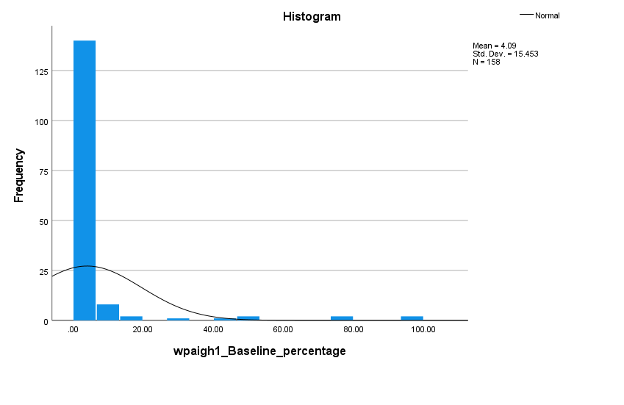
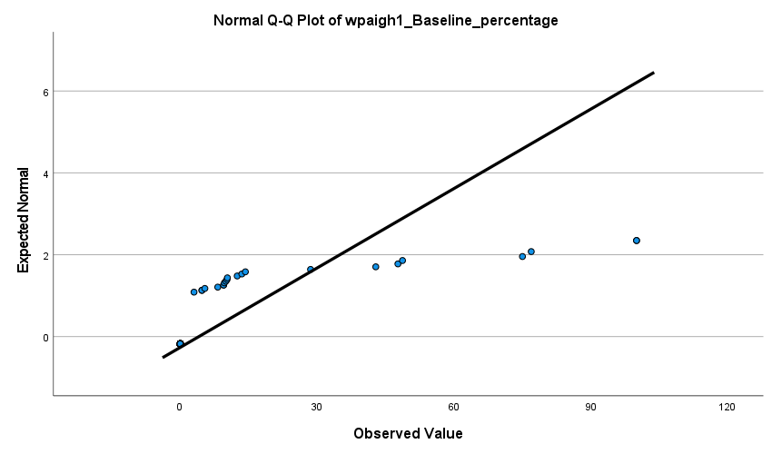

WPAI2-IWW
W (159) = .93, p < .001
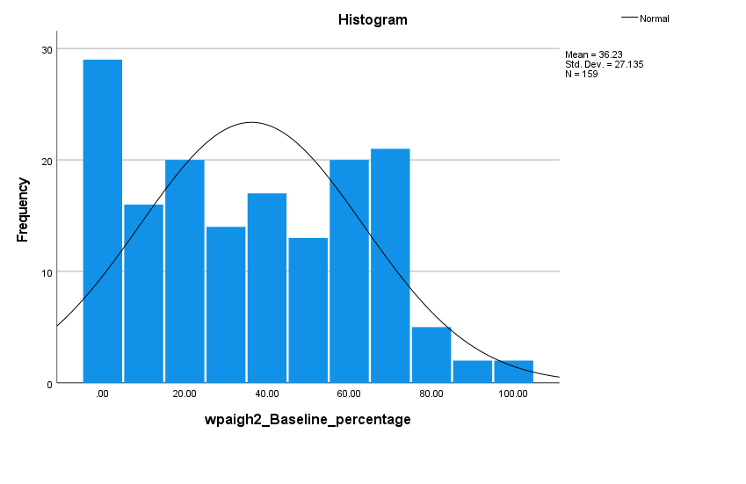
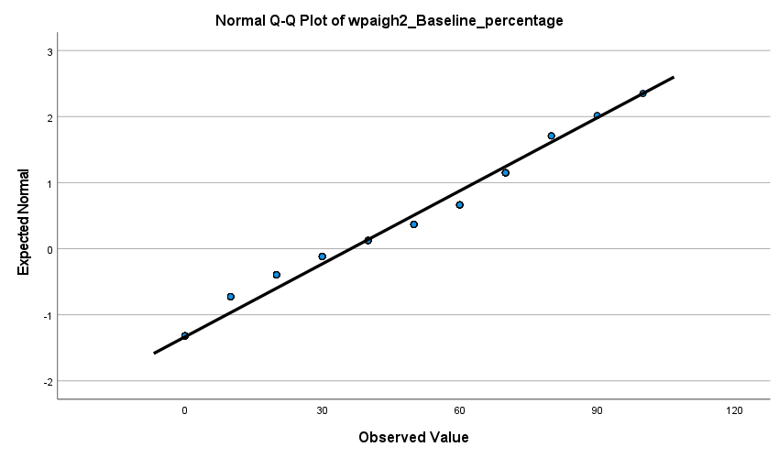

WPAI3-OWI
W (158) = .93, p < .001
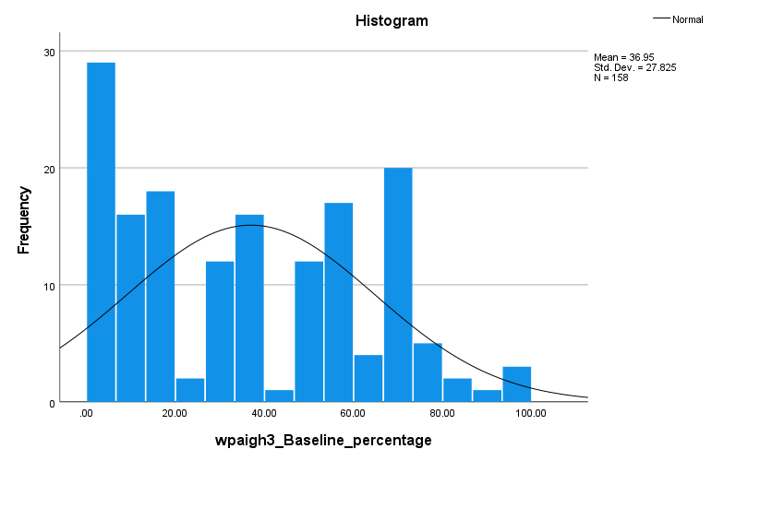
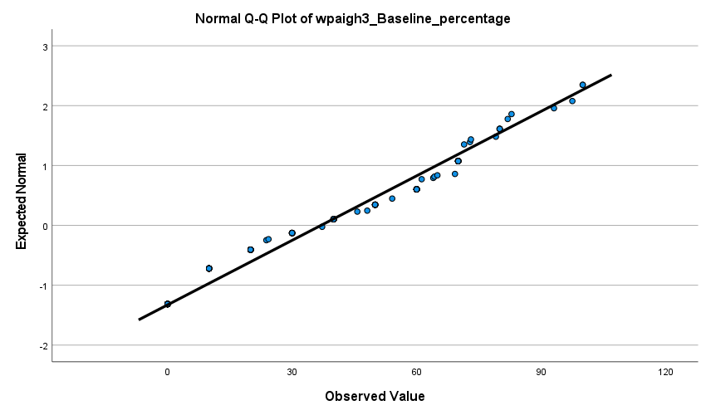

WPAI4-AI
W (159) = .93, p < .001
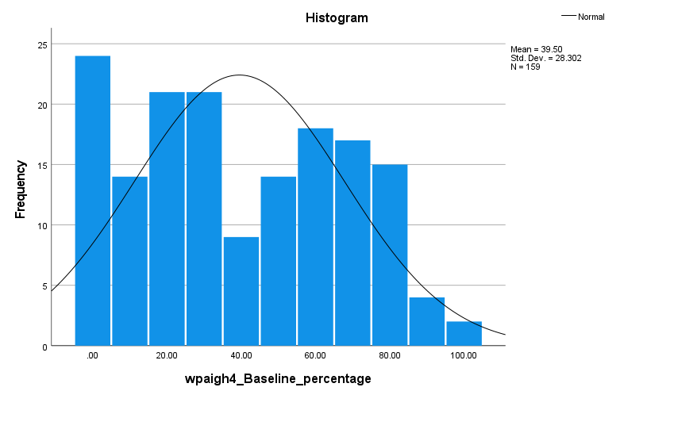
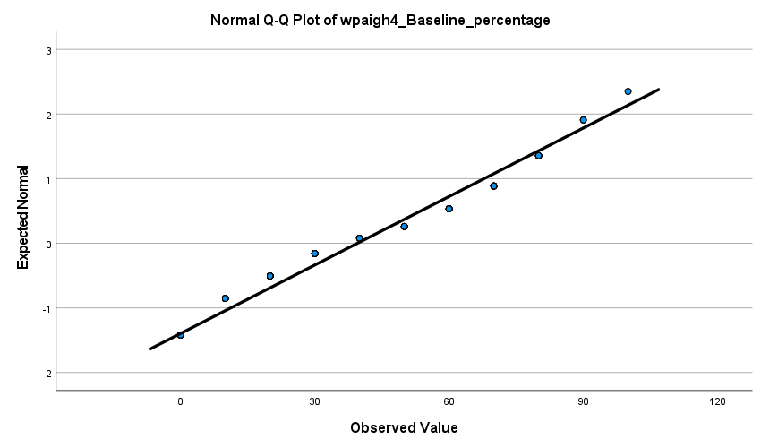

EQ5D – Utility score
W (155) = .92, p < .001

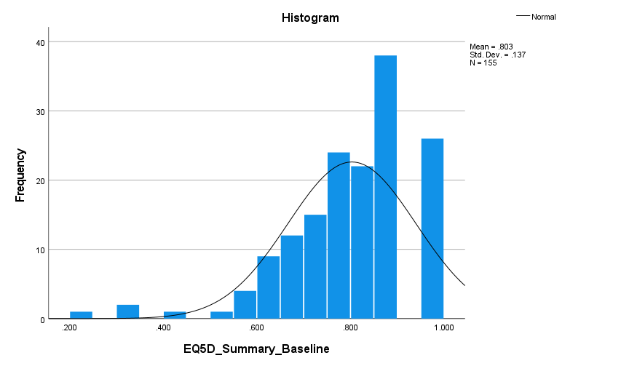
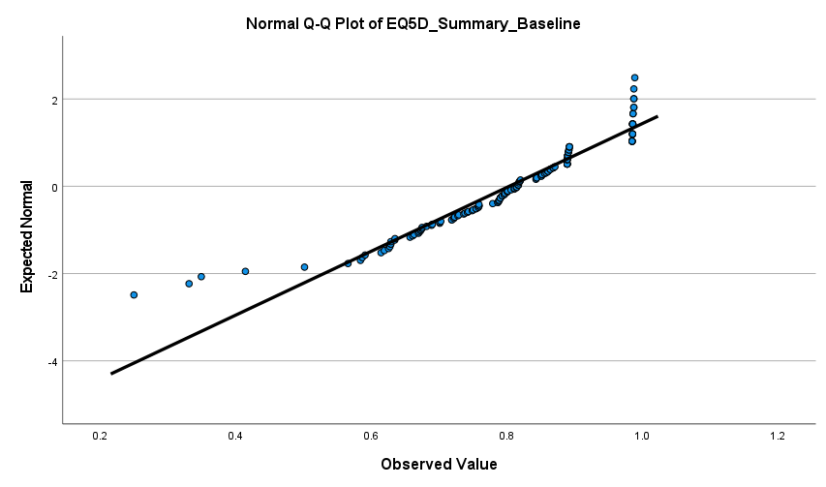

EQ5D – VAS score
W (156) = .94, p < .001
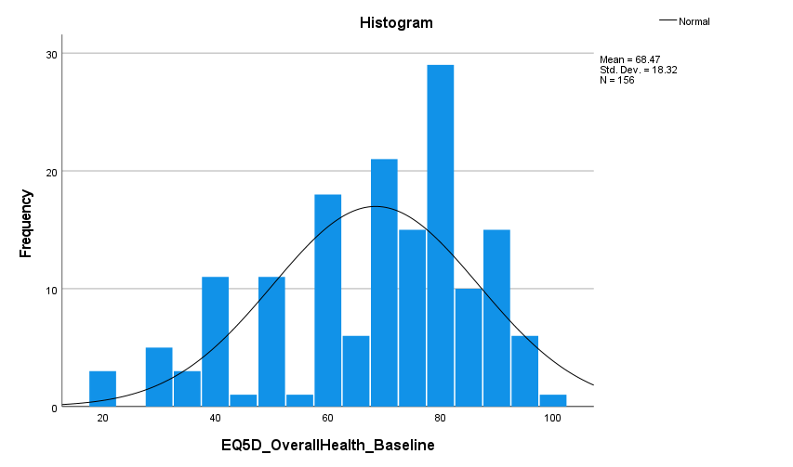
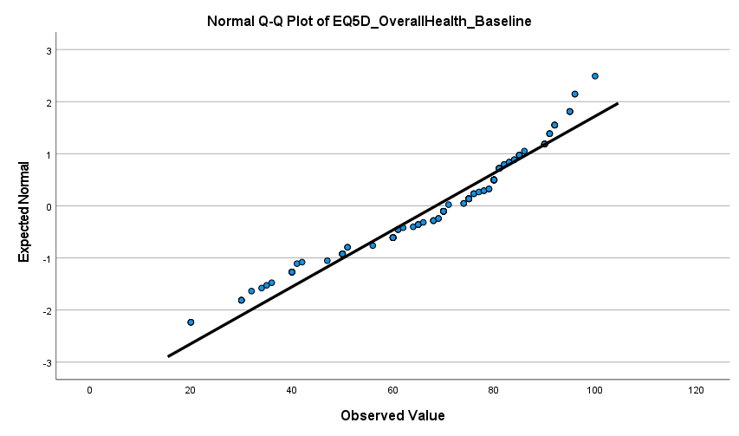

Secondary outcomes- objective sleep tracker
Sleep efficiency
W (119) = .84, p < .001
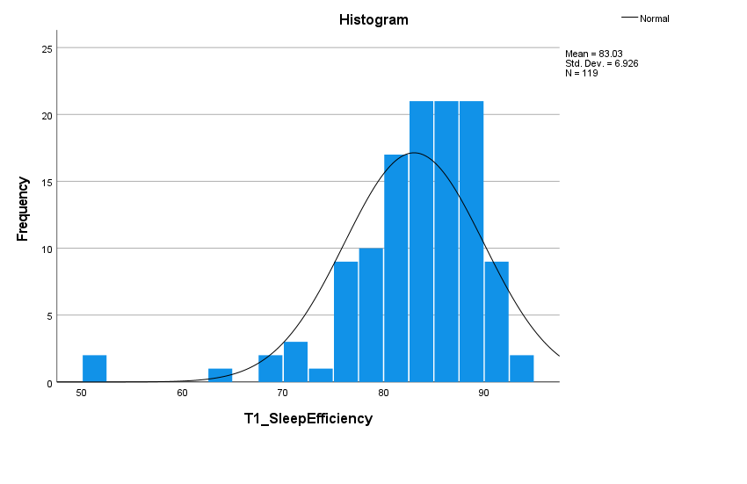
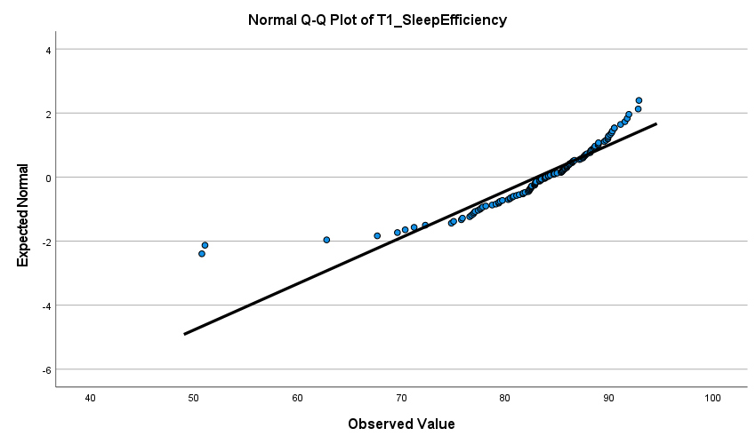

Total time in bed (TIB) in minutes
W (119) = .95, p < .001
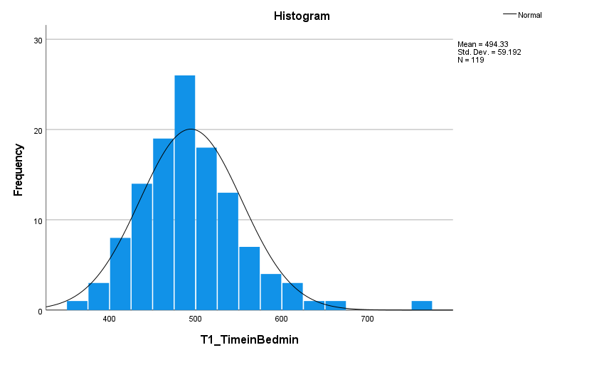
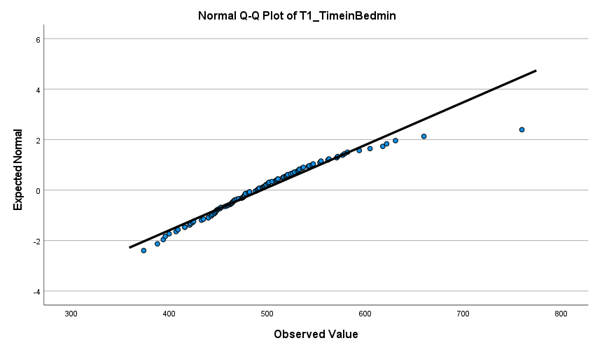

Total sleep time (TST) in minutes
W (119) = .98, p = .10
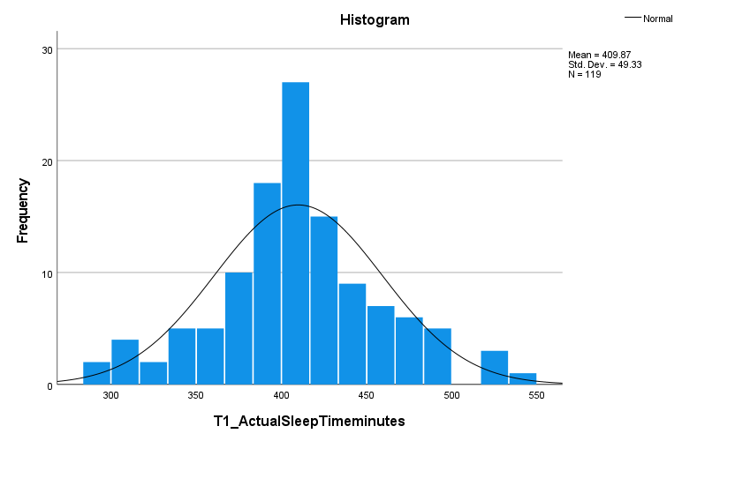
Normal Q-Q Plot of T1_TotalSleepTimeminutes
T1_TotalSleepTimeminutes
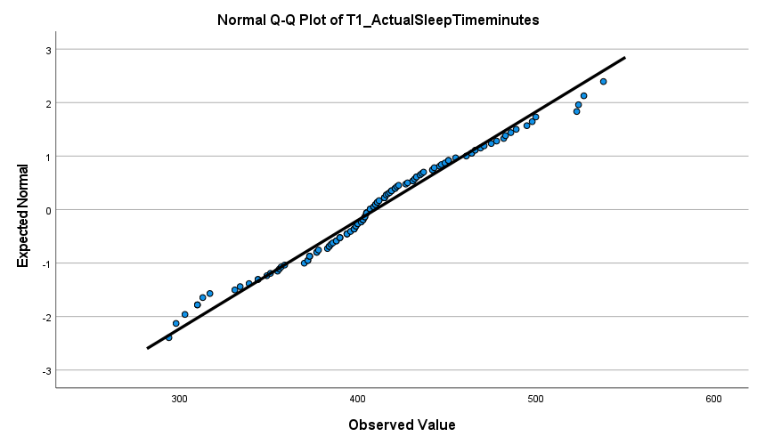

Total wake time in minutes
W (119) = .77, p < .001
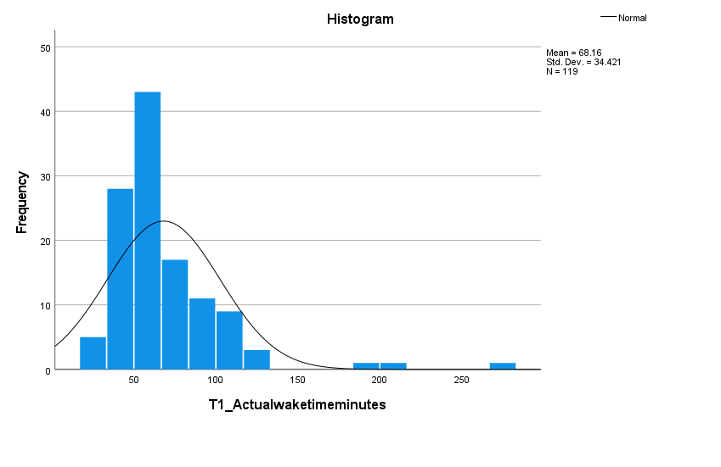
Normal Q-Q Plot of T1_TotalWakeTimeminutes
T1_TotalWakeTimeTimeminutes
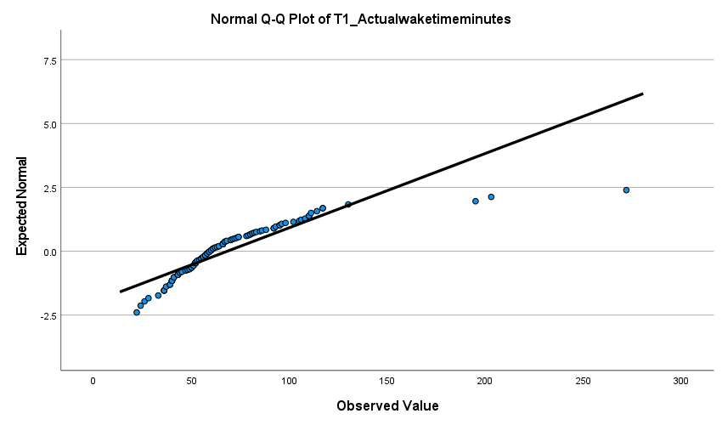

Secondary outcomes- self-reported sleep diary
Sleep efficiency
W (102) = .94, p < .001
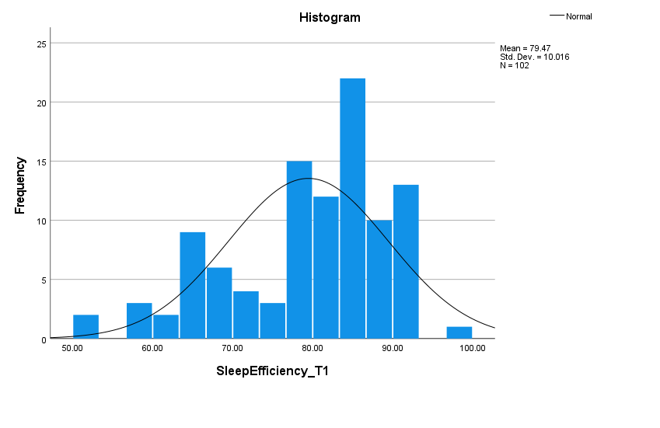
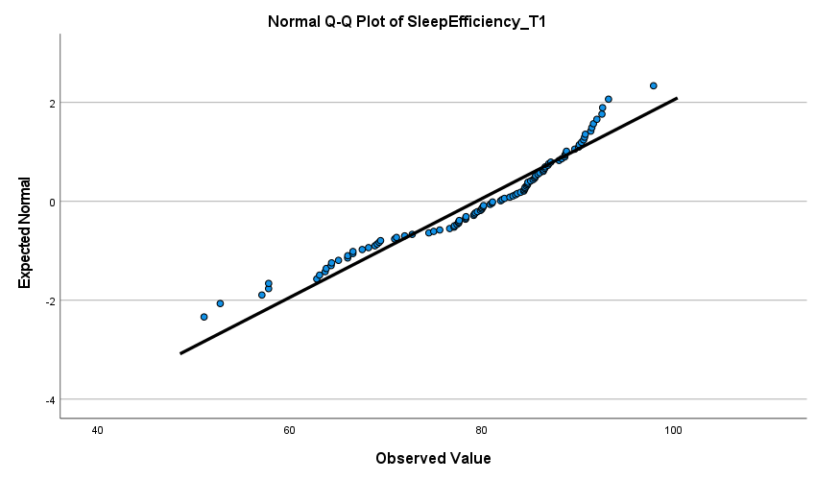

Sleep quality
W (102) = .98, p = .18
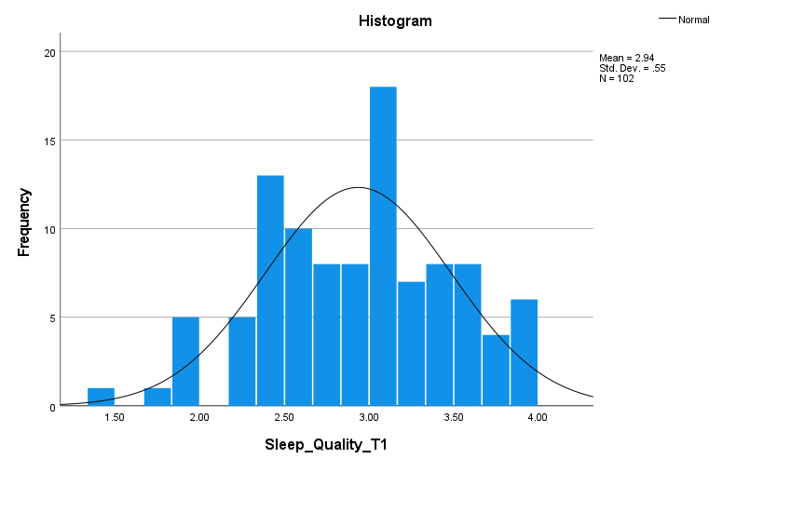
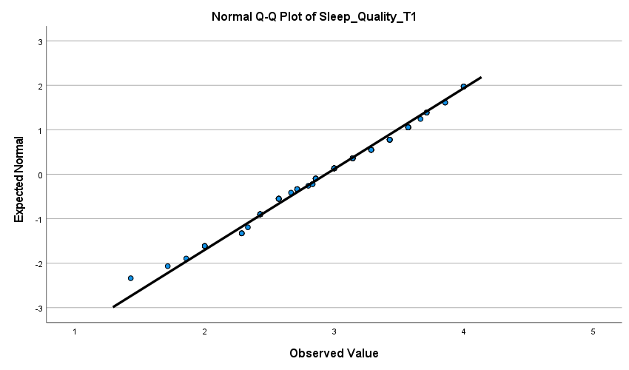

Sleep Onset Latency (SOL)
W (102) = .88, p < .001
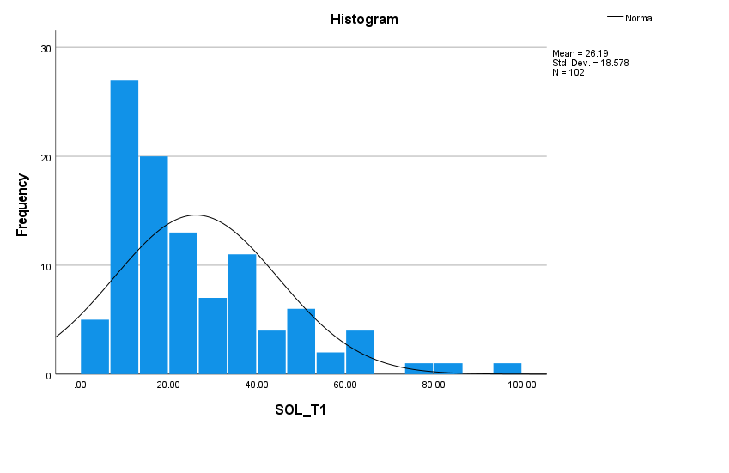
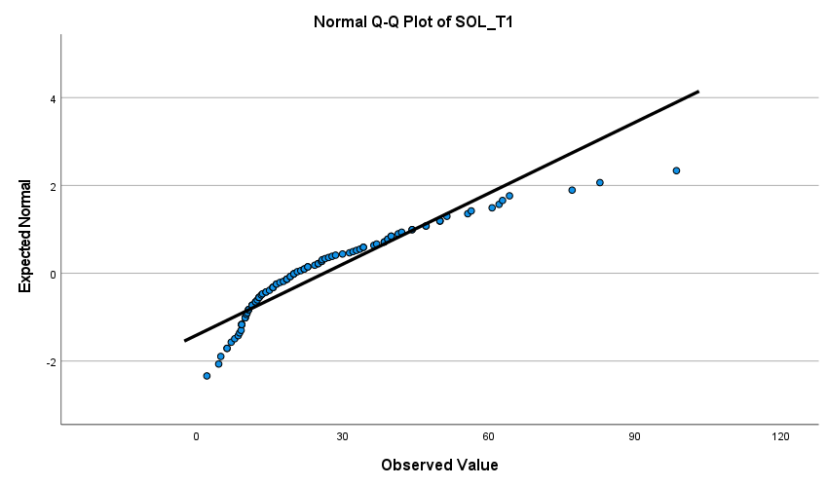

Wake After Sleep Onset (WASO)
W (102) = .87, p < .001
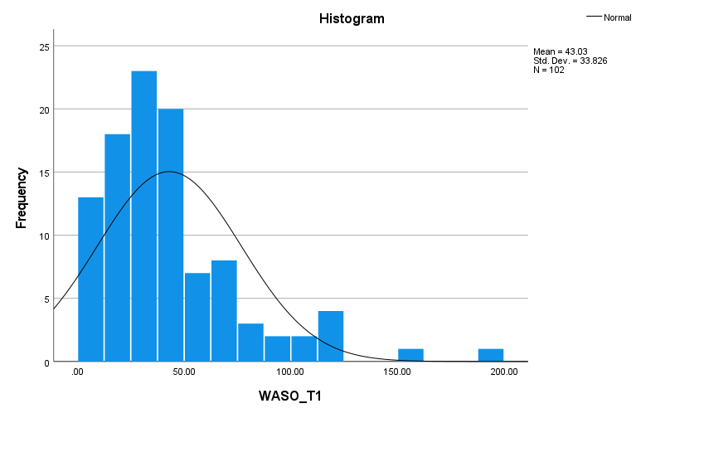
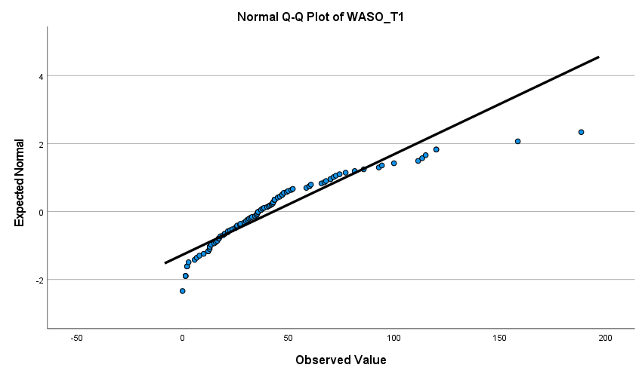

Time in bed (TIB)
W (102) = .96, p = .005
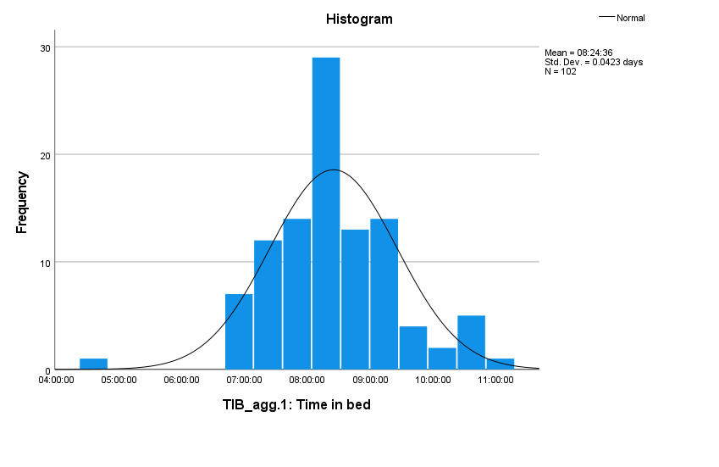
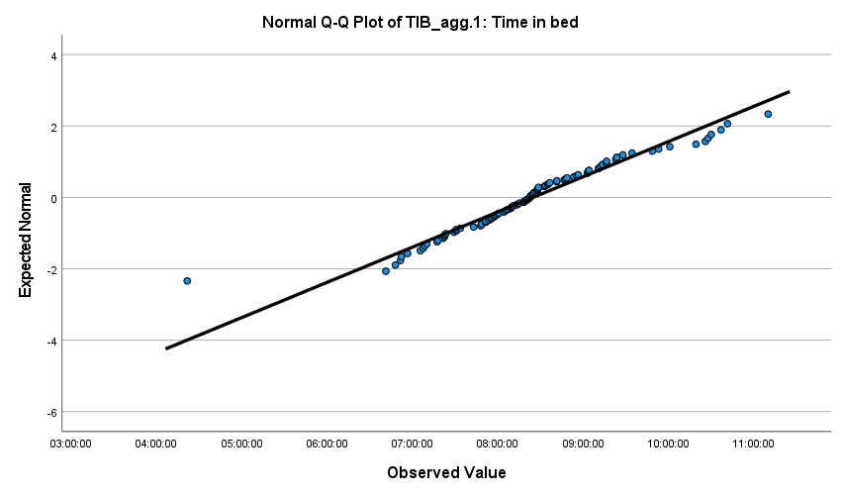

Total sleep time (TST)
W (102) = .98, p = .16
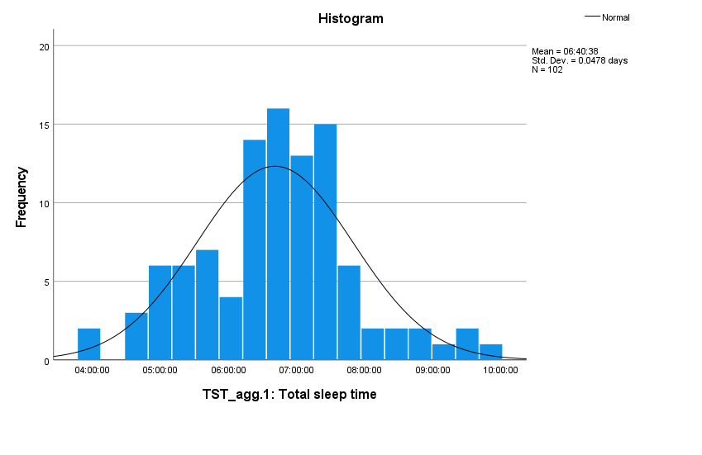
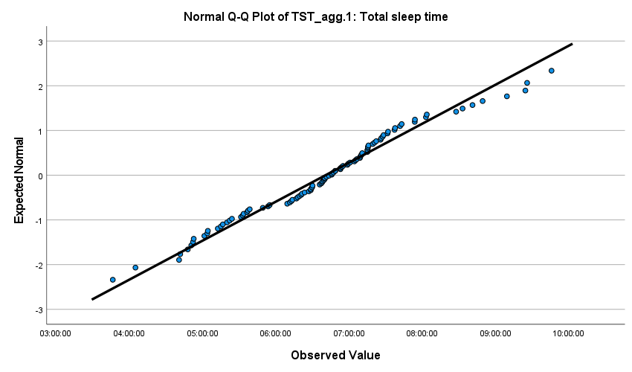

Appendix 3: Missingness
We created a categorical variable to indicate missingness and non-missingness at T2 (1= missing at T2, 2= complete at T2). We then ran multinomial logistic regression models using missingness as the dependent variable, allocation as factor and each of the outcome measures as covariates to predict missingness with the variables at T1 (i.e. does symptom severity on ISI at baseline predict missingness/drop out at T2).
We report below descriptives divided by allocation across the subgroup of people with missing or non-missing T2 outcomes, and p values from the model fitting. Using the Bonferroni corrected p value of 0.01667, of all the variables, only the three subscales of the WPAI appear to significantly predict missingness (attrition).

Table 2 Descriptive statistics and test statistic of the multinomial logistic regression models of all primary and secondary outcomes predicting missingness across the two groups.
 | Predicting missingness (p-value) | dCBTI+ER  (n= 79)  M(SD) |  | Control  (n= 80)  M(SD)
 |  | Missing  (n = 16) | Not missing  (n = 63) | Missing  (n = 7) | Not missing  (n = 73)
Demographics
Age, y | 0.110 | 43.88 (9.85) | 44.78 (8.98) | 42.71 (11.70) | 42.53 (9.55)
Sex, No. (%) | 0.110
Women |  | 12 (75.00) | 47 (74.60) | 5 (71.40) | 58 (79.50)
Men, Other |  | 4 (25.00) | 16 (25.40) | 2 (28.60) | 15 (20.50)
Ethnicity, No. (%) | 0.036
White |  | 14 (87.50) | 50 (79.40) | 7 (100.00) | 57 (78.10)
Black, Asian, Mixed, Other |  | 2 (12.50) | 13 (20.60) | 0 (0.00) | 16 (21.90)
Relationship status, No. (%) | 0.087
Married |  | 6 (37.50) | 33 (52.40) | 5 (71.40) | 38 (52.10)
Co-habiting |  | 2 (12.50) | 12 (19.00) | 1 (14.30) | 15 (20.50)
Single |  | 4 (25.00) | 10 (15.90) | 1 (14.30) | 13 (17.80)
Divorced, Separated, Widowed, Other |  | 4 (25.00) | 8 (12.70) | 0 (0.00) | 7 (9.60)
Hours of work | 0.113 | 37.56 (5.34) | 37.59 (7.02) | 37.71 (3.86) | 37.27 (6.89)
Education level, No. (%) | 0.091
Higher education |  | 11 (68.80) | 38 (60.30) | 1 (14.30) | 39 (53.40)
Lower education |  | 5 (31.30) | 25 (39.70) | 6 (85.70) | 34 (46.60)
Income No. (%) | 0.066
£10,000-£29,999 |  | 5 (31.30) | 7 (11.10) | 1 (14.30) | 19 (26.00)
£30,000 or higher |  | 11 (68.80) | 56 (88.90) | 6 (85.70) | 54 (74.00)
Primary outcomes
Insomnia (ISI) | 0.078 | 16.19 (3.73) | 16.38 (4.25) | 18.29 (3.09) | 15.40 (4.41)
Depression (PHQ-9) | 0.11 | 9.50 (4.94) | 10.02 (4.38) | 10.71 (4.54) | 10.36 (4.67)
Anxiety (GAD-7) | 0.077 | 8.13 (4.29) | 8.84 (4.64) | 8.00 (3.96) | 9.23 (4.35)
Categorical
Insomnia | 0.082
No clinically significant insomnia |  | 0 (0.00) | 2 (3.20) | 0 (0.00) | 4 (5.50)
Subthreshold insomnia |  | 6 (37.50) | 17 (27.00) | 1 (14.30) | 30 (41.10)
Clinical insomnia |  | 10 (62.50) | 44 (69.80) | 6 (85.70) | 39 (53.40)
Depression (PHQ-9) | 0.111
Normal |  | 3 (18.80) | 6 (9.50) | 0 (0.00) | 4 (5.50)
Mild |  | 5 (31.30) | 26 (41.30) | 4 (57.10) | 32 (43.80)
Mild-moderate |  | 5 (31.30) | 21 (33.30) | 2 (28.60) | 26 (35.60)
Moderate |  | 3 (18.80) | 7 (11.10) | 0 (0.00) | 7 (9.60)
Severe |  | 0 (0.00) | 3 (4.80) | 1 (14.30) | 4 (5.50)
Anxiety (GAD-7) | 0.083
No to low risk |  | 5 (31.30) | 10 (15.90) | 1 (14.30) | 9 (12.30)
Mild |  | 5 (31.30) | 30 (47.60) | 3 (42.90) | 31 (42.50)
Moderate |  | 4 (25.00) | 14 (22.20) | 3 (42.90) | 24 (32.90)
Severe |  | 2 (12.50) | 9 (14.30) | 0 (0.00) | 9 (12.30)
Secondary outcomes
Work productivity (WPAI:GH)
WPAIGH1 | < 0.001 | 5.39 (18.68) | 1.23 (4.63)³ | 34.69 (47.28) | 3.29 (12.02)
WPAIGH2 | 0.013 | 39.38 (30.87) | 32.86 (25.87) | 61.43 (36.71) | 36.03 (25.59)
WPAIGH3 | 0.010 | 40.18 (31.89) | 32.54 (25.47)³ | 63.27 (37.52) | 37.48 (26.89)
WPAIGH4 | 0.094 | 35.00 (30.98) | 37.30 (26.35) | 57.14 (28.70) | 40.68 (29.17)
Job satisfaction (IJSS) | 0.111 | 2.94 (0.39) | 3.02 (0.40) | 3.08 (0.26) | 2.97 (0.39)
Well-being (WEMWBS) | 0.098 | 42.80 (6.60)² | 41.71 (7.48) | 43.86 (9.35) | 40.49 (7.48)¹
Quality of life (EQ-5D-5L)
EQ-5D-5L utility score | 0.084 | 0.85 (0.16) | 0.81 (0.10)⁴ | 0.72 (0.20) | 0.80 (0.15)
EQ-5D-5L VAS | 0.091 | 73.38 (21.74) | 68.98 (16.70)⁵ | 59.29 (19.51) | 67.86 (18.70)
Footnote:
- n = 71
- n = 15
- n = 62
- n = 59
- n = 60

Appendix 4: Caseness
We defined caseness on the outcomes according to the Improving Access to Psychological Therapies (IAPT) framework. This is defined as those with a PHQ-9 score of at least 10, a GAD-7 score of at least 8 (NHS England, 2018), and an ISI score of at least 8 (Harvey et al., 2014). Binary (yes/no) variables were computed for baseline and week 8 for these three outcomes indicating caseness. Clinically significant change (CSC), or symptom reduction of reliable change was also explored; this is defined as those with a reduction of at least 8 points on the ISI (Morin et al., 2011), 4 points on the GAD and 6 points on the PHQ-9 (England, 2018). We created change score variables from baseline to week 8 for the primary outcome measures, then created binary (yes/no) CSC variables with the above benchmark scores. Differences of CSC between the control and treatment groups are tested by Chi-Square tests.

Appendix 5: Fixed effects of group x time interactions on secondary outcomes

- WPAI-WTM: F(1, 133.48) = 0.66, p = 0.4184
- WPAI-IWW: F(1, 134) = 1.99, p = 0.1610
- WPAI-OWI: F(1, 131.92) = 1.09, p = 0.2985
- WPAI-AI: F(1, 134) = 4.82, p = 0.0298 (did not withstand Bonferroni correction)
- IJSS: F(1, 134) = 0.16, p = 0.6897
- EQ-5D-5L Utility: F(1, 130.24) = 1.83, p = 0.17818
- E5-5D-5L VAS: F(1, 131.34) = 3.35, p = 0.06939

- Time in Bed: F(1, 101) = 13.34, p = 0.0004
- Sleep Onset Latency: F(1, 101) = 11.21, p = 0.0011
- Wake After Sleep Onset: F(1, 101) = 6.78, p = 0.0106
- Sleep efficiency: F(1, 101) = 12.52, p = 0.0006
- Sleep quality: F(1, 100.19) = 14.25, p = 0.0003

References
NHS England, (2018). The Improving Access to Psychological Therapies Manual. https://www.england.nhs.uk/publication/the-improving-access-to-psychological-therapies-manual/
Harvey, A. G., Bélanger, L., Talbot, L., Eidelman, P., Beaulieu-Bonneau, S., Fortier-Brochu, É., Ivers, H., Lamy, M., Hein, K., Soehner, A. M., Mérette, C., & Morin, C. M. (2014). Comparative efficacy of behavior therapy, cognitive therapy, and cognitive behavior therapy for chronic insomnia: a randomized controlled trial. J Consult Clin Psychol, 82(4), 670-683. https://doi.org/10.1037/a0036606
Kyle, S. D., Miller, C. B., Rogers, Z., Siriwardena, A. N., MacMahon, K. M., & Espie, C. A. (2014). Sleep Restriction Therapy for Insomnia is Associated with Reduced Objective Total Sleep Time, Increased Daytime Somnolence, and Objectively Impaired Vigilance: Implications for the Clinical Management of Insomnia Disorder. Sleep, 37(2), 229-237. https://doi.org/10.5665/sleep.3386
Morin, C. M., Belleville, G., Bélanger, L., & Ivers, H. (2011). The Insomnia Severity Index: Psychometric Indicators to Detect Insomnia Cases and Evaluate Treatment Response. Sleep, 34(5), 601-608. https://doi.org/10.1093/sleep/34.5.601
Moukhtarian, T. R., Patel, K., Toro, C., Russel, S., Daly, G., Walasek, L., Tang, N. K. Y., & Meyer, C. (2022). Effects of a hybrid digital cognitive-behavioural therapy for insomnia and emotion regulation in the workplace (SLEEP): study protocol for a randomised waitlist control trial. BMJ Open, 12(7), e058062. https://doi.org/10.1136/bmjopen-2021-058062

