Supplementary Material

Supplementary Figure 1 - Stability of the Centrality Indices of the overall network model

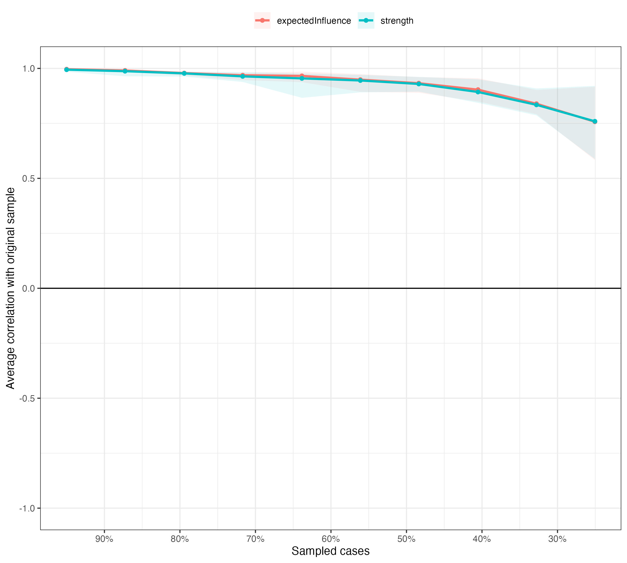

Supplementary Figure 2 - Male Network

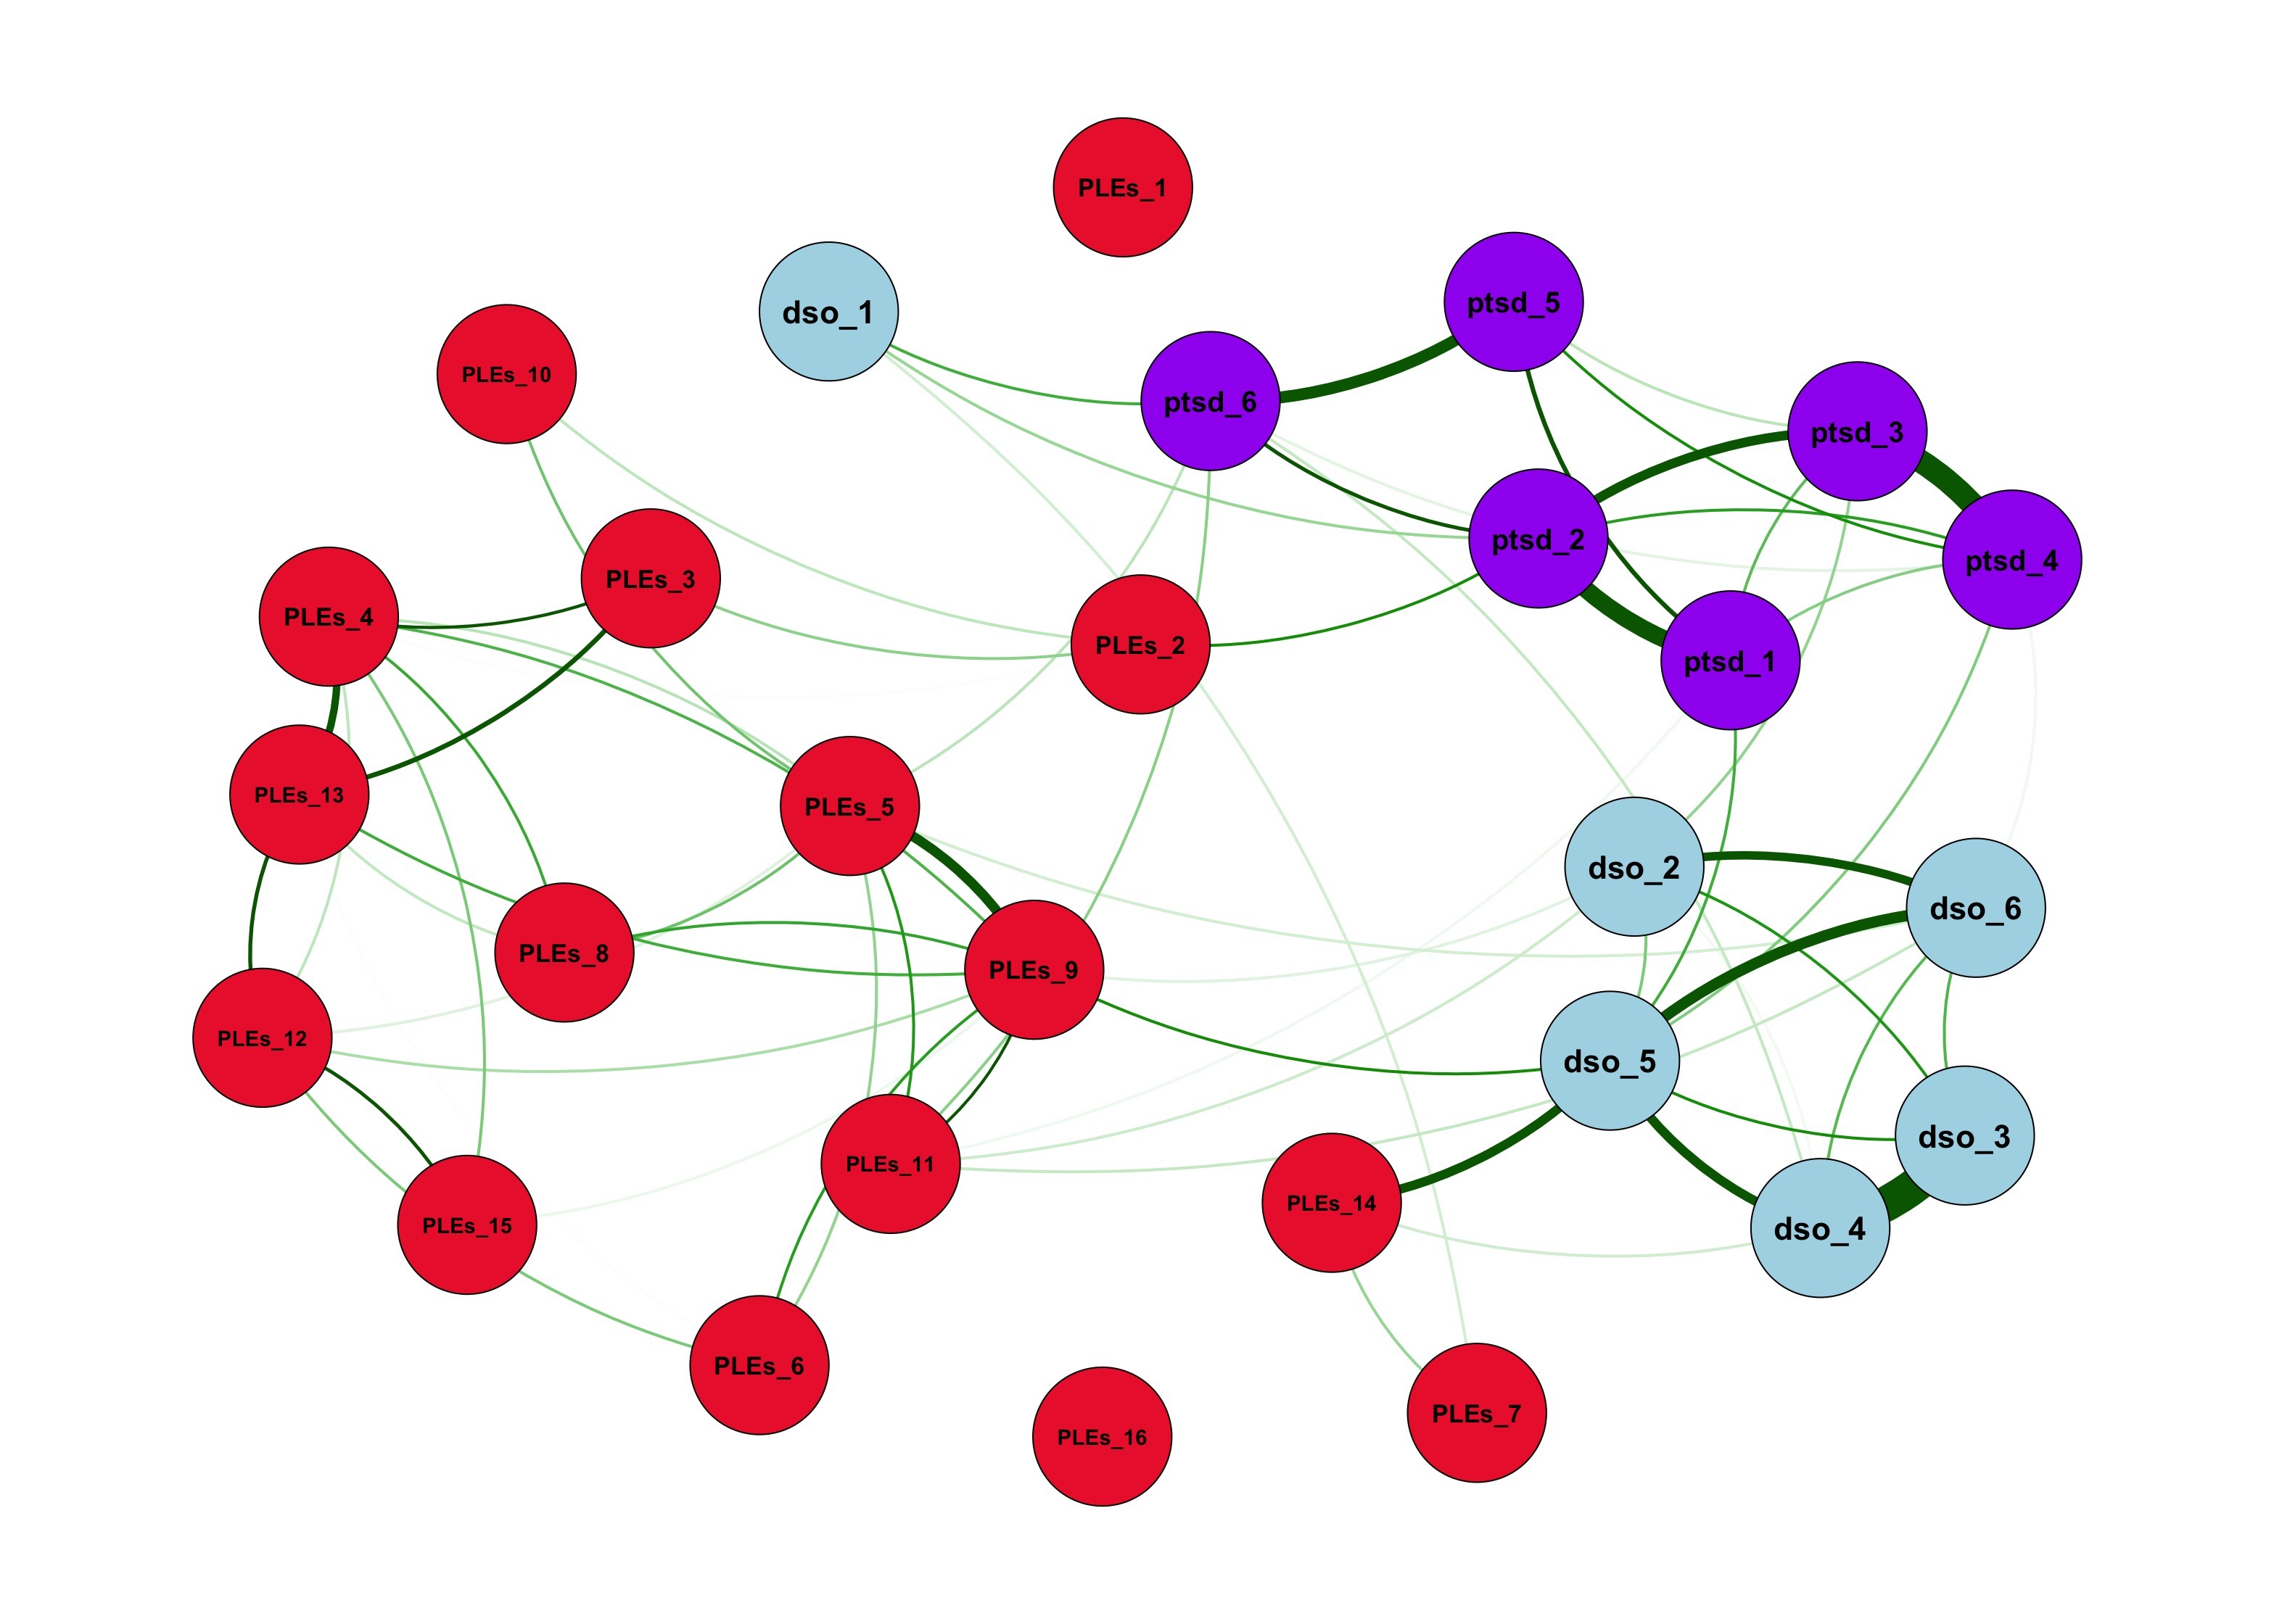

Supplementary Figure 3 - Stability of the Centrality Indices of the Males' Network

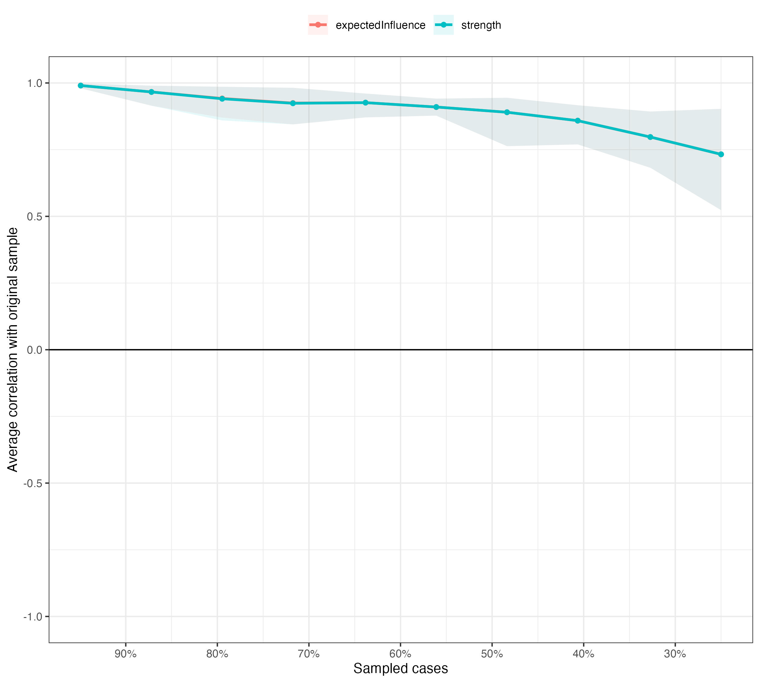

Supplementary Figure 4 – Females’ Network

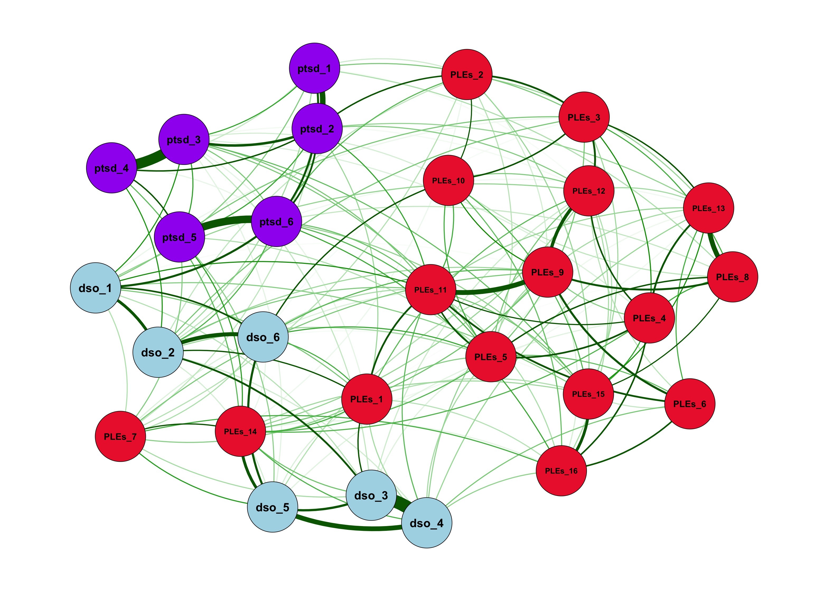

Supplementary Figure 5 - Stability of the Centrality Indices of the Females' Network

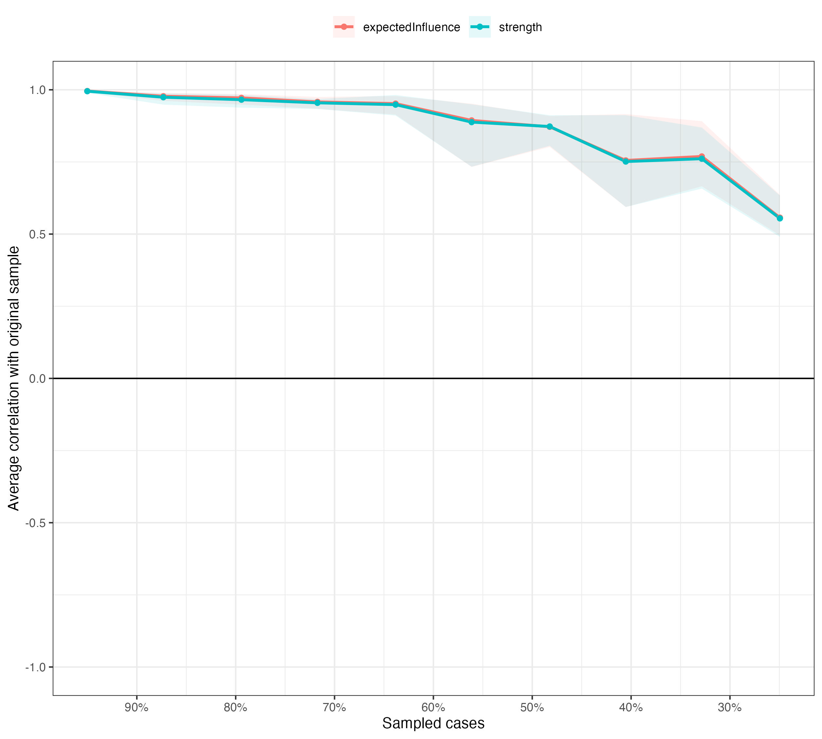

Supplementary Figure 6 - Bridge Centrality Indices for Males' Network

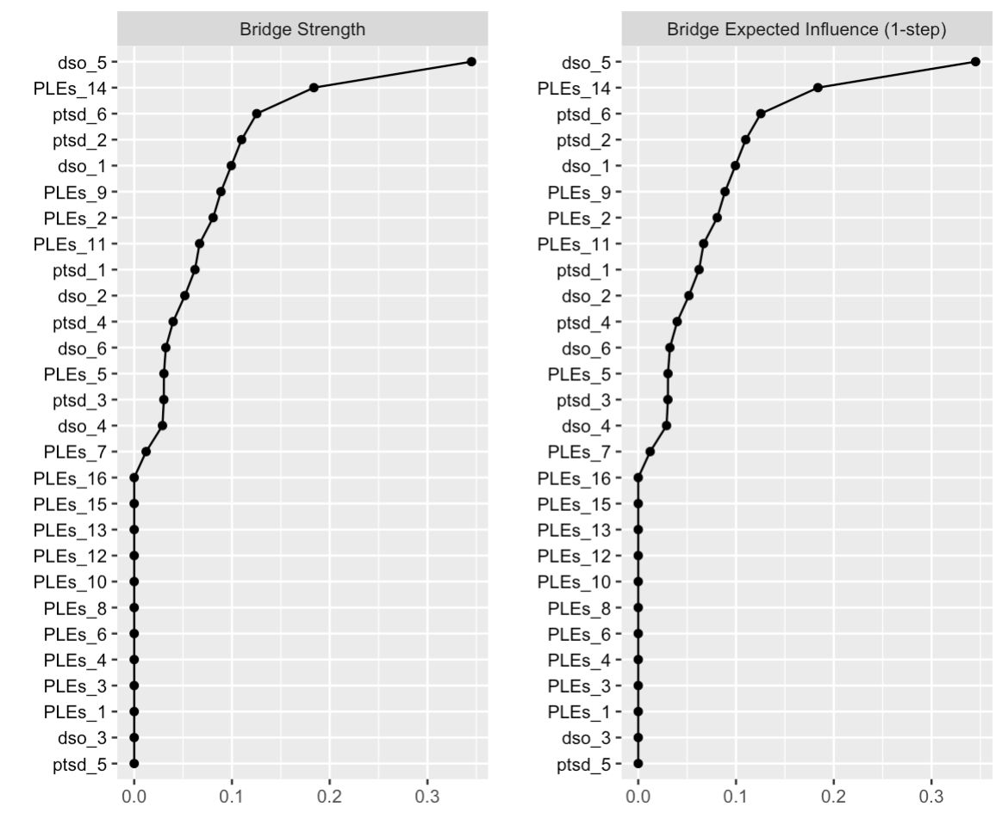

Supplementary Figure 7 - Bridge Centrality Indices for Females' Network

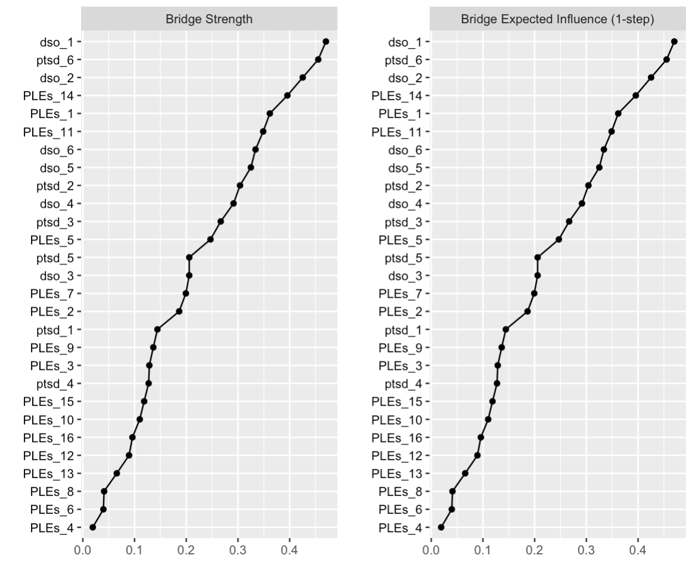
Supplementary Figure 8 – Combination of Directed Acyclic Graphs for Male and Female Populations

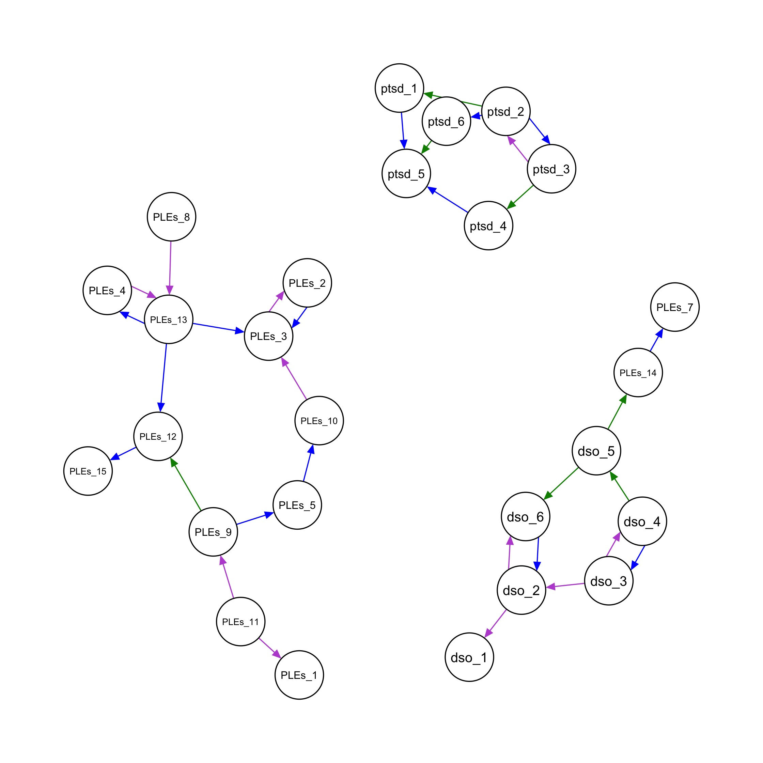

PTSD: Post-Traumatic Stress Disorder; DSO: Disturbances of Self-Organization; PLEs: Psychotic-Like Experiences. Violet arrows indicate a causal relationship in the female population; blue arrows indicate a causal relationship in the male population; green arrows indicate a causal relationship in both populations.

Supplementary Table 1 – Explanation of Network’s Nodes

Item Name | Explanation
ptsd_1 | Having upsetting dreams that replay part of the experience or are clearly related to the experience?
ptsd_2 | Having powerful images or memories that sometimes come into your mind in which you feel the experience is happening again in the here and now?
ptsd_3 | Avoiding internal reminders of the experience (for example, thoughts, feelings, or physical sensations)?
ptsd_4 | Avoiding external reminders of the experience (for example, people, places, conversations, objects, activities, or situations)?
ptsd_5 | Being “super-alert”, watchful, or on guard?
ptsd_6 | Feeling jumpy or easily startled?
dso_1 | When I am upset, it takes me a long time to calm down
dso_2 | I feel numb or emotionally shut down
dso_3 | I feel like a failure
dso_4 | I feel worthless
dso_5 | I feel distant or cut off from people
dso_6 | I find it hard to stay emotionally close to people
PLEs_1 | I feel uninterested in the things I used to enjoy
PLEs_2 | I often seem to live through events exactly as they happened before (déjà vu)
PLEs_3 | I sometimes smell or taste things that other people can’t smell or taste
PLEs_4 | I often hear unusual sounds like banging, clicking, hissing, clapping or ringing in my ears
PLEs_5 | I have been confused at times whether something I experienced was real or imaginary
PLEs_6 | When I look at a person, or look at myself in a mirror, I have seen the face change right before my eyes
PLEs_7 | I get extremely anxious when meeting people for the first time
PLEs_8 | I have seen things that other people apparently can't see
PLEs_9 | My thoughts are sometimes so strong that I can almost hear them
PLEs_10 | I sometimes see special meanings in advertisements, shop windows, or in the way things are arranged around me
PLEs_11 | Sometimes I have felt that I’m not in control of my own ideas or thoughts
PLEs_12 | Sometimes I feel suddenly distracted by distant sounds that I am not normally aware of
PLEs_13 | I have heard things other people can't hear like voices of people whispering or talking
PLEs_14 | I often feel that others have it in for me
PLEs_15 | I have had the sense that some person or force is around me, even though I could not see anyone
PLEs_16 | I feel that parts of my body have changed in some way, or that parts of my body are working differently than before

Variable | Median (IQR) / Numerosity (%)  Overall N = 972 |  | P-values
 | Males  N = 492 | Females  N = 480
Age | 18.58 (18.33-18.91) | 18.50 (18.33-18.83) | 0.2
Education  Lyceum  Technical  Vocational | 189 (38%)  296 (60%)  7 (1.4%) | 313 (65%)  161 (34%)  6 (1.3%) | <0.001
Trauma Diagnosis  probable PTSD  probable cPTSD | 28 (5.7%)  10 (2.0%) | 61 (13%)  30 (6.3%) | <0.001  <0.001
PLEs Diagnosis  PLEs  no PLEs | 179 (36%)  313 (64%) | 233 (49%)  247 (51%) | <0.001

Supplementary Table 2 – Sample Characteristics as Broken Down by Gender

IQR = Interquartile Range; PTSD = Post-Traumatic Stress Disorder; cPTSD = Complex PTSD; PLEs = Psychotic-Like Experiences;

Supplementary Table 3 – Strength and Minimum Direction in the Whole Population

Starting Node | Ending Node | Strength | Minimum Direction
ptsd_2 | ptsd_1 | 1.0 | 0.6985
ptsd_2 | ptsd_6 | 0.97 | 0.5283505
ptsd_2 | PLEs_2 | 0.972 | 0.9331276
ptsd_3 | ptsd_2 | 1.0 | 0.5525
ptsd_3 | ptsd_4 | 1.0 | 0.5285
ptsd_4 | ptsd_5 | 0.912 | 0.5926535
ptsd_6 | ptsd_5 | 1.0 | 0.557
ptsd_6 | dso_1 | 0.994 | 0.9044266
ptsd_6 | PLEs_11 | 0.976 | 0.5594262
dso_2 | dso_1 | 0.913 | 0.7102957
dso_3 | dso_2 | 0.986 | 0.7991886
dso_4 | dso_3 | 1.0 | 0.535
dso_4 | dso_5 | 0.999 | 0.7397397
dso_5 | dso_6 | 1.0 | 0.8265
dso_5 | PLEs_14 | 0.999 | 0.8518519
dso_6 | dso_2 | 1.0 | 0.5415
PLEs_3 | PLEs_2 | 0.995 | 0.6221106
PLEs_3 | PLEs_10 | 0.87 | 0.5275862
PLEs_4 | PLEs_3 | 0.943 | 0.6611877
PLEs_5 | PLEs_8 | 0.892 | 0.6093049
PLEs_5 | PLEs_10 | 0.938 | 0.8486141
PLEs_9 | PLEs_6 | 0.938 | 0.8560768
PLEs_9 | PLEs_8 | 0.952 | 0.7447479
PLEs_9 | PLEs_12 | 0.948 | 0.8765823
PLEs_10 | PLEs_2 | 0.956 | 0.6291841
PLEs_11 | dso_1 | 0.862 | 0.7981439
PLEs_11 | PLEs_1 | 0.926 | 0.9200864
PLEs_11 | PLEs_5 | 0.898 | 0.7884187
PLEs_11 | PLEs_9 | 1.0 | 0.5755
PLEs_12 | PLEs_3 | 0.882 | 0.6094104
PLEs_13 | PLEs_3 | 0.954 | 0.7321803
PLEs_13 | PLEs_4 | 0.985 | 0.5583756
PLEs_13 | PLEs_8 | 0.981 | 0.5076453
PLEs_14 | PLEs_7 | 0.951 | 0.9106204
PLEs_16 | PLEs_15 | 0.927 | 0.5587918

Supplementary Table 4 – Arc Strengths in the Whole Population

From | To | Strength
ptsd_2 | ptsd_1 | -160.318833
ptsd_2 | ptsd_6 | -84.046852
ptsd_2 | PLEs_2 | -25.751073
ptsd_3 | ptsd_2 | -137.862707
ptsd_3 | ptsd_4 | -307.827815
ptsd_4 | ptsd_5 | -26.797066
ptsd_6 | ptsd_5 | -119.950373
ptsd_6 | dso_1 | -27.261485
ptsd_6 | PLEs_11 | -74.425835
dso_2 | dso_1 | -15.841914
dso_3 | dso_2 | -46.995219
dso_4 | dso_3 | -601.479871
dso_4 | dso_5 | -231.712566
dso_5 | dso_6 | -105.533272
dso_5 | PLEs_14 | -102.367551
dso_6 | dso_2 | -60.580828
PLEs_3 | PLEs_2 | -14.809224
PLEs_3 | PLEs_10 | -15.571813
PLEs_4 | PLEs_3 | -14.934438
PLEs_5 | PLEs_8 | -11.381579
PLEs_5 | PLEs_10 | -24.754177
PLEs_9 | PLEs_6 | -56.425624
PLEs_9 | PLEs_8 | -15.030796
PLEs_9 | PLEs_12 | -61.702974
PLEs_10 | PLEs_2 | -9.971701
PLEs_11 | dso_1 | -12.478156
PLEs_11 | PLEs_1 | -48.958559
PLEs_11 | PLEs_5 | -78.596902
PLEs_11 | PLEs_9 | -125.044476
PLEs_12 | PLEs_3 | -10.495955
PLEs_13 | PLEs_3 | -15.97002
PLEs_13 | PLEs_4 | -74.31451
PLEs_13 | PLEs_8 | -32.236869
PLEs_14 | PLEs_7 | -38.719418
PLEs_16 | PLEs_15 | -33.333843

Supplementary Table 5 – Strength and Minimum Direction in the Male Population

From | To | Strength | Direction
ptsd_1 | ptsd_5 | 0.917 | 0.5937841
ptsd_2 | ptsd_1 | 1.0 | 0.5975
ptsd_2 | ptsd_3 | 1.0 | 0.507
ptsd_2 | ptsd_6 | 0.941 | 0.5504782
ptsd_3 | ptsd_4 | 1.0 | 0.515
ptsd_4 | ptsd_5 | 0.876 | 0.6238584
ptsd_6 | ptsd_5 | 1.0 | 0.511
dso_4 | dso_3 | 1.0 | 0.587
dso_4 | dso_5 | 0.967 | 0.6277146
dso_5 | dso_6 | 0.998 | 0.7249499
dso_5 | PLEs_14 | 0.999 | 0.8503504
dso_6 | dso_2 | 0.992 | 0.7056452
PLEs_2 | PLEs_3 | 0.959 | 0.5067779
PLEs_5 | PLEs_10 | 0.854 | 0.8079625
PLEs_9 | PLEs_5 | 0.966 | 0.5802277
PLEs_12 | PLEs_15 | 0.952 | 0.6018908
PLEs_13 | PLEs_3 | 0.919 | 0.7317737
PLEs_13 | PLEs_4 | 0.897 | 0.590301
PLEs_13 | PLEs_12 | 0.926 | 0.7035637
PLEs_14 | PLEs_7 | 0.884 | 0.7641403

Supplementary Table 6 – Strength and Minimum Direction in the Female Population

From | To | Strength | Direction
ptsd_2 | ptsd_1 | 1.0 | 0.729
ptsd_3 | ptsd_2 | 0.926 | 0.5858531
ptsd_3 | ptsd_4 | 1.0 | 0.515
ptsd_6 | ptsd_5 | 1.0 | 0.546
dso_2 | dso_1 | 0.956 | 0.7751046
dso_2 | dso_6 | 0.996 | 0.6129518
dso_3 | dso_2 | 0.941 | 0.6705632
dso_3 | dso_4 | 1.0 | 0.5085
dso_4 | dso_5 | 1.0 | 0.752
dso_5 | dso_6 | 0.971 | 0.6622039
dso_5 | PLEs_14 | 0.932 | 0.8401288
PLEs_3 | PLEs_2 | 0.86 | 0.7819767
PLEs_4 | PLEs_13 | 0.903 | 0.5204873
PLEs_8 | PLEs_13 | 0.975 | 0.5307692
PLEs_9 | PLEs_12 | 0.979 | 0.8314607
PLEs_10 | PLEs_3 | 0.853 | 0.6430246
PLEs_11 | PLEs_1 | 0.944 | 0.8236229
PLEs_11 | PLEs_9 | 1.0 | 0.5935

Supplementary Table 7 – Arc Strengths in the Male Population

From | To | Strength
ptsd_1 | ptsd_5 | -7.774821
ptsd_2 | ptsd_1 | -87.185535
ptsd_2 | ptsd_3 | -61.579812
ptsd_2 | ptsd_6 | -25.958967
ptsd_3 | ptsd_4 | -111.323018
ptsd_4 | ptsd_5 | -7.62645
ptsd_6 | ptsd_5 | -29.340639
dso_4 | dso_3 | -264.971916
dso_4 | dso_5 | -78.080509
dso_5 | dso_6 | -58.694597
dso_5 | PLEs_14 | -42.582154
dso_6 | dso_2 | -45.203025
PLEs_2 | PLEs_3 | -12.375849
PLEs_5 | PLEs_10 | -16.629431
PLEs_9 | PLEs_5 | -47.8477
PLEs_12 | PLEs_15 | -22.848703
PLEs_13 | PLEs_3 | -25.520395
PLEs_13 | PLEs_4 | -35.758569
PLEs_13 | PLEs_12 | -28.129479
PLEs_14 | PLEs_7 | -13.883324

Supplementary Table 8 – Arc Strengths in the Female Population

From | To | Strength
ptsd_2 | ptsd_1 | -68.43673
ptsd_3 | ptsd_2 | -65.25836
ptsd_3 | ptsd_4 | -170.8976
ptsd_6 | ptsd_5 | -100.51518
dso_2 | dso_1 | -46.22999
dso_2 | dso_6 | -33.02571
dso_3 | dso_2 | -57.53321
dso_3 | dso_4 | -319.89497
dso_4 | dso_5 | -139.4808
dso_5 | dso_6 | -16.87014
dso_5 | PLEs_14 | -53.56039
PLEs_3 | PLEs_2 | -16.7901
PLEs_4 | PLEs_13 | -17.4682
PLEs_8 | PLEs_13 | -27.91347
PLEs_9 | PLEs_12 | -39.51695
PLEs_10 | PLEs_3 | -18.79872
PLEs_11 | PLEs_1 | -42.34201
PLEs_11 | PLEs_9 | -79.08156

