Supplementary Material

Loneliness and cognition in older adults: A meta-analysis of harmonized studies from the United States, England, India, China, South Africa, Mexico, and Chile

Table S1
Cognitive measures across studies
Domain | Measures | Test Description / Score | HRS | ELSA | LASI-DAD | CHARLS | DS-HAALSI | Mex-Cog | Chile-Cog
Global cognition | Mini-Mental State Examination (MMSE) | Max score 30 or 28; participants with more than 5 missing MMSE domains or tasks (Godin et al. 2017) were excluded from MMSE computation. | Max 3. Items = orientation time (5), orientation place (5), immediate and delayed word recall (3 + 3), spelling task (5), object naming (2), sentence (1), read and follow (1), 3-stage task (3), writing (1) and drawing (1). | Max 3. Note: Serial 7 (5) instead of the spelling task. | Max 3. Same as HRS. | Max 3. Note: Serial 7 (5) instead of the spelling task. | Max 3. Note: Serial 7 or spelling task (5). | Max 28. Note: Orientation place (3). | Max 3. Note: Digit backward or Serial 7 (5).
Episodic Memory | CERAD Word List Memory | Learning and Immediate Recall of 10 words (3 trials), score 0-3. | Similar across studies.
 |  | Delayed Recall (1 trail), score 0-1. | Similar across studies.
 |  | Recognition (20 words), score 0-2. | Similar across studies.
 | Logical Memory, Long Story. Most studies used an adapted version of the Wechsler Memory Scale (‘Anna’ story). | Immediate Recall. Participants were given credit either for exact answers and/or approximate answers (2 or 1 point). | Exact answers only (25 items). Total score 0-25. | Same as HRS. | Same as HRS. | NA | Exact answers only (24 items). Total score 0-24. | Same as LASI-DAD. | Same as LASI-DAD.
 |  | Delayed Recall. Participants were given credit either for exact answers and/or approximate answers (2 or 1 points). | Exact answers only (25 items). Total score 0-25. | Same as HRS. | Same as HRS. | NA | Exact answers only (24 items). Total score 0-24. | Same as LASI-DAD. | Same as LASI-DAD.
 |  | Recognition. One point for each correct answer. | Score 0-15. | Score 0-15. | Score 0-15. | NA | Score 0-15. | NA | NA
 | Logical Memory, Short Story. Most studies used a version of a fire/assault (‘Brave Man’ story). | Immediate Recall. Participants were given credit either for exact answers and/or approximate answers (2 or 1 points). | Exact and approximate answers (6 items). Total score is 0-12. | Exact answers only (6 items). Total score is 0-6. | Exact and approximate answers (10 items). Score provided is comparable to HRS. | NA | Exact answers only (10 items). Total score is 0-1. | Same as HRS. | Same as HRS.
 |  | Delayed Recall. Participants were given credit either for exact answers and/or approximate answers (2 or 1 points). | Exact and approximate answers (6 items). Total score is 0-12. | Exact answers only (6 items). Total score is 0-6. | Exact and approximate answers (10 items). Score provided is comparable to HRS. | NA | Exact answers only (10 items). Total score is 0-1. | Same as HRS. | Same as HRS.
Speed-Attention | Letter or Symbol Cancellation | Point for each marked symbol/letter. The score is derived from how many letters/symbols they mark given a time. | Letter | Letter | Symbol | NA | Symbol | Symbol | Symbol
 | Backward counting or naming | Count backward from 100 or 2. Alternatively, naming backward (e.g., weekdays). | Counting (100). Number of correct counts. Time = 30 seconds. | Same as HRS. | NA | NA | Naming (days of the week). Total score 0-7. | Counting (20). Time = 60 seconds. The score ranged from 0-4.ª A second trial was offered. | Similar to HRS. Time = 90 seconds.
 | Symbol Digit Modality Test | Nine digits are presented associated with a symbol. The respondent has to fill in blank boxes with the symbol that correspond to each digit, according to the example given. | Time = 90 seconds. Score is the number of attempted pairings minus the number of mistakes or skipped pairings. | Same as HRS. | NA | NA | NA | Max score 56 (56 boxes). | Max score 56 (56 boxes).
 | Trail Making A & B | Trail A involves numbered circles and the respondent is asked to draw a line linking the circles in numeric order (1, 2, 3, etc.). Trail B involves numbered circles and circles containing letters, and the respondent is asked to draw a line linking the numbers and letters alternately (1, A,  2, B, 3, C, etc.). The task is timed. | The score is the time taken to complete each task. | Same as HRS. | NA | NA | NA | NA | NA
Visuospatial Ability | Constructional Praxis | Four sheets are typically presented: circle, rhombus, rectangle, and cube. The respondent has to copy the corresponding figures. In the recall task, is asked to draw from memory the four figures. | Max score 11 for immediate and delayed recall. | Same as HRS. | Same as HRS. | NA | Same as HRS. | NA | NA
 | Raven's Matrixes | Respondent is asked to identify the missing element that completes a pattern. Respondent is given 1 point for each pattern correctly identified. | Max score 17. | Same as HRS. | Same as HRS. | NA | Same as HRS. | NA | NA
Numeric Reasoning | Number Series | Respondent is presented with a series of numbers with one or two numbers missing. Participants are asked to identify the missing numbers. The test consists of a 6-item block adapted based on participants' performance. | Score based on HRS syntax. |  | NA | NA | NA | NA | NA
Language | Verbal Fluency | Animal naming. The score reflected the total number of correct animals named om 1 minute. | Similar across studies.
Note. Studies are the Health and Retirement Study (HRS), the English Longitudinal Study of Ageing (ELSA), the Diagnostic Assessment of Dementia for the Longitudinal Aging Study in India (LASI-DAD), China Health and Retirement Longitudinal Study (CHARLS), Dementia Study of the Health and Aging in Africa (DS-HAALSI), the Mexican Cognitive Aging Ancillary Study (Mex-Cog) of the Mexican Health and Aging Study, and the Chile Cognitive Aging Study (Chile-Cog). NA = Not assessed. ª The score was 4 = correct and within 10 seconds, 3 = correct within 11-20 seconds, 2 = correct within 21-30 seconds, 1 = correct within 31-59 seconds, 0 = incorrect and/or out of time.
Table S2
Informant ratings across studies
Measure | Test Description / Score | HRS | ELSA | LASI-DAD | CHARLS | DS-HAALSI | Mex-Cog | Chile-Cog
IQ-CODE | Response scale from 1= much better to 5 = much worse. Mean across items (score range 1-5). | 16-item version | Same as HRS. | Same as HRS. | 26-item version | Same as HRS. | NA | NA
CSI-D | The presence of certain symptoms or behaviors was scored as 1. The sum was taken across items. | 15-item version Responses were coded: Yes, or Sometimes (=1) and No (=0). Score range 0-15. | Same as HRS. | Same as HRS. | 6-item version Responses were yes (=1) or no (=0). Score range 0-6. | Same as HRS. | Administered 28 questions on cognitive and functional decline (long-form). Six items were administered to all participants. Responses were coded: Yes, always or sometimes (=1) or No (=0). Score range 0-6. | Administered 28 questions on cognitive and functional decline (long-form). Six items were administered to all participants. Responses were coded: Yes, always or sometimes (=1) or No (=0). Score range 0-6.
Blessed Dementia Rating Scale – Part 1 | Items (e.g., “remembering a short list of items such as a shopping list”) were coded as 1 (Some loss or Severe loss) or 0 (No loss).The sum was taken across items. | 8-item version Score range 0-8. | Same as HRS. | Skipped for ~1,500 participants. Not used in the analysis. | NA | Same as HRS. | NA | NA
10/66 | Items (e.g., “Has there been a change in his/her ability to handle money? as 1 (Some difficulty or Cannot do) or 0 (No difficulty). The sum was taken across items. | 5-item version Score range 0-5. | Same as HRS. | Same as HRS. | NA | Same as HRS. | NA | NA
Informant Information | Age of the informant was reported in years across studies. Sex was recoded as 0 = male and 1 = female. Education reported in years or highest level. Relationship with the respondent was recoded as 1 = spouse and 0 = other across studies. Living arrangements were recoded 1= living together with the respondent, 0 = not living together/other frequency of contact. Additional information on the caregiver role (yes/no) and years of knowing the respondents were unavailable in some studies and thus were not included as covariates in the analysis.
Note. Studies are the Health and Retirement Study (HRS), the English Longitudinal Study of Ageing (ELSA), the Diagnostic Assessment of Dementia for the Longitudinal Aging Study in India (LASI-DAD), China Health and Retirement Longitudinal Study (CHARLS), Dementia Study of the Health and Aging in Africa (DS-HAALSI), the Mexican Cognitive Aging Ancillary Study (Mex-Cog) of the Mexican Health and Aging Study, and the Chile Cognitive Aging Study (Chile-Cog). NA = Not assessed.
Table S3
Covariates across studies
Variable | Study | Description
Age | All studies | Reported in years.
 | * CHARLS | Computed from date of birth. Date of birth was reported according to lunar calendar. We computed age from dates converted to solar calendar provided by the g2aging harmonized files.
Sex | All studies | Recoded 1 = female, 0 = male.
Race | HRS, ELSA | Recoded as 1 = Black/other or non-white, 0 = white.
Ethnicity | HRS | Recoded as 1= Hispanic/Latinx, 0 = Non-Hispanic/Latinx.
Education | HRS, Mex-Cog | Reported in years.
 | ELSA | Completed level of education. The original 7-point ordinal scale was: No qualification; foreign qualification or other; nvq1/gse other grade equivalent; nvq2/gce o level equivalent; nvq3/gce a level equivalent; higher ed below degree; nvq4/nvq5/degree or equivalent.
 | LASI-DAD | Completed level of education. Responses were harmonized by g2aging (10-point scale): Never attended school; less than primary (standard1-4); primary (standard 5-7); middle (standard 8-9); secondary (standard 10-11); higher secondary (standard12); diploma and certificate; graduate degree; post-graduate degree; professional course/degree.
 | CHARLS | Completed level of education. The original 11-point ordinal scale was recorded in 4 categories: No formal education/no finished primary education; elementary/middle school; high school or vocational school; degree or higher.
 | DS-HAALSI | Completed level of education. The ordinal scale included the following categories: No formal education; some primary (1-7 years); some secondary (8-11 years); secondary or more (12+ years).
 | Chile-Cog | Not retrieved.
Marital Status | All studies | Recoded 1 = married or cohabitation with a partner, 0 = single, separated, divorced, widowed.
 | * Chile-Cog | Not retrieved.
Depression | HRS, ELSA | CESD (8-item version), responses were yes (1) or no (0). The sum was taken across the time (range 0-7); the score excluded the item on loneliness.
 | LASI-DAD, CHARLS | CESD (10-item version), response scale 1-4. The mean was taken across items; the score excluded the item on loneliness.
 | DS-HAALSI | CESD (20-item version), response scale 0-3. The mean was taken across items; the score excluded the item on loneliness.
 | Mex-Cog | CESD (9-item version), responses were yes (1) or no (0). The sum was taken across the time (range 0-8); the score excluded the item on loneliness.
 | Chile-Cog | CESD (15-items), responses were yes (1) or no (0). The sum was taken across the time (range 0-15). The scale did not include items on loneliness.
Living Arrangements | All studies | No. of people in the household. Recoded 1 = living alone, 0 = living with others.
 | * Chile-Cog | Not retrieved.
Language | HRS | English or Spanish (coded as 1). Note: Results remained the same when including this covariate.
 | LASI-DAD | Hindi or other (coded as 1). Note: Results remained the same when including this covariate.
 | CHARLS | Mandarin Chinese or other (coded as 1); use of a translator (yes = 1). Note: Results remained the same when including these covariates.
Time | HRS, ELSA, | Time (years or months) between loneliness assessment and HCAP administration. Note: Results were the same when controlling for this covariate.
 | * Mex-Cog | Loneliness was derived from the same interview year of the HCAP assessment; information on dates of assessment was not available and thus we did not control for time (days/months) between regular and HCAP interviews.
Note. Studies are the Health and Retirement Study (HRS), the English Longitudinal Study of Ageing (ELSA), the Diagnostic Assessment of Dementia for the Longitudinal Aging Study in India (LASI-DAD), China Health and Retirement Longitudinal Study (CHARLS), Dementia Study of the Health and Aging in Africa (DS-HAALSI), the Mexican Cognitive Aging Ancillary Study (Mex-Cog) of the Mexican Health and Aging Study, and the Chile Cognitive Aging Study (Chile-Cog). Information on covariates was retrieved from regular interviews or HCAP.

Table S4
Descriptive statistics and zero-order correlations for each sample
Study: HRS | M (SD); range | 1 | 2 | 3 | 4 | 5 | 6 | 7
1. Global cognition (MMSE) | 27.11(3.24);1-30 | 1 | .621** | .651** | .586** | .416** | .452** | -.434**
2. Episodic Memory (Composite) | -0.01 (0.75); -3.67-1.96 | .621** | 1 | .584** | .557** | .383** | .540** | -.426**
Word List
Immediate Recall | 17.86 (4.87); 0-30 | .571** | .772** | .536** | .487** | .322** | .486** | -.389**
Delayed Recall | 5.31 (2.56); 0-10 | .531** | .785** | .506** | .469** | .305** | .475** | -.387**
Recognition | 18.70 (2.11); 0-20 | .504** | .665** | .398** | .380** | .165** | .346** | -.352**
Short Story
Immediate Recall | 7.27 (2.32);0-12 | .424** | .722** | .382** | .355** | .220** | .324** | -.280**
Delayed Recall | 5.21 (3.28); 0-12 | .365** | .752** | .367** | .380** | .263** | .371** | -.271**
Long Story
Immediate Recall | 10.18 (5.03);0-23 | .481** | .797** | .474** | .458** | .341** | .440** | -.291**
Delayed Recall | 7.59 (5.42);0-25 | .456** | .812** | .475** | .456** | .341** | .460** | -.297**
Recognition | 10.46 (2.65);0-15 | .412** | .675** | .389** | .366** | .250** | .333** | -.258**
3. Speed–Attention (Composite) | -0.04(0.87); -4.74-2.16 | .651** | .584** | 1 | .672** | .528** | .549** | -.445**
Letter/Symbol Cancellation | 15.22(5.05);0-37 | .441** | .417** | .805** | .444** | .267** | .384** | -.347**
Symbol Digit Modality Test | 33.59(12.04);0-71 | .558** | .560** | .899** | .638** | .500** | .507** | -.382**
Backward Counting/Naming | 30.22(10.88);0-70 | .530** | .441** | .770** | .511** | .464** | .453** | -.322**
Trails A | -53.64(36.74); -300--3 | .538** | .433** | .782** | .544** | .359** | .386** | -.336**
Trails B | -138.72(73.70); -300--32 | .494** | .459** | .767** | .556** | .489** | .460** | -.314**
4. Visuospatial Ability (Composite) | -0.01 (0.85); -3.69-1.24 | .586** | .557** | .672** | 1 | .565** | .516** | -.343**
Constructional Praxis | 8.37 (2.24);0-11 | .423** | .329** | .471** | .784** | .356** | .344** | -.224**
Constructional Praxis, Recall | 6.07 (3.14); 0-11 | .476** | .545** | .518** | .769** | .338** | .448** | -.355**
Raven Matrices | 12.73 (3.45); 0-17 | .530** | .492** | .635** | .903** | .571** | .466** | -.277**
5. Numeric Reasoning | 523.76 (30.67); 409-584 | .416** | .383** | .528** | .565** | 1 | .389** | -.186**
6. Verbal Fluency | 16.47 (6.41);0-43 | .452** | .540** | .549** | .516** | .389** | 1 | -.320**
7. Informant Ratings (Composite) | 0.02 (0.88); -2.00-3.36 | -.434** | -.426** | -.445** | -.343** | -.186** | -.320** | 1
Jorm IQ-CODE | 3.06 (0.40);1-5 | -.253** | -.254** | -.241** | -.156** | -.023 | -.149** | .802**
CSI-D | 3.38 (3.02); 0-15 | -.415** | -.412** | -.402** | -.313** | -.191** | -.305** | .877**
Blessed Dementia Scale I | 2.14 (2.08); 0-8 | -.392** | -.386** | -.423** | -.334** | -.203** | -.294** | .904**
10/66 | 1.01 (1.36); 0-5 | -.371** | -.360** | -.408** | -.323** | -.177** | -.298** | .871**
Note. Values represent means (standard deviations) and ranges. Higher informant ratings indicate a higher decline.
** p <.01
Study: ELSA | M (SD); range | 1 | 2 | 3 | 4 | 5 | 6 | 7
1. Global cognition (MMSE) | 26.43(3.32);9-30 | 1 | .630** | .623** | .577** | .489** | .421** | -.481**
2. Episodic Memory (Composite) | -0.02 (0.78); -2.89-1.56 | .630** | 1 | .592** | .561** | .438** | .457** | -.487**
Word List
Immediate Recall | 17.74 (5.28); 0-30 | .560** | .767** | .597** | .495** | .378** | .431** | -.492**
Delayed Recall | 5.08 (2.67); 0-10 | .534** | .795** | .561** | .490** | .360** | .442** | -.488**
Recognition | 18.32 (2.63); 0-20 | .453** | .679** | .437** | .431** | .323** | .342** | -.431**
Short Story
Immediate Recall | 4.02 (1.47); 0-6 | .484** | .774** | .406** | .408** | .317** | .315** | -.326**
Delayed Recall | 2.74 (1.96); 0-6 | .375** | .741** | .354** | .356** | .226** | .267** | -.273**
Long Story
Immediate Recall | 8.75 (4.70); 0-24 | .532** | .833** | .470** | .460** | .365** | .364** | -.379**
Delayed Recall | 6.63 (4.78); 0-21 | .487** | .836** | .460** | .448** | .355** | .341** | -.335**
Recognition | 11.13 (2.82); 0-15 | .412** | .691** | .342** | .355** | .311** | .290** | -.296**
3. Speed–Attention (Composite) | -0.05 (0.85); -3.68-2.17 | .623** | .592** | 1 | .627** | .542** | .507** | -.455**
Letter/Symbol Cancellation | 16.08(5.13); 0-35 | .391** | .435** | .795** | .421** | .315** | .363** | -.365**
Symbol Digit Modality Test | 32.99(12.66);0-72 | .515** | .536** | .878** | .574** | .512** | .431** | -.376**
Backward Counting/Naming | 30.60(11.10);0-74 | .522** | .419** | .763** | .486** | .474** | .408** | -.268**
Trails A | -57.40 (37.17); -300--4 | .448** | .415** | .756** | .520** | .375** | .336** | -.357**
Trails B | -123.33 (62.29); -300--10 | .469** | .459** | .750** | .417** | .419** | .344** | -.365**
4. Visuospatial Ability (Composite) | -0.03 (0.89); -4.49-1.02 | .577** | .561** | .627** | 1 | .593** | .434** | -.357**
Constructional Praxis | 9.48 (1.83); 0-11 | .405** | .345** | .446** | .787** | .415** | .283** | -.199**
Constructional Praxis, Recall | 7.54 (2.93); 0-11 | .450** | .530** | .490** | .791** | .425** | .366** | -.330**
Raven Matrices | 13.38 (3.53); 0-17 | .531** | .518** | .591** | .907** | .577** | .404** | -.324**
5. Numeric Reasoning | 527.38 (33.59); 409-584 | .489** | .438** | .542** | .593** | 1 | .356** | -.207**
6. Verbal Fluency | 18.31 (8.64); 0-51 | .421** | .457** | .507** | .434** | .356** | 1 | -.304**
7. Informant Ratings (Composite) | -0.00 (0.85); -4.16-2.94 | -.481** | -.487** | -.455** | -.357** | -.207** | -.304** | 1
Jorm IQ-CODE | 3.17 (0.52); 1-5 | -.411** | -.373** | -.326** | -.281** | -.136** | -.209** | .773**
CSI-D | 3.54 (3.15); 0-15 | -.437** | -.457** | -.415** | -.307** | -.165** | -.289** | .878**
Blessed Dementia Scale I | 2.05 (2.02); 0-8 | -.455** | -.468** | -.453** | -.338** | -.223** | -.301** | .899**
10/66 | 2.56 (0.92); 0-5 | -.335** | -.359** | -.348** | -.280** | -.183** | -.243** | .800**
Note. Values represent means (standard deviations) and ranges. Higher informant ratings indicate a higher decline.
** p <.01
Study: LASI-DAD | M (SD); range | 1 | 2 | 3 | 4 | 5 | 6 | 7
1. Global cognition (MMSE) | 22.79(5.29);0-30 | 1 | .637** | .547** | .630** | -- | .421** | -.426**
2. Episodic Memory (Composite) | -0.04 (0.76); -4.67-2.79 | .637** | 1 | .505** | .572** | -- | .424** | -.399**
Word List
Immediate Recall | 11.63 (5.03); 0-28 | .519** | .747** | .441** | .479** | -- | .407** | -.340**
Delayed Recall | 3.15 (2.30); 0-10 | .473** | .706** | .385** | .432** | -- | .359** | -.310**
Recognition | 16.15 (3.46); 0-20 | .546** | .659** | .386** | .479** | -- | .348** | -.297**
Short Story
Immediate Recall | 5.44 (3.05); 0-12 | .480** | .791** | .344** | .399** | -- | .330** | -.324**
Delayed Recall | 3.08 (3.50); 0-12 | .463** | .758** | .356** | .391** | -- | .271** | -.266**
Long Story
Immediate Recall | 3.98 (4.03); 0-24 | .455** | .785** | .370** | .403** | -- | .288** | -.278**
Delayed Recall | 2.94 (4.06); 0-25 | .464** | .788** | .404** | .434** | -- | .312** | -.286**
Recognition | 7.71 (3.00); 0-15 | .418** | .664** | .332** | .377** | -- | .226** | -.292**
3. Speed–Attention (Composite) | 0.00 (1.00); -0.84-5.93 | .547** | .505** | 1 | .623** | -- | .384** | -.296**
Letter/Symbol Cancellation | 7.09(8.41); 0-57 | .547** | .505** | 1 | .623** | -- | .384** | -.296**
Symbol Digit Modality Test | -- | -- | -- | -- | -- | -- | -- | --
Backward Counting/Naming | -- | -- | -- | -- | -- | -- | -- | --
Trails A | -- | -- | -- | -- | -- | -- | -- | --
Trails B | -- | -- | -- | -- | -- | -- | -- | --
4. Visuospatial Ability (Composite) | -0.04 (0.84); -2.39-2.62 | .630** | .572** | .623** | 1 | -- | .364** | -.352**
Constructional Praxis | 5.74 (3.20); 0-11 | .588** | .466** | .616** | .770** | -- | .324** | -.288**
Constructional Praxis, Recall | 2.80 (2.71); 0-11 | .474** | .478** | .542** | .764** | -- | .285** | -.261**
Raven Matrices | 7.68 (3.21); 0-17 | .515** | .471** | .457** | .882** | -- | .298** | -.296**
5. Numeric Reasoning | Not Assessed | -- | -- | -- | -- | -- | -- | --
6. Verbal Fluency | 11.46 (4.53); 0-32 | .421** | .424** | .384** | .364** | -- | 1 | 1
7. Informant Ratings (Composite) | 0.00 (0.84); -2.21-2.66 | -.426** | -.399** | -.296** | -.352** | -- | -.282** | 1.000**
Jorm IQ-CODE | 3.44 (0.54); 1-5 | -.400** | -.374** | -.297** | -.352** | -- | -.286** | .840**
CSI-D | 4.19 (3.50); 0-15 | -.338** | -.318** | -.203** | -.258** | -- | -.190** | .838**
Blessed Dementia Scale I | -- | -- | -- | -- | -- | -- | -- | --
10/66 | 1.74 (1.56); 0-5 | -.337** | -.314** | -.246** | -.276** | -- | -.233** | .847**
Note. Values represent means (standard deviations) and ranges. Higher informant ratings indicate a higher decline.
** p <.01
Study: CHARLS | M (SD); range | 1 | 2 | 3 | 4 | 5 | 6 | 7
1. Global cognition (MMSE) | 20.06(6.28);0-30 | 1 | .684** | -- | -- | -- | .458** | -.226**
2. Episodic Memory (Composite) | -0.07 (0.92); -2.68-2.38 | .684** | 1 | -- | -- | -- | .439** | -.183**
Word List
Immediate Recall | 11.55 (6.62); 0-30 | .641** | .916** | -- | -- | -- | .432** | -.163**
Delayed Recall | 3.46 (2.70); 0-10 | .589** | .894** | -- | -- | -- | .395** | -.191**
Recognition | 17.18 (3.43); 0-20 | .555** | .802** | -- | -- | -- | .293** | -.157**
Short Story
Immediate Recall | -- | -- | -- | -- | -- | -- | -- | --
Delayed Recall | -- | -- | -- | -- | -- | -- | -- | --
Long Story
Immediate Recall | -- | -- | -- | -- | -- | -- | -- | --
Delayed Recall | -- | -- | -- | -- | -- | -- | -- | --
Recognition | -- | -- | -- | -- | -- | -- | -- | --
3. Speed–Attention (Composite) | Not Assessed | -- | -- | -- | -- | -- | -- | --
4. Visuospatial Ability (Composite) | Not Assessed | -- | -- | -- | -- | -- | -- | --
5. Numeric Reasoning | Not Assessed | -- | -- | -- | -- | -- | -- | --
6. Verbal Fluency | 11.82 (4.90); 0-71 | .458** | .439** | -- | -- | -- | 1 | -.137**
7. Informant Ratings (Composite) | 0.00 (0.92); -2.64-2.41 | -.226** | -.183** | -- | -- | -- | -.137** | 1
Jorm IQ-CODE | 3.47 (0.59); 1-5 | -.215** | -.173** | -- | -- | -- | -.127** | .920**
CSI-D | 1.99 (1.80); 0-6 | -.203** | -.166** | -- | -- | -- | -.126** | .920**
Blessed Dementia Scale I | -- | -- | -- | -- | -- | -- | -- | --
10/66 | -- | -- | -- | -- | -- | -- | -- | --
Note. Values represent means (standard deviations) and ranges. Higher informant ratings indicate a higher decline.
** p <.01

Study: DS-HAALSI | M (SD); range | 1 | 2 | 3 | 4 | 5 | 6 | 7
1. Global cognition (MMSE) | 18.59(5.11);5-29 | 1.000** | .649** | .647** | .566** | -- | .333** | -.581**
2. Episodic Memory (Composite) | -0.01 (0.76); -2.59-1.80 | .649** | 1.000** | .558** | .524** | -- | .354** | -.515**
Word List
Immediate Recall | 12.15 (4.44); 0-24 | .616** | .735** | .460** | .465** | -- | .248** | -.443**
Delayed Recall | 3.71 (1.98); 0-10 | .565** | .701** | .433** | .470** | -- | .186** | -.406**
Recognition | 15.27 (3.03); 0-20 | .521** | .663** | .472** | .449** | -- | .293** | -.444**
Short Story
Immediate Recall | 5.83 (2.29); 0-10 | .504** | .855** | .435** | .365** | -- | .351** | -.459**
Delayed Recall | 4.88 (2.52); 0-10 | .435** | .836** | .425** | .338** | -- | .286** | -.357**
Long Story
Immediate Recall | 8.54 (4.18); 0-24 | .505** | .815** | .418** | .399** | -- | .278** | -.358**
Delayed Recall | 6.98 (4.21); 0-18 | .444** | .811** | .409** | .388** | -- | .208** | -.302**
Recognition | 8.96 (1.92); 0-14 | .300** | .526** | .316** | .300** | -- | .222** | -.303**
3. Speed–Attention (Composite) | -0.04 (0.88); -1.94-1.98 | .647** | .558** | 1.000** | .559** | -- | .338** | -.443**
Letter/Symbol Cancellation | 15.55(12.33);0-54 | .443** | .512** | .840** | .460** | -- | .279** | -.322**
Symbol Digit Modality Test | -- | -- | -- | -- | -- | -- | -- | --
Backward Counting/Naming | 4.89(2.53);0-7 | .650** | .462** | .867** | .494** | -- | .279** | -.422**
Trails A | -- | -- | -- | -- | -- | -- | -- | --
Trails B | -- | -- | -- | -- | -- | -- | -- | --
4. Visuospatial Ability (Composite) | -0.02 (0.86); -2.63-2.27 | .566** | .524** | .559** | 1.000** | -- | .188** | -.447**
Constructional Praxis | 5.26 (2.57); 0-11 | .538** | .409** | .577** | .727** | -- | .242** | -.342**
Constructional Praxis, Recall | 2.94 (2.69); 0-11 | .482** | .435** | .426** | .759** | -- | .130** | -.264**
Raven Matrices | 7.39 (2.81); 0-16 | .463** | .443** | .464** | .901** | -- | .126** | -.400**
5. Numeric Reasoning | Not Assessed | -- | -- | -- | -- | -- | -- | --
6. Verbal Fluency | 10.61 (3.67); 0-25 | .333** | .354** | .338** | .188** | -- | 1.000** | -.315**
7. Informant Ratings (Composite) | 0.00 (0.83); -0.86-3.34 | -.581** | -.515** | -.443** | -.447** | -- | -.315** | 1.000**
Jorm IQ-CODE | 3.30 (0.43); 2-5 | -.558** | -.533** | -.473** | -.395** | -- | -.227** | .821**
CSI-D | 2.90 (3.40); 0-15 | -.473** | -.404** | -.361** | -.385** | -- | -.280** | .797**
Blessed Dementia Scale I | 1.34 (2.32); 0-8 | -.428** | -.361** | -.315** | -.315** | -- | -.255** | .825**
10/66 | 0.92 (1.23); 0-5 | -.456** | -.414** | -.329** | -.367** | -- | -.280** | .874**
Note. Values represent means (standard deviations) and ranges. Higher informant ratings indicate a higher decline.
** p <.01
Study: Mex-Cog | M (SD); range | 1 | 2 | 3 | 4 | 5 | 6 | 7
1. Global cognition (MMSE) | 20.09(4.17);2-28 | 1 | .618** | .691** | .576** | -- | .512** | -.314**
2. Episodic Memory (Composite) | -0.05 (0.79); -2.93-2.59 | .618** | 1 | .559** | .432** | -- | .492** | -.273**
Word List
Immediate Recall | 12.19 (4.16); 0-30 | .499** | .718** | .515** | .384** | -- | .449** | -.248**
Delayed Recall | 3.00 (2.10); 0-10 | .443** | .709** | .410** | .335** | -- | .380** | -.254**
Recognition | 16.52 (2.58); 8-20 | .458** | .671** | .430** | .340** | -- | .352** | -.220**
Short Story
Immediate Recall | 5.72 (2.43); 0-12 | .412** | .770** | .371** | .279** | -- | .313** | -.164**
Delayed Recall | 4.50 (2.61); 0-12 | .396** | .761** | .336** | .298** | -- | .289** | -.154**
Long Story
Immediate Recall | 11.70 (7.61); 0-42 | .491** | .833** | .443** | .343** | -- | .374** | -.188**
Delayed Recall | 9.38 (7.49); 0-49 | .480** | .837** | .421** | .344** | -- | .358** | -.176**
Recognition | -- | -- | -- | -- | -- | -- | -- | --
3. Speed–Attention (Composite) | -0.05 (0.87); -2.05-2.15 | .691** | .559** | 1 | .612** | -- | .563** | -.269**
Letter/Symbol Cancellation | 23.90(14.77);0-60 | .566** | .508** | .862** | .562** | -- | .507** | -.245**
Symbol Digit Modality Test | 18.60(12.13);0-56 | .580** | .511** | .878** | .573** | -- | .504** | -.203**
Backward Counting/Naming | 2.75(1.34);0-4 | .575** | .365** | .793** | .425** | -- | .392** | -.184**
Trails A | -- | -- | -- | -- | -- | -- | -- | --
Trails B | -- | -- | -- | -- | -- | -- | -- | --
4. Visuospatial Ability (Composite) | -0.04 (0.93); -3.00-1.43 | .576** | .432** | .612** | 1 | -- | .401** | -.200**
Constructional Praxis | 7.98 (2.65); 0-11 | .542** | .350** | .567** | .901** | -- | .345** | -.178**
Constructional Praxis, Recall | 5.48 (3.21); 0-11 | .482** | .440** | .550** | .893** | -- | .383** | -.178**
Raven Matrices | -- | -- | -- | -- | -- | -- | -- | --
5. Numeric Reasoning | Not Assessed | -- | -- | -- | -- | -- | -- | --
6. Verbal Fluency | 13.83 (5.04); 0-33 | .512** | .492** | .563** | .401** | -- | 1 | -.224**
7. Informant Ratings (Composite) | 0.00 (1.00); -0.78-3.91 | -.314** | -.273** | -.269** | -.200** | -- | -.224** | 1
Jorm IQ-CODE | -- | -- | -- | -- | -- | -- | -- | --
CSI-D | 1.00 (1.28); 0-6 | -.314** | -.273** | -.269** | -.200** | -- | -.224** | 1
Blessed Dementia Scale I | -- | -- | -- | -- | -- | -- | -- | --
10/66 | -- | -- | -- | -- | -- | -- | -- | --
Note. Values represent means (standard deviations) and ranges. Higher informant ratings indicate a higher decline.
** p <.01
Study: Chile-Cog | M (SD); range | 1 | 2 | 3 | 4 | 5 | 6 | 7
1. Global cognition (MMSE) | 25.75(3.74);12-30 | 1 | .575** | .572** | .435** | -- | .438** | -.388**
2. Episodic Memory (Composite) | -0.03 (0.81); -3.85-2.44 | .575** | 1 | .566** | .448** | -- | .501** | -.366**
Word List
Immediate Recall | 13.60 (4.32); 1-30 | .442** | .731** | .476** | .371** | -- | .403** | -.290**
Delayed Recall | 4.14 (1.90); 1-10 | .268** | .664** | .351** | .300** | -- | .286** | -.182**
Recognition | 15.95 (2.93); 0-20 | .458** | .668** | .392** | .293** | -- | .331** | -.316**
Short Story
Immediate Recall | 7.10 (2.65); 0-12 | .419** | .780** | .368** | .268** | -- | .348** | -.234**
Delayed Recall | 5.62 (3.03); 0-12 | .435** | .789** | .393** | .320** | -- | .373** | -.264**
Long Story
Immediate Recall | 17.59 (9.19); 0-50 | .472** | .850** | .496** | .388** | -- | .431** | -.272**
Delayed Recall | 14.30 (9.65); 0-45 | .450** | .847** | .530** | .424** | -- | .444** | -.255**
Recognition | -- | -- | -- | -- | -- | -- | -- | --
3. Speed–Attention (Composite) | -0.04 (0.88);-1.96-2.55 | .572** | .566** | 1 | .672** | -- | .589** | -.324**
Letter/Symbol Cancellation | 27.98(15.06);0-60 | .512** | .493** | .879** | .588** | -- | .518** | -.263**
Symbol Digit Modality Test | 25.69(14.34);0-56 | .480** | .481** | .884** | .594** | -- | .528** | -.287**
Backward Counting/Naming | 21.18(10.29);0-64 | .485** | .474** | .837** | .544** | -- | .467** | -.251**
Trails A | -- | -- | -- | -- | -- | -- | -- | --
Trails B | -- | -- | -- | -- | -- | -- | -- | --
4. Visuospatial Ability (Composite) | -0.04 (0.89); -3.00-1.67 | .435** | .448** | .672** | 1 | -- | .448** | -.231**
Constructional Praxis | 7.96 (2.32); 1-11 | .413** | .356** | .593** | .885** | -- | .377** | -.188**
Constructional Praxis, Recall | 4.59 (3.18); 0-11 | .331** | .417** | .582** | .880** | -- | .397** | -.187**
Raven Matrices | -- | -- | -- | -- | -- | -- | -- | --
5. Numeric Reasoning | Not Assessed | -- | -- | -- | -- | -- | -- | --
6. Verbal Fluency | 15.08 (5.26); 2-36 | .438** | .501** | .589** | .448** | -- | 1 | -.283**
7. Informant Ratings (Composite) | 0.00 (1.00); -0.70-3.71 | -.388** | -.366** | -.324** | -.231** | -- | -.283** | 1
Jorm IQ-CODE | -- | -- | -- | -- | -- | -- | -- | --
CSI-D | 0.95 (1.36); 0-6 | -.388** | -.366** | -.324** | -.231** | -- | -.283** | 1
Blessed Dementia Scale I | -- | -- | -- | -- | -- | -- | -- | --
10/66 | -- | -- | -- | -- | -- | -- | -- | --
Note. Values represent means (standard deviations) and ranges. Higher informant ratings indicate a higher decline.
** p <.01
Table S5
Associations with overall cognition and informant-rated cognitive decline controlling for depressive symptoms
Overall Cognition |  | Regressions |  | Meta-analysis
Studies (7) |  | β | p | Fisher’s z (95% CI) | Weight
HRS |  | -.030 | .098 | -.030 (-.067, .007) | 12.15
ELSA |  | -.122 | <.001 | -.123 (-.183, -.062) | 4.56
LASI-DAD |  | -.027 | .058 | -.027 (-.058, .004) | 17.18
CHARLS |  | -.036 | <.001 | -.036 (-.056, -.016) | 41.23
DS-HAALSI |  | -.020 | .583 | -.020 (-.098, .058) | 2.68
Mex-Cog |  | -.045 | .005 | -.045 (-.080, -.010) | 13.74
Chile-Cog |  | -.045 | .067 | -.045 (-.089, -.001) | 8.45
Overall |  | Estimate = -.039 (-.052, -.026), p <.001
Heterogeneity |  | Q = 8.72, I² (%) = 0.00, tau² = .000
Informant-rated cognitive decline |  | Regressions |  | Meta-analysis
Studies (7) |  | β | p | Fisher’s z (95% CI) | Weight
HRS |  | .102 | <.001 | .102 (.064, .141) | 15.28
ELSA |  | .099 | .005 | .099 (.034, .165) | 11.39
LASI-DAD |  | .022 | .169 | .022 (-.009, .053) | 16.31
CHARLS |  | .018 | .136 | .018 (-.003, .039) | 17.54
DS-HAALSI |  | .012 | .770 | .012 (-.067, .091) | 9.71
Mex-Cog |  | .116 | <.001 | .117 (.082, .151) | 15.81
Chile-Cog |  | .096 | .001 | .096 (.049, .144) | 13.98
Overall |  | Estimate = .067(.031,.102), p <.001
Heterogeneity |  | Q = 39.88, I² (%) = 82.72, tau² = .001
Note. Studies are the Health and Retirement Study (HRS), the English Longitudinal Study of Ageing (ELSA), the Diagnostic Assessment of Dementia for the Longitudinal Aging Study in India (LASI-DAD), China Health and Retirement Longitudinal Study (CHARLS), Dementia Study of the Health and Aging in Africa (DS-HAALSI), the Mexican Cognitive Aging Ancillary Study (Mex-Cog) of the Mexican Health and Aging Study, and the Chile Cognitive Aging Study (Chile-Cog). βs are standardized coefficients from regressions within each sample; for informant ratings, higher scores indicate cognitive decline. We further report Fisher’s z (95% Confidence Intervals) and weights for each study included in the meta-analysis. Results controlling for age, sex, education, marital status, and race and ethnicity (where possible) are illustrated in Figures 1 and 2; the analysis reported here further accounted for depressive symptoms.

Table S6
Associations with overall cognition and informant-rated cognitive decline controlling for living arrangements
Overall Cognition |  | Regressions |  | Meta-analysis
Studies (7) |  | β | p | Fisher’s z (95% CI) | Weight
HRS |  | -0.048 | .005 | -.048 (-.085, -.011) | 17.93
ELSA |  | -0.140 | <.001 | -.141 (-.201, -.081) | 10.99
LASI-DAD |  | -0.085 | <.001 | -.085 (-.116, -.054) | 20.17
CHARLS |  | -0.102 | <.001 | -.102 (-.122, -.082) | 24.50
DS-HAALSI |  | -0.082 | .010 | -.082 (-.161, -.004) | 7.66
Mex-Cog |  | -0.052 | <.001 | -.052 (-.087, -.017) | 18.75
Chile-Cog |  | -- |  | -- | --
Overall |  | Estimate = -.082 (-.108, -.057), p <.001
Heterogeneity |  | Q = 13.53, I² (%) = 63.84, tau² = .001
Informant-rated cognitive decline |  | Regressions |  | Meta-analysis
Studies (7) |  | β | p | Fisher’s z (95% CI) | Weight
HRS |  | 0.159 | <.001 | .160 (.122, .199) | 12.88
ELSA |  | 0.157 | <.001 | .158 (.093, .224) | 4.48
LASI-DAD |  | 0.157 | <.001 | .158 (.127, .189) | 19.74
CHARLS |  | 0.150 | <.001 | .151 (.130, .172) | 44.02
DS-HAALSI |  | 0.245 | <.001 | .250 (.171, .329) | 3.10
Mex-Cog |  | 0.150 | <.001 | .151 (.116, .186) | 15.79
Chile-Cog |  | -- |  | -- | --
Overall |  | Estimate =.157 (.143,.171), p <.001
Heterogeneity |  | Q = 5.84, I² (%) = 0.01, tau² = .000
Note. Studies are the Health and Retirement Study (HRS), the English Longitudinal Study of Ageing (ELSA), the Diagnostic Assessment of Dementia for the Longitudinal Aging Study in India (LASI-DAD), China Health and Retirement Longitudinal Study (CHARLS), Dementia Study of the Health and Aging in Africa (DS-HAALSI), the Mexican Cognitive Aging Ancillary Study (Mex-Cog) of the Mexican Health and Aging Study. βs are standardized coefficients from regressions within each sample; for informant ratings, higher scores indicate cognitive decline. We further report Fisher’s z (95% Confidence Intervals) and weights for each study included in the meta-analysis. Results controlling for age, sex, education, marital status, and race and ethnicity (where possible) are illustrated in Figures 1 and 2; the analysis reported here further accounted for living arrangements (i.e., living alone). Information on living arrangements was not retrieved for the Chile Cognitive Aging Study (Chile-Cog) and thus the study was not included in this follow-up analysis.

Table S7
Loneliness association with cognitive tasks and informant scales
CERAD Word List Memory – Immediate Recall |  | Regressions |  |  | Meta-analysis
Studies (7) | N | β |  | p | Fisher’s z (95% CI) | Weight
HRS | 2,814 | -.050 |  | .004 | -.050 (-.087, -.013) | 15.58
ELSA | 1,056 | -.080 |  | .005 | -.080 (-.141, -.020) | 9.09
LASI-DAD | 3,966 | -.065 |  | <.001 | -.065 (-.096, -.034) | 17.79
CHARLS | 8,442 | -.084 |  | <.001 | -.084 (-.106, -.063) | 21.79
DS-HAALSI | 630 | -.017 |  | .636 | -.017 (-.095, .061) | 6.26
Mex-Cog | 3,185 | -.034 |  | .028 | -.034 (-.069, .001) | 16.39
Chile-Cog | 1,953 | -.119 |  | <.001 | -.120 (-.164, -.075) | 13.10
Overall |  | Estimate = -.067 (-.090, -.045), p <.001
Heterogeneity |  |  | Q = 13.70, I² (%) = 57.45, tau² = .001
CERAD Word List Memory – Delayed Recall |  | Regressions |  |  | Meta-analysis
Studies (7) | N | β |  | p | Fisher’s z (95% CI) | Weight
HRS | 2,820 | -.034 |  | .045 | -.034 (-.071, .003) | 15.79
ELSA | 1,059 | -.044 |  | .112 | -.044 (-.104, .016) | 8.84
LASI-DAD | 3,939 | -.057 |  | <.001 | -.057 (-.088, -.026) | 18.23
CHARLS | 8,008 | -.094 |  | <.001 | -.094 (-.116, -.072) | 22.73
DS-HAALSI | 630 | -.040 |  | .273 | -.040 (-.118, .038) | 5.97
Mex-Cog | 3,086 | -.041 |  | .014 | -.041 (-.076, -.006) | 16.46
Chile-Cog | 1,681 | -.085 |  | <.001 | -.085 (-.133, -.037) | 11.97
Overall |  | Estimate = -.060 (-.082,-.039), p <.001
Heterogeneity |  | Q = 13.06, I² (%) = 52.16, tau² = .000
CERAD Word List Memory – Recognition |  | Regressions |  |  | Meta-analysis
Studies (7) | N | β |  | p | Fisher’s z (95% CI) | Weight
HRS | 2,817 | -.017 |  | .346 | -.017 (-.054, .020) | 15.59
ELSA | 1,057 | -.028 |  | .361 | -.028 (-.088,.032) | 10.80
LASI-DAD | 3,894 | -.059 |  | <.001 | -.059 (-.090,-.028) | 16.83
CHARLS | 7,664 | -.094 |  | <.001 | -.094 (-.117,-.072) | 18.74
DS-HAALSI | 630 | -.109 |  | .004 | -.109 (-.188,-.031) | 8.09
Mex-Cog | 3,086 | -.027 |  | .115 | -.027 (-.062,.008) | 15.96
Chile-Cog | 1,967 | -.102 |  | <.001 | -.102 (-.147,-.058) | 13.98
Overall |  | Estimate = -.061 (-.089, -.032), p <.001
Heterogeneity |  | Q = 23.05, I² (%) = 72.98, tau² = .001
(continues)

Logical Memory, Long Story – Immediate Recall |  | Regressions |  |  | Meta-analysis
Studies (6) | N | β |  | p | Fisher’s z (95% CI) | Weight
HRS | 2,800 | -.032 |  | .064 | -.032 (-.069, .005) | 18.32
ELSA | 1,056 | -.063 |  | .033 | -.063 (-.123, -.003) | 14.76
LASI-DAD | 3,765 | -.039 |  | .012 | -.039 (-.071, -.007) | 19.03
CHARLS | 630 | -.006 |  | .875 | -.006 (-.084, .072) | 12.18
Mex-Cog | 3,007 | -.032 |  | .061 | -.032 (-.068, .004) | 18.51
Chile-Cog | 1,937 | -.153 |  | <.001 | -.154 (-.199, -.110) | 17.20
Overall |  | Estimate = -.056 (-.097, -.014), p = .008
Heterogeneity |  |  | Q = 24.59, I² (%) = 81.39, tau² = .002
Logical Memory, Long Story – Delayed Recall |  | Regressions |  |  | Meta-analysis
Studies (6) | N | β |  | p | Fisher’s z (95% CI) | Weight
HRS | 2,808 | -.027 |  | .123 | -.027 (-.064, .010) | 17.37
ELSA | 1,024 | -.044 |  | .140 | -.044 (-.105, .017) | 15.97
LASI-DAD | 3,700 | -.051 |  | .001 | -.051 (-.083, -.019) | 17.59
DS-HAALSI | 619 | .117 |  | .002 | .118 (.039, .197) | 14.74
Mex-Cog | 2,841 | -.025 |  | .160 | -.025 (-.062, .012) | 17.38
Chile-Cog | 1,887 | -.166 |  | <.001 | -.168 (-.213, -.122) | 16.96
Overall |  | Estimate = -.036 (-.105,.033), p = .303
Heterogeneity |  | Q = 46.59, I² (%) = 93.19, tau² = .007
Logical Memory, Long Story – Recognition |  | Regressions |  |  | Meta-analysis
Studies (4) | N | β |  | p | Fisher’s z (95% CI) | Weight
HRS | 2,762 | -.028 |  | .120 | -.028 (-.065, .009) | 34.11
ELSA | 1,032 | -.057 |  | .064 | -.057 (-.118, .004) | 12.73
LASI-DAD | 3,676 | -.041 |  | .009 | -.041 (-.073, -.009) | 45.39
DS-HAALSI | 630 | -.069 |  | .089 | -.069 (-.147, .009) | 7.76
Overall |  | Estimate = -.041 (-.063, -.019), p <.001
Heterogeneity |  | Q = 1.23, I² (%) = .08, tau² = .000
Logical Memory, Short Story – Immediate Recall |  | Regressions |  |  | Meta-analysis
Studies (6) | N | β |  | p | Fisher’s z (95% CI) | Weight
HRS | 2,819 | -.034 |  | .061 | -.034 (-.071, .003) | 19.06
ELSA | 1,060 | -.056 |  | .069 | -.056 (-.116, .004) | 13.57
LASI-DAD | 3,842 | -.039 |  | .012 | -.039 (-.071, -.007) | 20.38
DS-HAALSI | 630 | -.088 |  | .024 | -.088 (-.167, -.010) | 10.31
Mex-Cog | 3,070 | -.011 |  | .535 | -.011 (-.046, .024) | 19.45
Chile-Cog | 1,967 | -.118 |  | <.001 | -.119 (-.163, -.074) | 17.24
Overall |  | Estimate = -.054 (-.086,-.021), p = .001
Heterogeneity |  | Q = 15.90, I² (%) = 70.03, tau² = .001
(continues)
Logical Memory, Short Story – Delayed Recall |  | Regressions |  |  | Meta-analysis
Studies (6) | N | β |  | p | Fisher’s z (95% CI) | Weight
HRS | 2,821 | -.028 |  | .131 | -.028 (-.065, .009) | 18.78
ELSA | 1,028 | -.002 |  | .937 | -.002 (-.063, .059) | 14.05
LASI-DAD | 3,815 | -.051 |  | .001 | -.051 (-.083, -.019) | 19.77
CHARLS | 619 | .007 |  | .866 | .007 (-.072, .086) | 11.13
Mex-Cog | 2,957 | -.016 |  | .366 | -.016 (-.052, .020) | 18.94
Chile-Cog | 1,967 | -.121 |  | <.001 | -.122 (-.166, -.077) | 17.33
Overall |  | Estimates = -.039 (-.075, -.002), p = .037
Heterogeneity |  |  | Q = 18.42, I² (%) = 75.68, tau² = .002
Symbol or Letter Cancellation |  | Regressions |  |  | Meta-analysis
Studies (6) | N | β |  | p | Fisher’s z (95% CI) | Weight
HRS | 2,730 | -.078 |  | <.001 | -.078 (-.116, -.041) | 18.77
ELSA | 999 | -.121 |  | <.001 | -.122 (-.184, -.059) | 14.38
LASI-DAD | 3,905 | -.065 |  | <.001 | -.065 (-.096, -.034) | 19.82
DS-HAALSI | 533 | -.099 |  | .011 | -.099 (-.184, -.014) | 10.85
Mex-Cog | 3,035 | -.061 |  | <.001 | -.061 (-.097, -.025) | 19.11
Chile-Cog | 1,741 | -.180 |  | <.001 | -.182 (-.229, -.135) | 17.06
Overall |  | Estimate = -.099 (-.137, -.060), p <.001
Heterogeneity |  | Q = 21.05, I² (%) = 77.67, tau² = .002
Symbol Digit  Modality Test |  | Regressions |  |  | Meta-analysis
Studies (4) | N | β |  | p | Fisher’s z (95% CI) | Weight
HRS | 2,722 | -.063 |  | <.001 | -.063 (-.101, -.025) | 26.13
ELSA | 1,009 | -.149 |  | <.001 | -.150 (-.212, -.088) | 22.62
Mex-Cog | 2,828 | -.036 |  | .011 | -.036 (-.073, .001) | 26.22
Chile-Cog | 1,846 | -.166 |  | <.001 | -.168 (-.213, -.122) | 25.04
Overall |  | Estimate = -.102 (-.165, -.038), p = .002
Heterogeneity |  |  | Q = 24.86, I² (%) = 88.07, tau² = .004
Backward Counting or Naming |  | Regressions |  |  | Meta-analysis
Studies (5) | N | β |  | p | Fisher’s z (95% CI) | Weight
HRS | 2,807 | -.055 |  | .001 | -.055 (-.092, -.018) | 23.90
ELSA | 1,052 | -.126 |  | <.001 | -.127 (-.187, -.066) | 17.13
DS-HAALSI | 630 | -.065 |  | .066 | -.065 (-.143, .013) | 13.13
Mex-Cog | 3,069 | -.057 |  | .001 | -.057 (-.092, -.022) | 24.39
Chile-Cog | 1,897 | -.137 |  | <.001 | -.138 (-.183, -.093) | 21.46
Overall |  | Estimate = -.087 (-.124, -.050), p <.001
Heterogeneity |  | Q = 12.12, I² (%) = 67.07, tau² = .001
(continues)

Trail Making A |  | Regressions |  |  | Meta-analysis
Studies (2) | N | β |  | p | Fisher’s z (95% CI) | Weight
HRS | 2765 | -.040 |  | .022 | -.040 (-.077, -.003) | 67.50
ELSA | 1019 | -.082 |  | .008 | -.082 (-.144, -.021) | 32.50
Overall |  | Estimate = -.054 (-.092, -.015), p = .006
Heterogeneity |  | Q = 1.32, I² (%) = 24.27, tau² = .000
Trail Making B |  | Regressions |  |  | Meta-analysis
Studies (2) | N | β |  | p | Fisher’s z (95% CI) | Weight
HRS | 2692 | -.085 |  | <.001 | -.085 (-.123, -.047) | 74.89
ELSA | 904 | -.120 |  | <.001 | -.121 (-.186, -.055) | 25.11
Overall |  | Estimate = -.094 (-.127, -.061), p <.001
Heterogeneity |  | Q = .84, I² (%) = .06, tau² = .000
Constructional Praxes |  | Regressions |  |  | Meta-analysis
Studies (6) | N | β |  | p | Fisher’s z (95% CI) | Weight
HRS | 2,807 | -.026 |  | .141 | -.026 (-.063, .011) | 18.93
ELSA | 1,048 | -.104 |  | .001 | -.104 (-.165, -.044) | 14.64
LASI-DAD | 3,662 | -.053 |  | <.001 | -.053 (-.085 ,-.021) | 19.73
DS-HAALSI | 479 | -.051 |  | .177 | -.051 (-.141, .039) | 10.22
Mex-Cog | 3,032 | -.042 |  | .009 | -.042 (-.078, -.006) | 19.18
Chile-Cog | 1,823 | -.147 |  | <.001 | -.148 (-.194, -.102) | 17.30
Overall |  | Estimate = -.070 (-.108, -.031), p < .001
Heterogeneity |  | Q =20.55, I² (%) = 77.36, tau² = .002
Constructional Praxes, Delayed Recall |  | Regressions |  |  | Meta-analysis
Studies (6) | N | β |  | p | Fisher’s z (95% CI) | Weight
HRS | 2,806 | -.050 |  | .004 | -.050 (-.087, -.013) | 20.54
ELSA | 992 | -.068 |  | .024 | -.068 (-.130, -.006) | 12.29
LASI-DAD | 3,637 | -.059 |  | <.001 | -.059 (-.092, -.027) | 22.41
DS-HAALSI | 482 | -.007 |  | .866 | -.007 (-.097, .083) | 7.41
Mex-Cog | 2,802 | -.004 |  | .786 | -.004 (-.041, .033) | 20.53
Chile-Cog | 1,751 | -.094 |  | <.001 | -.094 (-.141, -.047) | 16.83
Overall |  | Estimate = -.049 (-.077,-.021), p <.001
Heterogeneity |  |  | Q =10.82, I² (%) = 54.80, tau² = .001
Raven’s Matrixes |  | Regressions |  |  | Meta-analysis
Studies (4) | N | β |  | p | Fisher’s z (95% CI) | Weight
HRS | 2,793 | -.066 |  | <.001 | -.066 (-.103, -.029) | 33.98
ELSA | 1,053 | -.115 |  | <.001 | -.116 (-.176, -.055) | 12.79
LASI-DAD | 3,776 | -.085 |  | <.001 | -.085 (-.117, -.053) | 45.93
DS-HAALSI | 602 | -.084 |  | .028 | -.084 (-.164, -.004) | 7.30
Overall |  | Estimate = -.083 (.104, -.061), p <.001
Heterogeneity |  | Q =1.92, I² (%) = .07, tau² = .000
(continues)
Jorm IQ-CODE |  | Regressions |  |  | Meta-analysis
Studies (5) | N | β |  | p | Fisher’s z (95% CI) | Weight
HRS | 2,149 | .103 |  | <.001 | .103 (.061, .146) | 18.45
ELSA | 897 | .097 |  | .005 | .097 (.032, .163) | 9.41
LASI-DAD | 3,957 | .089 |  | <.001 | .089 (.058, .120) | 26.88
CHARLS | 8,833 | .129 |  | <.001 | .130 (.109, .151) | 38.38
DS-HAALSI | 624 | .112 |  | .007 | .112 (.034, .191) | 6.87
Overall |  | Estimate = .110 (.088,.132), p <.001
Heterogeneity |  | Q = 5.10, I² (%) = 35.69, tau² = .000
CSI-D |  | Regressions |  |  | Meta-analysis
Studies (7) | N | β |  | p | Fisher’s z (95% CI) | Weight
HRS | 2,587 | .140 |  | <.001 | .141 (.102, .179) | 13.33
ELSA | 900 | .136 |  | <.001 | .137 (.071, .202) | 5.10
LASI-DAD | 3,958 | .157 |  | <.001 | .158 (.127, .189) | 18.98
CHARLS | 8,808 | .143 |  | <.001 | .144 (.123, .165) | 33.90
DS-HAALSI | 625 | .228 |  | <.001 | .232 (.153, .311) | 3.59
Mex-Cog | 3,172 | .149 |  | <.001 | .150 (.115, .185) | 15.84
Chile-Cog | 1,712 | .200 |  | <.001 | .203 (.155, .250) | 9.26
Overall |  | Estimate = .156 (.140, .171), p <.001
Heterogeneity |  | Q = 9.56, I² (%) = 14.87, tau² = .000
Blessed Dementia Scale,  Part I |  | Regressions |  |  | Meta-analysis
Studies (3) | N | β |  | p | Fisher’s z (95% CI) | Weight
HRS | 2,587 | .156 |  | <.001 | .157 (.119, .196) | 62.99
ELSA | 899 | .137 |  | <.001 | .138 (.072, .203) | 21.85
DS-HAALSI | 625 | .213 |  | <.001 | .216 (.138, .295) | 15.17
Overall |  | Estimate = .162 (.131,.193), p <.001
Heterogeneity |  |  | Q = 2.41, I² (%) = .01, tau² = .000
10/66 |  | Regressions |  |  | Meta-analysis
Studies (4) | N | β |  | p | Fisher’s z (95% CI) | Weight
HRS | 2,587 | .159 |  | <.001 | .160 (.122, .199) | 31.52
ELSA | 899 | .142 |  | <.001 | .143 (.077, .208) | 17.95
LASI_DAD | 3,957 | .125 |  | <.001 | .126 (.094, .157) | 36.61
DS-HAALSI | 625 | .223 |  | <.001 | .227 (.148, .305) | 13.91
Overall |  | Estimate = .154 (.120, .188), p <.001
Heterogeneity |  | Q = 6.24, I² (%) = 49.72, tau² = .000
Note. Studies are the Health and Retirement Study (HRS), the English Longitudinal Study of Ageing (ELSA), the Diagnostic Assessment of Dementia for the Longitudinal Aging Study in India (LASI-DAD), China Health and Retirement Longitudinal Study (CHARLS), Dementia Study of the Health and Aging in Africa (DS-HAALSI), the Mexican Cognitive Aging Ancillary Study (Mex-Cog) of the Mexican Health and Aging Study, and the Chile Cognitive Aging Study (Chile-Cog). N is the number of participants with data on the cognitive measures. βs are standardized coefficients from regressions within each sample; for informant measures, higher scores indicate cognitive decline. We further report Fisher’s z (95% Confidence Intervals) and weights for each study included in the meta-analysis. The analyses accounted for age, sex, education, marital status, and race and ethnicity (where possible).

Table S8
Associations with five cognitive domains controlling for depressive symptoms
Episodic Memory |  | Regressions |  | Meta-analysis
Studies (7) |  | β | p | Fisher’s z (95% CI) | Weight
HRS |  | -.022 | .216 | -.022 (-.059, .015) | 12.79
ELSA |  | -.039 | .196 | -.039 (-.099, .021) | 4.80
LASI-DAD |  | -.016 | .307 | -.016 (-.047, .015) | 18.04
CHARLS |  | -.035 | .002 | -.035 (-.056, -.014) | 38.20
DS-HAALSI |  | .010 | .802 | .010 (-.068, .088) | 2.84
Mex-Cog |  | -.026 | .135 | -.026 (-.061, .009) | 14.43
Chile-Cog |  | -.073 | .003 | -.073 (-.117, -.029) | 8.90
Overall |  | Estimate = -.031 (-.044, -.018), p <.001
Heterogeneity |  | Q = 5.95, I²(%) = 0.02, tau² = .000
Speed-Attention |  | Regressions |  | Meta-analysis
Studies (6) |  | β | p | Fisher’s z (95% CI) | Weight
HRS |  | -.052 | .002 | -.052 (-.089, -.015) | 19.90
ELSA |  | -.112 | <.001 | -.112 (-.173, -.052) | 11.81
LASI-DAD |  | -.028 | .047 | -.028 (-.059, .003) | 22.46
DS-HAALSI |  | -.084 | .033 | -.084 (-.162, -.006) | 8.16
Mex-Cog |  | -.025 | .094 | -.025 (-.060, .010) | 20.85
Chile-Cog |  | -.076 | .001 | -.223 (-.267, -.178) | 16.83
Overall |  | Estimate = -.055 (-.080, -.029), p <.001
Heterogeneity |  | Q = 10.05, I²(%) = 52.00, tau² = .000
Visuospatial Ability |  | Regressions |  | Meta-analysis
Studies (6) |  | β | p | Fisher’s z (95% CI) | Weight
HRS |  | -.044 | .009 | -.044 (-.081, -.007) | 21.12
ELSA |  | -.100 | .001 | -.100 (-.161, -.040) | 7.92
LASI-DAD |  | -.057 | <.001 | -.057 (-.088, -.026) | 29.53
DS-HAALSI |  | -.023 | .571 | -.023 (-.103, .057) | 4.51
Mex-Cog |  | -.025 | .146 | -.025 (-.061, .011) | 22.75
Chile-Cog |  | -.032 | .194 | -.032 (-.077, .013) | 14.16
Overall |  | Estimate = -.045 (-.062, -.028), p <.001
Heterogeneity |  | Q = 5.62, I2(%) = 0.01, tau2 = .000
(continues)

Num. Reasoning |  | Regressions |  | Meta-analysis
Studies (2) |  | β | p | Fisher’s z (95% CI) | Weight
HRS |  | -.060 | .001 | -.060 (-.100, -.020) | 71.36
ELSA |  | -.072 | .023 | -.072 (-.135, -.010) | 28.64
Overall |  | Estimate = -.064 (-.097, -.030), p <.001
Heterogeneity |  | Q = 0.10, I²(%) = .04, tau² = .000
Verbal Fluency |  | Regressions |  | Meta-analysis
Studies (7) |  | β | p | Fisher’s z (95% CI) | Weight
HRS |  | -.020 | .278 | -.020 (-.057, .017) | 15.30
ELSA |  | -.055 | .083 | -.055 (-.115, .005) | 7.67
LASI-DAD |  | .003 | .854 | .003 (-.028, .034) | 18.42
CHARLS |  | .003 | .818 | .003 (-.019, .025) | 25.13
DS-HAALSI |  | .034 | .461 | .034 (-.044, .112) | 4.94
Mex-Cog |  | -.031 | .085 | -.031 (-.066, .004) | 16.44
Chile-Cog |  | -.052 | .036 | -.052 (-.096, -.008) | 12.11
Overall |  | Estimate = -.016 (-.034, .003), p =.099
Heterogeneity |  | Q = 10.50, I²(%) = 40.22, tau² = .000
Note. Studies are the Health and Retirement Study (HRS), the English Longitudinal Study of Ageing (ELSA), the Diagnostic Assessment of Dementia for the Longitudinal Aging Study in India (LASI-DAD), China Health and Retirement Longitudinal Study (CHARLS), Dementia Study of the Health and Aging in Africa (DS-HAALSI), the Mexican Cognitive Aging Ancillary Study (Mex-Cog) of the Mexican Health and Aging Study, and the Chile Cognitive Aging Study (Chile-Cog). βs are standardized coefficients from regressions within each sample. We further report Fisher’s z (95% Confidence Intervals) and weights for each study included in the meta-analysis. Results controlling for age, sex, education, marital status, and race and ethnicity (where possible) are reported in Table 2; the analysis reported here further accounted for depressive symptoms.

Table S9
Associations with five cognitive domains controlling for living arrangements
Episodic Memory |  | Regressions |  | Meta-analysis
Studies (7) |  | β | p | Fisher’s z (95% CI) | Weight
HRS |  | -.042 | .011 | -.042 (-.079, -.005) | 17.98
ELSA |  | -.054 | .058 | -.054 (-.114, .006) | 10.69
LASI-DAD |  | -.070 | <.001 | -.070 (-.101, -.039) | 20.40
CHARLS |  | -.097 | <.001 | -.097 (-.119, -.076) | 24.69
DS-HAALSI |  | -.047 | .200 | -.047 (-.125, .031) | 7.39
Mex-Cog |  | -.032 | .040 | -.032 (-.067, .003) | 18.85
Chile-Cog |  | -- |  | -- | --
Overall |  | Estimate = -.061 (-.086, -.037), p <.001
Heterogeneity |  | Q = 13.70, I²(%) = 60.30, tau² = .001
Speed-Attention |  | Regressions |  | Meta-analysis
Studies (6) |  | β | p | Fisher’s z (95% CI) | Weight
HRS |  | -.080 | <.001 | -.080 (-.117, -.043) | 24.54
ELSA |  | -.144 | <.001 | -.145 (-.205, -.085) | 10.70
LASI-DAD |  | -.068 | <.001 | -.068 (-.099, -.037) | 31.29
DS-HAALSI |  | -.106 | .002 | -.106 (-.185, -.028) | 6.61
Mex-Cog |  | -.065 | <.001 | -.065 (-.100, -.030) | 26.86
Chile-Cog |  | -- |  | -- | --
Overall |  | Estimate = -.081 (-.102, -.060), p < .001
Heterogeneity |  | Q = 6.16, I²(%) = 17.95, tau² = .000
Visuospatial Ability |  | Regressions |  | Meta-analysis
Studies (6) |  | β | p | Fisher’s z (95% CI) | Weight
HRS |  | -.063 | <.001 | -.063 (-.100, -.026) | 23.90
ELSA |  | -.114 | <.001 | -.114 (-.175, -.054) | 14.74
LASI-DAD |  | -.093 | <.001 | -.093 (-.125, -.062) | 26.74
DS-HAALSI |  | -.074 | .037 | -.074 (-.154, .006) | 10.06
Mex-Cog |  | -.031 | .044 | -.031 (-.067, .005) | 24.56
Chile-Cog |  | -- |  | -- | --
Overall |  | Estimate = -.072 (-.102, -.042), p <.001
Heterogeneity |  | Q = 8.97, I2(%) = 55.80, tau2 = .001
(continues)

Num. Reasoning |  | Regressions |  | Meta-analysis
Studies (2) |  | β | p | Fisher’s z (95% CI) | Weight
HRS |  | -.088 | <.001 | -.088 (-.128, -.049) | 71.36
ELSA |  | -.116 | <.001 | -.117 (-.179, -.054) | 28.64
Overall |  | Estimate = -.096 (-.130, -.063), p <.001
Heterogeneity |  | Q = 0.56, I²(%) = .07, tau² = .000
Verbal Fluency |  | Regressions |  | Meta-analysis
Studies (7) |  | β | p | Fisher’s z (95% CI) | Weight
HRS |  | -.040 | .022 | -.040 (-.077, -.003) | 14.25
ELSA |  | -.075 | .011 | -.075 (-.135, -.015) | 5.34
LASI-DAD |  | -.043 | .005 | -.043 (-.074, -.012) | 19.89
CHARLS |  | -.064 | <.001 | -.064 (-.086, -.042 | 41.25
DS-HAALSI |  | -.036 | .379 | -.036 (-.114, .042) | 3.16
Mex-Cog |  | -.049 | .003 | -.049 (-.084, -.014) | 16.12
Chile-Cog |  | -- |  | -- | --
Overall |  | Estimate = -.054 (-.068, -.040), p <.001
Heterogeneity |  | Q = 2.61, I²(%) = 0.01, tau² = .000
Note. Studies are the Health and Retirement Study (HRS), the English Longitudinal Study of Ageing (ELSA), the Diagnostic Assessment of Dementia for the Longitudinal Aging Study in India (LASI-DAD), China Health and Retirement Longitudinal Study (CHARLS), Dementia Study of the Health and Aging in Africa (DS-HAALSI), the Mexican Cognitive Aging Ancillary Study (Mex-Cog) of the Mexican Health and Aging Study, and the Chile Cognitive Aging Study (Chile-Cog). βs are standardized coefficients from regressions within each sample. We further report Fisher’s z (95% Confidence Intervals) and weights for each study included in the meta-analysis. Results controlling for age, sex, education, marital status, and race and ethnicity (where possible) are reported in Table 2; the analysis reported here further accounted for living arrangements (i.e., living alone). Information on living arrangements was not retrieved for the Chile Cognitive Aging Study (Chile-Cog) and thus the study was not included in this follow-up analysis.

Table S10
Meta-analysis of interactions
 | Interaction with…
Overall | Depression |  | Cog. Imp. |  | Age |  | Sex |  | Education |  | Mar. Status |  | Liv. Alone |  | Race
Cognition | β | p | β | p | β | p | β | p | β | p | β | p | β | p | β | p
HRS | .039 | .048 | -.008 | .471 | -.026 | .119 | .010 | .722 | -.006 | .707 | .013 | .547 | -.010 | .615 | -.007 | .722
ELSA | .028 | .381 | .025 | .269 | .006 | .824 | -.011 | .799 | .032 | .261 | -.031 | .456 | .038 | .330 | -.034 | .230
LASI-DAD | .007 | .645 | -.007 | .534 | -.022 | .094 | -.006 | .773 | .065 | <.001 | .032 | .098 | .012 | .437 | --
CHARLS | .009 | .352 | .038 | <.001 | -.012 | .153 | -.041 | .001 | .035 | <.001 | -.046 | .001 | .035 | <.001 | --
DS-HAALSI | -.092 | .006 | .015 | .619 | .015 | .631 | -.032 | .511 | .007 | .824 | -.068 | .070 | .030 | .413 | --
Mex-Cog | .017 | .319 | .002 | .883 | -.033 | .023 | -.034 | .146 | .039 | .008 | .048 | .011 | -.008 | .640 | --
Chile-Cog | .022 | .356 | .022 | .202 | .009 | .666 | .082 | .016 | -- |  | -- |  | -- |  | --
Meta-analysis | Est.= .013 (95% CI = -.000,.026), p = .054 |  | Est.= .013 (95% CI = -.005,.031), p = .162 |  | Est.=-.015 (95% CI =-.028,-.002), p = .022 |  | Est.=-.005(95% CI =-.037,.027), p = .773 |  | Est.= .036 (95% CI =.018,.053),  p < .001 |  | Est.=-.004(95% CI =-.040,.032),  p = .832 |  | Est.=.015 (95% CI =-.005,.034),  p = .137 |  | Est.= -.014 (95% CI = -.046,.017), p = .370
Informant | Depression |  | Cog. Imp. |  | Age |  | Sex |  | Education |  | Mar. Status |  | Liv. Alone |  | Race
ratings | β | p | β | p | β | p | β | p | β | p | β | p | β | p | β | p
HRS | -.006 | .774 | -.003 | .884 | .018 | .337 | .039 | .201 | -.011 | .554 | -.030 | .299 | -.018 | .412 | .031 | .133
ELSA | -.058 | .120 | .006 | .854 | -.015 | .640 | .024 | .640 | -.002 | .941 | .040 | .408 | -.062 | .152 | .021 | .516
LASI-DAD | -.015 | .329 | .002 | .924 | .010 | .524 | -.006 | .793 | -.026 | .090 | -.002 | .928 | -.009 | .611 | --
CHARLS | -.029 | .017 | -.027 | .019 | -.004 | .676 | .034 | .031 | .016 | .135 | .031 | .085 | -.020 | .104 | --
DS-HAALSI | .159 | <.001 | -.002 | .961 | -.027 | .498 | .180 | .006 | -.012 | .770 | .022 | .630 | -.145 | .002 | --
Mex-Cog | -.011 | .583 | .007 | .701 | -.023 | .183 | .069 | .014 | -.035 | .046 | .001 | .954 | .007 | .703 | --
Chile-Cog | .032 | .236 | -.032 | .219 | -.047 | .045 | .042 | .287 | -- |  | -- |  | -- |  | --
Meta-analysis | Est = .005 (95% CI = -.038,.048),  p = .814 |  | Est =-.011 (95% CI =-.026,.005),  p = .175 |  | Est =-.006 (95% CI =-.019,.007),  p = .368 |  | Est =.048(95% CI = .013,.083), p = .007 |  | Est =-.010 (95% CI =-.031,.011), p = .333 |  | Est = .008(95% CI =-.014,.030), p = .467 |  | Est = -.030(95% CI =-.062,.002), p = .067 |  | Est = .028 (95% CI = -.005,.062), p = .093
(continues)

 | Interaction with…
Episodic | Depression |  | Cog. Imp. |  | Age |  | Sex |  | Education |  | Mar. Status |  | Liv. Alone |  | Race
Memory | β | p | β | p | β | p | β | p | β | p | β | p | β | p | β | p
HRS | .027 | .148 | .006 | .724 | -.001 | .961 | .009 | .731 | .006 | .710 | .012 | .622 | .014 | .474 | .008 | .662
ELSA | -.005 | .862 | .023 | .378 | .004 | .874 | -.028 | .508 | .000 | .986 | -.001 | .973 | .002 | .966 | .015 | .587
LASI-DAD | .004 | .792 | .018 | .203 | -.015 | .257 | .001 | .947 | .016 | .240 | -.018 | .392 | .034 | .036 | --
CHARLS | -.006 | .607 | .032 | .001 | -.012 | .193 | -.028 | .049 | .030 | .002 | -.066 | <.001 | .046 | <.001 | --
DS-HAALSI | -.069 | .079 | -.013 | .735 | .012 | .749 | -.039 | .488 | -.038 | .305 | -.045 | .304 | .017 | .678 | --
Mex-Cog | .028 | .122 | .028 | .084 | .004 | .795 | .005 | .835 | .004 | .794 | .008 | .690 | -.035 | .044 | --
Chile-Cog | .049 | .039 | .014 | .519 | .003 | .878 | .015 | .648 | -- |  | -- |  |  |  | --
Meta-analysis | Est.= .010 (95% CI =-.008,.028),  p = .278 |  | Est.= .022(95% CI =.009,.035), p < .001 |  | Est.= -.006(95% CI =-.019,.007), p = .369 |  | Est.= -.008(95% CI =-.024,.009), p = .367 |  | Est.= .015(95% CI =.000,.030), p = .045 |  | Est.= -.019(95% CI =-.048,.010), p = .201 |  | Est.= .015(95% CI =-.012,.042), p = .276 |  | Est.= .010(95% CI =-.022,.041), p = .537
Speed | Depression |  | Cog. Imp. |  | Age |  | Sex |  | Education |  | Mar. Status |  | Liv. Alone |  | Race
Attention | β | p | β | p | β | p | β | p | β | p | β | p | β | p | β | p
HRS | .027 | .127 | .002 | .909 | -.008 | .596 | -.009 | .704 | -.011 | .460 | -.004 | .865 | -.009 | .634 | -.005 | .751
ELSA | .019 | .512 | .062 | .012 | .013 | .617 | .000 | .995 | .000 | .988 | .002 | .953 | .004 | .916 | -.015 | .570
LASI-DAD | .060 | <.001 | .027 | .050 | .032 | .013 | .026 | .191 | -.015 | .237 | -.047 | .015 | .012 | .406 | --
DS-HAALSI | .019 | .608 | -.003 | .934 | .006 | .863 | -.059 | .268 | -.021 | .558 | .000 | .996 | -.007 | .852 | --
Mex-Cog | .034 | .028 | -.021 | .119 | -.014 | .278 | -.030 | .154 | .004 | .758 | .026 | .131 | -.016 | .272 | --
Chile-Cog | .085 | <.001 | -.009 | .665 | .052 | .009 | .038 | .225 | -- |  | -- |  | -- |  | --
Meta-analysis | Est.= .045 (95% CI =.025,.065), p <.001 |  | Est.=.007 (95% CI =-.015,.029), p = .522 |  | Est.= .013 (95% CI =-.010,.037), p = .258 |  | Est.=-.001 (95% CI =-.026,.025), p = .961 |  | Est.=-.008(95% CI=-.026,.010),  p = .403 |  | Est.=-.007 (95% CI =-.036,.023), p = .663 |  | Est.=-.003(95% CI=-.021,.016), p = .784 |  | Est.=-.008(95% CI =-.039,.024), p = .630
(continues)
 | Interaction with…
Visuo-spatial | Depression |  | Cog. Imp. |  | Age |  | Sex |  | Education |  | Mar. Status |  | Liv. Alone |  | Race
Ability | β | p | β | p | β | p | β | p | β | p | β | p | β | p | β | p
HRS | .029 | .113 | -.017 | .250 | -.015 | .312 | .034 | .174 | -.014 | .372 | -.016 | .467 | .010 | .581 | -.024 | .163
ELSA | .039 | .210 | .024 | .364 | .000 | .997 | .027 | .513 | -.014 | .596 | -.043 | .266 | .050 | .183 | -.032 | .240
LASI-DAD | -.020 | .151 | -.016 | .235 | .004 | .777 | -.007 | .737 | .035 | .008 | -.001 | .942 | .014 | .343 | --
DS-HAALSI | -.028 | .463 | -.043 | .254 | -.017 | .622 | .027 | .618 | .031 | .403 | -.013 | .769 | .016 | .687 | --
Mex-Cog | .022 | .226 | -.002 | .885 | -.023 | .120 | -.010 | .675 | .024 | .112 | .029 | .147 | -.014 | .424 | --
Chile-Cog | .051 | .032 | -.016 | .488 | .008 | .714 | .031 | .364 | -- |  | -- |  |  |  | --
Meta-analysis | Est.=.017 (95% CI =-.008,.041), p = .188 |  | Est.=-.011(95% CI =-.028,.006), p = .201 |  | Est.=-.007(95% CI =-.024,.010), p = .429 |  | Est.=.012(95% CI =-008,.032),  p = .237 |  | Est.=.014(95% CI =-.009,.037), p = .242 |  | Est.=-.003(95% CI =-.025,.020), p = .812 |  | Est.=.009(95% CI =-.009,.027), p = .335 |  | Est.=-.026(95% CI =-.058,.005), p = .103
Numeric | Depression |  | Cog. Imp. |  | Age |  | Sex |  | Education |  | Mar. Status |  | Liv. Alone |  | Race
Reasoning | β | p | β | p | β | p | β | p | β | p | β | p | β | p | β | p
HRS | .009 | .649 | -.011 | .517 | -.001 | .937 | -.006 | .836 | .002 | .927 | .022 | .382 | .002 | .929 | -.025 | .170
ELSA | -.006 | .848 | .036 | .215 | .016 | .561 | -.022 | .621 | .014 | .624 | -.026 | .529 | .019 | .631 | -.032 | .269
Meta-analysis | Est.=.005 (95% CI =-.029,.038), p = .783 |  | Est.=.006 (95% CI =-.038,.050), p = .789 |  | Est.=.004 (95% CI =-.030,.037), p = .821 |  | Est.=-.011(95% CI =-.044,.023), p = .535 |  | Est.=.005 (95% CI =-.028,.039), p = .750 |  | Est.=.004(95% CI =-.041,.050), p = .851 |  | Est.=.007(95% CI =-.027,.040), p = .687 |  | Est.=-.027 (95% CI =-.060,.006),  p = .113
Verbal | Depression |  | Cog. Imp. |  | Age |  | Sex |  | Education |  | Mar. Status |  | Liv. Alone |  | Race
Fluency | β | p | β | p | β | p | β | p | β | p | β | p | β | p | β | p
HRS | .015 | .462 | -.005 | .782 | .004 | .813 | -.024 | .388 | .010 | .573 | .012 | .634 | .012 | .568 | .010 | .573
ELSA | .000 | .991 | .023 | .419 | .001 | .970 | -.032 | .476 | -.050 | .229 | .020 | .489 | .057 | .149 | .020 | .489
LASI-DAD | .032 | .054 | -.008 | .616 | -.035 | .019 | .047 | .045 | .016 | .300 | .002 | .920 | .020 | .268 | --
CHARLS | .036 | .003 | .008 | .461 | -.012 | .260 | -.027 | .087 | -.005 | .630 | -.049 | .006 | .039 | .002 | --
DS-HAALSI | .039 | .382 | .000 | .992 | .063 | .122 | .058 | .356 | -.120 | .004 | -.059 | .228 | .023 | .631 | --
Mex-Cog | .035 | .066 | .032 | .059 | .001 | .934 | .004 | .872 | -.012 | .454 | -.001 | .950 | -.006 | .720 | --
Chile-Cog | .070 | .005 | -.008 | .742 | .013 | .542 | .017 | .616 | -- |  | -- |  | -- |  | --
Meta-analysis | Est.=.034(95% CI =.021,.047), p <.001 |  | Est.=.006(95% CI =-.007,.019), p = .376 |  | Est.=-.006(95% CI=-.021,.009), p = .409 |  | Est.=.003 (95% CI =-.023,.028), p = .821 |  | Est.=-.014(95% CI =-.041,.013), p = .303 |  | Est.=-.012(95% CI =-.037,.014), p = .363 |  | Est.=.023(95% CI =-.005,.041), p = .011 |  | Est.=.013 (95% CI =-.019,.044), p = .428
Note. Studies are the Health and Retirement Study (HRS), the English Longitudinal Study of Ageing (ELSA), the Diagnostic Assessment of Dementia for the Longitudinal Aging Study in India (LASI-DAD), China Health and Retirement Longitudinal Study (CHARLS), Dementia Study of the Health and Aging in Africa (DS-HAALSI), the Mexican Cognitive Aging Ancillary Study (Mex-Cog) of the Mexican Health and Aging Study, and the Chile Cognitive Aging Study (Chile-Cog). Ethnicity was tested as a moderator in HRS, but none of the interactions between loneliness and this variable was found significant: Loneliness × Ethnicity, β = .01 for overall cognition and visuospatial ability, β = .00 for episodic memory, speed attention, and numeric reasoning, and β = -.02 for informant-rated decline and verbal fluency (all ps>.01).
Figure S1
Sub-group analysis: Loneliness association with overall cognition

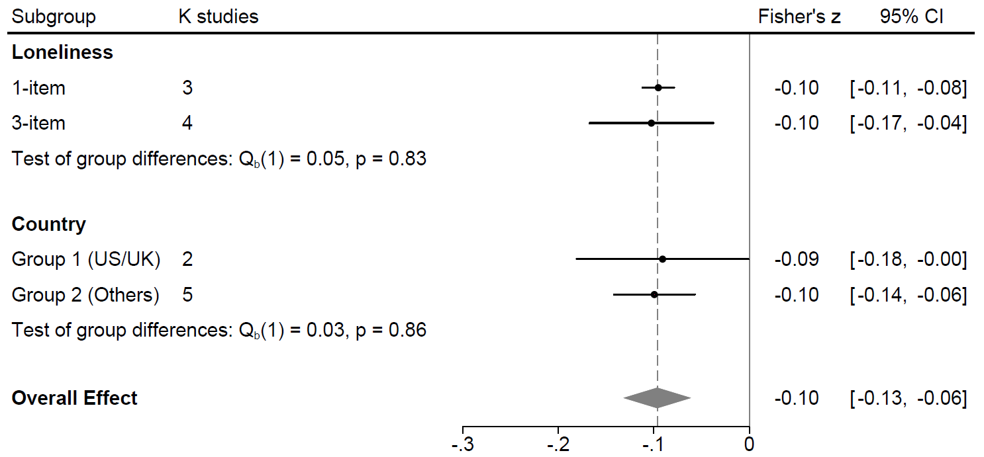
Figure S2
Sub-group analysis: Loneliness association with informant-rated cognitive decline

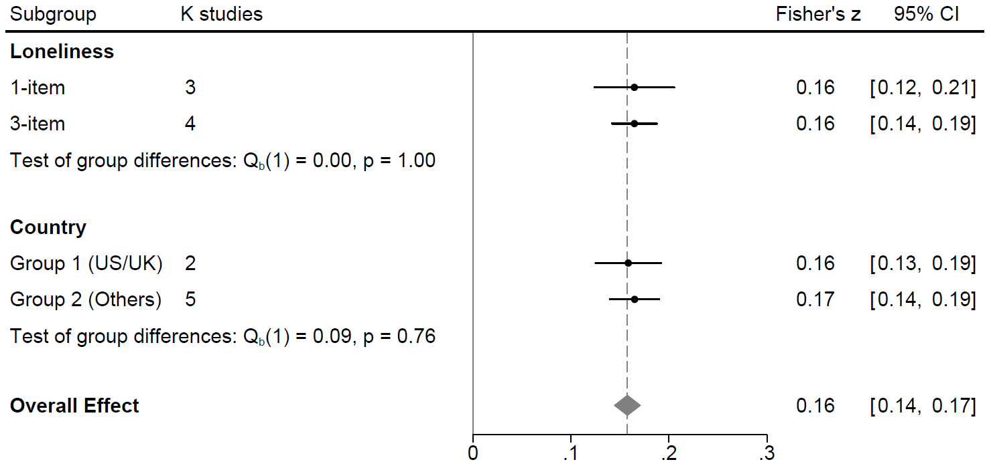
Figure S3
Sub-group analysis: Loneliness association with episodic memory

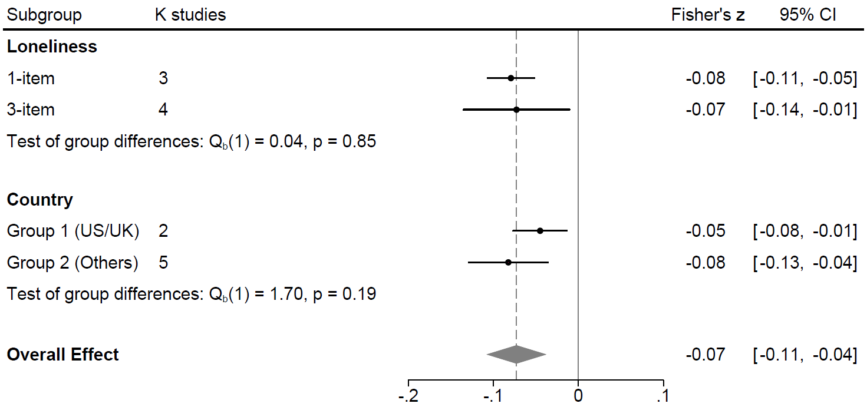
Figure S4
Sub-group analysis: Loneliness association with speed-attention

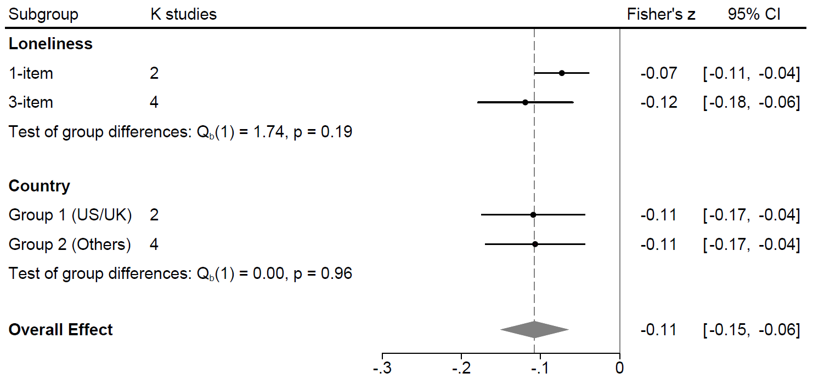
Figure S5
Sub-group analysis: Loneliness association with visuospatial abilities

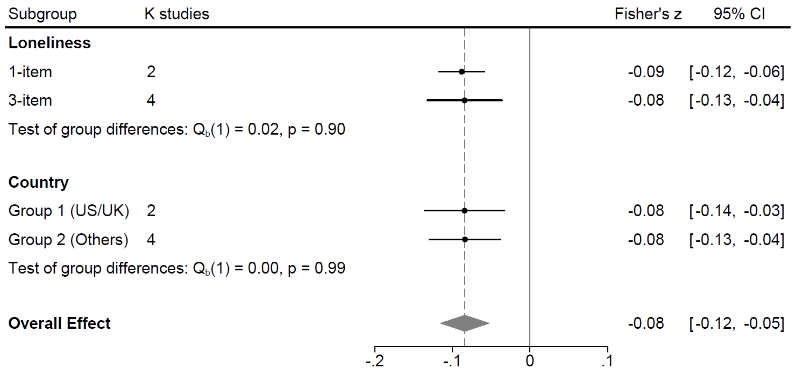
Figure S6
Sub-group analysis: Loneliness association with verbal fluency
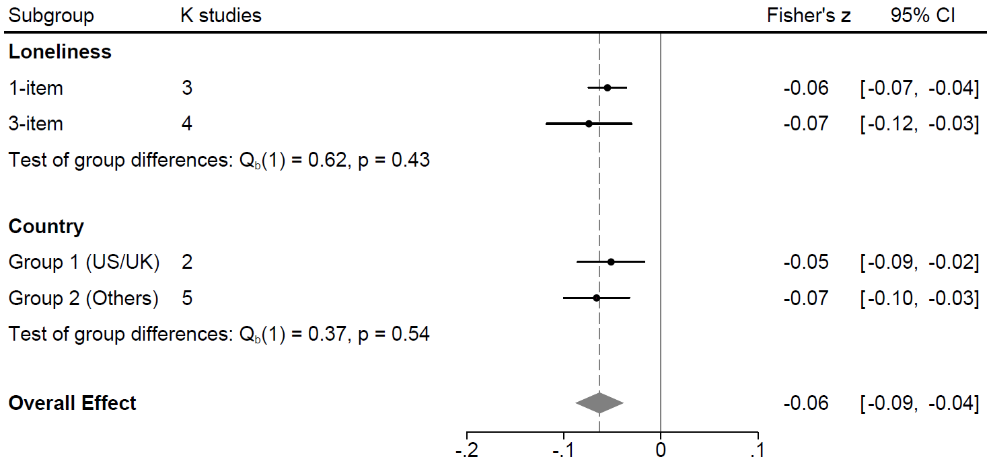

Figure S7
Graphical representation of interactions
Panel (a)
Loneliness x Depression
DV = Speed-attention
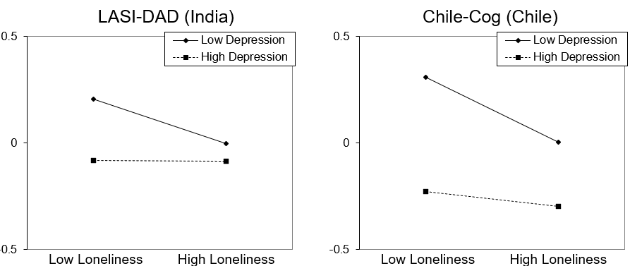

Panel (b)
Loneliness x Depression
DV = Verbal Fluency
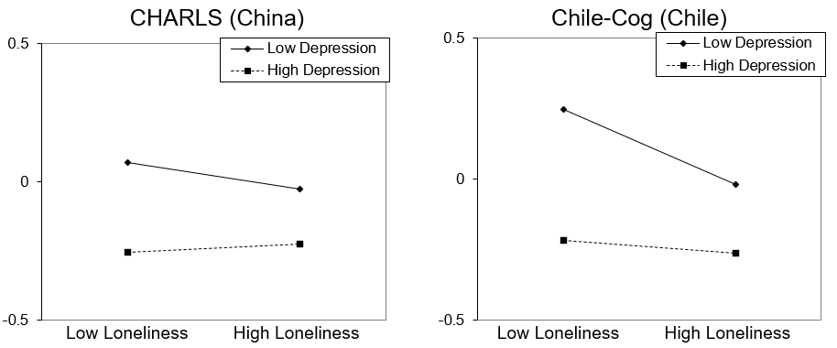

Panel (c)
Loneliness x Cognitive Impairment (Yes/No)
DV = Episodic Memory
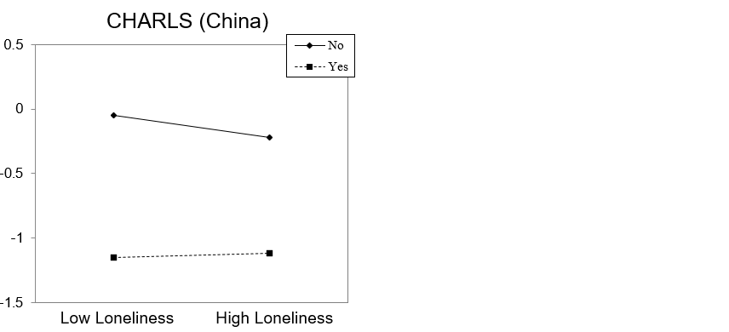

Panel (d)
Loneliness x Education
DV = Overall Cognition
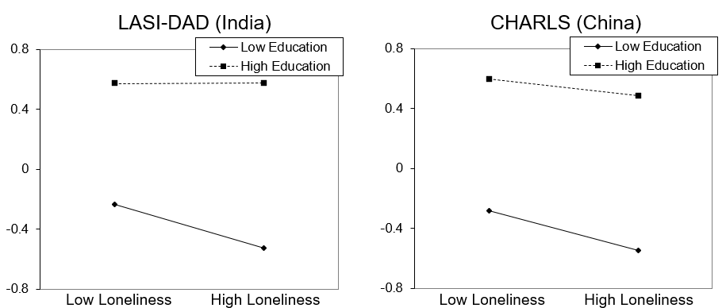
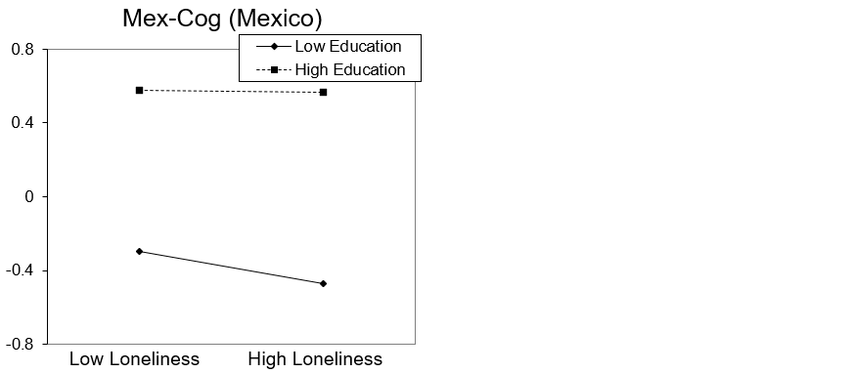

Panel (e)
Loneliness x Sex
DV = Informant Ratings
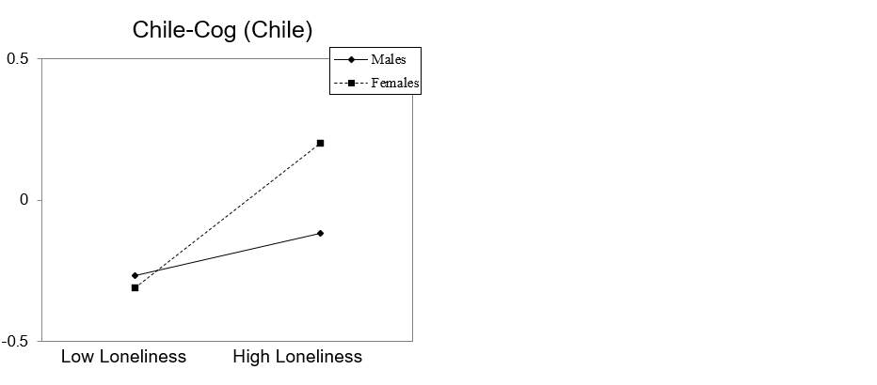
Note. For the meta-analysis of interactions that indicated a significant moderation, we plotted the effect for those samples for which the interaction term was significant. The graphs were generated using Excel templates from http://www.jeremydawson.co.uk/slopes.htm. Dawson, J. F. (2014). Moderation in management research: What, why, when and how. Journal of Business and Psychology, 29, 1-19.

