Table of Contents
sTable1 (A) Participants’ response to the Childhood Trauma Screener-5 items (CTS-5) 2
sTable1 (B) Items on the ACE-IQ used in this study 3
sTable2 Details of autoimmune disease from SAGA cohort 4
sTable3 The International Classification of Diseases (ICD) codes for diagnoses used in this study (UK Biobank) 5
sTable4 Details of depression, anxiety and PTSD (UK Biobank) 7
sTable5 Associations between different types of ACEs and any autoimmune disease 8
sTable6 Associations between total number of ACEs and types of autoimmune disease 9
sTable 7 Estimated hazard ratios for the association between number of ACEs and any autoimmune diseases, with the application of a 1-year lag time 10
sTable 8: Estimated hazard ratios for the association between number of ACEs and any autoimmune diseases (history of mental disorders as mediators). 11
sFigure1 Rank order correlations for type of ACEs (SAGA) 12
sFigure2 Rank order correlations for type of ACEs (UK Biobank) 13
sFigure3 The flow chart of study 14

sTable1 (A) Participants’ response to the Childhood Trauma Screener-5 items (CTS-5)
Item | Never true | Rarely true | Sometimes  true | Often true | Very often  true
Physical abuse:  People in my family hit me so hard that it left me with bruises or marks | 124805(81.3) | 16467(10.7) | 10139(6.6) | 1329(0.9) | 861(0.6)
Emotional abuse:  I felt that someone in my family hated me | 129935(84.6) | 9315(6.1) | 10043(6.5) | 2357(1.5) | 1951(1.3)
Sexual abuse:  Someone molested me (sexually) | 140149(91.2) | 7113(4.6) | 4912(3.2) | 780(0.5) | 647(0.4)
Physical neglect:  There was someone to take me to the doctor if I needed it | 3288(2.1) | 1231(0.8) | 4118(2.7) | 16263(10.6) | 128701(83.8)
Emotional neglect:  I felt loved | 2164(1.4) | 7024(4.6) | 24829(16.2) | 39074(25.4) | 80510(52.4)
Red fonts indicate the response that are categorized as ACEs

sTable1 (B) Items on the ACE-IQ used in this study
Items | scoring
Physical abuse
Did a parent, guardian or other household member spank, slap, kick, punch or beat you up? | Never, Once, A few times, Many times
Did a parent, guardian or other household member hit or cut you with an object, such as a stick (or cane), bottle, club, knife, whip etc? | Never, Once, A few times, Many times
Emotional abuse
﻿Did a parent, guardian or other household member yell, scream or swear at you, insult or humiliate you? | Never, Once, A few times, Many times
﻿Did a parent, guardian or other household member threaten to, or actually, abandon you or throw you out of the house? | Never, Once, A few times, Many times
Sexual abuse
﻿Did someone touch or fondle you in a sexual way when you did not want them to? | Never, Once, A few times, Many times
﻿Did someone make you touch their body in a sexual way when you did not want them to? | ﻿ Never, Once, A few times, Many times
﻿Did someone attempt oral, anal, or vaginal intercourse with you when you did not want them to? | Never, Once, A few times, Many times
﻿Did someone actually have oral, anal, or vaginal intercourse with you when you did not want them to? | Never, Once, A few times, Many times
Physical neglect
﻿How often did your parents/guardians not give you enough food  even when they could easily have done so? | Never, Once, A few times, Many times
﻿Were your parents/guardians too drunk or intoxicated by drugs to take care of you? | Never, Once, A few times, Many times
﻿How often did your parents/guardians not send you to school even when it was available? | Never, Once, A few times, Many times
Emotional neglect
﻿Did your parents/guardians understand your problems and  worries? | ﻿Always, Most of the time, Sometimes, Rarely, Never
﻿Did your parents/guardians really know what you were doing with  your free time when you were not at school or work? | Always, Most of the time, Sometimes, Rarely, Never

Note: We used frequency version to calculate the ACE scores

sTable2 Details of autoimmune disease from SAGA cohort

Items | Choices
Have you been diagnosed with diabetes? | 0=No, 1=Yes, treated with dietary changes, 2=Yes, treated with tablets, 3=Yes, treated with insulin incections, 4=Can/Will not answer
What type of diabetes do/did you have? | 0=Type 1 (most often originates during childhood), 1=Type 2 (most often diagnosed in adulthood), 2=Can /Will not answer
Have you been diagnosed with multiple sclerosis? | 0=No, 1=Yes, 2=Can/Will not answer
Have you been diagnosed with Crohn's disease? | 0=No, 1=Yes, 2=Can/Will not answer
Have you been diagnosed with Celiac disease? | 0=No, 1=Yes, 2=Can/Will not answer
Have you been diagnosed with thyroid disease? | 0=No, 1=Yes, 2=Can/Will not answer
Have you been diagnosed with Sjögrens disease? | 0=No, 1=Yes, 2=Can/Will not answer
Have you been diagnosed with Addisons disease? | 0=No, 1=Yes, 2=Can/Will not answer
Have you been diagnosed with rheumatoid arthritis? | 0=No, 1=Yes, 2=Can/Will not answer
Have you been diagnosed with systemic lupus erythematous? | 0=No, 1=Yes, 2=Can/Will not answer
Have you been diagnosed with polymyalgia rheumatica? | 0=No, 1=Yes, 2=Can/Will not answer
Have you been diagnosed with psoriasis? | 0=No, 1=Yes, 2=Can/Will not answer
Have you been diagnosed with psoriatic arthritis? | 0=No, 1=Yes, 2=Can/Will not answer

sTable3 The International Classification of Diseases (ICD) codes for diagnoses used in this study (UK Biobank)

Disease |  | ICD-10
Autoimmune disease
Disease of endocrine system | Diabetes mellitus, insulin dependent | E10
 | Autoimmune thyroid disease | E03.5, E03.9, E05.0, E05.5, E05.9, E06.3, E06.5
 | Addison’s disease | E27.1, E27.2
 | Autoimmune polyglandular syndrome | E31.0
Inflammatory arthritis | Reactive arthritis (Reiter’s syndrome) | M02.3, M02.8, M02.9, M05, M06, M08.0
 | Rheumatoid arthritis | M08.1, M08.2, M08.3, M08.4
 | Ankylosing spondylitis | M45
Vasculitis | Polyarteritis nodosa and related condition (Incl. Kawasaki, Churg-Strauss syndrome, etc.) | M30
 | Thrombotic microangiopathy | M31.1
 | Granulomatosis with polyangiitis  (Wegeners’s granulomatosis) | M31.3
 | Microscopic polyangiitis | M31.7
 | Henoch-Schonlein purpura | D69.0
 | Giant cell arteritis/Polymyalaia rheumatica | M35.3, M31.5, M31.6
Connective tissue disorders | Systemic lupus erythematosus | M32
 | Polymyositis/dermatomyositis | M33.0, M33.1, M33.2, M33.9
 | Systematic sclerosis (scleroderma) | M34
 | Sjogren’s syndrome | M35.0
 | Mixed connective tissue disease | M35.1
 | Behcet’s syndrome | M35.2
Disease of skin system | Pemphigus anemia | L10.0
 | Bullous pemphigoid | L12
 | Dermatitis herpetiformis | L13.0
 | Psoriasis | L40
 | Alopecia areata | L64
 | Vitiligo | L80
Hematological disease | Pernicious anemia | D51.0
 | Autoimmune hemolytic anemia | D59.0, D59.1
 | Idiopathic thrombocytopenic purpura | D69.3
Disease of nervous system | Acute disseminated encephalitis | G04
 | Anti-NMDA receptor encephalitis | G13.1
 | Multiple sclerosis | G35
 | Neuromyelitis optica and ADEM | G36
 | Guillain-Barre syndrome | G61.0, G61.1, G61.8, G61.9
 | Myasthenia gravis | G70.0
Disease of the digestive system | Primary biliary cirrhosis | K74.3
 | Crohn’s disease | K50
 | Ulcerative colitis | K51
 | Celiac disease | K90.0
Others | Acute rheumatic fever and chorea | I00, I01.0, I01.1, I01.2, I01.8, I0I.9, I02.0, I02.9
 | Sarcoidosis | D86
 | IgA nephropathy | N00, N01, N03, N05

sTable4 Details of depression, anxiety and PTSD (UK Biobank)

Questions | Field code
Items of depression (PHQ-9)
Little interest or pleasure in doing things | 20514
Feeling down, depressed, or hopeless | 20510
Trouble sleeping | 20517
Feeling tired | 20519
Poor appetite or overeating | 20511
Feeling bad about yourself | 20507
Trouble concentrating | 20508
Moving or speaking slowly or fidgety or restless | 20518
Thoughts that you would be better off dead | 20513
Items of anxiety (GAD-7)
Feeling nervous, anxious or on edge | 20506
Not being able to stop or control worrying | 20509
Worrying too much about different things | 20520
Trouble relaxing | 20515
Being so restless that it is hard to sit still | 20516
Becoming easily annoyed or irritable | 20505
Feeling afraid as if something awful might happen | 20512
Items of PTSD (PCL-S)
Repeated disturbing thoughts of stressful experience in past month | 20497
Felt very upset when reminded of stressful experience in past month | 20498
Avoided activities or situations because of previous stressful experience in past month | 20495
Felt distant from other people in past month | 20496
Felt irritable or had angry outbursts in past month | 20494
Trouble concentrating | 20508

sTable5 Associations between different types of ACEs and any autoimmune disease
 | SAGA |  | UK Biobank |  | Overall
 | PR (95%CI)ª | PR (95%CI)^{b} | PR (95%CI) ª | PR (95%CI) ^{b} | PR (95%CI)ª | PR (95%CI)^{b}
Physical abuse
No | Ref | Ref | Ref | Ref | Ref | Ref
Yes | 1.25(1.17-1.35) | 1.02(0.94-1.10) | 1.24(1.18-1.32) | 1.12(1.05-1.20) | 1.25(1.19-1.30) | 1.07(0.98-1.18)
Emotional abuse
No | Ref | Ref | Ref | Ref | Ref | Ref
Yes | 1.28(1.21-1.34) | 1.15(1.08-1.22) | 1.17(1.11-1.23) | 1.03(0.97-1.09) | 1.22(1.13-1.33) | 1.09(0.98-1.21)
Sexual abuse
No | Ref | Ref | Ref | Ref | Ref | Ref
Yes | 1.20(1.14-1.25) | 1.14(1.09-1.19) | 1.16(1.1-1.22) | 1.09(1.04-1.15) | 1.18(1.14-1.22) | 1.12(1.07-1.17)
Physical neglect
No | Ref | Ref | Ref | Ref | Ref | Ref
Yes | 1.25(1.16-1.33) | 1.10(1.02-1.18) | 1.29(1.21-1.37) | 1.18(1.11-1.26) | 1.27(1.21-1.33) | 1.14(1.06-1.23)
Emotional neglect
No | Ref | Ref | Ref | Ref | Ref | Ref
Yes | 1.21(1.15-1.26) | 1.11(1.06-1.17) | 1.16(1.12-1.21) | 1.08(1.03-1.13) | 1.18(1.14-1.22) | 1.09(1.06-1.13)
a. Adjusted for age, education, income, BMI and smoking status.
b. additionally adjusted for other types of ACEs;

sTable6 Associations between total number of ACEs and types of autoimmune disease

Types of autoimmune disease | SAGA | UK Biobank | Overall
 | PR (95%CI) | PR (95%CI) | PR (95%CI)
Multiple sclerosis | 1.09(0.96-1.23) | 0.96(0.87-1.06) | 0.98(0.90-1.14)
Crohn's disease | 1.15(1.06-1.26) | 0.98(0.87-1.11) | 1.07(0.91-1.26)
Celiac disease | 1.30(1.22-1.38) | 1.08(0.99-1.17) | 1.19(0.99-1.42)
Thyroid disease | 1.11(1.08-1.14) | 1.11(1.09-1.14) | 1.11(1.09-1.13)
Sjögrens disease | 1.38(1.23-1.54) | 1.29(1.14-1.46) | 1.34(1.23-1.45)
Rheumatoid arthritis | 1.19(1.14-1.25) | 1.09(1.02-1.16) | 1.14(1.05-1.25)
Systemic lupus erythematous | 1.11(1.00-1.24) | 1.17(0.99-1.38) | 1.13(1.03-1.24)
Polymyalgia rheumatica | 1.28(1.19-1.39) | 1.12(1.02-1.22) | 1.20(1.05-1.37)
Psoriasis | 1.08(1.04-1.13) | 1.03(0.94-1.13) | 1.07(1.03-1.12)
Psoriatic arthritis | 1.16(1.07-1.26) | 0.89(0.74-1.06) | 1.03(0.79-1.33)
Diabetes type-1 | 0.97(0.79-1.18) | 1.08(0.97-1.21) | 1.05(0.96-1.16)
Adjusted for age, education, income, BMI and smoking status.

sTable 7 Estimated hazard ratios for the association between number of ACEs and any autoimmune diseases, with the application of a 1-year lag time

 | Number of cases  (incidence rate, per 1000 person years) | M0 model  HR (95% CI) | M1:  M0+depression  HR (95% CI) | M2:  M0+anxiety  HR (95% CI) | M3:  M0+PTSD  HR (95% CI) | M4:  M0+all  HR (95% CI)
Total number of ACEs | 2487/ (7.51) | 1.07 (1.03-1.12) | 1.05 (1.01-1.09) | 1.07 (1.03-1.11) | 1.05 (1.01-1.10) | 1.05 (1.01-1.09)
Proportion mediated (%) |  | - | 18.5% (11.9%-29.6%) | 7.6% (1.8%-12.7%) | 16.0% (4.7%-23.4%) | 25.1% (14.7%-47.9%)
By number of ACEs
0 ACEs | 1566/ (7.18) | Ref | Ref | Ref | Ref | Ref
1 ACE | 511/ (7.75) | 1.08 (0.97-1.19) | 1.06 (0.96-1.17) | 1.07 (0.97-1.18) | 1.06 (0.96-1.17) | 1.05 (0.95-1.16)
≥2 ACEs | 410/ (8.67) | 1.21 (1.09-1.36) | 1.15 (1.03-1.29) | 1.19 (1.06-1.33) | 1.15 (1.03-1.29) | 1.13 (1.01-1.26)
Proportion mediated (%) |  | - | 26.5% (11.6%-92.7%) | 11.1% (2.0%-39.8%) | 22.8% (8.4%-80.5%) | 23.0% (17.1%-67.4%)
Abbreviation: BMI, body mass index; HR, hazard ratio; 95%CI, 95% confidence interval
Depression symptoms were assessed with the 9-item Patient Health Questionnaire (PHQ-9) with a score of ≥10 as the cutoff for a probable case.
Anxiety symptoms were assessed with the 7-item Generalized Anxiety Disorders (GAD-7) with a score of ≥10 as the cutoff for a probable case.
PTSD symptoms were assessed with the 6-item Post-Traumatic Stress Disorder Checklist (PCL-6) with a score of ≥14 as the cutoff for a probable case.
M0: basic model, adjusted for age, education, income, BMI and smoking status.
M4: M0+ depression, anxiety and PTSD.
Proportion mediated: the proportion of the total effect that is mediated through the specific mediator.

sTable 8: Estimated hazard ratios for the association between number of ACEs and any autoimmune diseases (history of mental disorders as mediators).

 | Number of cases  (incidence rate, per 1000 person years) | Basic model  HR (95%CI) | Additionally adjusted for history of mental disorders  HR (95%CI)
Total number of ACEs | 3204/ (9.67) | 1.07 (1.04-1.11) | 1.07 (1.03-1.10)
Proportion mediated (%) |  | - | 5.0% (2.7%-6.3%)
By number of ACEs
0 ACEs | 2007/ (9.20) | Ref | Ref
1 ACE | 672/ (10.18) | 1.10 (1.01-1.20) | 1.10 (1.01-1.20)
≥2 ACEs | 525/ (11.09) | 1.20 (1.09-1.33) | 1.19 (1.08-1.31)
Proportion mediated (%) |  | - | 5.0% (2.8%-6.0%)
basic model, adjusted for age, education, income, BMI and smoking status.
Proportion mediated: the proportion of the total effect that is mediated through the specific mediator
2,497 participants with a history of depression, anxiety and stress-related disorder

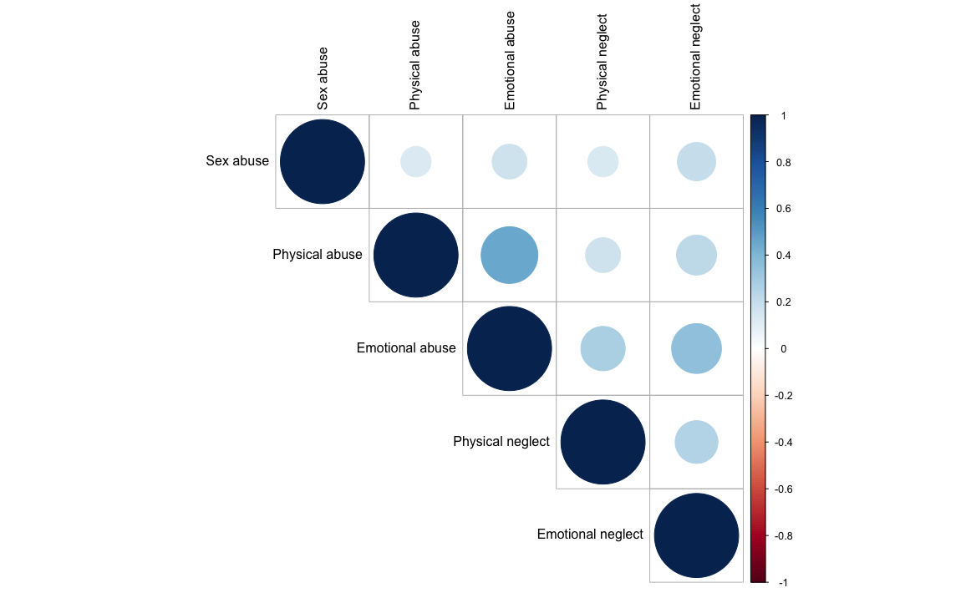

sFigure1 Rank order correlations for type of ACEs (SAGA)

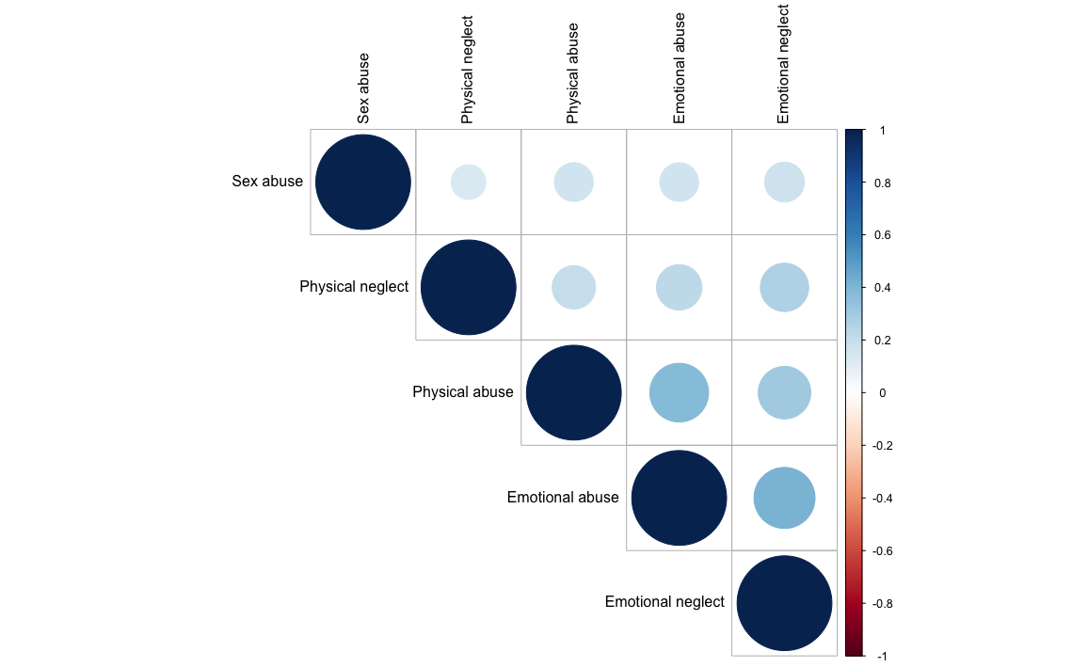

sFigure2 Rank order correlations for type of ACEs (UK Biobank)
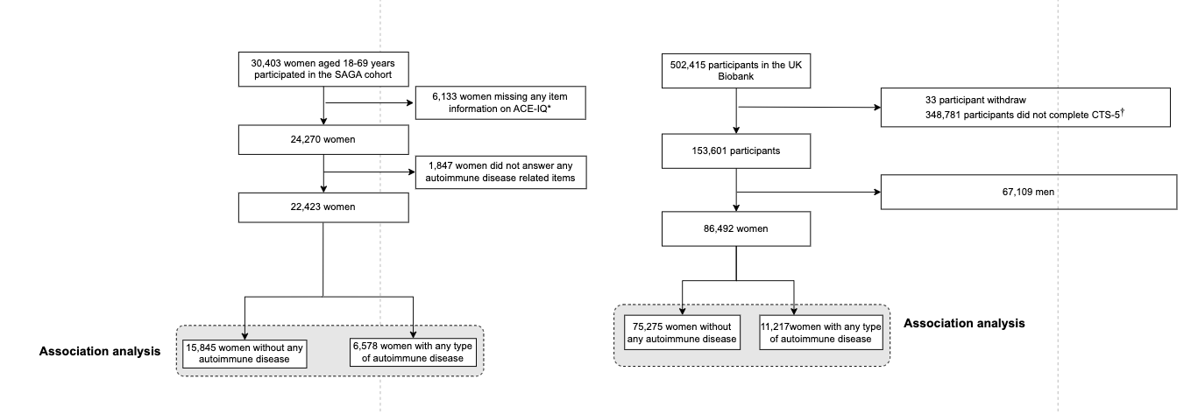

sFigure3 The flow chart of study

