**Patient safety incidents within adult community-based mental health services in England: A mixed-methods study of reported incidents, contributory factors, and proposed solutions.**

**Supplementary Material1.** Search strategy for incidents relating to community-based mental healthcare for working age adults

|  |  |  |  |
| --- | --- | --- | --- |
| **Extraction date:** | 16th December 2021 | | |
| **Date range:** | Incidents reported to have occurred between 1st January 2019 and 31st December 2019, and reported to the NRLS on or before 22nd October 2021 | | |
| **Categorical criteria:** | Care setting of occurrence | = | Mental Health Service |
| Incident location | ≠ | Mental Health Unit/Facility, Intermediate Care Setting, Hospice, Nursing Home, Prison, or Remand Centre |
| Incident category | ≠ | Failure to return from authorised leave |
| Trust code | = | Redacted for purpose of publication |
| Patient age | = | 18-65 Years |
| **Free text search:** | Free-text exclusion terms |  | [‘AWOL’] or [‘section’ or ‘MHA,’ within a number of words 3 of term ‘leave’] or [‘Abscon*] or ['Escorted' or 'unescorted' within 2 words of term 'leave'] or ['Informal patient' or 'Informal pt'] or ['on leave' within 3 words from 'ward'] or ['return*' within 3 words of 'leave'] or ['overnight leave'] or ['home leave'] or ['patient' within 3 words of 'on leave'] or ['breach*' within 2 words of 'hour']. |
| **Reported harm:** | No harm |  | Random sample of 1,000 reports captured by search criteria retrieved |
| Low harm |  | All reports captured by search criteria retrieved |
| Moderate harm |  | All reports captured by search criteria retrieved |
| Severe harm |  | All reports captured by search criteria retrieved |
| Death |  | All reports captured by search criteria retrieved |

*Note:* Owing to large numbers of reports,‘No harm’ and ‘Low harm’ reports were further sampled to reduce the size of the analysis sample (see Table 1).

**Supplementary Material2.** Exemplar inductive codes generated prior to the application of existing coding schemes

|  |
| --- |
| **Exemplar open codes for incident type** |
| * Deviation from/ delay/ failure to follow indicated care procedures |
| * Disjointed or poorly coordinated care |
| * Delay/ failure in care transitions |
| * Breach of patient confidentiality |
| * Delay/ failure to carry out clinical assessments or investigations |
| * Poor communication with other services involved in patient care |
| * Medication – acquisition of medications without valid prescription |

**Supplementary Material3.** Exemplar adaptations to the PISA incident classification system and new codes generated

|  |  |  |
| --- | --- | --- |
| **Adaptation to framework** | **Description of change(s)** | **Rationale** |
| Adaptation | Reports describing potential or actual harmful outcomes where service influence is unclear were coded and retained in analyses:   * Deaths by suicide, suspicious deaths, unexpected deaths, other deaths * Self-harm * Suicide attempts * Falls or accidents * Acts of violence by patient * Issues concerning vulnerable adults (e.g. reporting of safeguarding concern) | Reports of this nature are deemed incorrect uses of the reporting system in the original framework, but given the prevalence of these events and their relevance to risk assessment in community mental healthcare, these reports will be retained in analyses |
| New code | *Administration*   * Ability to access out of hours or crisis care professionals * Errors in legal administration (e.g. Mental Health Act) | These codes reflected challenges observed amongst incident reporting data |
| New code | *Diagnosis and assessment*   * Delayed Mental Health Act assessment | This code reflected challenges observed amongst incident reporting data |

*Note:* The PISA Classification System (Carson-Stevens et al., 2015) was adapted for use in this study

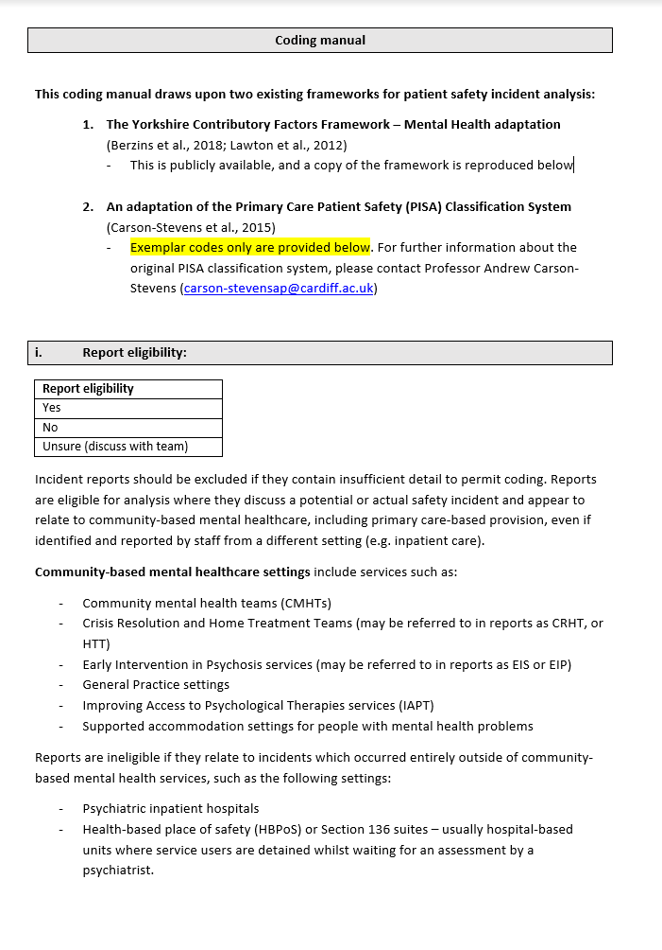 **Supplementary Material4.** Incident report coding manual with exemplar codes

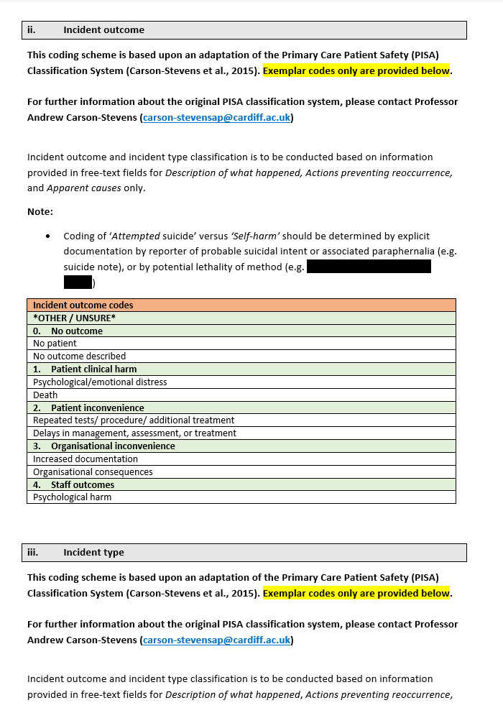

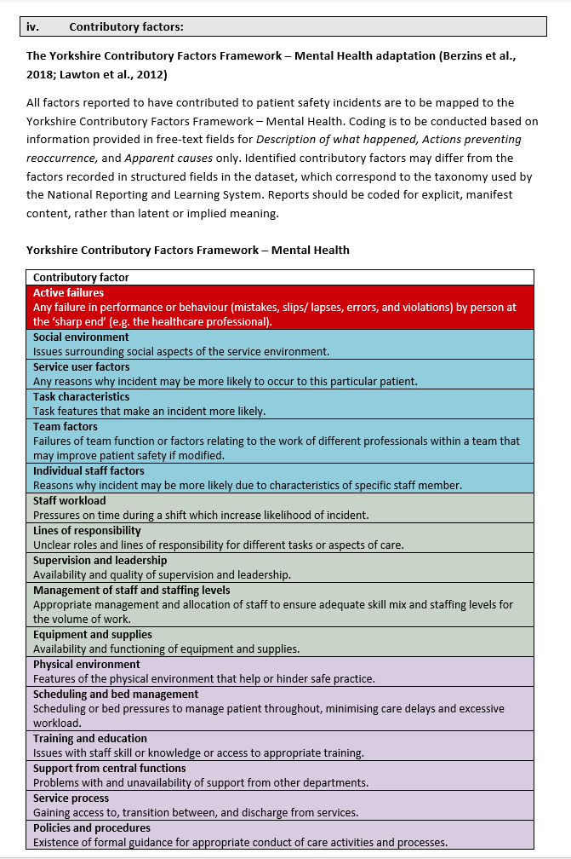

**Note:** The authors acknowledge the work of the [Yorkshire and Humber Improvement Academy](https://improvementacademy.org/resource/yorkshire-contributory-factors-framework/) (Bradford Teaching Hospitals NHS Foundation Trust) in the preparation of this coding manual. The above table was adapted and incorporated into this document according to [permissions set out by Yorkshire and Humber Improvement Academy](https://www.improvementacademy.org/wp-content/uploads/2022/02/Yorkshire-Contributory-Factors-Framework-Checklist.pdf).A close-up of a document
