**Supplemental figure 1: Edge-weight accuracy indexes with confidence intervals of the network**

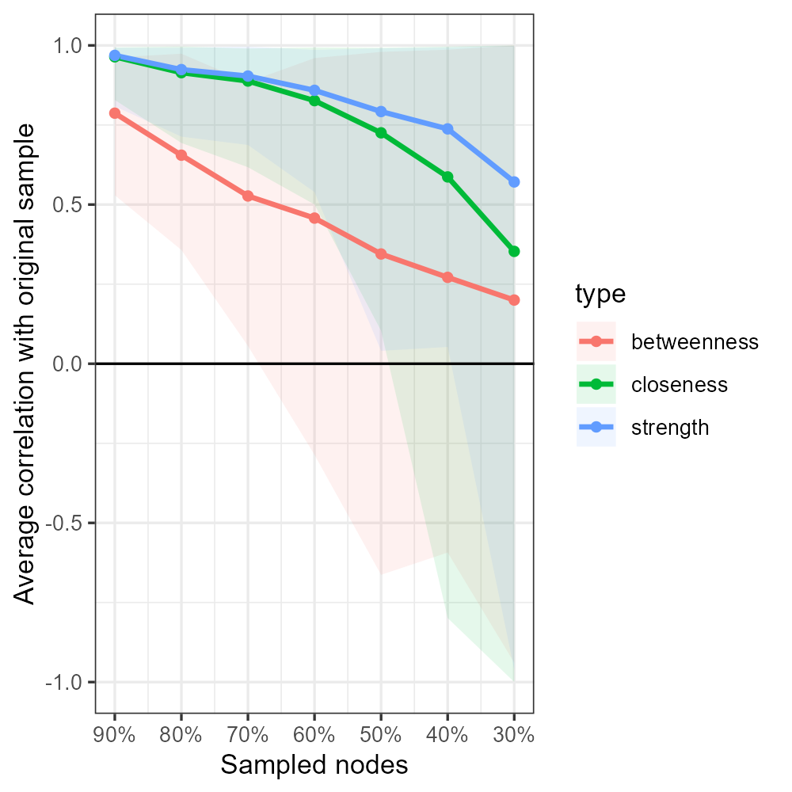

**Supplementary table 1: Weights matrix of the outcomes measures in the network analysis**



Symp= Symptom severity; Funct: Functioning ( SOFAS total score of the last year); Recov=QPR-15 Total Score; SocDis= Social disadvantage score: PhyDis= Physical disadvantage score; Abuse= ASI (Addiction Severity Index ) total score last year; Episod= number of episodes; SuicAtt= number of suicide attempts; DYAps= Dose-years of antipsychotic drugs; Diagn= DSM 5 final diagnosis (three groups); SCIP: Cognitive score ([The screen for cognitive impairment in psychiatry](https://bmcpsychiatry.biomedcentral.com/articles/10.1186/s12888-021-03508-4); Motor= Motor abnormalities;