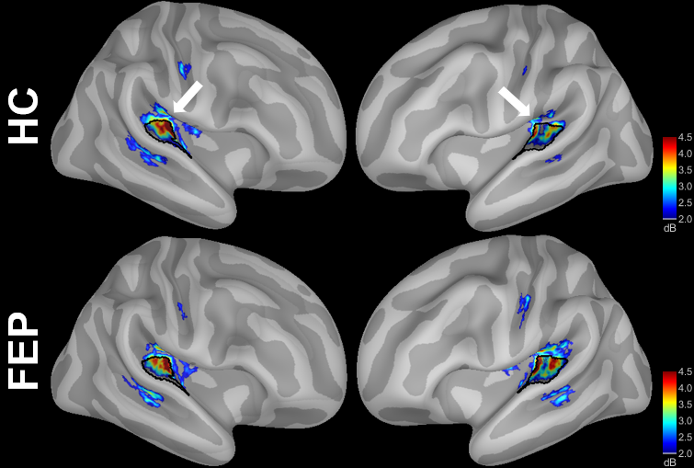
Supplemental Figure 1. Localization of EAGBR power, averaged across attention condition and time point, for healthy controls (HC) and first-episode psychosis (FEP) groups. While arrows indicate the location of our auditory cortex parcel (shaded in black).

 | PANSS Posª | PANSS Neg^{b} | GF:R^{c} | GF:S^{d}
Baseline  Power Mod  ITPC Mod | ρ = .04  ρ = .01 | ρ = -.20  ρ = -.26 | ρ = .15  ρ = .06 | ρ = .10  ρ = .02
Follow-Up  Power Mod  ITPC Mod | ρ = .11  ρ = .13 | ρ = -.12  ρ = -.09 | ρ = -.26  ρ = -.15 | ρ = -.01  ρ = -.05
Delta  Power Mod  ITPC Mod | ρ = -.20  ρ = .00 | ρ = -.43*  ρ = -.55* | ρ = .25  ρ = .06 | ρ = .21  ρ = .16
Supplemental Table 1. Correlations between EAGBR modulation and clinical ratings
ªPositive symptom component of the Positive and Negative Syndrome Scale; ^{b}Negative symptom component of the Positive and Negative Syndrome Scale; ^{c}Global Functioning: Role scale; ^{d}Global Functioning: Social scale
*p<.05

Supplemental Table 2. Exploratory correlations between EAGBR and clinical measures
 | PANSS Posª | PANSS Neg^{b} | GF:R^{c} | GF:S^{d}
Baseline  Power Active  Power Passive  ITPC Active  ITPC Passive | ρ = -.16  ρ = .08  ρ = .02  ρ = .07 | ρ = .20  ρ = .50*  ρ = .03  ρ = .18 | ρ = -.02  ρ = -.24  ρ = -.12  ρ = -.12 | ρ = .03  ρ = -.30  ρ = -.16  ρ = -.09
Follow-Up  Power Active  Power Passive  ITPC Active  ITPC Passive | ρ = .10  ρ = -.02  ρ = .11  ρ = .03 | ρ = .27  ρ = .33  ρ = .23  ρ = .46* | ρ = -.26  ρ = -.07  ρ = -.23  ρ = -.12 | ρ = -.03  ρ = -.04  ρ = -.24  ρ = -.22
Delta  Power Active  Power Passive  ITPC Active  ITPC Passive | ρ = .21  ρ = .02  ρ = -.05  ρ = -.04 | ρ = .15  ρ = .51*  ρ = .10  ρ = .45* | ρ = .11  ρ = -.16  ρ = .03  ρ = .01 | ρ = .25  ρ = -.07  ρ = .01  ρ = -.31
ªPositive symptom component of the Positive and Negative Syndrome Scale; ^{b}Negative symptom component of the Positive and Negative Syndrome Scale; ^{c}Global Functioning: Role scale; ^{d}Global Functioning: Social scale
*p<.05

