Supplementary material

2.1. DCM results shown separately for each patient.

Model evidence for each of the 4 modulatory families:
Patient 1 Patient 2 Both
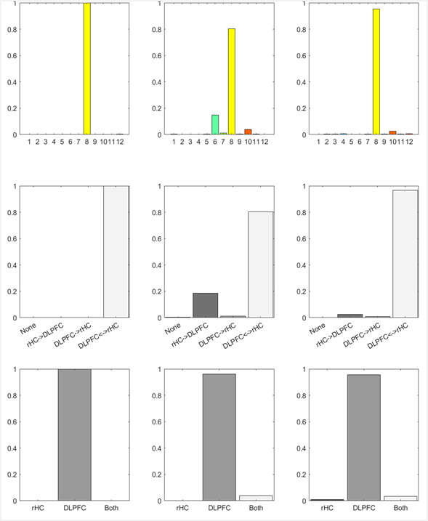

Model evidence for each of the 3 driving input families
Patient 1 Patient 2 Both

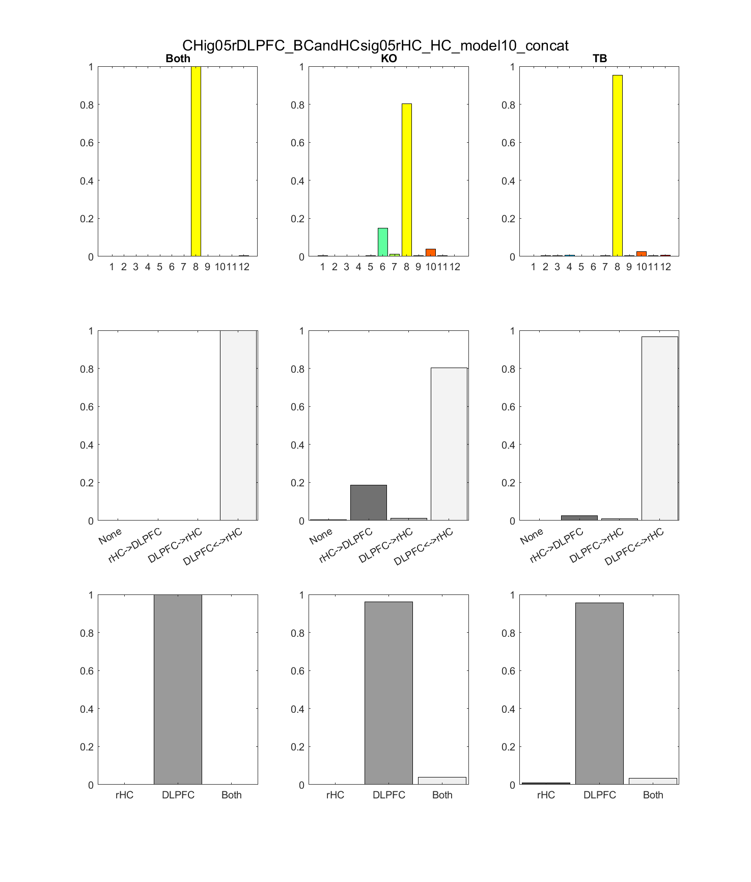

Model evidence across all 12 models
Patient 1 Patient 2 Both

Coupling parameters
Patient 1 Patient 2 Both

