**Online Supplement**

**Overlapping and Differential Neuropharmacological Mechanisms of Stimulants and Nonstimulants for Attention-Deficit/Hyperactivity Disorder: A Comparative Neuroimaging Meta-analysis**

Appendix 1. Literature Search Strategy 2

Appendix 2. Coding Task Experiments 2

Appendix 3. Quality Assessment Checklist 2

Table S1. Meta-regression Analysis for Confounding Factors 4

Table S2. Publication Bias Analysis for Identified Clusters 6

Table S3. Sensitivity Analysis for Included Studies of Stimulants and Nonstimulants 7

Table S4. Subgroup Analysis on Cognitive Control Studies 9

Table S5. Subgroup Analysis on Child Sample 10

Figure S1. Funnel Plots for Identified Brain Clusters. 11

The supplementary material has been provided by the authors to give readers additional information about their work.

# Appendix 1. Literature Search Strategy

We searched for studies that investigated the brain abnormalities of children and adolescents with bipolar disorder or attention-deficit/hyperactivity disorder (ADHD) on voxel-based morphometry (VBM) of structural magnetic resonance imaging (sMRI). According to a preregistered protocol (https://osf.io/65vn4), we conducted a literature search in PubMed (https://pubmed.ncbi.nlm.nih.gov/), Web of Science (https://apps.webofknowledge.com), and Medline (https://gateway.ovid.com). The search strategy involved three components: terms for articles enrolling patients with ADHD, for brain fMRI studies, and for medications. Within each component, we employed the “OR” operator to connect individual search terms, and between components, we used the “AND” operator. The search terms for articles enrolling patients with ADHD were the MeSH terms of “attention deficit disorder with hyperactivity” or keywords for “attention-deficit/hyperactivity disorder” OR “attention deficit disorder with hyperactivity” OR “ADHD” OR “hyperkinetic syndrome” OR “attention deficit disorder” in the title or abstract. The search keywords for brain fMRI studies included "functional magnetic resonance imaging" OR "MRI" OR "neuroimaging" OR "brain function". The search keywords for medication included "pharmacology" OR "medication" OR "stimulant" OR "methylphenidate" OR "dexmethylphenidate" OR "hydrochloride" OR "focalin" OR "amphetamine" OR "litalin" OR "coneerta" OR "benzedrine" OR "dextroamphetamine" OR "dexamfetamine" OR "amphetamine" OR "lisdexamfetamine" OR "tomoxetine" OR "atomoxetine" OR "strattera" OR "guanfacine" OR "tenex" OR "clonidine" OR "catapres" OR "viloxazine hydrochloride".

# Appendix 2. Coding Task Experiments

To code the included fMRI experiments, we employed the RDoC research framework (https://www.nimh.nih.gov/research/research-funded-by-nimh/rdoc/about-rdoc.shtml) to inform the varying degrees of psychiatric nosology based on neuroscience and behavioral science in psychological dimensions. The RDoC system differs from the criteria of DSM and ICD, and its framework highlights the adoption in investigating neurocircuit-based behavioral dimensions that pool across traditional diagnostic classifications. For tasks with multiple levels of difficulty, we included only the coordinates of the contrast corresponding to the most difficult condition.

# Appendix 3. Quality Assessment Checklist

We used the Imaging Methodology Quality Assessment Checklist to assess the quality of the included articles objectively and to suggest their limitations in methodology so that we may infer to weigh the importance of these findings. The 12-point checklist is modified from Shepherd et al. with three categories: subject characters (items 1-4), methods for image acquisition and analysis (items 5-10), and results and conclusions (items 11-12) (Shepherd *et al.*, 2012). The items of the checklist were revised to meet the purposes of our meta-analysis and to enhance the transparency of reports. The items are as follows:

Category 1: Subject score

1. Patients taking medications were evaluated prospectively in a mixed-design study to investigate the group-by-time interaction, and demographic data were reported.

2. Healthy control subjects were evaluated prospectively, psychiatric and medical illnesses were excluded, and demographic data were reported.

3. Important variables or details (e.g., diagnostic criteria, medication status, past illness history) were checked either by stratification or statistically.

4. Sample size per group > 10, and no significant difference in age and sex existed.

Category 2: Methods for image acquisition and analysis

5. The magnet strength was at least 1.5 T, and the slice thickness was at least 1.5 mm in the T1-weighted 3D sequence or 5 mm in the echo-planar imaging sequence.

6. Whole-brain analysis was automated without a priori regional selection.

7. Peak coordinates were reported in a standard space.

8. The imaging technique used was clearly described so that it could be reproduced.

9. Measurements were clearly described so that they could be reproduced.

10. The results were corrected for multiple comparisons.

Category 3: Results and conclusions

11. Statistical parameters for significant and important nonsignificant differences were provided.

12. The conclusions were consistent with the results obtained, and the limitations were discussed.

Note: Each item received a score of 1, 0.5 or 0 according to the criteria that were fully, partially or not met, respectively. The assessment score for each included study was reported in Table 1.

Ref:

Shepherd, A. M. *et al.* (2012) ‘Systematic meta-analysis of insula volume in schizophrenia.’, *Biological psychiatry*, 72(9), pp. 775–784. doi: 10.1016/j.biopsych.2012.04.020.

# Table S1. Meta-regression Analysis for Confounding Factors

|  |  |  |  |  |  |  |
| --- | --- | --- | --- | --- | --- | --- |
| Confounding variable  / Brain region | Brodmann area | MNI coordinates  (x, y, z) | SDM-Z | *p* value | Cluster size | Cluster breakdown  (Number of voxels) |
| **Age** | | | | | | |
| *Stimulant* | | | | | | |
| R supplementary motor area | 6 | 16, -6, 70 | 2.570 | .0001 | 35 | R superior frontal gyrus, dorsolateral (25)  R supplementary motor area (10) |
| *Nonstimulant* | | | | | | |
| L amygdala  (extending to L temporal pole) | 34/48 | -32, 2, -18 | -2.459 | <.0001 | 498 | L amygdala (133)  L temporal pole, superior temporal gyrus (116)  L insula (36) |
| **Gender** | | | | | | |
| *Stimulant* | | | | | | |
| None | | | | | | |
| *Nonstimulant* | | | | | | |
| L amygdala  (extending to L temporal pole) | 34/48 | -34, 4, -18 | 2.374 | <.0001 | 410 | L temporal pole, superior temporal gyrus (160)  L amygdala (46)  L insula (45) |

*Note:* Significant between-study heterogeneity was explored with meta-regression analyses. The overlap between significant areas of heterogeneity and areas of cortex differences was systematically investigated with separate meta-regressions using available potential confounders, which were provided in a sufficient proportion of the included studies. Meta-regression analysis examined the modulatory effects of confounding variables on brain regions with significant normalization effects. Suprathreshold clusters of meta-regression analysis were identified at a more rigid threshold (*p* < .0005 and cluster size > 20 voxels) for its exploratory nature. *Abbreviations:* L = left; R = right; MNI = Montreal Neurological Institute.

# Table S2. Publication Bias Analysis for Identified Clusters

|  |  |  |  |
| --- | --- | --- | --- |
| Region | Peak coordinates  (x, y, z) in MNI | Publication bias | |
| Symmetry of Funnel plot | *p* of Egger’s test |
| Stimulant vs. Control | | | |
| L supplementary motor area | -2, 20, 50 | Yes | .148 |
| L cerebellum | -10, -54, -10 | Yes | .713 |
| R supplementary motor area | 18 -6, 68 | Yes | .630 |
| R anterior cingulate gyrus | 12, 40, -4 | Yes | .651 |
| R postcentral gyrus | 30, -42, 62 | Yes | .667 |
| L middle frontal gyrus | -42, 32, 28 | Yes | .604 |
| Nonstimulant vs. Control | | | |
| L anterior/middle cingulate gyrus | 6, 26, 16 | Yes | .880 |
| L amygdala | -32, 2, -18 | Yes | .105 |
| L superior frontal gyrus | -22, 46, 32 | Yes | .102 |
| R caudate nucleus | 12, 18, 14 | Yes | .798 |

*Note:* Asymmetric funnel plots or *p* <.10 in Egger’s test indicated potential publication bias.

# Table S3. Sensitivity Analysis for Included Studies of Stimulants and Nonstimulants

|  |  |  |  |  |  |  |  |  |  |  |  |
| --- | --- | --- | --- | --- | --- | --- | --- | --- | --- | --- | --- |
| Discarded study | Stimulant vs. Control | | | | | | Discarded study | Nonstimulant vs. Control | | | |
| L SMA | L Cereb | R SMA | R ACC | R posG | L MFG | L ACC | L AMYG | L SFG | R CAU |
| Bush et al. (2008) | Yes | Yes | No | Yes | No | Yes | Bedard et al. (2015) | Yes | Yes | Yes | Yes |
| Chou et al. (2015) | Yes | Yes | Yes | Yes | Yes | No | Bush et al. (2013) | Yes | Yes | Yes | Yes |
| Congdon et al. (2014) | No | Yes | Yes | Yes | Yes | No | Chantiluke et al. (2015) | Yes | Yes | Yes | Yes |
| Cubillo et al. (2011) * | Yes | No | Yes | Yes | Yes | Yes | Chou et al. (2015) | Yes | Yes | Yes | Yes |
| Kobel et al. (2009) | Yes | Yes | Yes | Yes | Yes | Yes | Cubillo et al. (2014) * | Yes | Yes | No | No |
| Konrad et al. (2007) | Yes | Yes | Yes | Yes | Yes | Yes | Fan et al. (2017) | Yes | No | Yes | Yes |
| Kowalczyk et al. (2019) | Yes | Yes | Yes | Yes | Yes | Yes | Kowalczyk et al. (2019) | Yes | Yes | Yes | Yes |
| Kristensen et al. (2011) | Yes | Yes | Yes | Yes | Yes | Yes | Suzuki et al. (2011) | Yes | No | Yes | No |
| Lee et al. (2010) | Yes | Yes | Yes | Yes | Yes | Yes | Total | 8/8 | 6/8 | 7/8 | 6/8 |
| Mizuno et al. (2013) | Yes | Yes | Yes | Yes | Yes | Yes |
| Peterson et al. (2009) | Yes | Yes | Yes | Yes | Yes | Yes |
| Posner et al. (2011) | Yes | Yes | Yes | Yes | Yes | Yes |
| Rubia et al. (2009) * | Yes | Yes | Yes | No | Yes | No |
| Sheridan et al. (2010) | Yes | Yes | Yes | Yes | Yes | Yes |
| Stoy et al. (2011) | Yes | Yes | Yes | Yes | Yes | Yes |
| Sweitzer et al. (2018) | Yes | Yes | No | No | No | Yes |
| Total | 15/16 | 15/16 | 14/16 | 14/16 | 14/16 | 13/16 |

*Note:* Yes, the brain region remains significant when considering neural bases underlying medication effects in sensitivity analyses compared to pooled findings; no, the brain region is no longer significant. * Datasets with the same group of participants who completed various tasks were included in the meta-analysis as a single set. *Abbreviations:* L = left; R = right; SMA = supplementary motor area; Cereb = cerebellum; ACC = anterior cingulate cortex; posG = postcentral gyrus; MFG = middle frontal gyrus; AMYG = amygdala; SFG = superior frontal gyrus; CAU = caudate nucleus.

# Table S4. Subgroup Analysis on Cognitive Control Studies

|  |  |  |  |  |  |
| --- | --- | --- | --- | --- | --- |
| Contrast  /Brain region | Brodmann area | Coordinate  (x, y, z) | SDM-Z | *p* value | Cluster size |
| *Stimulant vs. Control* | | | | | |
| L lingual gyrus | 30 | -12, -50, -8 | 1.660 | .0001 | 773 |
| L middle occipital gyrus | 19 | -32, -82, 26 | 1.417 | .0007 | 199 |
| R superior frontal gyrus | 6 | 18, -6, 66 | 1.373 | .0010 | 173 |
| L inferior frontal gyrus | 45 | -44, 32, 24 | 1.345 | .0012 | 101 |
| R postcentral gyrus | 2 | 30, -40, 60 | 1.284 | .0017 | 49 |
| R supplementary motor area | 6 | 2, 14, 54 | -1.346 | .0016 | 454 |
| R inferior frontal gyrus | 48 | 56, 16, 10 | -1.250 | .0029 | 32 |
| *Non-stimulant vs. Control* | | | | | |
| R supplementary motor area | 6 | 2, -12, 58 | 1.893 | <.0001 | 1801 |
| L postcentral gyrus | 4 | -48, -16, 46 | 1.354 | .0008 | 382 |
| L superior frontal gyrus | 9 | -20, 48, 34 | -2.172 | <.0001 | 654 |

*Note:* Suprathreshold clusters were identified at p < .005 and cluster size > 20 voxels. *Abbreviations:* L = left; R = right; MNI = Montreal Neurological Institute

# Table S5. Subgroup Analysis on Child Sample

|  |  |  |  |  |  |
| --- | --- | --- | --- | --- | --- |
| Contrast  /Brain region | Brodmann area | MNI coordinates  (x, y, z) | SDM-Z | *p value* | Cluster size |
| Stimulant vs. control | | | | | |
| L cerebellum | 18 | -10, -54, -6 | 1.627 | <.0001 | 984 |
| L inferior frontal gyrus | 45 | -42, 32, 28 | 1.265 | .0002 | 354 |
| R middle cingulate cortex | 24 | 2, 24, 30 | -1.368 | .0005 | 841 |
| R precuneus | 5 | 6, -40, 54 | -1.205 | .0011 | 262 |
| R middle frontal gyrus | 46 | 26, 48, 30 | -1.119 | .0019 | 66 |
| Nonstimulant vs. control | | | | | |
| R putamen | 48 | 34, -12, -8 | 1.094 | <.0001 | 194 |
| R hippocampus | 20 | 34, -16, -14 | 1.100 | <.0001 | 133 |
| L superior frontal gyrus | 9 | -22, 48, 38 | -1.825 | <.0001 | 623 |
| L middle cingulate cortex | 24 | -2, 2, 32 | -1.070 | .0012 | 488 |
| L inferior temporal gyrus | 37 | -46, -58, -6 | -1.103 | .0008 | 66 |

*Note:* Suprathreshold clusters were identified at p < .005 and cluster size > 20 voxels. *Abbreviations:* L = left; R = right; MNI = Montreal Neurological Institute.

# Figure S1. Funnel Plots for Identified Brain Clusters.

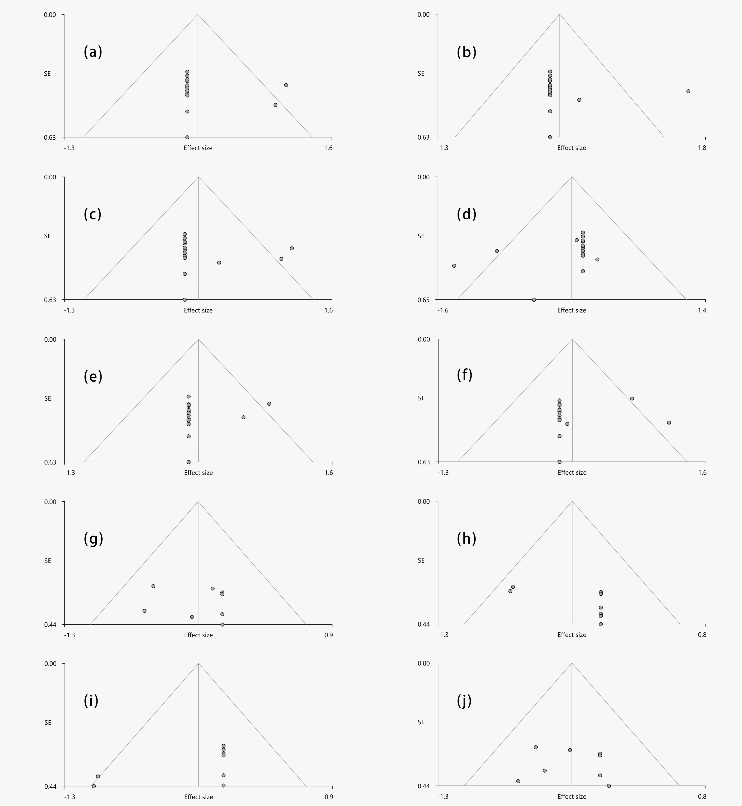

*Note:* (a): The funnel plot for the right supplementary motor area in the stimulant group.

(b): The funnel plot for the right postcentral gyrus in the stimulant group.

(c): The funnel plot for the right anterior cingulate cortex in the stimulant group.

(d): The funnel plot for the left supplementary motor area in the stimulant group.

(e): The funnel plot for the left middle frontal gyrus in the stimulant group.

(f): The funnel plot for the left cerebellum in the stimulant group.

(g): The funnel plot for the right caudate nucleus in the nonstimulant group.

(h): The funnel plot for the left superior frontal gyrus in the nonstimulant group.

(i): The funnel plot for the left amygdala in the nonstimulant group.

(j): The funnel plot for the left anterior cingulate cortex in the nonstimulant group.