**Supplementary Material 1. Flowcharts of inclusion process for the NESDA and TRANS-ID datasets**

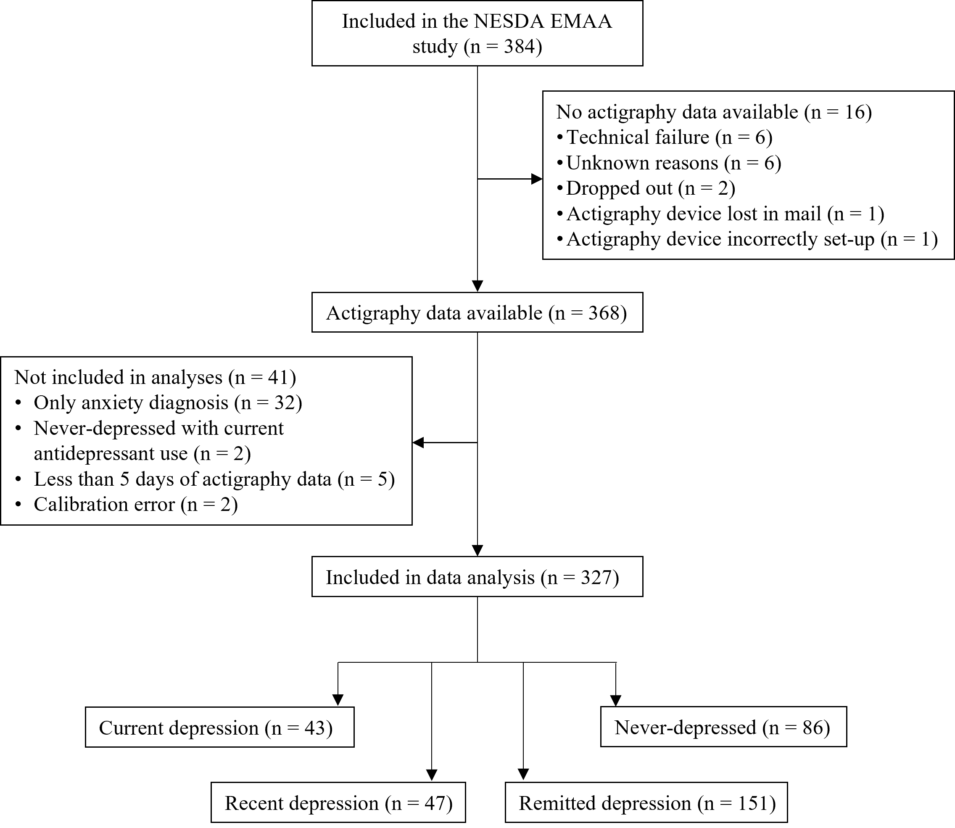

**Figure 1a. Flowchart of the NESDA participants**

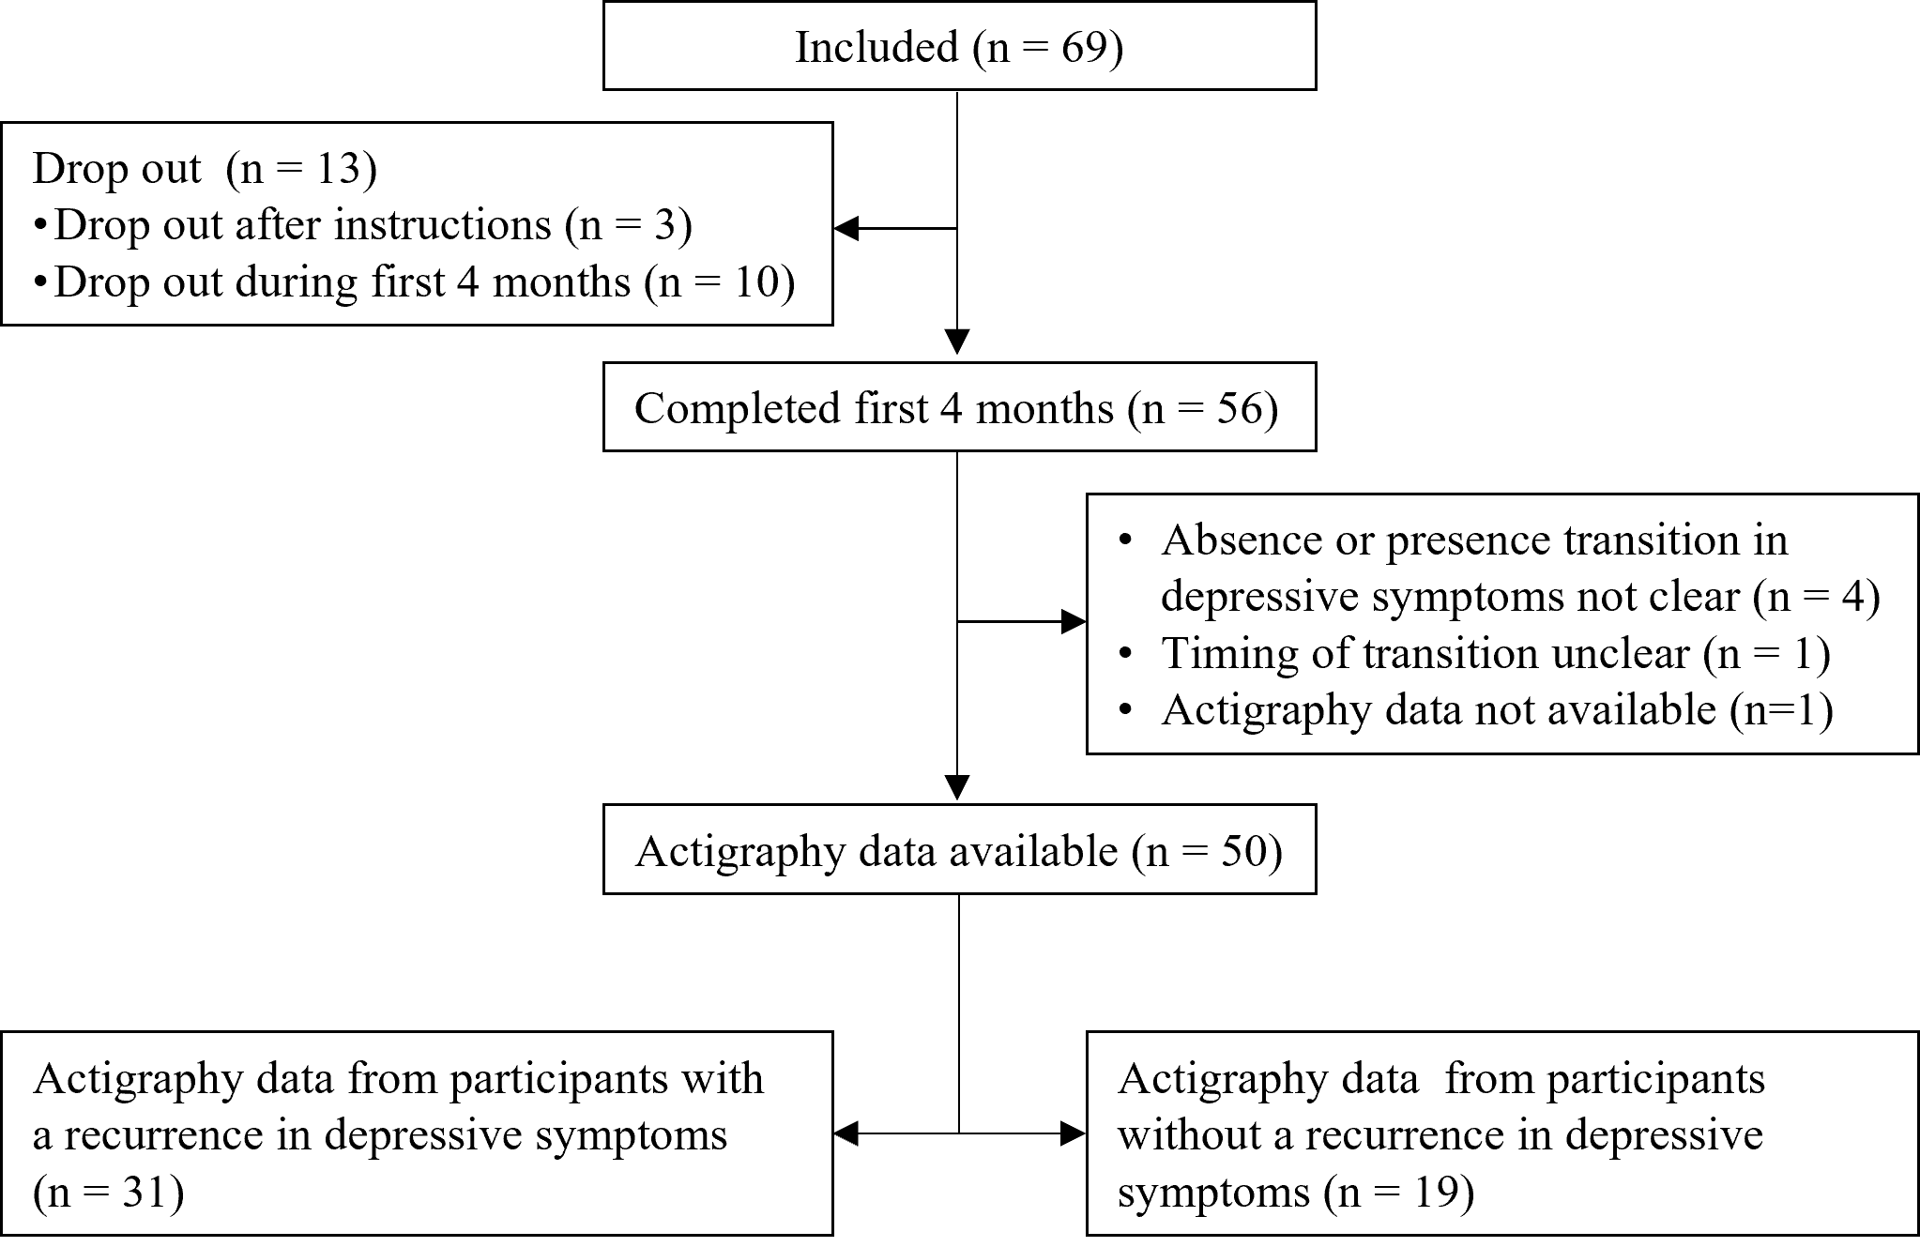

**Figure 1b. Flowchart of the TRANS-ID participants**