Supplementary Material

eMethods 1. MOOSE checklist 3
eMethods 2. Documentation of deviations from the pre-registered protocol 5
eMethods 3. Search strategy supplemental information 9
eMethods 4. Modified Newcastle Ottawa Scale (NOS) 15
eMethods 5. Statistical approach 16
eMethods 6. E-value calculation 18
eMethods 7. Directed Acyclic Graph (DAG) 20
eMethods 8. Confounder matrix judgement criteria 21
eMethods 9. References 23
eTable 1. Studies excluded at full-text screening 26
eTable 2. Tobacco and mood disorder study characteristics 36
eTable 3. Tobacco and anxiety disorder study characteristics 53
eTable 4. Tobacco and psychotic disorder study characteristics 56
eTable 6. Cannabis and anxiety disorder study characteristics 61
eTable 7. Cannabis and psychotic disorder study characteristics 64
eTable 8. NOS quality assessment 66
eTable 9. Summary of NOS ratings and mean scores by exposure/outcome 69
eTable 10. Confounder matrix assessment for studies included in meta-analysis of tobacco and mood disorders 70
eTable 11. Confounder matrix assessment for studies included in meta-analysis of tobacco and anxiety disorders 84
eTable 12. Confounder matrix assessment for studies included in meta-analysis of tobacco and psychotic disorders 88
eTable 13. Confounder matrix assessment for studies included in meta-analysis of cannabis and mood disorders 90
eTable 14. Confounder matrix assessment for studies included in meta-analysis of cannabis and anxiety disorders 94
eTable 15. Confounder matrix assessment for studies included in meta-analysis of cannabis and psychotic disorders 97
eTable 16. Subgroup analyses for tobacco and mood disorders 99
eTable 17. Meta-regression analyses for tobacco and mood disorders 100
eFigure 1. PRISMA flow-chart 101
eFigure 2. Unadjusted meta-analysis of tobacco use and mood disorders 102
eFigure 3. Unadjusted meta-analysis of tobacco use and anxiety disorders 103
eFigure 4. Unadjusted meta-analysis of tobacco use and psychotic disorders 104
eFigure 5. Unadjusted meta-analysis of cannabis use and mood disorders 105
eFigure 6. Unadjusted meta-analysis of cannabis use and anxiety disorders 106
eFigure 7. Unadjusted meta-analysis of cannabis use and psychotic disorders 107
eFigure 8. Summary matrix for tobacco use and mood disorders 108
eFigure 9. Summary matrix for tobacco use and anxiety disorders 109
eFigure 10. Summary matrix for tobacco use and psychotic disorders 110
eFigure 11. Summary matrix for cannabis use and mood disorders 111
eFigure 12. Summary matrix for cannabis use and anxiety disorders 112
eFigure 13. Summary matrix for cannabis use and psychotic disorders 113
eFigure 14. Doi plot and LFK index for tobacco use and mood disorders 114
eFigure 15. Doi plot and LFK index for tobacco use and anxiety disorders 115
eFigure 16. Doi plot and LFK index for tobacco use and psychotic disorders 116
eFigure 17. Doi plot and LFK index for cannabis use and mood disorders 117
eFigure 18. Doi plot and LFK index for cannabis use and anxiety disorders 118
eFigure 19. Doi plot and LFK index for cannabis use and psychotic disorders 119

eMethods 1. MOOSE checklist
MOOSE Checklist for Meta-analyses of Observational Studies (Brooke, Schwartz, & Pawlik, 2021)
Item No | Recommendation | Reported
Reporting of background should include
1 | Problem definition | Introduction
2 | Hypothesis statement | N/A
3 | Description of study outcome(s) | Eligibility Criteria
4 | Type of exposure or intervention used | Eligibility Criteria
5 | Type of study designs used | Eligibility Criteria
6 | Study population | Eligibility Criteria
Reporting of search strategy should include
7 | Qualifications of searchers (eg, librarians and investigators) | eMethods
8 | Search strategy, including time period included in the synthesis and key words | eMethods
9 | Effort to include all available studies, including contact with authors | eMethods
10 | Databases and registries searched | eMethods
11 | Search software used, name and version, including special features used (eg, explosion) | eMethods
12 | Use of hand searching (eg, reference lists of obtained articles) | eMethods
13 | List of citations located and those excluded, including justification | eTable1
14 | Method of addressing articles published in languages other than English | eMethods
15 | Method of handling abstracts and unpublished studies | eMethods
16 | Description of any contact with authors | eMethods
Reporting of methods should include
17 | Description of relevance or appropriateness of studies assembled for assessing the hypothesis to be tested | Eligibility Criteria
18 | Rationale for the selection and coding of data (eg, sound clinical principles or convenience) | Eligibility Criteria
19 | Documentation of how data were classified and coded (eg, multiple raters, blinding and interrater reliability) | Search and Selection; Data Extraction
20 | Assessment of confounding (eg, comparability of cases and controls in studies where appropriate) | eMethods
21 | Assessment of study quality, including blinding of quality assessors, stratification or regression on possible predictors of study results | Data Extraction; eMethods
22 | Assessment of heterogeneity | Statistical Analysis
23 | Description of statistical methods (eg, complete description of fixed or random effects models, justification of whether the chosen models account for predictors of study results, dose-response models, or cumulative meta-analysis) in sufficient detail to be replicated | Statistical Analysis, eMethods
24 | Provision of appropriate tables and graphics | Results; Supplement
Reporting of results should include
25 | Graphic summarizing individual study estimates and overall estimate | Figure 1-3
26 | Table giving descriptive information for each study included | eTable 2-7
27 | Results of sensitivity testing (eg, subgroup analysis) | eTable 16 - 17
28 | Indication of statistical uncertainty of findings | Results (CIs and PIs)
Reporting of discussion should include
29 | Quantitative assessment of bias (eg, publication bias) | Meta-Biases; eFigure 10-15; Discussion
30 | Justification for exclusion (eg, exclusion of non-English language citations) | Eligibility Criteria; Discussion
31 | Assessment of quality of included studies | eTable 8 + 9
Reporting of conclusions should include
32 | Consideration of alternative explanations for observed results | Discussion
33 | Generalization of the conclusions (ie, appropriate for the data presented and within the domain of the literature review) | Discussion
34 | Guidelines for future research | Discussion
35 | Disclosure of funding source | Acknowledgements

eMethods 2. Documentation of deviations from the pre-registered protocol
Summary of protocol deviations informed by suggested structure (Moreau & Gamble, 2022) for reporting available online at: https://osf.io/q8stz/
Deviation (1): Eligibility criteria – population characteristic
Description: | Change in inclusion criteria made during title/abstract screening to exclude studies where participants were selected based on health status (e.g. pregnant women, asthmatic) or other clinically meaningful characteristics (e.g. incarcerated persons).
Justification: | This amendment was made to reduce the substantial heterogeneity in populations, and was informed by recommendations from a previous review in this area which cites highly specific samples as a barrier to interpretation of evidence synthesis (Fluharty, Taylor, Grabski, & Munafò, 2017).
Impact: | Major; reduced the total number of included studies and applicability of the review to other populations i.e. does the association of smoking with subsequent mental illness differ in different populations? Furthermore, evidence of positive association across heterogeneous populations would have added further evidence to assessment of causality. However, also enabled a more targeted assessment of confounding bias in ‘general population’ studies.
Deviation (2): Search strategy – citation searching tool
Description: | A citation chasing tool not pre-specified in the protocol was used for forward and backward citation searching (https://estech.shinyapps.io/citationchaser/).
Justification: | The tool was not publicly available at the time of writing the pre-registration.
Impact: | Minor; may have yielded a more comprehensive search of records than achieved through standard manual approach, although also possible that some records missed due to software reliance on Lens.org database to compile all reference and/or citing records. These supplementary references were screened by one reviewer due to resource availability, which may have increased possible biases in screening.
Deviation (3): Data synthesis – meta-analysis method
Description: | Change in pre-planned random-effects meta-analysis method from using Mantel-Haenszel (MH) method, to generic inverse variance method (GIV).
Justification: | MH method was originally selected due to recommendation by Cochrane Handbook as optimal approach for binary outcome data with few events (Higgins et al., 2020) However, it was discovered after protocol registration that this method is only applicable to raw data, rather than pre-calculated estimates - which was the target of the primary meta-analysis of adjusted effect estimates.
Impact: | Minor; still random-effects (i.e. assumption true effect varies from study to study) and GIV is a commonly implemented approach for random-effects meta-analysis. Under this method, the weight given to each study is the inverse of the variance of the effect estimate, which may have made the pooled estimate more precise. However, importantly, the synthesis of pre-calculated effect estimates would not have been possible using the MH method.

Deviation (4): Data synthesis – unadjusted/minimally-adjusted
Description: | Change from pooling unadjusted and adjusted estimates separately, to pooling ‘minimally-adjusted’ (i.e. age/sex, none) and adjusted estimates separately.
Justification: | Numerous studies didn’t provide unadjusted estimates but estimates adjusted for age and sex. Some studies provided only estimates adjusted for age and sex as their maximally adjusted estimate. Given the aims of the review, we chose to treat these as ‘minimally adjusted’ results and these were pooled alongside crude estimates.
Impact: | Minor; including the estimates adjusted for age and/or sex in the unadjusted meta-analyses may have slightly attenuated the difference between adjusted vs. unadjusted meta-analyses. However, there was still an observed difference and a more in-depth assessment of confounding bias was also conducted using a subgroup analyses informed by the confounder matrix judgements.
Deviation (5): Data synthesis – confounder matrix
Description: | A confounding assessment tool, the ‘confounder matrix’ (Petersen et al., 2022) that was not pre-specified in the protocol was used to inform the assessment of control for confounding across the studies included in the primary meta-analyses.
Justification: | The tool was not publicly available at the time of writing the pre-registration.
Impact: | Minor; in order to interpret the E-values, an assessment of important confounders controlled for was necessary and recommended by concept developers (VanderWeele & Ding, 2017). The use of a transparent, visual approach was selected as review team felt it aided interpretability.
Deviation (6): Data synthesis – summary estimate (approximate RR vs. OR)
Description: | A change in summary estimate for the meta-analyses was made from the odds ratio (OR) to the risk ratio (RR).
Justification: | Given that E-values are assessed on the RR scale, and estimates required transformation if outcome prevalence >15%, we selected the square-root transformation available for OR RR and HR RR to increase consistency across the review (VanderWeele, 2017; VanderWeele, 2020). Alternative methods required information frequently not provided by studies (VanderWeele, 2020; Zhang & Yu, 1998). This approach has been employed in other published reviews (Ahn et al., 2023). For outcomes where prevalence was rare (e.g. psychotic disorder), estimates were pooled together without conversion. This is line with approaches employed in other reviews (Hunter, Murray, Asher, & Leonardi-Bee, 2020).
Impact: | Major; as a result, the pooled estimate reflects an ‘approximate’ RR. The review team felt this was the optimal approach for interpretability of the review. Risk ratios are also recommended as a preferred summary estimate by Cochrane Handbook, due to increased interpretability of the estimate (Higgins et al., 2020).

Deviation (7): Data synthesis - subgroup analyses
Description: | An additional subgroup analysis using judgements from the confounder matrix was added, instead of the planned meta-regression using ‘number of covariates’.
Justification: | Number of covariates was planned as a meta-regression to explore impact of control for confounding on the pooled estimate. However, this was felt to be less informative than information on ‘important’ confounders adjusted for from the confounder matrix assessment.
Impact: | Minor; a quantitative exploration of bias due to inadequate confounding control was still performed.

Deviation (8): Data synthesis – sensitivity analyses
Description: | A planned sensitivity analysis excluding studies not rated as ‘high quality’ was instead performed as a subgroup analysis. A planned sensitivity analysis excluding studies not using a validated outcome measure was not performed.
Justification: | A small number of studies were rated as high quality; therefore, it was deemed a better use of available information to compare estimates across ‘low’, ‘moderate’ and ‘high’ quality studies. There were few studies using non-validated outcome measures, and therefore a planned subgroup analysis by outcome type was deemed satisfactory exploration of the role of outcome measurement in the pooled estimate.
Impact: | Minor; a quantitative exploration of the possible influence of study quality and outcome measure on pooled estimate was still performed.
Deviation (9): Risk of bias in individual studies – additional modifications
Description: | Change from total score cut-off to distinguish quality of studies (i.e., low, moderate, high) to using a weighted approach to key items on the Newcastle Ottawa Scale. For details see eMethods 5.
Justification: | Total score approach has been criticised for not providing a nuanced assessment of possible sources of bias (e.g. a study could score >=7 with limited adjustment for confounding and substantial, or unclear, loss to follow-up). A weighted approach allows key sources of bias (i.e. confounding, attrition) to be preferentially considered in overall judgement of quality, and has been employed in other systematic reviews which assess risk factors for incident mental health conditions (Richardson, Westley, Gariépy, Austin, & Nandi, 2015).
Impact: | Moderate; some studies that would have been rated as ‘high’ based on original cut-off (i.e. >=7) were instead rated as ‘moderate’ quality due to lack of information about attrition. However, we have also presented total scores in order to enable readers to have access to the overall ‘score’.

Deviation (10): E-values for individual studies versus overall synthesis
Description: | We planned to calculate E-values for individual studies, and for the overall meta-analyses using the extension of E-values to the random-effects meta-analysis but did not perform the latter.
Justification: | Due to feasibility, it was decided that the E-values performed for individual studies in combination with the confounder matrix assessment was sufficient exploration of confounding bias.
Impact: | Minor; an assessment of confounding bias using E-values was still performed and impact considered on the overall synthesis. This approach has been applied in other published systematic reviews (Chan et al., 2020; Wilson et al., 2022). Other measures of uncertainty (e.g. 95CIs) were also considered in interpretation of results.

eMethods 3. Search strategy supplemental information
The search strategy for all databases have been provided below. The search terms and strategy were developed by the lead author (CB), reviewed and agreed amongst the review team and reviewed by a scientific librarian. Searches were initially performed in March 2021, and updated again in January 2022 and November 2022. Final searches were run on 18th November 2022.
Databases:
CINAHL (via EBSCOhost), Embase (via embase.com), MEDLINE (via PubMed), PsycINFO (via APA PsycNET). Searched from inception to present (i.e. point at which search performed). Base strategy was created in PubMed, which was adapted as required for the syntax and subject headings of the other databases used in the search. The following vocabulary databases were used to find equivalent terms: APA Thesaurus, CINAHL Headings and Emtree. For studies published in languages other than English, Google Translate was used to adequately translate the title, abstract and full text as required.
Grey literature:
Unpublished dissertations/theses were searched via the database ProQuest Dissertation & Theses.
Other sources:
- The shiny app ‘citationchaser’ (https://estech.shinyapps.io/citationchaser/; Haddaway, Grainger & Gray, 2021) was used to perform forward and backward citation searching of: (1) included studies, and (2) identified relevant reviews.
- Authors of published conference abstracts without accompanying full-texts were contacted where possible to ascertain study eligibility and acquire relevant results.
- A defined list of 10 experts in the field were successfully contacted via e-mail for unpublished findings or ‘file drawer’ data that might fulfil inclusion criteria. The response rate was 100%. A list of contacted persons is available on request.
Search field:
Text-words searched in Title/Abstract throughout all databases, except where otherwise specified.
Limits:
None applied (e.g. language, publication status) – not exclusion criteria for the review.

De-duplication:
Applied in Endnote and Covidence.
Full-text screening:
Studies were excluded following a hierarchy, as presented in eTable 1. As such, studies excluded on a higher-level criteria (e.g. not longitudinal, not binary) do not necessarily meet remaining criteria. Please note, exclusion on ‘not longitudinal’ refers to both cross-sectional studies, in addition to longitudinal studies with no eligible prospective association (i.e. temporal separation between exposure and outcome could not be established due to data collection methods or analysis).
Missing data and non-retrievable full-texts:
All authors of studies excluded on ‘FT not retrieved’ or ‘Missing data’ were contacted where a corresponding e-mail address could be located. Reasons for non-retrieval include (1) author non-response, (2) no e-mail address located, and (3) authors no longer having access to the data.

PubMed Search Strategy
All MeSH Terms exploded unless otherwise specified by ‘MeSH Terms:noexp’
ID | Searches
#1 | "cannabis"[MeSH Terms] OR "marijuana abuse"[MeSH Terms] OR "marijuana smoking"[MeSH Terms] OR cannabis[Title/Abstract] OR marijuana[Title/Abstract] OR marihuana[Title/Abstract]
#2 | "tobacco use"[MeSH Terms] OR "tobacco products"[MeSH Terms] OR "tobacco smoking"[MeSH Terms] OR "tobacco use disorder"[MeSH Terms] OR cigar*[Title/Abstract] OR smok*[Title/Abstract] OR nicotin*[Title/Abstract] OR tobacco[Title/Abstract]
#3 | #1 OR #2
#4 | "schizophrenia spectrum and other psychotic disorders"[MeSH Terms] OR schizo*[Title/Abstract] OR psychosis[Title/Abstract] OR psychotic[Title/Abstract]
#5 | "mood disorders"[MeSH Terms] OR "bipolar and related disorders"[MeSH Terms] OR “depression”[MeSH Terms] OR depress*[Title/Abstract] OR bipolar[Title/Abstract] OR dysthymia[Title/Abstract] OR "mood disorder*"[Title/Abstract]
#6 | "anxiety disorders"[MeSH Terms] OR "Anxiety"[MeSH Terms:noexp] OR phobia*[Title/Abstract] OR panic[Title/Abstract] OR anxi*[Title/Abstract]
#7 | "Mental Disorders"[MeSH Terms:noexp] OR "mental illness*"[Title/Abstract] OR "mental disorder*"[Title/Abstract] OR "psychiatric diagnos*"[Title/Abstract] OR "psychiatric disorder*"[Title/Abstract]
#8 | #4 OR #5 OR #6 OR #7
#9 | "Epidemiologic Studies"[MeSH Terms:noexp] OR "cohort studies"[MeSH Terms] OR "case control studies"[MeSH Terms] OR "case control stud*"[Title/Abstract] OR "cohort stud*"[Title/Abstract] OR retrospective[Title/Abstract] OR prospective[Title/Abstract] OR longitudinal[Title/Abstract] OR inciden*[Title/Abstract] OR "follow up"[Title]
#10 | #3 AND #8 AND #9

Embase
Limits applied: MEDLINE limiter
ID | Searches
#1 | 'cannabis'/exp/mj OR 'cannabis use'/exp/mj OR 'cannabis addiction'/exp/mj OR cannabis:ab,ti OR marijuana:ab,ti OR marihuana:ab,ti
#2 | 'tobacco'/exp/mj OR 'tobacco use'/exp/mj OR 'tobacco dependence'/exp/mj OR cigar*:ab,ti OR smok*:ab,ti OR nicotin*:ab,ti OR tobacco:ab,ti
#3 | 'psychosis'/exp/mj OR schizo*:ab,ti OR psychotic:ab,ti OR psychosis:ab,ti
#4 | 'mood disorder'/exp/mj OR 'bipolar disorder'/exp/mj OR depress*:ab,ti OR 'mood disorder*':ab,ti OR bipolar:ab,ti OR dysthymia:ab,ti
#5 | 'anxiety disorder'/exp/mj OR phobia*:ab,ti OR panic:ab,ti OR anxi*:ab,ti
#6 | 'mental disease'/mj OR 'mental illness*':ab,ti OR 'mental disorder*':ab,ti OR 'psychiatric disorder*':ab,ti OR 'psychiatric diagnos*':ab,ti
#7 | 'epidemiology'/mj OR 'cohort analysis'/mj OR 'case control study'/exp/mj OR 'cohort stud*':ab,ti OR 'case control stud*':ab,ti OR retrospective:ab,ti OR prospective:ab,ti OR longitudinal:ab,ti OR inciden*:ab,ti OR 'follow up':ti
#8 | #1 OR #2
#9 | #3 OR #4 OR #5 OR #6
#10 | #7 AND #8 AND #9
#11 | #7 AND #8 AND #9 NOT [medline]/lim

CINAHL Search Strategy
ID | Searches
S1 | MH ( (MH "Cannabis+") ) OR TI ( cannabis OR marijuana OR marihuana ) OR AB ( cannabis OR marijuana OR marihuana)
S2 | MH ( ( MH "Tobacco") OR (MH "Smoking") OR (MH "Tobacco Products") ) OR TI ( cigar* OR smok* OR nicotin* OR tobacco ) OR AB ( cigar* OR smok* OR nicotin* OR tobacco )
S3 | MH ( (MH "Bipolar Disorder+") OR (MH "Affective Disorders+") ) OR TI ( "mood disorder*" OR depress* OR bipolar OR dysthymia ) OR AB ( "mood disorder*" OR depress* OR bipolar OR dysthymia )
S4 | MH (MH "Anxiety Disorders+") OR TI ( phobia* OR panic OR anxi* ) OR AB ( phobia* OR panic OR anxi* )
S5 | MH (MH "Psychotic Disorders+") OR TI ( psychosis OR schizo* OR psychotic) OR AB ( psychosis OR schizo* OR psychotic)
S6 | MH (MH "Mental Disorders") OR TI ( "mental illness*" OR "mental disorder*" OR "psychiatric disorder*" OR "psychiatric diagnos*” ) OR AB ( "mental illness*" OR "mental disorder*" OR "psychiatric disorder*" OR "psychiatric diagnos*” )
S7 | MH ( (MH "Case Control Studies+") OR (MH "Prospective Studies") ) OR TI ( “cohort stud*” OR “case control stud*” OR retrospective OR prospective OR longitudinal OR inciden* OR “follow up” ) OR AB ( “cohort stud*” OR “case control stud*” OR retrospective OR prospective OR longitudinal OR inciden* )
S8 | S1 OR S2
S9 | OR/S3 – S6
S10 | S7 AND S8 AND S9

(NB: ‘+’ indicates that subject heading exploded in search)

PsycINFO
ID | Searches
#1 | Index Terms: {Cannabis} OR {Hashish} OR {Marijuana} OR {Cannabis Use Disorder} OR Title: cannabis OR Title: marijuana OR Title: marihuana OR Abstract: cannabis OR Abstract: marijuana OR Abstract: marihuana
#2 | Index Terms: {Tobacco Smoking} OR {Smokeless Tobacco} OR {Tobacco Use Disorder} OR Title: cigar* OR Title: smok* OR Title: nicotin* OR Title: tobacco OR Abstract: cigar* OR Abstract: smok* OR Abstract: nicotin* OR Abstract: tobacco
#3 | Index Terms: {Psychosis} OR {Schizophrenia} OR {Acute Psychosis} OR {Affective Psychosis} OR {Serious Mental Illness} OR Title: psychosis OR Title: schizo* OR Title: psychotic OR Abstract: psychosis OR Abstract: schizo* OR Abstract: psychotic
#4 | Index Terms: {Seasonal Affective Disorder} OR {Major Depression} OR {Disruptive Mood Dysregulation Disorder} OR {Affective Disorders} OR {Mania} OR {Cyclothymic Disorder} OR {Dysthymic Disorder} OR {Bipolar II Disorder} OR {Bipolar I Disorder} OR {Bipolar Disorder} OR Title: “mood disorder*” OR depress* OR bipolar OR dysthymia OR Abstract: “mood disorder*” OR depress* OR bipolar OR dysthymia
#5 | Index Terms: {Anxiety Disorders} OR {Generalized Anxiety Disorder} OR {Panic Attack} OR {Panic Disorder} OR {Phobias} OR Title: phobia* OR Title: panic OR Title: anxi* OR Abstract: phobia* OR Abstract: panic OR Abstract: anxi*
#6 | Index Terms: {Mental Disorders} OR Title: "mental illness*" OR "mental disorder*" OR "psychiatric disorder*" OR "psychiatric diagnos*” OR Abstract: "mental illness*" OR "mental disorder*" OR "psychiatric disorder*" OR "psychiatric diagnos*”
#7 | Index Terms: {Epidemiology} OR {Longitudinal Studies} OR {Prospective Studies} OR {Followup Studies} OR {Retrospective Studies} OR Title: “cohort stud*” OR “case control stud*” OR retrospective OR prospective OR longitudinal OR inciden* OR "follow up" OR Abstract: “cohort stud*” OR “case control stud*” OR retrospective OR prospective OR longitudinal OR inciden*
#8 | #1 OR #2
#9 | OR/#3-6
#10 | #7 AND #8 AND #9

ProQuest Dissertation + Theses
S1 | diskw.Exact("Cannabis") OR ti(cannabis OR marijuana OR marihuana) OR ab(cannabis OR marijuana OR marihuana)
S2 | diskw.Exact("Tobacco") OR ti(cigar* OR smok* OR nicotin* OR tobacco) OR ab(cigar* OR smok* OR nicotin* OR tobacco)
S3 | diskw.Exact("Psychotic") OR ti(psychosis OR schizophren* OR schizoaff* OR schizoty* OR psychotic) OR ab(psychosis OR schizophren* OR schizoaff* OR schizoty* OR psychotic)
S4 | diskw.Exact("Depression" OR "Bipolar disorder") OR ti(“mood disorder*” OR depress* OR bipolar OR dysthymia) OR ab(“mood disorder*” OR depress* OR bipolar OR dysthymia)
S5 | diskw.Exact("Anxiety disorders") OR ti(anxi* OR phobia* OR panic) OR ab(anxi* OR phobia* OR panic OR)
S6 | diskw.Exact("Mental illness") OR ti(“mental illness*” OR “mental disorder*” OR “psychiatric disorder*” OR “psychiatric diagnos*”) OR ab (“mental illness*” OR “mental disorder*” OR “psychiatric disorder*” OR “psychiatric diagnos*”)
S7 | diskw.Exact("Epidemiologic Studies" OR "Cohort study" OR "Case-control study") OR ti("cohort studies" OR "cohort study" OR "case control studies" OR "case control study" OR retrospective OR prospective OR longitudinal OR inciden* OR "follow up") OR ab("cohort studies" OR "cohort study" OR "case control studies" OR "case control study" OR retrospective OR prospective OR longitudinal OR inciden*)
S8 | S1 OR S2
S9 | OR/S3-S6
S10 | S7 AND S8 AND S9

eMethods 4. Modified Newcastle Ottawa Scale (NOS)
Quality of included studies was evaluated using an adapted version of the Newcastle Ottawa Scale (NOS) for case-control and cohort studies (Wells et al., 2013). The adapted scale can be found in Appendix A of the online protocol (https://osf.io/5t2pu/). The original scare can be found online (https://www.ohri.ca/programs/clinical_epidemiology/oxford.asp). Assessments were performed by two independent reviewers, and any disagreements were discussed between reviewers with a third reviewer consulted if a consensus could not be reached.
The NOS evaluates the quality of individual studies across selection of participants, comparability and outcome assessments. In eTable 8, scores on each section have been broken down by assessment area i.e. selection (S1, S2, S3, S4), comparability (C1, C2, C3) and outcome (O1, O2, O3). The NOS assigns a maximum of 9 points using a star-based system. Whilst reviews commonly employ standard cut-offs (e.g. ≥7) to denote ‘low’ vs ‘high’ risk of bias, this approach has been criticised for not providing a nuanced assessment of possible sources of bias. For example, a study could score ≥7 with limited adjustment for confounding and substantial, or unclear, loss to follow-up.
As such, in this review we employed a weighted approach in which potential risk of bias was awarded based on satisfactory approaches to key sources of bias. To be rated as ‘high quality’, a study must score 2 stars on items relating to confounding (5) and 1 star on items relating to attrition (8), and only score <1 star on one other item. To be rated as ‘moderate quality’ a study must score ≥1 on items relating to either confounding (5) or attrition (8) and may score <1 star on more than one other item. To be rated as ‘low quality’ a study must score <1 star on items related to confounding (5) and attrition (8). This is similar to approaches taken in other systematic reviews which assess risk factors for incident mental health conditions (e.g., Richardson et al., 2015). Subgroup analyses were performed based on study quality. The ‘total score’ and number of points allocated per domain (i.e. selection, comparability, exposure/outcome) have also been reported.

eMethods 5. Statistical approach

Included studies presented varied effect estimates. For studies providing only raw data, an unadjusted risk ratio (RR) was calculated using the number of positive and negative events in the exposed group and reference group (see Formula 1). The same approach was applied when studies did not present crude effect estimates, to facilitate inclusion in both adjusted and unadjusted meta-analyses. For studies which fulfilled the ‘rare event’ assumption (i.e. outcome prevalence <15%) the odds ratio (OR) and Hazard Ratio (HR) were considered to approximate the RR (VanderWeele, 2017; VanderWeele, 2020). Each study was checked for reported outcome prevalence, rather than assuming rare events. Where the outcome prevalence was >15%, the OR and HR were approximately transformed using the square-root transformation (VanderWeele, 2020). See Formula 2 (OR RR) and Formula 3 (HR RR; VanderWeele, 2020). The Incident Rate Ratio (IRR) was approximated as an HR and treated as described (i.e. >15% converted to approximate RR using square-root transformation).
Studies which only presented effect measures stratified by population characteristics (e.g. age, sex, ethnicity) were combined using random-effects meta-analysis and included as one estimate. For studies which presented frequency of use estimates (e.g. 1-9 CPD, 19-20 CPD, ≥20CPD), only the estimate for the highest use category was used in the main meta-analysis unless there were justified reasons to extract an alternative estimate (e.g. alternative exposure level subject to multiple imputation or buffer period to reduce risk of prodromal symptoms). Adjusted and unadjusted effect estimates were extracted and pooled separately. Studies which provided estimates that were adjusted only for age and/or sex (i.e. restriction, stratification, statistical) were not included in the primary meta-analysis as they were deemed insufficiently adjusted. These were instead included in the unadjusted meta-analysis as ‘minimally adjusted’ estimates.
Outliers were excluded as an exploratory sensitivity analysis, defined as all studies for which upper bound of the 95% confidence interval of the study is lower than the lower bound of the pooled effect confidence interval (i.e., extremely small effects) and for which the lower bound of the 95% confidence interval of the study is higher than the higher bound of the pooled effect confidence interval (i.e., extremely large effects).

Formula 1:
$$RR_{i}=\frac{a_{i}∕n_{1i}}{c_{i}∕n_{2i}}$$

Formula 2:
$${\{\frac{OR(u+OR-ORu)}{1-w+ORw}\text{\}}}^{1⁄2}$$

Formula 3:
$${\{\frac{1-{(1-w)}^{ϕ}}{1-{(1-u)}^{1/ϕ}}\frac{u}{w}\}}^{1/2}$$

eMethods 6. E-value calculation
A brief introduction to the E-value. and its calculation, has been summarised below. For a detailed introduction to the E-value and its application we recommend the following papers and commentaries (Mathur, Ding, Riddell, & VanderWeele, 2018; VanderWeele, 2022; VanderWeele & Ding, 2017; VanderWeele, Ding, & Mathur, 2019; VanderWeele & Mathur, 2020). The online calculator also provides information on producing and interpreting the E-value: https://www.evalue-calculator.com/
Two sensitivity parameters jointly determine the maximum possible bias from unmeasured confounding for a given observed risk ratio: (i) the strength of the association between the unmeasured confounder(s), U, and the outcome D i.e. RR_{UD}; (ii) the strength of the association between the exposure, E, and the unmeasured confounder(s) i.e. RR_{EU} (Mathur et al., 2018). If the two sensitivity parameters are assumed to be equal, the E-value is the minimum value for both associations that would be capable of attenuating the observed association to the null (Mathur et al., 2018; VanderWeele & Ding, 2017). The E-value is straightforward to calculate from an observed risk ratio, using the following formula:

E-value = $RR+ \sqrt{RR ×(RR-1)}$

In the circumstance that the observed risk ratio is below 1 (i.e., RR <1), the inverse of the observed risk ratio is taken before applying the E-value formula (i.e., let RR* = 1/RR). The formula is also applicable to hazard ratios (HR), or odds ratios (OR) with rare outcomes at the end of follow-up (i.e., <15%). In the instance that outcomes were not rare at the end of follow-up (i.e., >15%), the square-root transformation described in eMethods 5 was applied prior to calculating the E-value, which is also the approach recommended by the developers of the E-value and utilized within the online calculator (VanderWeele & Ding, 2017). The E-value can also be reported for the corresponding confidence interval limit that is closer to the null using the same formula; representing the minimum confounding strength capable of attenuating the confidence interval such that it includes the null. If the CI includes the null of a RR = 1, then the E-value for the CI is automatically since no confounding is needed to move the CI to include 1 (VanderWeele & Ding, 2017).
Crucially, what constitutes a ‘large’ or ‘small’ E-value is context dependent and is relative to the outcome, exposure and measured covariates which have been adjusted for (VanderWeele & Ding, 2017). That is, RR_{UD} and RR_{EU} are conditional on C and therefore reflect residual confounding not captured by C i.e. to interpret the E-value the association of U with both D and E, independent of C, must be considered (Diagram A). In most circumstances, control for pre-exposure covariates C will reduce some of the bias due to unmeasured confounding (e.g. adjustment for education level, in the absence of information about annual income).
Diagram A:
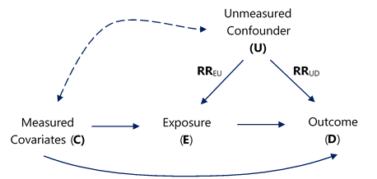

eMethods 7. Directed Acyclic Graph (DAG)
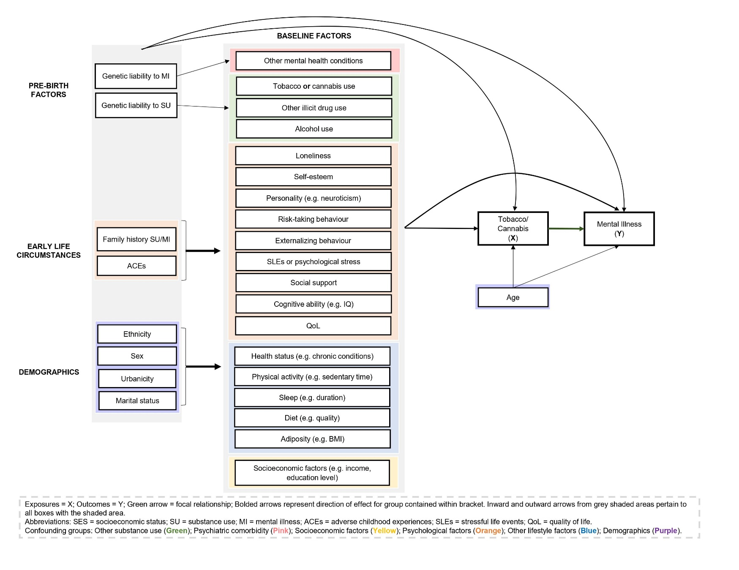

eMethods 8. Confounder matrix judgement criteria

Construct | Variables Controlled
 | Adequate | Some Concerns | Inadequate
Co-use ^{a,b} | Cannabis use or tobacco use are adjusted for (i.e., cannabis use adjusted for tobacco use, and vice versa); for cannabis exposures this must include adjustment for co-administration | Cannabis exposures do not adjust for tobacco confounding via co-administration | None
Other substance use ^{b} | Alcohol use + other illicit drug use | Some but not all of the variables (e.g., alcohol use only) | None
Psychiatric comorbidity | Composite indicator of any other mental health condition or adjustment for other key groups | Adjustment for some diagnostic groups (e.g., anxiety disorders) | None
Socioeconomic factors ^{c} | SES index or social class or two of: education, income (e.g. personal, household), unemployment, occupation | Only education, income, employment status or occupation | None
Sociodemographic factors ^{c} | Age, sex and one of: race/ethnicity, marital/partner status or urbanicity | Some but not all of the variables (e.g. age + urbanicity but not sex) | Only age or sex
Psychological factors | Two of: stressful life events, ACEs, loneliness, personality, self-esteem, social support, risk-taking externalizing behaviours, family history of mental illness, IQ/cognitive ability, quality of life | Adjustment for only one psychological factor (e.g., ACEs) | None
Lifestyle factors | Two of: physical activity, diet, adiposity, sleep, health status | Adjustment for only one lifestyle factor (e.g. diet) | None
ª For tobacco use studies, adjustment for cannabis use falls under adequate (i.e., adjusted for) or inadequate (i.e., not adjusted for); whilst unmeasured tobacco exposure via co-administration is a form of measurement error this relates to exposure misclassification versus confounding control.
^{b} For middle/older adult populations, adequate adjustment was alcohol-use only given the documented low prevalence of cannabis use and other controlled substances (e.g. cocaine, heroin) in these groups.
^{c} For adolescent populations, variables measuring family-level factors (e.g. family structure, parental income, parental education) were considered for assessment.

eMethods 9. References

Ahn, N., Nolde, M., Krause, E., Güntner, F., Günter, A., Tauscher, M., … Rückert-Eheberg, I.-M. (2023). Do proton pump inhibitors increase the risk of dementia? A systematic review, meta-analysis and bias analysis. British Journal of Clinical Pharmacology, 89(2), 602–616. doi: 10.1111/bcp.15583
Brooke, B. S., Schwartz, T. A., & Pawlik, T. M. (2021). MOOSE Reporting Guidelines for Meta-analyses of Observational Studies. JAMA Surgery, 156(8), 787–788. doi: 10.1001/jamasurg.2021.0522
Chan, G. C. K., Stjepanović, D., Lim, C., Sun, T., Anandan, A. S., Connor, J. P., … Leung, J. (2020). Gateway or common liability? A systematic review and meta-analysis of studies of adolescent e-cigarette use and future smoking initiation. Addiction, 116(4), 743-756. doi: 10.1111/add.15246
Fluharty, M., Taylor, A. E., Grabski, M., & Munafò, M. R. (2017). The Association of Cigarette Smoking With Depression and Anxiety: A Systematic Review. Nicotine & Tobacco Research: Official Journal of the Society for Research on Nicotine and Tobacco, 19(1), 3–13. doi: 10.1093/ntr/ntw140
Haddaway, N R, Grainger, M. J., & Gray, C. T. (2021). citationchaser: An R package and Shiny app for forward and backward citations chasing in academic searching. Zenodo. doi: 10.5281/ZENODO.4543513
Higgins, J., Thomas, J., Chandler, J., Cumpston, M., Li, T., Page, M., & Welch, V. (2020). Cochrane Handbook for Systematic Reviews of Interventions. Retrieved from www.training.cochrane.org/handbook
Hunter, A., Murray, R., Asher, L., & Leonardi-Bee, J. (2020). The Effects of Tobacco Smoking, and Prenatal Tobacco Smoke Exposure, on Risk of Schizophrenia: A Systematic Review and Meta-Analysis. Nicotine & Tobacco Research, 22(1), 3–10. doi: 10.1093/ntr/nty160
Mathur, M. B., Ding, P., Riddell, C. A., & VanderWeele, T. J. (2018). Website and R Package for Computing E-Values. Epidemiology (Cambridge, Mass.), 29(5), e45–e47. doi: 10.1097/EDE.0000000000000864
Moreau, D., & Gamble, B. (2022). Conducting a meta-analysis in the age of open science: Tools, tips, and practical recommendations. Psychological Methods, 27, 426–432. doi: 10.1037/met0000351
Petersen, J. M., Barrett, M., Ahrens, K. A., Murray, E. J., Bryant, A. S., Hogue, C. J., … Trinquart, L. (2022). The confounder matrix: A tool to assess confounding bias in systematic reviews of observational studies of etiology. Research Synthesis Methods, 13(2), 242–254. doi: 10.1002/jrsm.1544
Richardson, R., Westley, T., Gariépy, G., Austin, N., & Nandi, A. (2015). Neighborhood socioeconomic conditions and depression: A systematic review and meta-analysis. Social Psychiatry and Psychiatric Epidemiology, 50(11), 1641–1656. doi: 10.1007/s00127-015-1092-4
VanderWeele, T. (2017). On a square-root transformation of the odds ratio for a common outcome. Epidemiology (Cambridge, Mass.), 28(6), e58–e60. doi: 10.1097/EDE.0000000000000733
VanderWeele, T. J. (2020). Optimal approximate conversions of odds ratios and hazard ratios to risk ratios. Biometrics, 76(3), 746–752. doi: 10.1111/biom.13197
VanderWeele, T. J. (2022). Are Greenland, Ioannidis and Poole opposed to the Cornfield conditions? A defence of the E-value. International Journal of Epidemiology, 51(2), 364–371. doi: 10.1093/ije/dyab218
VanderWeele, T. J., & Ding, P. (2017). Sensitivity Analysis in Observational Research: Introducing the E-Value. Annals of Internal Medicine, 167(4), 268–274. doi: 10.7326/M16-2607
VanderWeele, T. J., Ding, P., & Mathur, M. (2019). Technical Considerations in the Use of the E-Value. Journal of Causal Inference, 7(2). doi: 10.1515/jci-2018-0007
VanderWeele, T. J., & Mathur, M. B. (2020). Commentary: Developing best-practice guidelines for the reporting of E-values. International Journal of Epidemiology, 49(5), 1495–1497. doi: 10.1093/ije/dyaa094
Wells, G., Shea, B., O’Connell, D., Peterson, J., Welch, V., Losos, M., & Tugwell, P. (2013). The Nwecastle-Ottawa Scale (NOS) for assessing the quality of nonrandomised studies in meta-analyses. Retrieved from http://www.ohri.ca/programs/clinical_epidemiology/oxford.asp
Wilson, J., Mills, K., Freeman, T. P., Sunderland, M., Visontay, R., & Marel, C. (2022). Weeding out the truth: A systematic review and meta-analysis on the transition from cannabis use to opioid use and opioid use disorders, abuse or dependence. Addiction, 117(2), 284–298. doi: 10.1111/add.15581
Zhang, J., & Yu, K. F. (1998). What’s the Relative Risk?A Method of Correcting the Odds Ratio in Cohort Studies of Common Outcomes. JAMA, 280(19), 1690–1691. doi: 10.1001/jama.280.19.1690

eTable 1. Studies excluded at full-text screening
First Author/Year | DOI/URL/PMID | Exclusion reason
Barata 2018 | 10.1183/13993003.congress-2018.PA1256 | FT not retrieved
Bourque 2016 | 10.1016/j.jaac.2016.09.406 | FT not retrieved
Cao 2014 | 10.1111/jgs.13075 | FT not retrieved
Cheng 2014 | N/A | FT not retrieved
Delgado 1989 | https://www.researchgate.net/publication/291745248_Cannabis_consumption_Incidence_and_psychological_effects | FT not retrieved
Duroseau 2020 | 10.1016/j.jadohealth.2019.11.259 | FT not retrieved
Marfatia 2009 | 10.1002/pds.1806 | FT not retrieved
Martinez-Hernaez 2015 | 10.1016/S0924-9338(15)30153-X | FT not retrieved
Michal 2015 | N/A | FT not retrieved
Prom-Wormley 2012 | 10.1007/s10519-012-9566-6 | FT not retrieved
Regeer 2009 | 10.1016/S0924-9338(09)70293-7 | FT not retrieved
Stuchlik 2015 | 10.1161/circ.132.suppl_3.18557 | FT not retrieved
Bakhshaie 2014 | 10.1016/j.comppsych.2014.10.012 | Duplicate
Fritz 2016 | https://scholar.colorado.edu/concern/undergraduate_honors_theses/8910jv21p | Duplicate
Hill 2017 | 10.1001/jamapsychiatry.2015.3229 | Duplicate
Addington 2005 | 10.1136/ebmh.8.3.87. | Ineligible design
Bulacia 2016 | 28898309 | Ineligible design
Beutel 2020 | 10.13109/zptm.2020.66.4.355 | Ineligible design
Costello 2016 | 10.1007/s00127-015-1168-1 | Ineligible design
Fergusson 2015 | 10.1007/s00127-015-1070-x | Ineligible design
Kirkbride 2011 | 10.1136/ebmh.14.3.70 | Ineligible design
Kuepper 2011 | 10.1016/j.schres.2011.06.012 | Ineligible design
Lewinsohn 1998 | 10.1016/s0272-7358(98)00010-5 | Ineligible design
Nishida 2007 | 17561673 | Ineligible design
Noda 2016 | 10.11560/jahp.28.special_issue_129 | Ineligible design
SeguíDíaz 2017 | 10.1016/j.semerg.2016.05.005 | Ineligible design
Skosnik 2007 | 10.1136/ebmh.10.2.61 | Ineligible design
Abuladze 2020 | 10.1177/2050312120974167 | Not longitudinal
Agrawal 2007 | 10.1111/j.1360-0443.2006.01630.x | Not longitudinal
Agrawal 2017 | 10.1016/s2215-0366(17)30280-8 | Not longitudinal
Baggio 2014 | 10.1515/ijamh-2013-0305 | Not longitudinal
Bandiera 2015 | 10.1093/ntr/ntu209 | Not longitudinal
Barkhuizen 2020 | 10.1016/j.jaac.2018.06.037 | Not longitudinal
Barrera 2016 | 28898304 | Not longitudinal
Baskak 2012 | 10.1016/j.psychres.2012.01.027 | Not longitudinal
Bhandari 2020 | 10.1007/s12126-020-09371-0 | Not longitudinal
Buckner 2012 | 10.1016/j.drugalcdep.2011.12.023 | Not longitudinal
Campbell 2020 | 10.1080/02791072.2020.1747665 | Not longitudinal
Carceller-Maicas 2014 | 10.20882/adicciones.127 | Not longitudinal
Catalao 2022 | 10.1136/bmjopen-2021-059257 | Not longitudinal
Chabrol 2004 | 10.1016/S0013-7006(04)95424-3 | Not longitudinal
Chaiton 2015 | 10.1016/j.addbeh.2014.11.026 | Not longitudinal
Chen 2002 | 10.1007/s00127-002-0541-z | Not longitudinal
Chéron-Launay 2011 | 10.1016/j.addbeh.2011.02.013 | Not longitudinal
Cheung 2010 | 10.3109/00952991003713784 | Not longitudinal
Cougle 2010 | 10.1093/ntr/ntq006 | Not longitudinal
Cruz-Barreda 2022 | 10.1016/j.ypmed.2022.107156 | Not longitudinal
Cunningham 2022 | 10.1016/j.amepre.2021.06.024 | Not longitudinal
Davis 2019 | 10.1016/j.drugalcdep.2019.107696 | Not longitudinal
Degenhardt 2001 | 10.1080/09652140120080732 | Not longitudinal
Degenhardt 2003 | 10.1016/s0376-8716(03)00064-4 | Not longitudinal
DeSousa 2013 | 10.1016/j.schres.2013.10.037 | Not longitudinal
Dominguez 2010 | 10.1176/appi.ajp.2010.09060883 | Not longitudinal
Emerson 2018 | 10.1016/j.mhp.2018.09.002 | Not longitudinal
Espada 2011 | https://www.redalyc.org/pdf/560/56017110002.pdf | Not longitudinal
Ferdinand 2005 | 10.1111/j.1360-0443.2005.01070.x | Not longitudinal
Ferdinand 2005 | 10.1016/j.schres.2005.07.027 | Not longitudinal
Fernandez-Pujals 2015 | 10.1371/journal.pone.0142197 | Not longitudinal
Field 2001 | 11817630 | Not longitudinal
Geus 2004 | https://www.researchgate.net/publication/289162839_Psychotic_disorders_and_use_of_cannabis_Retrospective_study | Not longitudinal
Gonçalves-Pinho 2019 | 10.1002/mpr.1813 | Not longitudinal
Goodwin 2012 | 10.1111/j.1521-0391.2012.00263.x | Not longitudinal
Green 2000 | 10.2307/2676359 | Not longitudinal
Haavisto 2004 | 10.1016/j.jad.2004.06.008 | Not longitudinal
Han 2019 | 10.1016/j.jad.2019.07.003 | Not longitudinal
Harder 2008 | 10.1093/aje/kwn184 | Not longitudinal
Hearld 2015 | 10.1016/j.jad.2014.11.041 | Not longitudinal
Hong 2020 | 10.1007/s00127-020-01945-2 | Not longitudinal
Hooker 2022 | 10.1016/j.jpsychores.2022.110920 | Not longitudinal
Jitnarin 2015 | 10.1093/ntr/ntu131 | Not longitudinal
Kawasaki 2015 | 10.1539/sangyoeisei.b14011 | Not longitudinal
Keskitalo-Vuokko 2016 | 10.1017/thg.2016.36 | Not longitudinal
Kim 2021 | 10.3390/ijerph18189887 | Not longitudinal
Kim 2022 | 10.1186/s12877-021-02729-2 | Not longitudinal
Kiviruusu 2022 | 10.1080/08039488.2021.2019912 | Not longitudinal
Liu 2022 | 10.1080/08039488.2021.2019912 | Not longitudinal
Livne 2021 | 10.1176/appi.ajp.2021.21010073 | Not longitudinal
Lyons 2008 | 10.1080/14622200701705332 | Not longitudinal
Martínez-Ortega 2013 | 10.1016/j.jpsychires.2013.03.012 | Not longitudinal
Martín-Merino 2010 | 10.4088/PCC.08m00764blu | Not longitudinal
Martín-Merino 2010 | 10.1093/fampra/cmp071 | Not longitudinal
Massak 2008 | 10.1080/14622200802163449 | Not longitudinal
McCaffery 2008 | 10.1037/0278-6133.27.3(suppl.).s207 | Not longitudinal
McGrath 2010 | 10.1001/archgenpsychiatry.2010.6 | Not longitudinal
McGrath 2016 | 10.1177/0004867415587341 | Not longitudinal
Miettunen 2008 | 10.1192/bjp.bp.107.045740 | Not longitudinal
Mykletun 2007 | 10.1016/j.eurpsy.2007.10.005 | Not longitudinal
Nesvåg 2017 | 10.1093/schbul/sbw101 | Not longitudinal
Noh 2014 | 10.4306/pi.2014.11.3.272 | Not longitudinal
Park 2013 | 10.1097/jan.0b013e3182a4cad3 | Not longitudinal
Pedersen 2009 | 10.4045/tidsskr.09.34699 | Not longitudinal
Punjani 2018 | 10.1177/1557988318799022 | Not longitudinal
Purborini 2021 | 10.1016/j.jfma.2021.01.016 | Not longitudinal
Quadros 2020 | 10.1590/0034-7167-2018-0162 | Not longitudinal
Rabiee 2020 | 10.1016/j.drugalcdep.2020.108332 | Not longitudinal
Radhakrishnan 2019 | 10.1017/s0033291718002635 | Not longitudinal
Riala 2005 | https://oulurepo.oulu.fi/handle/10024/37573 | Not longitudinal
Romans 1993 | 10.3109/00048679309075795 | Not longitudinal
Rougemont-Bücking 2019 | 10.1080/02791072.2019.1571258 | Not longitudinal
Santangelo 2018 | 10.4081/mi.2018.7649 | Not longitudinal
Scholes-Balog 2013 | 10.1016/j.adolescence.2013.03.001 | Not longitudinal
Shevlin 2017 | 10.1108/dat-03-2017-0014 | Not longitudinal
Sideli 2015 | 10.1111/eip.12285 | Not longitudinal
Slomp 2019 | 10.2147/NDT.S217069 | Not longitudinal
Son 1997 | 10.1093/oxfordjournals.aje.a009081 | Not longitudinal
Sourander 2004 | 10.1097/01.chi.0000134493.88549.e2 | Not longitudinal
Stefanis 1976 | 10.1111/j.1749-6632.1976.tb49885.x | Not longitudinal
Van der Pol 2013 | 10.1111/add.12196 | Not longitudinal
Yunis 2003 | 10.2224/sbp.2003.31.5.461 | Not longitudinal
Zablocki 1991 | 10.2307/2136800 | Not longitudinal
Zvolensky 2008 | 10.1016/j.jpsychires.2006.09.012 | Not longitudinal
Andreas 2021 | 10.1177/00048674211025711 | No X/Y association
Benjet 2015 | 10.1007/s00787-015-0721-5 | No X/Y association
Bierhoff 2019 | 10.1080/10826084.2019.1581220 | No X/Y association
Boffin 2012 | 10.1093/fampra/cms024 | No X/Y association
Bogren 2009 | https://lup.lub.lu.se/search/publication/1484236 | No X/Y association
Bratlien 2014 | 10.1016/j.psychres.2013.12.048 | No X/Y association
Brook 2010 | 10.1093/ntr/ntq027 | No X/Y association
Cartier 2017 | 10.4158/ep161456.Or | No X/Y association
Conde-Sala 2018 | 10.1016/j.jad.2018.10.358 | No X/Y association
Crane 2015 | 10.1016/j.addbeh.2015.05.014 | No X/Y association
Crespo 2022 | 10.1016/j.ypmed.2021.106932 | No X/Y association
deGraaf 2002 | 10.1034/j.1600-0447.2002.01397.x | No X/Y association
deGraaf 2013 | 10.1016/j.jad.2013.01.009 | No X/Y association
Filatova 2016 | 10.1017/s2045796016000123 | No X/Y association
Forsell 1999 | https://pubmed.ncbi.nlm.nih.gov/10389040/ | No X/Y association
Grant 2008 | 10.1038/mp.2008.41 | No X/Y association
Harris 2005 | 10.1093/ageing/afi216 | No X/Y association
Hofstra 2002 | 10.1097/00004583-200202000-00012 | No X/Y association
Holley 2006 | 10.1097/01.jgp.0000192504.48810.cb | No X/Y association
Kang 2015 | 10.1017/s1041610215001301 | No X/Y association
Kim 2006 | 10.1192/bjp.bp.105.015032 | No X/Y association
Köhler 2007 | 10.1007/s00127-007-0171-6 | No X/Y association
Lyness 2009 | 10.1176/appi.ajp.2009.08101489 | No X/Y association
Mazza 2008 | 10.1177/0272431608324193 | No X/Y association
Misawa 2018 | 10.1080/13607863.2018.1496225 | No X/Y association
Mojtabai 2004 | 10.1017/s0033291703001764 | No X/Y association
Moutinho 2019 | 10.1016/j.psychres.2019.02.041 | No X/Y association
Ogasawara 2011 | 10.1016/j.jad.2010.06.015 | No X/Y association
Phifer 1986 | 10.1037/0021-843x.95.3.282 | No X/Y association
Reinherz 1993 | 10.1097/00004583-199311000-00007 | No X/Y association
Shedler 1990 | 10.1037//0003-066x.45.5.612 | No X/Y association
Smit 2004 | 10.1016/j.jad.2003.08.007 | No X/Y association
Stek 2006 | 10.1192/bjp.188.1.65 | No X/Y association
Uemura 2017 | 10.1002/gps.4776 | No X/Y association
vanGool 2003 | 10.1093/ageing/32.1.81 | No X/Y association
Weinstein 2013 | 10.1037/a0031488 | No X/Y association
Welzel 2021 | 10.3390/ijerph182312786 | No X/Y association
Whitbeck 2009 | 10.1016/j.addbeh.2008.12.009 | No X/Y association
Yu 2016 | 10.1016/j.addbeh.2016.02.007 | No X/Y association
Aneshensel 1983 | 10.1037//0021-843x.92.2.134 | Not binary
Anglin 2012 | 10.1016/j.schres.2012.01.019 | Not binary
Anstey 2009 | 10.1097/PSY.0b013e3181beab60 | Not binary
Arria 2016 | 10.1016/j.drugalcdep.2015.12.009 | Not binary
Assari 2018 | 10.3389/fpsyg.2018.02135 | Not binary
Audrain-McGovern 2009 | 10.1111/j.1360-0443.2009.02617.x | Not binary
Baggio 2014 | 10.1111/add.12490 | Not binary
Bares 2014 | 10.1080/15504263.2014.961852 | Not binary
Beal 2014 | 10.1007/s11121-013-0402-x | Not binary
Bilsky 2021 | 10.1016/j.addbeh.2021.106981 | Not binary
Block 1991 | 10.1037//0022-3514.60.5.726 | Not binary
Bourque 2018 | 10.1001/jamapsychiatry.2018.1330 | Not binary
Brook 2006 | 10.2466/pr0.99.2.421-438 | Not binary
Brook 2013 | 10.2466/15.13.PR0.113x26z6 | Not binary
Caldeira 2012 | 10.1016/j.drugalcdep.2012.02.022 | Not binary
Campbell 2020 | 10.1186/s40695-020-00050-3 | Not binary
Capaldi 2022 | 10.1177/11782218221096154 | Not binary
Chang 2018 | 10.1007/s10802-018-0414-x | Not binary
DeBoer 2021 | 10.1017/S0033291721002968 | Not binary
Duncan 2021 | 10.1007/s00127-020-01900-1 | Not binary
Duperrouzel 2018 | 10.1016/j.addbeh.2017.11.005 | Not binary
Fergusson 2015 | 10.1016/s2215-0366(15)00208-4 | Not binary
Fleming 2008 | 10.1037/0893-164x.22.2.186 | Not binary
Frost 1999 | 10.1037/h0080411 | Not binary
Griffith-Lendering 2011 | 10.1016/j.drugalcdep.2010.11.024 | Not binary
Griffith-Lendering 2013 | 10.1111/add.12050 | Not binary
Grunberg 2015 | 10.1037/adb0000109 | Not binary
Gunn 2020 | 10.1037/pha0000357 | Not binary
Guttmannova 2017 | 10.1016/j.drugalcdep.2017.06.016 | Not binary
Hoffmann 2018 | 10.4236/health.2018.108080 | Not binary
Hooshmand 2012 | 10.1016/j.jadohealth.2011.05.016 | Not binary
Horwood 2012 | 10.1016/j.drugalcdep.2012.06.002 | Not binary
Hossain 2019 | 10.1016/j.jad.2019.06.001 | Not binary
Leadbeater 2019 | 10.1111/add.14459 | Not binary
Lee 2021 | https://www.proquest.com/docview/2454357025?pq-origsite=gscholar&fromopenview=true&sourcetype=Dissertations%20&%20Theses | Not binary
Lin 2014 | 10.1016/j.ridd.2014.07.018 | Not binary
London-Nadeau 2021 | 10.1037/abn0000542 | Not binary
Magee 2020 | 10.1016/j.addbeh.2020.106641 | Not binary
Marsden 2019 | 10.1016/j.addbeh.2019.106078 | Not binary
McIntyre 2020 | https://www.proquest.com/docview/2377687833?pq-origsite=gscholar&fromopenview=true&sourcetype=Dissertations%20&%20Theses | Not binary
Meier 2020 | 10.1007/s10802-020-00641-8 | Not binary
Melamed 2020 | 10.1111/sjop.12699 | Not binary
Mino 2001 | 10.1006/pmed.2000.0803 | Not binary
Moylan 2013 | 10.1371/journal.pone.0063252 | Not binary
Munafò 2008 | 10.1111/j.1360-0443.2007.02052.x | Not binary
Nault-Briere 2011 | https://papyrus.bib.umontreal.ca/xmlui/handle/1866/6150 | Not binary
Needham 2007 | 10.1016/j.socscimed.2007.04.037 | Not binary
Newcomb 1993 | 10.1037/1064-1297.1.1-4.215 | Not binary
Newcomb 1999 | 10.1002/(SICI)1520-6629(199907)27:4<405::AID-JCOP4>3.0.CO;2-2 | Not binary
Ostrowsky 2006 | https://psycnet.apa.org/record/2007-99015-033 | Not binary
Otten 2013 | 10.1111/j.1369-1600.2011.00380.x | Not binary
Otten 2017 | 10.1111/adb.12372 | Not binary
Pahl 2011 | 10.1017/s0033291710002345 | Not binary
Patten 2010 | 10.1177/070674371005501006 | Not binary
Pedersen 2009 | 10.1111/j.1360-0443.2008.02395.x | Not binary
Piumatti 2018 | 10.1016/j.psychres.2017.12.009 | Not binary
Poole 2018 | 10.1007/s12529-017-9703-y | Not binary
Ranjit 2019 | 10.1007/s11121-019-01020-6 | Not binary
Ranjit 2019 | 10.1016/j.drugalcdep.2019.03.012 | Not binary
Repetto 2005 | 10.1037/0278-6133.24.2.209 | Not binary
Repetto 2008 | 10.1111/j.1532-7795.2008.00566.x | Not binary
Sarris 2020 | 10.1186/s12916-020-01813-5 | Not binary
Schaefer 2021 | 10.1037/abn0000701 | Not binary
Scholes-Balog 2015 | 10.1177/0272431614540526 | Not binary
Scholes-Balog 2016 | 10.1016/j.addbeh.2015.09.008 | Not binary
Schuler 2015 | 10.1016/j.drugalcdep.2015.10.005 | Not binary
Shanahan 2021 | 10.1016/j.drugalcdep.2021.109063 | Not binary
Thompson 2018 | 10.1037/cbs0000090 | Not binary
Thompson 2021 | 10.3390/ijerph18073652 | Not binary
Tjora 2014 | 10.1111/add.12522 | Not binary
Tubman 1990 | 10.1016/s0899-3289(10)80004-5 | Not binary
Tucker 2019 | 10.1016/j.drugalcdep.2019.06.004 | Not binary
Tully 2010 | 10.1017/s0954579410000490 | Not binary
Vaillant 1990 | 10.1176/ajp.147.1.31 | Not binary
vanGastel 2014 | 10.1016/j.schres.2014.04.023 | Not binary
Velten 2018 | 10.1186/s12889-018-5526-2 | Not binary
Vermeulen 2019 | 10.1016/s2215-0366(18)30424-3 | Not binary
Walsh 2013 | 10.1007/s13142-012-0189-5 | Not binary
Wang 1996 | 10.2466/pr0.1996.79.1.127 | Not binary
Washburn 2014 | 10.1017/s0954579414000686 | Not binary
Wilhoit 2013 | https://www.proquest.com/docview/1364611100?pq-origsite=gscholar&fromopenview=true&sourcetype=Dissertations%20&%20Theses | Not binary
Wilkinson 2016 | 10.1016/j.jadohealth.2016.07.010 | Not binary
Wilkinson 2016 | 10.1016/j.addbeh.2016.03.036 | Not binary
Williams 2021 | 10.3390/ijerph181910468 | Not binary
Williams 2022 | 10.1097/CXA.0000000000000144 | Not binary
Womack 2016 | 10.15288/jsad.2016.77.287 | Not binary
Wymbs 2014 | 10.15288/jsad.2014.75.269 | Not binary
Xu 2010 | 10.1080/07399332.2010.486096 | Not binary
Almeida 2006 | 10.1097/01.Jgp.0000192486.20308.42 | Not incident
Ajdacic-Gross 2009 | 10.1111/j.1360-0443.2009.02640.x | Not incident
Amialchuk 2022 | 10.1002/hec.4469 | Not incident
Anderson 2022 | 10.1177/13591053211072685 | Not incident
Andréasson 1987 | 10.1016/s0140-6736(87)92620-1 | Not incident
Andréasson 1989 | 10.1111/j.1600-0447.1989.tb10296.x | Not incident
Angst 1996 | 10.1192/S0007125000298383 | Not incident
Anstey 2007 | 10.1097/JGP.0b013e31802e21d8 | Not incident
Arseneault 2002 | 10.1136/bmj.325.7374.1212 | Not incident
Bagade 2022 | 10.1038/s41598-022-15064-2 | Not incident
Bechtold 2015 | 10.1037/adb0000103 | Not incident
Bechtold 2016 | 10.1176/appi.ajp.2016.15070878 | Not incident
Boden 2010 | 10.1192/bjp.bp.109.065912 | Not incident
Boden 2020 | 10.1111/add.14814 | Not incident
Bolanis 2020 | 10.1016/j.jad.2020.05.136 | Not incident
Breslau 1999 | 10.1001/archpsyc.56.12.1141 | Not incident
Brook 2002 | 10.1001/archpsyc.59.11.1039 | Not incident
Brook 2004 | 10.2466/pr0.95.1.159-166 | Not incident
Brook 2014 | 10.2105/AJPH.2014.301880 | Not incident
Brook 2016 | 10.1016/j.addbeh.2016.06.003 | Not incident
Bruin 2018 | 10.1002/gps.4889 | Not incident
Cardno 2021 | 10.1176/appi.prcp.20200010 | Not incident
Caspi 2005 | 10.1016/j.biopsych.2005.01.026 | Not incident
Chan 2021 | 10.1111/dar.13239 | Not incident
Chang 2022 | 10.1007/s11469-022-00912-z | Not incident
Cho 2018 | 10.1093/ntr/ntx270 | Not incident
Copeland 2021 | 10.1016/j.jaac.2021.07.824 | Not incident
Costello 1999 | 10.1207/S15374424jccp280302 | Not incident
Degenhardt 2010 | 10.1192/bjp.bp.108.056952 | Not incident
Degenhardt 2013 | 10.1111/j.1360-0443.2012.04015.x | Not incident
Du 2022 | 10.3389/fpubh.2022.913636 | Not incident
Dugan 2015 | 10.1249/MSS.0000000000000407 | Not incident
Duncan 2005 | 10.1093/aje/kwi219 | Not incident
Feng 2018 | 10.1016/S0140-6736(18)32688-6 | Not incident
Fergusson 1996 | 10.1007/bf01441571 | Not incident
Fergusson 1997 | 10.1111/j.1360-0443.1997.tb03198.x | Not incident
Fergusson 2002 | 10.1046/j.1360-0443.2002.00103.x | Not incident
Fergusson 2003 | 10.1017/s0033291703008596 | Not incident
Fergusson 2003 | 10.1017/s0033291702006402 | Not incident
Fergusson 2005 | 10.1111/j.1360-0443.2005.01001.x | Not incident
Fergusson 2011 | 10.1007/s00127-010-0268-1 | Not incident
Franco 2019 | 10.1016/j.drugalcdep.2019.03.003 | Not incident
Frederick 1988 | 10.1016/0091-7435(88)90061-8 | Not incident
Georgiades 2007 | 10.1111/j.1469-7610.2007.01740.x | Not incident
Green 2012 | 10.1016/j.addbeh.2012.06.008 | Not incident
Green 2017 | 10.1080/00952990.2016.1258706 | Not incident
Gueltzow 2021 | 10.4054/mpidr-wp-2021-017 | Not incident
Guo 2021 | 10.1186/s12911-021-01674-9 | Not incident
Hamdi 2016 | https://conservancy.umn.edu/items/dd0d9757-0e10-4ac8-a90c-95cfc2d45b18 | Not incident
Hamer 2008 | 10.1001/archinte.168.22.2474 | Not incident
Handley 2019 | 10.1007/s00127-018-1591-1 | Not incident
Harder 2006 | 10.1111/j.1360-0443.2006.01545.x | Not incident
Hashmi 2022 | 10.1371/journal.pone.0267191 | Not incident
Hayatbakhsh 2007 | 10.1097/chi.0b013e31802dc54d | Not incident
Hengartner 2020 | 10.1016/j.jad.2020.03.126 | Not incident
Henquet 2005 | 10.1136/bmj.38267.664086.63 | Not incident
Hozawa 2006 | 10.1016/j.ypmed.2005.12.008 | Not incident
Jackson 2004 | https://digitalcommons.library.tmc.edu/dissertations/AAI3155309/ | Not incident
John 2004 | 10.1016/j.drugalcdep.2004.06.004 | Not incident
Johnson 2000 | 10.1001/jama.284.18.2348 | Not incident
Johnson 2004 | 10.1080/14622200412331324901 | Not incident
Johnson 2006 | 10.1080/14622200600576644 | Not incident
Jones 2018 | 10.1001/jamapsychiatry.2017.4271 | Not incident
Kendler 1993 | 10.1001/archpsyc.1993.01820130038007 | Not incident
Keyes 2011 | 10.1016/j.socscimed.2010.12.005 | Not incident
Klungsøyr 2006 | 10.1093/aje/kwj058 | Not incident
Konings 2012 | 10.1017/S0033291711000973 | Not incident
Korhonen 2007 | 10.1017/s0033291706009639 | Not incident
Korhonen 2011 | 10.1093/ntr/ntq251 | Not incident
Korn 2018 | 10.1016/j.drugpo.2018.05.003 | Not incident
Kounali 2014 | 10.1017/s0033291714000026 | Not incident
Lavallee 2021 | 10.1016/j.abrep.2021.100347 | Not incident
Lee 2017 | 10.1080/10550887.2017.1303958 | Not incident
Lee 2019 | 10.1080/08897077.2019.1572047 | Not incident
Lee 2019 | 10.1080/09687637.2019.1698518 | Not incident
Leventhal 2008 | 10.1080/00952990802013367 | Not incident
Lien 2009 | 10.1016/j.jadohealth.2009.04.011 | Not incident
Lyness 2000 | 10.1176/appi.ajp.157.9.1499 | Not incident
Manrique-Garcia 2012 | 10.1017/s0033291711002078 | Not incident
Marmorstein 2011 | 10.1016/j.addbeh.2011.02.006 | Not incident
Marwaha 2018 | 10.1093/schbul/sbx158 | Not incident
Mather 2015 | 10.1097/JOM.0000000000000504 | Not incident
McGee 2000 | 10.1046/j.1360-0443.2000.9544912.x | Not incident
Nelson 2018 | 10.1177/2333721418766127 | Not incident
Paffenbarger 1994 | 10.1111/j.1600-0447.1994.tb05796.x | Not incident
Pahwa 2012 | 22762903 | Not incident
Pasco 2008 | 10.1192/bjp.bp.107.046706 | Not incident
Patrick 2020 | 10.1016/j.drugalcdep.2020.108018 | Not incident
Patton 2002 | 10.1136/bmj.325.7374.1195 | Not incident
Patton 2006 | 10.1016/j.jadohealth.2005.11.027 | Not incident
Rasic 2013 | 10.1016/j.drugalcdep.2012.09.009 | Not incident
Rössler 2007 | 10.1016/j.schres.2007.01.002 | Not incident
Rössler 2012 | 10.1111/j.1360-0443.2011.03760.x | Not incident
Ruggles 2017 | 10.1007/s10461-016-1492-9 | Not incident
Schaefer 2021 | 10.1073/pnas.2013180118 | Not incident
Schoeler 2018 | 10.1017/s0033291717003658 | Not incident
Shidhaye 2010 | 10.1093/ije/dyq179 | Not incident
Silberg 2003 | 10.1111/1469-7610.00153 | Not incident
Silins 2014 | 10.1016/s2215-0366(14)70307-4 | Not incident
Steuber 2006 | 10.1016/j.addbeh.2005.04.010 | Not incident
Strong 2014 | 10.1007/s11524-013-9849-0 | Not incident
Tait 2012 | 10.1017/s1041610212000087 | Not incident
Talati 2016 | 10.1038/mp.2015.224 | Not incident
vanGool 2007 | 10.2105/ajph.2004.053199 | Not incident
Welham 2009 | 10.1017/s0033291708003760 | Not incident
Weller 1985 | 10.1176/ajp.142.7.848 | Not incident
Werneck 2022 | 10.1016/j.maturitas.2021.09.010 | Not incident
Windle 2001 | 10.1037/0022-006X.69.2.215 | Not incident
Windle 2004 | 10.1017/s0954579404040118 | Not incident
Woo 2002 | 10.1159/000058356 | Not incident
Woodruff 2010 | 10.1093/ntr/ntq007 | Not incident
Woodward 2016 | 10.1007/s10519-016-9812-4 | Not incident
Yoo 2016 | 10.1136/bmjopen-2015-008570 | Not incident
Bildt 2002 | 10.1007/s00420-001-0299-8 | Ineligible outcome
Bovasso 2001 | 10.1176/appi.ajp.158.12.2033 | Ineligible outcome
Cougnard 2007 | 10.1017/s0033291706009731 | Ineligible outcome
Federman 1997 | 10.1016/s0376-8716(96)01317-8 | Ineligible outcome
Gage 2014 | 10.1017/s0033291714000531 | Ineligible outcome
Goodman 2010 | 10.1111/j.1360-0443.2010.02981.x | Ineligible outcome
Gubata 2013 | 10.1016/j.jpsychores.2013.04.003 | Ineligible outcome
Hamer 2010 | 10.1001/archgenpsychiatry.2010.76 | Ineligible outcome
Henquet 2006 | 10.1016/j.jad.2006.05.002 | Ineligible outcome
Kuepper 2011 | 10.1017/s0033291711000511 | Ineligible outcome
Kuepper 2011 | 10.1136/bmj.d738 | Ineligible outcome
Markota 2018 | 10.1016/j.jaac.2018.09.025 | Ineligible outcome
Miettunen 2014 | 10.1017/s0033291713002328 | Ineligible outcome
Patel 2006 | 10.1192/bjp.bp.106.022558 | Ineligible outcome
Samuelsson 2013 | 10.1186/1471-2458-13-621 | Ineligible outcome
Shang 2020 | 10.3390/cancers12061700 | Ineligible outcome
Smith 2014 | 10.1097/adm.0000000000000050 | Ineligible outcome
Suwazono 2003 | 10.1093/occmed/kqg102 | Ineligible outcome
Tien 1990 | 10.1097/00005053-199017880-00001 | Ineligible outcome
Tijssen 2010 | 10.1111/j.1600-0447.2010.01539.x | Ineligible outcome
vanOs 2021 | 10.1093/schbul/sbab019 | Ineligible outcome
Wang 2022 | 10.1016/j.jpsychires.2022.10.040 | Ineligible outcome
Wang 2022 | 10.1016/j.jad.2022.04.064 | Ineligible outcome
Wiles 2006 | 10.1192/bjp.bp.105.012179 | Ineligible outcome
Wu 1999 | 10.2105/ajph.89.12.1837 | Ineligible outcome
Zammit 2011 | 10.1192/bjp.bp.111.091421 | Ineligible outcome
Brown 1996 | 10.1097/00005768-199602000-00012 | Ineligible exposure
Frisher 2005 | 10.1136/jech.2004.030833 | Ineligible exposure
Fukunaga 2019 | 10.2188/jea.JE20190018 | Ineligible exposure
Bach 2021 | 10.1016/j.psychres.2021.114109 | Ineligible comparator
Breslau 1993 | 10.1001/archpsyc.1993.01820130033006 | Ineligible comparator
Chou 2011 | 10.4088/JCP.09m05618gry | Ineligible comparator
Giordano 2015 | 10.1017/s0033291714001524 | Ineligible comparator
Griesler 2008 | 10.1097/CHI.0b013e318185d2ad | Ineligible comparator
Griesler 2011 | 10.1111/j.1360-0443.2011.03403.x | Ineligible comparator
Keerthy 2021 | 10.1017/S003329172100386X | Ineligible comparator
Kinnunen 2006 | 10.2190/g652-t403-73h7-2x28 | Ineligible comparator
Nay 2013 | 10.1016/j.psychres.2013.03.006 | Ineligible comparator
Nielsen 2017 | 10.1017/s0033291717000162 | Ineligible comparator
Pacek 2013 | 10.1016/j.jad.2012.11.059 | Ineligible comparator
Sullivan 2018 | 10.1001/jamanetworkopen.2018.5174 | Ineligible comparator
Martín-Santos 2010 | 10.1111/j.1369-1600.2009.00180.x | No OR/HR/RR/IRR
Wade 2005 | 10.3138/cjccj.47.4.619 | No OR/HR/RR/IRR
Kirli 2016 | 10.1016/j.eurpsy.2016.01.526 | Population
Larson 2009 | 10.7205/milmed-d-02-0308 | Population
Galambos 2004 | 10.1080/01650250344000235 | Missing data
Green 1992 | 10.1111/j.1600-0447.1992.tb03254.x | Missing data
Kivelä 1996 | 10.1002/(SICI)1099-1166(199610)11:10<871::AID-GPS396>3.0.CO;2-6 | Missing data
Lewinsohn 1994 | 10.1037/0021-843X.103.2.302 | Missing data
Pedersen 2008 | 10.1111/j.1600-0447.2008.01259.x | Missing data
Takeuchi 2004 | 10.1539/joh.46.489 | Missing data
Blanco 2016 | 10.1001/jamapsychiatry.2015.3229 | Cohort overlap
Chang 2016 | 10.1016/j.jagp.2016.07.008 | Cohort overlap
Cheng 2016 | 10.1016/j.jad.2016.02.023 | Cohort overlap
Chigogora 2018 | https://discovery.ucl.ac.uk/id/eprint/10046397/ | Cohort overlap
Denissoff 2022 | 10.1016/j.schres.2022.06.014 | Cohort overlap
Denissoff 2022 | 10.1111/add.15881 | Cohort overlap
Ernst 2021 | 10.1038/s41598-021-81927-9 | Cohort overlap
Fann 2022 | 10.3390/ijerph19127300 | Cohort overlap
Khaled 2012 | 10.1016/j.jpsychires.2011.11.011 | Cohort overlap
McDowell 2018 | 10.1093/ije/dyy141 | Cohort overlap
McLachlan 2006 | https://central.bac-lac.gc.ca/.item?id=MR19113&op=pdf&app=Library&oclc_number=298133976 | Cohort overlap
Meng 2014 | 10.1016/j.jad.2014.02.007 | Cohort overlap
Mo 2007 | https://rc.library.uta.edu/uta-ir/handle/10106/682 | Cohort overlap
Mojtabai 2013 | 10.2105/ajph.2012.300911 | Cohort overlap
Moon 2010 | 10.1007/s10560-010-0212-y | Cohort overlap
Munafò 2016 | 10.1016/j.drugalcdep.2016.04.035 | Cohort overlap
Patel 2018 | 10.1097/psy.0000000000000583 | Cohort overlap
Sánchez-Villegas 2008 | 10.1157/13117850 | Cohort overlap
Tellez 2019 | https://academicworks.cuny.edu/jj_etds/122/ | Cohort overlap
Wen 2019 | 10.1136/bmjopen-2019-029529 | Cohort overlap
Zammit 2010 | 10.1192/bjp.bp.109.070904 | Cohort overlap

eTable 2. Tobacco and mood disorder study characteristics

Studies highlighted in grey represent studies that were only included in the meta-analysis of unadjusted (i.e., crude)/minimally adjusted (i.e., age/sex) estimates.
Record; Country | Cohort | Sample size | Follow-up length | Population | Baseline age | Exposure definition | Outcome subtype | Outcome definition | Covariates
Albers 2002  USA | Massachusetts Tobacco Survey of Youth | 503 | 4 years | General | 13.49 years  Adolescents | Ever smoking vs. never smoking | Depression | Kandel & Davies six-item scale ≥29 | Age, sex, race, parental education, presence of household smoker, baseline depression level and rebelliousness
Almeida 2013  Australia | Health in Men Study (HIMS) | 4636 | ~5.7 years | General | 71.5 years (SD 4.1)  Middle/  Older | Current smoking vs non-smoking | Depression | GDS-15 ≥7 | Crude
An 2015  USA | Health and Retirement Study (HRS) | 24759 | ≤20 years | General | 60.5 years (95% CI 60.3 - 60.6)  Middle/  Older | Current smoking vs. non-smoking | Depression | CES-D-8 ≥3 | Gender, race/ethnicity, education level, birth cohort, history of any psychiatric problem, alcohol consumption, age in years, marital status, household net wealth, diagnosis of chronic condition, residential region, BMI
Armstrong 2017  USA | Johns Hopkins Precursors Study (JHPS) | 821 | ≤63 years | Medical students | 26.3 years (SD 2.3)  Young adult | Ever smoking vs. never smoking | Depression | Self-reported depression, antidepressant use or lifetime history of mental health treatment | Sex, race, baseline age, enrolment wave, lack of physical activity, heavy alcohol use
Bakhshaie 2015  USA | Midlife Development in the United States Survey (MIDUS) | 1406 | 10 years | General | 43.8 years (SD 13.5)  Middle/  Older | Persistent smoking (daily smoking at baseline and follow-up) vs. never smoking | Depression | CIDI-SF (DSM-IV) | Age, gender and alcohol/drug use problems
Bolstad 2022  Finland | Northern Finland Birth Cohort Study (NFBC86) | 5279 | ≤17years | General | 15-16 years  Adolescents | Daily smoking vs. no daily smoking | Depression | Major Depression measured by ICD-10 codes recorded in national health care registers | Age, sex, lifetime parental psychiatric disorder, family structure, illicit substance use, alcohol use, externalizing and internalizing symptoms, intellectual disability
Beutel 2019  Germany | Gutenberg Health Study (GHS) | 9943 | 5 years | General | 54.3 years (SD 10.9)  Middle/  Older | Current smoking vs. non-smoking | Depression | PHQ-9 ≥10 | Crude estimate extracted
Borges 2018  Mexico | Mexican Adolescent Mental Health Survey (MAMHS) | 928 | 8 years | General | 12-17 years  Adolescent | Ever smoking vs. never smoking | Any mood disorder | WMH-CIDI | Age/cohort, sex, alcohol use, any other drug use, anxiety disorders, disruptive behaviour
Bots 2008  Finland, Italy, Netherlands | The Finland, Italy and Netherlands Elderly (FINE) Study | 526 | 5 years | General | 75.2 years  Middle/  Older | Current smoking vs. non-smoking | Depression | ZSDS-20 ≥48/80 | Age
Breslau 1998  USA | Detroit Epidemiologic Study | 843 | 5 years | General | 26 years  Young adult | Ever daily smoking (≥1 CPD for 1+ month) vs. never daily smoking | Depression | NIMH-DIS (DSM-III-R) | Sex, early conduct problems, history of alcohol dependence
Brown 1996  USA | Oregon Adolescent Depression Project | 1471 | ~2 years | General | 16.6 years (SD 1.2)  Adolescent | Regular smoking (≥3 times per week) vs. non-regular smoking (≤2 times per week) | Depression | K-SADS and LIFE | Age, gender, race, number of biological parents in household, parental education, other psychiatric disorders (i.e. anxiety, disruptive behaviour disorders, alcohol dependence and other drug dependence)
Cabello 2017  Ghana, India, Mexico, Russia | Study on Global AGEing and Adult Health (SAGE) | 5970 | 3-8 years | General | ≥50 years  Middle/  Older | Daily smoking vs. non-smoking | Depression | CIDI | Age, sex, country, education level, employment status, household income, presence of physical health condition, BMI, general health status, alcohol consumption, physical inactivity
Chang 2016  USA | Nurses Health Study (NHS) | 21728 | ≤10 years | Nurses | 71.4 years (SD 4.1)  Middle/  Older | Current smoking (≥ 25 CPD) vs. never smoking | Depression | Self-reported clinician diagnosis, SSRI use or depressive symptoms CES-D-10 ≥10 or GDS-15 ≥6 | Age, sex, education level, race/ethnicity, occupation, social network, social class, regular caregiving to children/grandchildren, regular caregiving to disabled/ill relatives, BMI, Mediterranean diet score, physical activity level, daily alcohol consumption, medical comorbidity, daily hours of sleep, sleeping difficulties, bodily pain, physical/functional limitation
Chin 2016  China | Chinese Primary Care Patients | 2540 | ≤1 year | General | 49.3 years (SD 7.0)  Adult | Smoker vs. non-smoker | Depression | PHQ-9 ≥10 | Sex, age, ethnicity, marital status, income, education level, employment status, alcohol consumption, exercise, comorbidities, family history of mental illness, visits to medical practitioners, area of residence, physician factors (e.g. sex, training)
Chireh 2019  Canada | National Population Health Survey (NPHS) | 2,743 | 10 years | General | >45 years  Middle/  Older | Daily smoking vs. no daily smoking | Depression | CIDI-SF (DSM-III-R) | Sex, age, household income, race/ethnicity, high blood pressure, physical activity, BMI, family stress, traumatic life events, chronic disease, heart disease
Choi 1997  USA | National Teenage Attitudes and Practices Survey (TAPS) | 6863 | ~4 years | General | 12 - 18 years  Adolescent | Past-month smoking vs. never smoking | Depression | Kandel & Davies six-item scale ≥29 | Age, sex, household income, perceived school performance, availability of social support, rebelliousness, participation in organised sports, race/ethnicity, parental educational level
Clark 2007  UK | Research with East London Adolescents: Community Health Survey (RELACHS) | 1170 | 2 years | School students | 11 - 14 years  Adolescent | Ever smoking vs. never smoking | Depression | sMFQ ≥8 | Age, gender, eligibility for free school meals, ethnicity, alcohol and drug-health risk behaviours, general health status, long-standing illness, overweight
Cougle 2015  USA | National Epidemiologic Study of Alcohol and Related Conditions (NESARC) | 27769 | ~3 years | General | ≥18 years  Adults | Past-year weekly smoking vs. past-year no weekly smoking | Any mood disorder | AUDADIS-IV (DSM-IV) | Age, income, marital status, gender, ethnicity, education, psychiatric comorbidity (i.e. anxiety, disorder, depressive disorder, personality disorder, bipolar disorder), alcohol use and cannabis/nicotine use
Cuijpers 2007  Netherlands | Netherlands Mental Health Survey and Incidence  Study (NEMESIS) | 2726 | 2 years | General | 18 - 64 years  Adults | Past year smoking vs. no past year smoking | Any mood disorder | CIDI (DSM-III-R) | Age, gender, education level, employment status, neuroticism, locus of control, presence of somatic illness, parental history of psychopathology, childhood trauma (i.e. emotional neglect, psychological abuse, physical abuse, sexual abuse), lifetime psychiatric condition
Flensborg-Madsen 2011  Denmark | Copenhagen City Heart Study (CCHS-I-III)) | 17814 | ≤26 years | General | >20 years  Adults | Current smoking (max. >20g per/day) vs. never smoking | Depression | ICD code for depression diagnosis recorded in national registers | Age, sex, alcohol use, education level, income, number of children living at home, marital status, physical activity level
Fonseca 2021  Brazil | Longitudinal Study on the Lifestyle and Health of Unviersity Students (ELESEU) | 1034 | ≤3 years | University students | 16 - 25 years  Adolescent | Past-month smoking vs. no past-month smoking | Depression | PHQ-9 ≥9 | Sex
Ford 1998  USA | John Hopkins Precursors Study (JHPS) | 1190 | ≤37 years | Medical students | 26 years  Young adult | Smoking vs. non-smoking | Depression | Self-reported diagnosis, treatment or antidepressant medication | Sex
Gage 2015  UK | The Avon Longitudinal Study of Parents and Children (ALSPAC) | 4561 | ~2 years | General | ~16 years  Adolescent | Frequency of use (max. daily) vs. never smoking | Depression | CIS-R | Age, family history of depression, gender, urban dwelling, maternal education, childhood borderline personality, childhood IQ, childhood psychotic experiences, conduct disorder group membership, peer problems, victimisation, cannabis use, alcohol, other illicit drugs
Gentile 2021  Sweden | Swedish National Military Conscription Register | 24041 | ≤48 years | Military conscripts | 18.1 years (SD 0.5)  Young adult | Current smoking (max.>20 CPD) vs. non-smoking | Depression | ICD code for diagnosis or antidepressant treatment | Age, sex, BMI, handgrip strength, verbal comprehension, alcohol consumption, other substance use (including cannabis/hashish)
Goodman 2000  USA | National Longitudinal Study of Adolescent to Adult Health (Add Health) | 8704 | 1 year | School students | 15.48 (SD 1.59)  Adolescent | Past month smoking vs never smoking | Depression | CES-D-20 ≥22/24; modified 18-item version of CES-D-20 | Age, gender, race, parental education level, baseline depression score, smoking level at follow-up, teenager poor self-rated health, GPA, other drug use, alcohol use, delinquency, lower self-esteem, temperament, parental problematic alcohol use, parental understanding of teenager and perception of teenagers life, parental relationship with teenager and satisfaction with relationship
Goodwin 2013  USA | Ohio Army National Guard Health Initiative (OHARNG MHI) | 1391 | 1 year | National Guard Soldiers | 64.9% were under 35 years  Adult | Persistent smoking vs. never smoking | Depression | PHQ-9 ≥2 | Age, gender
Groffen 2013  USA | Health, Aging and Body Composition Study (Health ABC) | 2694 | ≤9 years | General | 73.6 years (SD 2.87)  Middle/  Older | Current smoking vs. never smoking | Depression | Self-reported use of antidepressant medication and/or CESD-10 ≥11 | Age, sex, race, recruitment site, marital status and prevalent health conditions (e.g. CVD, diabetes, cancer)
Hahad 2022  Germany | Gutenberg Health Study (GHS) | 9937 | ~5 years | General | 54.9 years (SD 11.1)  Middle/  Older | Pack-years of smoking (max. ≥30 years) vs. non-smoking | Depression | PHQ-9 ≥10 | Age, sex, SES, employment status, shift work, retirement status, relationship status, alcohol use, passive smoking, cardiovascular risk factors (e.g. BMI) and diseases, C-reactive protein
Hiles 2015  Australia | Hunter Community Study (HCS) | 1145 | ≤5.5 years | General | 65.6 years (SD 7.1)  Middle/  Older | Current smoking vs. non-smoking | Depression | CES-D-20 ≥16 | Sex, age, inflammatory marker (IL-6), waist-to-hip ratio, steps per day, % energy intake from saturated fat, alcohol misuse, number of physical illnesses, quality of life
Hoveling 2022  Netherlands | Lifelines Cohort Study (LCS) | 76045 | ~3.8 years | General | 44.5 years (SD 12.0)  Adults | Current smoking vs. never smoking | Depression | MINI | Age, sex, socioeconomic position (index of years of education, household income, occupational prestige)
Jackson 2019  UK | English Longitudinal Study of Aging (ELSA) | 2019 | ≤12 years | General | 65.9 years (SD 9.34)  Middle/  Older | Current smoking vs. never smoking | Depression | CES-D-8 ≥4 | Age, sex, ethnicity, household wealth, alcohol intake, BMI and physical activity
Kang 2010  Korea | Korea Welfare Panel Study (KoWePs) | 10125 | 6 months | Low-income | >20 years; 48.2% 20 – 44 years  Adult | Past year smoking (max. ≥ two packs/day) vs. past-year non-smoking | Depression | CES-D-11 ≥16 | Alcohol consumption, stressful life events, self-esteem, educational level, religion, marital status, urbanicity, household income, employment status, age, gender, depressive symptoms at baseline, health status
Khaled 2012  Canada | National Population Health Survey (NPHS) | 3824 | 12 years | General | NR  Adult | Current smoker (max. ‘heavy’/>20CPD) vs. never smoker | Depression | CIDI-SF (DSM-III-R) | Crude
Kim 2022  Korea | National Health Insurance Service - Health Screening Cohort (NHIS-HEALS) | 88931 | ~7.7 years | General | >40 years; 38.3% 40 – 49 years  Middle/  Older | Current smoking (max. ≥20 CPD) vs. never smoking | Depression | ICD code for diagnosis and record of at least one prescription for antidepressants | Crude
Korhonen 2017  Finland | Finnish Twin Cohort | 8963 | ≤10 years | Twins | 43.7 years (SD 7.70)  Middle/  Older | Lifetime smoking (max. ≥20 CPD) vs. lifetime non-smoking | Depression | ICD code for at least 4 consecutive prescriptions of anti-depressants | Age, sex, social class, binge drinking, presence of somatic disease
Lam 2005  China | Hong Kong Secondary Schools | 1409 | 1 year | General | 12.7 years (SD 0.85)  Adolescent | Ever smoked vs. never smoked | Depression | 13-item custom scale 75th percentile | Age, sex
Leung 2012  Australia | Australian Longitudinal Study on Women's Health (ALSWH) | 5740 | ≤13 years | General | 18-23 years  Young adult | Current smoking (max. >20 CPD) vs lifetime non-smoking | Depression | CES-D-10 ≥10 | Sex, marital status, education level, employment status
Luijendijk 2008  Netherlands | The Rotterdam Study | 2801 | ~5 years | General | 71.0 years (SD 6.3)  Middle/  Older | Current smoking vs. never smoking | Any mood disorder | CES-D-20 ≥16 and diagnosis via PSE | Age, sex, education level, income, disability in daily living, cognitive function, BMI, blood pressure, diabetes, cholesterol, cardiovascular disease, medication
Meng 2017 | National Population Health Survey (NPHS) | 12227 | 16 years | General | >12 years  Adults | Regular smoking vs. no regular smoking | Depression | CIDI-SF | Crude
Monroe 2021  Ireland | The Irish Longitudinal Study on Ageing (TILDA) | 5309 | ≤6 years | General | 64.4 years (SD 9.1)  Middle/  Older | Current smoking vs. never regular smoking | Depression | CIDI-SF | Age, sex, education level, marital status, physical activity, number of chronic conditions, number of cardiovascular conditions, number of physical limitations, anxiety disorder at baseline
Monshouwer 2021  Netherlands | NEMESIS-II | 4204 | ~3 years | General | 18 - 64 years  Adult | Frequency of use (max. >20 per day) vs no past-month use | Any mood disorder | CIDI (DSM-IV) | Age, gender, employment status, living with partner, education level, psychiatric comorbidity (i.e. anxiety disorder, SUD), physical activity, any somatic disorder, negative life events, childhood abuse
Murphy 2003  Canada | Stirling County Study (1970 – 1992) | 396 | 22 years | General | >18 years  Adult | Current smoking vs. non-smoking | Depression | DPAX-1 and DPAX-2; approximates DSM-III and DSMI-IV criteria via computerised algorithm | Crude
Najafipour 2021  Iran | Kerman Coronary Artery Disease Risk Factors Study (KERCADRS) | 2813 | 5 years | General | 46.2 years (SD 15.7)  Adult | Current smoking vs. non-smoking | Depression | BDI ≥31 | Crude
do Nascimento 2015  Brazil | Bambuí Cohort Study of  Ageing (BCSA) | 701 | ≤11 years | General | 67.4 years (SD 6.1)  Middle/  Older | Current smoking vs. never smoking | Depression | GHQ-12 ≥5 | Crude
Park 2009  Korea | Korea Youth Panel Survey (KYPS) | 1742 | 1 year | School students | 14 - 15 years  Adolescent | Continued smoking vs. never smoking | Depression | Six depressive symptoms listed in DSM-IV; cut-off: “greater than normal" | Age, gender, intact family, household income, parental education level, relationship with siblings, relationship with parents, parenting style, parental expectation towards education level, relationship with teachers, loneliness at school, number of friends, peer delinquency, self-esteem, number of stressors, life satisfaction, parental loss, difficulty inhibiting negative affect
Raffetti 2019  Sweden | The Kupol Cohort | 2900 | 1 year | School students | 13-14 years  Adolescent | Current tobacco use vs. no tobacco use | Depression | CES-DC ≥30 | Age, sex, alcohol consumption, parental education level, parent born abroad, depressive symptoms score at baseline
Ren 2021  China | China Health and Retirement Longitudinal Study (CHARLS) | 10508 | ~3 years | General | 57.62 years (SD 9.44)  Middle/  Older | Current smoking vs. never smoking | Depression | CES-D-10 ≥10 | Age, educational level, BMI, urban/rural, marital status, alcohol consumption, digestive disease, cardiovascular disease, chronic kidney disease
Rudaz 2017  Switzerland | CoLaus/PsyCoLaus | 1524 | ~5.5 years | General | 51.4 years (SD 8.7)  Middle/  Older | Daily smoking vs. no daily smoking | Depression | DIGS (DSM-IV) | Age, sex, SES, family history of depression, lifetime history of subthreshold depressive disorders (i.e. dysthymia, OSDD), alcohol use disorders, drug use disorders, anxiety disorders, BMI, dyslipidaemia, hypertension, diabetes, inflammatory markers (i.e. IL6, TNF-a, IL-1B, hs-CRP), childhood stressful events, adult life-event impact score, physical inactivity, neuroticism, problem-solving coping, help-seeking behaviours
Sánchez-Villegas 2021  Spain | Seguimiento University of Navarra (SUN) Cohort | 15096 | ~11 years | University graduates | 17.6% of sample were ≥50 years  Adults | Number of pack-years (max. ≥20) vs. never smoked | Depression | Self-reported physician-provided diagnosis of depression | Age, sex, education level, living alone, employment status, BMI, physical activity, total energy intake, alcohol consumption, adherence to Mediterranean diet, personality traits (i.e., competitiveness, psychological tension, dependency)
Storeng 2020  Norway | Nord-Trøndelag Health Studies (HUNT2 + HUNT3) | 4239 | ~11 years | General | 55-64 years  Middle/  Older | Daily smoking (≥1 CPD) vs. non-regular smoking | Depression | HADS-D ≥8 | Age, sex, education level, marital status, presence of chronic illness, physical activity, alcohol consumption, disturbed sleep duration, excessive sitting time, low social participation
Tanaka 2011  Japan | The Komo-Ise Study | 8502 | 7 years | General | 40 - 69 years  Middle/  Older | Current smoking vs. never smoking | Depression | DSM-12D ≥5 | Age, sex, rural/urban, education level, occupation type, social network (i.e., marital status, household size, enjoyment of good fellowship with neighbours, participation in hobbies/activities, having close friends), self-report any mental illness
Tomita 2020  South Africa | South African National Income Dynamics Study (SA-NIDS) | 14118 | ≤7 years | General | >15 years; 33.1% 35 – 64 years  Adult | Current smoking vs. non-smoking | Elevated symptoms | CES-D-10 ≥10 | Race, age, sex, marital status, education level, employment status, household income, rural/urban
Tsai 2013  Taiwan | Taiwan Longitudinal Study on Aging (TLSA) | 2145 | 8 years | General | >50 years; 36.5% 53 – 64 years  Middle/  Older | Current smoking vs. never smoking | Depression | CES-D-10 ≥10 | Age, sex, level of education, psychological stress, diabetes, heart disease, IADL status, family support, audio acuity, betel quid chewing, alcohol consumption, tea consumption, physical activity
Werneck 2022  Brazil | Routine health evaluations in hospital | 4032 | ~3.1 years | General | 41.2 years (SD 7.9)  Adult | Current smoking vs. non-smoking | Depression | BDI ≥10 | Age, sex, length of follow-up, number of metabolic risk factors, self-rated health status, HS-CRP (i.e., inflammatory marker), physical activity, alcohol consumption
Weyerer 2013  Germany | German Study on Ageing, Cognition, Dementia (AgeCoDe Study) | 2512 | 3 years | General | 79.6 years (SD 3.5)  Middle/  Older | Current smoking vs. non-smoking | Elevated symptoms | GDS ≥6 | Age, sex, living alone, marital status, education level, mobility impairment, vision impairment, hearing impairment, functional impairment, number of somatic comorbidities, mild cognitive impairment, subjective memory impairment, alcohol consumption, apoE4 status
Zhang 2018  Germany | Dresden Predictor Study (DPS) | 1157 | ~1.4 years | General | 21.03 years (SD 1.73)  Young adult | Current smoking vs. non-smoking | Depression | DIS (DSM-IV) | Sex, BMI, risk level of alcohol consumption, physical activity, good physical health
Zimmerman 2009  Mexico | Hispanic Established Population for the Epidemiologic Study of the Elderly (EPESE) | 964 | 2 years | General | 71.7 years (SD 5.6)  Middle/  Older | Lifetime smoking (>100 cigarettes) vs. lifetime non-smoking | Depression | CES-D-20 ≥16 | Crude

eTable 3. Tobacco and anxiety disorder study characteristics

Studies highlighted in grey represent studies that were only included in the meta-analysis of unadjusted (i.e., crude)/minimally adjusted (i.e., age/sex) estimates.
Record; Country | Cohort | Sample size | Follow-up length | Population | Baseline age | Exposure definition | Outcome subtype | Outcome definition | Covariates
Borges 2018  Mexico | MAMHS | 553 | 8 years | General | 12 – 17 years  Adolescent | Ever smoking (<15 years) vs. never smoking | Any anxiety disorder | WMH-CIDI (DSM-IV) | Crude
Cougle 2015  USA | NESARC | 28326 | ~3 years | General | ≥18 years  Adults | Past-year weekly smoking vs. past-year non-regular smoking | Any anxiety disorder | AUDADIS-IV (DSM-IV) | Age, income, marital status, gender, ethnicity, education, psychiatric comorbidity (i.e. depressive disorder, personality disorder, bipolar disorder), alcohol use and cannabis use
Cuijpers 2007  Netherlands | NEMESIS | 2726 | 2 years | General | 18 – 64 years  Adults | Past-year smoking vs past-year non-smoking | Any anxiety disorder | CIDI (DSM-III-R) | Age, gender, education level, employment status, neuroticism, locus of control, presence of somatic illness, parental history of psychopathology, childhood trauma (i.e. emotional neglect, psychological abuse, physical abuse, sexual abuse), lifetime psychiatric condition
Gage 2015  UK | ALSPAC | 4561 | ~2 years | General | ~16 years  Adolescent | Frequency of use (max. daily) vs. never smoking | Any anxiety disorder | CIS-R | Age, family history of depression, gender, urban dwelling, maternal education, childhood borderline personality, childhood IQ, childhood psychotic experiences, conduct disorder group membership, peer problems, victimisation, cannabis use, alcohol, other illicit drugs, depression at age 12 (anxiety model only)
Isensee 2003  Germany | EDSP | 2548 | 3.5 years | General | 14-24 years  Young adult | Tobacco use (max. non-dependent regular smoking) vs. never use | GAD | DIA-X/M-CIDI | Age, sex
Hahad 2022  Germany | GHS | 10324 | ~5 years | General | 54.9 years (SD 11.1) | Pack years of smoking (max. ≥30 years) vs. non-smoking | Anxiety | GAD-2 ≥3 | Age, sex, SES, employment status, shift work, retirement status, relationship status, alcohol use, passive smoking, cardiovascular risk factors (e.g. BMI) and diseases, C-reactive protein
Monshouwer 2021  Netherlands | NEMESIS-II | 4182 | ~3 years | General | 18 - 64 years  Adult | Frequency of use (max. >20 per day) vs no past-month use | Any anxiety disorder | CIDI (DSM-IV) | Age, gender, employment status, living with partner, education level, psychiatric comorbidity (i.e. mood disorder, SUD), physical activity, any somatic disorder, negative life events, childhood abuse
Monroe 2021  Ireland | TILDA | 5309 | ≤6 years | General | 64.4 years (SD 9.1)  Middle/Older | Current smoking vs. never regular smoking | GAD | CIDI-SF | Age, sex, education level, marital status, physical activity, number of chronic conditions, number of cardiovascular conditions, number of physical limitations, mood disorder at baseline
Storeng 2020  Norway | HUNT2 + HUNT3 | 3728 | ~11 years | General | 55-64 years  Middle/Older | Daily smoking (≥1 CPD) vs. non-regular smoking | Anxiety | HADS-A ≥8 | Age, sex, education level, marital status, presence of chronic illness, physical activity, alcohol consumption, disturbed sleep duration, excessive sitting time, low social participation
Zvolensky 2008  USA | OADP | 889 | NR | School students | 16.6 years (SD 1.2)  Adolescent | Current smoking vs non-smoking | Panic Disorder | LIFE (DSM-IV) | Crude

eTable 4. Tobacco and psychotic disorder study characteristics

Studies highlighted in grey represent studies that were only included in the meta-analysis of unadjusted (i.e., crude)/minimally adjusted (i.e., age/sex) estimates.
Record; Country | Cohort | Sample size | Follow-up length | Population | Baseline age | Exposure definition | Outcome subtype | Outcome definition | Covariates
Kendler 2015  Sweden | Swedish Conscript Registry (2002 – 2008) | 233879 | ~7.9 years | Military conscripts | 18.3 years (SD 0.6)  Young adult | Frequency of use (max. >20 CPD) vs. non-smoking | Schizophrenia | ICD code for schizophrenia diagnosis/  hospitalization | Age, sex, parental education, neighbourhood deprivation, any drug abuse
King 2021  UK | The Health Improvement Network (THIN) | 907586 | ~6 years | General | 15 – 30 years  Young adult | Frequency of use (max. ≥ 20 CPD) vs. non-smoking | Schizophrenia | READ code for any non-affective psychosis | Sex, social deprivation (Townsend deprivation score)
Mustonen 2018b  Finland | NFBC-1986 | 4198 | ≤16 years | General | 15-16 years  Adolescents | Frequency of use (max. ≥10 CPD) vs. non-smoking | Any psychotic disorder | ICD code for any psychotic disorder diagnosis/  hospitalization | Age, cannabis use, alcohol consumption, other substance use, parental substance use, parental psychosis, number of psychotic experiences at baseline
Okkenhaug 2018  Norway | Young-HUNT1 | 60 | NR | School students | 16 years (SD 1.54)  Adolescents | Daily smoking (≥1 CPD) vs. non-daily smoking | Schizophrenia | ICD code for schizophrenia diagnosis/  hospitalization | Crude
Weiser 2004  Israel | Israel Defense Forces Medical Corps | 14248 | ~10.2 years | Military conscripts | 16-17 years  Adolescents | Frequency of use (max. ≥10 CPD) vs. non-smoking | Schizophrenia | ICD code for schizophrenia diagnosis/  hospitalization | Age, sex, other psychiatric disorder at baseline, social functioning, IQ, SES
Zammit 2003  Sweden | Swedish Conscript Registry (1969/1970) | 48772 | ≤27 years | Military conscripts | 18-20 years  Young adult | Frequency of use (max. >20 CPD) vs. non-smoking | Schizophrenia | ICD code for schizophrenia diagnosis/  hospitalization | Age, sex, IQ, cannabis use, poor social integration, other psychiatric diagnoses, urbanicity, disturbed behaviour in childhood, family socioeconomic status, father's occupation, family psychiatric history, history of problematic alcohol use
eTable 5. Cannabis and mood disorder study characteristics
Studies highlighted in grey represent studies that were only included in the meta-analysis of unadjusted (i.e., crude)/minimally adjusted (i.e., age/sex) estimates.
Record; Country | Cohort | Sample size | Follow-up length | Population | Baseline age | Exposure definition | Outcome subtype | Outcome definition | Covariates
Danielsson 2016  Sweden | Mental Health, Work and Relations Study (PART) | 6719 | ~3 years | General | 41.4 years (SD 19.1)  Adult | Ever use vs. never use | Depression | MDI ≥ 20 | Age, sex, other illicit drug use, alcohol consumption (AUDIT), education, place of upbringing, childhood adverse circumstances (i.e. economic deprivation and serious family tension), ethnicity, anxiety at baseline
Gage 2015  UK | ALSPAC | 4561 | ~2 years | General | ~16 years  Adolescent | Lifetime frequency (cumulative) vs. never use | Depression | CIS-R | Family history of depression, age, gender, urban dwelling, maternal education, childhood borderline personality, childhood IQ, childhood psychotic experiences, conduct disorder group membership, peer problems, victimisation, tobacco use, alcohol, other illicit drugs
Feingold 2015  USA | NESARC | 28630 | ~3 years | General | 18+ years  Adult | Past-year use (max. almost daily/daily) vs. past-year non-use | Depression | AUDADIS-IV (DSM-IV) | Sex, age, educational level, household income, marital status, urbanicity and region, past-year SUDs, other psychiatric disorders at baseline (e.g. anxiety disorder, personality disorder)
Manrique-Garcia 2012  Sweden | Swedish Conscript Registry | 45087 | ≤35 years | Military conscripts | 18-20 years  Young adult | Lifetime frequency (max. >50) vs. never use | Any mood disorder | ICD code for hospitalization | Age, sex, prior personality disorders, IQ, disturbed behaviour in childhood, social adjustment, risky use of alcohol, smoking, early adulthood socioeconomic position, use of other illicit substances, urbanicity
Mustonen 2021  Finland | NFBC-1986 | 5038 | ≤17 years | General | 15-16 years  Adolescent | Lifetime frequency (max. ≥5 times) vs. never use | Depression | ICD-10 code for depression drawn from various national registries | Age, externalizing symptoms, daily smoking, other illicit substance use, alcohol use, family structure, parental psychiatric disorder, any prior psychiatric disorder
Paton 1977  USA | New York Schools | 2400 | 6 months | School students | <18 years  Adolescent | Past-month use vs. past-month non-use | Elevated symptoms | Custom six-item scale (e.g. unhappiness, sadness) adapted from SCL ≥22 | Crude
Rognli 2020  Norway | Young in Norway | 2468 | 9 years | General | 28.5 years  Young adult | Past-year use vs. never use | Depression | ATC-code for prescription of antidepressants | Age, gender, country of birth, parental education, living with biological parents in adolescence, conduct problems, alcohol intoxication episodes, daily smoking, other illicit drug use, mental distress, any other psychotropic medicine at baseline
vanLaar 2007  Netherlands | Netherlands Mental Health Survey and Incidence Study (NEMESIS) | 3881 | 3 years | General | 39 years (SD 12.9)  Adult | Frequency of use (max. almost every day/daily) vs. no lifetime use (<5 times) | Any mood disorder | CIDI (DSM-II-R) | Gender, age, education, urbanicity, employment, partner status, neurotic personality, parental psychiatric history, traumatic events in childhood, lifetime alcohol-use disorders or other SUDs, lifetime psychotic symptoms and lifetime anxiety disorders

eTable 6. Cannabis and anxiety disorder study characteristics
Record; Country | Cohort | Sample size | Follow-up length | Population | Baseline age | Exposure definition | Outcome subtype | Outcome definition | Covariates
Danielsson 2016  Sweden | Mental Health, Work and Relations Study (PART) | 6720 | 3 years | General | 41.4 years (SD 19.1)  Adult | Ever use vs. never use | Anxiety | > 1.75 average on SCL-10 for Anxiety | Age, sex, other illicit drug use, alcohol consumption (AUDIT), education, place of upbringing, childhood adverse circumstances (i.e. economic deprivation and serious family tension), ethnicity, depression at baseline
Feingold 2016  USA | NESARC | 28505 | ~3 years | General | 18+ years  Adult | Past-year use (max. almost daily/daily) vs. past-year non-use | Any anxiety disorder | AUDADIS-IV (DSM-IV) | Sex, age, educational level, household income, marital status, urbanicity and region, alcohol use disorders and other (non-cannabis) SUDs), other psychiatric disorders at baseline (e.g. MDD, personality disorders)
Gage 2015  UK | ALSPAC | 4561 | ~2 years | General | ~16 years  Adolescent | Lifetime frequency (cumulative) vs. never use | Any anxiety disorder | CIS-R | Family history of depression, gender, age, urban dwelling, maternal education, childhood borderline personality, childhood IQ, childhood psychotic experiences, conduct disorder group membership, peer problems, victimisation, cannabis use, alcohol, other illicit drugs, depression at age 12
Mustonen 2021  Finland | NFBC-1986 | 5038 | ≤17 years | General | 15-16 years  Adolescent | Lifetime frequency (max. ≥5 times) vs. never use | Any anxiety disorder | ICD-10 code for any anxiety disorder drawn from various national registries | Age, externalizing symptoms, daily smoking, other illicit substance use, alcohol use, family structure, parental psychiatric disorder, any prior psychiatric disorder
Rognli 2020  Norway | Young in Norway | 2468 | 9 years | General | 28.5 years  Young adult | Past-year use vs. never use | Any anxiety disorder | ATC-code for prescription of anxiolytics | Age, gender, country of birth, parental education, living with biological parents in adolescence, conduct problems, alcohol intoxication episodes, daily smoking, other illicit drug use, mental distress, any other psychotropic medicine at baseline
vanLaar 2007  Netherlands | Netherlands Mental Health Survey and Incidence Study (NEMESIS) | 3854 | 3 years | General | 39 years (SD 12.9)  Adult | Frequency of use (max. almost every day/daily) vs. no lifetime use (<5 times) | Any anxiety disorder | CIDI (DSM-II-R) | Gender, age, education, urbanicity, employment, partner status, neurotic personality, parental psychiatric history, traumatic events in childhood, lifetime alcohol-use disorders or other SUDs, lifetime psychotic symptoms and lifetime mood disorders
Zvolensky 2008  USA | OADP | 889 | ~60 months | School students | 16.6 years (SD 1.2)  Adolescent | Lifetime use vs. lifetime non-use | Panic Disorder | LIFE (DSM-IV) | Age, non-cannabis drug dependence, cigarette smoking

eTable 7. Cannabis and psychotic disorder study characteristics

Record; Country | Cohort | Sample size | Follow-up length | Population | Baseline age | Exposure definition | Outcome subtype | Outcome definition | Covariates
Mustonen 2018a  Finland | NFBC-1986 | 5872 | ≤14 years | General | 15-16 years  Adolescent | Lifetime frequency (max. ≥5 times) vs. never use | Any psychotic disorder | ICD-10 code for any psychotic disorder drawn from various national registries | Age, prodromal psychosis, other substance use, alcohol use, daily smoking, parental psychosis
Rognli 2020  Norway | Young in Norway | 2468 | 9 years | General | 28.5 years  Young adult | Past-year use vs. never use | Any psychotic disorder | ATC-code for prescription of antipsychotics | Age, gender, country of birth, parental education, living with biological parents in adolescence, conduct problems, alcohol intoxication episodes, daily smoking, other illicit drug use, mental distress, any other psychotropic medicine at baseline
vanOs 2002  Netherlands | NEMESIS | 4045 | 3 years | General | 18 – 64 years  Adult | Lifetime frequency (cumulative) vs. never use | Psychosis | Composite outcome of psychosis requiring treatment, determined via BPRS ≥4, CIDI and SCID (DSM-III-R) | Age, sex, ethnicity, marital status, education level, urbanicity and level of discrimination, other illicit drug use
Zammit 2002  Sweden | Swedish Conscript Registry | 40643 | ≤27 years | Military conscripts | 18- 20 years  Young adult | Lifetime frequency (max. >50 times) vs. never use | Schizophrenia | ICD code for schizophrenia diagnosis/  hospitalization recorded in Swedish National Hospital Discharge Register | Age, sex, other psychiatric diagnoses at conscription, IQ, poor social integration, disturbed behaviour, cigarette smoking and urbanicity

eTable 8. NOS quality assessment
Study | S1 | S2 | S3 | S4 | C1 | C2 | C3 | O1 | O2 | O3 | Rating | Score
Albers 2002 | 1 | 1 | 0 | 1 | 0 | 0.5 | 0.5 | 1 | 1 | 0 | Moderate | 6
An 2015 | 1 | 1 | 0.5 | 1 | 1 | 0.5 | 0.5 | 1 | 1 | 0 | Moderate | 7.5
Armstrong 2017 | 0 | 1 | 0 | 1 | 1 | 0.5 | 0 | 0 | 1 | 0 | Moderate | 4.5
Bakhshaie 2015 | 1 | 1 | 0.5 | 1 | 1 | 0.5 | 0 | 1 | 1 | 0 | Moderate | 7
Bolstad 2022 | 1 | 1 | 1 | 1 | 1 | 0.5 | 0.5 | 1 | 1 | 1 | High | 9
Borges 2018 | 1 | 1 | 0 | 1 | 1 | 0.5 | 0 | 1 | 1 | 1 | Moderate | 7.5
Breslau 1998 | 1 | 1 | 0.5 | 1 | 1 | 0 | 0 | 1 | 1 | 1 | Moderate | 7.5
Brown 1996 | 1 | 1 | 1 | 1 | 1 | 0.5 | 0.5 | 1 | 1 | 0 | Moderate | 8
Cabello 2017 | 1 | 1 | 1 | 1 | 1 | 0.5 | 0.5 | 1 | 1 | 0 | Moderate | 8
Chang 2016 | 0 | 1 | 1 | 1 | 1 | 0.5 | 0.5 | 0 | 1 | 0 | Moderate | 8
Chin 2016 | 0 | 1 | 0 | 1 | 1 | 0.5 | 0.5 | 1 | 0 | 0 | Moderate | 5
Chireh 2019 | 1 | 1 | 1 | 1 | 0 | 0.5 | 0.5 | 1 | 1 | 0 | Moderate | 7
Choi 1997 | 1 | 1 | 0.5 | 1 | 0 | 0.5 | 0.5 | 1 | 1 | 0 | Moderate | 6.5
Clark 2007 | 1 | 1 | 0 | 1 | 1 | 0.5 | 0.5 | 1 | 1 | 1 | High | 8
Cougle 2015 | 1 | 1 | 0.5 | 1 | 1 | 0.5 | 0.5 | 1 | 1 | 1 | High | 8.5
Cuijpers 2007 | 1 | 1 | 0.5 | 1 | 0 | 0.5 | 0.5 | 1 | 1 | 1 | Moderate | 7.5
Danielsson 2016 | 1 | 1 | 0 | 1 | 1 | 0.5 | 0.5 | 1 | 1 | 1 | High | 8
Feingold 2015 | 1 | 1 | 1 | 1 | 1 | 0.5 | 0.5 | 1 | 1 | 1 | High | 9
Feingold 2016 | 1 | 1 | 1 | 1 | 1 | 0.5 | 0.5 | 1 | 1 | 1 | High | 9
Flensborg-Madsen 2011 | 1 | 1 | 1 | 1 | 1 | 0.5 | 0.5 | 1 | 1 | 1 | High | 9
Gage 2015 | 1 | 1 | 1 | 1 | 1 | 0.5 | 0.5 | 1 | 1 | 1 | High | 9
Gentile 2021 | 1 | 1 | 1 | 1 | 1 | 0.5 | 0.5 | 1 | 1 | 1 | High | 9
Goodman 2000 | 1 | 1 | 0.5 | 1 | 1 | 0.5 | 0.5 | 0 | 1 | 0 | Moderate | 6.5
Groffen 2013 | 1 | 1 | 0.5 | 1 | 0 | 0.5 | 0 | 0 | 1 | 0 | Low | 5
Hahad 2022 | 1 | 1 | 1 | 1 | 1 | 0.5 | 0.5 | 1 | 1 | 0 | Moderate | 8
Hiles 2015 | 0 | 1 | 0.5 | 1 | 1 | 0.5 | 0.5 | 1 | 1 | 0 | Moderate | 6.5
Hoveling 2022 | 1 | 1 | 0.5 | 1 | 0 | 0.5 | 0.5 | 1 | 1 | 0 | Moderate | 6.5
Jackson 2019 | 1 | 1 | 0.5 | 1 | 1 | 0.5 | 0.5 | 1 | 1 | 0 | Moderate | 7.5
Kang 2010 | 0 | 1 | 1 | 1 | 1 | 0.5 | 0.5 | 1 | 0 | 0 | Moderate | 6
Kendler 2015 | 1 | 1 | 1 | 1 | 1 | 0.5 | 0 | 1 | 1 | 1 | Moderate | 8.5
King 2021 | 1 | 1 | 1 | 1 | 0 | 0 | 0.5 | 1 | 1 | 1 | Moderate | 7.5
Korhonen 2017 | 1 | 1 | 1 | 1 | 1 | 0.5 | 0.5 | 1 | 1 | 1 | High | 9
Leung 2012 | 0 | 1 | 1 | 1 | 0 | 0.5 | 0 | 1 | 1 | 0 | Low | 5.5
Luijendijk 2008 | 1 | 1 | 1 | 1 | 0 | 0.5 | 0.5 | 1 | 1 | 0 | Moderate | 6.5
Manrique-Garcia 2012 | 1 | 1 | 1 | 1 | 1 | 0.5 | 0.5 | 1 | 1 | 1 | High | 9
Monroe 2021 | 1 | 1 | 0.5 | 1 | 0 | 0.5 | 0.5 | 1 | 1 | 0 | Moderate | 6.5
Monshouwer 2021 | 1 | 1 | 1 | 1 | 1 | 0.5 | 0.5 | 1 | 1 | 0 | Moderate | 8
Mustonen 2018a | 1 | 1 | 0 | 1 | 1 | 0 | 0 | 1 | 1 | 0.5 | Moderate | 6.5
Mustonen 2018b | 1 | 1 | 1 | 1 | 1 | 0 | 0.5 | 1 | 1 | 0.5 | Moderate | 7.5
Mustonen 2021 | 1 | 1 | 0 | 1 | 1 | 0 | 0.5 | 1 | 1 | 1 | Moderate | 7.5
Park 2009 | 1 | 1 | 0 | 1 | 0 | 0.5 | 0.5 | 0 | 1 | 0 | Moderate | 5
Raffetti 2019 | 0 | 1 | 0.5 | 1 | 1 | 0.5 | 0.5 | 1 | 1 | 0 | Moderate | 6.5
Ren 2021 | 1 | 1 | 0.5 | 1 | 1 | 0.5 | 0.5 | 1 | 1 | 0 | Moderate | 7.5
Rognli 2020 | 1 | 1 | 0.5 | 1 | 1 | 0.5 | 0.5 | 1 | 1 | 0.5 | Moderate | 8
Rudaz 2017 | 1 | 1 | 1 | 1 | 1 | 0.5 | 0.5 | 1 | 1 | 0 | Moderate | 8
Sánchez-Villegas 2021 | 0 | 1 | 1 | 1 | 1 | 0.5 | 0.5 | 0 | 1 | 0 | Moderate | 6
Storeng 2020 | 1 | 1 | 1 | 1 | 1 | 0.5 | 0.5 | 1 | 1 | 0 | Moderate | 8
Tanaka 2011 | 1 | 1 | 0.5 | 1 | 0 | 0.5 | 0.5 | 0 | 1 | 0 | Moderate | 5.5
Tomita 2020 | 1 | 1 | 0.5 | 1 | 0 | 0.5 | 0 | 1 | 1 | 0 | Low | 6
Tsai 2013 | 1 | 1 | 0.5 | 1 | 1 | 0.5 | 0.5 | 1 | 1 | 0 | Moderate | 7.5
van Laar 2007 | 1 | 1 | 0 | 1 | 1 | 0.5 | 0.5 | 1 | 1 | 1 | High | 8
van Os 2002 | 1 | 1 | 1 | 1 | 1 | 0.5 | 0.5 | 1 | 1 | 1 | High | 9
Weiser 2004 | 1 | 1 | 1 | 1 | 0 | 0.5 | 0.5 | 1 | 1 | 1 | Moderate | 8
Werneck 2022 | 0 | 1 | 0.5 | 1 | 1 | 0.5 | 0.5 | 1 | 1 | 0 | Moderate | 6.5
Weyerer 2013 | 0 | 1 | 0.5 | 1 | 1 | 0.5 | 0.5 | 1 | 1 | 0 | Moderate | 6.5
Zammit 2002 | 1 | 1 | 1 | 1 | 1 | 0.5 | 0.5 | 1 | 1 | 1 | High | 9
Zammit 2003 | 1 | 1 | 1 | 1 | 1 | 0.5 | 0.5 | 1 | 1 | 1 | High | 9
Zhang 2018 | 1 | 1 | 0.5 | 1 | 1 | 0 | 0.5 | 1 | 1 | 0 | Moderate | 7
Zvolensky 2008 | 1 | 1 | 0 | 1 | 1 | 0 | 0 | 1 | 1 | 0 | Moderate | 6

eTable 9. Summary of NOS ratings and mean scores by exposure/outcome

Exposure | Outcome | K | Low (%) | Moderate (%) | High (%) | Mean (SD)
Tobacco | Mood | 43 | 7% | 77% | 16% | 7.01 (1.00)
Tobacco | Anxiety | 7 | 0% | 29% | 71% | 7.93 (0.53)
Tobacco | Psychosis | 5 | 0% | 80% | 20% | 8.10 (0.52)
Cannabis | Mood | 7 | 0% | 29% | 71% | 8.21 (0.67)
Cannabis | Anxiety | 7 | 0% | 43% | 57% | 7.92 (0.67)
Cannabis | Psychosis | 4 | 0% | 50% | 50% | 8.13 (0.88)
 | Overall | 59 | 5% | 68% | 27% | 7.35 (1.01)

eTable 10. Confounder matrix assessment for studies included in meta-analysis of tobacco and mood disorders
 | Constructs
Study details | Co-use (i.e., cannabis use) | Other substance use |  | Psychiatric comorbidity | Socio-demographic factors | SES | Psychological factors | Other lifestyle factors | Variables adjusted for ª
 |  | Alcohol use | Illicit drug use
Albers 2002 |  |  |  |  |  |  |  |  | Age, sex, race, parental education, presence of household smoker, baseline depression level and rebelliousness
An 2015 |  |  |  |  |  |  |  |  | Gender, race/ethnicity, education level, birth cohort, history of any psychiatric problem, alcohol consumption, age in years, marital status, household net wealth, diagnosis of chronic condition, residential region, BMI
Armstrong 2017 |  |  |  |  |  |  |  |  | Sex, race, baseline age, enrolment wave, lack of physical activity, heavy alcohol use
Bakhshaie 2015 |  |  |  |  |  |  |  |  | Age, gender and alcohol/drug use problems
Bolstad 2022 |  |  |  |  |  |  |  |  | Age, sex, lifetime parental psychiatric disorder, family structure, illicit substance use, alcohol use, externalizing and internalizing symptoms, intellectual disability
Borges 2018 |  |  |  |  |  |  |  |  | Age/cohort, sex, alcohol use, any other drug use, anxiety disorders, disruptive behaviour
Breslau 1998 |  |  |  |  |  |  |  |  | Sex, early conduct problems, history of alcohol dependence
Brown 1996 |  |  |  |  |  |  |  |  | Age, gender, race, number of biological parents in household, parental education, other psychiatric disorders (i.e. anxiety, disruptive behaviour disorders, alcohol dependence and other drug dependence)
Cabello 2017 |  |  |  |  |  |  |  |  | Age, sex, country, education level, employment status, household income, presence of physical health condition, BMI, general health status, alcohol consumption, physical inactivity
Chang 2016 |  |  |  |  |  |  |  |  | Age, sex, education level, race/ethnicity, occupation, social network, social class, regular caregiving to children/grandchildren, regular caregiving to disabled/ill relatives, BMI, Mediterranean diet score, physical activity level, daily alcohol consumption, medical comorbidity, daily hours of sleep, sleeping difficulties, bodily pain, physical/functional limitation
Chin 2016 |  |  |  |  |  |  |  |  | Sex, age, ethnicity, marital status, income, education level, employment status, alcohol consumption, exercise, comorbidities, family history of mental illness, visits to medical practitioners, area of residence, physician factors (e.g. sex, training)
Chireh 2019 |  |  |  |  |  |  |  |  | Sex, age, household income, race/ethnicity, high blood pressure, physical activity, BMI, family stress, traumatic life events, chronic disease, heart disease
Choi 1997 |  |  |  |  |  |  |  |  | Age, sex, household income, perceived school performance, availability of social support, rebelliousness, participation in organised sports, race/ethnicity, parental educational level
Clark 2007 |  |  |  |  |  |  |  |  | Age, gender, eligibility for free school meals, ethnicity, alcohol and drug-health risk behaviours, general health status, long-standing illness, overweight
Cougle 2015 |  |  |  |  |  |  |  |  | Age, income, marital status, gender, ethnicity, education, psychiatric comorbidity (i.e. anxiety, disorder, depressive disorder, personality disorder, bipolar disorder), alcohol use and cannabis/nicotine use
Cuijpers 2007 |  |  |  |  |  |  |  |  | Age, gender, education level, employment status, neuroticism, locus of control, presence of somatic illness, parental history of psychopathology, childhood trauma (i.e. emotional neglect, psychological abuse, physical abuse, sexual abuse), lifetime psychiatric condition
Flensborg-Madsen 2011 |  |  |  |  |  |  |  |  | Age, sex, alcohol use, education level, income, number of children living at home, marital status, physical activity level
Gage 2015 |  |  |  |  |  |  |  |  | Age, family history of depression, gender, urban dwelling, maternal education, childhood borderline personality, childhood IQ, childhood psychotic experiences, conduct disorder group membership, peer problems, victimisation, cannabis use, alcohol, other illicit drugs
Gentile 2021 |  |  |  |  |  |  |  |  | Age, sex, BMI, handgrip strength, verbal comprehension, alcohol consumption, other substance use (including cannabis/hashish)
Goodman 2000 |  |  |  |  |  |  |  |  | Age, gender, race, parental education level, baseline depression score, smoking level at follow-up, teenager poor self-rated health, GPA, other drug use, alcohol use, delinquency, lower self-esteem, temperament, parental problematic alcohol use, parental understanding of teenager and perception of teenagers life, parental relationship with teenager and satisfaction with relationship
Groffen 2013 |  |  |  |  |  |  |  |  | Age, sex, race, recruitment site, marital status and prevalent health conditions (e.g. CVD, diabetes, cancer)
Hahad 2022 |  |  |  |  |  |  |  |  | Age, sex, SES, employment status, shift work, retirement status, relationship status, alcohol use, passive smoking, cardiovascular risk factors (e.g. BMI) and diseases, C-reactive protein
Hiles 2015 |  |  |  |  |  |  |  |  | Sex, age, inflammatory marker (IL-6), waist-to-hip ratio, steps per day, % energy intake from saturated fat, alcohol misuse, number of physical illnesses, quality of life
Hoveling 2022 |  |  |  |  |  |  |  |  | Age, sex, socioeconomic position (index of years of education, household income, occupational prestige)
Jackson 2019 |  |  |  |  |  |  |  |  | Age, sex, ethnicity, household wealth, alcohol intake, BMI and physical activity
Kang 2010 |  |  |  |  |  |  |  |  | Alcohol consumption, stressful life events, self-esteem, educational level, religion, marital status, urbanicity, household income, employment status, age, gender, depressive symptoms at baseline, health status
Korhonen 2017 |  |  |  |  |  |  |  |  | Age, sex, social class, binge drinking, presence of somatic disease
Leung 2012 |  |  |  |  |  |  |  |  | Sex, marital status, education level, employment status
Luijendijk 2008 |  |  |  |  |  |  |  |  | Age, sex, education level, income, disability in daily living, cognitive function, BMI, blood pressure, diabetes, cholesterol, cardiovascular disease, medication
Monroe 2021 |  |  |  |  |  |  |  |  | Age, sex, education level, marital status, physical activity, number of chronic conditions, number of cardiovascular conditions, number of physical limitations, anxiety disorder at baseline
Monshouwer 2021 |  |  |  |  |  |  |  |  | Age, gender, employment status, living with partner, education level, psychiatric comorbidity (i.e. anxiety disorder, SUD), physical activity, any somatic disorder, negative life events, childhood abuse
Park 2009 |  |  |  |  |  |  |  |  | Age, gender, intact family, household income, parental education level, relationship with siblings, relationship with parents, parenting style, parental expectation towards education level, relationship with teachers, loneliness at school, number of friends, peer delinquency, self-esteem, number of stressors, life satisfaction, parental loss, difficulty inhibiting negative affect
Raffetti 2019 |  |  |  |  |  |  |  |  | Age, sex, alcohol consumption, parental education level, parent born abroad, depressive symptoms score at baseline
Ren 2021 |  |  |  |  |  |  |  |  | Age, educational level, BMI, urban/rural, marital status, alcohol consumption, digestive disease, cardiovascular disease, chronic kidney disease
Rudaz 2017 |  |  |  |  |  |  |  |  | Age, sex, SES, family history of depression, lifetime history of subthreshold depressive disorders (i.e. dysthymia, OSDD), alcohol use disorders, drug use disorders, anxiety disorders, BMI, dyslipidaemia, hypertension, diabetes, inflammatory markers (i.e. IL6, TNF-a, IL-1B, hs-CRP), childhood stressful events, adult life-event impact score, physical inactivity, neuroticism, problem-solving coping, help-seeking behaviours
Sánchez-Villegas 2021 |  |  |  |  |  |  |  |  | Age, sex, education level, living alone, employment status, BMI, physical activity, total energy intake, alcohol consumption, adherence to Mediterranean diet, personality traits (i.e., competitiveness, psychological tension, dependency)
Storeng 2020 |  |  |  |  |  |  |  |  | Age, sex, education level, marital status, presence of chronic illness, physical activity, alcohol consumption, disturbed sleep duration, excessive sitting time, low social participation
Tanaka 2011 |  |  |  |  |  |  |  |  | Age, sex, rural/urban, education level, occupation type, social network (i.e., marital status, household size, enjoyment of good fellowship with neighbours, participation in hobbies/activities, having close friends), self-report any mental illness
Tomita 2020 |  |  |  |  |  |  |  |  | Race, age, sex, marital status, education level, employment status, household income, rural/urban
Tsai 2013 |  |  |  |  |  |  |  |  | Age, sex, level of education, psychological stress, diabetes, heart disease, IADL status, family support, audio acuity, betel quid chewing, alcohol consumption, tea consumption, physical activity
Werneck 2022 |  |  |  |  |  |  |  |  | Age, sex, length of follow-up, number of metabolic risk factors, self-rated health status, HS-CRP (i.e., inflammatory marker), physical activity, alcohol consumption
Weyerer 2013 |  |  |  |  |  |  |  |  | Age, sex, living alone, marital status, education level, mobility impairment, vision impairment, hearing impairment, functional impairment, number of somatic comorbidities, mild cognitive impairment, subjective memory impairment, alcohol consumption, apoE4 status
Zhang 2018 |  |  |  |  |  |  |  |  | Sex, BMI, risk level of alcohol consumption, physical activity, good physical health
Total: ^{b} |  |  |  |  |  |  |  |  | Legend:
Adequate | 63% | 72% | 60% | 7% | 65% | 47% | 26% | 44% |  | Adequate ^{c}
Concerns | 0% | 0% | 0% | 19% | 30% | 33% | 30% | 21% |  | Some concerns
Inadequate | 37% | 28% | 40% | 74% | 5% | 21% | 44% | 35% |  | Inadequate
Note: ª Variables were considered as adjusted for either as part of an adjustment model (e.g., included in propensity score, included as covariate in multivariable regression) or as part of the study design (e.g., restricted to subgroup by age, sex, history of mental health conditions). ^{b} Percentages may not sum to 100% due to rounding. ^{c} Due to the low prevalence of cannabis use and other drug use (e.g., cocaine, ecstasy) in older age groups, these studies were not required to adjust for these specific aspects of other substance use and are automatically graded as ‘adequate’.

eTable 11. Confounder matrix assessment for studies included in meta-analysis of tobacco and anxiety disorders

 | Constructs
Study details | Co-use (i.e., cannabis use) | Other substance use |  | Psychiatric comorbidity | Socio-demographic factors | SES | Psychological factors | Other lifestyle factors | Variables adjusted for ª
 |  | Alcohol use | Illicit drug use
Cougle 2015 |  |  |  |  |  |  |  |  | Age, income, marital status, gender, ethnicity, education, psychiatric comorbidity (i.e.,  depressive disorder, personality disorder, bipolar disorder), alcohol use and cannabis use
Cuijpers 2007 |  |  |  |  |  |  |  |  | Age, gender, education level, employment status, neuroticism, locus of control, presence of somatic illness, parental history of psychopathology, childhood trauma (i.e. emotional neglect, psychological abuse, physical abuse, sexual abuse), lifetime psychiatric condition
Gage 2015 |  |  |  |  |  |  |  |  | Age, family history of depression, gender, urban dwelling, maternal education, childhood borderline personality, childhood IQ, childhood psychotic experiences, conduct disorder group membership, peer problems, victimisation, cannabis use, alcohol, other illicit drugs, depression at age 12 (anxiety model only)
Hahad 2022 |  |  |  |  |  |  |  |  | Age, sex, SES, employment status, shift work, retirement status, relationship status, alcohol use, passive smoking, cardiovascular risk factors (e.g. BMI) and diseases, C-reactive protein
Monroe 2021 |  |  |  |  |  |  |  |  | Age, sex, education level, marital status, physical activity, number of chronic conditions, number of cardiovascular conditions, number of physical limitations, mood disorder at baseline
Monshouwer 2021 |  |  |  |  |  |  |  |  | Age, gender, employment status, living with partner, education level, psychiatric comorbidity (i.e. mood disorder, SUD), physical activity, any somatic disorder, negative life events, childhood abuse
Storeng 2020 |  |  |  |  |  |  |  |  | Age, sex, education level, marital status, presence of chronic illness, physical activity, alcohol consumption, disturbed sleep duration, excessive sitting time, low social participation
Total: ^{b} |  |  |  |  |  |  |  |  | Legend:
Adequate | 86% | 71% | 71% | 29% | 86% | 57% | 43% | 57% |  | Adequate ^{c}
Concerns | 0% | 0% | 0% | 43% | 14% | 43% | 29% | 14% |  | Some concerns
Inadequate | 14% | 29% | 29% | 29% | 0% | 0% | 29% | 29% |  | Inadequate
Note: ª Variables were considered as adjusted for either as part of an adjustment model (e.g., included in propensity score, included as covariate in multivariable regression) or as part of the study design (e.g., restricted to subgroup by age, sex, history of mental health conditions). ^{b} Percentages may not sum to 100% due to rounding. ^{c} Due to the low prevalence of cannabis use and other drug use (e.g., cocaine, ecstasy) in older age groups, these studies were not required to adjust for these specific aspects of other substance use and are automatically graded as ‘adequate’.

eTable 12. Confounder matrix assessment for studies included in meta-analysis of tobacco and psychotic disorders

 | Constructs
Study details | Co-use (i.e., cannabis use) | Other substance use |  | Psychiatric comorbidity | Socio-demographic factors | SES | Psychological factors | Other lifestyle factors | Variables adjusted for ª
 |  | Alcohol use | Illicit drug use
Kendler 2015 |  |  |  |  |  |  |  |  | Age, sex, parental education, neighbourhood deprivation, any drug abuse
King 2021 |  |  |  |  |  |  |  |  | Sex, social deprivation (Townsend deprivation score)
Mustonen 2018b |  |  |  |  |  |  |  |  | Age, cannabis use, alcohol consumption, other substance use, parental substance use, parental psychosis, number of psychotic experiences at baseline
Weiser 2004 |  |  |  |  |  |  |  |  | Age, sex, other psychiatric disorder at baseline, social functioning, IQ, SES
Zammit 2003 |  |  |  |  |  |  |  |  | Age, sex, IQ, cannabis use, poor social integration, other psychiatric diagnoses, urbanicity, disturbed behaviour in childhood, family socioeconomic status, father's occupation, family psychiatric history, history of problematic alcohol use
Total: ^{b} |  |  |  |  |  |  |  |  | Legend:
Adequate | 60% | 40% | 40% | 40% | 20% | 80% | 40% | 0% |  | Adequate
Concerns | 0% | 0% | 0% | 0% | 40% | 0% | 20% | 0% |  | Some concerns
Inadequate | 40% | 60% | 60% | 60% | 40% | 20% | 40% | 100% |  | Inadequate
Note: ª Variables were considered as adjusted for either as part of an adjustment model (e.g., included in propensity score, included as covariate in multivariable regression) or as part of the study design (e.g., restricted to subgroup by age, sex, history of mental health conditions). ^{b} Percentages may not sum to 100% due to rounding.

eTable 13. Confounder matrix assessment for studies included in meta-analysis of cannabis and mood disorders

 | Constructs
Study details | Co-use  (i.e., tobacco use) | Other substance use |  | Psychiatric comorbidity | Socio-demographic factors | SES | Psychological factors | Other lifestyle factors | Variables adjusted for ª
 |  | Alcohol use | Illicit drug use
Danielsson 2016 |  |  |  |  |  |  |  |  | Age, sex, other illicit drug use, alcohol consumption (AUDIT), education, place of upbringing, childhood adverse circumstances (i.e. economic deprivation and serious family tension), ethnicity, anxiety at baseline
Feingold 2015 |  |  |  |  |  |  |  |  | Sex, age, educational level, household income, marital status, urbanicity and region, past-year SUDs, other psychiatric disorders at baseline (e.g. anxiety disorder, personality disorder)
Gage 2015 |  |  |  |  |  |  |  |  | Family history of depression, age, gender, urban dwelling, maternal education, childhood borderline personality, childhood IQ, childhood psychotic experiences, conduct disorder group membership, peer problems, victimisation, tobacco use, alcohol, other illicit drugs
Manrique-Garcia 2012 |  |  |  |  |  |  |  |  | Age, sex, prior personality disorders, IQ, disturbed behaviour in childhood, social adjustment, risky use of alcohol, smoking, early adulthood socioeconomic position, use of other illicit substances, urbanicity
Mustonen 2021 |  |  |  |  |  |  |  |  | Age, externalizing symptoms, daily smoking, other illicit substance use, alcohol use, family structure, parental psychiatric disorder, any prior psychiatric disorder
Rognli 2020 |  |  |  |  |  |  |  |  | Age, gender, country of birth, parental education, living with biological parents in adolescence, conduct problems, alcohol intoxication episodes, daily smoking, other illicit drug use, mental distress, any other psychotropic medicine at baseline
vanLaar 2007 |  |  |  |  |  |  |  |  | Gender, age, education, urbanicity, employment, partner status, neurotic personality, parental psychiatric history, traumatic events in childhood, lifetime alcohol-use disorders or other SUDs, lifetime psychotic symptoms and lifetime anxiety disorders
Total: ^{b} |  |  |  |  |  |  |  |  | Legend:
Adequate | 0% | 100% | 100% | 43% | 86% | 43% | 57% | 0% |  | Adequate
Concerns | 57% | 0% | 0% | 57% | 14% | 43% | 29% | 0% |  | Some concerns
Inadequate | 43% | 0% | 0% | 0% | 0% | 14% | 14% | 100% |  | Inadequate
Note: ª Variables were considered as adjusted for either as part of an adjustment model (e.g., included in propensity score, included as covariate in multivariable regression) or as part of the study design (e.g., restricted to subgroup by age, sex, history of mental health conditions). ^{b} Percentages may not sum to 100% due to rounding.

eTable 14. Confounder matrix assessment for studies included in meta-analysis of cannabis and anxiety disorders

 | Constructs
Study details | Co-use  (i.e., tobacco use) | Other substance use |  | Psychiatric comorbidity | Socio-demographic factors | SES | Psychological factors | Other lifestyle factors | Variables adjusted for ª
 |  | Alcohol use | Illicit drug use
Danielsson 2016 |  |  |  |  |  |  |  |  | Age, sex, other illicit drug use, alcohol consumption (AUDIT), education, place of upbringing, childhood adverse circumstances (i.e. economic deprivation and serious family tension), ethnicity, depression at baseline
Feingold 2016 |  |  |  |  |  |  |  |  | Sex, age, educational level, household income, marital status, urbanicity and region, alcohol use disorders and other (non-cannabis) SUDs), other psychiatric disorders at baseline (e.g. MDD, personality disorders)
Gage 2015 |  |  |  |  |  |  |  |  | Family history of depression, gender, age, urban dwelling, maternal education, childhood borderline personality, childhood IQ, childhood psychotic experiences, conduct disorder group membership, peer problems, victimisation, cannabis use, alcohol, other illicit drugs, depression at age 12
Mustonen 2021 |  |  |  |  |  |  |  |  | Age, externalizing symptoms, daily smoking, other illicit substance use, alcohol use, family structure, parental psychiatric disorder, any prior psychiatric disorder
Rognli 2020 |  |  |  |  |  |  |  |  | Age, gender, country of birth, parental education, living with biological parents in adolescence, conduct problems, alcohol intoxication episodes, daily smoking, other illicit drug use, mental distress, any other psychotropic medicine at baseline
vanLaar 2007 |  |  |  |  |  |  |  |  | Gender, age, education, urbanicity, employment, partner status, neurotic personality, parental psychiatric history, traumatic events in childhood, lifetime alcohol-use disorders or other SUDs, lifetime psychotic symptoms and lifetime mood disorders
Zvolensky 2008 |  |  |  |  |  |  |  |  | Age, non-cannabis drug dependence, cigarette smoking
Total: ^{b} |  |  |  |  |  |  |  |  | Legend:
Adequate | 0% | 86% | 100% | 43% | 71% | 43% | 43% | 0% |  | Adequate
Concerns | 57% | 0% | 0% | 43% | 14% | 29% | 29% | 0% |  | Some concerns
Inadequate | 43% | 14% | 0% | 14% | 14% | 29% | 29% | 100% |  | Inadequate
Note: ª Variables were considered as adjusted for either as part of an adjustment model (e.g., included in propensity score, included as covariate in multivariable regression) or as part of the study design (e.g., restricted to subgroup by age, sex, history of mental health conditions). ^{b} Percentages may not sum to 100% due to rounding.

eTable 15. Confounder matrix assessment for studies included in meta-analysis of cannabis and psychotic disorders

 | Constructs
Study details | Co-use (i.e., tobacco use) | Other substance use |  | Psychiatric comorbidity | Socio-demographic factors | SES | Psychological factors | Other lifestyle factors | Variables adjusted for ª
 |  | Alcohol use | Illicit drug use
Mustonen 2018a |  |  |  |  |  |  |  |  | Age, prodromal psychosis, other substance use, alcohol use, daily smoking, parental psychosis
Rognli 2020 |  |  |  |  |  |  |  |  | Age, gender, country of birth, parental education, living with biological parents in adolescence, conduct problems, alcohol intoxication episodes, daily smoking, other illicit drug use, mental distress, any other psychotropic medicine at baseline
vanOs 2002 |  |  |  |  |  |  |  |  | Age, sex, ethnicity, marital status, education level, urbanicity and level of discrimination, other illicit drug use
Zammit 2002 |  |  |  |  |  |  |  |  | Age, sex, other psychiatric diagnoses at conscription, IQ, poor social integration, disturbed behaviour, cigarette smoking and urbanicity
Total: ^{b} |  |  |  |  |  |  |  |  | Legend:
Adequate | 0% | 50% | 75% | 50% | 75% | 0% | 25% | 0% |  | Adequate
Concerns | 75% | 0% | 0% | 0% | 0% | 50% | 75% | 0% |  | Some concerns
Inadequate | 25% | 50% | 25% | 50% | 25% | 50% | 0% | 100% |  | Inadequate
Note: ª Variables were considered as adjusted for either as part of an adjustment model (e.g., included in propensity score, included as covariate in multivariable regression) or as part of the study design (e.g., restricted to subgroup by age, sex, history of mental health conditions). ^{b} Percentages may not sum to 100% due to rounding.

eTable 16. Subgroup analyses for tobacco and mood disorders
 | K | RR | 95%CI | I² | Q | p_{subgroup}
Overall | 43 | 1.39 | 1.30-1.47 | 61.2%
Age Group |  |  |  |  | 4.28 | 0.233
Adolescent | 10 | 1.32 | 1.08-1.61 | 36.3%
Young adult | 5 | 1.51 | 1.37-1.66 | 0.0%
Adult | 10 | 1.50 | 1.29-1.75 | 69.8%
Middle/Older | 18 | 1.35 | 1.24-1.46 | 53.8%
Exposure Type ª |  |  |  |  | 1.23 | 0.267
Status | 25 | 1.34 | 1.24-1.44 | 57.0%
Heaviness | 18 | 1.44 | 1.30-1.60 | 50.8%
Exposure Measure |  |  |  |  | 3.57 | 0.311
Ever use | 5 | 1.35 | 1.10-1.65 | 0.0%
Current or recent use (e.g. past year) | 20 | 1.35 | 1.23-1.48 | 64.0%
Regular use (e.g. daily) | 8 | 1.31 | 1.22-1.41 | 1.8%
Frequency of use (e.g. CPD) | 10 | 1.55 | 1.32-1.82 | 54.3%
Outcome Type |  |  |  |  | 0.05 | 0.826
Depression | 38 | 1.38 | 1.29-1.48 | 63.8%
Mood disorder | 5 | 1.36 | 1.21-1.54 | 9.6%
Outcome Measure |  |  |  |  | 1.72 | 0.788
Self-reported | 2 | 1.37 | 1.06-1.76 | 0.0%
Scale | 20 | 1.32 | 1.20-1.46 | 44.3%
Interview | 14 | 1.43 | 1.30-1.57 | 41.4%
Composite | 3 | 1.35 | 1.10-1.66 | 45.3%
Registry code | 4 | 1.53 | 1.13-2.07 | 68.8%
High Quality (NOS) |  |  |  |  | 0.01 | 0.907
No | 36 | 1.38 | 1.29-1.47 | 54.9%
Yes | 7 | 1.36 | 1.13-1.65 | 72.9%
Confounder Matrix (Co-use) |  |  |  |  | 0.38 | 0.534
Co-use adjusted for = No | 16 | 1.43 | 1.29-1.59 | 43.5%
Co-use adjusted for = Yes | 27 | 1.37 | 1.27-1.49 | 65.2%
Confounder Matrix (Adequate) ^{b} |  |  |  |  | 4.20 | 0.521
Constructs adequately adjusted for ≤1 | 8 | 1.56 | 1.39-1.75 | 0.0%
Constructs adequately adjusted for: 2 | 5 | 1.44 | 1.12-1.84 | 72.0%
Constructs adequately adjusted for: 3 | 15 | 1.40 | 1.33-1.47 | 2.8%
Constructs adequately adjusted for: 4 | 10 | 1.29 | 1.08-1.54 | 39.1%
Constructs adequately adjusted for: 5 | 3 | 1.51 | 1.06-2.15 | 49.6%
Constructs adequately adjusted for: 6 | 2 | 1.58 | 0.70-3.55 | 79.2%
Note. ª ‘Status’ exposure types were broadly defined as those which do not specify a particular frequency level (e.g., ever use, current use, past-year use), whereas ‘heaviness’ exposure types were broadly defined as those which gave some indication of frequency of use (e.g., daily, cigarettes per day). ^{b} Subgroup analyses informed by confounder matrix were considered on number of constructs in the confounder matrix assessment rated as ‘adequately’ adjusted for (i.e., total number of constructs ‘adequately’ adjusted for out of: co-use, other substance use, psychiatric comorbidity, SES, socio-demographics, psychological factors and other lifestyle factors).

eTable 17. Meta-regression analyses for tobacco and mood disorders

Moderator | K | Coefficient | SE | Z value | P value | 95% CI
Follow-up length | 43 | 0.0000 | 0.0002 | 0.1121 | 0.9108 | -0.0004; 0.0005
Sample size | 43 | 0.0000 | 0.0000 | 1.2354 | 0.2167 | -0.0000; 0.0000

eFigure 1. PRISMA flow-chart
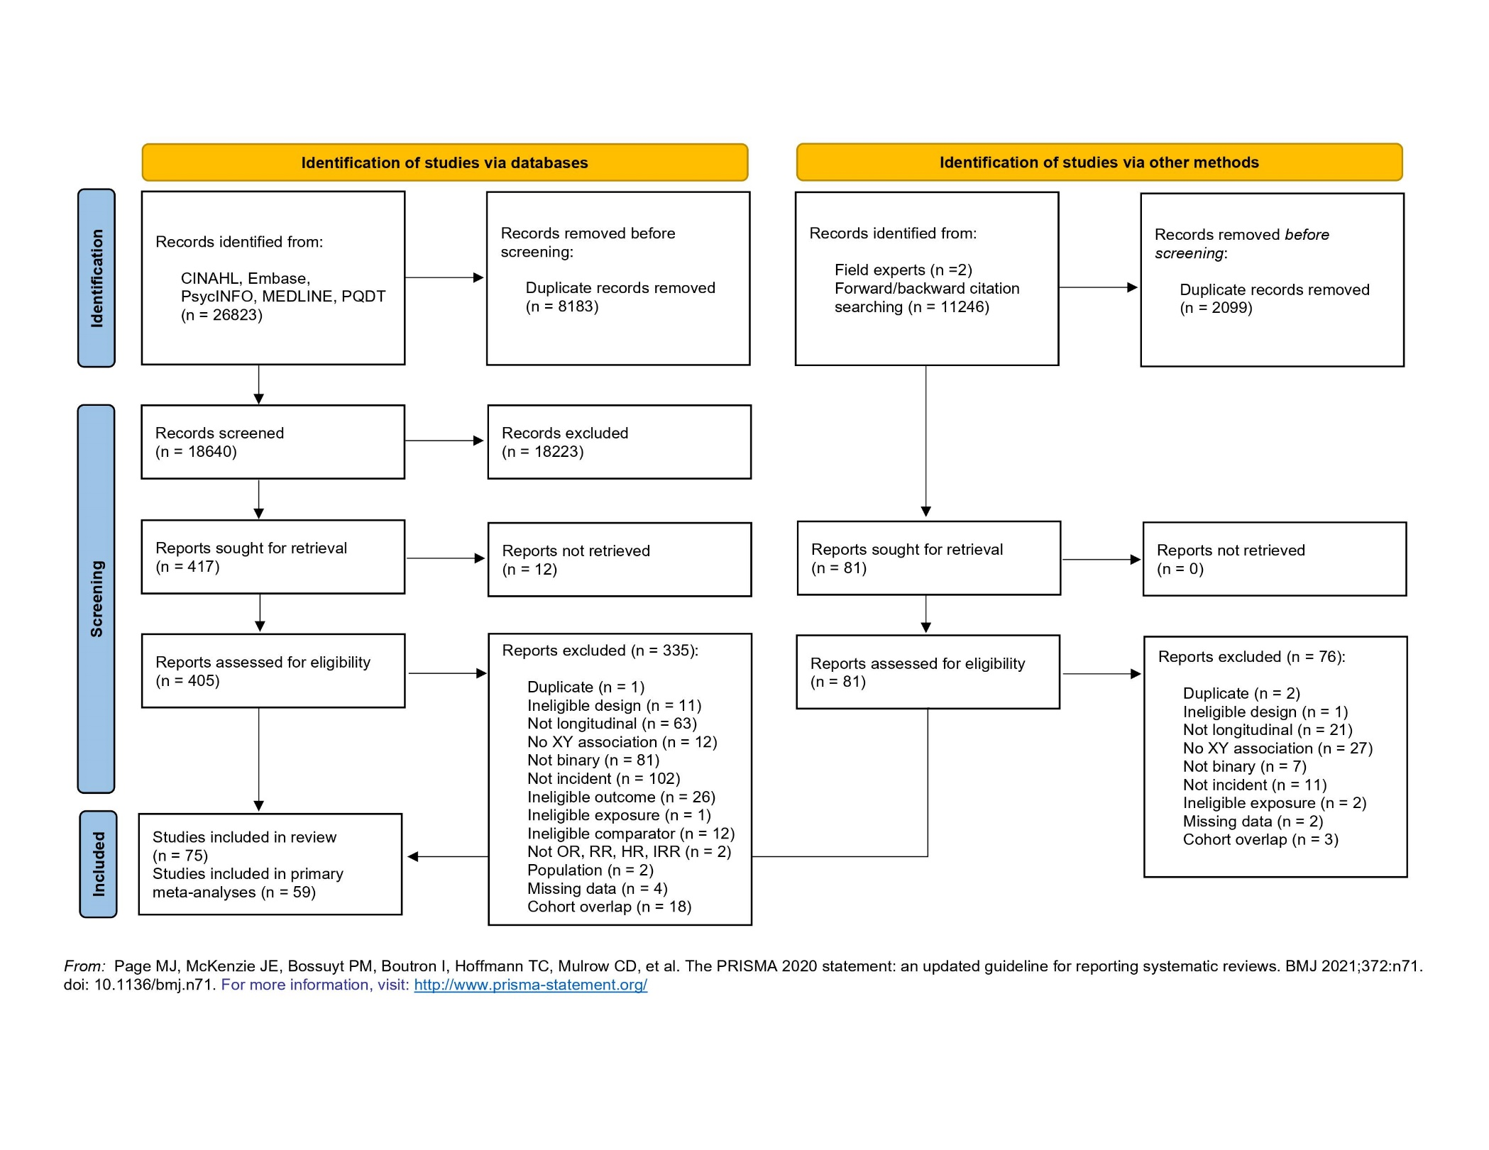
eFigure 2. Unadjusted meta-analysis of tobacco use and mood disorders
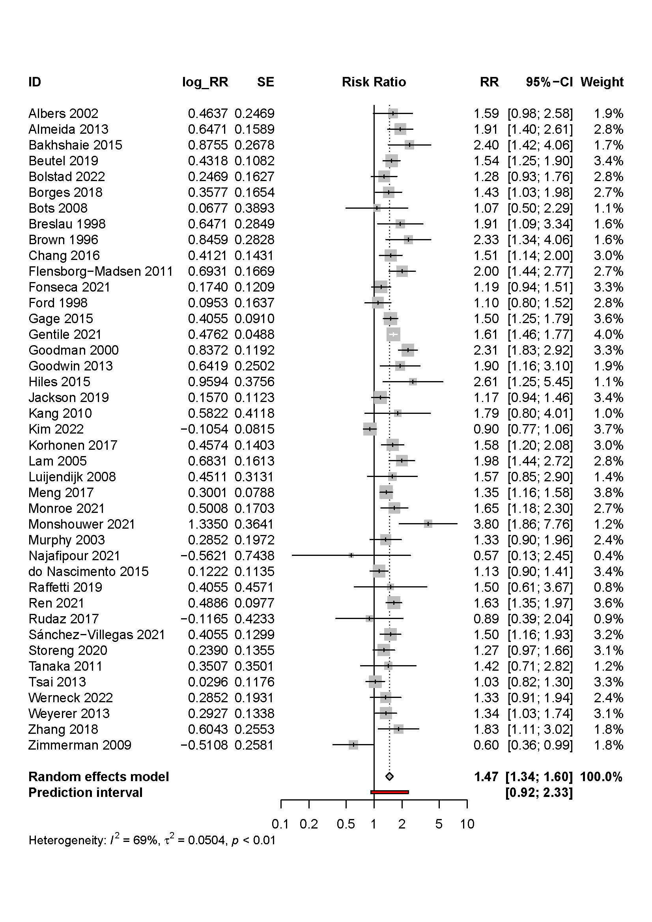

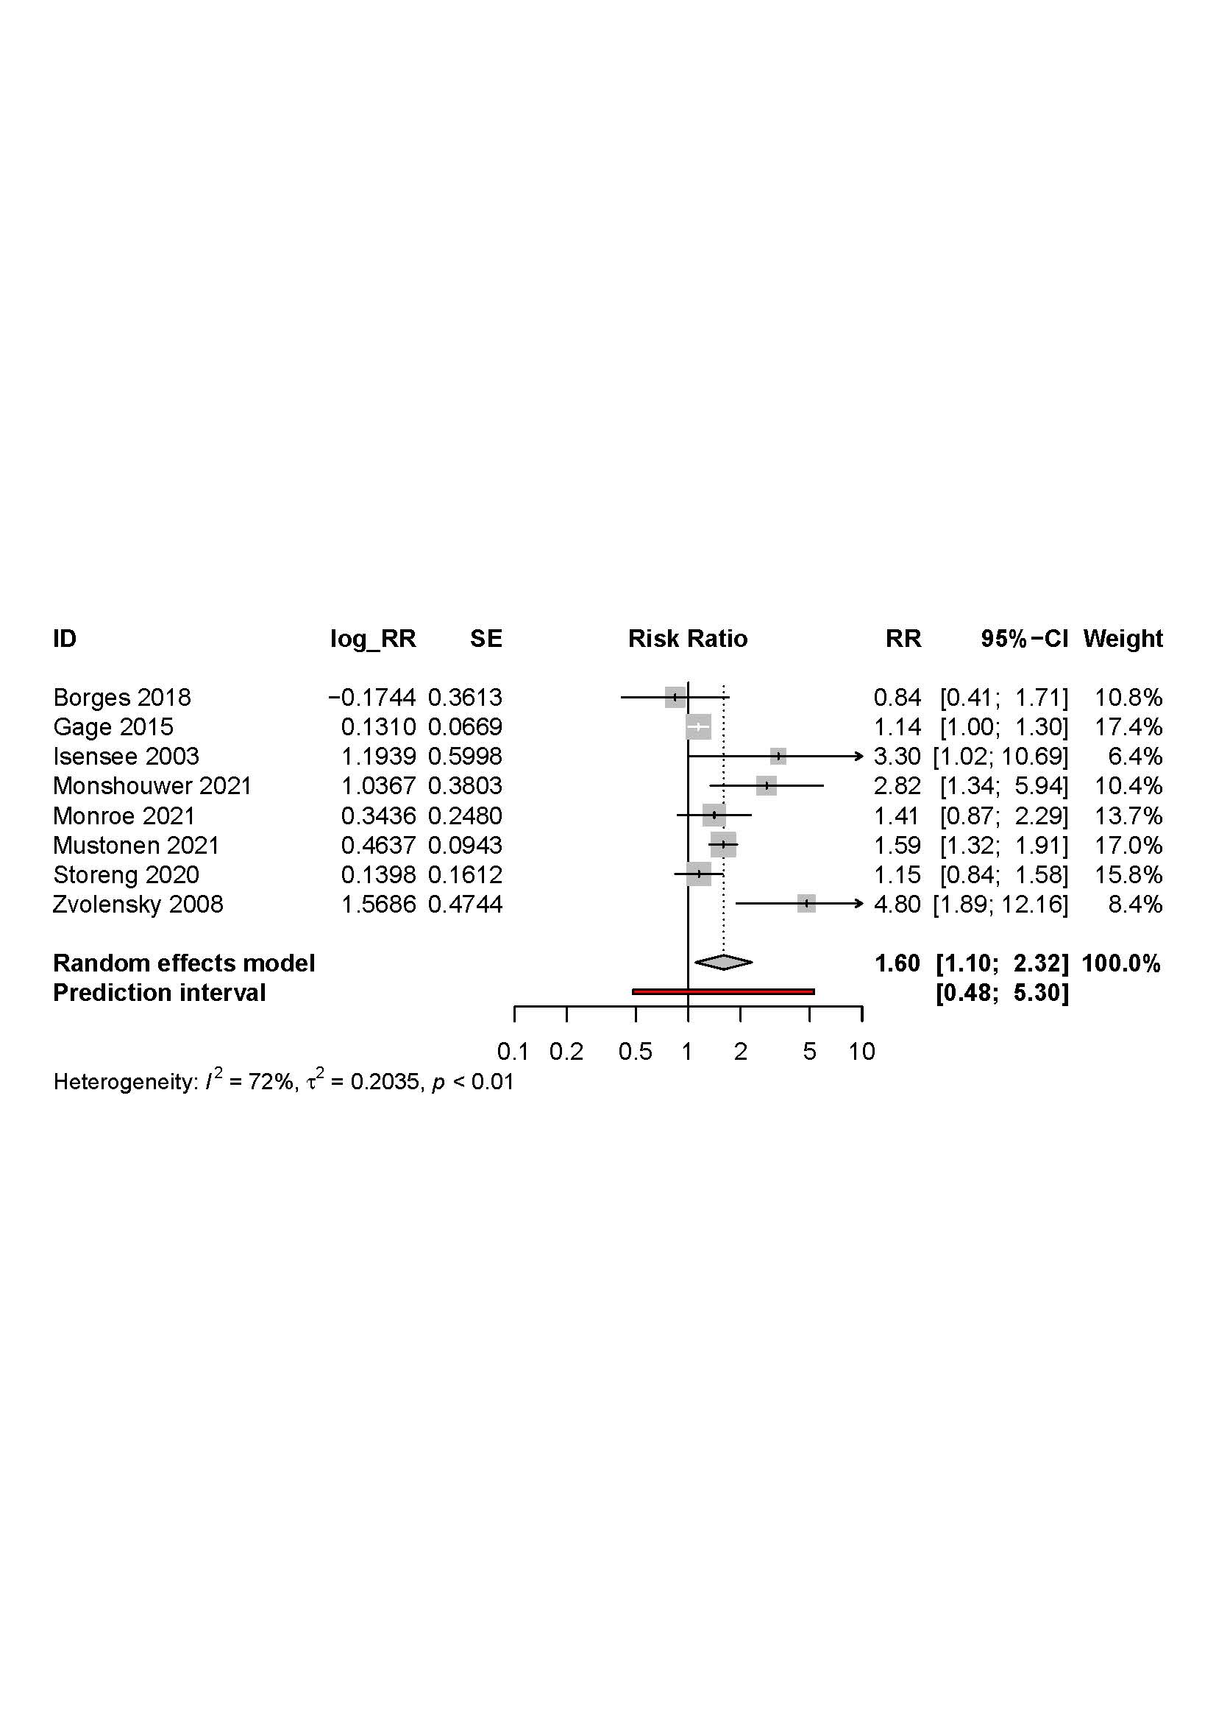
eFigure 3. Unadjusted meta-analysis of tobacco use and anxiety disorders

eFigure 4. Unadjusted meta-analysis of tobacco use and psychotic disorders

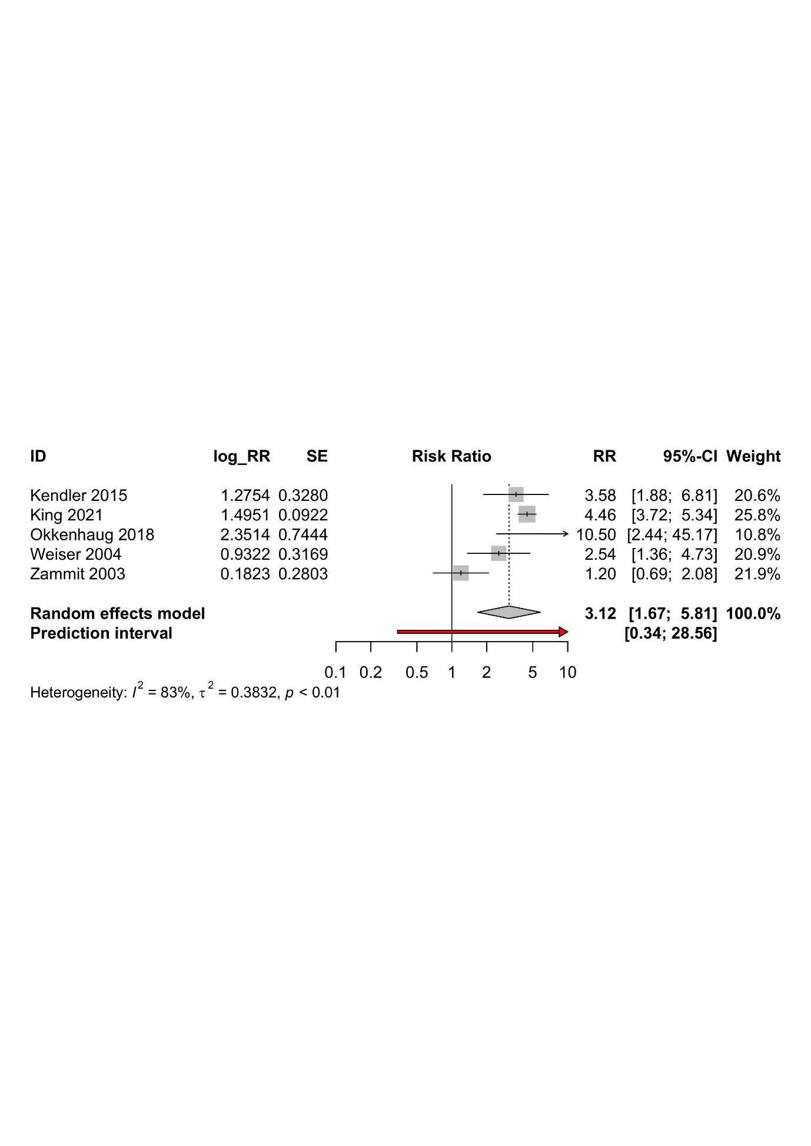

eFigure 5. Unadjusted meta-analysis of cannabis use and mood disorders

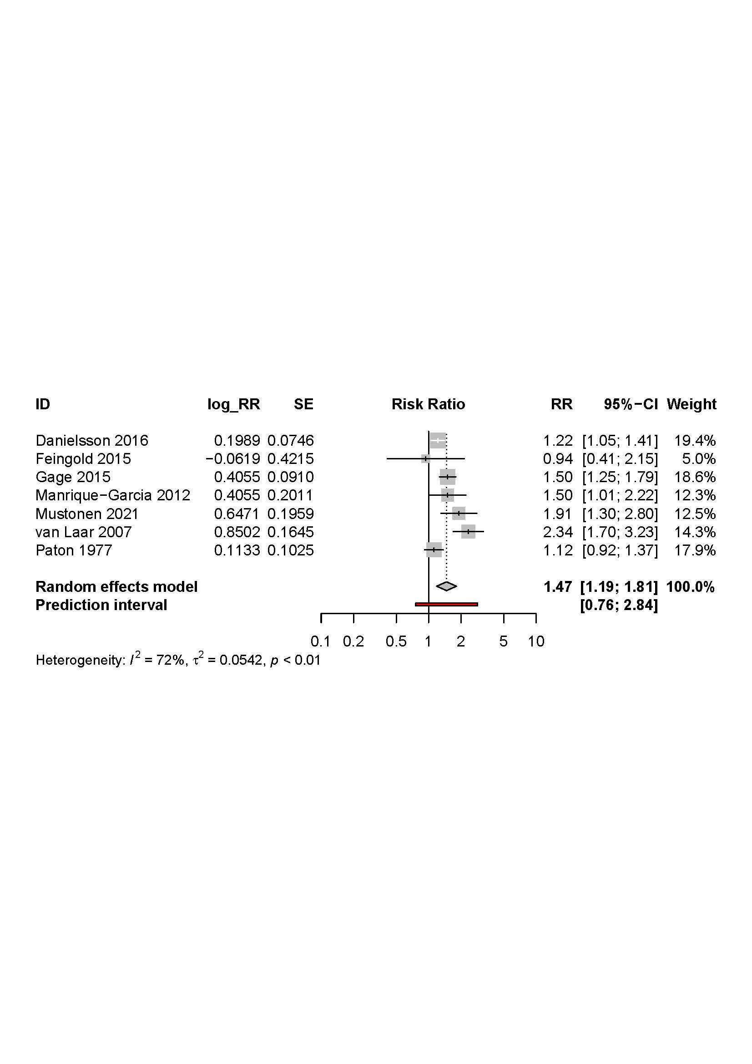

eFigure 6. Unadjusted meta-analysis of cannabis use and anxiety disorders

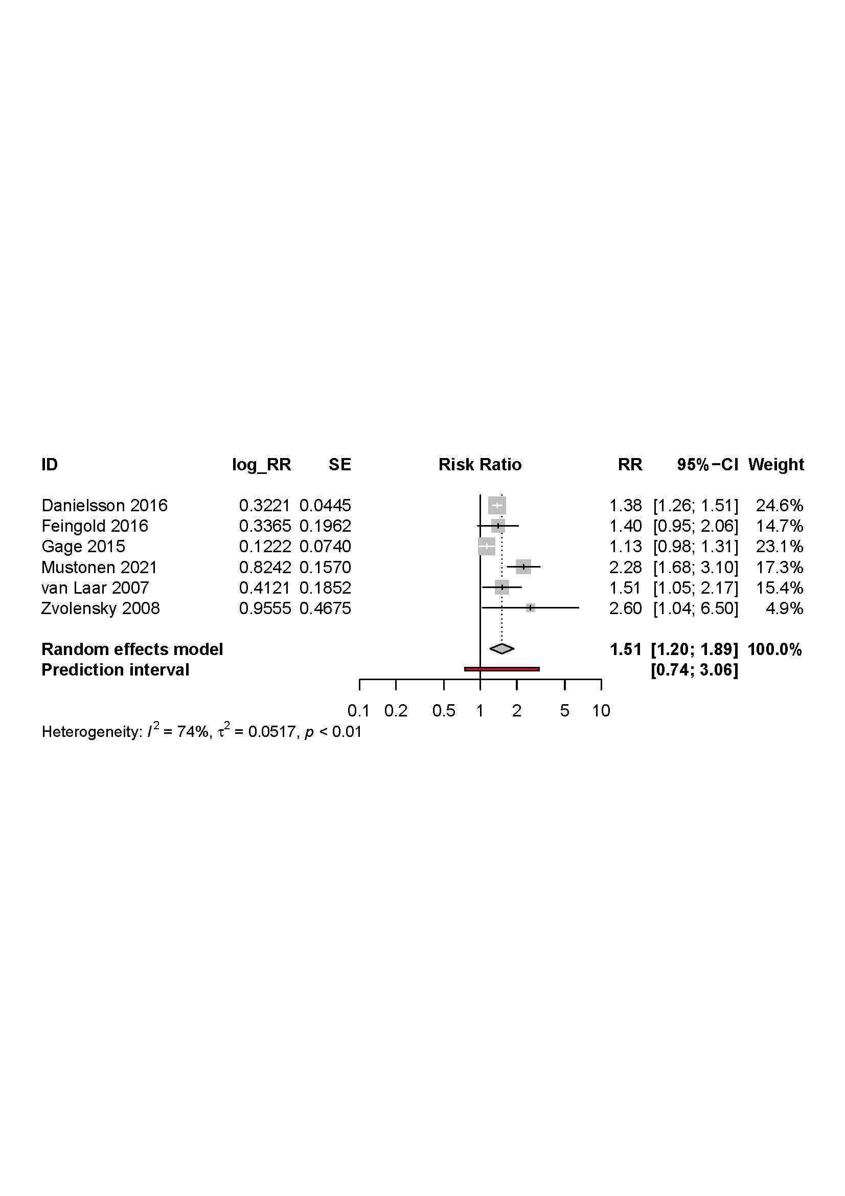

eFigure 7. Unadjusted meta-analysis of cannabis use and psychotic disorders

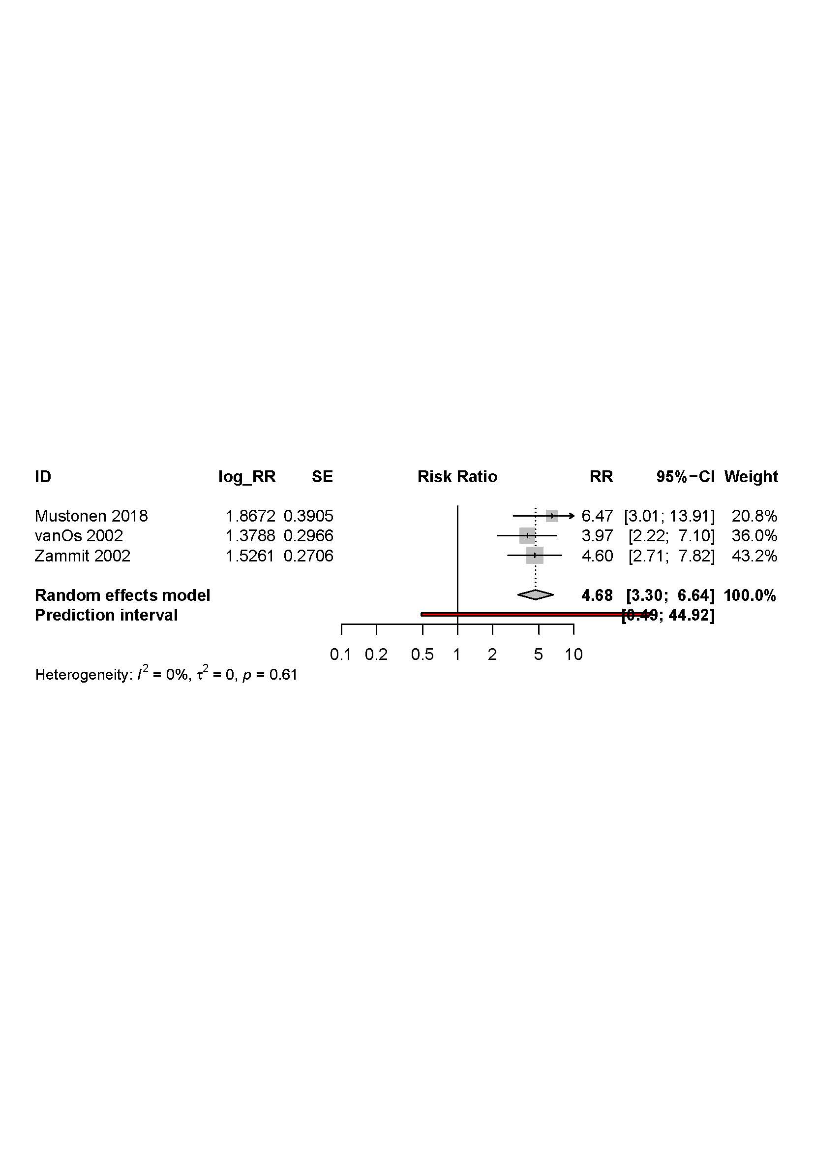

eFigure 8. Summary matrix for tobacco use and mood disorders

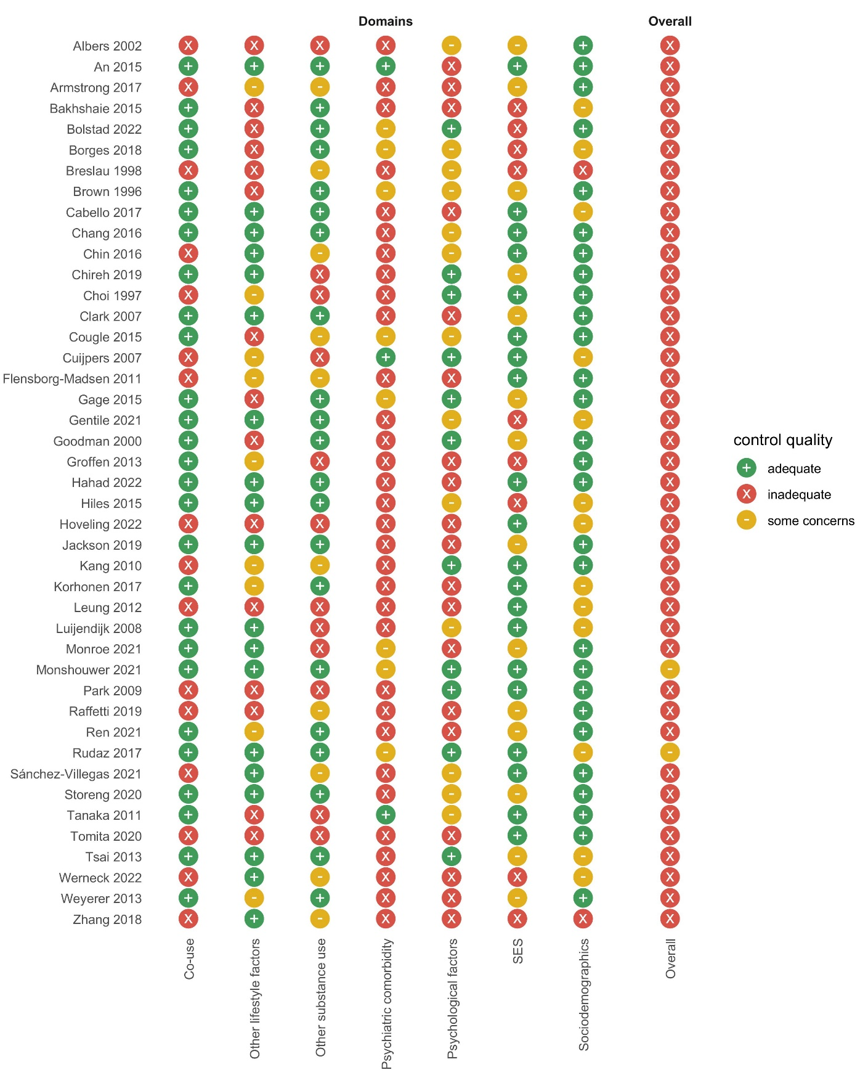

eFigure 9. Summary matrix for tobacco use and anxiety disorders

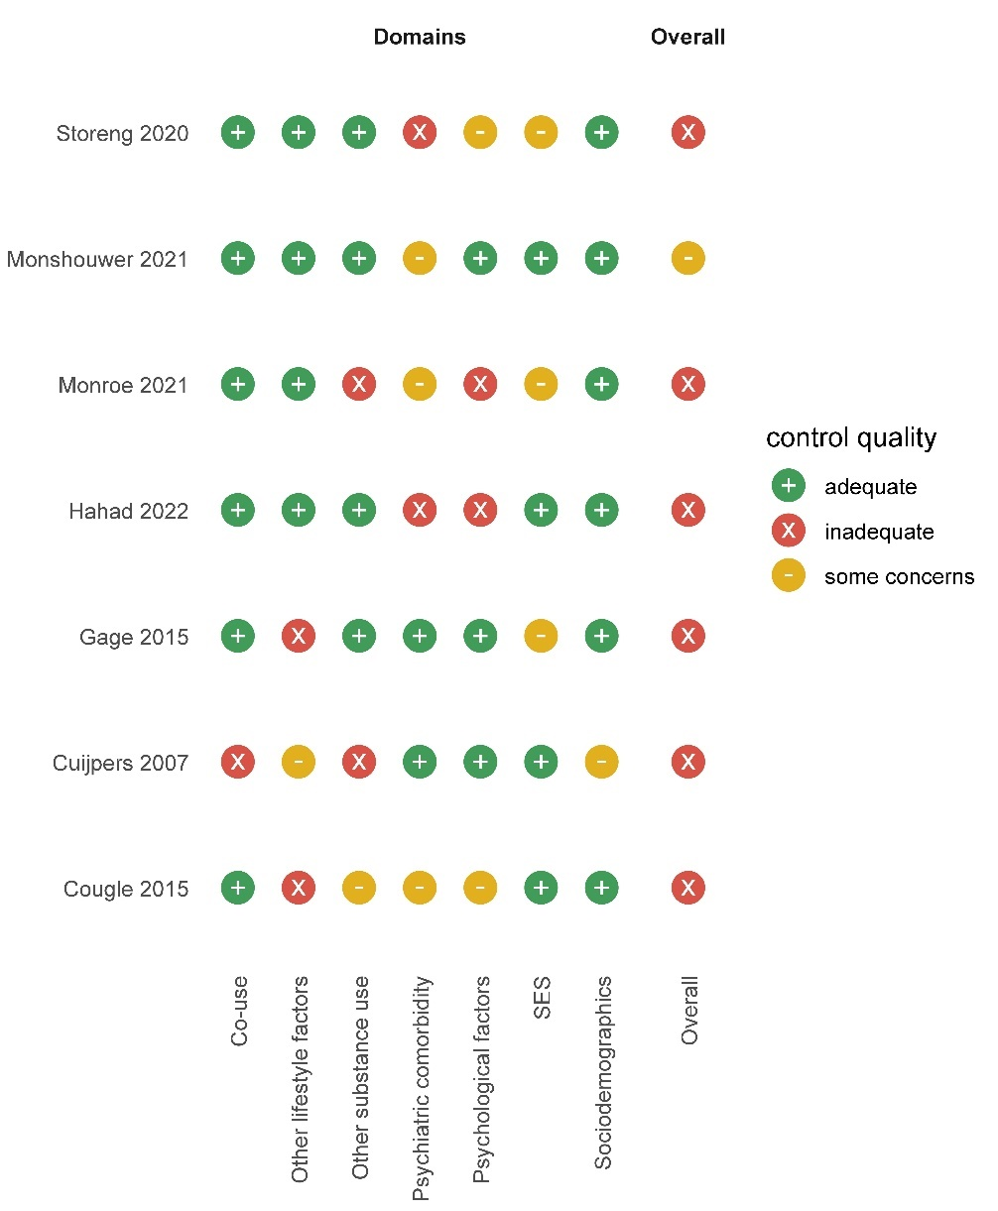

eFigure 10. Summary matrix for tobacco use and psychotic disorders

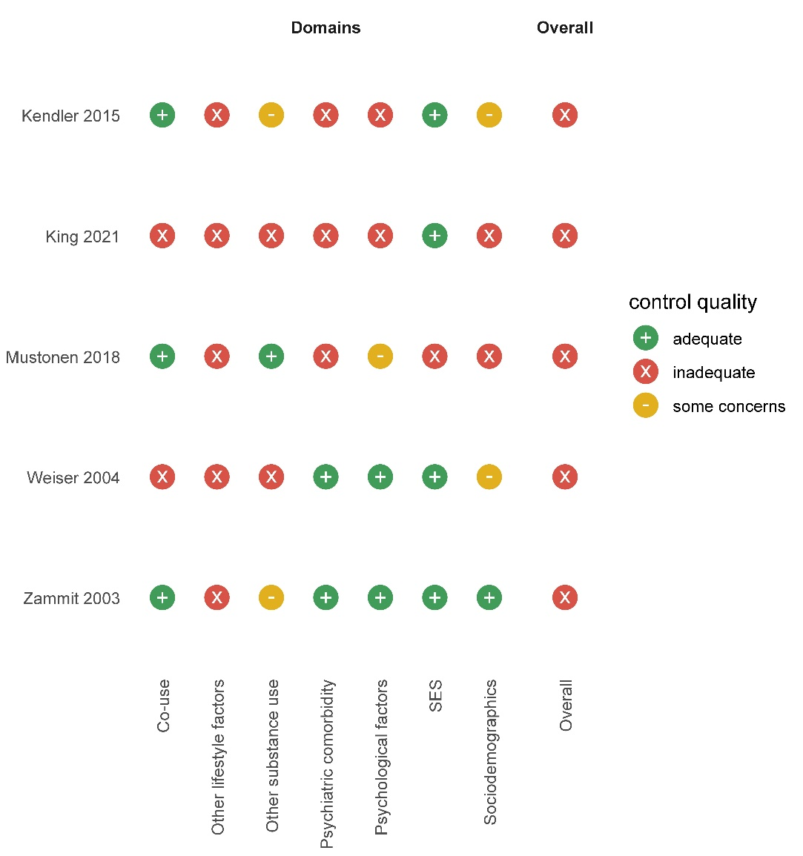

eFigure 11. Summary matrix for cannabis use and mood disorders

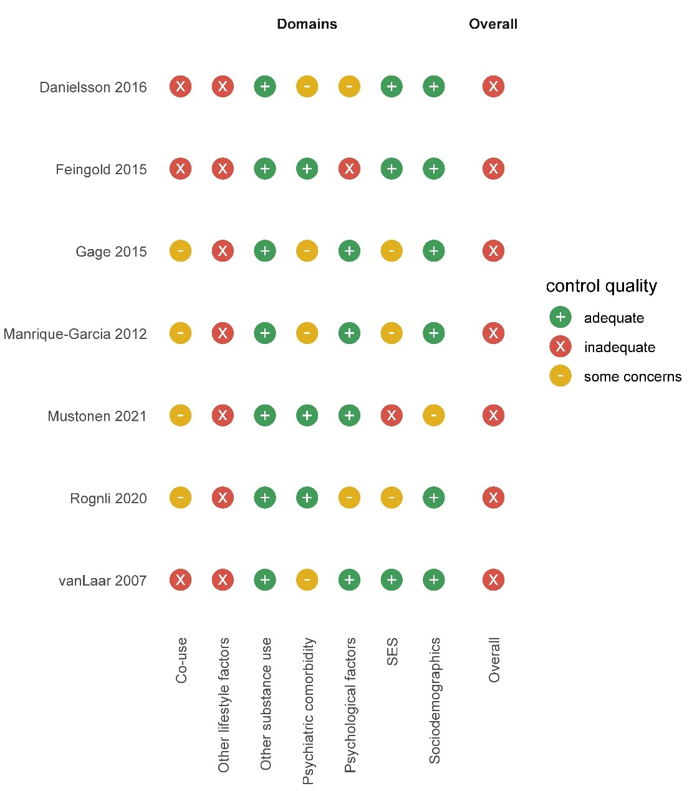

eFigure 12. Summary matrix for cannabis use and anxiety disorders

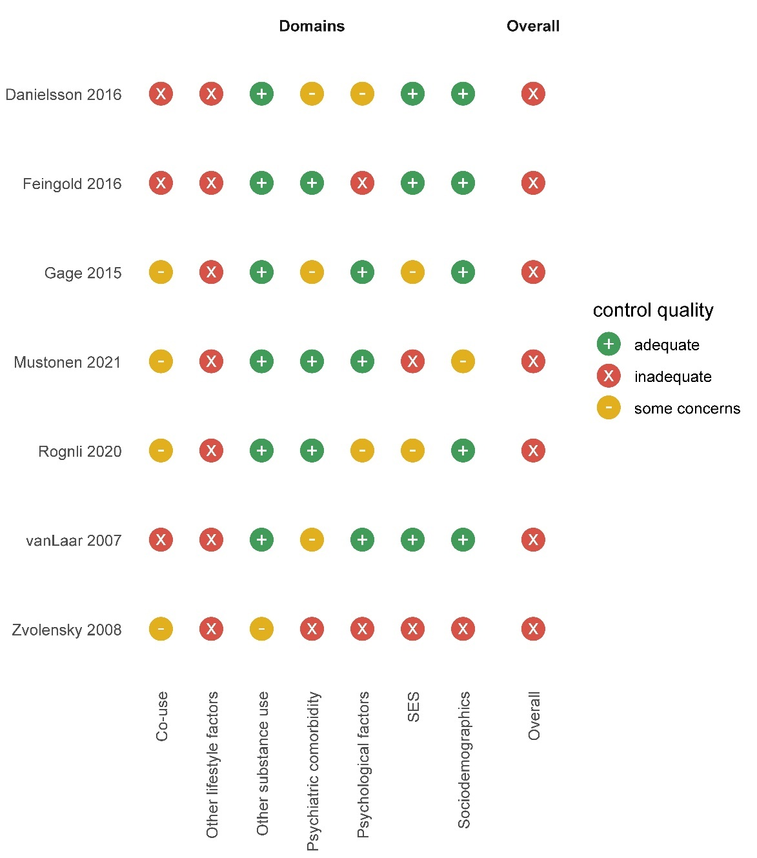

eFigure 13. Summary matrix for cannabis use and psychotic disorders

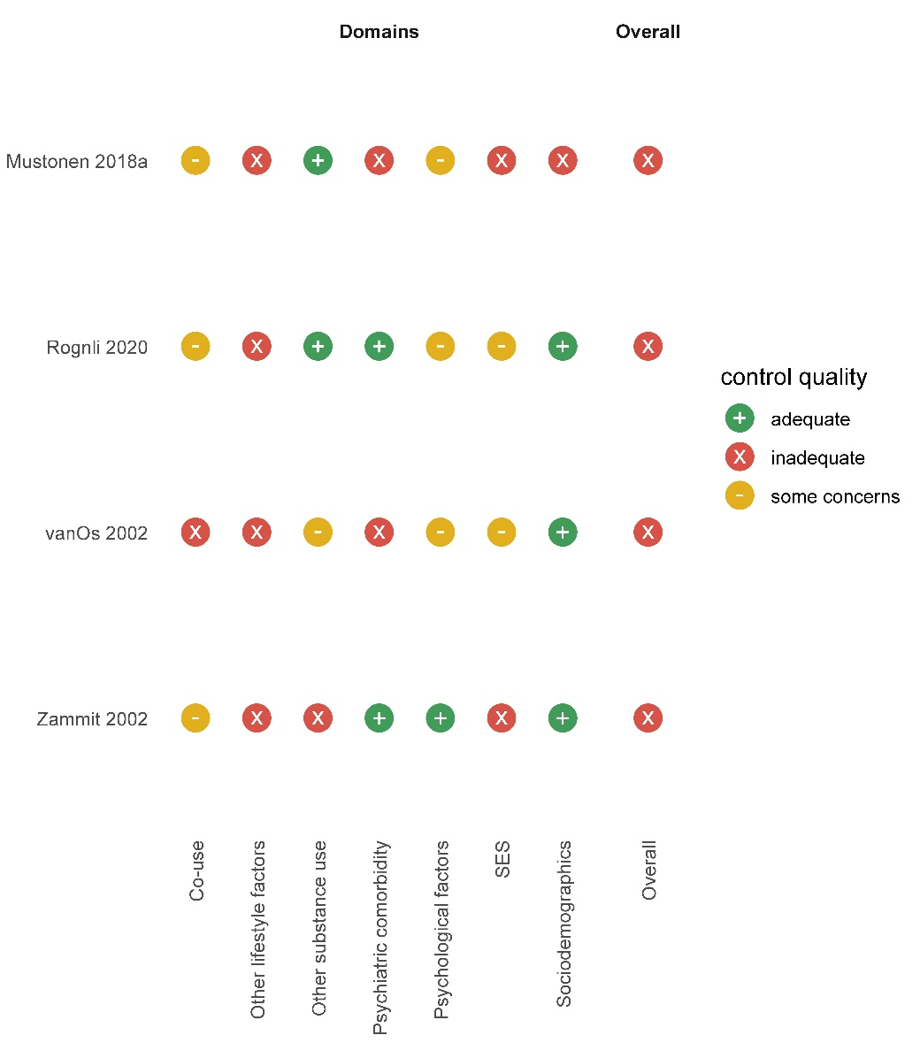

eFigure 14. Doi plot and LFK index for tobacco use and mood disorders
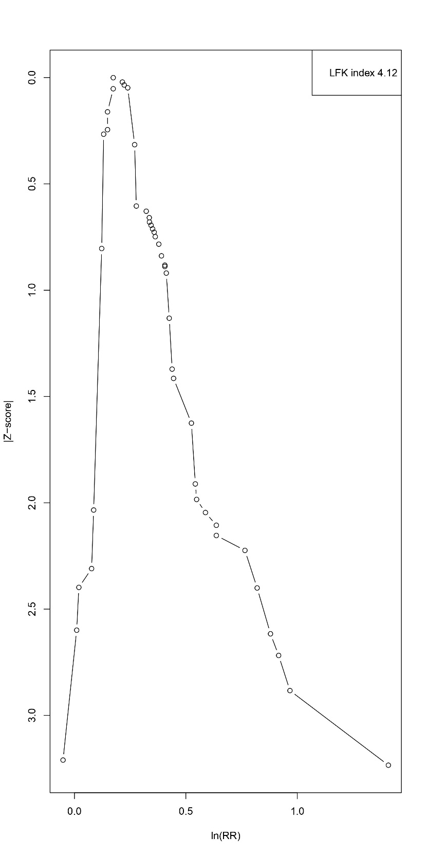

eFigure 15. Doi plot and LFK index for tobacco use and anxiety disorders
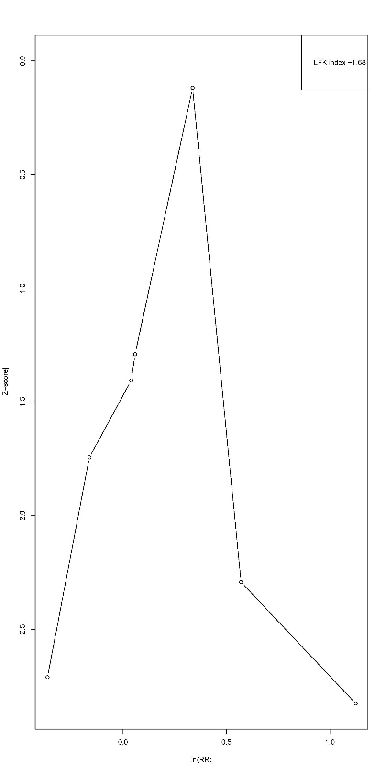

eFigure 16. Doi plot and LFK index for tobacco use and psychotic disorders
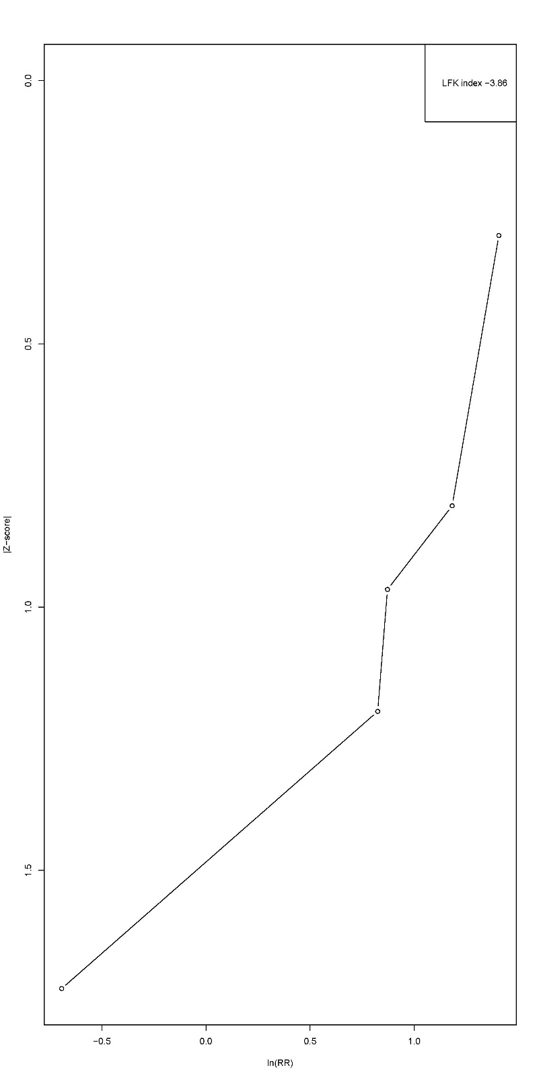

eFigure 17. Doi plot and LFK index for cannabis use and mood disorders
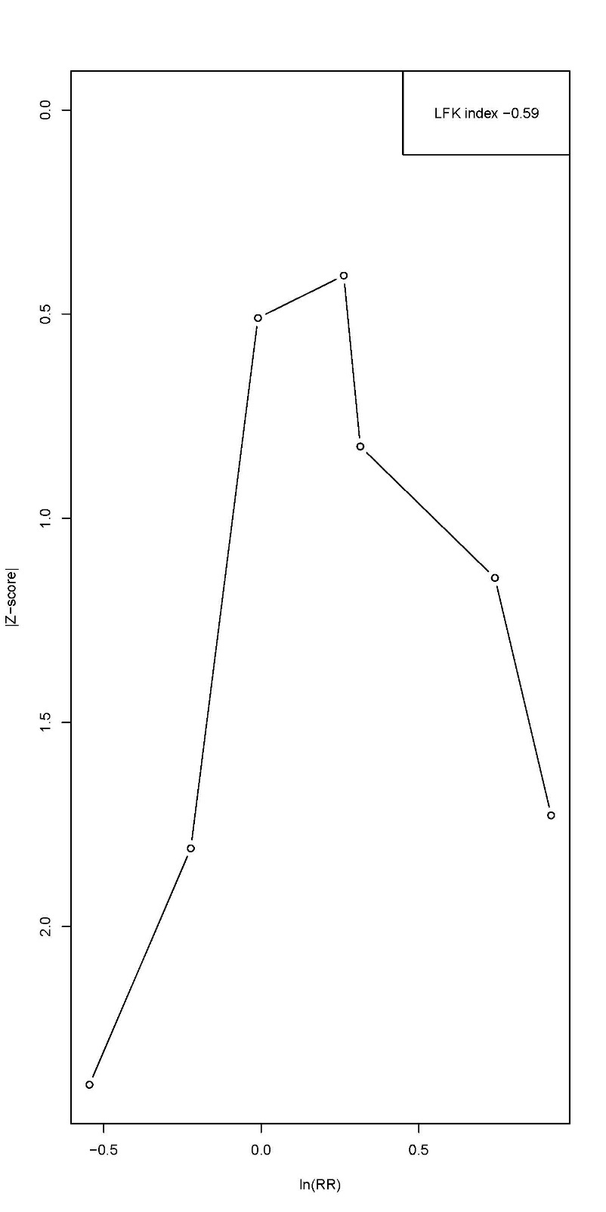

eFigure 18. Doi plot and LFK index for cannabis use and anxiety disorders
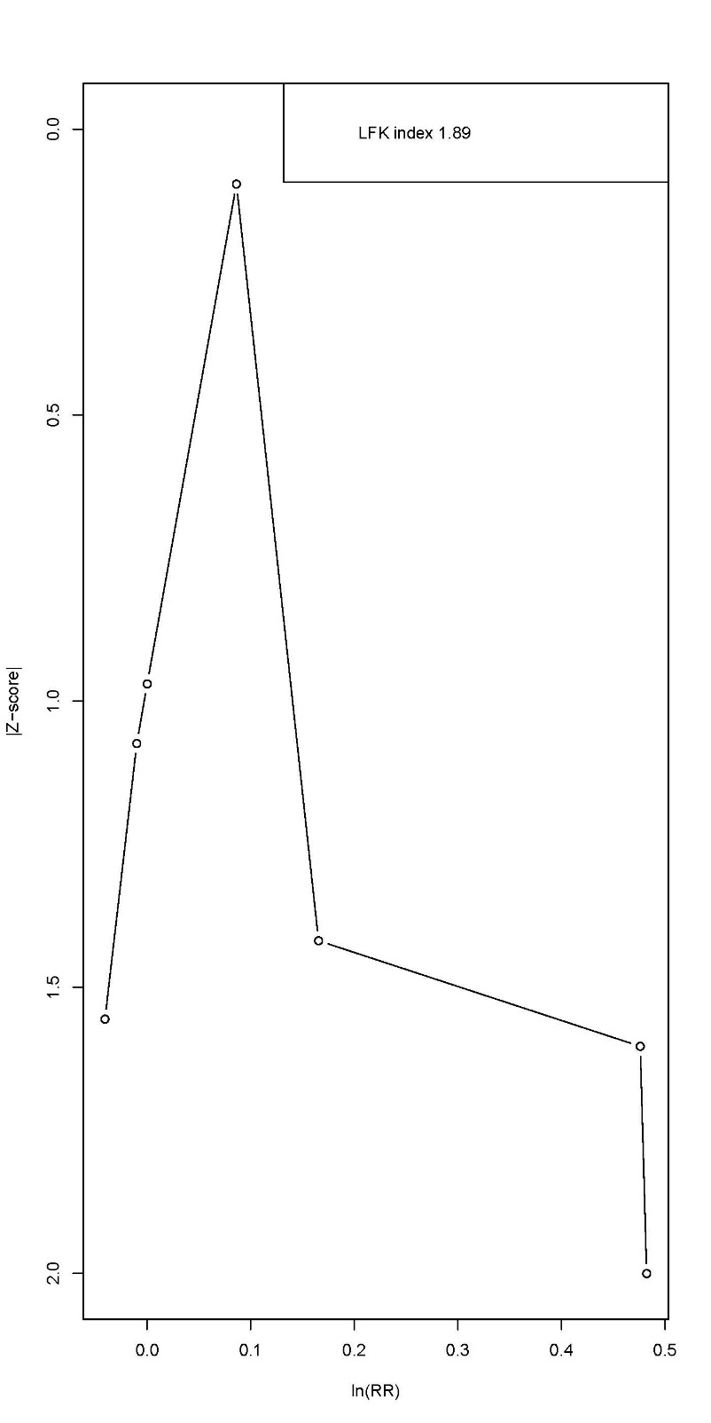

eFigure 19. Doi plot and LFK index for cannabis use and psychotic disorders
