SUPPLEMENTARY MATERIALS: Across the multiverse: Exploring a diverse set of specifications related to cross-sectional and prospective associations between adolescent alcohol use and emotional problems
Halladay, Visontay, Slade, Devine, Smout, Andrews, Champion, Teesson, Sunderland

Figure 4.A Volcano Plot Multiverse A

Figure 4.B Volcano Plot Multiverse B
Extended Data
Figure 4.A Volcano Plots for Multiverse A
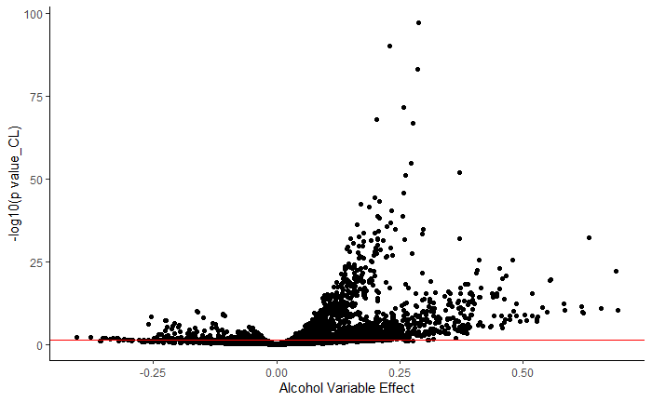
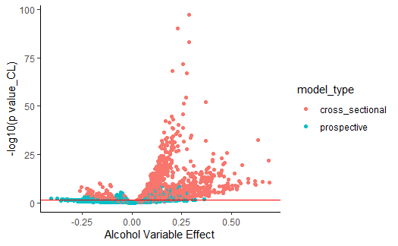

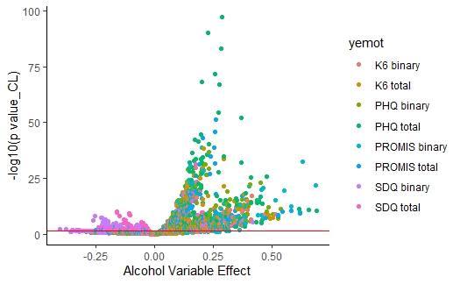
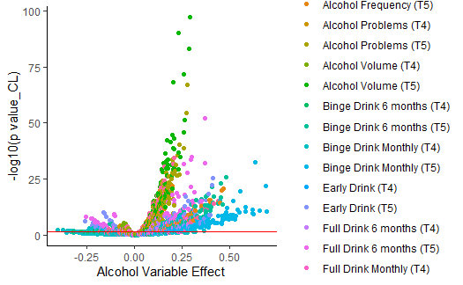
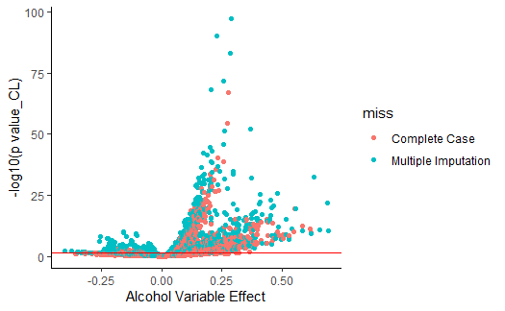
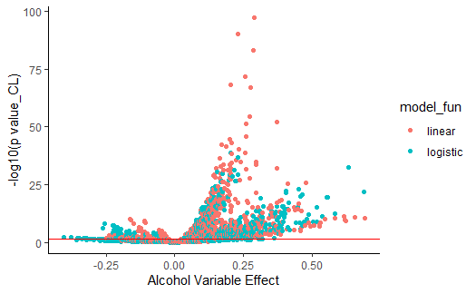
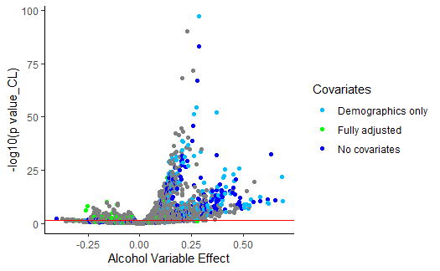
*note, the light grey dots are the models with other sets of confounder adjustments
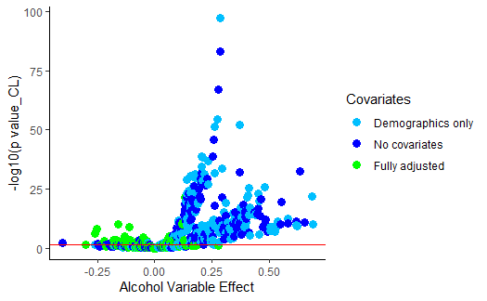
Figure 4.B Volcano Plot Multiverse B

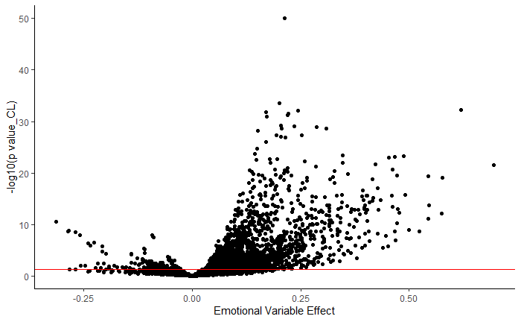
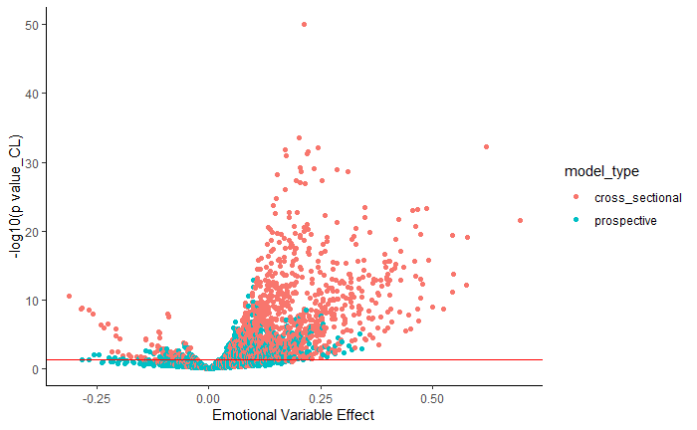
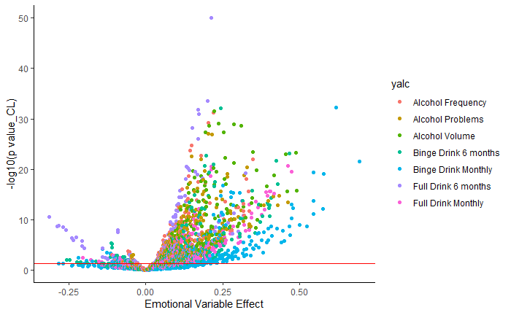
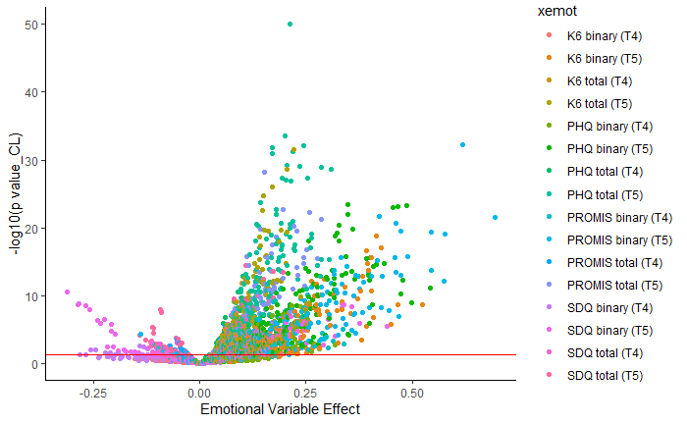
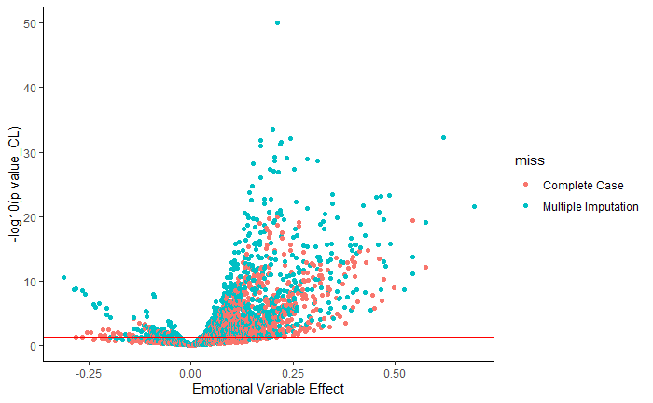
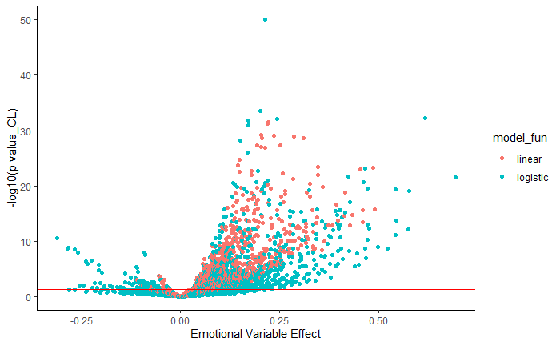
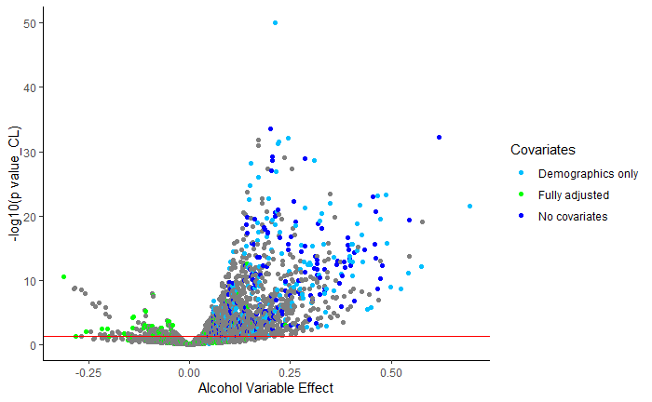
*note, the light grey dots are the models with other sets of confounder adjustments
