**Supplementary Methods**

**Table 1.** Demographic details of the sample

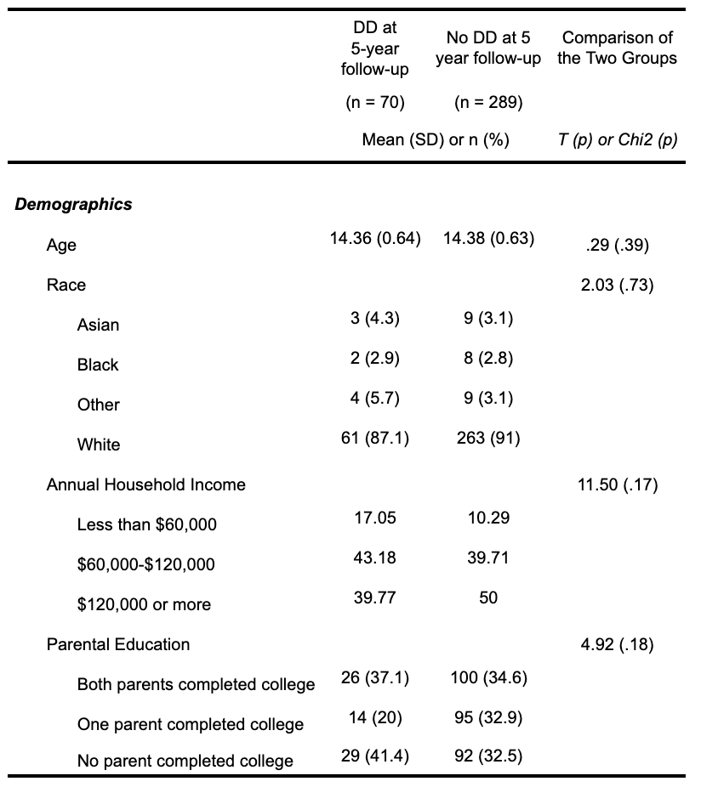

**Supplementary Results**

**Table 2.** Bivariate associations between baseline predictor measures established by Michelini et al. (2021) and DD at 3-year follow-up

