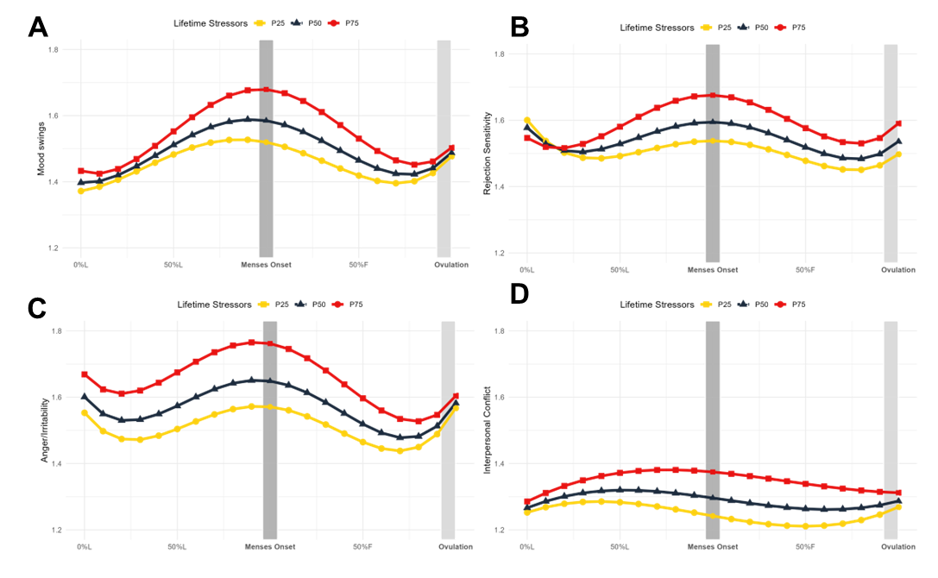
Figure 3. Lifetime stressors predict mood swings, rejection sensitivity, anger and irritability, and interpersonal conflict trajectories across the menstrual cycle. Model-implied values of symptom trajectories across the menstrual cycle by number of lifetime stressors where squares represent more 75th percentile of number of stressors in the sample (34 stressors) (P75), triangles represent 50th percentile (23 stressors) (P50), and circles represent 25th percentile (15 stressors) (P25). L = luteal phase; F = follicular phase. A) Daily mood swings (rated from 1= “Not at All” to 6=” Extremely”) across the menstrual cycle are predicted by number of lifetime stressors. Significance (p < .05) in the interaction between menstrual cycle time and stressors at > 13 stressors (outside Johnson-Neyman interval [-98.05, 12.61]). B) Daily rejection sensitivity (rated from 1= “Not at All” to 6=” Extremely”) across the menstrual cycle are predicted by number of lifetime stressors. Marginal significance (p = 0.079) in the interaction between lifetime stressors and menstrual cycle time at $>22$ stressors (inside Johnson-Neyman interval [22.40, 731.81]). C) Daily anger and irritability (rated from 1= “Not at All” to 6=” Extremely”) across the menstrual cycle are predicted by number of lifetime stressors. Significance (p < .05) in the interaction between menstrual cycle time and stressors at > 18 stressors (outside Johnson-Neyman interval [-455.46, 18.05]). D) Daily interpersonal conflict (rated from 1= “Not at All” to 6=” Extremely”) across the menstrual cycle are predicted by number of lifetime stressors. Significance (p < .05) in the interaction between menstrual cycle time and stressors at > 31 stressors (outside Johnson-Neyman interval [1.84, 31.00]).

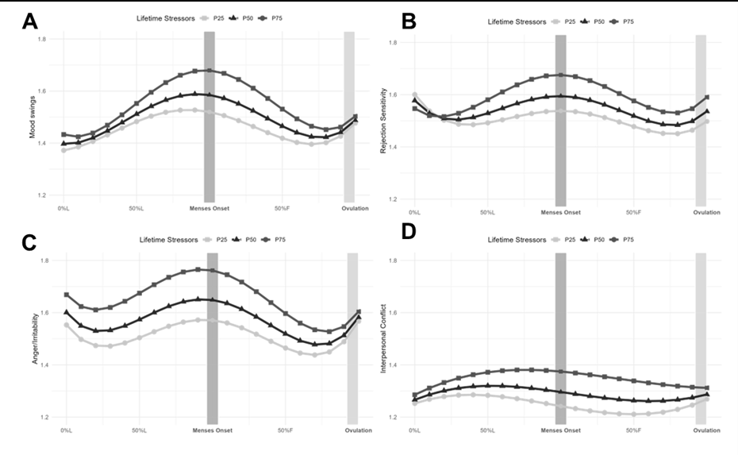
Figure 3. Lifetime stressors predict mood swings, rejection sensitivity, anger and irritability, and interpersonal conflict trajectories across the menstrual cycle. Model-implied values of symptom trajectories across the menstrual cycle by number of lifetime stressors where squares represent more 75th percentile of number of stressors in the sample (34 stressors)(P75), triangles represent 50th percentile (23 stressors)(P50), and circles represent 25th percentile (15 stressors)(P25). L = luteal phase; F = follicular phase. A) Daily mood swings (rated from 1= “Not at All” to 6=” Extremely”) across the menstrual cycle are predicted by number of lifetime stressors. Significance (p < .05) in the interaction between menstrual cycle time and stressors at > 13 stressors (outside Johnson-Neyman interval [-98.05, 12.61]). B) Daily rejection sensitivity (rated from 1= “Not at All” to 6=” Extremely”) across the menstrual cycle are predicted by number of lifetime stressors. Marginal significance (p = 0.079) in the interaction between lifetime stressors and menstrual cycle time at $>22$ stressors (inside Johnson-Neyman interval [22.40, 731.81]). C) Daily anger and irritability (rated from 1= “Not at All” to 6=” Extremely”) across the menstrual cycle are predicted by number of lifetime stressors. Significance (p < .05) in the interaction between menstrual cycle time and stressors at > 18 stressors (outside Johnson-Neyman interval [-455.46, 18.05]). D) Daily interpersonal conflict (rated from 1= “Not at All” to 6=” Extremely”) across the menstrual cycle are predicted by number of lifetime stressors. Significance (p < .05) in the interaction between menstrual cycle time and stressors at > 31 stressors (outside Johnson-Neyman interval [1.84, 31.00]).

