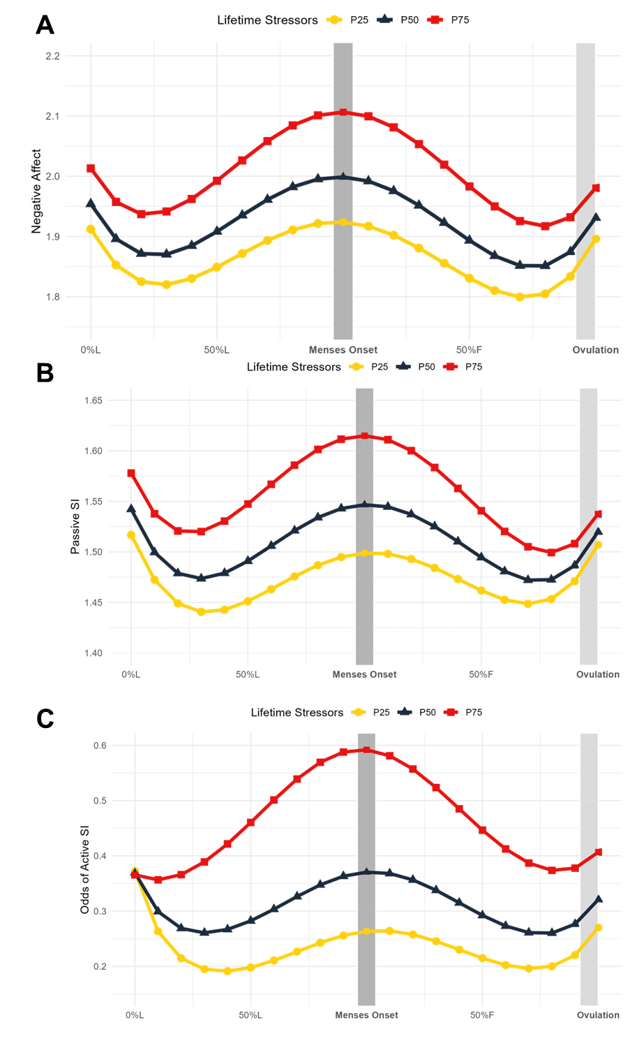
Figure 1. Lifetime stressors predict symptom trajectories across the menstrual cycle. Model-implied values of symptom trajectories across the menstrual cycle by number of lifetime stressors where squares represent more 75th percentile of number of stressors in the sample (34 stressors) (P75), triangles represent 50th percentile (23 stressors) (P50), and circles represent 25th percentile (15 stressors) (P25). L = luteal phase; F = follicular phase. A) Daily negative affect is a daily mean score of the core emotional symptoms of the Daily Record of Severity of Problems (rated from 1= “Not at All” to 6=” Extremely”). Marginal significance (p = .072) in the interaction between lifetime stressors and menstrual cycle time at > 15 stressors (outside Johnson-Neyman interval [-18143.50, 15.65]) B) Daily passive SI is a daily mean score of items 1, 9, and 19 of the Adult Suicidal Ideation Questionnaire, as well as “I wished I could go to sleep and not wake up” (rated from 1 (not at all) to 5 (extremely)). Marginal significance (p = 0.076) in the interaction between lifetime stressors and menstrual cycle time at $>22$ stressors (outside Johnson-Neyman interval [-12632.59, 22.52]). C) Active SI items included items 2, 17, and 25 of the Adult Suicidal Ideation Questionnaire, as well as “I wanted to kill myself”. On days when the participant rated any of the above active SI items greater than a 1 (not at all), that day was assigned a value of 0 for active SI; otherwise, they were assigned a value of 1. Odds of active SI were predicted by the number of lifetime stressors. Significance ( p < .05) in the interaction between lifetime stressors and menstrual cycle time at > 26 stressors (of outside Johnson-Neyman interval [-82.21, 26.01])

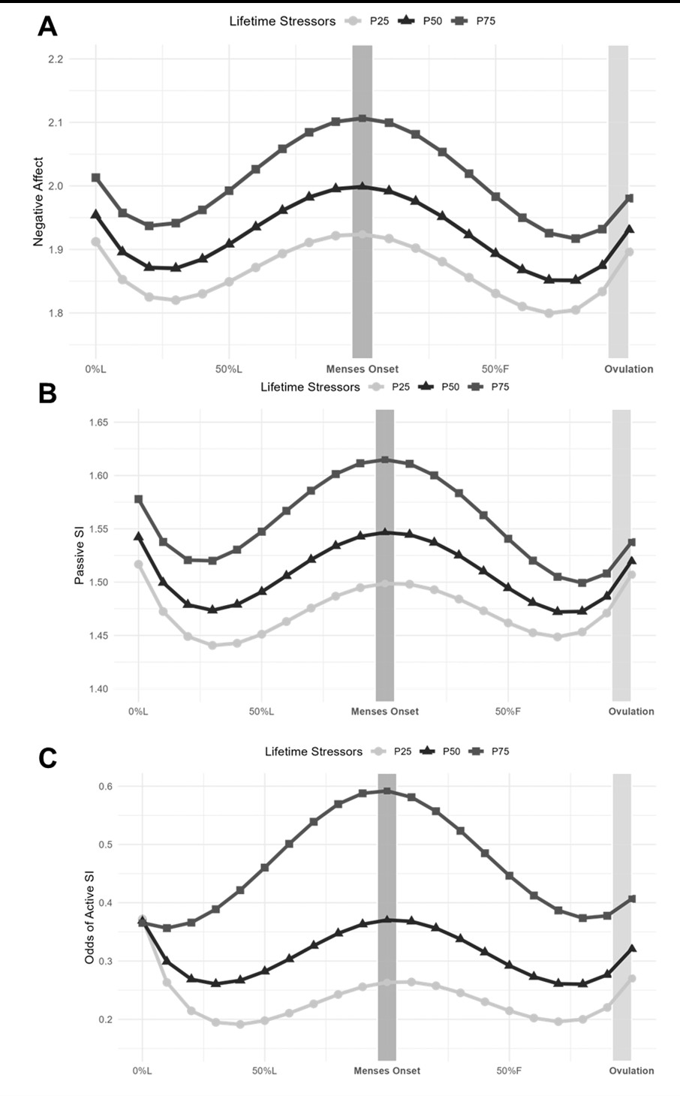
Figure 1. Lifetime stressors predict symptom trajectories across the menstrual cycle. Model-implied values of symptom trajectories across the menstrual cycle by number of lifetime stressors where squares represent more 75th percentile of number of stressors in the sample (34 stressors) (P75), triangles represent 50th percentile (23 stressors) (P50), and circles represent 25th percentile (15 stressors) (P25). L = luteal phase; F = follicular phase. A) Daily negative affect is a daily mean score of the core emotional symptoms of the Daily Record of Severity of Problems (rated from 1= “Not at All” to 6=” Extremely”). Marginal significance (p = .072) in the interaction between lifetime stressors and menstrual cycle time at > 15 stressors (outside Johnson-Neyman interval [-18143.50, 15.65]) B) Daily passive SI is a daily mean score of items 1, 9, and 19 of the Adult Suicidal Ideation Questionnaire, as well as “I wished I could go to sleep and not wake up” (rated from 1 (not at all) to 5 (extremely)). Marginal significance (p = 0.076) in the interaction between lifetime stressors and menstrual cycle time at $>22$ stressors (outside Johnson-Neyman interval [-12632.59, 22.52]). C) Active SI items included items 2, 17, and 25 of the Adult Suicidal Ideation Questionnaire, as well as “I wanted to kill myself”. On days when the participant rated any of the above active SI items greater than a 1 (not at all), that day was assigned a value of 0 for active SI; otherwise, they were assigned a value of 1. Odds of active SI were predicted by the number of lifetime stressors. Significance ( p < .05) in the interaction between lifetime stressors and menstrual cycle time at > 26 stressors (of outside Johnson-Neyman interval [-82.21, 26.01])

