1 Supplementary Methods

1.1 Details of predictor variables
The 28 variables used in the prediction modelling are indicated with a *

1.1.1 Socio-demographic
- Age (in years)
- Sex at birth (all participants disclosing as Male or Female)
- Ethnicity (White, Asian, Black, Mixed or Other)
- Education (No qualifications, GCSE, A Levels, University or Higher)
- Employment status (Employed, Student, Unemployed, Long term sick)
- Income (£0-£5,475, £5,476-£12,097, £12,098-£20,753, £20,754-£31,494, £31,495 or more)
- Relationship status (Single or Divorced, In a relationship, Married, Other)

1.1.2 Clinical status
- Age of patient of the first onset of psychiatric symptoms (in years, date of current episode onset - date of birth)
- Duration of the current episode (in months)
- Current anti-depressant use (Yes or No)
- Depression Severity (Patient Health Questionnaire, PHQ 9)
- Anxiety Disorder (Generalized Anxiety Disorder, GAD 7)
- Diagnoses selected from the MINI diagnostic interview (Sheehan et al., 1998) not covered by PHQ-9 or GAD-7:
  - Bipolar Status (Unipolar or Bipolar)
  - Social phobia (Yes or No)
  - Panic Disorder (Yes or No)
  - Agoraphobia (Yes or No)
  - Obsessive Compulsive Disorder, OCD (Yes or No)
  - Post-traumatic stress disorder, PTSD (Yes or No)
  - Alcohol abuse (Yes or No)
  - Substance Abuse or Dependence (Yes or No)
  - Anorexia (Yes or No)
  - Bulimia (Yes or No)
- Personality disorder traits (Standardised Assessment of Personality – Abbreviated Scale, SAPAS, Moran et al., 2003)
- Physical health using the Cumulative Illness Rating Scale (Linn et al., 1968, CIRS)

1.1.3 Psycho-social status and history
- Current beliefs about mental illness by the total score of the Brief Illness Perceptions questionnaire, (α, B-IPQ, (Broadbent et al., 2006)
- Self-criticism, Forms of Self Reassurance and Self Criticism scale (Gilbert et al., 2004, FSRC)
  - The FSRC has 3 subscales, but a confirmatory factor analysis (CFA) showed that self-inadequacy and self-hatred could be combined into one ‘negative cognitions’ measure. The self-reassurance dimension was the other subscale. Items were summed by these two dimensions.
- Self-efficacy by the sum score of the general self-efficacy scale (Schwarzer & Jerusalem, 1995)
- Quality of life was assessed using the EuroQol questionnaire (Herdman et al., 2011, EQ5D)
- The 5 domains (usual activities, anxiety and depression, mobility ratings) were converted into a single utility index using an algorithm weighted by country, ranging from – 0.285 (worse than being dead) to 1 (Devlin et al., 2018). For this analysis we excluded the additional visual analogue scale for conceptual and statistical overlap with the utility index (r = 0.58, 95% CI: 0.48, 0.64)
- Strength of social support was measured with the Oslo Social Support scale, OSS (Dalgard et al., 2006)
- The List of Threatening Events Questionnaire, LTE (Brugha et al., 1985)
  - A count of 12 stressful events over lifetime such as death and unemployment, used as a total score
- Childhood Trauma Questionnaire, CTQ (Bernstein et al., 2003)
  - This scale assesses five types of maltreatment: sexual abuse, physical abuse, emotional neglect, physical neglect, and emotional abuse. Here we used the total score.

1.1.4 Pre-processing of predictor variables
The details of the pre-processing of predictor variables is as follows. Several demographic variables had the number of categories reduced. The number of ethnicity categories was reduced to 2 (BME or white). The mainly white sample (78%) meant there were few participants in individual non-white categories by outcome condition. Similarly, education was re-categorised according to level of qualification (none, school, and university) and employment was reduced to 3 categories: employed (including students and homemakers), unemployed and long-term sick, the latter identified as a particularly vulnerable category. All variables were standardised to mean 0 and 1 to allow evaluation of relevance and facilitate model computation (Gelman et al., 2020). All continuous variables were checked for non-linear relationships with outcome variables via spike histograms (binary) and loess smooths (continuous), none of which showed significant deviation from linearity.

2 Supplementary Results

2.1 Missing data
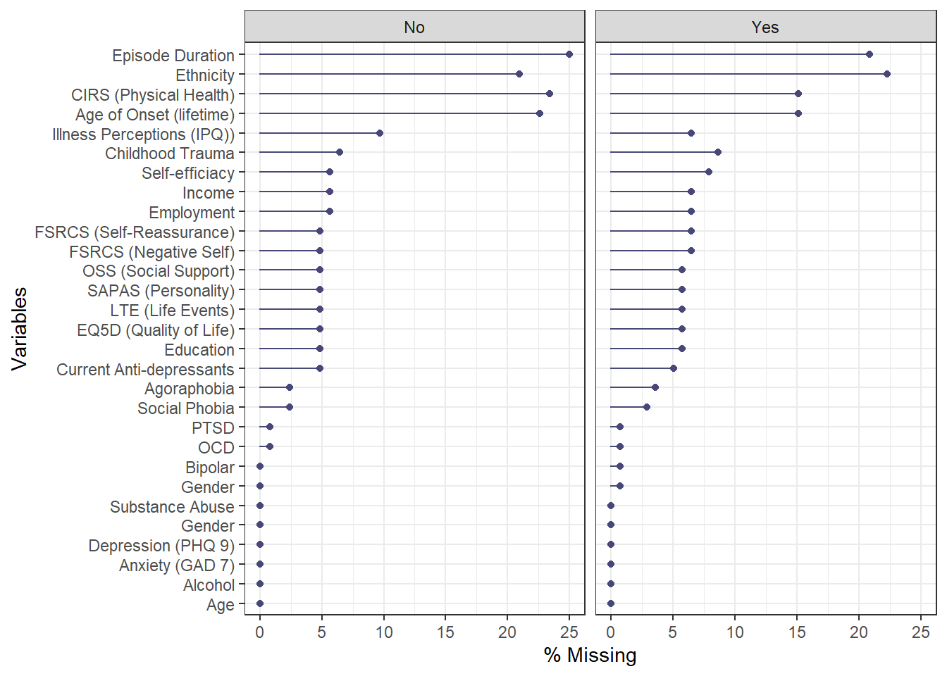
Figure 1: Percentage missing data by variable and recovery outcome
Overall, rates of missingness were relatively high ( > 20%) for 4 variables, duration of current illness episode, age of illness onset, ethnicity and physical health (CIRS).

2.2 Reference models and variable selection

2.2.1 IAPT Recovery
Table 1: Model coefficients for reference model including median odds ratio, 95 CI, Rhat and effective sample size (ESS) of posterior distribution.
Parameter | Median | CI | CI_low | CI_high | Rhat | ESS
(Intercept) | 1.18 | 0.95 | 0.88 | 1.60 | 1.000 | 10853
age | 1.01 | 0.95 | 0.95 | 1.41 | 1.000 | 6038
sex | 1.00 | 0.95 | 0.80 | 1.09 | 1.000 | 8004
bme | 1.00 | 0.95 | 0.71 | 1.15 | 1.000 | 7162
education | 1.00 | 0.95 | 0.89 | 1.14 | 1.000 | 8101
unemployed | 1.00 | 0.95 | 0.74 | 1.16 | 1.000 | 7279
long_term_sick | 1.00 | 0.95 | 0.58 | 1.12 | 1.000 | 5638
income | 1.02 | 0.95 | 0.95 | 1.51 | 1.000 | 5066
age_onset_lifetime | 1.00 | 0.95 | 0.91 | 1.21 | 1.000 | 7706
ln_curr_ep_dur | 1.00 | 0.95 | 0.85 | 1.10 | 1.000 | 8797
curr_AD | 1.00 | 0.95 | 0.83 | 1.10 | 1.000 | 8492
bipolar | 1.00 | 0.95 | 0.87 | 1.12 | 1.000 | 8734
sapas | 0.98 | 0.95 | 0.65 | 1.05 | 1.000 | 4963
ln_cirs | 1.00 | 0.95 | 0.83 | 1.10 | 1.001 | 7587
panic_disorder2 | 0.99 | 0.95 | 0.72 | 1.07 | 1.000 | 6503
agoraphobia | 0.95 | 0.95 | 0.59 | 1.04 | 1.001 | 4102
social_phobia | 0.99 | 0.95 | 0.73 | 1.06 | 1.000 | 6333
ocd | 0.80 | 0.95 | 0.51 | 1.02 | 1.000 | 3092
ptsd | 0.99 | 0.95 | 0.75 | 1.06 | 1.000 | 5682
alcohol | 1.00 | 0.95 | 0.91 | 1.16 | 1.000 | 7902
substance_use | 0.99 | 0.95 | 0.71 | 1.06 | 1.000 | 6336
ipq | 0.99 | 0.95 | 0.72 | 1.07 | 1.000 | 4806
neg_cogs | 1.00 | 0.95 | 0.88 | 1.15 | 1.000 | 8434
self_reassure | 1.00 | 0.95 | 0.90 | 1.18 | 1.000 | 9102
efficacy | 1.00 | 0.95 | 0.89 | 1.16 | 1.000 | 8103
eq5d_wd | 1.01 | 0.95 | 0.95 | 1.51 | 1.000 | 5043
soc_support | 1.00 | 0.95 | 0.91 | 1.20 | 1.000 | 8861
life_events | 1.00 | 0.95 | 0.83 | 1.10 | 1.000 | 8345
ch_trauma | 1.00 | 0.95 | 0.82 | 1.10 | 1.000 | 7814
phq9_t0 | 0.32 | 0.95 | 0.21 | 0.46 | 1.000 | 7952
gad7_t0 | 1.00 | 0.95 | 0.82 | 1.14 | 1.000 | 8666

Table 2: Projection model variable selection path and variable stability
size | solution_terms | elpd | elpd.se | rmse | rmse.se | prop_included
0 | intercept | -182.6 | 0.9 | 0.501 | 0.002 | 1.000
1 | phq9_t0 | -146.8 | 7.4 | 0.434 | 0.014 | 1.000
2 | ocd | -144.7 | 7.8 | 0.429 | 0.014 | 0.996
3 | agoraphobia | -142.3 | 7.5 | 0.426 | 0.014 | 1.000
4 | sapas | -142.9 | 7.6 | 0.427 | 0.014 | 0.981
5 | income | -144.7 | 7.8 | 0.431 | 0.014 | 0.890
6 | eq5d_wd | -145.7 | 7.9 | 0.432 | 0.015 | 0.875
7 | panic_disorder2 | -144.9 | 7.9 | 0.431 | 0.015 | 0.894
8 | substance_use | -144.3 | 7.8 | 0.430 | 0.014 | 0.901
9 | social_phobia | -144.2 | 7.8 | 0.429 | 0.015 | 0.913
10 | ptsd | -144.8 | 7.8 | 0.430 | 0.014 | 0.665
11 | age | -145.1 | 7.8 | 0.431 | 0.014 | 0.525
12 | ipq | -144.1 | 7.8 | 0.429 | 0.014 | 0.966
13 | ch_trauma | -144.7 | 7.8 | 0.430 | 0.014 | 0.422
14 | age_onset_lifetime | -144.6 | 7.9 | 0.430 | 0.014 | 0.772
15 | sex | -144.4 | 7.9 | 0.429 | 0.014 | 0.852
16 | ln_cirs | -144.2 | 7.9 | 0.429 | 0.014 | 0.878
17 | soc_support | -144.5 | 7.9 | 0.429 | 0.014 | 0.730
18 | curr_AD | -144.8 | 7.9 | 0.430 | 0.015 | 0.654
19 | long_term_sick | -145.2 | 7.9 | 0.431 | 0.014 | 0.673
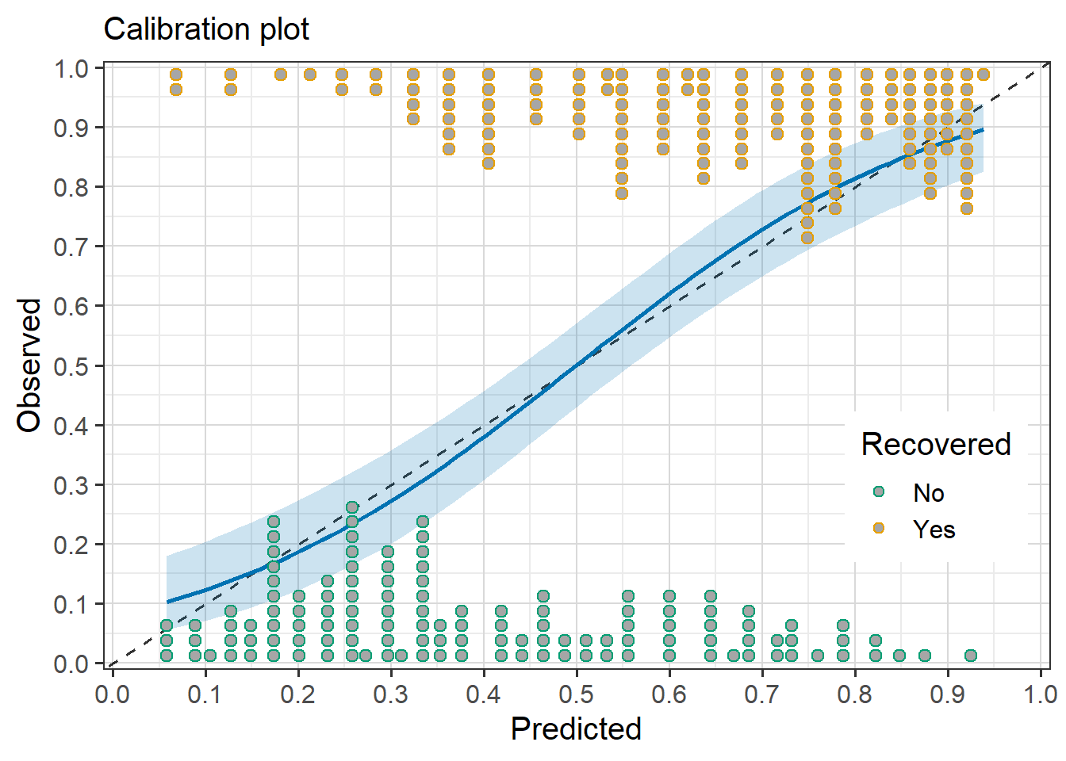
Figure 2: Calibration plot for projection model for IAPT recovery

2.2.2 IAPT Recovery (cases only)
Table 3: Model coefficients for reference model including median odds ratio, 95 CI, Rhat and effective sample size (ESS) of posterior distribution.
Parameter | Median | CI | CI_low | CI_high | Rhat | ESS
(Intercept) | 0.71 | 0.95 | 0.52 | 0.99 | 1.001 | 8600
age | 1.01 | 0.95 | 0.94 | 1.44 | 1.000 | 4503
sex | 1.00 | 0.95 | 0.83 | 1.08 | 1.000 | 7598
bme | 1.00 | 0.95 | 0.74 | 1.14 | 1.000 | 6021
education | 1.00 | 0.95 | 0.88 | 1.16 | 1.000 | 8391
unemployed | 1.00 | 0.95 | 0.76 | 1.18 | 1.000 | 5778
long_term_sick | 1.00 | 0.95 | 0.44 | 1.12 | 1.001 | 3621
income | 1.01 | 0.95 | 0.94 | 1.41 | 1.000 | 4785
age_onset_lifetime | 1.00 | 0.95 | 0.93 | 1.28 | 1.000 | 6150
ln_curr_ep_dur | 1.00 | 0.95 | 0.85 | 1.10 | 1.000 | 8159
curr_AD | 1.00 | 0.95 | 0.80 | 1.07 | 1.000 | 6777
bipolar | 1.00 | 0.95 | 0.87 | 1.12 | 1.000 | 7971
sapas | 0.99 | 0.95 | 0.69 | 1.06 | 1.000 | 4794
ln_cirs | 1.00 | 0.95 | 0.83 | 1.09 | 1.000 | 5962
panic_disorder2 | 1.00 | 0.95 | 0.82 | 1.08 | 1.000 | 6941
agoraphobia | 0.98 | 0.95 | 0.67 | 1.05 | 1.000 | 4161
social_phobia | 1.00 | 0.95 | 0.76 | 1.07 | 1.000 | 5055
ocd | 0.76 | 0.95 | 0.47 | 1.02 | 1.001 | 2323
ptsd | 0.99 | 0.95 | 0.71 | 1.06 | 1.000 | 5414
alcohol | 1.00 | 0.95 | 0.91 | 1.18 | 1.000 | 7972
substance_use | 0.99 | 0.95 | 0.64 | 1.05 | 1.001 | 4791
ipq | 1.00 | 0.95 | 0.77 | 1.07 | 1.000 | 6387
neg_cogs | 1.00 | 0.95 | 0.88 | 1.14 | 1.000 | 8317
self_reassure | 1.00 | 0.95 | 0.91 | 1.18 | 1.000 | 7432
efficacy | 1.00 | 0.95 | 0.87 | 1.12 | 1.000 | 8258
eq5d_wd | 1.01 | 0.95 | 0.93 | 1.40 | 1.000 | 5888
soc_support | 1.00 | 0.95 | 0.90 | 1.17 | 1.000 | 8022
life_events | 1.00 | 0.95 | 0.86 | 1.11 | 1.000 | 8141
ch_trauma | 1.00 | 0.95 | 0.83 | 1.10 | 1.000 | 7454
phq9_t0 | 0.47 | 0.95 | 0.32 | 0.68 | 1.000 | 7197
gad7_t0 | 1.00 | 0.95 | 0.89 | 1.18 | 1.000 | 8151

Table 4: Projection model variable selection path and variable stability
size | solution_terms | elpd | elpd.se | rmse | rmse.se | prop_included
0 | intercept | -145.1 | 2.0 | 0.497 | 0.005 | 1.000
1 | phq9_t0 | -130.7 | 5.2 | 0.464 | 0.012 | 1.000
2 | ocd | -128.1 | 5.6 | 0.457 | 0.012 | 1.000
3 | agoraphobia | -129.9 | 5.9 | 0.460 | 0.013 | 0.953
4 | sapas | -129.6 | 6.0 | 0.459 | 0.013 | 0.929
5 | eq5d_wd | -130.3 | 6.0 | 0.461 | 0.013 | 0.844
6 | substance_use | -131.9 | 6.0 | 0.465 | 0.013 | 0.720
7 | income | -132.0 | 5.9 | 0.465 | 0.013 | 0.654
8 | age_onset_lifetime | -129.1 | 5.9 | 0.459 | 0.013 | 0.991
9 | ptsd | -127.5 | 5.7 | 0.455 | 0.013 | 1.000
10 | social_phobia | -128.9 | 5.8 | 0.458 | 0.013 | 0.635
11 | age | -128.6 | 5.8 | 0.458 | 0.013 | 0.891
12 | ipq | -129.5 | 5.9 | 0.459 | 0.013 | 0.673
13 | long_term_sick | -130.2 | 5.9 | 0.461 | 0.013 | 0.654
14 | bme | -130.6 | 6.0 | 0.462 | 0.013 | 0.441
15 | curr_AD | -131.0 | 6.0 | 0.463 | 0.013 | 0.654
16 | alcohol | -131.3 | 6.0 | 0.463 | 0.013 | 0.265
17 | sex | -131.1 | 6.0 | 0.463 | 0.013 | 0.787
18 | self_reassure | -130.3 | 5.9 | 0.461 | 0.013 | 0.303
19 | panic_disorder2 | -130.3 | 5.9 | 0.461 | 0.013 | 0.839
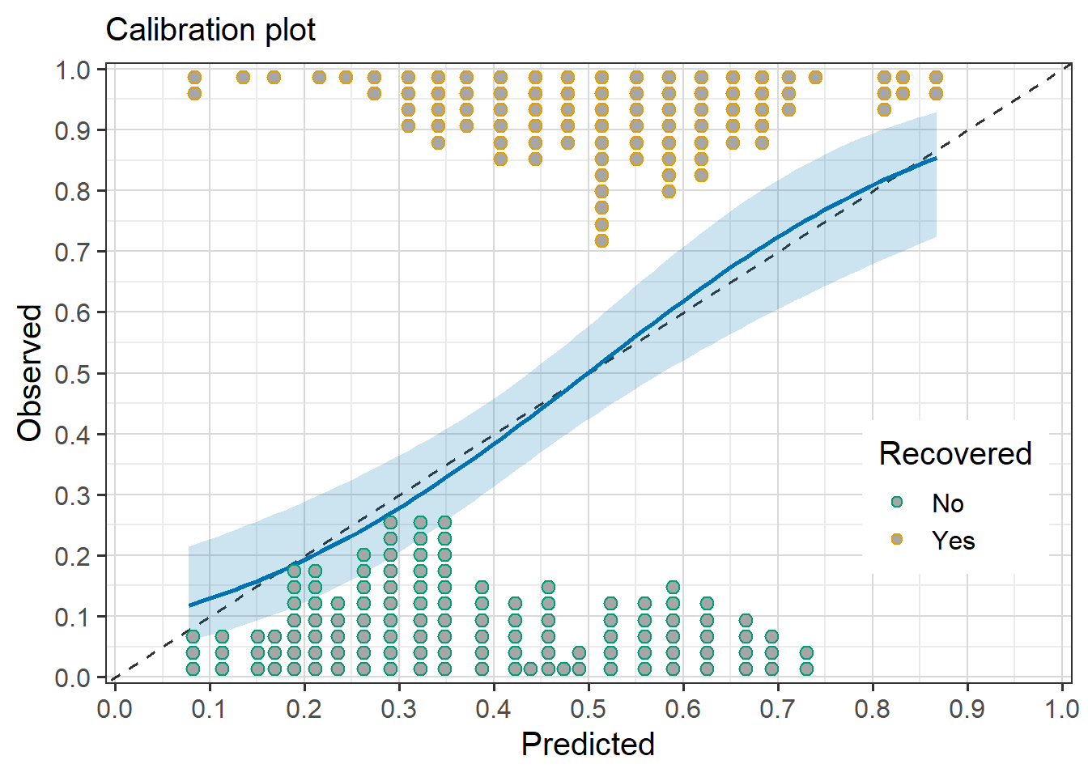
Figure 3: Calibration plot for projection model for IAPT recovery (Cases only)

2.2.3 IAPT Reliable improvement
Table 5: Model coefficients for reference model including median odds ratio, 95 CI, Rhat and effective sample size (ESS) of posterior distribution.
Parameter | Median | CI | CI_low | CI_high | Rhat | ESS
(Intercept) | 1.19 | 0.95 | 0.91 | 1.57 | 1.000 | 10980
age | 1.00 | 0.95 | 0.92 | 1.24 | 1.000 | 7175
sex | 1.00 | 0.95 | 0.81 | 1.08 | 1.001 | 7476
bme | 1.00 | 0.95 | 0.76 | 1.17 | 1.000 | 7372
education | 1.02 | 0.95 | 0.95 | 1.43 | 1.001 | 5646
unemployed | 1.00 | 0.95 | 0.80 | 1.19 | 1.000 | 7410
long_term_sick | 1.00 | 0.95 | 0.60 | 1.14 | 1.000 | 5725
income | 1.00 | 0.95 | 0.93 | 1.26 | 1.000 | 6809
age_onset_lifetime | 1.00 | 0.95 | 0.87 | 1.12 | 1.000 | 8260
ln_curr_ep_dur | 1.00 | 0.95 | 0.89 | 1.15 | 1.000 | 9229
curr_AD | 0.98 | 0.95 | 0.71 | 1.05 | 1.000 | 5678
bipolar | 1.00 | 0.95 | 0.91 | 1.19 | 1.000 | 7690
sapas | 0.89 | 0.95 | 0.58 | 1.03 | 1.001 | 3919
ln_cirs | 0.99 | 0.95 | 0.75 | 1.07 | 1.000 | 6775
panic_disorder2 | 1.00 | 0.95 | 0.82 | 1.08 | 1.000 | 8504
agoraphobia | 0.99 | 0.95 | 0.75 | 1.07 | 1.000 | 5988
social_phobia | 0.98 | 0.95 | 0.68 | 1.05 | 1.000 | 5081
ocd | 0.90 | 0.95 | 0.58 | 1.03 | 1.000 | 3681
ptsd | 1.00 | 0.95 | 0.81 | 1.08 | 1.000 | 7802
alcohol | 1.00 | 0.95 | 0.88 | 1.12 | 1.000 | 8901
substance_use | 1.00 | 0.95 | 0.82 | 1.08 | 1.000 | 8064
ipq | 1.00 | 0.95 | 0.80 | 1.09 | 1.000 | 7563
neg_cogs | 1.00 | 0.95 | 0.84 | 1.12 | 1.000 | 8820
self_reassure | 1.00 | 0.95 | 0.87 | 1.12 | 1.000 | 9195
efficacy | 1.02 | 0.95 | 0.95 | 1.49 | 1.000 | 5081
eq5d_wd | 1.08 | 0.95 | 0.96 | 1.68 | 1.002 | 3904
soc_support | 1.00 | 0.95 | 0.91 | 1.19 | 1.000 | 8720
life_events | 1.00 | 0.95 | 0.79 | 1.07 | 1.001 | 5788
ch_trauma | 1.00 | 0.95 | 0.92 | 1.25 | 1.000 | 6124
phq9_t0 | 1.00 | 0.95 | 0.77 | 1.10 | 1.001 | 6726
gad7_t0 | 2.46 | 0.95 | 1.68 | 3.73 | 1.001 | 5424

Table 6: Projection model variable selection path and variable stability
size | solution_terms | elpd | elpd.se | rmse | rmse.se | prop_included
0 | intercept | -182.5 | 1.2 | 0.500 | 0.002 | 1.000
1 | gad7_t0 | -170.2 | 4.8 | 0.477 | 0.009 | 1.000
2 | sapas | -171.6 | 5.4 | 0.479 | 0.010 | 0.951
3 | eq5d_wd | -168.5 | 5.5 | 0.473 | 0.010 | 0.989
4 | ocd | -165.1 | 5.5 | 0.467 | 0.010 | 1.000
5 | efficacy | -165.4 | 5.5 | 0.468 | 0.010 | 0.977
6 | social_phobia | -168.7 | 5.6 | 0.474 | 0.010 | 0.798
7 | education | -165.5 | 5.6 | 0.468 | 0.010 | 0.977
8 | curr_AD | -164.3 | 5.4 | 0.466 | 0.010 | 0.992
9 | agoraphobia | -166.5 | 5.6 | 0.470 | 0.010 | 0.768
10 | income | -167.4 | 5.6 | 0.472 | 0.010 | 0.840
11 | ptsd | -166.2 | 5.6 | 0.469 | 0.010 | 0.871
12 | ln_cirs | -166.9 | 5.6 | 0.471 | 0.010 | 0.829
13 | ipq | -167.8 | 5.6 | 0.472 | 0.010 | 0.544
14 | sex | -168.2 | 5.6 | 0.473 | 0.010 | 0.677
15 | substance_use | -167.6 | 5.6 | 0.472 | 0.010 | 0.738
16 | age | -167.5 | 5.6 | 0.472 | 0.010 | 0.563
17 | life_events | -167.0 | 5.6 | 0.471 | 0.010 | 0.894
18 | phq9_t0 | -166.6 | 5.6 | 0.470 | 0.010 | 0.924
19 | panic_disorder2 | -166.8 | 5.6 | 0.471 | 0.010 | 0.764
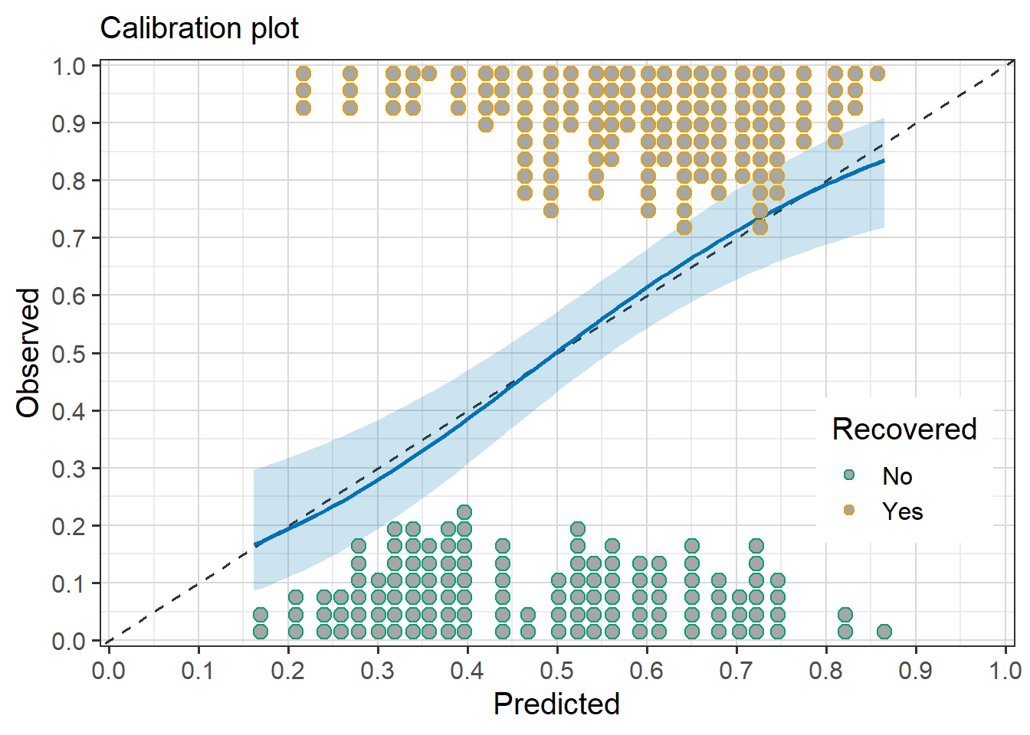
Figure 4: Calibration plot for projection model for IAPT reliable improvement

2.2.4 PHQ 9
Table 7: Model coefficients for reference model including median, 95 CI, Rhat and effective sample size (ESS) of posterior distribution.
Parameter | Median | CI | CI_low | CI_high | Rhat | ESS
(Intercept) | 9.03 | 0.95 | 8.30 | 9.72 | 1.000 | 9939
age | -0.03 | 0.95 | -0.68 | 0.19 | 1.000 | 6554
sex | 0.08 | 0.95 | -0.12 | 0.88 | 1.000 | 5009
bme | 0.01 | 0.95 | -0.35 | 1.19 | 1.000 | 6757
education | -0.01 | 0.95 | -0.54 | 0.24 | 1.000 | 8233
unemployed | 0.00 | 0.95 | -0.51 | 0.80 | 1.000 | 7138
long_term_sick | 0.02 | 0.95 | -0.38 | 1.43 | 1.000 | 6142
income | -0.10 | 0.95 | -1.02 | 0.13 | 1.000 | 4846
age_onset_lifetime | 0.00 | 0.95 | -0.34 | 0.34 | 1.000 | 8939
ln_curr_ep_dur | 0.00 | 0.95 | -0.34 | 0.35 | 1.000 | 9636
curr_AD | 0.01 | 0.95 | -0.28 | 0.44 | 1.000 | 9409
bipolar | -0.02 | 0.95 | -0.57 | 0.23 | 1.000 | 7585
sapas | 0.11 | 0.95 | -0.13 | 1.01 | 1.000 | 5052
ln_cirs | 0.01 | 0.95 | -0.23 | 0.55 | 1.000 | 7689
panic_disorder2 | 0.01 | 0.95 | -0.25 | 0.50 | 1.000 | 8409
agoraphobia | 0.14 | 0.95 | -0.10 | 1.09 | 1.000 | 5081
social_phobia | 0.09 | 0.95 | -0.13 | 0.96 | 1.000 | 5479
ocd | 0.67 | 0.95 | -0.03 | 1.48 | 1.000 | 3282
ptsd | 0.03 | 0.95 | -0.20 | 0.66 | 1.000 | 7667
alcohol | -0.02 | 0.95 | -0.53 | 0.22 | 1.000 | 7650
substance_use | 0.00 | 0.95 | -0.40 | 0.29 | 1.000 | 8440
ipq | 0.00 | 0.95 | -0.45 | 0.33 | 1.000 | 8560
neg_cogs | 0.00 | 0.95 | -0.38 | 0.38 | 1.000 | 8672
self_reassure | 0.01 | 0.95 | -0.26 | 0.51 | 1.000 | 8053
efficacy | 0.00 | 0.95 | -0.35 | 0.38 | 1.000 | 9161
eq5d_wd | -1.08 | 0.95 | -1.94 | -0.02 | 1.001 | 4621
soc_support | -0.06 | 0.95 | -0.83 | 0.16 | 1.000 | 6040
life_events | 0.00 | 0.95 | -0.35 | 0.34 | 1.000 | 9451
ch_trauma | 0.00 | 0.95 | -0.34 | 0.40 | 1.000 | 8544
phq9_t0 | 3.24 | 0.95 | 2.43 | 4.08 | 1.000 | 7738
gad7_t0 | -0.01 | 0.95 | -0.70 | 0.31 | 1.000 | 7661

Table 8: Projection model variable selection path and variable stability
size | solution_terms | elpd | elpd.se | rmse | rmse.se | prop_included
0 | intercept | -883.7 | 9.9 | 6.949 | 0.260 | 1.000
1 | phq9_t0 | -830.3 | 11.4 | 5.666 | 0.247 | 1.000
2 | eq5d_wd | -824.1 | 11.0 | 5.542 | 0.233 | 1.000
3 | ocd | -821.0 | 11.0 | 5.478 | 0.233 | 1.000
4 | agoraphobia | -821.9 | 11.3 | 5.496 | 0.237 | 0.985
5 | income | -826.8 | 11.5 | 5.598 | 0.237 | 0.745
6 | sapas | -824.4 | 11.6 | 5.549 | 0.240 | 0.932
7 | sex | -824.0 | 11.6 | 5.541 | 0.239 | 0.890
8 | social_phobia | -824.0 | 11.5 | 5.539 | 0.237 | 0.905
9 | soc_support | -820.4 | 11.3 | 5.466 | 0.236 | 0.992
10 | ptsd | -820.6 | 11.2 | 5.469 | 0.235 | 0.992
11 | alcohol | -820.6 | 11.2 | 5.469 | 0.234 | 0.992
12 | bipolar | -822.2 | 11.3 | 5.503 | 0.234 | 0.487
13 | age | -823.2 | 11.4 | 5.524 | 0.235 | 0.795
14 | ln_cirs | -823.6 | 11.4 | 5.532 | 0.235 | 0.844
15 | education | -823.7 | 11.4 | 5.535 | 0.236 | 0.555
16 | self_reassure | -824.3 | 11.4 | 5.547 | 0.235 | 0.635
17 | gad7_t0 | -824.3 | 11.4 | 5.547 | 0.235 | 0.639
18 | panic_disorder2 | -823.8 | 11.4 | 5.536 | 0.235 | 0.863
19 | bme | -823.6 | 11.4 | 5.532 | 0.235 | 0.825

2.2.5 GAD 7
Table 9: Model coefficients for reference model including median, 95 CI, Rhat and effective sample size (ESS) of posterior distribution.
Parameter | Median | CI | CI_low | CI_high | Rhat | ESS
(Intercept) | 7.66 | 0.95 | 7.03 | 8.27 | 1.000 | 8763
age | -0.05 | 0.95 | -0.70 | 0.18 | 1.000 | 6615
sex | 0.18 | 0.95 | -0.10 | 0.90 | 1.000 | 5366
bme | 0.06 | 0.95 | -0.28 | 1.68 | 1.000 | 5468
education | -0.03 | 0.95 | -0.62 | 0.22 | 1.001 | 7612
unemployed | 0.02 | 0.95 | -0.41 | 1.19 | 1.000 | 6650
long_term_sick | 0.01 | 0.95 | -0.48 | 1.04 | 1.000 | 7320
income | -0.15 | 0.95 | -0.97 | 0.13 | 1.001 | 5406
age_onset_lifetime | -0.01 | 0.95 | -0.42 | 0.30 | 1.000 | 9152
ln_curr_ep_dur | 0.02 | 0.95 | -0.24 | 0.49 | 1.000 | 8612
curr_AD | 0.05 | 0.95 | -0.18 | 0.65 | 1.000 | 5801
bipolar | 0.00 | 0.95 | -0.33 | 0.38 | 1.000 | 9096
sapas | 0.08 | 0.95 | -0.15 | 0.81 | 1.000 | 5696
ln_cirs | 0.02 | 0.95 | -0.24 | 0.52 | 1.000 | 7731
panic_disorder2 | 0.13 | 0.95 | -0.13 | 0.90 | 1.000 | 4821
agoraphobia | 0.57 | 0.95 | -0.04 | 1.41 | 1.001 | 3513
social_phobia | 0.11 | 0.95 | -0.14 | 0.87 | 1.000 | 5238
ocd | 0.48 | 0.95 | -0.04 | 1.19 | 1.001 | 3869
ptsd | 0.06 | 0.95 | -0.18 | 0.69 | 1.000 | 6086
alcohol | 0.00 | 0.95 | -0.35 | 0.34 | 1.000 | 8882
substance_use | 0.01 | 0.95 | -0.24 | 0.47 | 1.000 | 8675
ipq | 0.02 | 0.95 | -0.26 | 0.60 | 1.000 | 7993
neg_cogs | 0.00 | 0.95 | -0.45 | 0.32 | 1.000 | 7987
self_reassure | 0.06 | 0.95 | -0.16 | 0.73 | 1.000 | 5471
efficacy | 0.01 | 0.95 | -0.29 | 0.43 | 1.000 | 8742
eq5d_wd | -0.56 | 0.95 | -1.41 | 0.04 | 1.000 | 4224
soc_support | -0.02 | 0.95 | -0.56 | 0.23 | 1.000 | 6911
life_events | 0.01 | 0.95 | -0.26 | 0.44 | 1.000 | 8925
ch_trauma | 0.01 | 0.95 | -0.26 | 0.48 | 1.000 | 8814
phq9_t0 | 1.36 | 0.95 | 0.04 | 2.49 | 1.000 | 3750
gad7_t0 | 1.22 | 0.95 | 0.00 | 2.36 | 1.000 | 3621

Table 10: Projection model variable selection path and variable stability
size | solution_terms | elpd | elpd.se | rmse | rmse.se | prop_included
0 | intercept | -841.4 | 9.2 | 5.918 | 0.205 | 1.000
1 | gad7_t0 | -824.5 | 12.1 | 5.518 | 0.222 | 0.894
2 | phq9_t0 | -820.8 | 12.3 | 5.431 | 0.219 | 0.859
3 | agoraphobia | -800.3 | 11.6 | 5.053 | 0.217 | 0.859
4 | eq5d_wd | -789.3 | 11.1 | 4.848 | 0.210 | 1.000
5 | ocd | -787.2 | 11.0 | 4.808 | 0.208 | 1.000
6 | income | -792.3 | 11.5 | 4.904 | 0.212 | 0.871
7 | sex | -789.5 | 11.5 | 4.851 | 0.213 | 0.962
8 | panic_disorder2 | -791.5 | 11.4 | 4.889 | 0.209 | 0.875
9 | sapas | -790.5 | 11.4 | 4.870 | 0.209 | 0.814
10 | social_phobia | -788.6 | 11.3 | 4.834 | 0.208 | 0.951
11 | ptsd | -788.5 | 11.2 | 4.833 | 0.207 | 0.916
12 | bme | -788.7 | 11.4 | 4.837 | 0.210 | 0.970
13 | curr_AD | -790.0 | 11.4 | 4.860 | 0.208 | 0.802
14 | self_reassure | -789.6 | 11.4 | 4.852 | 0.208 | 0.859
15 | education | -790.0 | 11.4 | 4.861 | 0.209 | 0.882
16 | age | -790.7 | 11.4 | 4.873 | 0.209 | 0.627
17 | ln_cirs | -791.4 | 11.5 | 4.885 | 0.209 | 0.582
18 | ch_trauma | -792.3 | 11.5 | 4.903 | 0.209 | 0.373
19 | ipq | -791.7 | 11.5 | 4.892 | 0.210 | 0.274

2.2.6 IAPT reliable recovery
- Note that this outcome was not included in the main analysis
Table 11: Model coefficients for reference model including median, 95 CI, Rhat and effective sample size (ESS) of posterior distribution.
Parameter | Median | CI | CI_low | CI_high | Rhat | ESS
(Intercept) | 0.59 | 0.95 | 0.45 | 0.77 | 1.000 | 10043
age | 1.00 | 0.95 | 0.96 | 1.21 | 1.000 | 5730
sex | 1.00 | 0.95 | 0.85 | 1.05 | 1.000 | 5849
bme | 1.00 | 0.95 | 0.86 | 1.10 | 1.000 | 7255
education | 1.00 | 0.95 | 0.95 | 1.16 | 1.000 | 7460
unemployed | 1.00 | 0.95 | 0.80 | 1.10 | 1.000 | 7039
long_term_sick | 1.00 | 0.95 | 0.68 | 1.08 | 1.001 | 3952
income | 1.00 | 0.95 | 0.96 | 1.26 | 1.000 | 4857
age_onset_lifetime | 1.00 | 0.95 | 0.93 | 1.10 | 1.000 | 8805
ln_curr_ep_dur | 1.00 | 0.95 | 0.91 | 1.07 | 1.000 | 7891
curr_AD | 1.00 | 0.95 | 0.80 | 1.04 | 1.000 | 5656
bipolar | 1.00 | 0.95 | 0.93 | 1.09 | 1.000 | 8374
sapas | 1.00 | 0.95 | 0.76 | 1.04 | 1.001 | 4336
ln_cirs | 1.00 | 0.95 | 0.90 | 1.07 | 1.001 | 7369
panic_disorder2 | 1.00 | 0.95 | 0.90 | 1.06 | 1.000 | 7149
agoraphobia | 1.00 | 0.95 | 0.86 | 1.05 | 1.000 | 5458
social_phobia | 1.00 | 0.95 | 0.84 | 1.04 | 1.001 | 5047
ocd | 0.90 | 0.95 | 0.54 | 1.01 | 1.002 | 1854
ptsd | 1.00 | 0.95 | 0.76 | 1.04 | 1.000 | 5050
alcohol | 1.00 | 0.95 | 0.93 | 1.10 | 1.000 | 8739
substance_use | 1.00 | 0.95 | 0.81 | 1.04 | 1.001 | 5083
ipq | 1.00 | 0.95 | 0.87 | 1.06 | 1.000 | 7529
neg_cogs | 1.00 | 0.95 | 0.93 | 1.11 | 1.000 | 8420
self_reassure | 1.00 | 0.95 | 0.92 | 1.08 | 1.000 | 7812
efficacy | 1.00 | 0.95 | 0.95 | 1.15 | 1.000 | 6391
eq5d_wd | 1.00 | 0.95 | 0.97 | 1.41 | 1.000 | 4082
soc_support | 1.00 | 0.95 | 0.93 | 1.11 | 1.000 | 8250
life_events | 1.00 | 0.95 | 0.90 | 1.06 | 1.000 | 7616
ch_trauma | 1.00 | 0.95 | 0.92 | 1.09 | 1.000 | 8463
phq9_t0 | 1.00 | 0.95 | 0.52 | 1.04 | 1.001 | 1306
gad7_t0 | 1.00 | 0.95 | 0.97 | 2.02 | 1.002 | 1194
- OCD was the only non 0 (OR = 1) coefficient

2.3 Sensitivity analyses

2.3.1 Equivalent subsets (PHQ 9)
Projection paths for PHQ-9 outcome model including 3 other predictors (income, agoraphobia and ocd diagnoses) as alternative to Quality of Life as a predictor, able to match reference model performance
Table 12: Projection paths for PHQ-9 outcome model including 3 other predictors (income, agoraphobia and ocd diagnoses) as alternative to Quality of Life as a predictor, able to match reference model performance
size | solution_terms | elpd | elpd.se | rmse | rmse.se | prop_included
0 | intercept | -883.6 | 10.0 | 6.948 | 0.260 | 1.000
1 | income | -870.5 | 10.1 | 6.608 | 0.257 | 1.000
2 | agoraphobia | -865.8 | 9.7 | 6.490 | 0.245 | 0.992
3 | ocd | -861.1 | 9.9 | 6.373 | 0.250 | 1.000
4 | phq9_t0 | -823.1 | 11.1 | 5.514 | 0.239 | 0.000
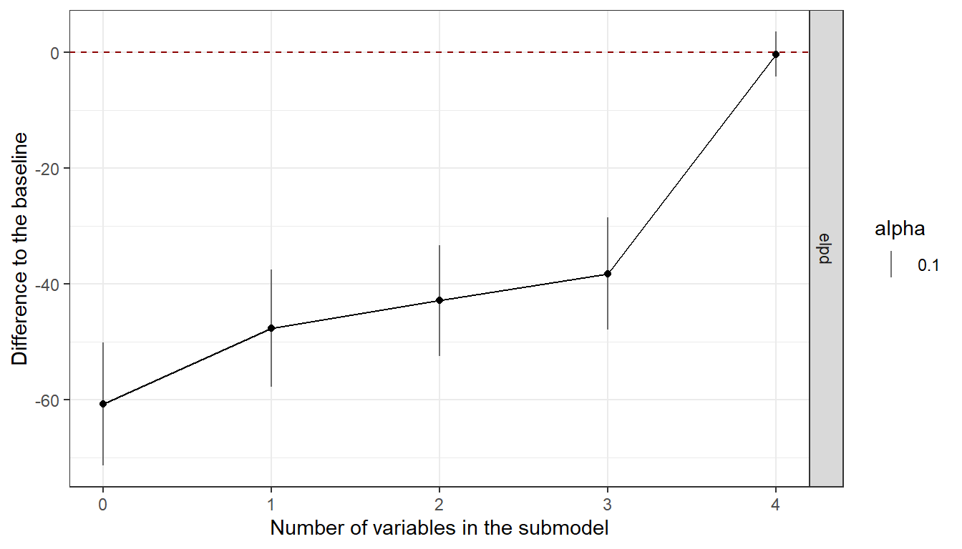
Figure 5: Projection path for PHQ-9 outcome model ewith income, agoraphobia and OCD diagnosis

2.3.2 PHQ 9 Projection model no Baseline
Table 13: Projection path excluding baseline for PHQ 9 scores
size | solution_terms | elpd | elpd.se | rmse | rmse.se | prop_included
0 | intercept | -883.6 | 10.0 | 6.948 | 0.260 | 1.000
1 | eq5d_wd | -859.7 | 10.3 | 6.342 | 0.245 | 1.000
2 | ipq | -863.2 | 11.4 | 6.423 | 0.263 | 0.943
3 | ocd | -851.3 | 10.6 | 6.144 | 0.248 | 0.996
4 | income | -848.2 | 10.8 | 6.070 | 0.250 | 1.000
5 | neg_cogs | -847.2 | 10.8 | 6.049 | 0.249 | 1.000
6 | bme | -846.2 | 10.9 | 6.024 | 0.251 | 0.992
7 | agoraphobia | -844.3 | 10.6 | 5.980 | 0.244 | 1.000
8 | ln_cirs | -844.7 | 10.8 | 5.990 | 0.247 | 0.989
9 | education | -846.3 | 10.8 | 6.027 | 0.246 | 0.939
10 | ptsd | -845.0 | 10.9 | 5.998 | 0.249 | 0.985
11 | unemployed | -846.1 | 11.0 | 6.023 | 0.249 | 0.882
12 | soc_support | -846.9 | 11.0 | 6.042 | 0.249 | 0.715
13 | panic_disorder2 | -845.1 | 11.1 | 6.000 | 0.251 | 0.973
14 | age | -847.8 | 11.1 | 6.062 | 0.250 | 0.681
15 | age_onset_lifetime | -848.0 | 11.0 | 6.068 | 0.248 | 0.734
16 | social_phobia | -847.3 | 11.1 | 6.050 | 0.249 | 0.829
17 | bipolar | -845.8 | 11.0 | 6.015 | 0.248 | 0.981
18 | substance_use | -843.7 | 10.9 | 5.968 | 0.248 | 0.996
19 | efficacy | -844.1 | 10.9 | 5.978 | 0.248 | 0.966
20 | life_events | -844.9 | 10.9 | 5.996 | 0.248 | 0.924
21 | ch_trauma | -845.6 | 11.0 | 6.012 | 0.249 | 0.829
22 | long_term_sick | -845.2 | 11.0 | 6.003 | 0.248 | 0.970
23 | ln_curr_ep_dur | -845.0 | 10.9 | 5.999 | 0.248 | 0.920
24 | curr_AD | -845.4 | 11.0 | 6.009 | 0.249 | 0.905
25 | alcohol | -845.8 | 11.0 | 6.016 | 0.247 | 0.582
26 | sex | -845.2 | 10.9 | 6.003 | 0.248 | 0.962
27 | self_reassure | -845.4 | 10.9 | 6.008 | 0.248 | 0.821
28 | sapas | -845.5 | 11.0 | 6.011 | 0.248 | 1.000
3 or 4 variables provide a solution within the SE of near maximum performance. For this projection model Bayesian R2 (95% CI) = 0.24 (0.14, 0.32)

2.3.3 GAD 7 Projection model no Baseline
Table 14: Projection path excluding baseline for GAD 7 scores
size | solution_terms | elpd | elpd.se | rmse | rmse.se | prop_included
0 | intercept | -841.4 | 9.2 | 5.918 | 0.205 | 1.000
1 | eq5d_wd | -832.0 | 10.7 | 5.705 | 0.221 | 0.962
2 | agoraphobia | -825.8 | 11.0 | 5.570 | 0.218 | 0.954
3 | ipq | -827.2 | 11.2 | 5.590 | 0.216 | 0.772
4 | ocd | -805.3 | 10.1 | 5.152 | 0.207 | 1.000
5 | income | -803.1 | 10.2 | 5.108 | 0.208 | 1.000
6 | bme | -801.0 | 10.2 | 5.066 | 0.208 | 0.996
7 | neg_cogs | -800.5 | 10.4 | 5.057 | 0.210 | 1.000
8 | ln_cirs | -801.1 | 10.6 | 5.069 | 0.215 | 0.992
9 | education | -803.7 | 10.8 | 5.122 | 0.215 | 0.882
10 | social_phobia | -802.2 | 10.8 | 5.092 | 0.217 | 0.970
11 | unemployed | -804.0 | 11.2 | 5.128 | 0.221 | 0.935
12 | ptsd | -805.8 | 11.3 | 5.163 | 0.221 | 0.863
13 | substance_use | -807.3 | 11.3 | 5.192 | 0.220 | 0.483
14 | self_reassure | -806.4 | 11.3 | 5.176 | 0.220 | 0.920
15 | long_term_sick | -804.2 | 11.2 | 5.132 | 0.220 | 0.924
16 | soc_support | -804.1 | 11.2 | 5.130 | 0.220 | 0.821
17 | sex | -805.4 | 11.2 | 5.156 | 0.219 | 0.570
18 | efficacy | -805.3 | 11.2 | 5.153 | 0.218 | 0.867
19 | sapas | -805.4 | 11.2 | 5.155 | 0.218 | 0.852
20 | age | -805.9 | 11.1 | 5.165 | 0.217 | 0.802
21 | age_onset_lifetime | -806.0 | 11.1 | 5.167 | 0.217 | 0.825
22 | ch_trauma | -805.0 | 11.1 | 5.147 | 0.216 | 0.711
23 | panic_disorder2 | -803.3 | 11.0 | 5.113 | 0.216 | 0.977
24 | bipolar | -804.2 | 11.0 | 5.132 | 0.216 | 0.445
25 | curr_AD | -804.0 | 11.0 | 5.127 | 0.216 | 0.806
26 | alcohol | -803.3 | 11.0 | 5.113 | 0.215 | 1.000
27 | life_events | -803.5 | 11.0 | 5.118 | 0.215 | 0.825
28 | ln_curr_ep_dur | -803.6 | 11.0 | 5.120 | 0.216 | 1.000
4 variables provide a solution within the SE of near maximum performance. For this projection model Bayesian R2 (95% CI) = 0.24 (0.16, 0.32)

3 References
Bernstein, David P., Judith A. Stein, Michael D. Newcomb, Edward Walker, David Pogge, Taruna Ahluvalia, John Stokes, et al. 2003. “Development and Validation of a Brief Screening Version of the Childhood Trauma Questionnaire.” Child Abuse and Neglect 27 (2): 169–90. https://doi.org/10.1016/S0145-2134(02)00541-0.
Broadbent, Elizabeth, Keith J. Petrie, Jodie Main, and John Weinman. 2006. “The Brief Illness Perception Questionnaire.” Journal of Psychosomatic Research 60 (6): 631–37. https://doi.org/10.1016/j.jpsychores.2005.10.020.
Brugha, Traolach, Paul Bebbington, Christopher Tennant, and Jane Hurry. 1985. “The List of Threatening Experiences: A Subset of 12 Life Event Categories with Considerable Long-Term Contextual Threat.” Psychological Medicine 15 (1): 189–94. https://doi.org/10.1017/S003329170002105X.
Dalgard, Odd Steffen, Christopher Dowrick, Ville Lehtinen, Jose Luis Vazquez-Barquero, Patricia Casey, Greg Wilkinson, Jose Luis Ayuso-Mateos, Helen Page, and Graham Dunn. 2006. “Negative Life Events, Social Support and Gender Difference in Depression.” Social Psychiatry and Psychiatric Epidemiology 41 (6): 444–51. https://doi.org/10.1007/s00127-006-0051-5.
Devlin, Nancy J., Koonal K. Shah, Yan Feng, Brendan Mulhern, and Ben van Hout. 2018. “Valuing Health-Related Quality of Life: An EQ-5D-5L Value Set for England.” Health Economics 27 (1): 7–22. https://doi.org/10.1002/hec.3564.
Gelman, Andrew, Jennifer Hill, and Aki Vehtari. 2020. Regression and Other Stories. Cambridge University Press.
Gilbert, P., M. Clarke, S. Hempel, J.n.v. Miles, and C. Irons. 2004. “Criticizing and Reassuring Oneself: An Exploration of Forms, Styles and Reasons in Female Students.” British Journal of Clinical Psychology 43 (1): 31–50. https://doi.org/10.1348/014466504772812959.
Herdman, M., C. Gudex, A. Lloyd, MF. Janssen, P. Kind, D. Parkin, G. Bonsel, and X. Badia. 2011. “Development and Preliminary Testing of the New Five-Level Version of EQ-5D (EQ-5D-5L).” Quality of Life Research 20 (10): 1727–36. https://doi.org/10.1007/s11136-011-9903-x.
Kroenke, Kurt, Robert L. Spitzer, and Janet B. W. Williams. 2001. “The PHQ-9.” Journal of General Internal Medicine 16 (9): 606–13. https://doi.org/10.1046/j.1525-1497.2001.016009606.x.
Linn, Bernard S., Margaret W. Linn, and Lee Gurel. 1968. “Cumulative Illness Rating Scale.” Journal of the American Geriatrics Society 16 (5): 622–26. https://doi.org/10.1111/j.1532-5415.1968.tb02103.x.
Moran, Paul, Morven Leese, Tennyson Lee, Paul Walters, Graham Thornicroft, and Anthony Mann. 2003. “Standardised Assessment of Personality - Abbreviated Scale (SAPAS): Preliminary Validation of a Brief Screen for Personality Disorder.” British Journal of Psychiatry 183 (SEPT.): 228–32. https://doi.org/10.1192/bjp.183.3.228.
Schwarzer, R., and M. Jerusalem. 1995. “Generalized Self-Efficacy Scale.” In Measures in Health Psychology: A User’s Portfolio. Causal and Control Beliefs., edited by J. Weimann, S. Wright, and M. Johnson, 35–37. Windsor, UK: NFER-NELSON.
Sheehan, David V., Yves Lecrubier, K. Harnett Sheehan, Patricia Amorim, Juris Janavs, Emmanuelle Weiller, Thierry Hergueta, Roxy Baker, and Geoffrey C. Dunbar. 1998. “The Mini-International Neuropsychiatric Interview (M.I.N.I.): The Development and Validation of a Structured Diagnostic Psychiatric Interview for DSM-IV and ICD-10.” Journal of Clinical Psychiatry 59 (SUPPL. 20): 22–33.
Spitzer, Robert L., Kurt Kroenke, Janet B. W. Williams, and Bernd Löwe. 2006. “A Brief Measure for Assessing Generalized Anxiety Disorder: The GAD-7.” Archives of Internal Medicine 166 (10): 1092–97. https://doi.org/10.1001/archinte.166.10.1092.
Stochl, Jan, Eiko I. Fried, Jessica Fritz, Tim J. Croudace, Debra A. Russo, Clare Knight, Peter B. Jones, and Jesus Perez. 2020. “On Dimensionality, Measurement Invariance, and Suitability of Sum Scores for the PHQ-9 and the GAD-7.” Assessment, December, 107319112097686. https://doi.org/10.1177/1073191120976863.

