Supplemental Materials

Supplemental Table 1.
Description of posts included in datasets.
 | All Data | Training Set | Validation Set | Test Set
Total Posts | 8449 | 6478 | 692 | 1279
STB | 851 (10.07%) | 637 (9.83%) | 79 (11.42%) | 135 (10.56%)
Non-STB | 7598 (89.93%) | 5841 90.17%) | 613 (88.58%) | 1144 (89.44%)
Note. STB: suicidal thoughts and behaviors. Percentages are computed column-wise.

Supplemental Table 2.
Demographic and profile information of sample and RallyPoint.
 |  | Users with STB posts (n=307) | Users with non-STB posts (n=2,440) | All users included in final sample (n=2,747) | Overall RallyPoint User Base* (N=1,972,085)
Age | 18-24 | 20 (6.5%) | 97 (4.0%) | 117 (4.3%) | 219,643 (11.1%)
 | 25-34 | 50 (16.3%) | 559 (22.9%) | 609 (22.2%) | 987,006 (50.0%)
 | 35-44 | 60 (19.5%) | 574 (23.5%) | 634 (23.1%) | 268,016 (13.6%)
 | 45-54 | 71 (23.1%) | 467 (19.1%) | 538 (19.6%) | 163,678 (8.3%)
 | 55+ | 99 (32.2%) | 690 (28.3%) | 789 (28.7%) | 82,979 (4.2%)
 | Missing | 7 (2.3%) | 53 (2.2%) | 60 (2.2%) | 250,763 (12.7%)
Sex | Male | 245 (79.8%) | 2117 (86.8%) | 2362 (86.0%) | 1,606,435 (81.2%)
 | Female | 62 (20.2%) | 323 (13.2%) | 385 (14.0%) | 226,459 (11.5%)
 | Missing | N/A | N/A | N/A | 139,191 (7.1%)
User Type | Servicemember | 49 (16.0%) | 706 (28.9%) | 755 (27.5%) | 756,269 (38.3%)
 | Veteran | 245 (79.8%) | 1648 (67.5%) | 1893 (68.9%) | 862,049 (43.7%)
 | Civilian | 13 (4.2%) | 86 (3.5%) | 99 (3.6%) | 214,576 (10.9%)
 | Missing | N/A | N/A | N/A | 139,191 (7.1%)
Branch | Air Force | 31 (10.1%) | 260 (10.7%) | 291 (10.6%) | 221,510 (11.2%)
 | Army | 208 (67.8%) | 1612 (66.1%) | 1820 (66.3%) | 926,903 (47.0%)
 | Coast Guard | 2 (0.7%) | 18 (0.7%) | 20 (0.7%) | 18,345 (.9%)
 | Marine Corp | 15 (4.9%) | 218 (8.9%) | 233 (8.5%) | 216,535 (11.0%)
 | Navy | 38 (12.4%) | 246 (10.1%) | 284 (10.3%) | 235,113 (11.9%)
 | Space Force | 0 (0.0%) | 0 (0.0%) | 0 (0.0%) | 73 (0.0%)
 | N/A (Civilian) | 13 (4.2%) | 86 (3.5%) | 99 (3.6%) | 214,415 (10.9%)
 | Missing | N/A | N/A | N/A | 139,191 (7.1%)
Note. *As of March 2024. STB = suicidal thoughts and behaviors. Demographic and profile information is optionally provided by the user as part of their RallyPoint profile. Data in columns “Users with STB posts” and “Users with non-STB posts” reflect the demographic and profile information of users who had one or more post included in final datasets.

Supplemental Table 3.
Metadata comparisons for STB vs. non-STB posts.

Metadata category | Metadata name | STB Post % | Non-STB Post %
Post type | Comment | 91.4 | 85.9
 | Status update | 4.1 | 9.3
 | Question | 4.6 | 4.8
Most common user-generated tags | Suicide | 10.6 | 2.2
 | PTSD | 9.3 | 3.6
 | Mental health | 3.9 | 1.1
 | Health | 3.0 | 1.4
 | Victory for veterans | 2.9 | 1.5
 | Depression | 2.8 | <1.0
 | Help | 2.4 | <1.0
 | Veterans affairs | 1.9 | 1.8
 | Inspiration | 1.4 | 1.0
 | Motivation | 1.4 | 1.0
 | Humor | <1.0 | 2.5
 | Transition | <1.0 | 1.0
Note. STB = suicidal thoughts and behaviors.

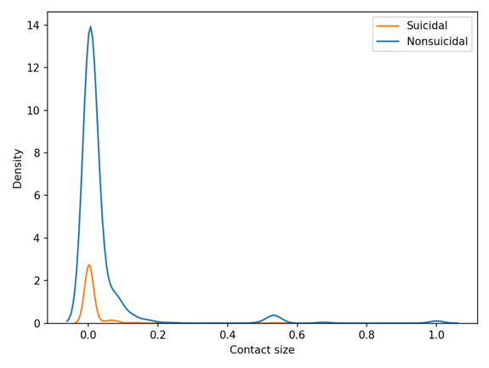 | 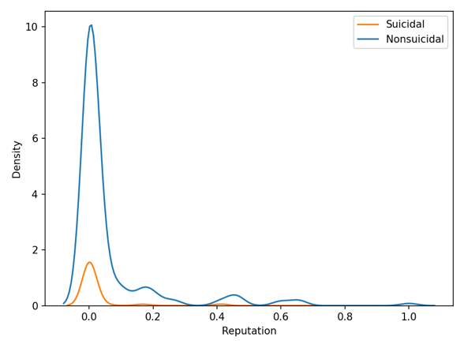
Supplemental Figure 1. Distributions for contact size (left) and reputation score (right) for STB vs. non-STB posts. Suicidal=STB, Nonsuicidal=non-STB.

