**Supplementary Information**

**Improving social cognition following theta burst stimulation over the right inferior frontal gyrus in autism spectrum: An 8-week double-blind sham-controlled trial**

Hsing-Chang Ni1,2＊, Yi-Lung Chen3,4, Meng-Ying Hsieh5,6, Chen-Te Wu7, Rou-Shayn Chen8, Chi-Hung Juan9, Cheng-Ta Li10, Susan Shur-Fen Gau11,12,13, Hsiang-Yuan Lin14,15＊

**Supplementary Results and Discussion**

Earlier studies highlighted a possible age-dependent response to TBS in autistic people (Jannati et al., 2020; Oberman et al., 2014). To explore the age effect on our findings, we did an additional age-stratified GEE by categorizing our sample into Older (aged 20-30 years, n=33) and Younger (8-20 years, n=27) subgroups. This age cut-off is arbitrarily decided to have an even sample size for each subgroup.

Distributions of demographic and clinical features of active vs. sham in the two age subgroups were similar to the main group (Table S4). For autistic symptoms, in the Younger subgroup (Table S5 and S6), we found a significant treatment-by-time interaction effect on RBS-R (p=0.050, Z=-1.96, Cohen’s d=0.70; driven by the reduced scores in the active group; Figure S5) and ADOS-2 CSS (p=0.032, Z=2.15, Cohen’s d=0.79; driven by the reduced scores in the sham group; Figure S5) from baseline to Week 8. In the Older subgroup (Table S7 and S8), we did not find a significant treatment-by-time interaction effect on SRS, RBS-R and AD0S-2 CSS from baseline to Week 8 and Week 12. For social cognition, in the Older subgroup, there was a significant treatment-by-time interaction effect on feeling scores of Frith-Happe Animations (p=0.018, Z=2.36, Cohen’s d=0.79; driven by the improved scores in the active group; Figure S5) from baseline to Week 8. This interaction was insignificant in the Younger subgroup, but the pattern/direction of change was similar to the whole sample and the Older subgroup. Regarding the exploratory outcome, a significant treatment-by-time interaction was observed in the Younger subgroup on EDI (p=0.042, Z=-2.03, Cohen’s d=0.77) from baseline to Week 12.

Overall, the age-stratified sub-analysis showed a similar pattern/direction of changes in the Animations task across the whole sample, Older, and Younger subgroups. On the other hand, despite the insufficient power, we observed some age-specific changes in clinical symptoms following the iTBS treatment.

Our age-stratified sub-analysis revealed some signals of possible age-related responses to TBS in autistic people. Specifically, the Older subgroup had a stronger change in Feeling scores of Animations following iTBS than the Younger subgroup. Still, both subgroups had an identical direction of change to the whole sample. The Younger subgroup showed a treatment-by-time interaction in the RBS-R and ADOS-2 CSS, but in reverse directions, while these interaction effects were not observed in the Older subgroup. An early study has demonstrated an age-dependent response to cTBS in 19 autistic males aged 9-18 years (Oberman et al., 2014). Another study has shown the maximum cTBS-induced motor-evoked potential suppression is negatively correlated with age in 11 autistic children aged 10-16 years (Jannati et al., 2020). Three-way interaction analysis in our previous study (Ni et al., 2023) suggests that age might moderate the response to DLPFC cTBS in 60 autistic people aged 8-30 years, while age-stratified analysis does not indicate different patterns of clinical/behaivoral changes following treatment between older and younger autistic people. Nonetheless, this age-moderating effect has not been observed in our other RCT of pSTS iTBS in autistic people (Ni et al., 2021). All of these studies (including the current one) exploring the age effect on rTMS/TBS in autistic people have the caveat of insufficient statistical power. This limitation is partly driven by the challenge in recruitment when participants’ age range is narrow and partly explained by the fact that the age effect is generally not the primary or secondary study objective, given the scarce number of efficacy trials in this field. In addition to the small sample size in the age subgroups making our sub-analysis results unstable and uncertain, the inconsistent directions between changes in RBS-R and ADOS-2 CSS might also be partly driven by the longstanding challenges in the harmonization and development of approvable outcome measures in autism intervention studies (Jacob et al., 2022). Parent-rated RBS-R may be subject to a broader class of nonspecific effects that likely pertain to many subjective scales for autism (Jones et al., 2017). On the other hand, given its diagnostic root, the ADOS is relatively insensitive to changes (Anagnostou et al., 2015; Dawson et al., 2010). Further, the ADOS retains a degree of subjectivity because it is scored by trained research staff. Taken together, age-related moderation of response to rTMS/TBS in autistic people is far from conclusive and merits dedicated investigations in the future.

**Supplementary References**

Anagnostou, E., Jones, N., Huerta, M., Halladay, A. K., Wang, P., Scahill, L., . . . Dawson, G. (2015). Measuring social communication behaviors as a treatment endpoint in individuals with autism spectrum disorder. *Autism, 19*(5), 622-636. <https://doi.org/10.1177/1362361314542955>

Dawson, G., Rogers, S., Munson, J., Smith, M., Winter, J., Greenson, J., . . . Varley, J. (2010). Randomized, controlled trial of an intervention for toddlers with autism: the Early Start Denver Model. *Pediatrics, 125*(1), e17-23. <https://doi.org/10.1542/peds.2009-0958>

Jacob, S., Anagnostou, E., Hollander, E., Jou, R., McNamara, N., Sikich, L., . . . Veenstra-VanderWeele, J. (2022). Large multicenter randomized trials in autism: key insights gained from the balovaptan clinical development program. *Mol Autism, 13*(1), 25. <https://doi.org/10.1186/s13229-022-00505-6>

Jannati, A., Block, G., Ryan, M. A., Kaye, H. L., Kayarian, F. B., Bashir, S., . . . Rotenberg, A. (2020). Continuous Theta-Burst Stimulation in Children With High-Functioning Autism Spectrum Disorder and Typically Developing Children. *Front Integr Neurosci, 14*, 13. <https://doi.org/10.3389/fnint.2020.00013>

Jones, R. M., Carberry, C., Hamo, A., & Lord, C. (2017). Placebo-like response in absence of treatment in children with Autism. *Autism Res, 10*(9), 1567-1572. <https://doi.org/10.1002/aur.1798>

Ni, H. C., Chen, Y. L., Chao, Y. P., Wu, C. T., Chen, R. S., Chou, T. L., . . . Lin, H. Y. (2023). A lack of efficacy of continuous theta burst stimulation over the left dorsolateral prefrontal cortex in autism: A double blind randomized sham-controlled trial. *Autism Res, 16*(6), 1247-1262. <https://doi.org/10.1002/aur.2954>

Ni, H. C., Chen, Y. L., Chao, Y. P., Wu, C. T., Wu, Y. Y., Liang, S. H., . . . Lin, H. Y. (2021). Intermittent theta burst stimulation over the posterior superior temporal sulcus for children with autism spectrum disorder: A 4-week randomized blinded controlled trial followed by another 4-week open-label intervention. *Autism, 25*(5), 1279-1294. <https://doi.org/10.1177/1362361321990534>

Oberman, L. M., Pascual-Leone, A., & Rotenberg, A. (2014). Modulation of corticospinal excitability by transcranial magnetic stimulation in children and adolescents with autism spectrum disorder. *Front Hum Neurosci, 8*, 627. <https://doi.org/10.3389/fnhum.2014.00627>

**Supplementary Tables**

**Table S1.** Co-occurring psychiatric conditions and medication use for Active and Sham groups

|  |  |  |
| --- | --- | --- |
|  | Active group (n = 30) | Sham group (n = 30) |
| **Comorbidity** | | |
| No comorbidity | 10 | 10 |
| ADHD | 13 | 14 |
| Tic disorders | 3 | 2 |
| OCD | N/A | 3 |
| Anxiety disorder | 1 | 5 |
| **Medications** | | |
| Methylphenidate | 2 | 7 |
| ﻿Atomoxetine | 3 | 1 |
| Antipsychotics | 4 (3 Aripiprazole, 1 Risperidone) | 5 (5 Aripiprazole) |
| Antidepressant | 4 (2 Fluoxetine,1 Fluvoxamine,1 Venlafaxine) | 3 (2 Sertraline, 1 Fluoxetine) |
| Benzodiazepines | 2 (1 Alprazolam,1 Clonazepam) | 1 (1 Alprazolam) |

Acronym – ADHD: Attention Deficit/Hyperactivity Disorder; OCD: Obsessive Compulsive Disorder; PTSD: Posttraumatic Stress Disorder

**Table S2**. Adverse events during iTBS for Active and Sham groups

|  |  |  |  |  |
| --- | --- | --- | --- | --- |
|  | Active (n=30) | | Sham (n=30) | |
| Baseline to Week8 | n | % | n | % |
| Pain at application site | 19 | 63% | 1 | 3% |
| Headache | 0 | 0% | 1 | 3% |
| Dizziness | 3 | 10% | 1 | 3% |
| Eye pain | 1 | 3% | 0 | 0% |

**Table S3.** Adjusted estimates of primary, secondary and exploratory outcomes based on the GEE model from baseline to week 12 for Active and Sham groups

|  |  |  |  |  |  |  |  |  |
| --- | --- | --- | --- | --- | --- | --- | --- | --- |
|  | Treatment effect | | Time effect | | Treatment x Time effect | | | |
|  | Estimate | *P* value | Estimate | *P* value | Estimate | *P* value | *Z* | *Cohen’s d+* |
| ***Primary outcome*** |  |  |  |  |  |  |  |  |
| SRS | -0.02 (1.39) | 0.990 | -11.71 (3.69) | 0.002** | 4.18 (4.95) | 0.399 | 0.84 | 0.21 |
| RBS-R | 0.46 (0.88) | 0.600 | -0.33 (2.90) | 0.910 | -4.32 (3.73) | 0.247 | -1.16 | 0.29 |
| ADOS-2, CSS | 0.06 (0.13) | 0.614 | -0.94 (0.26) | 0.001** | 0.25 (0.46) | 0.580 | 0.55 | 0.14 |
| ***Secondary outcome*** |  |  |  |  |  |  |  |  |
| Frith-Happe Animations, Categorization | -0.09 (0.13) | 0.460 | -0.48 (0.26) | 0.063 | 0.43 (0.39) | 0.269 | 1.10 | 0.28 |
| Frith-Happe Animations, Feeling | -0.22 (0.15) | 0.133 | -0.19 (0.30) | 0.533 | 1.00 (0.44) | 0.025* | 2,24 | 0.57 |
| RMET, total correct | -0.73 (0.34) | 0.033* | 1.20 (0.82) | 0.146 | -0.32 (1.20) | 0.789 | -0.27 | 0.07 |
| ***Exploratory outcome*** |  |  |  |  |  |  |  |  |
| ABAS-II | -0.08 (0.36) | 0.833 | 2.58 (1.75) | 0.141 | 0.05 (2.67) | 0.986 | 0.02 | <0.01 |
| EDI | 1.69 (2.19) | 0.441 | -3.17 (2.61) | 0.226 | -7.35 (4.28) | 0.086 | -1.72 | 0.43 |

The Sham group serves as the reference group.  
SRS=Social Responsiveness Scale; RBS-R=Repetitive Behavior Scale-Revised; EDI=Emotion Dysregulation Inventory; ABAS-II= Adaptive Behavior Assessment System-II; RMET= Reading the Mind in the Eyes Test

* *p*<0.05, ** *p*<0.01

+ Cohen’s d effect size was calculated using the mean difference between groups with difference score as the mean score at follow-up minus the mean score at baseline score for each group to take the difference at baseline into account

**Table S4. Demographic data of two age subgroups**

|  |  |  |  |  |  |  |
| --- | --- | --- | --- | --- | --- | --- |
|  | ***Younger subgroup (n=27)*** | | | ***Older subgroup (n=33)*** | | |
|  | **Active (n=12)** | **Sham (n=15)** | ***P* value** | **Active (n=18)** | **Sham (n=15)** | ***P* value** |
| Age, mean (S.D.) | 12.5 (3.7) | 12.9 (3.8) | .768 | 24.2 (3.1) | 23.5 (3.7) | .595 |
| Male, n (%) | 12 (100) | 14 (93.3) | 1 | 16 (88.9) | 13 (86.7) | 1 |
| Full intelligence Quotient, mean (S.D.) | 86.8 (19.6) | 96.4 (20.8) | .235 | 78.5 (19.4) | 84.1 (21.3) | .438 |
| *Clinical symptoms* |  |  |  |  |  |  |
| Social Responsiveness Scale, mean (S.D.) | 114.3 (24.0) | 116.7 (26.4) | .808 | 100.9 (30.5) | 106.7 (21.3) | .541 |
| Repetitive Behavior Scale-Revised, mean (S.D.) | 43.3 (23.3) | 35.2 (25.7) | .402 | 28.3 (21.5) | 25.7 (15.0) | .694 |
| Emotion Dysregulation Inventory score, mean (S.D.) | 34.2 (25.3) | 22.1 (22.8) | .206 | 19.1 (18.8) | 20.6 (21.5) | .827 |
| Adaptive Behavior Assessment System –II: mean (S.D.) | 79.3 (16.9) | 77.0 (17.9) | .733 | 79.3 (16.0) | 77.9 (12.4) | .774 |
| Autism Diagnostic Observation Schedule (ADOS)-2 |  |  |  |  |  |  |
| Calibrated Severity Score, total score, mean (S.D.) | 6.8 (2.6) | 7.3 (2.9) | .591 | 7.4 (2.0) | 6.7 (2.5) | .364 |
| *Social cognitive functions* |  |  |  |  |  |  |
| Reading the Mind in the Eyes Test, mean (S.D.) | 16.5 (5.1) | 25.1 (6.4) | .001 | 22.1 (6.7) | 24.7 (8.8) | .340 |
| Frith-Happe Animations, Categorization, mean (S.D.) | 5.8 (1.4) | 6.2 (1.9) | .582 | 5.7 (1.8) | 7.0 (1.5) | .031 |
| Frith-Happe Animations, Feeling, mean (S.D.) | 1.8 (1.9) | 3.2 (2.1) | .074 | 2.5 (2.1) | 4.0 (2.0) | .048 |
| Comorbid with ADHD, n (%) | 7 (58.3) | 7 (46.7) | .547 | 6 (33.3) | 7 (46.7) | .435 |
| Concurrent Methylphenidate use, n (%) | 2 (16.7) | 4 (26.7) | .662 | 0 (0) | 3 (20.0) | .083 |
| Concurrent Antipsychotics use, n (%) | 3 (25.0) | 2 (13.3) | .628 | 1 (5.6) | 3 (20.0) | .308 |
| Psychotherapy, n (%) | 5 (41.7) | 5 (33.3) | .706 | 0 (0) | 0 (0) | - |
| \**p*<0.05 \*\**p*<0.01 |  |  |  |  |  |  |

**Table S5.** Adjusted estimates of primary, secondary and exploratory outcomes based on the GEE model from baseline to week 8 for Active and Sham groups in the Younger subgroup

|  |  |  |  |  |  |  |  |  |
| --- | --- | --- | --- | --- | --- | --- | --- | --- |
|  | Treatment effect | | Time effect | | Treatment x Time effect | | | |
|  | Estimate | *P* value | Estimate | *P* value | Estimate | *P* value | *Z* | *Cohen’s d+* |
| ***Primary outcome*** |  |  |  |  |  |  |  |  |
| SRS | 0.36 (3.40) | 0.916 | -12.83 (6.61) | 0.052 | -1.42 (8.18) | 0.862 | -0.17 | 0.05 |
| RBS-R | 1.60 (1.93) | 0.408 | -1.67 (4.55) | 0.713 | -10.33 (5.27) | 0.050* | -1.96 | 0.70 |
| ADOS-2, CSS | -0.05 (0.14) | 0.719 | -1.15 (0.44) | 0.009** | 1.27 (0.59) | 0.032* | 2.15 | 0.79 |
| ***Secondary outcome*** |  |  |  |  |  |  |  |  |
| Frith-Happe Animations, Categorization | 0.03 (0.19) | 0.864 | -0.67 (0.45) | 0.143 | 0.88 (0.62) | 0.157 | 1.42 | 0.51 |
| Frith-Happe Animations, Feeling | -0.21 (0.16) | 0.171 | -0.20 (0.35) | 0.560 | 0.34 (0.62) | 0.584 | 0.55 | 0.18 |
| RMET, total correct | -1.87 (0.75) | 0.013* | 0.68 (1.01) | 0.498 | 2.36 (1.63) | 0.149 | 1.44 | 0.53 |
| ***Exploratory outcome*** |  |  |  |  |  |  |  |  |
| ABAS-II | 0.15 (0.76) | 0.846 | -0.34 (2.08) | 0.870 | 4.34 (3.18) | 0.172 | 1.36 | 0.53 |
| EDI | 2.80 (2.23) | 0.208 | -6.09 (3.43) | 0.076 | -7.58 (5.74) | 0.187 | -1.32 | 0.51 |

The Sham group serves as the reference group.  
SRS=Social Responsiveness Scale; RBS-R=Repetitive Behavior Scale-Revised; EDI=Emotion Dysregulation Inventory; ABAS-II= Adaptive Behavior Assessment System-II; RMET= Reading the Mind in the Eyes Test

* *p*<0.05, ** *p*<0.01

+ Cohen’s d effect size was calculated using the mean difference between groups with difference score as the mean score at follow-up minus the mean score at baseline score for each group to take the difference at baseline into account

**Table S6.** Adjusted estimates of primary, secondary and exploratory outcomes based on the GEE model from baseline to week 12 for Active and Sham groups in the Young subgroups

|  |  |  |  |  |  |  |  |  |
| --- | --- | --- | --- | --- | --- | --- | --- | --- |
|  | Treatment effect | | Time effect | | Treatment x Time effect | | | |
|  | Estimate | *P* value | Estimate | *P* value | Estimate | *P* value | *Z* | *Cohen’s d+* |
| ***Primary outcome*** |  |  |  |  |  |  |  |  |
| SRS | 0.36 (3.40) | 0.916 | -12.68 (6.57) | 0.054 | 4.26 (8.98) | 0.635 | 0.47 | 0.18 |
| RBS-R | 1.60 (1.93) | 0.408 | -3.10 (5.25) | 0.555 | -4.11 (6.38) | 0.519 | -0.64 | 0.23 |
| ADOS-2, CSS | -0.05 (0.14) | 0.719 | -1.49 (0.42) | 0.001** | 0.58 (0.83) | 0.485 | 0.70 | 0.27 |
| ***Secondary outcome*** |  |  |  |  |  |  |  |  |
| Frith-Happe Animations, Categorization | 0.03 (0.19) | 0.864 | -0.93 (0.48) | 0.054 | 0.81 (0.65) | 0.216 | 1.24 | 0.45 |
| Frith-Happe Animations, Feeling | -0.21 (0.16) | 0.171 | -0.37 (0.32) | 0.237 | 0.83 (0.62) | 0.177 | 1.35 | 0.50 |
| RMET, total correct | -1.87 (0.75) | 0.013* | 0.60 (1.29) | 0.640 | 0.29 (1.85) | 0.874 | 0.16 | 0.05 |
| ***Exploratory outcome*** |  |  |  |  |  |  |  |  |
| ABAS-II | 0.15 (0.76) | 0.846 | 0.23 (3.15) | 0.942 | 1.92 (5.17) | 0.710 | 0.37 | 0.15 |
| EDI | 2.80 (2.23) | 0.208 | -4.66 (4.10) | 0.257 | -12.25 (6.03) | 0.042* | -2.03 | 0.77 |

The Sham group serves as the reference group.  
SRS=Social Responsiveness Scale; RBS-R=Repetitive Behavior Scale-Revised; EDI=Emotion Dysregulation Inventory; ABAS-II= Adaptive Behavior Assessment System-II; RMET= Reading the Mind in the Eyes Test

* *p*<0.05, ** *p*<0.01

+ Cohen’s d effect size was calculated using the mean difference between groups with difference score as the mean score at follow-up minus the mean score at baseline score for each group to take the difference at baseline into account

**Table S7.** Adjusted estimates of primary, secondary and exploratory outcomes based on the GEE model from baseline to week 8 for Active and Sham groups in the Older subgroup

|  |  |  |  |  |  |  |  |  |
| --- | --- | --- | --- | --- | --- | --- | --- | --- |
|  | Treatment effect | | Time effect | | Treatment x Time effect | | | |
|  | Estimate | *P* value | Estimate | *P* value | Estimate | *P* value | *Z* | *Cohen’s d+* |
| ***Primary outcome*** |  |  |  |  |  |  |  |  |
| SRS | -0.95 (1.20) | 0.425 | -9.77 (3.76) | 0.009** | 0.72 (5.37) | 0.894 | 0.13 | 0.08 |
| RBS-R | 0.15 (0.58) | 0.795 | -2.52 (2.89) | 0.383 | -1.82 (4.70) | 0.699 | -0.39 | 0.08 |
| ADOS-2, CSS | 0.35 (0.17) | 0.039* | 0.07 (0.32) | 0.822 | -0.29 (0.43) | 0.493 | -0.69 | 0.28 |
| ***Secondary outcome*** |  |  |  |  |  |  |  |  |
| Frith-Happe Animations, Categorization | -0.20 (0.19) | 0.302 | -0.47 (0.21) | 0.024* | 0.74 (0.39) | 0.056 | 1.91 | 0.65 |
| Frith-Happe Animations, Feeling | -0.20 (0.21) | 0.339 | -0.45 (0.46) | 0.333 | 1.39 (0.59) | 0.018* | 2.36 | 0.79 |
| RMET, total correct | -0.23 (0.28) | 0.413 | 1.48 (0.93) | 0.112 | 1.35 (1.21) | 0.264 | 1.12 | 0.38 |
| ***Exploratory outcome*** |  |  |  |  |  |  |  |  |
| ABAS-II | 0.08 (0.73) | 0.914 | 4.09 (1.79) | 0.023* | 0.69 (2.79) | 0.805 | 0.25 | 0.08 |
| EDI | 0.60 (3.22) | 0.853 | -4.02 (3.24) | 0.215 | 1.30 (6.26) | 0.836 | 0.21 | 0.08 |

The Sham group serves as the reference group.  
SRS=Social Responsiveness Scale; RBS-R=Repetitive Behavior Scale-Revised; EDI=Emotion Dysregulation Inventory; ABAS-II= Adaptive Behavior Assessment System-II; RMET= Reading the Mind in the Eyes Test

* *p*<0.05, ** *p*<0.01

+ Cohen’s d effect size was calculated using the mean difference between groups with difference score as the mean score at follow-up minus the mean score at baseline score for each group to take the difference at baseline into account

**Table S8.** Adjusted estimates of primary, secondary and exploratory outcomes based on the GEE model from baseline to week 12 for Active and Sham groups in the Older subgroup

|  |  |  |  |  |  |  |  |  |
| --- | --- | --- | --- | --- | --- | --- | --- | --- |
|  | Treatment effect | | Time effect | | Treatment x Time effect | | | |
|  | Estimate | *P* value | Estimate | *P* value | Estimate | *P* value | *Z* | *Cohen’s d+* |
| ***Primary outcome*** |  |  |  |  |  |  |  |  |
| SRS | -0.95 (1.20) | 0.425 | -11.08 (3.66) | 0.003** | 4.19 (5.19) | 0.419 | 0.81 | 0.28 |
| RBS-R | 0.15 (0.58) | 0.795 | 2.11 (2.78) | 0.449 | -5.00 (4.12) | 0.226 | -1.21 | 0.42 |
| ADOS-2, CSS | 0.35 (0.17) | 0.039* | -0.37 (0.25) | 0.142 | -0.13 (0.47) | 0.777 | -0.28 | 0.16 |
| ***Secondary outcome*** |  |  |  |  |  |  |  |  |
| Frith-Happe Animations, Categorization | -0.20 (0.19) | 0.302 | -0.09 (0.18) | 0.623 | 0.09 (0.42) | 0.831 | 0.21 | 0.03 |
| Frith-Happe Animations, Feeling | -0.20 (0.21) | 0.339 | -0.01 (0.50) | 0.982 | 1.07 (0.64) | 0.100 | 1.67 | 0.54 |
| RMET, total correct | -0.23 (0.28) | 0.413 | 1.73 (1.04) | 0.095 | -0.84 (1.53) | 0.584 | -0.55 | 0.19 |
| ***Exploratory outcome*** |  |  |  |  |  |  |  |  |
| ABAS-II | 0.08 (0.73) | 0.914 | 5.02 (1.44) | 0.001** | -2.08 (2.45) | 0.395 | -0.85 | 0.38 |
| EDI | 0.60 (3.22) | 0.853 | -1.77 (3.33) | 0.594 | -4.39 (5.69) | 0.440 | -0.77 | 0.26 |

The Sham group serves as the reference group.  
SRS=Social Responsiveness Scale; RBS-R=Repetitive Behavior Scale-Revised; EDI=Emotion Dysregulation Inventory; ABAS-II= Adaptive Behavior Assessment System-II; RMET= Reading the Mind in the Eyes Test

* *p*<0.05, ** *p*<0.01

+ Cohen’s d effect size was calculated using the mean difference between groups with difference score as the mean score at follow-up minus the mean score at baseline score for each group to take the difference at baseline into account

**Supplementary Figures**

**Figure S1.** Changes of raw scores and symmetrized percentage in the total scores of (A) SRS, (B) RBS-R, and (C) ADOS-2 CSS in the active and sham iTBS groups across baseline, week 8 and week 12.



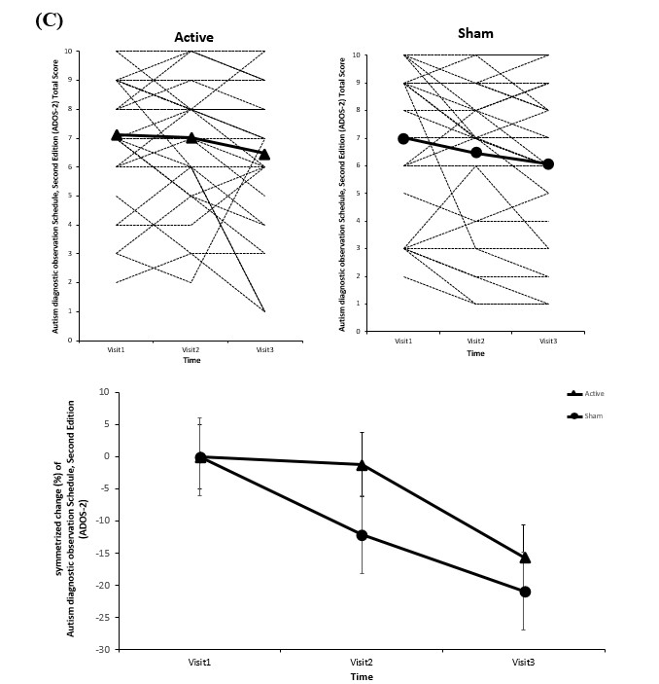

**Figure S2.** Changes of raw scores and symmetrized percentage in the total scores of Reading the Mind in the Eye Test in the active and sham iTBS groups across baseline, week 8 and week 12. (a) raw scores in the active group; (b) raw scores in the sham group; (c) symmetrized percentage changes for both groups

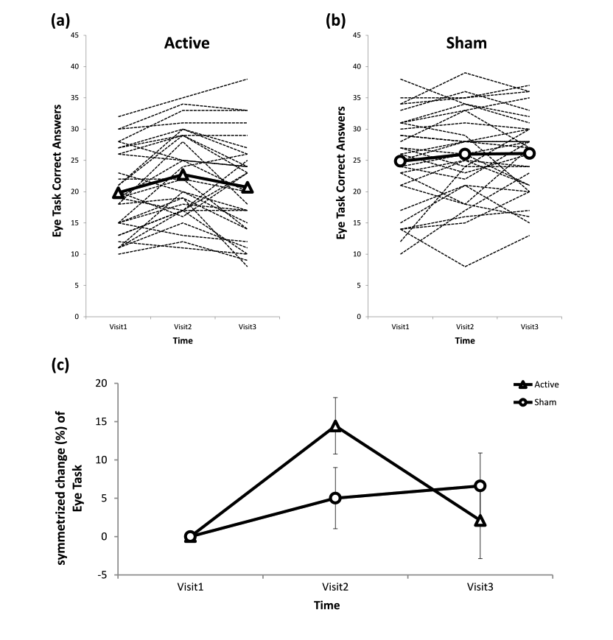

**Figure S3.** Changes of raw scores and symmetrized percentage in the total scores of emotion dysregulation inventory in the active and sham iTBS groups across baseline, week 8 and week 12. (a) raw scores in the active group; (b) raw scores in the sham group; (c) symmetrized percentage changes for both groups

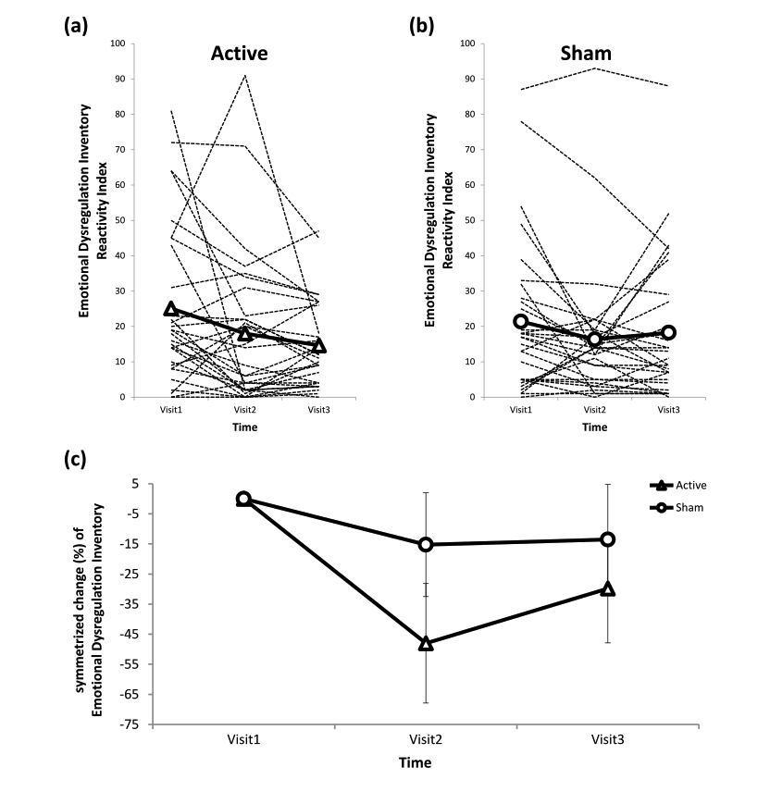

**Figure S4.** Changes of raw scores and symmetrized percentage in the total scores of adaptive behavior assessment system-II in the active and sham iTBS groups across baseline, week 8 and week 12. (a) raw scores in the active group; (b) raw scores in the sham group; (c) symmetrized percentage changes for both groups

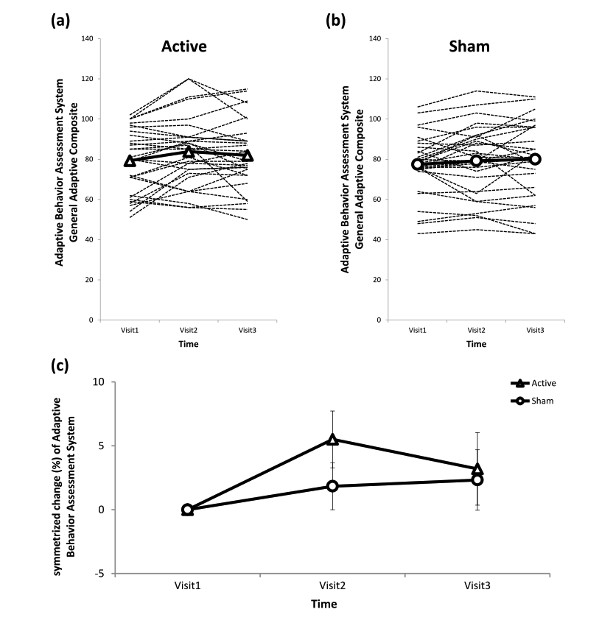

**Figure S5.** The raw scores in two age subgroups. (A) SRS, (B) RBS-R, (C) ADOS-2 CSS, (D) RMET, (E) Frith-Happe Animations, Categorization, (F) Frith-Happe Animations, Feeling, (G) EDI, (H) ABAS-II

