Appendix A. Full search strings in the international and Chinese databases
Appendix B. The definition of psychological treatment
Appendix C. Characteristics of psychological treatments
Appendix D. Funnel plot and Egger’s test
Appendix E. Bivariate meta-regression analyses
Appendix F. References of included studies

Appendix A. Full search strings in the international and Chinese databases
International databases
PubMed search
("obsessive compulsive"[Title/Abstract] OR "OCD"[Title/Abstract]) AND (randomizedcontrolledtrial[Filter])
Embase
'obsessive compulsive':ti,ab,kw OR ocd:ti,ab,kw
AND 'randomized controlled trial'/de
PsycINFO
MA "obsessive compulsive" or OCD
Expanders - Apply equivalent subjects
Narrow by Methodology: - clinical trial
Search modes - Boolean/Phrase
WHO’s Registry (international clinical trials registry platform of WHO)
“obsessive compulsive” or OCD
Chinese databases
CNKI (TKA=Title/Keyword/Abstract; FT=Full Text)
TKA = ('强迫症' + '强迫性神经官能症' + '强迫性障碍' + '强迫障碍' + '强迫性神经症') AND TKA = ('治疗' + '疗法' + '干预' + '医治' + '辅导') AND (FT= ('临床试验'+'随机对照试验') OR TKA= ('临床'+'试验'+'随机'+'交叉'+'组'+'安慰剂'+'双盲'+'单盲'+'三盲'+'平行组'+'对照研究'+'对照试验'+'对照设计'+'随机对照'+'随机对照研究'+'随机对照临床试验'+'随机对照临床研究'+'随机对照实验'+'随机化'+'RCT'))
同义词扩展
WanFang (题名或关键词=Title or Keyword; 摘要=Abstract)
((题名或关键词:(强迫症 or 强迫性神经官能症 or 强迫性障碍 or 强迫障碍 or 强迫性神经症) AND 题名或关键词:(治疗 or 疗法 or 干预 or 医治 or 辅导)) or (摘要:(强迫症 or 强迫性神经官能症 or 强迫性障碍 or 强迫障碍 or 强迫性神经症) AND 摘要:(治疗 or 疗法 or 干预 or 医治 or 辅导)))
AND (全部: (临床试验 OR 随机对照试验) OR 题名或关键词: (临床 OR 试验 OR 随机 OR交叉 OR 组 OR 安慰剂OR 双盲OR 单盲OR 三盲OR 平行组 OR 对照研究 OR 对照试验 OR 对照设计 OR 随机对照 OR 随机对照研究 OR 随机对照临床试验 OR 随机对照临床研究 OR 随机对照实验 OR 随机化 OR RCT) OR 摘要: (临床 OR 试验 OR 随机 OR交叉 OR 组 OR 安慰剂OR 双盲OR 单盲OR 三盲OR 平行组 OR 对照研究 OR 对照试验 OR 对照设计 OR 随机对照 OR 随机对照研究 OR 随机对照临床试验 OR 随机对照临床研究 OR 随机对照实验 OR 随机化 OR RCT))
主题词扩展
WeiPu (M=Title/Keyword; R=Abstract)
((M=(强迫症+强迫性神经官能症+强迫性障碍+强迫障碍+强迫性神经症) AND M=(治疗+疗法+干预+医治+辅导)) OR (R=(强迫症+强迫性神经官能症+强迫性障碍+强迫障碍+强迫性神经症) AND R=(治疗+疗法+干预+医治+辅导)))
AND (U=(临床试验 OR 随机对照试验) OR (M=(临床 OR 试验 OR 随机 OR交叉 OR 组 OR 安慰剂OR 双盲OR 单盲OR 三盲OR 平行组 OR 对照研究 OR 对照试验 OR 对照设计 OR 随机对照 OR 随机对照研究 OR 随机对照临床试验 OR 随机对照临床研究 OR 随机对照实验 OR 随机化 OR RCT)) OR (R=(临床 OR 试验 OR 随机 OR交叉 OR 组 OR 安慰剂OR 双盲OR 单盲OR 三盲OR 平行组 OR 对照研究 OR 对照试验 OR 对照设计 OR 随机对照 OR 随机对照研究 OR 随机对照临床试验 OR 随机对照临床研究 OR 随机对照实验 OR 随机化 OR RCT)))
ChiCTR(Chinese Clinical Trial Registry)
强迫

Appendix B The definition of psychological treatment
Psychological treatment | Definition
Exposure and response prevention (ERP) | Treatment consists of graded exposure to OCD provoking situations, thoughts, images or objects that induce anxiety, and the response prevention part refers to not engaging in a compulsive (safety) behaviour once the anxiety or obsessions have been triggered.
Cognitive therapy (CT) | Treatment involves restructuring or modifying automatic negative thoughts (i.e., interpretations) related to the intrusive obsessive content, along with a similar focus on modifying the core beliefs/dysfunctional cognitive biases.
Cognitive-behavioural therapy (CBT) | Treatment content containing both cognitive and behavioural therapeutic techniques, such as containing both ERP and CT.
Third-wave CBT | Treatments are a heterogeneous group of therapies that introduce several new techniques to cognitive-behavioural therapies. They have in common that they abandon or only cautiously use content-oriented cognitive interventions. Well-known third-wave CBT includes Acceptance and Commitment Therapy (ACT), Mindfulness-based Cognitive Therapy (MBCT).

Appendix C. Characteristics of psychological treatments
Study | Treatment delivered by a licensed psychologist, psychiatrist, nurse / psychology Master or PhD students? |  | was treatment integrity verified? | Name of treatment | Was a treatment manual / protocol used?
Alcolado,2016 | Not reported |  | Yes | CT | Yes | The intervention was a manualized cognitive-behavioural module developed by the authors for the purpose of the current study, in collaboration with their research team, and in consultation with other experts in the cognitive-behavioural treatment for OCD.
Anderson,2007 | Yes | trained postgraduate level clinical psychology students | Yes | CBT | Yes | Rees, C., & Nathan, P. (2001). Obsessive Compulsive Disorder Group Treatment Program: A group cognitive behavioural programme. Nedlands, Western Australia: Riobay Enterprises.
Andersson,2012 | Yes | all clinical psychology students in their final year of the 5-year psychology program | Yes | CBT | Yes | Abramowitz JS (2006). The psychological treatment of obsessive-compulsive disorder. Canadian Journal of Psychiatry 51, 407–416.
Barrett,2003 | No report |  | No report | CBT | Yes | March JS, Mulle K, Herbel B (1994). Behavioral psychotherapy for children and adolescents with obsessive-compulsive disorder: An open trial of a new protocol-driven treatment package. Journal of the American Academy of Child and Adolescent Psychiatry, 33, 333-34
Barrett,2004 | Yes | All treatment was conducted by graduate students, trained and supervised by the first author | Yes | CBT | Yes | March J, Mulle K, Herbel B (1994), Behavioral psychotherapy for children and adolescents with obsessive-compulsive disorder: an open trial of a new protocol-driven treatment package. J Am Acad Child Adolesc Psychiatry 33:333–341
Bolton,2008 | Yes | The authors, both clinicians with extensive training and experience in E/RP and CBT for OCD in children and adolescents, delivered the treatment as described above. | Yes | ERP | Yes | Piacentini, J., Gitow, A., Jaffer, M., Graae, M. D., & Whitaker, M. D. (1994). Outpatient behavioral treatment of child and adolescent obsessive compulsive disorder. Journal of Anxiety Disorders, 8, 277–289.
Bolton,2011 | Yes | training, treatment was delivered by five of the authors (LA, DB, CG, SP & PW). | Yes | CBT | Yes | Salkovskis, P.M. (1999). Understanding and treating obsessive-compulsive disorder. Behaviour Research and Therapy, 37, s29–s52
Braga,2016 | Yes | All sessions were conducted by the same trained Ph.D. and masters level clinicians and assisted by an equally experienced cotherapist. All clinicians specialized in CBT for OCD, with at least 5 years ofclinical experience. | No report | CBT | Yes | Cordioli AV, Heldt E, Braga DT, et al. Cognitive-behavioral group therapy in obsessive-compulsive disorder: a randomized clinical trial. Psychother Psychosom 2003;72:211–216.
Challacombe,2017 | Yes | iCBT was predominantly delivered by the first author (F.L.C.) who is a qualified clinician, who received ongoing supervision in CBT for OCD for the duration of the study. | Yes | CBT | No report
Cordioli,2003 | Yes | All sessions were conducted by the same therapist, assisted by a co-therapist, both specialized in psychiatry and with a CBT experience of at least 10 years | No report | CBT | Yes | Cordioli AV, Heldt E, Bochi DB, Margis M, de Sousa MB, Tonello JF, Teruchkin B, Kapczinski F: Time-limited cognitive-behavioral group therapy in the treatment of obsessive-compulsive disorder: An open clinical trial. Rev Bras Psiquiatr 2002;24:113–120.
Fals-Stewart,1992 | Yes | behavior therapists with expertise in treating OCD. | No report | ERP | No report
Foa,2005 | Yes | Exposure and ritual prevention therapists received training and ongoing weekly supervision from faculty from the Philadelphia site | Yes | ERP | Yes | Kozak MJ, Foa EB: Mastery of Obsessive-Compulsive Disorder: A Cognitive Behavioral Approach. San Antonio, Tex, Graywind Publications, 1997
Freeman,2014 | Yes | Treatment providers for FB-CBT and FB-RT were clinical psychologists and clinical psychology trainees already familiar with CBT | Yes | CBT | Yes | Choate-Summers M, Freeman J, Garcia A, Coyne L, Przeworski A, Leonard HL. Clinical considerations when tailoring cognitive behavioral treatment for young children with obsessive compulsive disorder. Educ Treat Child. In press.
Freeman,2008 | Yes | All study therapists were clinical psychology interns, postdoctoral fellows, and clinical psychologists with expertise in the application of behavior therapy with anxiety disorders, parent behavior management training, and relaxation and family-based treatment. | Yes | CBT | Yes | Choate-Summers M, Freeman J, Garcia A, Coyne L, Przeworski A, Leonard HL. Clinical considerations when tailoring cognitive behavioral treatment for young children with obsessive compulsive disorder. Educ Treat Child. In press
Freeston,1997 | Yes | There were four therapists, all graduate students trained in cognitive behavior therapy techniques. | Yes | CBT | Yes | An updated English version based on the treatment manual is available from Mark H. Freeston
Gomes,2016 | Yes | CBGT was delivered in 12 sessions, lasting for 2 h each, over 3 months, coordinated by two therapists with prior experience in CBGT. | No report | CBT | Yes | Cordioli, A.V., Heldt, E., Bochi, D.B., Margis, M., de Sousa, M.B., Tonello, J.F., Teruchkin, B., Kapczinski, F., 2002. Cognitive-behavioral group therapy in obsessive-compulsive disorder: a clinical trial. Rev. Bras. Psiquiatr. 24, 113–120
Greist,2002 | Yes | Behavior therapist | Yes | ERP | Yes | Marks IM, Baer L, Greist JH, et al. Home self-assessment of obssivecompulsive disorder. Use of a manual and a computer-conducted telephone interview: two US-UK studies. Br J Psychiatry 1998;172:406–412
Herbst,2014 | Yes | The treatment was conducted by 3 experienced cognitive behavioral therapists, each with at least 4 years of therapeutic expertise. | No report | ERP | Yes | Lakatos A, Reinecker H: Kognitive Verhaltenstherapie bei Zwangsstörungen: ein Therapiemanual, revised ed 3. Göttingen, Hogrefe, 2007.
Khodarahimi,2009 | Yes | clinical psychologist | Yes | ERP; other psychotherapy | Yes | Salkovskis, P. M., & Kirk, J. (1989). Obsessional disorders. In K. Hawton, et al. (Eds.), Cognitive behavior therapy for psychiatric problems: A practical guide. Oxford: Oxford university press.
Kobayashi,2020 | Yes | Four clinical psychologists with doctorate or master’s degrees facilitated the FERP program. | Yes | ERP | Yes | Ministry of Health, Labour, and Welfare. Cognitive behavioral therapy for Obsessive-Compulsive Disorder. In: Treatment manual for therapist. Japan (2015). https://www.mhlw.go.jp/stf/seisakunitsuite/bunya/hukushi_kaigo/ shougaishahukushi/kokoro/index.html
Kyrios,2018 | Yes | Therapists (n=10) were either psychologists or students undertaking a masters or professional doctorate in clinical psychology and underwent an online training module for e-therapists working within the Mental Health Online platform [49]. | Yes | CBT | Yes | Kyrios M, Nedeljkovic M, Moulding R, Klein B, Austin D, Meyer D, et al. Study protocol for a randomised controlled trial of internet-based cognitive-behavioural therapy for obsessive-compulsive disorder. BMC Psychiatry 2014 Jul 25;14:209 [FREE Full text] [doi: 10.1186/1471-244X-14-209] [Medline: 25062747]
Launes,2019 | Yes | All therapists had taken part in the national OCD-training program (Kvale and Hansen, 2014). | Yes | ERP | Yes | Launes, G., Laukvik, I. L., Sunde, T., Klovning, I., Hagen, K., Solem, S., et al. (2019). The Bergen 4-day treatment for obsessive-compulsive disorder: does it work in a new clinical setting? Front. Psychol. 10:1069. doi: 10.3389/fpsyg.2019.01069
Lenhard,2017 | Yes | Treating clinicians were 6 trained psychologists with experience in treating pediatric OCD and ICBT | Yes | CBT | Yes | Lenhard F, Vigerland S, Andersson E, et al. Internet-delivered cognitive behavior therapy for adolescents with obsessive-compulsive disorder: an open trial. PLoS One. 2014;9:e100773.
Lewin,2014 | Yes | Therapists were licensed clinical psychologists or advanced clinical psychology doctoral students (who had3 years’ experience in E/RP for OCD under the supervision of the principal investigator); | Yes | ERP | Yes | Freeman, J. B., & Garcia, A. M. (2009). Family-based treatment for young children with OCD workbook. New York, NY: Oxford University Press.
Lindsay,1997 | Yes | Clinicians | No report | ERP | Yes | Andr.ws, G.,Crlno, R., Hunt,C., at at(I994) TheTreatment ofAnxietyDisorders.NewYork:CambridgeUniversity Press.
Mancebo,2021 | Yes | master’s-level therapist | Yes | ERP | Yes | Kozak, M. J., & Foa, E. B. (1997). Mastery of obsessivecompulsive disorder: A cognitive-behavioral approach. Graywind.
Mathur,2021 | Yes | The first author, a clinical psychologist, having post-graduate degrees in MA (psychology) and MPhil (Clinical Psychology) and pursuing doctoral course administered both CBT and MBCT. | Yes | Third-wave | Yes | Shapiro, S.L., Carlson, L.E., Astin, J.A., Freedman, B., 2006. Mechanisms of mindfulness. J. Clin. Psychol. 62, 373–386. https://doi.org/10.1002/jclp.20237.
Matsumoto,2022 | Yes | Two clinical psychologists with a PhD (one male [KM] and female [SH] in their early thirties) who completed the training in CBT and had experience providing CBT for OCD guided the participants using Share Medical | Yes | CBT | Yes | The ICBT program, was developed by the first author (KM) on the elearning platform (LearningBox®) of Tatsuno System Inc.
Norman,2021 | Yes | Therapy providers were trained to deliver both CBT and SMT. | Yes | ERP | Yes | Kozak M, Foa E: Mastery of obsessive-compulsive disorder: A cognitive-behavioral approach: Therapist guide. Oxford, England, Oxford University Press, 1997
O'Connor,1999 | No report |  | No report | CBT | No report
O'Connor,2006 | Yes | All six therapists (S.R., S.G., M.-C.P., V.L., S.G. and P.D.) were CBT trained and supervised by one of the principal investigators. | Yes | CBT | Yes | Steketee G, ed. Overcoming obsessive–compulsive disorder: a behavioural and cognitive protocol for the treatment of OCD. Oakland: New Harbinger Publications, 1999.
Piacentini,2011 | Yes | Treatment was provided by doctoral-level psychologists and advanced clinical child psychology interns with specialty training in CBT for pediatric OCD | Yes | CBT | Yes | Piacentini, J.; Langley, A.; Roblek, T. It’s Only a False Alarm: Child Workbook. New York: Oxford University Press; 2007.
Rezvan,2013 | No report |  | No report | other psychotherapy | No report
Rupp,2019 | Yes | Both therapists were Master level psychologists at an advanced stage oftheir clinical CBT licensing training | Yes | other psychotherapy | Yes | Wilhelm S, Steketee GS. Cognitive Therapy for Obsessive-Compulsive Disorder: A Guide for Professionals. Oakland, CA: New Harbinger Publications, Inc.; 2006.
Russell,2013 | Yes | The treating therapists were all clinical psychologists (n=4) trained within a cognitive behavioral framework who had extensive experience in treating OCD in both young people and adults. | Yes | ERP | Yes | Attwood T. Modifications to cognitive behaviour therapy to accommodate the cognitive profile of people with Asperger’s syndrome. 1999. Available at: http://www.tonyattwood. com/paper2.htm.
Russman Block,2023 | Yes | Both conditions were standardized using written manuals on which therapists were trained and supervised (available on request). | Yes | ERP | Yes | March J, Mulle K: OCD in Children and Adolescents: A Cognitive-Behavioral Treatment Manual. New York, Guilford Press, 1998
Storch,2011 | Yes | Therapists were doctoral students in clinical psychology with at least 1 year of applied experience with CBT for OCD. | Yes | CBT | Yes | Pediatric OCD Treatment Study, 2004. Cognitive-behavior therapy, sertraline, and their combination for children and adolescents with obsessive-compulsive disorder: the pediatric OCD Treatment Study randomized controlled trial. Journal of the American Medical Association 292, 1969–1976.
POST,2004 | No report |  | No report | CBT | Yes | March J, Mulle K. OCD in Children and Adolescents: ACognitive-Behavioral Treatment Manual.New York, NY: Guilford Press; 1998.
Twohig,2010 | Yes | All therapists and assessors were advanced graduate students in clinical psychology | Yes | Third-wave | Yes | Hayes, SC.; Strosahl, KD.; Wilson, KG. Acceptance and Commitment Therapy: An experiential approach to behavior change. Guilford Press; New York: 1999.
van Balkom,1998 | Yes | All therapists had experience with behavioral treatment for OCD and received training in cognitive therapy. | Yes | CT; ERP | Yes | van Oppen P, Arntz A (1994) Cognitive therapy for obsessive compulsive disorder. Behav Res Ther 32:79-87; Hoogduin CAL, Hoogduin WA (1984) The out-patient treatment of patients with an obsessive-compulsive disorder. Behav Res Ther 22:455-460
Vogel,2014 | No report |  | Yes | ERP | No report
Whittal,2010 | Yes | Postdoctoral fellows with experience in the treatment of anxiety and OCD | Yes | CT | Yes | Rachman, S. (2003). The treatment of obsessions. Oxford: Oxford University Press.
Wilhelm,2009 | Yes | Treatment was administered by advanced doctoral students in psychology or by postdoctoral clinicians in training. | Yes | CT | Yes | Wilhelm, S.; Steketee, G. Cognitive therapy for obsessive-compulsive disorder: A guide for professionals. Oakland, CA: New Harbinger Publications; 2006.
Williams,2010 | Yes | the therapists for the trial (TW, HW, ST) were clinical psychologists employed by the National Health Service (NHS) in England to work in community child and adolescent mental health clinics. | Yes | CBT | Yes | 29. Salkovskis PM (1998) Psychological approaches to the understanding of obsessional problems. In: Swinson RP, Antony MM, Rachman SJ, Richter MA (eds) Obsessive-compulsive disorder: theory, research and treatment. Guilford, New York
Wootton,2013 | Yes | The first author (BMW), a Clinical Psychologist, provided all clinical contact with participants (telephone calls, emails, and diagnostic interviews) and collated all the data. | Yes | CBT | Yes | The remote protocol used in the study (The OCD Course) was developed by the first three authors and contains 5 Lessons, designed to be read by participants over 8 weeks
Wolters,2016 | Yes | CBT was delivered by master level clinicians certified as cognitive behavioral therapists and experienced in treating OCD in children | Yes | CBT | Yes | De Haan, E., & Wolters, L. H. (2009). Behandeling van de dwangstoornis bij kinderen en adolescenten. Met het cognitief-gedragstherapeutisch protocol Bedwing je dwang. Houten: Bohn Stafleu van Loghum.
Zhang,2021 | Yes | Psychotherapists or psychiatrists specialized to OCD treatment; Trained by the founder of MBCT for OCD (Fabrizio Didonna) and one of the founders of MBCT (Mark Williams) to ensure treatment fidelity | No report | Third-wave | Yes | Didonna F, Lanfredi M, Xodo E, Ferrari C, Rossi R, Pedrini L. Mindfulnessbased cognitive therapy for obsessive-compulsive disorder: a pilot study. J Psychiatr Pract. (2019) 25:156–70. doi: 10.1097/PRA.0000000000000377
符泽娟,2016 | No report |  | No report | CBT | No report

Appendix D. Funnel plot and Egger’s test
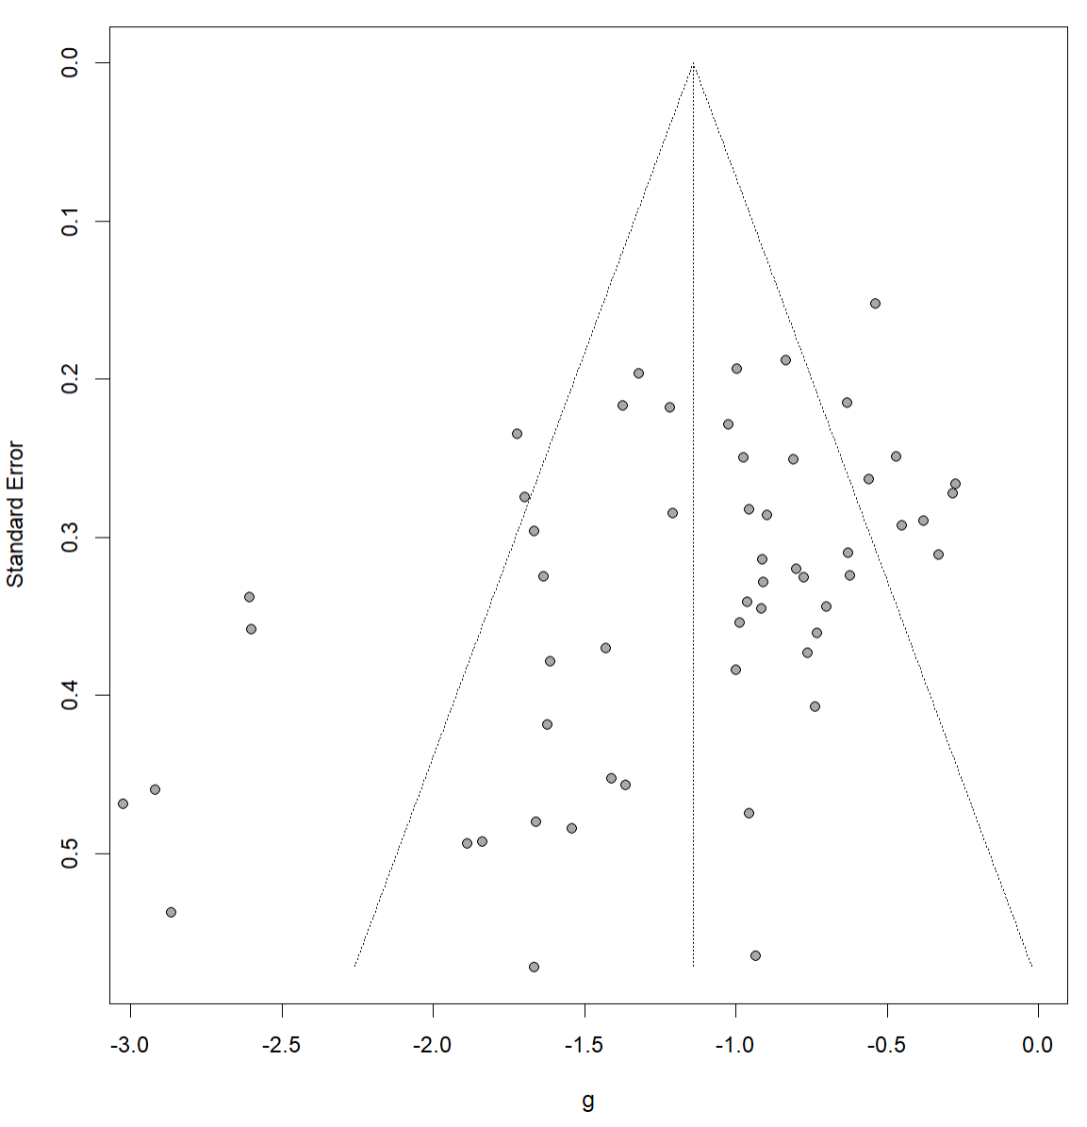
 | Intercept | 95% CI | t | p
Egger’s test | -2.57 | [-0.31, 0.24] | -3.23 | 0.0021

Appendix E. Bivariate meta-regression analyses

Variable | R² | β | 95% CI | P
Baseline symptom severity | 29.91% | -0.1 | [-0.18; -0.016] | 0.02
Mean age | 5.59% | -0.02 | [-0.07; 0.02] | 0.26
Proportion of women | 8.27% | -0.01 | [-0.03; 0.003] | 0.13
Proportion of participants using psychiatric medicine in treatment group | 0% | 0.002 | [-0.01; 0.01] | 0.76
Number of treatment sessions | 0% | -0.01 | [-0.05; 0.03] | 0.6

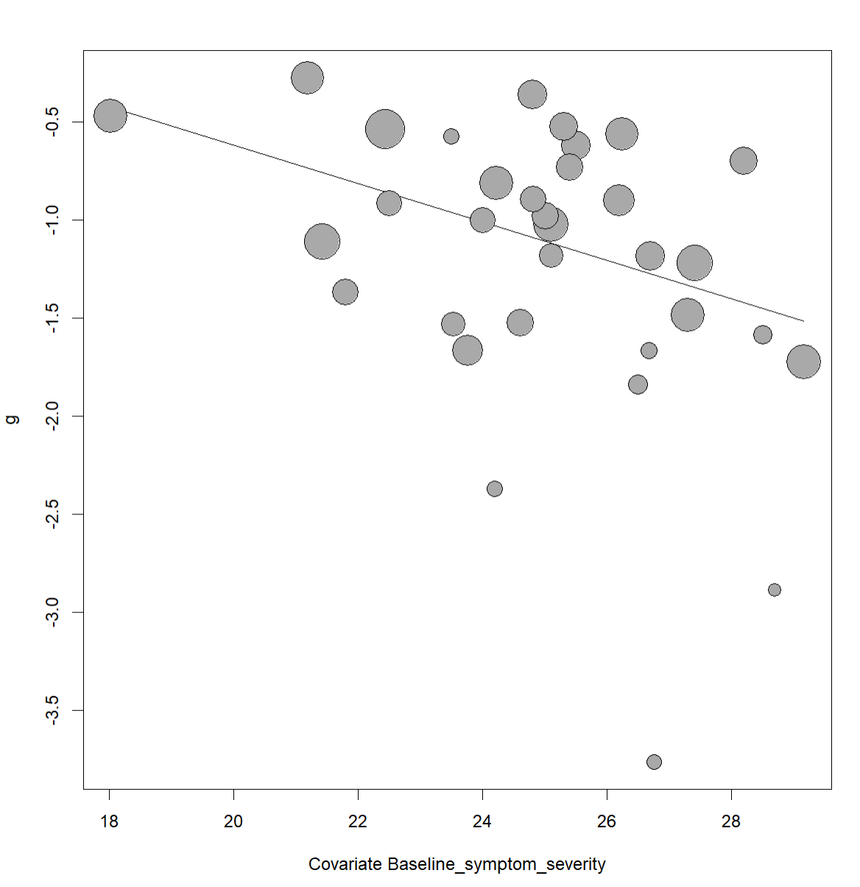
Association between baseline OCD symptom severity and treatment effect based on clinician-rated Y-BOCS

Association between baseline OCD symptom severity and treatment effect based on clinician-rated Y-BOCS

Appendix F. References of included studies
Alcolado, G. M., & Radomsky, A. S. (2016). A novel cognitive intervention for compulsive checking: Targeting maladaptive beliefs about memory. Journal of Behavior Therapy and Experimental Psychiatry, 53, 75-83.
Anderson, R. A., & Rees, C. S. (2007). Group versus individual cognitive-behavioural treatment for obsessive-compulsive disorder: a controlled trial. Behav Res Ther, 45(1), 123-137.
Andersson, E., Enander, J., Andrén, P., Hedman, E., Ljótsson, B., Hursti, T., . . . Rück, C. (2012). Internet-based cognitive behaviour therapy for obsessive-compulsive disorder: a randomized controlled trial. Psychol Med, 42(10), 2193-2203.
Barrett, P., Healy-Farrell, L., & March, J. S. (2004). Cognitive-behavioral family treatment of childhood obsessive-compulsive disorder: a controlled trial. J Am Acad Child Adolesc Psychiatry, 43(1), 46-62.
Barrett, P., Healy, L., & March, J. S. (2003). Behavioral avoidance test for childhood obsessive-compulsive disorder: A home-based observation. American Journal of Psychotherapy, 57(1), 80-100.
Bolton, D., & Perrin, S. (2008). Evaluation of exposure with response-prevention for obsessive compulsive disorder in childhood and adolescence. J Behav Ther Exp Psychiatry, 39(1), 11-22.
Bolton, D., Williams, T., Perrin, S., Atkinson, L., Gallop, C., Waite, P., & Salkovskis, P. (2011). Randomized controlled trial of full and brief cognitive-behaviour therapy and wait-list for paediatric obsessive-compulsive disorder. J Child Psychol Psychiatry, 52(12), 1269-1278.
Braga, D. T., Abramovitch, A., Fontenelle, L. F., Ferrão, Y. A., Gomes, J. B., Vivan, A. S., . . . Cordioli, A. V. (2016). NEUROPSYCHOLOGICAL PREDICTORS OF TREATMENT RESPONSE TO COGNITIVE BEHAVIORAL GROUP THERAPY IN OBSESSIVE-COMPULSIVE DISORDER. Depress Anxiety, 33(9), 848-861.
Challacombe, F. L., Salkovskis, P. M., Woolgar, M., Wilkinson, E. L., Read, J., & Acheson, R. (2017). A pilot randomized controlled trial of time-intensive cognitive–behaviour therapy for postpartum obsessive–compulsive disorder: Effects on maternal symptoms, mother–infant interactions and attachment. Psychological Medicine, 47(8), 1478-1488. R
Cordioli, A. V., Heldt, E., Bochi, D. B., Margis, R., De Sousa, M. B., Tonello, J. F., . . . Kapczinski, F. (2003). Cognitive-behavioral group therapy in obsessive-compulsive disorder: A randomized clinical trial. Psychotherapy and Psychosomatics, 72(4), 211-216.
Fals-Stewart, W., & Schafer, J. (1992). The treatment of substance abusers diagnosed with obsessive-compulsive disorder: an outcome study. J Subst Abuse Treat, 9(4), 365-370.
Foa, E. B., Liebowitz, M. R., Kozak, M. J., Davies, S., Campeas, R., Franklin, M. E., . . . Tu, X. (2005). Randomized, placebo-controlled trial of exposure and ritual prevention, clomipramine, and their combination in the treatment of obsessive-compulsive disorder. Am J Psychiatry, 162(1), 151-161.
Freeman, J., Sapyta, J., Garcia, A., Compton, S., Khanna, M., Flessner, C., . . . Benito, K. (2014). Family-based treatment of early childhood obsessive-compulsive disorder: The Pediatric Obsessive-Compulsive Disorder Treatment Study for Young Children (POTS Jr)—A randomized clinical trial. JAMA psychiatry, 71(6), 689-698.
Freeman, J. B., Garcia, A. M., Coyne, L., Ale, C., Przeworski, A., Himle, M., . . . Leonard, H. L. (2008). Early childhood OCD: Preliminary findings from a family-based cognitive-behavioral approach. Journal of the American Academy of Child & Adolescent Psychiatry, 47(5), 593-602.
Freeston, M. H., Ladouceur, R., Gagnon, F., Thibodeau, N., Rhéaume, J., Letarte, H., & Bujold, A. (1997). Cognitive-behavioral treatment of obsessive thoughts: a controlled study. J Consult Clin Psychol, 65(3), 405-413.
Gomes, J. B., Cordioli, A. V., Bortoncello, C. F., Braga, D. T., Gonçalves, F., & Heldt, E. (2016). Impact of cognitive-behavioral group therapy for obsessive-compulsive disorder on family accommodation: A randomized clinical trial. Psychiatry Res, 246, 70-76.
Greist, J. H., Marks, I. M., Baer, L., Kobak, K. A., Wenzel, K. W., Hirsch, M. J., . . . Clary, C. M. (2002). Behavior therapy for obsessive-compulsive disorder guided by a computer or by a clinician compared with relaxation as a control. J Clin Psychiatry, 63(2), 138-145.
Herbst, N., Voderholzer, U., Thiel, N., Schaub, R., Knaevelsrud, C., Stracke, S., . . . Külz, A. K. (2014). No talking, just writing! Efficacy of an Internet-based cognitive behavioral therapy with exposure and response prevention in obsessive compulsive disorder. Psychother Psychosom, 83(3), 165-175.
Khodarahimi, S. (2009). Satiation therapy and exposure response prevention in the treatment of obsessive compulsive disorder. Journal of Contemporary Psychotherapy, 39(3), 203-207.
Kobayashi, Y., Kanie, A., Nakagawa, A., Takebayashi, Y., Shinmei, I., Nakayama, N., . . . Mimura, M. (2020). An evaluation of family-based treatment for OCD in Japan: a pilot randomized controlled trial. Frontiers in Psychiatry, 10, 932.
Kyrios, M., Ahern, C., Fassnacht, D. B., Nedeljkovic, M., Moulding, R., & Meyer, D. (2018). Therapist-Assisted Internet-Based Cognitive Behavioral Therapy Versus Progressive Relaxation in Obsessive-Compulsive Disorder: Randomized Controlled Trial. J Med Internet Res, 20(8), e242.
Launes, G., Hagen, K., Sunde, T., Öst, L.-G., Klovning, I., Laukvik, I.-L., . . . Hansen, B. (2019). A randomized controlled trial of concentrated ERP, self-help and waiting list for obsessive-compulsive disorder: the Bergen 4-day treatment. Frontiers in Psychology, 10, 2500.
Lenhard, F., Andersson, E., Mataix-Cols, D., Rück, C., Vigerland, S., Högström, J., . . . Serlachius, E. (2017). Therapist-Guided, Internet-Delivered Cognitive-Behavioral Therapy for Adolescents With Obsessive-Compulsive Disorder: A Randomized Controlled Trial. J Am Acad Child Adolesc Psychiatry, 56(1), 10-19.e12.
Lewin, A. B., Park, J. M., Jones, A. M., Crawford, E. A., De Nadai, A. S., Menzel, J., . . . Storch, E. A. (2014). Family-based exposure and response prevention therapy for preschool-aged children with obsessive-compulsive disorder: a pilot randomized controlled trial. Behav Res Ther, 56, 30-38.
Lindsay, M., Crino, R., & Andrews, G. (1997). Controlled trial of exposure and response prevention in obsessive-compulsive disorder. Br J Psychiatry, 171, 135-139.
Mancebo, M. C., Yip, A. G., Boisseau, C. L., Rasmussen, S. A., & Zlotnick, C. (2021). Behavioral Therapy Teams for Obsessive-Compulsive Disorder: Lessons Learned From a Pilot Randomized Trial in a Community Mental Health Center. Behav Ther, 52(5), 1296-1309.
Mathur, S., Sharma, M. P., Balachander, S., Kandavel, T., & Reddy, Y. C. J. (2021). A randomized controlled trial of mindfulness-based cognitive therapy vs stress management training for obsessive-compulsive disorder. Journal of Affective Disorders, 282, 58-68.
Matsumoto, K., Hamatani, S., Makino, T., Takahashi, J., Suzuki, F., Ida, T., . . . Omori, I. M. (2022). Guided internet-based cognitive behavioral therapy for obsessive-compulsive disorder: A multicenter randomized controlled trial in Japan. Internet interventions, 28, 100515.
Norman, L. J., Mannella, K. A., Yang, H., Angstadt, M., Abelson, J. L., Himle, J. A., . . . Taylor, S. F. (2021). Treatment-Specific Associations Between Brain Activation and Symptom Reduction in OCD Following CBT: A Randomized fMRI Trial. Am J Psychiatry, 178(1), 39-47.
O'Connor, K., Todorov, C., Robillard, S., Borgeat, F., & Brault, M. (1999). Cognitive-behaviour therapy and medication in the treatment of obsessive-compulsive disorder: a controlled study. The Canadian Journal of Psychiatry, 44(1), 64-71.
O'Connor, K. P., Aardema, F., Robillard, S., Guay, S., Pélissier, M. C., Todorov, C., . . . Doucet, P. (2006). Cognitive behaviour therapy and medication in the treatment of obsessive-compulsive disorder. Acta Psychiatr Scand, 113(5), 408-419.
Piacentini, J., Bergman, R. L., Chang, S., Langley, A., Peris, T., Wood, J. J., & McCracken, J. (2011). Controlled comparison of family cognitive behavioral therapy and psychoeducation/relaxation training for child obsessive-compulsive disorder. J Am Acad Child Adolesc Psychiatry, 50(11), 1149-1161.
Rezvan, S., Bahrami, F., Abedi, M., Macleod, C., Doost, H. T. N., & Ghasemi, V. (2013). A preliminary study on the effects of attachment-based intervention on pediatric obsessive-compulsive disorder. International journal of preventive medicine, 4(1), 78.
Rupp, C., Jürgens, C., Doebler, P., Andor, F., & Buhlmann, U. (2019). A randomized waitlist-controlled trial comparing detached mindfulness and cognitive restructuring in obsessive-compulsive disorder. PLoS One, 14(3), e0213895.
Russell, A. J., Jassi, A., Fullana, M. A., Mack, H., Johnston, K., Heyman, I., . . . Mataix-Cols, D. (2013). Cognitive behavior therapy for comorbid obsessive-compulsive disorder in high-functioning autism spectrum disorders: a randomized controlled trial. Depress Anxiety, 30(8), 697-708.
Russman Block, S., Norman, L. J., Zhang, X., Mannella, K. A., Yang, H., Angstadt, M., . . . Fitzgerald, K. D. (2023). Resting-State Connectivity and Response to Psychotherapy Treatment in Adolescents and Adults With OCD: A Randomized Clinical Trial. Am J Psychiatry, 180(1), 89-99. doi:10.1176/appi.ajp.21111173
Storch, E. A., Caporino, N. E., Morgan, J. R., Lewin, A. B., Rojas, A., Brauer, L., . . . Murphy, T. K. (2011). Preliminary investigation of web-camera delivered cognitive-behavioral therapy for youth with obsessive-compulsive disorder. Psychiatry Res, 189(3), 407-412.
Team, P. O. T. S. P. (2004). Cognitive-behavior therapy, sertraline, and their combination for children and adolescents with obsessive-compulsive disorder: the Pediatric OCD Treatment Study (POTS) randomized controlled trial. Jama, 292(16), 1969-1976.
Twohig, M. P., Hayes, S. C., Plumb, J. C., Pruitt, L. D., Collins, A. B., Hazlett-Stevens, H., & Woidneck, M. R. (2010). A randomized clinical trial of acceptance and commitment therapy versus progressive relaxation training for obsessive-compulsive disorder. J Consult Clin Psychol, 78(5), 705-716.
van Balkom, A. J., de Haan, E., van Oppen, P., Spinhoven, P., Hoogduin, K. A., & van Dyck, R. (1998). Cognitive and behavioral therapies alone versus in combination with fluvoxamine in the treatment of obsessive compulsive disorder. The Journal of nervous and mental disease, 186(8), 492-499.
Vogel, P. A., Solem, S., Hagen, K., Moen, E. M., Launes, G., Håland, Å. T., . . . Himle, J. A. (2014). A pilot randomized controlled trial of videoconference-assisted treatment for obsessive-compulsive disorder. Behaviour Research and Therapy, 63, 162-168.
Whittal, M. L., Woody, S. R., McLean, P. D., Rachman, S. J., & Robichaud, M. (2010). Treatment of obsessions: a randomized controlled trial. Behav Res Ther, 48(4), 295-303.
Wilhelm, S., Steketee, G., Fama, J. M., Buhlmann, U., Teachman, B. A., & Golan, E. (2009). Modular cognitive therapy for obsessive-compulsive disorder: A wait-list controlled trial. Journal of Cognitive Psychotherapy, 23(4), 294-305.
Williams, T. I., Salkovskis, P. M., Forrester, L., Turner, S., White, H., & Allsopp, M. A. (2010). A randomised controlled trial of cognitive behavioural treatment for obsessive compulsive disorder in children and adolescents. Eur Child Adolesc Psychiatry, 19(5), 449-456.
Wolters, L. H., de Haan, E., Hogendoorn, S. M., Boer, F., & Prins, P. J. M. (2016). Severe pediatric obsessive compulsive disorder and co-morbid autistic symptoms: Effectiveness of cognitive behavioral therapy. Journal of Obsessive-Compulsive and Related Disorders, 10, 69-77.
Wootton, B. M., Dear, B. F., Johnston, L., Terides, M. D., & Titov, N. (2013). Remote treatment of obsessive-compulsive disorder: A randomized controlled trial. Journal of Obsessive-Compulsive and Related Disorders, 2(4), 375-384.
Zhang, T., Lu, L., Didonna, F., Wang, Z., Zhang, H., & Fan, Q. (2021). Mindfulness-Based Cognitive Therapy for Unmedicated Obsessive-Compulsive Disorder: A Randomized Controlled Trial With 6-Month Follow-Up. Frontiers in Psychiatry, 12.
Fu, Zejuan, & Xie, Hailin. (2016). Evaluation of the Effectiveness of Cognitive Behavioral Intervention Therapy on Improving the Psychological Status and Quality of Life of Patients with Obsessive-Compulsive Disorder. Practical Journal of Clinical Medicine, 20(8), 17-20.

