Figure 1s Probability X Reward X Group interaction in UHR-P, UHR-BD and healthy controls

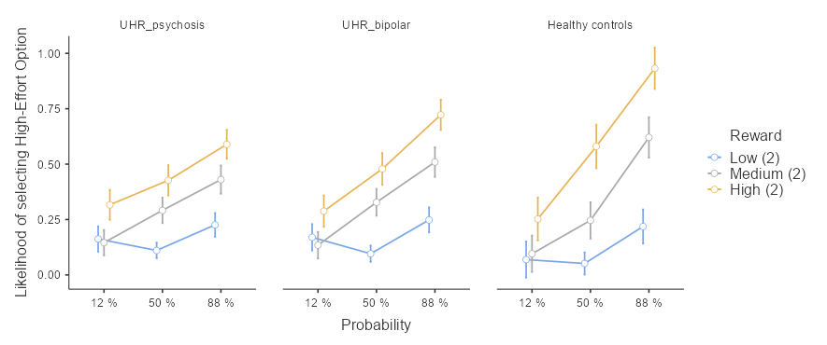

Figure 2s Probability X Reward X Group interaction in antipsychotic naïve UHR-P, UHR-BD and healthy controls

