**Supplemental Materials**

**Supplemental Methods**

***Participants***

A priori power analysis (G*power; Faul et al., 2009) for planned ANOVAs indicated n≥48 participants in each group (total of 96 participants) would be sufficient to obtain a statistical power of ≥80%, with $∝$ =0.05 (Cohen, 2013). Considering typical attrition rates in fear learning studies involving youth (Flasinski et al., 2022; Ryan, Zimmer-Gembeck, Neumann, & Waters, 2019), as well as potential dropouts before the second visit and data exclusion due to technical or other issues, we aimed to recruit 62 participants per group.

Individuals were deemed ineligible to participate if they had any of the following: current use of psychotropic medications, a history of head injuries, a history of any psychiatric disorder, a current diagnosis of attention deficit hyperactivity disorder, or color blindness (Ishihara color blindness test, 1917).

|  |  |  |  |  |  |  |  |  |
| --- | --- | --- | --- | --- | --- | --- | --- | --- |
| **Table S1.** Demographic and clinical characteristics by age group (adult, adolescent) | | | | | | | | |
|  | Adults (*n*=65) | | | Youth (*n*=63) | | |  |  |
| Variables | Mean | SD | Range | Mean | SD | Range | Test | *p.v.* |
| SCAARED/  SCARED | 22.66 | 14.13 | 0-49 | 25.26 | 12.24 | 6-54 | *t(*124) = -1.10 | .272 |
| Sleep hours | 7.08 | 1.38 | 4-10 | 7.56 | 1.63 | 3-11.25 | *t*(124) = -1.79 | .075 |
| Sleep quality | 2.45 | .73 | 0-3 | 2.43 | .734 | 0-3 | *t*(124) = .13 | .893 |
| IUS | 68.93 | 17.90 | 33-118 | 75.56 | 14.36 | 41-109 | *t*(124) = -2.288 | .024* |
| Gender | 55.4 % females | | | 57.1 % females | | | (1) = .04 | .841 |
| *Notes.* SCARED: Screen for Child Anxiety Related Emotional Disorders, SCAARED: Screen for Adult Anxiety Related Disorders. Sleep hours and quality between visit 1 and visit 2. IUS: Intolerance of Uncertainty Scale. | | | | | | | | |

Although female (*M*=15.04, *SD*=1.77) and male (*M*=15.01, *SD*=1.50) adolescents in our sample did not differ in age, *t*(61)=-.062, *p*=.951, differences emerged in their pubertal development.Specifically, femaleadolescents were found to be in later stages of pubertal development (*M*=3.22, *SD*=.72) than male adolescents (*M*=2.61, *SD*=.79), as indicated by the continuous Pubertal Development Scale (PDS) scores, *t*(59)=-3.170, *p*=.002.

***Threat Learning Task***

**Figure S1 A.** Sequential overview of the experimental phases

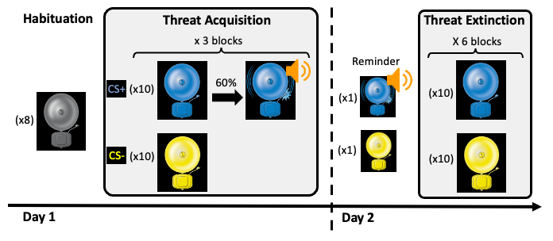

**Figure S1 B**. Trial structure and timeline

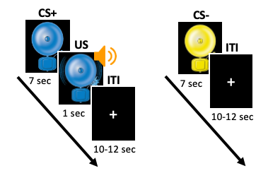

To maintain participants' attention during the extended extinction phase, a brief catch-trial was delivered between the second and third and between the fourth and fifth extinction blocks. Participants tracked white shapes on-screen in this catch-trial and pressed the spacebar whenever a 'V' sign appeared. They received no feedback or scores for this task.

**Measures**

***Self-Report Questionnaires***

**Intolerance of Uncertainty Scale (IUS).** This 27-item questionnaire measures emotional, cognitive, and behavioral responses to ambiguous situations, implications of being uncertain, and attempts to control the future (Freeston, Rhéaume, Letarte, Dugas, & Ladouceur, 1994). Each statement is rated on a 5-point Likert scale, from 1=not at all characteristic of me, to 5=entirely characteristic of me. The total IUS score ranges from 27 to 135. Internal consistency in our study was α=0.936 among adults, α=0.884 among adolescents, and α=0.918 overall.

**Pubertal Development Scale (PDS).** This self-report questionnaire is used to assess physical development among adolescents (Petersen, Crockett, Richards, & Boxer, 1988). Participants are asked to rate their physical development based on five indices, differing for males and females, on a 5-point scale (1=not yet started changing, 2=has barely started changing, 3=changes are definitely underway, 4=changes seem complete, and 0=I do not know). Males are asked about their physical changes on five dimensions: body hair, facial hair, voice change, skin change, and growth spurt. Females are asked about body hair, skin change, breast development, and growth spurt. Females are also asked about the onset of the first menstrual cycle using a yes-no question (1=no, 4=yes). Continuous scores are computed by averaging all items. The continuous PDS scores are converted into categorical 5-point ordinal scores, in line with the original Tanner categories (Tanner stages: 1=prepubertal, 2=early puberty, 3=midpubertal, 4=late puberty, 5=postpubertal), using a previously validated algorithm (Koopman-Verhoeff, Gredvig-Ardito, Barker, Saletin, & Carskadon, 2020). The internal consistency in our adolescent sample was α=0.804 in the male group, and α=0.668 in the female group.

***Electroencephalogram (EEG)***

**Recording.** During all task phases, EEG was recorded using a g.Nautilus RESEARCH 32 g.SCARABEO (g.tec, medical engineering GmbH, Austria) wearable headset with 32 Ag/AgCl electrodes. Electrodes were placed according to the standard 10-20 international system. Two additional electrodes were used, with AFz as a ground electrode and an active sintered Ag/AgCl electrode on the right earlobe as a reference. As per manufacturer’s instructions, electrode impedances were kept <30kΩ before recording. Data were amplified at 24-bit resolution and sampled at 500Hz.

**Pre-Processing.** We used standard guidelines for ERP analysis (Luck, 2014) and developmental considerations provided by the Maryland analysis of the developmental EEG (MADE) pipeline (Debnath et al., 2020). First, EEG data were high-pass filtered using a 2nd-order infinite impulse response (IIR) Butterworth filter (half-amplitude cutoff=0.1 Hz, slope=12 dB/octave). Next, EEG data were visually inspected for flat/noisy channels; these were deleted and interpolated during later stages of the pre-processing. Channels with high impedance during the recording (>100 kΩ, per the manufacturer) were inspected specifically. In line with MADE, participants with more than three bad channels (10% of the channels) were excluded from EEG analysis (Debnath et al., 2020). Global noisy/bad channels were excluded from all artifact rejection and correction processes and were interpolated in later stages of analysis.

Independent component analysis (ICA) was then applied to the continuous data using the Runica algorithm implemented in the EEGLAB toolbox. ICA components were manually inspected, and those corresponding to eye movements and blinks were corrected (0-4 components for each individual) using the EEGLAB algorithm. Continuous data were segmented into epochs spanning -500ms to 2500ms relative to CS onset. Thereafter, an automatic artifact detection algorithm implemented in the ERPLAB toolbox was employed for artifact detection and rejection in the segmented data. Trials were excluded if the peak-to-peak voltage within the EEG epoch was greater than 300 μV in any 200ms window in any channel. To ensure a good signal-to-noise ratio, participants with >20% rejected trials across the task were excluded from EEG analysis (Luck, 2014). Thus, 21 participants (6 adults, 15 adolescents) were excluded from acquisition analysis, and 16 participants (8 adults, 8 adolescents) were excluded from extinction analysis. Global channels with poor data quality were interpolated before average re-referencing. An additional participant was excluded from the acquisition analysis due to >10% globally noisy channels (Debnath et al., 2020). Finally, 4 additional participants (4 adults) were excluded from acquisition and 9 (8 adults, 1 adolescent) from extinction EEG analysis due to technical issues during the recording. For a summary of participants excluded from the EEG analysis, see Table S2.

|  |  |  |  |  |  |
| --- | --- | --- | --- | --- | --- |
| **Table S2.** Number of participants excluded from the final EEG analysis due to noisy data or technical issues (>20% rejected trials and/or >10% global bad channels) | | | | | |
| Rejection criteria |  | Adults | Adolescents | Total |  |
| 20% < rejected trials | Acquisition | 6 | 15 | 21 |  |
| Extinction | 8 | 8 | 16 |  |
| 10% < globally noisy channels | Acquisition | 1 | 0 | 1 |  |
| Extinction | 0 | 0 | 0 |  |
| Technical issues during EEG recording | Acquisition | 4 | 0 | 4 |  |
| Extinction | 8 | 1 | 9 |  |
| **Total rejected participants** | Acquisition | **11** | **15** | **26** |  |
| Extinction | **14** | **8** | **25** |  |

Ultimately, EEG analyses included 101 participants and 91 participants for the acquisition and extinction phases, respectively. For a detailed summary of the rejected trials among participants included in the final EEG analysis, see Table S3. Independent-sample *t*-tests revealed that the percentage of rejected trials among participants included in the analysis of acquisition and extinction did not differ based on age, anxiety levels, or gender, all *ps >*.184.

|  |  |  |  |  |  |  |
| --- | --- | --- | --- | --- | --- | --- |
| **Table S3.** Percentage of rejected trials among participants included in the final EEG analysis | | | | | | |
|  | Adults | | | Youth | | |
|  | M | SD | Range | M | SD | Range |
| Acquisition | 5.850 % | 5.406 | 0-18.33 % | 7.246 % | 5.765 | 0-20 % |
| Extinction | 5.862 % | 5.386 | 0-19.83 % | 7.438 % | 5.804 | 0-19.83 % |

Global channels with poor data quality (due to high impedance during recording or technical issues) were then interpolated using the spherical spline method before the average re-referencing. Finally, all EEG channels were re-referenced to the average of all electrodes.

Following LPP averaging, we employed a 2nd-order IIR Butterworth filter for low-pass filtering on the segmented and averaged data, with a half-amplitude cut-off frequency of 30Hz and 12 dB/octave roll-off.

**Results**

***Threat Acquisition***

**Self-Reported Threat Expectancy.** RM-ANCOVA on threat expectancy towards the conditioned cues with Stimulus (CS+, CS-) x Block (block 1, block 2, block 3) x Age (adolescents, adults) and anxiety levels as a covariate, yielded a main effect of stimulus, *F*(1, 119) = 1011.08, *p* < .001, *ηp2* = .895, such that participants expected to experience the US following the CS+ (*M* = 6.61, *SD* = 1.35) more than following the CS- (*M* = 1.71, *SD* = 1.23). A main effect of block also emerged, *F*(1.68, 199.92) = 7.09, *p* = .002, *ηp2* = .056. Follow-up analysis revealed that overall levels of threat expectancy stayed stable between the first and the second block, *t*(126) = .37, *p* = .708, but decreased between the second and the third block, *t*(123) = 4.16, *p* < .001. See Figure S2.

Finally, a two-way interaction of Stimulus x Anxiety level emerged but only at a trend level, *F*(1, 119) = 3.56, *p* = .062, *ηp2* = .029. All participants in both high-, *F*(1, 66) = 816.61, *p* < .001, *ηp2* = .925, and low-anxiety groups, *F*(1, 54) = 318.89, *p* < .001, *ηp2* = .855, reported higher threat expectancy towards the CS+ than the CS-.

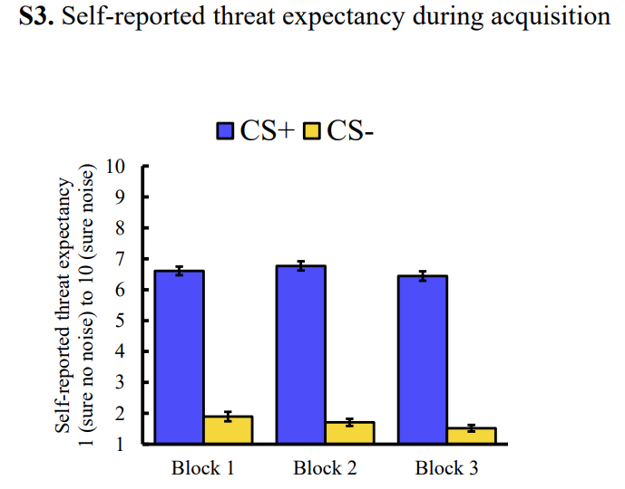

**Figure S2.** Self-reported threat expectancy during acquisition

**Figure S2.** Participants’ self-reported threat expectancy towards the CS+ and the CS- across acquisition learning.

*Notes.* Error bars represent the standard error of the mean.

**Skin Conductance Response (SCR).**

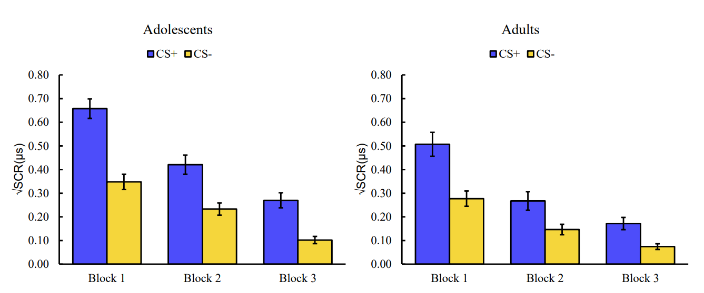

**Figure S3.** Descriptive presentation of developmental differences between adolescents and adults in SCR during acquisition learning. Error bars represent the standard error of the mean.

*Notes.* SCR: Skin conductance response.

**Figure S3.** Developmental differences in SCR during acquisition

An additional RM-ANCOVA was conducted on responses to the US across acquisition blocks. A Block (block 1, block 2, block 3) x Age (adolescents, adults) RM-ANCOVA yielded a two-way interaction of Block x Age, *F*(1.75, 193.08) = 9.13, *p* < .001, *ηp2* = .077. Both adults and adolescents presented a main effect of block, suggesting a decrease in response to the US across acquisition blocks, *F*(1.78,103.93) = 76.51, *p* < .001, *ηp2* = .569, and *F*(1.72, 94.52) = 21.66, *p* < .001, *ηp2* = .283. Follow-up analyses revealed that both adolescents and adults exhibited a significant decrease in SCR towards the US, between the first and second block (all *p*s < .001), and between the second and third blocks (all *p*s ≤ .002). However, as indicated by the effect sizes, adolescents showed less decrease (*d* = .560) in response to the US between the first and second acquisition blocks than adults (*d* = 1.203) (Figure S4). These findings suggest adolescents experienced greater arousal than adults during the acquisition phase, a phase that is less prone to habituation.

**S4.** Developmental differences in SCR in US trials during acquisition

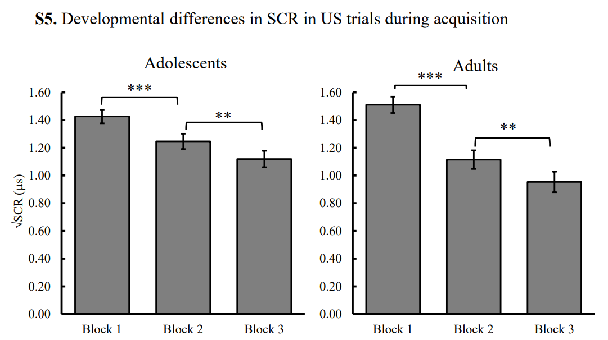

**Figure S4.** Developmental differences in SCR during US presentation across acquisition learning. Error bars represent the standard error of the mean.

*Notes.* SCR: Skin conductance response, \**p* < .05; \*\**p* < .01; \*\*\**p* < .001.

***Threat Extinction***

**Self-Reported Fear.** A main effect of block emerged, *F*(6, 242.09) = 98.14, *p* < .001, , *ηp2* = .467. Follow up analysis using *t*-tests revealed a significant decrease in overall self-reported fear between pre-extinction and block1, block 1 and block 2, block 2 and block 3, block 3 and block 4, and block 5 and block 6 (all *p*s ≤ .005).

**Self-Reported Threat Expectancy.** RM-ANCOVA on reported threat expectancy with Stimulus (CS+, CS-) x Block (pre-extinction, block 1, block 2, block 3, block 4, block 5, block 6) x Age (adolescents, adults) and anxiety levels as covariate yielded a three-way interaction of Stimulus x Block x Anxiety, *F*(1.815, 203.331) = 3.583, *p* = .034, *η*p2= .031. Participants exhibited two-way interactions of Stimulus x Block in both low-anxiety, *F*(1.880, 97.779) = 38.322, *p* < .001, *η*p2=.424, and high-anxiety levels, *F*(1.822, 111.136) = 159.607, *p* < .001, *η*p2=.723. However, individuals with high-anxiety levels showed greater threat anticipation towards the CS+ (*M* = 6.854, *SD* = 1.469) before extinction began than individuals with low-anxiety levels (*M* = 5.811, *SD* = 1.902), *t*(113) = -3.316, *p* = .001. While differences in threat expectancy for the CS+ and the CS- diminished across extinction blocks, they remained significant at the last extinction block, even following correction for multiple comparisons (Figure S5).

**Figure S6.** Differences in self-reported threat expectancy when perceiving the CS+ and CS- across extinction blocks, among individuals with high- and low-anxiety levels, defined by median split of SCARED/SCAARED questionnaires’ Z-scores. Error bars represent the standard error of the mean.

*Notes.* \**p* < .007 after correcting for multiple comparisons; \*\**p* < .001.

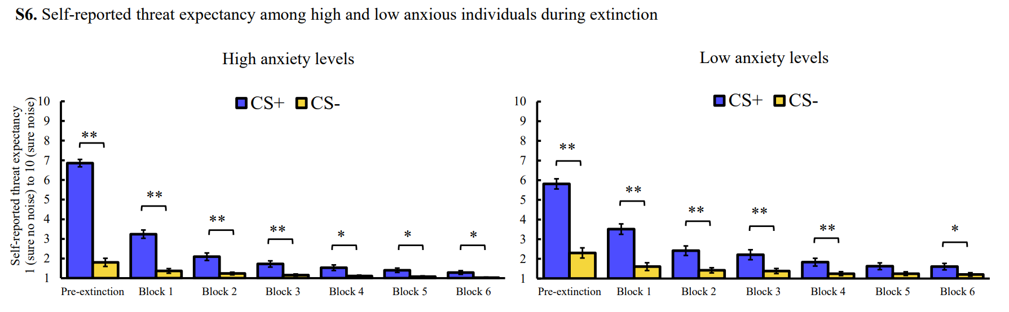

**S5.** Self-reported threat expectancy among high and low anxious individuals during extinction

**Skin Conductance Response (SCR).** A main effect of block emerged, *F*(5, 149.92) = 27.37, *p* < .001, ηp2 = .239. Follow up *t*-tests revealed a significant decrease in overall SCR between block 1 and block 2, block 2 and block 3, block 3 and block 4, and block 5 and block 6 (all *p*s ≤ .005).

**Figure S6.** Descriptive presentation of developmental differences between adolescents and adults in SCR during extinction learning. Error bars represent the standard error of the mean.

*Note:* SCR: Skin conductance response.

|  |  |  |  |  |  |  |  |  |  |
| --- | --- | --- | --- | --- | --- | --- | --- | --- | --- |
| **S6.** Developmental differences in SCR during extinction  **Table S4.** Summary of all significant results during threat acquisition | | | | | | | | | |
|  | Self-Reported Fear | | | SCR | | | LPP | | |
| Effects | *F* | *p* | *ηp2* | *F* | *p* | *ηp2* | *F* | *p* | *ηp2* |
| Stimulus | 243.82 | <.001 | .672 | 155.44 | <.001 | .592 | 27.3 | <.001 | .223 |
| Block | 163.51 | <.001 | .579 | 168.02 | <.001 | .053 | - | - | - |
| Age | - | - | - | 6.76 | .011 | .059 | 35.95 | <.001 | .275 |
| Anxiety | 12.43 | .001 | .095 | - | - | - | - | - | - |
| Stimulus*Block | - | - | - | 23.99 | <.001 | .183 | - | - | - |
| Stimulus*Age | - | - | - | 6.02 | .016 | .053 | - | - | - |
| Stimulus*Anxiety | - | - | - | - | - | - | - | - | - |
| Block*Age | - | - | - | - | - | - | - | - | - |
| Block*Anxiety | - | - | - | - | - | - | - | - | - |
| Age*Anxiety | - | - | - | - | - | - | - | - | - |
| Stimulus*Block*Age | - | - | - | - | - | - | - | - | - |
| Stimulus*Block*Anxiety | 5.986 | .002 | .048 | - | - | - | - | - | - |
| Stimulus*Age*Anxiety | - | - | - | - | - | - | - | - | - |
| Block*Age*Anxiety | - | - | - | - | - | - | - | - | - |
| Stimulus*Block*Age*Anxiety | - | - | - | - | - | - | - | - | - |
| *Notes.* Anxiety: Continuous Anxiety Score, SCR: Skin-Conductance Response, LPP: Late Positive Potential | | | | | | | | | |

|  |  |  |  |  |  |  |  |  |  |
| --- | --- | --- | --- | --- | --- | --- | --- | --- | --- |
| **Table S5.** Summary of all significant results during threat extinction | | | | | | | | | |
|  | Self-Reported Fear | | | SCR | | | LPP | | |
| Effects | F | p | ηp2 | F | p | ηp2 | F | p | ηp2 |
| Stimulus | 82.33 | <.001 | .424 | 64.06 | <.001 | .424 | 31.32 | <.001 | .267 |
| Block | 98.14 | <.001 | .467 | 27.37 | <.001 | .239 | 5.173 | .007 | .057 |
| Age | - | - | - | - | - | - | 7.69 | .007 | .082 |
| Anxiety | 5.55 | .020 | .047 | - | - | - | - | - | - |
| Stimulus*Block | 47.91 | <.001 | .300 | 19.77 | <.001 | .185 | - | - | - |
| Stimulus*Age | - | - | - | - | - | - | - | - | - |
| Stimulus*Anxiety | - | - | - | - | - | - | - | - | - |
| Block*Age | - | - | - | - | - | - | 3.74 | .026 | .042 |
| Block*Anxiety | - | - | - | - | - | - | - | - | - |
| Age*Anxiety | - | - | - | - | - | - | - | - | - |
| Stimulus*Block*Age | - | - | - | - | - | - | 3.16 | 0.45 | 0.35 |
| Stimulus*Block*Anxiety | 4.01 | .017 | .035 | - | - | - | - | - | - |
| Stimulus*Age*Anxiety | - | - | - | - | - | - | - | - | - |
| Block*Age*Anxiety | - | - | - | - | - | - | - | - | - |
| Stimulus*Block*Age*Anxiety | - | - | - | - | - | - | - | - | - |
| Notes. Anxiety: Continuous Anxiety Score, SCR: Skin-Conductance Response, LPP: Late Positive Potential | | | | | | | | | |

**Effects of Gender on Threat Learning**

We did not consider gender as a variable of interest in our planned (pre-registered) analysis, so our sample size might be too small to detect additional effects of gender. Nevertheless, we conducted exploratory analyses to investigate potential effects related to gender, age, and anxiety during threat learning, as detailed next.

***Threat Acquisition***

**Self-Reported Fear.**RM-ANCOVA of reported fear of the conditioned cues with Stimulus (CS+,CS-) x Block (pre-acquisition, block 1, block 2, block 3) x Age (adolescents, adults) x Gender (female, male) x Anxiety levels (continuous) yielded a three-way interaction of Stimulus x Block x Gender, *F*(2.238, 261.839)=3.287, *p*=.034. Follow-up analysis of each gender group indicated that a two-way interaction of Stimulus x Block emerged in both females, *F*(2.248, 152.884)=105.792, *p*<.001, *ηp2*=.609, and males, *F*(2.070, 258.764)=31.978, *p*<.001, *ηp2*=.372. To further examine self-reported fear of the CSs, we corrected for four multiple comparisons in each group (adolescents, adults) according to pre-acquisition and three acquisition blocks (corrected alpha=.013). In both genders, reported fear of the CS+ and CS- was comparable in pre-acquisition (all *p*s≥.616), but differential fear (CS+>CS-) was evident during the three subsequent blocks of threat acquisition (all *p*s<.001), indicating successful threat learning. Further analyses showed females reported greater fear levels towards the CS+ during the second and third blocks of acquisition than males; all *p*s≤.008. No other differences in self-reported fear of the CS+ or CS- emerged between females and males; all *p*s≥.110.

Finally, a Gender x Age interaction effect emerged, *F*(1,117)=4.033, *p*=.047, *ηp2*=.033. Follow-up analysis of each age group suggested that overall levels of self-reported fear were affected by gender among adults, *t*(61)=-2.433, *p*=.018, such that females reported overall higher levels of fear (*M*=3.24 *SD*=1.30) than males (*M*=2.24 *SD*=1.34). This effect was not evident among adolescents, *t*(59)=-.228, *p*=.820.

**SCR.**RM-ANCOVA of SCR with Stimulus (CS+,CS-) x Block (block 1, block 2, block 3) x Age (adolescents, adults) x Gender (female, male) x Anxiety levels (continuous) did not reveal any significant results related to gender; all *p*s≥.148.

**LPP.**RM-ANCOVA with Stimulus (CS+,CS-) x Age (adolescents, adults) x Gender (female, male) x Anxiety levels (continuous) yielded a three-way interaction of Stimulus x Age x Gender only at a trend level, *F*(1,93)=3.473, *p*=.066, *ηp2*=.036. Exploratory follow-up analysis of each age group revealed a significant two-way interaction of Stimulus x Gender among adults, *F*(1,52)=7.220, *p*=.010, *ηp2*=.122, but not among adolescents, *F*(1,44)=.242, *p*=.625, *ηp2*=.625. To better understand the source of the interaction among adults, we performed additional follow-up analysis; this revealed that adult females demonstrated significant CSs differentiation (CS+>CS-), *t*(30)=6.255, *p*<.001, but adult males did not, *t*(22)=1.618, *p*=.120.

***Threat Extinction***

**Self-Reported Fear.**RM-ANCOVA of self-reported fear with Stimulus (CS+,CS-) x Block (pre-extinction, block 1, block 2, block 3, block 4, block 5, block 6) x Age (adolescents, adults) x Gender (female, male) x Anxiety levels (continuous) did not reveal any significant results related to gender; all *p*s≥.073.

**SCR.**RM-ANCOVA of SCR with Stimulus (CS+,CS-) x Block (block 1, block 2, block 3, block 4, block 5, block 6) x Age (adolescents, adults) x Gender (female, male) x Anxiety levels (continuous) yielded a main effect of gender, *F*(1,85)=7.374, *p*=.008, *ηp2*=.080, showing males demonstrated overall greater SCR levels across extinction (*M*=.17, *SD*=.11) than females (*M*=.10, *SD*=.11).

**LPP.**RM-ANCOVA of Stimulus x Block (blocks 1&2, blocks 3&4, blocks 5&6) x Age (adolescents, adults) x Gender (females, males) x Anxiety (continuous) yielded a significant Block x Age x Gender interaction, *F*(2,168)=3.696, *p*=.027, *ηp2*=.042. Follow-up analysis of each age group did not yield any significant interaction with gender; all *p*s≥.086.

In summary, exploratory findings for gender indicated gender differences were primarily noticeable in the adult group, specifically during threat acquisition. Among adults, females reported greater fear of the CS+ than males and displayed a more pronounced LPP differentiation (CS+>CS-) during the acquisition learning phase. Despite differences in puberty development in the adolescent group, no gender-related differences in threat learning were observed for this group. Of note, we did not include gender as a variable in our pre-registration, and the sample size was likely underpowered to run these additional analyses, so findings should be interpreted with extra caution.

***Effects of Sleep Hours and Anxiety Levels on Threat Responses Immediately Before the Extinction Phase***

An exploratory RM-ANCOVA with Stimulus (CS+, CS-) x Age (adolescents, adults), with anxiety levels and sleep duration as covariates, was conducted using self-reported threat expectancy before extinction as a dependent measure. The RM-ANCOVA yielded a significant Stimulus x Sleep duration interaction only at a trend level, *F*(1, 111) = 3.81, *p* = .054, ηp2= .033. For interpretation reasons, we divided the sleep duration into two groups (long and short sleep duration) using a median split. Follow-up analysis indicated that both sleep duration groups showed differentiation in threat expectancy for the CS+ and the CS- (*p*s < .001), but the effect was larger in the long sleep duration group (ηp=.800) than in the short sleep duration group (ηp=.666). A significant Stimulus x Anxiety interaction also emerged, *F*(1, 110) = 5.77, *p* = .018, ηp2 = .50. Follow-up analysis revealed that individuals with high-, *t*(61) = 17.39, *p* < .001, *d* = 2.21 and low-anxiety levels, *t*(52) = 9.15, *p* < .001, *d =* 1.257,showed differential threat expectancy at pre-extinction. However, as indicated by the effect sizes, high-anxiety individuals exhibited greater differentiation than low-anxiety individuals.

A similar RM-ANCOVA with Stimulus (CS+, CS-) x Age (adolescents, adults), with anxiety levels and sleep duration as covariates, was conducted using self-reported fear before extinction as dependent measure. This analysis yielded a two-way interaction with Stimulus x Anxiety, *F*(1, 111) = 8.61, *p* = .004, ηp2 = .072. Follow-up analysis revealed that individuals with high-, *t*(61) = 8.45, *p* < .001, *d* = 1.073, and low-anxiety levels, *t*(52) = 4.30, *p* < .001, *d =* .590,showed differential threat expectancy at pre-extinction. However, as indicated by the effect sizes, high-anxiety individuals exhibited greater differentiation than low-anxiety individuals.

Finally, RM-ANCOVA on SCR during the pre-extinction reminder trials, with Stimulus (CS+, CS-) x Age (adults, adolescents) with anxiety levels and sleep duration as covariates, did not yield significant results (all *p*s ≥.123).

***Associations Between Self-Reports, Psychophysiological Measures, and Neural Measures during Threat Acquisition and Extinction***

As shown in Table S6, during acquisition, increased SCR towards both the CS+ and the CS- were correlated with higher self-reported fear towards the CS-. Furthermore, during extinction, increased LPP towards the CS+ was associated with increased self-reported fear and SCR towards the CS+.

|  |  |  |  |  |  |  |  |  |  |  |  |
| --- | --- | --- | --- | --- | --- | --- | --- | --- | --- | --- | --- |
| **Table S6.** Correlations between conditioned fear responses during acquisition and extinction phases across modalities (LPP, self-reports, and SCR) | | | | | | | | | | | |
|  | 1 | 2 | 3 | 4 | 5 | 6 | 7 | 8 | 9 | 10 | 11 |
| 1. LPP CS+ Acquisition |  |  |  |  |  |  |  |  |  |  |  |
| 2. LPP CS- Acquisition | **.736\*\*** |  |  |  |  |  |  |  |  |  |  |
| 3. Fear CS+ Acquisition | .183 | .114 |  |  |  |  |  |  |  |  |  |
| 4. Fear CS- Acquisition | .130 | .137 | **.384**\*\* |  |  |  |  |  |  |  |  |
| 5. SCR CS+ Acquisition | .106 | .059 | .173 | **.181\*** |  |  |  |  |  |  |  |
| 6. SCR CS- Acquisition | .104 | .117 | .147 | **.223\*** | **.856\*\*** |  |  |  |  |  |  |
| 7. LPP CS+ Extinction | **.529\*\*** | **.532\*\*** | .176 | .105 | .154 | .082 |  |  |  |  |  |
| 8. LPP CS- Extinction | **.460\*\*** | **.559\*\*** | .011 | .026 | .161 | .125 | **.711\*\*** |  |  |  |  |
| 9. Fear CS+ Extinction | .046 | .006 | **.630\*\*** | **.436\*\*** | .174 | .180 | **.283\*\*** | .078 |  |  |  |
| 10. Fear CS- Extinction | .045 | -.009 | **.326\*\*** | **.649\*\*** | **.304\*\*** | **.322\*\*** | .157 | -.005 | **.671\*\*** |  |  |
| 11. SCR CS+ Extinction | .136 | .051 | .011 | **.238\*** | **.657\*\*** | **.681\*\*** | .**231**\* | .142 | .179 | **.280\*\*** |  |
| 12. SCR CS- Extinction | .032 | .120 | -.103 | -.013 | **.410\*\*** | **.496\*\*** | .103 | .123 | .064 | .047 | **.807\*\*** |
| *Notes.*LPP: Late Positive Potential. SCR: Skin Conductance Response.  \**p* < .05; \*\**p* < .01; \*\*\**p* < .001. | | | | | | | | | | | |

***Associations Between Differential Responses during Acquisition Learning and Differential Responses during Extinction Learning***

To assess the associations between differential learning during acquisition and extinction, we ran a set of correlations between the differential response during acquisition (i.e., difference scores for the CS+ and the CS-) in each of the dependent variables and the comparable differential response during extinction.

As shown in Table S7, elevated LPP differential response during acquisition predicted enhanced differential SCR during extinction (i.e., less extinction). Greater differential self-reported fear during acquisition was associated with increased differential response in fear ratings during extinction.

Differential LPP during extinction was associated with greater differential fear during extinction. Finally, greater differential fear during extinction was associated with greater differential SCR during extinction.

|  |  |  |  |  |  |
| --- | --- | --- | --- | --- | --- |
| **Table S7.** Correlations between differential learning (using difference scores) during acquisition and differential learning during extinction across indices (LPP, self-reports, and SCR) | | | | | |
|  | 1 | 2 | 3 | 4 | 5 |
| 1. LPP difference score Acquisition |  |  |  |  |  |
| 2. Fear difference score Acquisition | .155 |  |  |  |  |
| 3. SCR difference score Acquisition | .141 | .156 |  |  |  |
| 4. LPP difference score Extinction | .116 | .115 | .087 |  |  |
| 5. Fear difference score Extinction | .077 | **.587\*\*** | .057 | **.259\*** |  |
| 6. SCR difference score Extinction | .**270\*** | .145 | **.501\*\*** | .187 | **.270\*\*** |
| *Notes.* LPP: Late Positive Potential. SCR: Skin Conductance Response.  \**p* < .05; \*\**p* < .01; \*\*\**p* < .001. | | | | | |

***Non-specific age-related differences in neural responsiveness***

To consider additional interpretations of the age-related main effect observed during acquisition, we conducted additional analyses. First, we visually inspected the overall Late Positive Potential (LPP) waveform for both adults and adolescents, revealing higher neural activity in adolescents primarily during the LPP time window (400-1000 ms), as shown in Figure S7 below. We then examined whether age affects earlier time window in Pz electrode that is used for the LPP analysis. RM-ANCOVA of the mean amplitude between 0 to 400 ms following stimulus onset, testing the Stimulus (CS+,CS-) x Age (adolescents, adults) x Anxiety (continuous) effect, yielded a main effect of Age, *F*(1,94)=6.218, *p*=.014, *ηp2*=.062. Although the effect size of the age main effect during the early time window (0-400 ms) was smaller compared to the effect size of the age main effect in the LPP time window (400-100 ms), it is reasonable to assume that some of the observed age-related differences are non-specific. No other significant results were obtained for this early time window all ps≥.127.

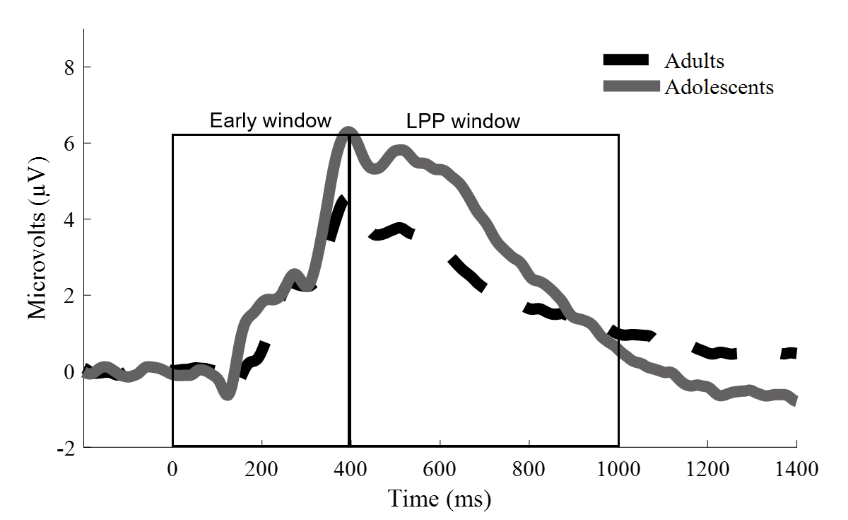

**Figure S7**. Grand-average ERP waveforms at the Pz electrode, among adolescents and adults, averaged acrossCS+ and CS- trials, and across acquisition blocks. between 400 and 1000 ms following stimulus onset across extinction blocks.

*Notes*: early window denotes the time window used for analysis between 0 to 400 ms. LPP window denotes the time window used for statistical analyses of LPP (400–1000 ms).

Second, we examine the P1 and N1 ERP components, reflecting earlier perceptual processing. Channel locations were chosen based on previous developmental literature (Linton & Levita, 2021), and time window for each component were chosen based on visual inspection of the grand averages. P1 was calculated in a time window of 100-200 ms following stimulus onset, at parietal-occipital channel locations (PO7 and PO8), and N1 was calculated in a time-window of 200-300 ms following stimulus onset, in parietal channel locations (P7 and P8). The components were averaged separately for CS+ and CS- trials during acquisition, across all three acquisition blocks.

RM-ANCOVA of P1 with Stimulus (CS+,CS-) x Age (adolescents, adults) x Anxiety (continuous) yielded only a main effect of age, suggesting greater (more positive) response among adolescents (*M*=5.097, *SD*=2.113) compare to adults (*M*=2.419, *SD*=2.113), *F*(1,94)=38.597, *p*<.001, *ηp2*=.291. No other effects were observed, all *p*s*≥.183.* RM-ANCOVA of N1 with Stimulus (CS+,CS-) x Age (adolescents, adults) x Anxiety (continuous) yielded only a main effect of age, suggesting greater (more positive) response among adolescents (*M*=2.560, *SD*=2.50) compare to adults (*M*=.140, *SD*=2.50), *F*(1,94)=22.591, *p*<.001, *ηp2*=.194. No other effects were observed, all *p*s*≥.130.*

These additional findings imply an increase in general arousal across various aspects of neural processing among adolescents compared to adults. It is important to note that these measures were exclusively assessed within a threat-related context, specifically during threat acquisition when the possibility of experiencing the unconditioned stimulus (UCS) existed. Therefore, we cannot definitively ascertain whether these effects are solely dependent on the threat-related context or if they are influenced by other non-neural factors, such as skull thickness impacting volume conduction and overall amplitudes. These factors could potentially contribute to the observed variations in event-related potential (ERP) amplitudes between youth and adults.

# **References**

Cohen, J. (2013). *Statistical Power Analysis for the Behavioral Sciences*. Routledge. doi: 10.4324/9780203771587

Debnath, R., Buzzell, G. A., Morales, S., Bowers, M. E., Leach, S. C., & Fox, N. A. (2020). The Maryland analysis of developmental EEG (MADE) pipeline. *Psychophysiology*, *57*(6), 1–13. doi: 10.1111/psyp.13580

Faul, F., Erdfelder, E., Buchner, A., & Lang, A.-G. (2009). Statistical power analyses using G*Power 3.1: Tests for correlation and regression analyses. *Behavior Research Methods*, *41*(4), 1149–1160. doi: 10.3758/BRM.41.4.1149

Flasinski, T., Sommer, K., Schneider, S., Margraf, J., Pflug, V., Lippert, M. W., … Adolph, D. (2022). Identifying characteristics of non-completers in fear conditioning paradigms with children and adolescents. *Journal of Experimental Psychopathology*, *13*(2), 1–9. doi: 10.1177/20438087221108291

Freeston, M. H., Rhéaume, J., Letarte, H., Dugas, M. J., & Ladouceur, R. (1994). Why do people worry? *Personality and Individual Differences*, *17*(6), 791–802. doi: 10.1016/0191-8869(94)90048-5

Koopman-Verhoeff, M. E., Gredvig-Ardito, C., Barker, D. H., Saletin, J. M., & Carskadon, M. A. (2020). Classifying Pubertal Development Using Child and Parent Report: Comparing the Pubertal Development Scales to Tanner Staging. *Journal of Adolescent Health*, *66*(5), 597–602. doi: 10.1016/j.jadohealth.2019.11.308

Linton, S. R., & Levita, L. (2021). Potentiated perceptual neural responses to learned threat during Pavlovian fear acquisition and extinction in adolescents. *Developmental Science*, *24*(5). doi: 10.1111/desc.13107

Luck, S. J. (2014). *An Introduction to the Event-Related Potential Technique* (Second Edi). MIT Press.

Petersen, A. C., Crockett, L., Richards, M., & Boxer, A. (1988). A self-report measure of pubertal status: Reliability, validity, and initial norms. *Journal of Youth and Adolescence*, *17*(2), 117–133. doi: 10.1007/BF01537962

Ryan, K. M., Zimmer-Gembeck, M. J., Neumann, D. L., & Waters, A. M. (2019). The need for standards in the design of differential fear conditioning and extinction experiments in youth: A systematic review and recommendations for research on anxiety. *Behaviour Research and Therapy*, *112*, 42–62. doi: 10.1016/j.brat.2018.11.009