Supplementary Table 1 – Items of the Center for Epidemiological Studies – Depression (CES-D) questionnaire included in the English Longitudinal Study of Ageing

|  |  |
| --- | --- |
| **Item name** | **Item content** |
| PScedA | *Whether respondent has felt depressed much of the time during the past week* |
| PScedB | *Whether respondent felt everything they did during the past week was an effort* |
| PScedC | *Whether respondent felt their sleep was restless during the past week* |
| PScedD | *Whether respondent was happy much of the time during the past week* |
| PScedE | *Whether respondent felt lonely much of the time during the past week* |
| PScedF | *Whether respondent enjoyed life much of the time during the past week* |
| PScedG | *Whether respondent felt sad much of the time during the past week* |
| PScedH | *Whether respondent could not get going much of the time during the past week* |

Supplementary Table 2 – *Incident dementia cases per Wave in the analytical sample*

|  |  |
| --- | --- |
| **ELSA Wave** | **Incident dementia cases** |
| 2 (baseline) | - |
| 3 | N=36 |
| 4 | N=114 |
| 5 | N=198 |
| 6 | N=265 |
| 7 | N=340 |
| 8 | N=425 |
| 9 | N=501 |

Supplementary Table 3 – Fit indices of the factor solutions derived from exploratory factor analysis of social relationship items in the English Longitudinal Study of Ageing.

|  |  |  |  |
| --- | --- | --- | --- |
| **Solution** | **RMSEA** | **TLI** | **CFI** |
| One factor | .14 | .42 | .45 |
| Two factors | .12 | .57 | .62 |
| Three factors | .12 | .67 | .74 |
| Four factors | .09 | .73 | .79 |
| Five factors | .08 | .78 | .84 |
| Six factors | .08 | .88 | .83 |
| Seven factors | .06 | .89 | .93 |
| Eight factors | .05 | .92 | .96 |
| Nine factors | .04 | .95 | .97 |

Abbreviations: CFI=Comparative fit index; RMSEA=Root mean squared error of approximation; TLI=Tucker-Lewis Index

Supplementary Table 4 – Item loadings of the OBLIMIN-rotated exploratory factor analysis of social relationship items in the English Longitudinal Study of Ageing. In a subsequent confirmatory factor analysis, items scchdg, scchdh, scfamg and scfamh (selectively loading on factors 2, 3 and 4) were loaded solely on factors 3 and 4, respectively. Loadings ≥|0.4| are marked in green.

|  |  |  |  |  |  |  |  |  |
| --- | --- | --- | --- | --- | --- | --- | --- | --- |
| **Item content** | **Item name** | **Factor 1** | **Factor 2** | **Factor 3** | **Factor 4** | **Factor 5** | **Factor 6** | **Factor 7** |
| How often the respondent meets up with their children on average | SCCHDG | -0,170* | 0,447* | -0,528* | 0,069* | -0,023 | 0,078* | -0,095* |
| How often the respondent speaks on the phone to their children | SCCHDH | -0,009 | 0,452* | -0,638* | 0,101* | -0,007 | 0,044* | -0,115* |
| How often the respondent writes to or emails their children | SCCHDI | 0,779* | -0,214* | -0,183* | -0,054* | 0,087* | 0,060* | -0,072* |
| How often the respondent meets up with other relatives | SCFAMG | -0,063* | 0,613* | -0,044* | -0,461* | 0,012 | 0,078* | -0,004 |
| How often the respondent speaks with other relatives on the phone | SCFAMH | 0,035* | 0,589* | -0,045* | -0,540* | 0,086* | 0,048* | -0,023* |
| How often the respondent writes to or emails other relatives | SCFAMI | 0,738* | -0,147* | -0,127* | -0,235* | 0,155* | 0,078* | -0,044* |
| How often the respondent meets up with their friends | SCFRDG | -0,014 | 0,357* | 0,009 | 0,095* | 0,117* | -0,501* | 0,046* |
| How often the respondent speaks with their friends on the phone | SCFRDH | 0,122* | 0,398* | 0,005 | 0,084* | 0,189* | -0,569* | -0,004 |
| How often the respondent writes to or emails their friends | SCFRDI | 0,758* | -0,108* | -0,083* | -0,017 | 0,103* | -0,077* | -0,080* |
| Organisational membership: none | SCORG09 | -0,405* | -0,069* | -0,041* | -0,077* | 0,108* | 0,082* | -0,048* |
| How often respondent goes to the cinema | SCACTA | 0,613* | 0,217* | 0,143* | 0,111* | -0,179* | -0,068* | 0,026 |
| How often respondent eats out of the house | SCACTB | 0,418* | 0,205* | 0,093* | 0,095* | -0,185* | -0,078* | 0,073* |
| How often respondent goes to an art gallery or museum | SCACTC | 0,683* | 0,169* | 0,147* | 0,093* | -0,201* | -0,037* | 0,054* |
| How often respondent goes to the theatre, a concert or the opera | SCACTD | 0,686* | 0,253* | 0,137* | 0,104* | -0,195* | -0,054* | 0,089* |
| Activities during last month: voluntary work | WPACTVW | 0,368* | 0,055* | 0,088* | 0,066* | -0,104* | -0,085* | 0,025 |
| Whether has a husband, wife or partner with whom they live | SCPTR | -0,060* | 0,077* | -0,039* | -0,018 | 0,628* | -0,260* | 0,167* |
| How much the children understand the way the respondent feels about things | SCCHDA | -0,077* | 0,076* | 0,670* | 0,089* | 0,082* | 0,103* | -0,138* |
| How much the respondent can rely on their children if they have a problem | SCCHDB | -0,048* | 0,010 | 0,784* | 0,019 | 0,095* | 0,049* | -0,113* |
| How much the respondent can open up to their children about their worries | SCCHDC | -0,029* | 0,116* | 0,751* | 0,138* | 0,077* | 0,141* | -0,024* |
| How much their children criticises the respondent | SCCHDD | -0,033* | -0,006 | -0,068* | 0,039* | 0,005 | 0,035* | 0,614* |
| How much their children lets the respondent down when they are counting on them | SCCHDE | 0,028* | -0,036* | -0,400* | 0,031* | -0,065* | 0,047* | 0,508* |
| How much do family members understand how respondent feels about things | SCFAMA | -0,019* | -0,039* | 0,089* | 0,764* | 0,011 | 0,067* | -0,080* |
| How much respondent can rely on other relatives if they have a serious problem | SCFAMB | -0,021* | -0,029* | -0,019* | 0,876* | 0,070* | 0,027* | -0,025* |
| How much respondent can open up to these other relatives if they need to talk | SCFAMC | 0,010 | 0,030* | 0,014 | 0,915* | 0,052* | 0,085* | 0,020* |
| How much other relatives criticise the respondent | SCFAMD | -0,024* | 0,008 | 0,014 | 0,032* | 0,035* | 0,065* | 0,742* |
| How much other relatives let the respondent down | SCFAME | 0,036* | 0,002 | 0,011 | -0,334* | -0,019 | 0,055* | 0,597* |
| How much these friends understand how respondent feels about things | SCFRDA | -0,004 | 0,042* | 0,097* | 0,049* | -0,013 | 0,759* | -0,003 |
| How much respondent can rely on these friends if they have a serious problem | SCFRDB | -0,022* | 0,071* | 0,019 | 0,054* | 0,093* | 0,822* | 0,007 |
| How much respondent can open up to these friends if they need to talk | SCFRDC | 0,025* | 0,083* | 0,025* | 0,083* | 0,017* | 0,871* | 0,076* |
| How much these friends criticise the respondent | SCFRDD | -0,058* | -0,017 | -0,013 | 0,044* | 0,029* | 0,091* | 0,630* |
| How much these friends let the respondent down | SCFRDE | -0,023 | -0,066* | -0,030 | 0,006 | -0,063* | -0,222* | 0,506* |
| How often respondent feels they lack companionship | SCFEELA | 0,028* | 0,027* | 0,017 | 0,035* | 0,882* | -0,002 | 0,039* |
| How often respondent feels left out | SCFEELB | 0,003 | -0,006 | 0,087* | 0,054* | 0,800* | 0,092* | -0,111* |
| How often respondent feels isolated from others | SCFEELC | 0,020 | -0,036* | 0,047* | 0,050* | 0,851* | 0,115* | -0,074* |
| Whether respondent felt lonely much of the time during the past week | PSCEDE | -0,055* | 0,038* | 0,039* | -0,015 | 0,806* | -0,101* | 0,053* |
| How often the respondent meets up with their children on average | SCCHDG | -0,170* | 0,447* | -0,528* | 0,069* | -0,023 | 0,078* | -0,095* |

*Statistically significant (*p*≤.05)

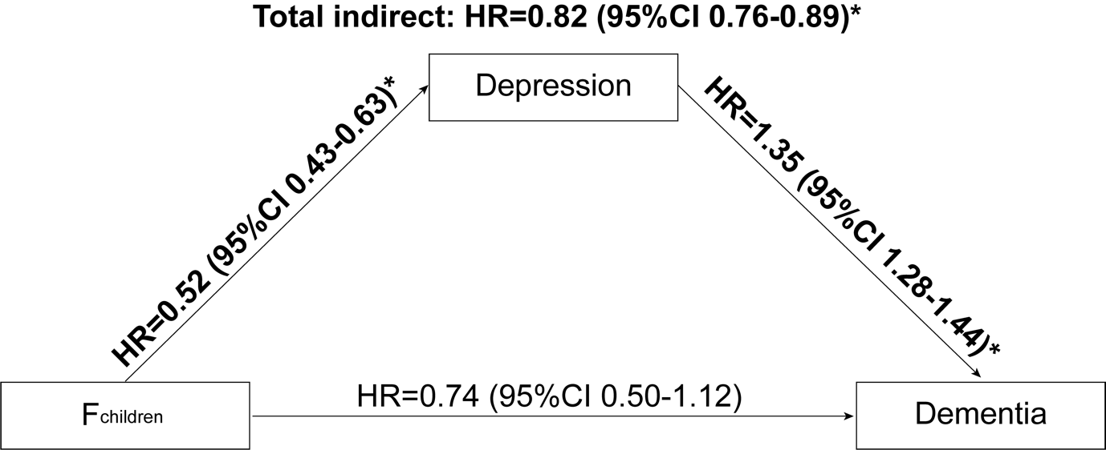

*Supplementary Figure 1* – Mediation of the association between Fchildren and dementia risk by depressive symptoms (Fdepression). *Statistically significant (p≤.05)

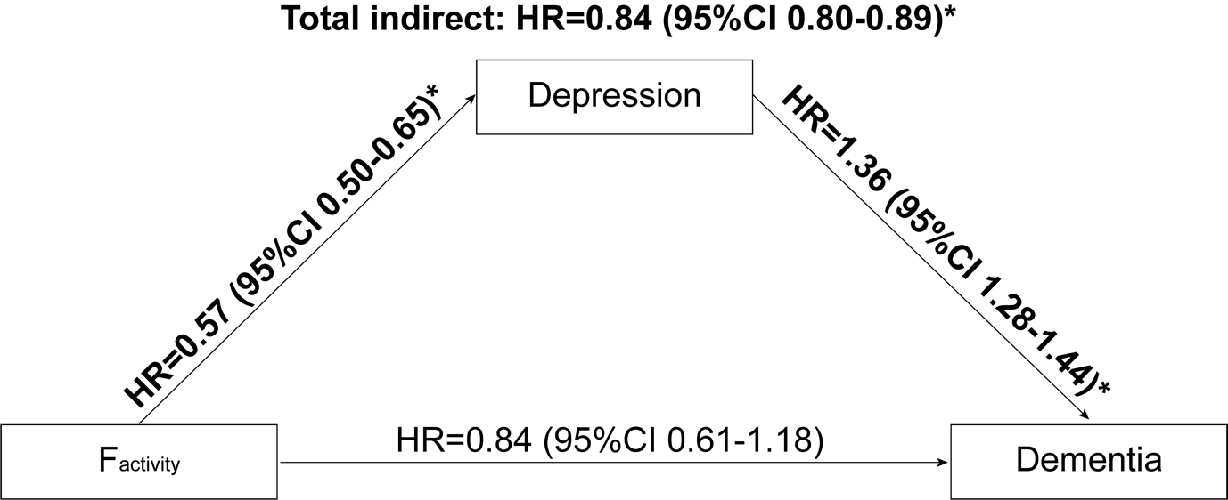

*Supplementary Figure 2* – Mediation of the association between Factivity and dementia risk by depressive symptoms (Fdepression). *Statistically significant (p≤.05)

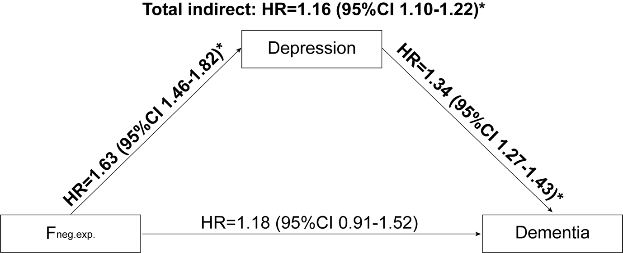

*Supplementary Figure 3* – Mediation of the association between Fneg.exp. and dementia risk by depressive symptoms (Fdepression). *Statistically significant (p≤.05)

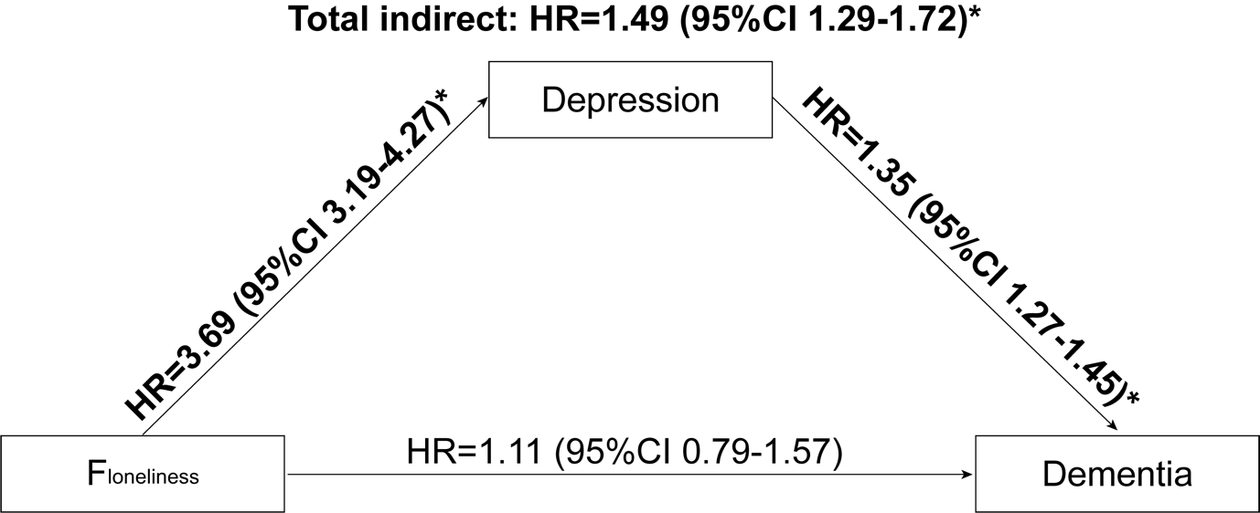

*Supplementary Figure 4* – Mediation of the association between Floneliness and dementia risk by depressive symptoms (Fdepression). *Statistically significant (p≤.05)