**Supplementary Material  
  
Executive functions in psychopathy: A meta-analysis of inhibition, planning, shifting, and working memory performance**

Matthias Burghart1,2, Sergej Schmidt1, Daniela Mier1

1Department of Psychology, University of Konstanz, Konstanz, Germany

2Max Planck Institute for the Study of Crime, Security and Law, Freiburg, Germany

**Author Note**

Matthias Burghart  <https://orcid.org/0000-0001-7300-1846>

Sergej Schmidt  <https://orcid.org/0000-0003-2398-2732>

Daniela Mier  <https://orcid.org/0000-0003-2518-7492>

Correspondence concerning this article should be addressed to Matthias Burghart, Max Planck Institute for the Study of Crime, Security and Law, Günterstalstraße 73, Freiburg im Br., Germany. Email: m.burghart@csl.mpg.de

**Supplementary Table 1**

*Search terms used in our systematic literature search*

|  |  |
| --- | --- |
| **Databases searched** | **Search terms** |
| PsychInfo, PubMed, Web of Science | (*psychopathy* OR *psychopath* OR *psychopathic* OR *pcl*)  AND  (*executive function* OR *executive dysfunction* OR *executive functioning* OR *executive functions* OR *cognitive flexibility* OR *working memory* OR *inhibition* OR *cognitive control* OR *planning* OR *shifting*) |

**Supplementary Table 2**

*Categorization of psychopathy subscales as interpersonal/affective or lifestyle/antisocial traits*

|  |  |  |
| --- | --- | --- |
| **Psychopathy Measure** | **Subscale** | **Categorization** |
| PCL-R / PCL:SV | Facet 1 | I/A |
|  | Facet 2 | I/A |
|  | Facet 3 | L/A |
|  | Facet 4 | L/A |
| SRP | Antisocial Behaviour | L/A |
|  | Pathological Lying | I/A |
|  | Erratic Lifestyle | L/A |
|  | Callous Affect | I/A |
| PPI(-R) | Fearless Dominance | I/A |
|  | Coldheartedness | I/A |
|  | Impulsivity | L/A |
| LSRP | Primary Psychopathy | I/A |
|  | Secondary Psychopathy | L/A |
| TriPM | Boldness | I/A |
|  | Meanness | I/A |
|  | Disinhibition | L/A |

*Note*. PCL-R / PCL:SV = Psychopathy Checklist – Revised / Psychopathy Checklist: Screening Version; SRP = Self Report Psychopathy Scale; PPI(-R) = Psychopathic Personality Inventory (– Revised); LSRP = Levenson Self-Report Psychopathy Scale; TriPM = Triarchic Psychopathy Measure; I/A = Interpersonal/Affective; L/A = Lifestyle/Antisocial.

This table was adapted from Gillespie et al. (2022).

**Supplementary Table 3**

*Results of multilevel models (Cohen’s d) for each neuropsychological task (with n > 1), sorted by effect size*

|  |  |  |  |
| --- | --- | --- | --- |
| **EF Task** | ***n*** | ***k*** | ***d* [95% CI]** |
| Tower of London | 3 | 19 | –1.03 [–1.83, –.23]* |
| Porteus Maze | 4 | 6 | –.61 [–1.28, .06] |
| GoStop Impulsivity Paradigm | 2 | 2 | –.34 [–.73, .04] |
| Go/No-Go | 9 | 21 | –.25 [–.49, –.01]* |
| Keep Track | 2 | 2 | –.23 [–.49, .03] |
| Letter Memory | 2 | 2 | –.22 [–.50, .06] |
| Flanker Task | 2 | 7 | –.16 [–.40, .07] |
| Color Word Inference Test (D-KEFS) | 2 | 5 | –.15 [–.29, –.01]* |
| Trail Making Test | 6 | 7 | –.15 [–.34, .03] |
| Wisconsin Card Sorting Test | 9 | 31 | –.11 [–.39, .17] |
| Digit Span | 4 | 5 | –.07 [–.26, .12] |
| Stroop Task | 9 | 44 | –.04 [–.22, .14] |
| Spatial Working Memory | 2 | 3 | –.04 [–.52, .43] |
| Number-Letter Task | 2 | 2 | .00 [–.14, .13] |
| Intra/Extradimensional Set Shifting | 4 | 7 | .05 [–.13, .24] |
| Stockings of Cambridge | 2 | 5 | .07 [–.14, .28] |
| Stop Signal Task | 6 | 11 | .09 [–.14, .31] |

*Note*. EF = executive function; *n* = number of studies; *k* = number of effect sizes; *d* = Cohen’s *d*; CI = confidence interval; *** *p* < .001; ** *p* < .01; * *p* < .05.

**Supplementary Figure 1**

*Funnel plot for each executive function domain*

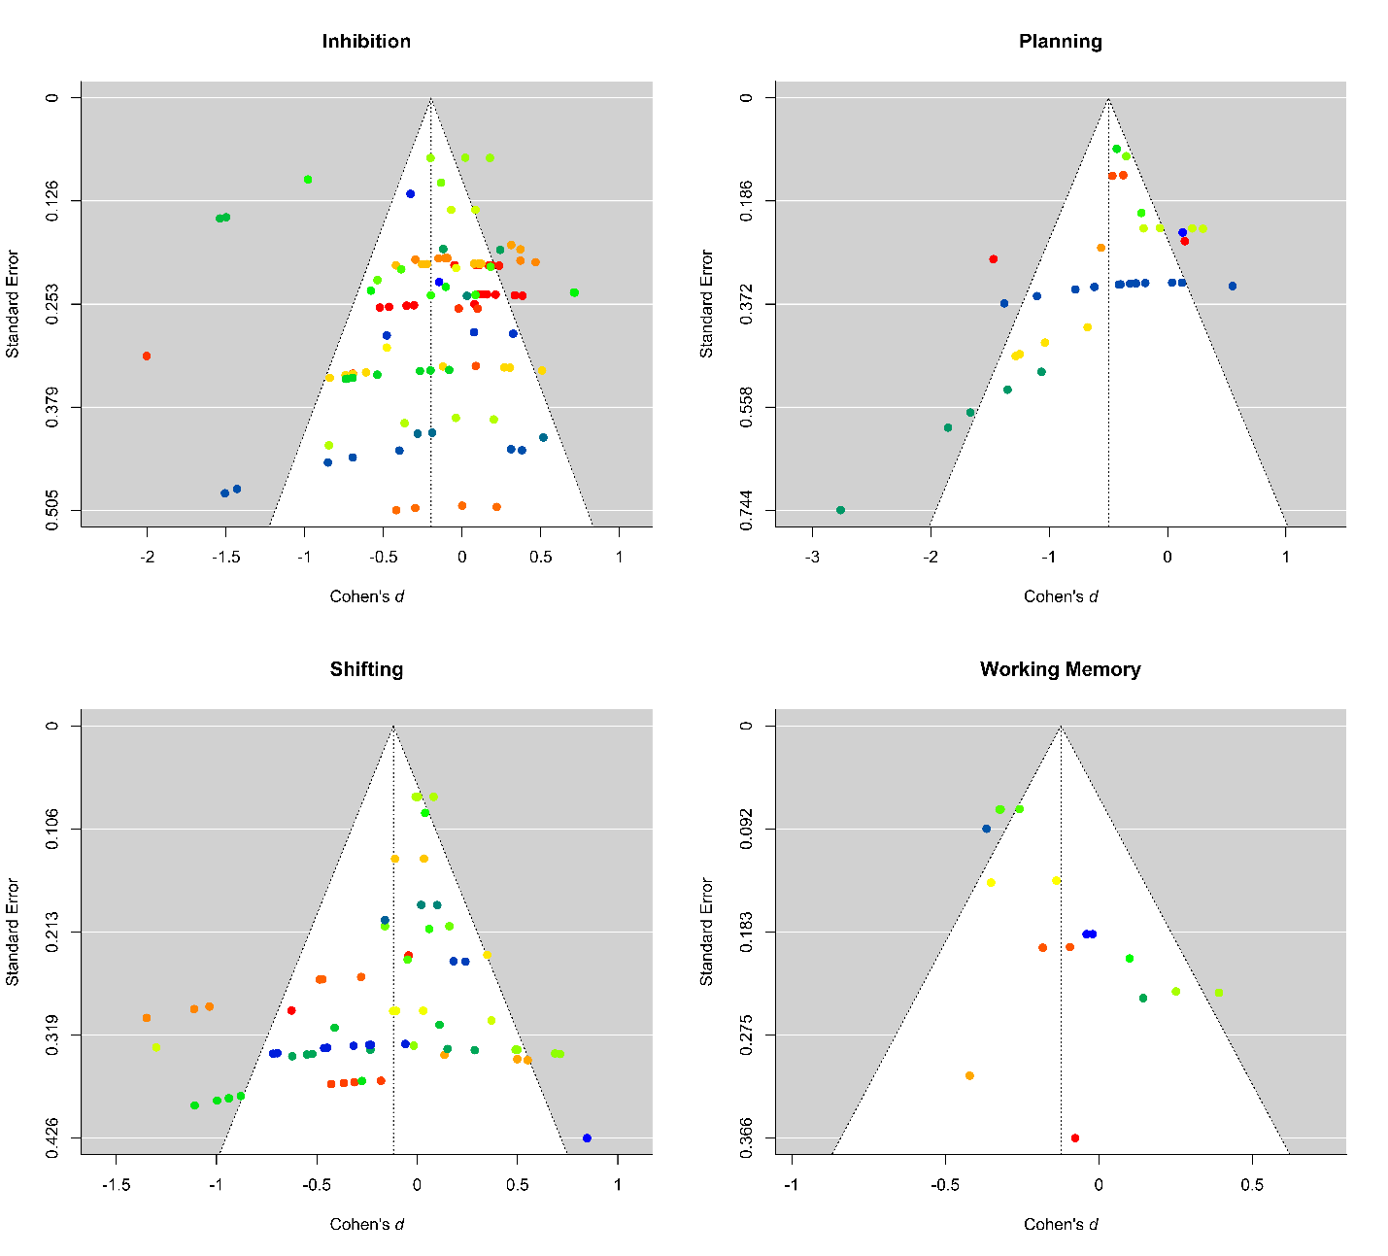

*Note*. Points of the same color represent dependent effect sizes. The colors can only be interpreted within a funnel plot and not across them.

# References

Gillespie, S. M., Lee, J., Williams, R., & Jones, A. (2022). Psychopathy and response inhibition: A meta-analysis of go/no-go and stop signal task performance. *Neuroscience & Biobehavioral Reviews*, *142*, 104868. https://doi.org/10.1016/j.neubiorev.2022.104868