List of Supplementary Information

- Supplementary Table S1. PRISMA checklist.
- Supplementary Table S2. Inclusion/Exclusion criteria for screening.
- Supplementary Table S3. Quality assessment checklists.
- Supplementary Results. Study characteristics.
- Supplementary Results. Meta-regression results of age and sex.
- Supplementary Table S4. Jake-knife sensitivity analysis of brain activity differences between MDD and HCs in reward anticipation.
- Supplementary Table S5. Subgroup meta-analysis of brain activity differences between MDD and HCs in reward anticipation.
- Supplementary Figure S1. Subgroup meta-analysis of brain activity differences between MDD and HCs in reward anticipation.
- Supplementary Table S6. Jake-knife sensitivity analysis of brain activity differences between MDD and HCs in reward processing.
- Supplementary Table S7. Subgroup meta-analysis of brain activity differences between MDD and HCs in reward processing.
- Supplementary Figure S2. Subgroup meta-analysis of brain activity differences between MDD and HCs in reward processing.
- Supplementary Table S8. Jake-knife sensitivity analysis of brain activity differences between MDD and HCs in reward learning.
- Supplementary Table S9. Subgroup meta-analysis of brain activity differences between MDD and HCs in reward learning.
- Supplementary Figure S3. Subgroup meta-analysis of brain activity differences between MDD and HCs in reward learning.

Supplementary Table S1. PRISMA checklist.
Section and Topic | Item # | Checklist item | Reported on page #
TITLE
Title | 1 | Identify the report as a systematic review. | P.1
ABSTRACT
Abstract | 2 | See the PRISMA 2020 for Abstracts checklist. | P.3-4
INTRODUCTION
Rationale | 3 | Describe the rationale for the review in the context of existing knowledge. | P.5-7
Objectives | 4 | Provide an explicit statement of the objective(s) or question(s) the review addresses. | P.7-8
METHODS
Eligibility criteria | 5 | Specify the inclusion and exclusion criteria for the review and how studies were grouped for the syntheses. | P.8-10
Information sources | 6 | Specify all databases, registers, websites, organisations, reference lists and other sources searched or consulted to identify studies. Specify the date when each source was last searched or consulted. | P.8-10
Search strategy | 7 | Present the full search strategies for all databases, registers and websites, including any filters and limits used. | P.8-10
Selection process | 8 | Specify the methods used to decide whether a study met the inclusion criteria of the review, including how many reviewers screened each record and each report retrieved, whether they worked independently, and if applicable, details of automation tools used in the process. | P.8-10
Data collection process | 9 | Specify the methods used to collect data from reports, including how many reviewers collected data from each report, whether they worked independently, any processes for obtaining or confirming data from study investigators, and if applicable, details of automation tools used in the process. | P.8-10
Data items | 10a | List and define all outcomes for which data were sought. Specify whether all results that were compatible with each outcome domain in each study were sought (e.g. for all measures, time points, analyses), and if not, the methods used to decide which results to collect. | P.10-12
 | 10b | List and define all other variables for which data were sought (e.g. participant and intervention characteristics, funding sources). Describe any assumptions made about any missing or unclear information. | P.10-12
Study risk of bias assessment | 11 | Specify the methods used to assess risk of bias in the included studies, including details of the tool(s) used, how many reviewers assessed each study and whether they worked independently, and if applicable, details of automation tools used in the process. | P.10-12
Effect measures | 12 | Specify for each outcome the effect measure(s) (e.g. risk ratio, mean difference) used in the synthesis or presentation of results. | P.10-12
Synthesis methods | 13a | Describe the processes used to decide which studies were eligible for each synthesis (e.g. tabulating the study intervention characteristics and comparing against the planned groups for each synthesis (item #5)). | P.10-13
 | 13b | Describe any methods required to prepare the data for presentation or synthesis, such as handling of missing summary statistics, or data conversions. | P.10-13
 | 13c | Describe any methods used to tabulate or visually display results of individual studies and syntheses. | P.10-13
 | 13d | Describe any methods used to synthesize results and provide a rationale for the choice(s). If meta-analysis was performed, describe the model(s), method(s) to identify the presence and extent of statistical heterogeneity, and software package(s) used. | P.10-13
 | 13e | Describe any methods used to explore possible causes of heterogeneity among study results (e.g. subgroup analysis, meta-regression). | P.10-13
 | 13f | Describe any sensitivity analyses conducted to assess robustness of the synthesized results. | P.10-13
Reporting bias assessment | 14 | Describe any methods used to assess risk of bias due to missing results in a synthesis (arising from reporting biases). | P.10-13
Certainty assessment | 15 | Describe any methods used to assess certainty (or confidence) in the body of evidence for an outcome. | P.10-13
RESULTS
Study selection | 16a | Describe the results of the search and selection process, from the number of records identified in the search to the number of studies included in the review, ideally using a flow diagram. | P.14
 | 16b | Cite studies that might appear to meet the inclusion criteria, but which were excluded, and explain why they were excluded. | P.14 & Table S2
Study characteristics | 17 | Cite each included study and present its characteristics. | P.14 & Supplementary Results
Risk of bias in studies | 18 | Present assessments of risk of bias for each included study. | P.14 & Table S3
Results of individual studies | 19 | For all outcomes, present, for each study: (a) summary statistics for each group (where appropriate) and (b) an effect estimate and its precision (e.g. confidence/credible interval), ideally using structured tables or plots. | P.14
Results of syntheses | 20a | For each synthesis, briefly summarise the characteristics and risk of bias among contributing studies. | P.14-20
 | 20b | Present results of all statistical syntheses conducted. If meta-analysis was done, present for each the summary estimate and its precision (e.g. confidence/credible interval) and measures of statistical heterogeneity. If comparing groups, describe the direction of the effect. | P.14-20
 | 20c | Present results of all investigations of possible causes of heterogeneity among study results. | P.14-20
 | 20d | Present results of all sensitivity analyses conducted to assess the robustness of the synthesized results. | P.14-20
Reporting biases | 21 | Present assessments of risk of bias due to missing results (arising from reporting biases) for each synthesis assessed. | P.14-20
Certainty of evidence | 22 | Present assessments of certainty (or confidence) in the body of evidence for each outcome assessed. | P.14-20
DISCUSSION
Discussion | 23a | Provide a general interpretation of the results in the context of other evidence. | P.20-27
 | 23b | Discuss any limitations of the evidence included in the review. | P.20-27
 | 23c | Discuss any limitations of the review processes used. | P.20-27
 | 23d | Discuss implications of the results for practice, policy, and future research. | P.20-27
OTHER INFORMATION
Registration and protocol | 24a | Provide registration information for the review, including register name and registration number, or state that the review was not registered. | P.8
 | 24b | Indicate where the review protocol can be accessed, or state that a protocol was not prepared. | P.8
 | 24c | Describe and explain any amendments to information provided at registration or in the protocol. | N/A
Support | 25 | Describe sources of financial or non-financial support for the review, and the role of the funders or sponsors in the review. | P.28
Competing interests | 26 | Declare any competing interests of review authors. | P.28
Availability of data, code and other materials | 27 | Report which of the following are publicly available and where they can be found: template data collection forms; data extracted from included studies; data used for all analyses; analytic code; any other materials used in the review. | N/A
From: Page MJ, McKenzie JE, Bossuyt PM, Boutron I, Hoffmann TC, Mulrow CD, et al. The PRISMA 2020 statement: an updated guideline for reporting systematic reviews. BMJ 2021;372:n71. doi: 10.1136/bmj.n71

Supplementary Table S2. Inclusion/Exclusion criteria for screening.
 | Inclusion criteria | Exclusion criteria
Study characteristic | - Empirical research studies with fMRI findings | - Reviews, book chapters, meta-analysis, narrative report  - No English versions of full text available
Population | - Adults diagnosed with current MDD | - Children, adolescents and older people (aged over 65)  - Subjects with remitted or past diagnosis of MDD  - Subjects with diagnosis of other psychiatric disorders other than anxiety disorders
Study design | - Reward-related tasks performed inside fMRI scanner  - Group comparison between MDD patients and healthy controls | - Resting-state fMRI studies  - Intervention study with no baseline findings  - No matched healthy controls
Contrasts of interest | - Reward anticipation  - Reward processing  - Reward learning | - No relevant reward contrast (e.g., reported punishment-related contrasts only)  - Social reward stimuli
Outcomes of interest | - Significant peak coordinates, t/z values, p values, at the whole-brain level.  - Insignificant results at the whole-brain level. | - Only region-of-interest (ROI)-based analyses were conducted.

Supplementary Table S3. Quality assessment checklists (Score 0/0.5/1 for each item*, total score =15).
Category 1: Subjects
- Patients were evaluated prospectively, specific diagnostic criteria were applied, and demographic data was reported
- Healthy comparison subjects were evaluated prospectively, psychiatric and medical illnesses were excluded and demographic data was reported
- Important variables (e.g., age, gender, intelligence quotient, i.e., IQ, handedness) were checked, either by stratification or statistically
- Withdrawals from the study were explained

Category 2: Methods for fMRI tasks
- All participants went through a training session outside the scanner
- The baseline condition was defined as almost the same with task condition except for the reward control

Category 3: Methods for image acquisition and statistical analysis
- MRI slice-thickness ≤ 3 mm
- All images had < 2 mm movement
- The imaging technique used was clearly described so that it could be reproduced
- Adjustments were made for multiple statistical comparisons
- Appropriate design and/or analytical methods to control confounding
- Appropriate use of statistics for primary analysis of effect (excluding control of confounding)

Category 4: Results, conclusions and conflict of interest
- Statistical parameters for significant, and important non-significant, differences were provided
- Conclusions were consistent with the results obtained and the limitations were discussed
- Declarations of conflict of interest or identification of funding sources
*For criteria partially met, 0.5 points were given.

Supplementary Results. Study characteristics.

For the contrast of reward anticipation, 11 studies were eligible, including a total sample size of 275 MDD patients and 352 HCs. The age difference between the MDD group (34.93 ± 4.88 years) and the HC group (33.30 ± 4.21 years) was not statistically significant (t = 0.842, p = 0.410). Similarly, there was no significant difference in the percentage of females between MDD patients (59.40%) and HCs (55.75%) (χ² = 0.810, p = 0.368).

For reward processing, 8 studies were included, resulting in a total sample size of 190 MDD patients and 260 HCs. The mean age of MDD patients (35.08 ± 3.66 years) and HCs (32.09 ± 4.26 years) did not significantly differ (t = 1.507, p = 0.154). Similarly, there was no significant difference in the percentage of females between MDD patients (56.91%) and HCs (50.20%) (χ² = 1.885, p = 0.170).

Regarding reward learning, a total of 8 studies were included, resulting in a sample size of 246 MDD patients and 200 HCs. The mean age of the patient group (34.87 ± 7.79 years) and the HC group (33.97 ± 6.27 years) did not significantly differ (t = 0.253, p = 0.804). Furthermore, the percentage of females between MDD patients (64.63%) and HCs (64.00%) was not significantly different (χ² = 0.019, p = 0.889).

Supplementary Results. Meta-regression results of age and sex.

Reward anticipation:
The percentage of female patients was negatively correlated with group differences (MDD vs. HC group) in activities in the left middle frontal gyrus (MNI coordinates: x = -32, y = 8, z =58; SDM-Z = -1.201; p < 0.001; 158 voxels). The mean age of patients was positively correlated with group differences (MDD vs. HC group) in activities in the right superior occipital gyrus (MNI coordinates: x = 24, y = -78, z = 42; SDM-Z = 3.029; p < 0.001; 391 voxels), the left middle occipital gyrus (MNI coordinates: x = -30, y = -88, z = 22; SDM-Z = 2.611; p < 0.001; 201 voxels), and the left middle frontal gyrus (MNI coordinates: x = -30, y = 18, z = 50; SDM-Z = 2.702; p < 0.001; 124 voxels).

Reward processing:
The mean age of patients was positively correlated with group differences (MDD vs. HC group) in activities in the left temporal gyrus (MNI coordinates: x = -40, y = -12, z = -32; SDM-Z = 2.836; p < 0.001; 912 voxels), and negatively correlated with activities in the right caudate nucleus (MNI coordinates: x = 14, y = 16, z = 14; SDM-Z = -2.860; p < 0.001; 46 voxels), dorsolateral prefrontal cortex (MNI coordinates: x =28, y =12, z = 52; SDM-Z = -3.023; p < 0.001; 81 voxels), and inferior frontal gyrus (MNI coordinates: x = 52, y = 22, z = 26; SDM-Z = -2.857; p < 0.001; 65 voxels).
The percentage of female patients was positively correlated with group differences (MDD vs. HC group) in activities in the right dorsolateral prefrontal cortex (MNI coordinates: x = 14, y = 30, z = 54; SDM-Z = 2.523; p < 0.001; 179 voxels).

Reward learning:
The mean age of patients was negatively correlated with group differences (MDD vs. HC group) in activities in the left putamen (MNI coordinates: x = -28, y =4, z = -4; SDM-Z = -2.225; p < 0.001; 1301 voxels).
The percentage of female patients was positively correlated with group differences (MDD vs. HC group) in activities in the right cerebellum (MNI coordinates: x = 10, y = -56, z = -6; SDM-Z = 2.734; p < 0.001; 1019 voxels), the left calcarine cortex (MNI coordinates: x = -10, y = -94, z = -12; SDM-Z = 1.789; p = 0.002; 62 voxels), the right thalamus (MNI coordinates: x = 14, y = -20, z = 16; SDM-Z = 1.545; p = 0.004; 48 voxels), and the left cerebellum (MNI coordinates: x = -32, y = -62, z = -24; SDM-Z = 1.628; p = 0.003; 20 voxels).
Supplementary Table S4. Jake-knife sensitivity analysis of brain activitiy differences between MDD and HCs in reward anticipation.
MDD > HC |  | MDD < HC
Brain region | CUN R | SOG R | THA R | MFG L | OFC R | MOG L
JK analysis
JK_Pizzagalli, 2009 | √ | √ | √ | √ | √ | √
JK_Smoski, 2009 | √ | × | √ | √ | √ | ×
JK_Smoski, 2011 | √ | √ | √ | √ | × | √
JK_Stoy, 2012 | √ | √ | √ | √ | √ | √
JK_Chase, 2013 | × | √ | × | × | √ | √
JK_Arrondo, 2015 | √ | √ | √ | √ | × | √
JK_Carl, 2016 | √ | √ | √ | √ | √ | √
JK_Rothkirc, 2017 | √ | √ | √ | √ | √ | √
JK_DelDonno, 2019 | √ | × | √ | √ | √ | ×
JK_Schwarz, 2020 | √ | √ | √ | √ | √ | √
JK_Wakatsuki, 2022 | √ | √ | √ | √ | × | √
JK sensitivity | 10/11 | 9/11 | 10/11 | 10/11 | 9/11 | 9/11

Supplementary Table S5. Subgroup meta-analysis of brain activity differences between MDD and HCs in reward anticipation.
Brain region | MNI  (x, y, z) |  | BA | SDM value | p value | Cluster size
Subgroup with MID (8/11)
MDD > HC
Right Rolandic operculum  Right superior temporal gyrus |  | 56, -10, 10 | 22/43 | 1.013 | 0.002 | 437
Left middle frontal gyrus |  | -26, 24, 42 | 8 | 1.013 | 0.002 | 117
Right superior frontal gyrus |  | 26, 16, 48 | 8 | 1.013 | 0.002 | 114
Left inferior frontal gyrus |  | -46, 14, 30 | 9 | 1.013 | 0.002 | 69
Right lingual gyrus |  | 12, -54, 2 | 18 | 1.013 | 0.002 | 60
Right fusiform gyrus |  | 34, -2, -34 | / | 1.013 | 0.002 | 59
Right middle frontal gyrus |  | 30, 30, 32 | 9 | 1.013 | 0.002 | 57
MDD < HC
Right orbitofrontal cortex |  | 36, 32, -14 | 11/47 | -1.451 | < 0.001 | 236
Right fusiform gyrus |  | 38, -64, -14 | / | -1.175 | 0.004 | 17
Subgroup with GAD comorbidity (6/11)
MDD > HC
Right cuneus |  | 10, -88, 18 | 18 | 1.127 | < 0.001 | 114
Right superior frontal gyrus |  | 24, 20, 46 | 8 | 1.005 | 0.003 | 75
Right middle frontal gyrus |  | 30, 26, 32 | 9 | 1.005 | 0.003 | 33
Left superior occipital gyrus |  | -12, -94, 32 | 19 | 1.122 | 0.001 | 17
MDD < HC
Right fusiform gyrus |  | 36, -64, -12 | / | -1.202 | 0.004 | 36
Right orbitofrontal cortex |  | 34, 28, -18 | 47 | -1.229 | 0.003 | 28

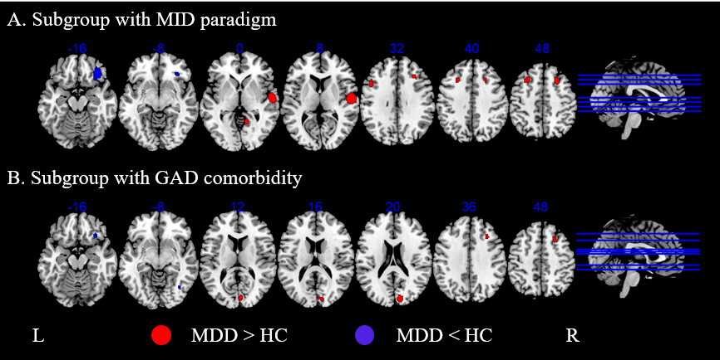

Supplementary Figure S1. Subgroup meta-analysis of brain activity differences between MDD and HCs in reward anticipation. A. Results based on studies which employed the MID paradigm. B. Results based on studies including subjects comorbid with GAD.

Supplementary Table S6. Jake-knife sensitivity analysis of brain activity differences between MDD and HCs in reward processing.
MDD > HC |  | MDD < HC
Brain region | ITG L | CAU R | SFG R | IFGoperc R
JK analysis
JK_Pizzagalli, 2009 | × | √ | × | ×
JK_Smoski, 2009 | √ | √ | √ | ×
JK_Smoski, 2011 | √ | √ | √ | √
JK_Segarra, 2016 | √ | × | × | √
JK_Carl, 2016 | √ | √ | √ | √
JK_Liu, 2017 | √ | √ | √ | √
JK_Schwarz, 2020 | √ | √ | √ | √
JK_Wakatsuki, 2022 | √ | √ | √ | √
JK sensitivity | 7/8 | 7/8 | 6/8 | 6/8

Supplementary Table S7. Subgroup meta-analysis of brain activity differences between MDD and HCs in reward processing.
Brain region | MNI  (x, y, z) | BA | SDM value | p value | Cluster size
Subgroup with MID (5/8)
MDD > HC
Left inferior temporal gyrus  Left fusiform gyrus | -40, -14, -32 | 20 | 1.007 | < 0.001 | 967
MDD < HC
Left posterior cingulate cortex | -2, -32, 30 | 23/31 | -1.005 | < 0.001 | 180
Left cerebellum crus I/II | -16, -78, -34 | / | -1.007 | < 0.001 | 143
Left precentral gyrus | -52, -6, 32 | 6 | -1.008 | < 0.001 | 104
Right superior frontal gyrus | 28, 12, 52 | 6/8 | -1.011 | < 0.001 | 84
Right caudate nucleus | 14, 16, 12 | / | -1.010 | < 0.001 | 68
Right inferior frontal gyrus | 52, 24, 26 | 46 | -1.007 | < 0.001 | 61
Left nuclear accumbens | -8, 10, -10 | / | -1.008 | < 0.001 | 57
Right temporal gyrus | 52, -60, -4 | 37 | -1.008 | < 0.001 | 52
Right superior frontal gyrus | 4, 48, 34 | 9 | -1.003 | 0.001 | 49
Right insula gyrus | 32, 16, 2 | 47 | -1.002 | 0.002 | 47
Left cerebellum louble VI | -8, -62, -26 | / | -1.007 | < 0.001 | 40
Right middle frontal gyrus | 52, 16, 42 | 8/9 | -1.011 | < 0.001 | 25
Right caudate nucleus | 16, -2, 22 | / | -1.003 | 0.002 | 25
Right middle cingulate cortex | 10, 16, 34 | 32 | -1.002 | 0.002 | 15
Subgroup with GAD comorbidity (5/8)
MDD > HC
Left inferior temporal gyrus  Left fusiform gyrus | -40, -14, -32 | 20 | 1.009 | < 0.001 | 963
MDD < HC
Left posterior cingulate cortex | -2, -32, 30 | 23/31 | -1.009 | < 0.001 | 130
Left cerebellum crus I/II | -16, -78, -34 | / | -1.009 | < 0.001 | 107
Left precentral gyrus | -52, -6, 32 | 6 | -1.009 | < 0.001 | 77
Right superior frontal gyrus | 28, 12, 52 | 6/8 | -1.011 | < 0.001 | 75
Right caudate nucleus | 14, 16, 12 | / | -1.010 | < 0.001 | 57
Right inferior frontal gyrus | 52, 24, 26 | 46 | -1.009 | < 0.001 | 49
Left nuclear accumbens | -8, 10, -10 | / | -1.009 | < 0.001 | 46
Right temporal gyrus | 52, -60, -4 | 37 | -1.009 | < 0.001 | 45
Right superior frontal gyrus | 4, 48, 34 | 9 | -1.008 | 0.001 | 38
Left cerebellum louble VI | -8, -62, -26 | / | -1.009 | < 0.001 | 34
Right insula gyrus | 32, 16, 2 | 47 | -1.008 | 0.003 | 24
Right middle frontal gyrus | 52, 16, 42 | 8/9 | -1.010 | < 0.001 | 22
Right caudate nucleus | 16, -2, 22 | / | -1.008 | 0.001 | 11

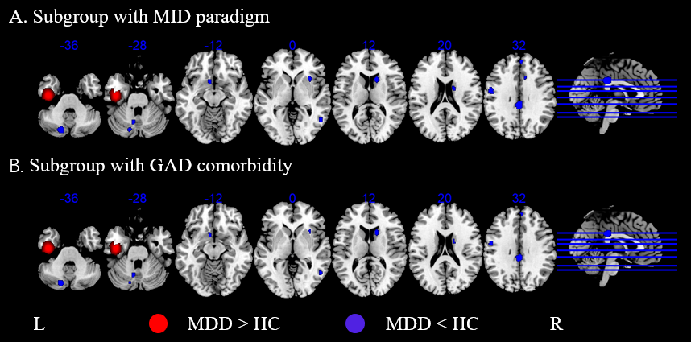

Supplementary Figure S2. Subgroup meta-analysis of brain activity differences between MDD and HCs in reward processing. A. Results based on studies which employed the MID paradigm. B. Results based on studies including subjects comorbid with GAD.

Supplementary Table S8. Jake-knife sensitivity analysis of brain activity differences between MDD and HCs in reward learning.
 | MDD > HC |  |  | MDD < HC
Brain region | CER4/5 L | CER6 R | CAL L | PUT L | CAU R | THA R | PHG R | CAL R | MFG L | SFG R | CAU L | REC R
JK analysis
JK_Kumar, 2008 | √ | √ | √ | √ | √ | √ | √ | √ | √ | √ | √ | √
JK_Gradin, 2011 | √ | √ | √ | × | × | √ | × | × | × | × | × | ×
JK_Chase, 2013 | × | × | × | √ | √ | √ | √ | √ | √ | √ | √ | √
JK_Greenberg, 2015 | √ | √ | √ | × | √ | √ | √ | × | × | √ | √ | √
JK_Liu, 2017 | √ | √ | √ | √ | √ | √ | √ | √ | √ | √ | √ | √
JK_Rothkirch, 2017 | √ | √ | √ | √ | √ | √ | √ | √ | √ | √ | √ | √
JK_Kumar, 2018 | √ | √ | √ | √ | × | × | × | √ | √ | √ | √ | ×
JK_Reinen, 2021 | √ | √ | √ | √ | √ | √ | √ | × | × | × | × | √
JK sensitivity | 7/8 | 7/8 | 7/8 | 6/8 | 6/8 | 7/8 | 6/8 | 5/8 | 5/8 | 6/8 | 6/8 | 6/8

Supplementary Table S9. Subgroup meta-analysis of brain activity differences between MDD and HCs in reward learning.
Brain region | MNI  (x, y, z) |  | BA | SDM value | p value | Cluster size
Subgroup with monetary rewarding stimuli (6/8)
MDD > HC
Left cerebellum louble VI |  | -32, -58, -22 | / | 1.134 | < 0.001 | 278
Vermis VI  Right cerebellum louble VI |  | 4, -68, -6 | / | 1.140 | < 0.001 | 219
Left calcarine cortex  Left lingual gyrus |  | -6, -94, -6 | 17 | 1.139 | < 0.001 | 187
Left fusiform gyrus |  | -28, -64, -12 | / | 1.137 | < 0.001 | 46
MDD < HC
Right thalamus |  | 18, -24, 12 | / | -1.021 | 0.001 | 71
Right lingual gyrus |  | 6, -40, -2 | / | -1.013 | 0.001 | 68
Subgroup with GAD comorbidity (5/8)
MDD > HC
Left cerebellum louble VI |  | -30, -64, -20 | / | 1.147 | < 0.001 | 304
Right lingual gyrus  Vermis VI  Right cerebellum VI |  | 16, -64, -12 | / | 1.146 | < 0.001 | 222
Left calcarine cortex  Left lingual gyrus |  | -10, -94, -4 | 17 | 1.147 | < 0.001 | 195
Left fusiform gyrus |  | -28, -68, -10 | / | 1.146 | < 0.001 | 51
MDD < HC
Right lingual gyrus |  | 6, -40, -2 | / | -1.030 | < 0.001 | 249
Right superior temporal pole  Right orbitofrontal gyrus |  | 54, 16, -6 | 47 | -1.017 | < 0.001 | 162
Right thalamus |  | 18, -24, 12 | / | -1.037 | < 0.001 | 144

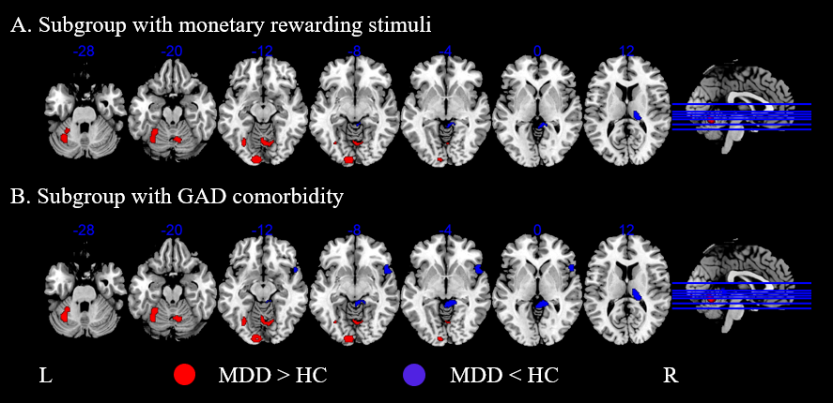
Supplementary Figure S3. Subgroup meta-analysis of brain activity differences between MDD and HCs in reward learning. A. Results included studies with monetary rewarding stimuli. B. Results based on studies including subjects comorbid with GAD.

