SUPPLEMENTARY MATERIAL

Supplementary Table 1. Sociodemographic and clinical characteristics of the subjects at follow-up

Supplementary Table 2. Childhood adversity ratings between followed and non-followed participants

Figure. Distribution of the Global Family Environment Scale score in 243 patients with psychotic disorders

Supplementary Table 3. Pearson’s correlation coefficients among confounders

Supplementary Table 1. Sociodemographic and clinical characteristics of the subjects at follow-up

 | N (%) | Mean (SD)
Gender (male) | 137 (56.4)
Civil status (single) | 150 (61.7)
Living:
Own family | 71 (29.2)
Other family members | 54 (22.2)
Other persons | 17 (7.0)
Supported housing | 37 (15.2)
Employment (paid working) | 80 (33)
DSM-5 illness course:
Full remission | 73 (30.0)
Partial remission | 149 (61.3)
Chronic/continuous | 59 (24.3)
Psychiatric medication:
Antipsychotics | 182 (74.9)
Mood stabilizers | 72 (29.6)
Antidepressants | 81 (33.3)
Anxiolytics/hypnotics | 105 (43.2)
None | 41 (16.9)
Age, years |  | 48.5 (10.4)
Parental socioeconomic status (1-5) |  | 3.07 (0.72)
No. of psychiatric admissions |  | 5.85 (6.24)
GAF |  | 64.0 (19.8)
SOFAS |  | 62.8 (21.4)
SAPS, global ratings total score |  | 2.86 (3.66)
SANS, global ratings total score |  | 5.89 (4.96)

DSM-5= Diagnostic and Statistical Manual, fifth edition; GAF= Global Assessment of Functioning Scale; SAPS= Scale for the Assessment of Positive Symptoms; SANS= Scale for the Assessment of Negative Symptoms; SOFAS= Social and Occupational Functioning Assessment Scale.

Supplementary Table 2. Childhood adversity ratings between followed and non-followed participants

 | Followed  (N=243) | Non-followed (N=267) | ꭕ² or t | p
GFES, mean (SD) | 30.0 | 32.5 | 1.30 | 0.194
Levels of adversity exposure, n (%) |  |  | 2.63 | 0.453
Absent | 110 (45.3) | 104 (39.0)
Mild | 34 (14.0) | 44 (16.5)
Moderate | 47 (19.3) | 51 (19.1)
Severe | 52 (21.4) | 68 (25.5)
Dichotomic rating of exposure, yes, n (%) | 163 (55.1) | 133 (44.9) | 2.08 | 0.149

GFES= Global Family Environment Scale

Figure. Distribution of the Global Family Environment Scale score in 243 patients with psychotic disorders

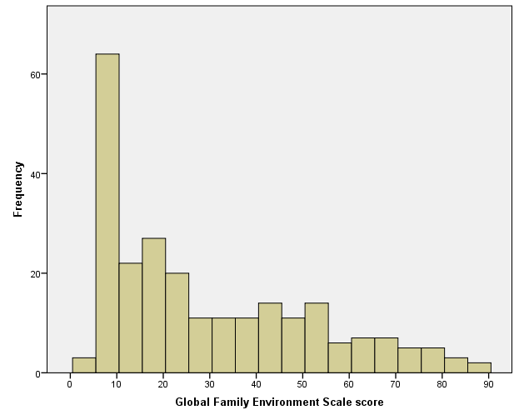

Supplementary Table 3. Pearson’s correlation coefficients among confounders

 |  | 1 | 2 | 3 | 4 | 5
1. Age at follow-up, y. |  | *
2. Sex, female=0, male=1 |  | -.130ª | *
3. Parental socioeconomic status |  | .272^{c} | .092 | *
4. Length of follow-up, y. |  | .373^{c} | .056 | .302^{c} | *
5. Familial load of SSD |  | -.048 | .050 | .094 | .137ª | *
6. Obstetric complications |  | -.081 | .062 | .058 | .067 | .171^{b}

ª = p<0.05; ^{b} = p<0.01; ^{c} = p<0.001
SSD schizophrenia spectrum disorders

