Supplementary Online Content

Table S1. EPIbipolar risk criteria (Leopold et al., 2012)

Figure S1. ROI-selection for conjunction analyses (one-tailed)

Figure S2. Significant clusters of GMV whole-brain differences among groups (F-test)

Figure S3. Significant putamen finding of conjunction analysis (red) within the selected ROIs derived from recent meta-analyses (yellow)

Supplement 1: Exploratory whole-brain conjunction analyses of individuals at risk and BD patients relative to HCs

Table S2: Results of FWE cluster-level significant post-hoc t-tests of exploratory whole-brain analyses

Table S3: Estimates of effect sizes using split-half cross-validation of significant post-hoc t-tests of whole-brain and ROI analyses

Table S4: Influence of current medication intake on identified clusters within patient samples

Table S5: Influence of psychiatric diagnoses, familial risk, and remission status on identified clusters within patient samples

Table S6: Relationship between observed clusters and current or past disease severity within patient samples
Supplement 2: Exploratory ROI-based conjunction analyses of low- or high-risk individuals and BD patients relative to HCs

Supplement 3: Association between the amount of risk factors and GMV

Table S7: Influence of risk factors on identified clusters within at-risk sample

References
Table S1. EPIbipolar risk criteria (Leopold et al., 2012)
Risk groups | Main risk factors | Secondary risk factors
Low-risk  - one or more risk factors of group A and one or more risk factors of group B, without any main risk-factor  - family history of bipolar disorder as main factor, without any other risk factors  High-risk  - one main risk factor and one or more secondary risk factors of group A and/or group B are met  - or more than one main risk factor | - family history of bipolar disorder  - increasing cyclothymic mood swings with increased activity  - subthreshold manic symptoms | Group A  - specific disturbances in sleep and/or circadian rhythm  - increasing cyclothymic mood swings without change of activity  - specific depressive features  Group B  - positive family history of MDD, schizophrenia, or schizoaffective disorder (not applicable if genetic vulnerability for bipolar disorder is a main risk factor)  - any affective disorder lifetime  - lifetime or present ADHD or behavioral disturbances  - impairment in psychosocial functioning  - episodic course of symptoms  - specific substance misuse
Note. For the purpose of this study, we pooled the low- and high-risk group into one risk group (BD-RISK).

Figure S1. ROI selection for conjunction analyses (one-tailed)
- Decreased GMV | - Increased GMV
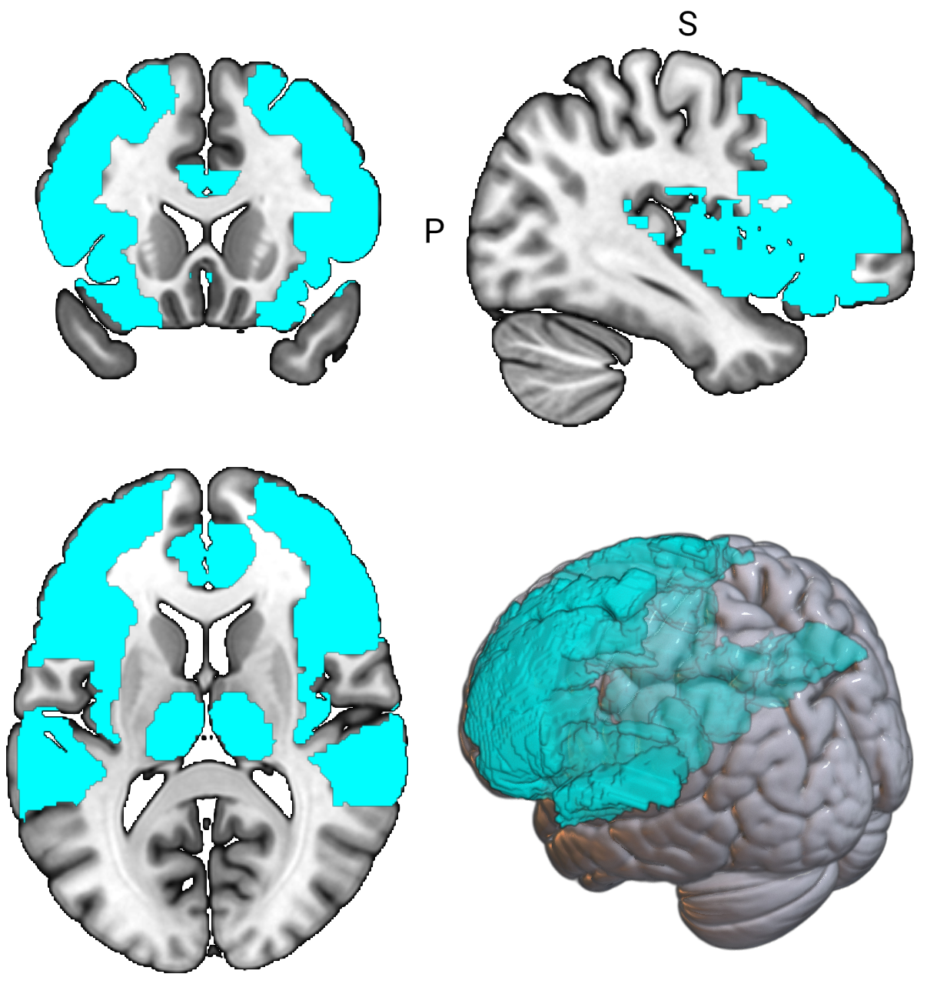 | 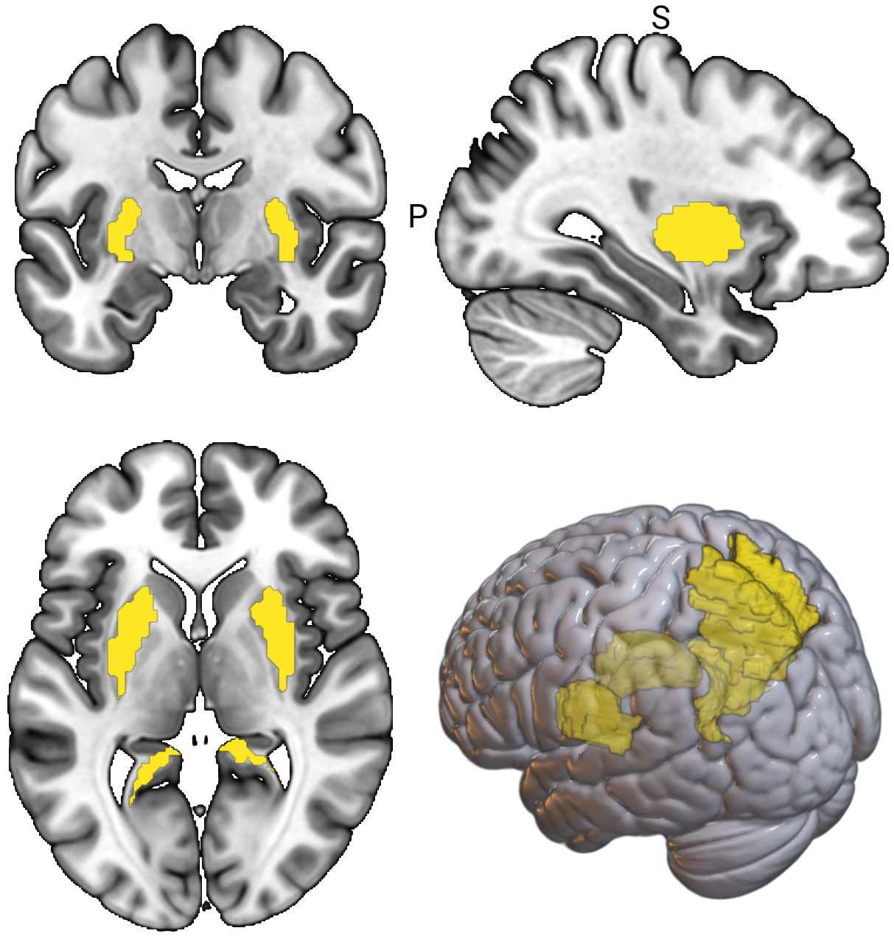
Note. A) shows the ROIs associated with decreased GMV derived from recent meta-analyses of BD patients relative to HCs, including the insula, thalamus, anterior cingulate cortex, inferior frontal gyrus, middle frontal gyrus, superior frontal gyrus, and superior temporal gyrus, while B) shows the ROIs associated with increased volumes derived from recent meta-analyses of BD patients relative to HCs, including the putamen, precuneus, and posterior cingulate cortex (Gong et al., 2021; Lu et al., 2019; Yu et al., 2019). These ROIs were created to test our hypotheses of shared GMV alterations in individuals at risk and BD patients relative to HCs, either decreased or increased, depending on the regions.

Figure S2. Significant clusters of whole-brain GMV differences among groups (F-test)
- Left supplementary motor area
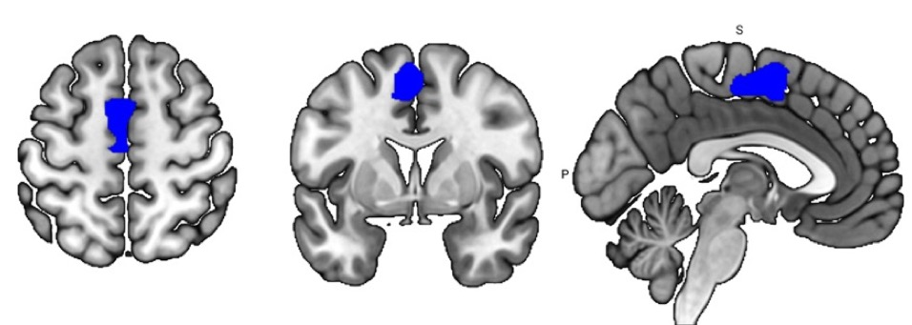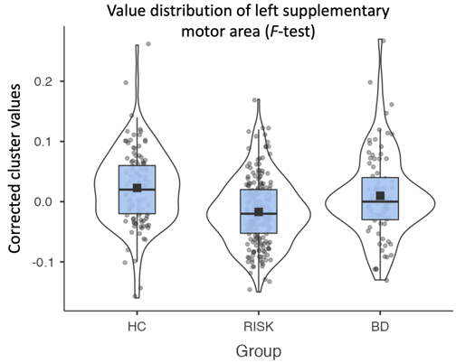

- Right inferior occipital gyrus/occipital fusiform gyrus
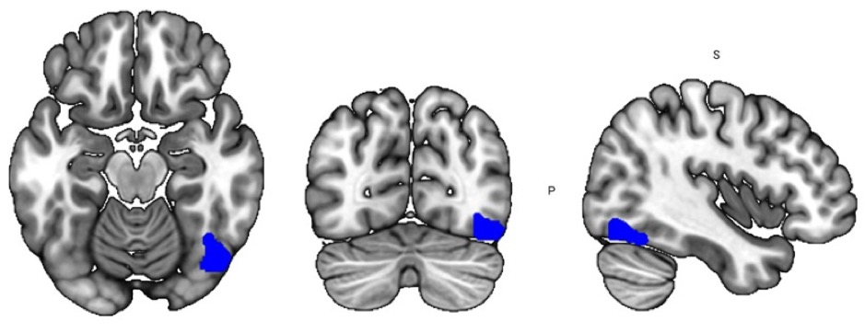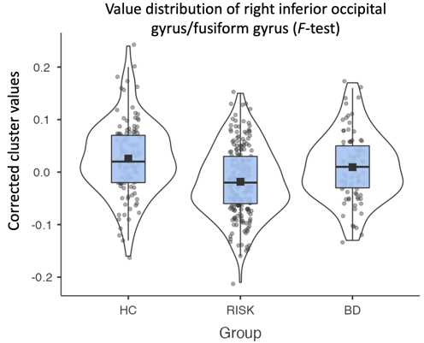
Note. ANCOVA (F-test) results show significant clusters of GMV differences between HC, BD-RISK, and BD in A) the left supplementary motor area (k=179, x/y/z=-10/3/51, F=16.94, η²_{p}=0.077, P=.002 FWE peak-level) and B) the right inferior occipital gyrus/occipital fusiform gyrus (k=77, x/y/z=40/-72/-15, F=15.81, η²_{p}=0.072, P=.006 FWE peak-level). Significant clusters were labelled using the Dartel space Neuromorphometrics atlas. Violin plots depict the jittered distribution of corrected mean intensity values of clusters for each group. For visualization, we show uncorrected clusters at an initial threshold of p<.001.

Figure S3. Significant putamen finding of conjunction analysis (red) within the selected ROIs derived from recent meta-analyses (yellow)
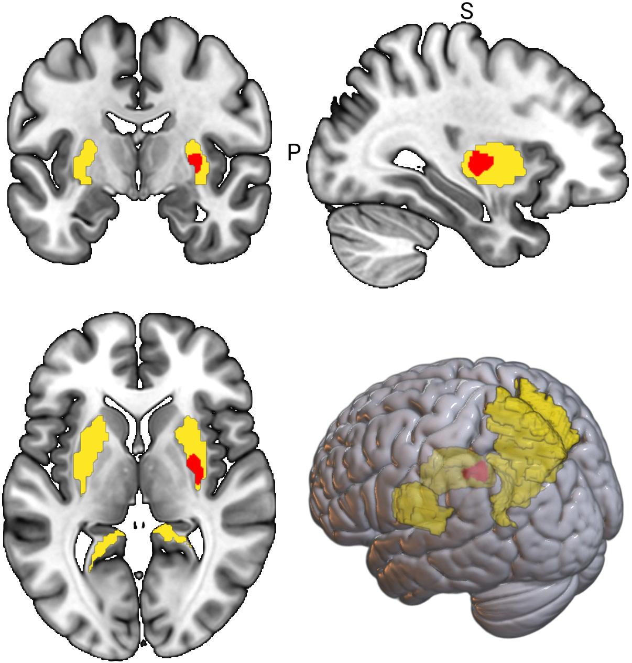
Note. Figure shows the significant putamen cluster of our conjunction analysis within the ROIs associated with increased volumes in BD patients (yellow), including the putamen, precuneus, and posterior cingulate cortex (Lu et al., 2019; Yu et al., 2019). These ROIs were created to test our hypotheses of shared GMV increases in individuals at risk and BD patients relative to HCs. For visualization, we show uncorrected clusters at an initial threshold of p<.001 (red).

Supplement 1: Exploratory whole-brain conjunction analyses of individuals at risk and BD patients relative to HCs
In addition to the region-of-interest (ROI)-based conjunction analysis of the BD risk and patient group against HCs (BD-RISK > HC ∩ BD > HC), we also provide results from whole-brain analyses at an initial threshold of p<.001 uncorrected for further reference. These analyses indicate that individuals at risk and BD patients have reductions in GMV in a) the right putamen (k=250, x/y/z=28/-10/0, t_{1,404}=3.88, d=0.386, p=.459 FWE peak-level) and in b) the bilateral subcallosal area (k=148, x/y/z=-2/18/-22, t_{1,404}=3.69, d=0.367, p=.677 FWE peak-level) relative to HCs, although not statistically significant. Larger right putamen volumes were also found in separate whole-brain post-hoc t-test analyses in a) individuals at risk (k=375, x/y/z=28/-10/0, t_{1,404}=3.88, d=0.386, p=.459) relative to HCs, and b) BD patients (k=702, x/y/z=26/-8/2, t_{1,404}=4.55, d=0.453, p=.054 FWE peak-level) relative to HCs, although not statistically significant, at an initial threshold of p<.001 uncorrected.

Table S2: Results of FWE cluster-level significant post-hoc t-tests of exploratory whole-brain analyses
 |  | MNI coordinates
 | H | x | y | z | T | k  cluster | Cohen’s  d | p  FWE cluster-level
 | HC < BD
100% Precuneus | L | -12 | -57 | 36 | 4.99 | 850 | 0.497 | .057
 | HC > BD-RISK
86% Inferior occipital gyrus 14% Occipital fusiform gyrus | R | 40 | -72 | -15 | 5.27 | 1192 | -0.524 | .018
100% Supplementary motor area | L | -3 | 2 | 56 | 5.14 | 2604 | -0.511 | <.001*
43% Middle temporal gyrus  43% Inferior temporal gyrus | L | -54 | -9 | -33 | 4.51 | 1429 | -0.449 | .009*
 | BD-RISK < BD
100% Supplementary motor area | L | -12 | 4 | 50 | 4.85 | 576 | 0.483 | .152
72% Precuneus  22% Precuneus | L  R | 0 | -66 | 34 | 4.36 | 1079 | 0.434 | .026
Note. R=right, L=left, H=hemisphere; k, number of significant voxels per cluster after initial p<.001 adjustment for multiple testing (i.e., FWE cluster-level correction). Only areas k≥10 voxels are included. Percentages show to what extent the identified clusters lie in the brain regions of the Dartel space Neuromorphometrics atlas. *Results were significant after adjustment for multiple testing using Holm-Bonferroni correction.

Table S3: Estimates of effect sizes using split-half cross-validation of significant post-hoc t-tests of whole-brain and ROI analyses
 |  |  | MNI coordinates
 | Sample half | H | x | y | z | T | Cohen’s d
 |  | HC < BD
Precuneus | 1st half | L | -8 | -57 | 32 | 4.79 | 0.684
 | 2nd half | L | -14 | -57 | 34 | 3.44 | 0.484
 |  | HC > BD-RISK
Inferior occipital gyrus | 1st half | R | 39 | -70 | -15 | 4.94 | -0.706
 | 2nd half | R | 38 | -74 | -4 | 2.59 | -0.364
Supplementary motor area | 1st half | L | -4 | 4 | 62 | 3.79 | -0.541
 | 2nd half | L | -4 | 0 | 48 | 5.44 | -0.766
 |  | BD-RISK < BD
Supplementary motor area | 1st half | L | -12 | 4 | 52 | 3.36 | 0.480
 | 2nd half | L | -8 | 3 | 48 | 5.17 | 0.728
 |  | HC < BD-RISK ∩ HC < BD
Putamen (ROI) | 1st half | R | 27 | -12 | 3 | 2.65 | 0.379
 | 2nd half | R | 28 | -10 | 3 | 3.23 | 0.455
Note. R=right, L=left, H=hemisphere.

Table S4: Influence of current medication intake on identified clusters within patient samples
 |  | Conjunction Cluster:  Right  Putamen | HC<BD Cluster:  Left Precuneus | HC>RISK  Cluster:  Right inferior occipital gyrus/ fusiform gyrus
Antidepressants | F | 2.16 | 1.70 | 1.01
 | p | .143 | .196 | .320
 | df | 285 | 81 | 199
Antipsychotics | F | 0.92 | 5.24 | 0.36
 | p | .338 | .025 | .550
 | df | 285 | 81 | 201
Lithium | F | 1.86 | 0.23 | 0.50
 | p | .174 | .636 | .481
 | df | 289 | 81 | 203
Stimulants | F | 0.74 | 0.02 | 0.31
 | p | .391 | .888 | .580
 | df | 288 | 82 | 201
Note. Using ANCOVA, results indicate that medication intake had no significant influence on the identified clusters, after correction for multiple testing. The influence of current medication intake on identified clusters was calculated for relevant samples (e.g., the effect of lithium medication on the left precuneus was assessed within 87 BD patients).

Table S5: Influence of psychiatric diagnoses, remission status, and familial risk (first-degree relative) on identified clusters within patient samples
 |  | Conjunction Cluster:  Right  Putamen | HC<BD Cluster:  Left Precuneus | HC>RISK  Cluster:  Right inferior occipital gyrus/fusiform gyrus
MDD | F | 0.01 | - | 0.17
 | p | .980 | - | .679
 | df | 201 | - | 201
ADHD | F | 0.62 | NA | 0.71
 | p | .540 | NA | .491
 | df | 202 | NA | 202
Remission status | F | 2.37 | 1.49 | 1.39
 | p | .125 | .227 | .240
 | df | 235 | 76 | 154
Family history of  BD | F | 0.44 | 0.20 | 3.96
 | p | .833 | .653 | .048
 | df | 253 | 45 | 203
Family history of MDD/SCZ/SZA | F | 0.22 | 2.54 | 1.40
 | p | .639 | .118 | .237
 | df | 253 | 45 | 203
 | F | 0.44 | 1.51 | 3.26
Anxiety disorder | p | .506 | .223 | .072
 | df | 290 | 82 | 203
 | F | 0.04 | 0.79 | 0.02
Eating disorder | p | .836 | .376 | .880
 | df | 286 | 82 | 199
 | F | 2.24 | 0.26 | 0.09
Alcohol abuse | p | .136 | .612 | .766
 | df | 288 | 82 | 201
 | F | 0.00 | 0.04 | 0.02
Cannabis abuse | p | .973 | .840 | .880
 | df | 286 | 82 | 199
Note. NA, not available. ANCOVA results indicate that identified clusters were not driven by psychiatric diagnoses or acute illness (vs. remission), after correction for multiple testing. Altered volumes likely occurred due to the combination of genetic and non-genetic risk factors for BD and not solely because of psychiatric illnesses, familial risk, or a current episode.

Table S6: Relationship between observed clusters and disease severity and course of illness within patient samples
 |  | Conjunction Cluster:  Right  Putamen | HC<BD Cluster:  Left Precuneus | HC>RISK Cluster:  Right inferior occipital gyrus/fusiform gyrus
Number of depressive episodes | rho | 0.11 | -0.04 | -0.06
 | p | .088 | .726 | .518
 | N | 226 | 81 | 145
Number of  manic  episodes | rho | -0.05 | -0.14 | NA
 | p | .425 | .221 | NA
 | N | 289 | 81 | NA
GAF | r | -0.09 | 0.16 | 0.01
 | p | .138 | .136 | .861
 | N | 286 | 87 | 199
Number of hospitalizations | rho | 0.12 | -0.25 | 0.04
 | p | .073 | .127 | .561
 | N | 246 | 43 | 203
Duration of illness* | rho | 0.11 | 0.16 | NA
 | p | 0.473 | .280 | NA
 | N | 50 | 50 | NA
Note. NA, not available. Using partial Pearson correlations, the relationship was assessed between the intensity values of the extracted clusters and the number of manic and depressive episodes, number of hospitalizations, duration of illness, or global functioning (GAF), or Spearman’s rho for non-normal data. Results indicate that the observed alterations in cluster volumes were not solely because of indicators of course of illness or disease severity but instead due to BD, or a variety of genetic and non-genetic risk factors for BD. *Data were only available for 50 BD participants.

Supplement 2: Exploratory ROI-based conjunction analyses of low- or high-risk individuals and BD patients
In addition to the ROI-based conjunction analysis of the overall risk and BD patient groups against HCs, we explored shared GMV separately in a) low-risk group and BD patients, and b) high-risk group and BD patients, relative to HCs, at an initial threshold of p<.001 uncorrected. It appears that a) individuals at low risk and BD patients both have larger GMV in the right putamen (k=161, x/y/z=30/-10/0, t_{1,404}= 3.70, d=0.368, p=.076 FWE peak-level) and b) individuals at high risk and BD patients both have larger GMV in the left precuneus (k=11, x/y/z=-14/-57/32, t_{1,404}=3.67, d=0.365, p=.085 FWE peak-level) relative to HCs. However, these findings were not statistically significant, indicating that our main finding was not influenced by high- or low-risk groups.

Supplement 3: Association between the amount of risk factors and GMV
Using multiple linear regression, the amount of risk factors (as estimated by the EPIbipolar risk score) was not significantly associated with the extracted intensity values of the putamen volume (β=0.05, p=0.422) and inferior occipital gyrus (β=.061, p=.226) in the BD-RISK group, controlling for age, sex, TIV. The EPIbipolar risk score is an indication for the amount or load of risk factors of a participant and ranges from 0 to 13. The main risk factors (see aforementioned Table S1) are weighted twice. The risk factors affective disorder, specific depressive features, functional impairment, and episodic course are closely related and are combined into the risk factor "depressive disorder” and are not added up separately.

Table S7: Influence of risk factors of the EPIbipolar scale (Leopold et al., 2012) on identified clusters within the BD-RISK sample
 |  |  | Conjunction Cluster:  Right  Putamen | HC>RISK  Cluster:  Right inferior occipital gyrus/fusiform gyrus
 | Family history  BD (first-degree relative) | F | 0.00 | 3.96
 |  | p | .999 | .048
 |  | df | 203 | 203
 | Cyclothymic mood swings with increased activity | F | 0.10 | 0.08
Main factors |  | p | .742 | .777
 |  | df | 203 | 203
 | Subthreshold manic symptoms | F | 0.02 | 0.01
 |  | p | .883 | .945
 |  | df | 202 | 202
 | Family history MDD/SCZ/SZA (first-degree relative) | F | 0.02 | 1.40
 |  | p | .882 | .237
 |  | df | 203 | 203
 | Sleep/circadian rhythm problems | F | 0.01 | 0.31
 |  | p | .926 | .580
 |  | df | 203 | 203
 | Cyclothymic mood swings without increased activity | F | 0.28 | 2.13
 |  | p | .594 | .146
 |  | df | 203 | 203
Secondary factors | Global functioning | F | 1.61 | 0.01
 |  | p | .206 | .918
 |  | df | 202 | 202
 | Episodic course | F | 0.02 | 0.04
 |  | p | .886 | .843
 |  | df | 203 | 203
 | Substance misuse | F | 1.32 | 0.04
 |  | p | .252 | .843
 |  | df | 203 | 203
 | Anxiety symptoms | F | 0.14 | 1.03
 |  | p | .699 | .311
 |  | df | 202 | 202
Note. ANCOVA results indicate that identified clusters were not influenced by any of the risk factors of the EPIbipolar scale individually, after correction for multiple testing. Altered cluster volumes likely occurred due to the combination of genetic and non-genetic risk factors for BD.

References
Gong, J., Wang, J., Chen, P., Qi, Z., Luo, Z., Wang, J., … Wang, Y. (2021). Large-scale network abnormality in bipolar disorder: A multimodal meta-analysis of resting-state functional and structural magnetic resonance imaging studies. Journal of Affective Disorders, 292, 9–20. https://doi.org/10.1016/j.jad.2021.05.052
Leopold, K., Ritter, P., Correll, C. U., Marx, C., Özgürdal, S., Juckel, G., … Pfennig, A. (2012). Risk constellations prior to the development of bipolar disorders: Rationale of a new risk assessment tool. Journal of Affective Disorders, 136(3), 1000–1010. https://doi.org/10.1016/j.jad.2011.06.043
Lu, X., Zhong, Y., Ma, Z., Wu, Y., Fox, P. T., Zhang, N., & Wang, C. (2019). Structural imaging biomarkers for bipolar disorder: Meta-analyses of whole-brain voxel-based morphometry studies. Depression and Anxiety, 36(4), 353–364. https://doi.org/10.1002/da.22866
Yu, H., Meng, Y., Li, X., Zhang, C., Liang, S., Li, M., … Li, T. (2019). Common and distinct patterns of grey matter alterations in borderline personality disorder and bipolar disorder: voxel-based meta-analysis. The British Journal of Psychiatry, 215(01), 395–403. https://doi.org/10.1192/bjp.2019.44

