Table S1. Search queries
Database | Query
Web of Science | TOPIC: ('suicid* attempt*') AND TOPIC: (repeat or repeat* or repetition)
 | TOPIC: (suicid*) AND TOPIC: (reattempt* or re-attempt*)
 | TOPIC: (suicid*) AND TOPIC: (attempt*) AND TOPIC: (repetition)
 | TOPIC: (suicid*) AND TOPIC: (self-destructive or self-injurious) AND TOPIC: (repetition)
 | TOPIC: (suicid*) AND TOPIC: ((self?harm OR self?injur* OR self?mutilat* OR self?destruct* OR self?poison* OR self?inflict* OR auto$mutilat*)) AND TOPIC: ((repetition or repeat or repeat*))
 | TOPIC: ((self?harm OR self?injur* OR self?mutilat* OR self?destruct* OR self?poison* OR self?inflict* OR auto$mutilat*)) AND TOPIC: ((repetition or repeat or repeat*))
PubMed | "Suicide, Attempted"[Mesh] and (re-attempt* or reattempt*)
 | ("Suicide, Attempted"[Mesh] or "Suicide"[Mesh]) and (re-attempt* or reattempt*)
 | ("Suicide, Attempted"[Mesh] or "Suicide"[Mesh]) and repetition
 | ("Suicide, Attempted"[Mesh] or "Suicide"[Mesh]) and (repeat or repeat*)
 | "Self-Injurious Behavior"[Mesh] AND (repeat or repeat*)
 | "Self-Injurious Behavior"[Mesh] AND repetition
SCOPUS | ( TITLE-ABS-KEY ( suicid* ) AND TITLE-ABS-KEY ( repetition ) )
 | ( TITLE-ABS-KEY ( suicid* ) AND TITLE-ABS-KEY ( repeat ) )
 | ( TITLE-ABS-KEY ( suicid* ) AND TITLE-ABS-KEY ( ( re-attempt* OR reattempt* ) ) )
 | ( TITLE-ABS-KEY ( suicid* ) AND TITLE-ABS-KEY ( ( self-destructive OR self-injurious ) ) AND TITLE-ABS-KEY ( ( repetition OR repeat OR repeat* ) ) )
 | ( TITLE-ABS-KEY ( suicid* ) AND TITLE-ABS-KEY ( ( self?harm OR self?injur* OR self?mutilat* OR self?destruct* OR self?poison* OR self?inflict* OR auto$mutilat* ) ) AND TITLE-ABS-KEY ( ( repetition OR repeat OR repeat* ) ) )
 | ( TITLE-ABS-KEY ( ( self?harm OR self?injur* OR self?mutilat* OR self?destruct* OR self?poison* OR self?inflict* OR auto$mutilat* ) ) AND TITLE-ABS-KEY ( ( repetition OR repeat OR repeat* ) ) )
 | ( TITLE-ABS-KEY ( ( self-destructive OR self-injurious ) ) AND TITLE-ABS-KEY ( ( repetition OR repeat OR repeat* ) ) )
Psychinfo | ('suicid* attempt*') AND repeat* AND rtype.exact("Journal Article") AND la.exact("Spanish" OR "English") AND po.exact("human")
 | suicid* AND (reattempt* OR re-attempt*) AND rtype.exact("Journal Article") AND la.exact("Spanish" OR "English") AND po.exact("human")
 | suicid* AND attempt* AND repetition AND la.exact("Spanish" OR "English") AND po.exact("human") AND rtype.exact("Journal Article")
 | suicid* AND (self-destructive or self-injurious) AND repetition AND la.exact("Spanish" OR "English") AND po.exact("human") AND rtype.exact("Journal Article")
 | suicid* AND (self-destructive OR self-injurious) AND ((repetition or repeat or repeat*)) AND la.exact("Spanish" OR "English") AND po.exact("human") AND rtype.exact("Journal Article")
 | ((self?harm OR self?injur* OR self?mutilat* OR self?destruct* OR self?poison* OR self?inflict* OR auto$mutilat*)) AND ((repetition OR repeat OR repeat*)) AND rtype.exact("Journal Article") AND la.exact("Spanish" OR "English") AND po.exact("human")
CINAHL | TOPIC: ('suicid* attempt*') AND TOPIC: (repeat or repeat* or repetition)
 | TOPIC: (suicid*) AND TOPIC: (reattempt* or re-attempt*)
 | TOPIC: (suicid*) AND TOPIC: (attempt*) AND TOPIC: (repetition)
 | TOPIC: (suicid*) AND TOPIC: (self-destructive or self-injurious) AND TOPIC: (repetition)
 | TOPIC: (suicid*) AND TOPIC: ((self?harm OR self?injur* OR self?mutilat* OR self?destruct* OR self?poison* OR self?inflict* OR auto$mutilat*)) AND TOPIC: ((repetition or repeat or repeat*))
 | TOPIC: ((self?harm OR self?injur* OR self?mutilat* OR self?destruct* OR self?poison* OR self?inflict* OR auto$mutilat*)) AND TOPIC: ((repetition or repeat or repeat*))
Cochrane Library. Trials Library | ('suicid attempt') AND (repeat or repeat or repetition) in Title Abstract Keyword
 | (suicid) AND (reattempt or re-attempt) in Title Abstract Keyword
 | (suicid) AND (attempt) AND (repetition) in Title Abstract Keyword
 | (suicid) AND (self-destructive or self-injurious) AND (repetition) in Title Abstract Keyword
 | (suicid) AND ((selfharm OR selfinjur OR selfmutilat OR selfdestruct OR selfpoison OR selfinflict OR auto$mutilat)) AND ((repetition or repeat or repeat)) in Title Abstract Keyword
 | ((selfharm OR selfinjur OR selfmutilat OR selfdestruct OR selfpoison OR selfinflict OR auto$mutilat)) AND ((repetition or repeat or repeat)) in Title Abstract Keyword

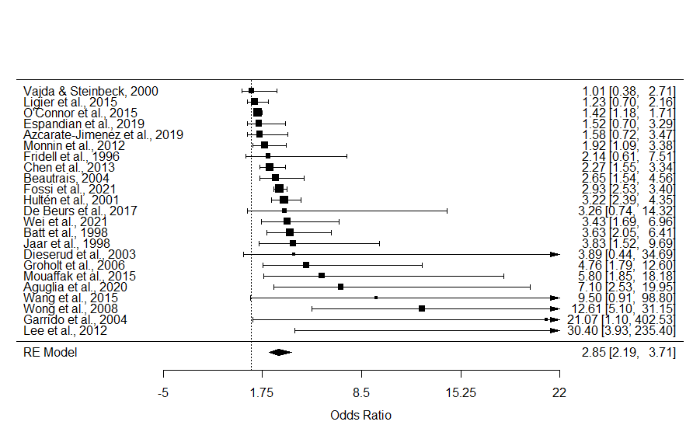
Figure S1. Forest plot of studies focused on suicide history.

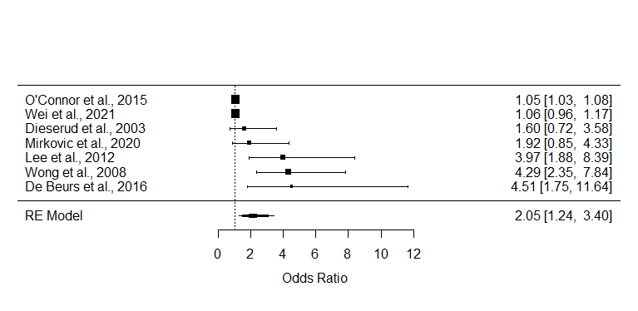
Figure S2. Forest plot of studies focused on ideation.

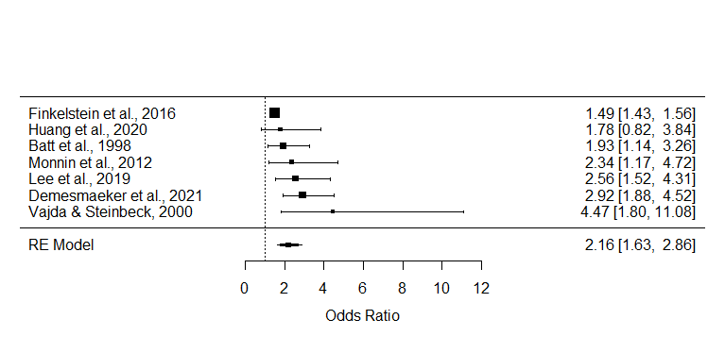
Figure S3. Forest plot of studies focused on alcohol.

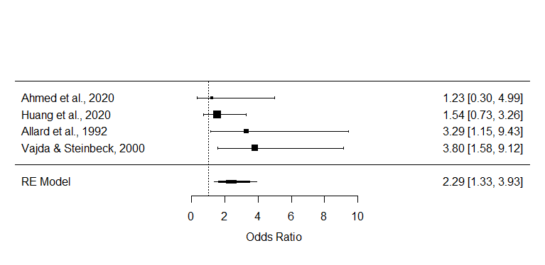
Figure S4. Forest plot of studies focused on drugs.

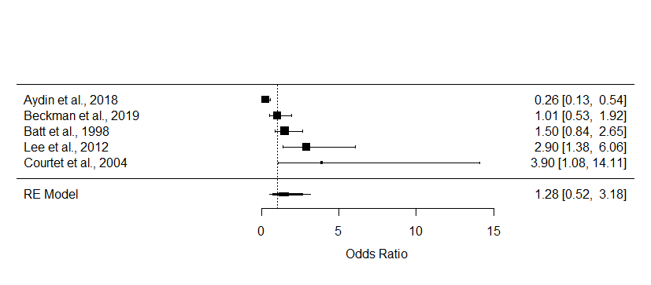
Figure S5. Forest plot of studies focused on impulsivity.

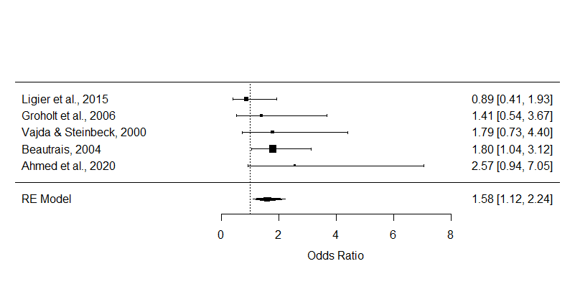
Figure S6. Forest plot of studies focused on trauma.

