Characterizing imaging phenotypes, clinical behavior, and genetic vulnerability of brain maturational subtypes in mood disorders
Supplementary Materials

- Methods and Materials
- Supplementary Tables:
Table S1, Table S2, Table S3, Table S4, Table S5, Table S6, Table S7, Table S8, Table S9, Table S10, Table S11, Table S12.
- Supplementary Figures:
Figure S1, Figure S2, Figure S3, Figure S4, Figure S5.

Methods and Materials
Participants
All patients met the DSM-IV criteria for MDD and BD, and had no comorbid Axis I mental disorders, and healthy controls (HC) participants did not have recurrent mood disorder or personal history of psychotic disorder. Patients and HC were excluded for (1) the presence of alcohol/drug dependence or abuse and concomitant major physical or nervous system disease, (2) any MRI contraindications, and (3) personal history of head injury with loss of consciousness for more than five minutes or any neurological disorders. HC participants were recruited from the local community by advertisement.

The replication cohort included 142 MDD patients and 126 BD patients. All the patients were also recruited from the Department of Psychiatry of the First Affiliated Hospital of China Medical University, Shenyang, China. All the patients were diagnosed by two experienced psychiatrists using the Structured Clinical Interview for the Diagnostic and Statistical Manual of Mental Disorders, 4th Edition, Text Revision (DSM-IV-TR) in patients aged 18 years and older and the Schedule for Affective Disorders and Schizophrenia for School-Age Children-present and Lifetime Version (K-SADS-PL) in those patients under the age of 18 years. The patients in the replication cohort were all currently received medication treatment before enrollment. The participants over 18 years old signed a written consent form themselves. If the participants age were less than 18 years, their parental/legal guardian provided written informed consent. This study was approved by the Ethics Committee of the First affiliated Hospital of China Medical University (Shenyang, China).

Image acquisition and MRI processing
Structural MRI scanning was conducted on a Signa HDx 3.0T superconductive MRI system (GE Healthcare, Little Chalfont, UK). T1-weighted images were acquired by using the three-dimensional fast spoiled gradient-echo sequence with the parameters: Repetition time/Echo time, 7.2/3.2 ms; Flip angle, 13°; image matrix, 240 × 240; field of view, 240 × 240 mm²; 176 contiguous 1.0 mm slices with a gap; and voxel size, 1.0 mm3. All participants were required to remain in a prostrate position.

T1-weighted images were preprocessed using the Computation Anatomy Toolbox (CAT 12; Christian Gaser; Department of Psychiatry, University of Jena) implemented in Statistical Parametric Mapping (SPM 12; Wellcome Department of Cognitive Neurology, University of London, UK) for voxel-based morphometry (VBM) [1]. We used the default parameters provided in (CAT 12) (http://neuro.uni-jena.de/ cat) to preprocess the T1-weighted images as previous studies(Jiang et al. 2023; Liu et al. 2021; Segal et al. 2023). Briefly, a fully automated procedure for standard voxel-based morphometry (including spatial registration, tissue segmentation and bias correction of intensity non-uniformities) was conducted, resulting in GMV images. Firstly, the T1-weighted images were corrected for intensity nonuniformities, and segmented into gray matter (GM), white matter and cerebrospinal fluid tissue probability maps; Then, using the high-dimensional Diffeomorphic Anatomical Registration Exponentiated Lie Algebra, the segmented scans were normalized into standard Montreal Neurological Institute IXI555 space; Lastly, the images were bias-field corrected and modulated by the linear and nonlinear components of the Jacobian determinant obtained from the Diffeomorphic Anatomical Registration Exponentiated Lie Algebra deformation fields to obtain voxel-wise estimates of GMV. To constrain our analyses to GM voxels, we generated a mean image from all the normalized GM maps and retained voxels with a tissue probability ≥0.2. Total intracranial volume (TIV), calculated as the sum of GM, WM, and CSF volumes, was used as a covariate for further statistical analyses.

The quality of images was assessed by using the automated weighted average image quality rating (IQR) included in the CAT12 toolbox (http://neuro.uni-jena.de/ cat). It constitutes a weighted average of the local (noise contrast ratio) and global (inhomogeneity contrast ratio) standard deviations within the optimized white matter segment scaled by the minimum tissue contrast, and the root mean square of the voxel size. A pdf is created for all subjects that contains a percentage rating (0-100%) and a corresponding letter value (F - A+) for noise, bias (inhomogeneity), resolution and IQR. The obtained quality ratings indicate images with good quality (grad A+, A and B) and modulate quality (grad C, D and E) and low quality (grad F, indicating problematic images). An image was classified as to fail QC if it had a noise grade less than or equal to ”C” (70%) and a total IQR grade of less than ”B”(80%). We applied the cut-off (>=80%, >= grad B) to ensure high quality images for analysis as low-quality images can lead to GM underestimations in preprocessing. The general IQR ratings in this study were 86.4% ± 0.74% (mean ± sd) in Dataset 1 and 86.3% ± 0.72% (mean ± sd) in Dataset 2.

Clinical symptoms network analysis in subtype groups
We created clinical symptoms network by using correlations between symptoms factors in each subtype and compared the network topological properties based on graph theory. Psychotic symptoms frequently occur in all stages of the affective disorders and are considered as the distinct and the most severe subtype of depression (Stamm et al. 2013; Tonna et al. 2012). In our study identifying subtypes of mood disorders, we attempt to investigate psychotic symptoms differences between subtypes. While the HAMD focuses predominantly on depressive symptoms and very few psychotic features are covered by the scale. We used the Brief Psychiatric Rating Scale (BPRS) (Overall and Gorham 1962) to allow rating of the severity of the psychotic symptomatology (Furuse and Hashimoto 2009). Moreover, multiple regression analyses showed that both HAMD and HAMA total scores were significantly associated with psychotic symptoms ratings such as PANSS positive symptom subscale score. Thus, the symptoms network analysis in this study included HAMD, HAMD, BPRS rating scores. Because items of BPRS were much more than items of HAMD and items in HAMA, we reduced the dimensions of BPRS items to five factors according to our previous study (Chang et al. 2022). The overall symptom network including 17 items of HAMD, 14 items of HAMA, 5 factors of BPRS, was represented with a symmetric 36 by 36 correlation coefficients matrix, where 36 denoted the sum of the number of these symptom items (nodes) (factors of BPRS were presented in Table S3). The Pearson correlation coefficient (r) between each pair of items was calculated across all patients as edges. Correlation coefficients above a fixed threshold (r >= 0.2, which produced the high similarity across all clinical symptoms) were selected as edges and removed weak correlations under this threshold in the network(Ye et al. 2021). We compared the between-subtype differences of global network strength, which was represented by the sum of weights of network edges, and then validated the differences at a range of network density thresholds (density = 0.1 ~ 0.6). We also conducted paired t-tests to examine differences in network strength ranges between subtypes. Then, we also calculated the nodal strength and nodal degree of symptom network (edge thresholds was set Correlation coefficients r >=0.2) in Subtype 1 and Subtype 2. The findings showed that the most distinctive nodes with different nodal characters between subtype 1 and subtype 2 were Guilt (HAMD), Somatic Anxiety (HAMA), Genito Urinary Symptoms (HAMA), Insomnia (HAMA) items (Figure S5).

Transcriptomic and genetic risks validation in subtype groups
Transcriptional data were acquired from brain tissue samples (n = 3702) of six donors from the open access Allen Human Brain Atlas (AHBA) database (https://human.brain-map.org/). The microarray data included genomic gene expression (20737 genes, 58692 probes). The AHBA dataset was preprocessed according to previous practical guide propose by Arnatkevic et al(Arnatkeviciute et al. 2019). The five steps of data preprocessing were shown as follows: (1) verifying probe-id to gene-symbol annotations utilizing the Re-annotator toolkit(Arloth et al. 2015); (2) filtering of probes not exceeding background signal noise, including at most 50% of all tissue samples; (3) selecting the probes with the highest association with RNA-seq data; (4) coregistering tissue samples to the DK 68 atlas with two millimeters Euclidean distance of a parcel; (5) spatially normalizing gene expression values utilizing sigmoid method for each donor. As the AHBA data only included 2 right hemisphere transcriptional data, we only used the left hemisphere data. Then, we calculated a mean of all tissue samples in a brain area and obtained the matrix (34 regions × 10027 genes) of gene expression values.

Transcriptome-imaging associations in subtype groups
We conducted the multivariate regression approach of partial least squares (PLS) to investigate the transcriptome-imaging associations(Morgan et al. 2019). The predictor variable consisted of a ROI × gene matrix (34 × 10027), and the response variable consisted of one vector (GMV deviations values of the 34 ROIs). PLS detected the Top-rank first component of transcriptional data possessing maximum covariance with GMV deviation values by singular value decomposition, such that the first PLS component (PLS1) provides the optimal one-dimensional representation of gene expression covariance. The PLS1 was tested for statistical significance with P < 0.05 by 5000 permutations through resampling the region labels assigned to the GMV deviations values of 34 ROIs. We also performed spatial bootstrapping (spherical rotations of the 34 areas) to estimate the variations of each gene in PLS1(Romero-Garcia et al. 2020). We used the ratio of the weight (the contribution to PLS1) of each gene to its bootstrapped error to compute the Z scores, and then ranked the genes according to Z scores. The set of genes with an FDR of 0.05, either Z > 3, or Z < -3, was the regional changes in GMV deviations gene list. Then we obtained two PLS1 gene lists respectively for subtype 1 (PLS1-subtype 1) and subtype 2 (PLS1-subtype 2).

Assigning PLS genes to cell types in virtual histology analysis
Following the procedure in previous study Seidlitz et al.(Seidlitz et al. 2020), we organized cell types into seven canonical classes: excitatory (Neuro.ex), and inhibitory neurons (Neuro.in), astrocytes (Astro), microglia (Micro), endothelial cells (Endo), oligodendrocyte precursors (OPC), oligodendrocytes (Oligo). All the gene lists were from previous studies(Darmanis et al. 2015; Habib et al. 2017; Lake et al. 2018; Li et al. 2018; Zhang et al. 2016). Because two studies (Darmanis et al., 2015, Zhang et al., 2016) did not subdivide neurons into excitatory and inhibitory sets, and thus we excluded these gene sets from this cell-class assignment. Additionally, one study included the annotation of the “Per” (pericyte) type, and thus this gene set was excluded. To assign GMV deviation related genes obtained by PLS analysis to cell types, we overlapped the gene set of each cell type with the PLS1−subype 1 and PLS1-subtype 2 rank gene lists. The details of cell type gene lists used in this study are available at https://github.com/zhengjunjie1234/Mood_Disorders_subtypeing.git.

Genotyping and quality control
We extracted genomic DNA from whole blood utilizing the standard protocols. The DNA samples were genotyped using the Illumina Global Screening Array-24 v1.0 BeadChip, which provides 642,824 fixed genetic variants and 53,411 customized variants. We removed single nucleotide polymorphisms (SNPs) with call rate < 95%, minor allele frequency < 1%, or Hardy-Weinberg equilibrium p < 10-5 for the quality control. We excluded samples with gender mismatch, excessive missingness > 5%, or an estimation of identity-by-descent > 0.9.

Imputation and calculation of polygenic risk scores
Genotype imputation was conducted by GenoImpute, a commercial imputation toolkit(Wang et al. 2013). We acquired a mean sample-level r² of 0.736 estimated by 1% hold out SNPs on the beadchip. We used PRSice software (www.PRSice.info) to calculate the Polygenetic risk scores (PRS). We used genomic wide association study (GWAS) data provided by the Psychiatric Genomics Consortium (https://pgc.unc.edu/) as discovery dataset and our imputed genotyped DNA samples as target dataset. Based on the Alzheimer Disease Working Group of the Psychiatric Genomics Consortium, genetic features were analyzed in 71,880 AD cases combined as a single phenotype and 383,378 controls, and the results were used for selecting the risk SNP list for calculating PRS-AD(Jansen et al. 2019). Genetic features related to MDD were analyzed in 135,458 MDD patients and 344,901 controls by Wray et al.(Wray et al. 2018); the selected SNP list was used to calculate PRS-MDD. We conducted p-value-informed clumping within a 250-kb window, using a cutoff of r²=0.1. For each set of PRS (PRS-AD and PRS-MDD), multiple thresholds of P values (ranging from 1.0e-06 to 0.1) were calculated for each participant.

Table S1. Clinical, Demographic and Cognitive Profiles Based on Clinical Diagnosis
Dataset 1 | HC | MDD | BD
Clinical and Demographic Data | N=404 | N=114 | N=60
Age | 29.0±9.3 | 28.7±11.1 | 27.8±8.5
Gender (male/female) | 160/244 | 34/80 | 23/37
Education | 14.5±3.6 | 12.2±3.7 | 12.5±4.1
First episode, yes | NA | 91(80%) | 31(51%)
Duration, months | NA | 13.4±46.6 | 33.4±53.4
HAMD |  | 22.0±8.5 | 11.7±10.1
HAMA |  | 17.3±10.4 | 9.0±9.5
BPRS |  | 16.2±15.3 | 18.6±11.2
Cognitive Function | N=316 | N=75 | N=45
WCST-Corrected responses | 31.5±12.0 | 26.3±10.7 | 27.4±13.6
WCST-Categories completed | 4.2±2.1 | 3.2±1.9 | 3.5±2.2
WCST-Total errors | 16.4±12.1 | 21.7±10.7 | 20.4±13.5
WCST-Perseverative errors | 5.8±6.9 | 8.5±7.4 | 9.4±12.5
WCST-Non-perseverative errors | 10.6±6.9 | 13.0±6.7 | 10.9±6.8

Abbreviation: MDD, major depressive disorder; BD, bipolar disorder; HC, healthy controls; NA, Not Applicable; HAMD, Hamilton Depression Scale; HAMA, Hamilton Anxiety Scale; BPRS, Brief Psychiatric Rating Scale; WCST, Wisconsin Card Sorting Test.

Table S2. Comparison of Clinical and Demographic Data between the Two Subtypes

Data | Subtype 1 (n=112) | Subtype 2 (n=62) | t/X² | P
MDD/BD | 74/38 | 40/22 | 0.04 | 0.83
age | 29.1±11 | 27.1±9 | 1.25 | 0.24
Gender (male/female) | 35/77 | 22/40 | 0.32 | 0.56
Education, years | 12.5±3.8 | 12.0±3.7 | 0.8 | 0.42
Duration, months | 19.4±40 | 21.9±63 | -0.31 | 0.75
HAMD-total scores | 20.08±7.5 | 23.82±8.9 | -2.67 | 0.008
HAMA-total scores | 16.7±9.3 | 16.6±9.8 | 0.03 | 0.68
BPRS-total scores | 18.1±14 | 15.2±15 | 1.17 | 0.25

Table S3. The five factors solution for Brief Psychiatric Rating Scale

Anxiety and depression | Negative symptoms | Hostility-suspicion | Activation | Disorganized Cognitive Processing
Anxiety | Emotional withdrawal | Hostility | Mannerisms and posturing | Somatic concern
Guilty | Conceptual disorganisation | Suspiciousness | Uncooperativeness | Grandiosity
Depression | Motor retardation | Hallucinations | Excitement
Tension | Blunted affect | Unusual thought content
 | Disorientation

Table S4. the number of overlapped genes between PLS1-subtype 1 and PLS1-subtype 2 and cell type specific genes and the comparison between groups.

Cell types /  the number of overlapped genes | PLS1-subtype 1  Gene (n=1049) | PLS1-subtype 2  Gene (n=1909) | X² | P_{FDR}
Astro | 51 | 126 | 3.63 | 0.1318
Endo | 88 | 93 | 14.57 | 0.0004
Neuro.ex | 118 | 204 | 0.22 | 0.7482
Neuro.in | 78 | 157 | 0.57 | 0.7482
Micro | 61 | 117 | 0.11 | 0.7482
Oligo | 56 | 35 | 27.89 | 8.977e-07
OPC | 10 | 16 | 0.10 | 0.7482

Table S5. the number of overlapped genes between PLS1-subtype 1 and cell type specific genes and the permutation test results.

Cell types /  the number of overlapped genes | PLS1-subtype 1  Gene (n=1049) | gene number corresponding to each Cell type | Permutation P values | P_{FDR}
Astro | 51 | 661 | 0.993 | 0.993
Endo | 88 | 697 | 0.020 | 0.128
Neuro.ex | 118 | 995 | 0.055 | 0.128
Neuro.in | 78 | 716 | 0.319 | 0.558
Micro | 61 | 477 | 0.038 | 0.128
Oligo | 56 | 624 | 0.881 | 0.993
OPC | 10 | 126 | 0.778 | 0.993

Table S6. the number of overlapped genes between PLS1-subtype 2 and cell type specific genes and the permutation test results.

Cell types /  the number of overlapped genes | PLS1-subtype 1  Gene (n=1049) | gene number corresponding to each Cell type | Permutation P values | P_{FDR}
Astro | 126 | 661 | 0.468 | 0.819
Endo | 93 | 697 | 1.000 | 1.000
Neuro.ex | 204 | 995 | 0.091 | 0.213
Neuro.in | 157 | 716 | 0.016 | 0.057
Micro | 117 | 477 | 0.001 | 0.005
Oligo | 35 | 624 | 1.000 | 1.000
OPC | 16 | 126 | 0.963 | 1.000

Table S7. PLS1-subtype 1 genes enriched Biological Processes and pathways from Metascape.

GO/KEGG  term id | Description | Enriched Genes  (number) | Log10(P_{FDR})
GO:0034645 | cellular macromolecule biosynthetic process | 77 | -11.84
GO:0007420 | brain development | 66 | -7.27
GO:0034330 | cell junction organization | 49 | -6.44
GO:0099536 | synaptic signaling | 43 | -5.18
GO:0044057 | regulation of system process | 50 | -5.01
GO:0044089 | positive regulation of cellular component biogenesis | 45 | -5.01
GO:0006812 | monoatomic cation transport | 59 | -4.86
hsa05010 | Alzheimer disease | 37 | -4.63
GO:0070201 | regulation of establishment of protein localization | 45 | -4.24
GO:1901699 | cellular response to nitrogen compound | 50 | -4.13
GO:0097435 | supramolecular fiber organization | 45 | -3.99
hsa05165 | Human papillomavirus infection | 32 | -3.93
GO:0031344 | regulation of cell projection organization | 50 | -3.86
GO:0060627 | regulation of vesicle-mediated transport | 43 | -3.83
GO:0048514 | blood vessel morphogenesis | 36 | -3.43
GO:0045785 | positive regulation of cell adhesion | 39 | -3.35
GO:0048598 | embryonic morphogenesis | 44 | -3.26
GO:0002477 | antigen processing and presentation of exogenous peptide antigen via MHC class Ib | 4 | -3.24
GO:0071560 | cellular response to transforming growth factor beta stimulus | 19 | -2.92
GO:1903530 | regulation of secretion by cell | 42 | -2.8

Table S8. PLS1-subtype 2 genes enriched Biological processes and pathways from Metascape.

GO/KEGG  term id | Description | Enriched Genes  (number) | Log10(P_{FDR})
GO:0099537 | trans-synaptic signaling | 72 | -9.42
GO:0007420 | brain development | 101 | -7.91
GO:0043269 | regulation of monoatomic ion transport | 84 | -7.86
GO:0006468 | protein phosphorylation | 92 | -7.84
GO:0034220 | monoatomic ion transmembrane transport | 100 | -7.72
GO:1903530 | regulation of secretion by cell | 80 | -7.48
GO:0031175 | neuron projection development | 87 | -7.48
GO:0140352 | export from cell | 69 | -7.48
GO:0031344 | regulation of cell projection organization | 88 | -7.48
GO:0098609 | cell-cell adhesion | 73 | -6.52
hsa04020 | Calcium signaling pathway | 43 | -6.37
GO:0071407 | cellular response to organic cyclic compound | 70 | -6.22
hsa04015 | Rap1 signaling pathway | 38 | -5.6
GO:0007507 | heart development | 73 | -5.6
GO:0007423 | sensory organ development | 72 | -5.42
GO:0022411 | cellular component disassembly | 48 | -5.19
GO:0080135 | regulation of cellular response to stress | 86 | -5.17
GO:0044057 | regulation of system process | 74 | -5.17
GO:1901361 | organic cyclic compound catabolic process | 53 | -5.07
GO:0030029 | actin filament-based process | 73 | -5

Table S9. Top 10 regions with higher GMV deviations values of subtype 1 found in Dataset 1 and their GMV deviations values of subtype 1 found in Dataset 2.

Top 10 regions name | Top10 GMV deviations (Dataset 1) | GMV deviations (Dataset 2)
caudalanteriorcingulate | 2.9596 | 3.0429
lateralorbitofrontal | 3.7147 | 6.4184
medialorbitofrontal | 3.9001 | 2.7665
parsorbitalis | 5.0527 | 2.8689
posteriorcingulate | 5.0790 | 8.0588
rostralanteriorcingulate | 3.3145 | 1.7265
rostralmiddlefrontal | 3.3233 | 4.1523
medialorbitofrontal | 2.9848 | 5.5111
paracentral | 3.6616 | 3.4667
superiorparietal | 3.5589 | 2.6430

Table S10. Top 10 regions with higher GMV deviations values of subtype 2 found in Dataset 1 and their GMV deviations values of subtype 2 found in Dataset 2.

Top 10 regions name | Top10 GMV deviations (Dataset 1) | GMV deviations (Dataset 2)
caudalanteriorcingulate | -5.9255 | -3.0902
inferiorparietal | -5.8810 | -5.4602
isthmuscingulate | -5.9608 | -2.6966
parsopercularis | -13.8077 | -5.5853
parstriangularis | -7.5228 | -7.4403
superiorparietal | -6.5582 | -5.0849
superiortemporal | -7.6906 | -3.8143
parsopercularis | -5.8437 | -5.9606
parstriangularis | -7.0742 | -6.5005
supramarginal | -6.5417 | -5.0380

Table S11.
Pathway Database | Pathway ID | Pathway Name | Enriched genes
KEGG | hsa05010 | Alzheimer disease | APC,ATP5MC1,ATP5PO,CHRM3,COX6A1,COX7A2,COX7B,GRM5,IL1B,KIF5B,KIF5C,NDUFA4,NDUFB3,PIK3R1,MAPK8,PSMA2,PSMA4,PSMA7,PSMD3,PSMD8,SDHB,WNT7A,WNT7B,WNT2B,FZD5,FZD3,SEM1,IRS2,COX5A,PSMD6,PSMD14,NCSTN,FRAT2,NDUFB11,SLC39A10,WNT10A,SLC39A11

Table S12. Clinical and Demographic information of the Two Subtypes in the validation data cohort.

Data | Subtype 1 (n=75) | Subtype 2 (n=193) | t/X² | P values
MDD/BD | 36/39 | 90/103 | 0.41 | 0.84
Age | 29.20±8.89 | 28.45±9.47 | 0.60 | 0.52
Gender(male/female) | 24/51 | 69/124 | 0.34 | 0.56
Education, years | 12.88±3.40 | 12.88±3.35 | 0.004 | 0.997
Duration, months | 41.41±60.39 | 40.43±50.23 | 0.12 | 0.90
HAMD-total scores | 14.69±9.85 | 14.37±10.38 | 0.23 | 0.82
HAMA-total scores | 13.21±10.47 | 13.10±11.08 | 0.08 | 0.94
BPRS-total scores | 27.97±8.03 | 27.83±9.05 | 0.11 | 0.92

Abbreviation: MDD, major depressive disorder; BD, bipolar disorder; HAMD, Hamilton Depression Scale; HAMA, Hamilton Anxiety Scale; BPRS, Brief Psychiatric Rating Scale.

Figure S1. Percentages of the variance explained by each PLS component in subtype 1 and subtype 2.

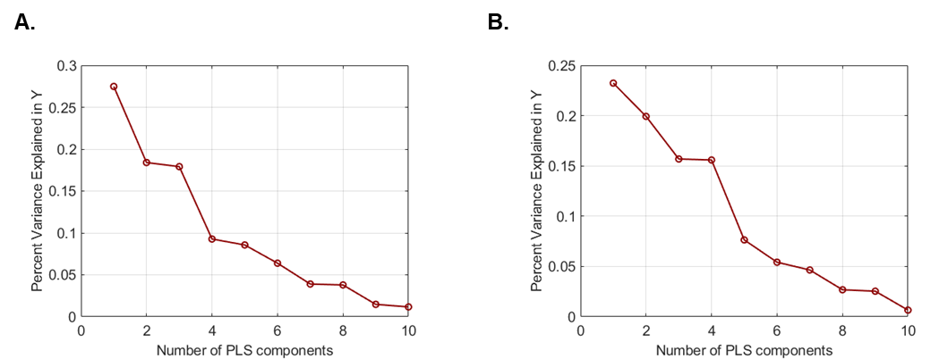
Figure S1. Percentages of the variance explained by each PLS components in subtype 1 and subtype 2. A. the sorted percentages of the variance explained by 10 PLS components in subtype 1. B. the sorted percentages of the variance explained by 10 PLS components in subtype 2.

Figure S2. the PLS1 weighted gene expression map was spatially correlated with the GMV deviations maps.

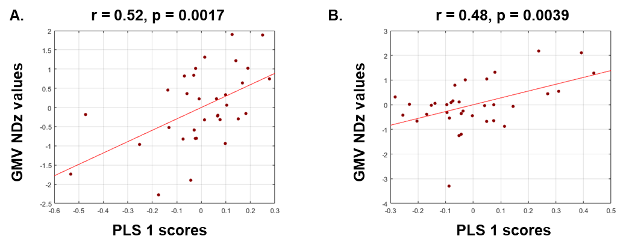
Figure S2. the PLS1 weighted gene expression map was spatially correlated with the GMV deviations maps. A. PLS1-subtype 1 scores were correlated with GMV deviations values of subtype 1(Pearson correlation, r = 0.52, p = 0.0017); B. PLS1-subtype 2 scores were correlated with GMV deviations values of subtype 2(Pearson correlation, r = 0.52, p = 0.0017);

Figure S3. The ARI scores of multiple subtypes numbers in 10-fold cross validation of clustering process.

Figure S3. The ARI scores of multiple subtypes numbers in 10-fold cross validation of clustering process. Each scatter represented mean values of ARI scores in 1000 time 10-fold cross validation of hierarchical clustering. ARI, Adjusted Rand Index.

Figure S4. The validation of GMV deviations maps in Dataset 2 patients.

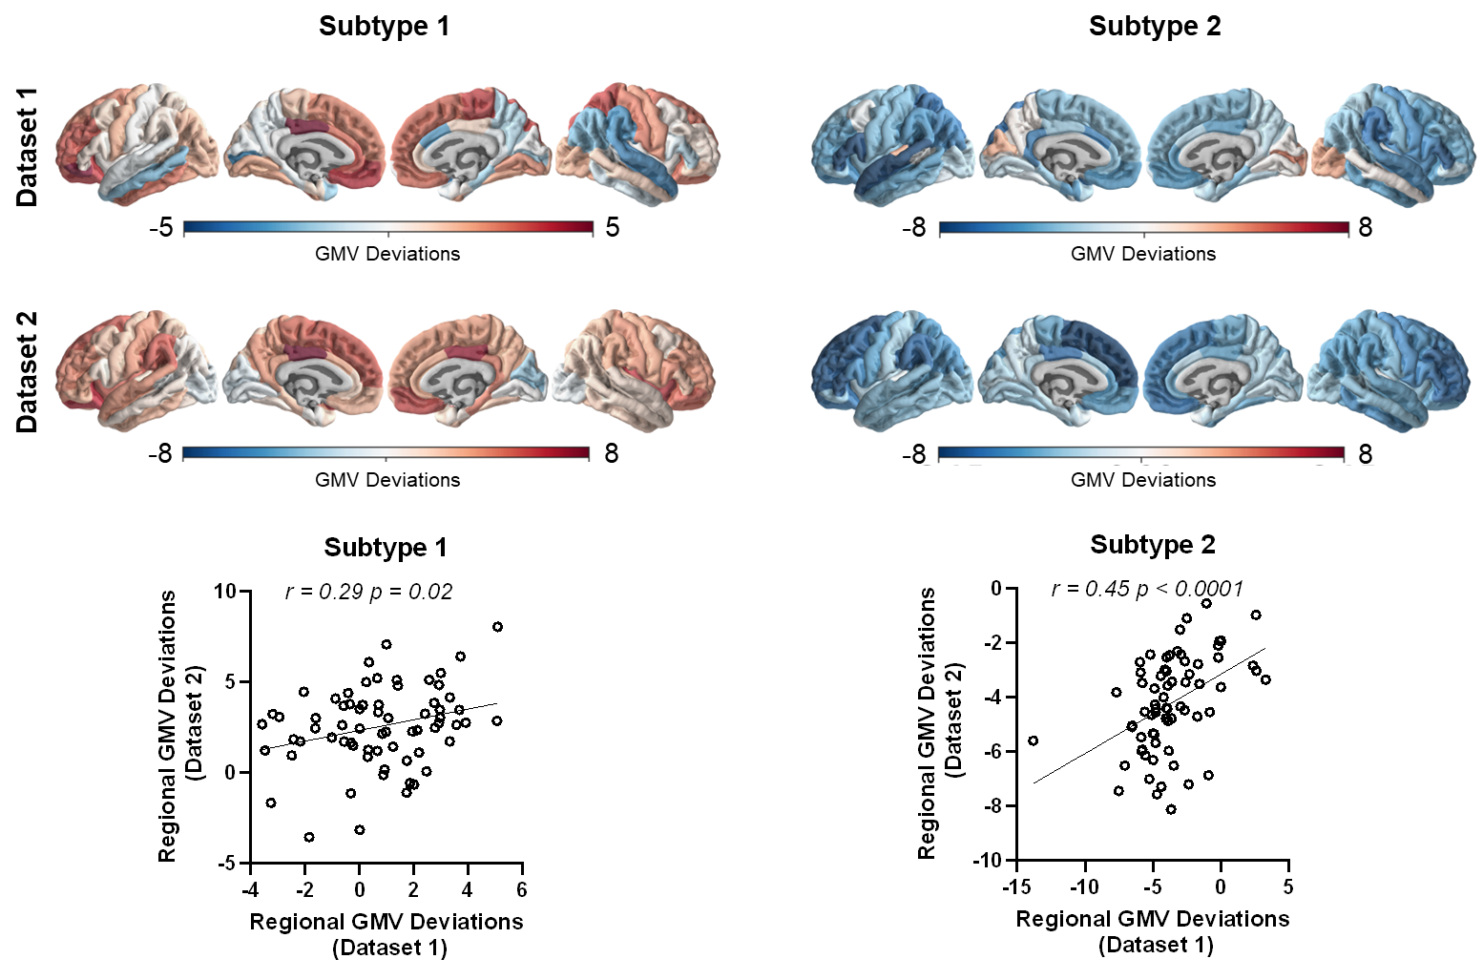

Figure S4. The validation of GMV deviations maps in Dataset 2 with medication patients. GMV deviations maps were calculated in both subtype 1 and subtype 2 of patients in Dataset 2. The group averaged regional GMV deviations values were mapped and found to show significantly correlations between dataset 1 and dataset 2 in both subtype 1(r=0.29, p<0.05) and subtype 2(r=0.45, p<0.0001).

Figure S5. Nodal characteristics of symptoms in both subtype 1 and subtype 2.

Figure S6. HAMD items differences between subtype 1 and subtype 2.
Figure S6. HAMD items differences between subtype 1 and subtype 2. Bar, mean values of groups; Error bar, standard deviation of groups; red star, significantly different between subtype 1 and subtype 2 (p < 0.05, uncorrected).

References

Arloth, J., Bader, D. M., Röh, S. and Altmann, A. (2015). Re-annotator: annotation pipeline for microarray probe sequences. Plos One, 10(10), e0139516. doi:10.1371/journal.pone.0139516.
Arnatkeviciute, A., Fulcher, B. D. and Fornito, A. (2019). A practical guide to linking brain-wide gene expression and neuroimaging data. NeuroImage, 189, 353-367. doi:10.1016/j.neuroimage.2019.01.011.
Darmanis, S., Sloan, S. A., Zhang, Y., Enge, M., Caneda, C., Shuer, L. M., . . . Quake, S. R. (2015). A survey of human brain transcriptome diversity at the single cell level. Proceedings of the National Academy of Sciences of the United States of America, 112(23), 7285-7290. doi:10.1073/pnas.1507125112.
Furuse, T. and Hashimoto, K. (2009). Fluvoxamine monotherapy for psychotic depression: the potential role of sigma-1 receptors. Annals of General Psychiatry, 8(26), 1-3. doi:10.1186/1744-859X-8-26.
Habib, N., Avraham-Davidi, I., Basu, A., Burks, T., Shekhar, K., Hofree, M., . . . Regev, A. (2017). Massively parallel single-nucleus RNA-seq with DroNc-seq. Nature Methods, 14(10), 955-958. doi:10.1038/nmeth.4407.
Jansen, I. E., Savage, J. E., Watanabe, K., Bryois, J., Williams, D. M., Steinberg, S., . . . Posthuma, D. (2019). Genome-wide meta-analysis identifies new loci and functional pathways influencing Alzheimer's disease risk. Nature Genetics, 51(3), 404-413. doi:10.1038/s41588-018-0311-9.
Jiang, Y., Wang, J., Zhou, E., Palaniyappan, L., Luo, C., Ji, G., . . . Huang, C.-C. (2023). Neuroimaging biomarkers define neurophysiological subtypes with distinct trajectories in schizophrenia. Nature Mental Health, 1(3), 186-199. doi:10.1038/s44220-023-00024-0.
Lake, B. B., Chen, S., Sos, B. C., Fan, J., Kaeser, G. E., Yung, Y. C., . . . Zhang, K. (2018). Integrative single-cell analysis of transcriptional and epigenetic states in the human adult brain. Nature Biotechnology, 36(1), 70-80. doi:10.1038/nbt.4038.
Li, M., Santpere, G., Imamura Kawasawa, Y., Evgrafov, O. V., Gulden, F. O., Pochareddy, S., . . . Sestan, N. (2018). Integrative functional genomic analysis of human brain development and neuropsychiatric risks. Science, 362(6420). doi:10.1126/science.aat7615.
Liu, Z., Palaniyappan, L., Wu, X., Zhang, K., Du, J., Zhao, Q., . . . Wei, Y. (2021). Resolving heterogeneity in schizophrenia through a novel systems approach to brain structure: individualized structural covariance network analysis. Molecular Psychiatry, 26(12), 7719-7731. doi:10.1038/s41380-021-01229-4.
Morgan, S. E., Seidlitz, J., Whitaker, K. J., Romero-Garcia, R., Clifton, N. E., Scarpazza, C., . . . Donohoe, G. (2019). Cortical patterning of abnormal morphometric similarity in psychosis is associated with brain expression of schizophrenia-related genes. Proceedings of the National Academy of Sciences of the United States of America, 116(19), 9604-9609. doi:10.1073/pnas.1820754116.
Overall, J. E. and Gorham, D. R. (1962). The brief psychiatric rating scale. Psychological Reports, 10(3), 799-812. doi:10.2466/pr0.1962.10.3.799.
Romero-Garcia, R., Seidlitz, J., Whitaker, K. J., Morgan, S. E., Fonagy, P., Dolan, R. J., . . . Bullmore, E. (2020). Schizotypy-related magnetization of cortex in healthy adolescence is colocated with expression of schizophrenia-related genes. Biological Psychiatry, 88(3), 248-259. doi:10.1016/j.biopsych.2019.12.005.
Segal, A., Parkes, L., Aquino, K., Kia, S. M., Wolfers, T., Franke, B., . . . Fornito, A. (2023). Regional, circuit and network heterogeneity of brain abnormalities in psychiatric disorders. Nature Neuroscience, 26(9), 1613-1629. doi:10.1038/s41593-023-01404-6.
Seidlitz, J., Nadig, A., Liu, S., Bethlehem, R. A., Vértes, P. E., Morgan, S. E., . . . Clasen, L. S. (2020). Transcriptomic and cellular decoding of regional brain vulnerability to neurogenetic disorders. Nature Communications, 11(1), 3358. doi:10.1038/s41467-020-17051-5.
Stamm, T., Stingl, J., Wiethoff, K., Ricken, R., Heinz, A., Bauer, M., . . . Adli, M. (2013). Depression with psychotic features is influenced by the polymorphism of the serotonin transporter gene. Journal of Affective Disorders, 151(2), 605-610. doi:10.1016/j.jad.2013.07.005.
Tonna, M., De Panfilis, C. and Marchesi, C. (2012). Mood-congruent and mood-incongruent psychotic symptoms in major depression: the role of severity and personality. Journal of Affective Disorders, 141(2-3), 464-468. doi:10.1016/j.jad.2012.03.017.
Wang, Y., Lu, J., Yu, J., Gibbs, R. A. and Yu, F. (2013). An integrative variant analysis pipeline for accurate genotype/haplotype inference in population NGS data. Genome Research, 23(5), 833-842. doi:10.1101/gr.146084.112.
Wray, N. R., Ripke, S., Mattheisen, M., Trzaskowski, M., Byrne, E. M., Abdellaoui, A., . . . Major Depressive Disorder Working Group of the Psychiatric Genomics, C. (2018). Genome-wide association analyses identify 44 risk variants and refine the genetic architecture of major depression. Nature Genetics, 50(5), 668-681. doi:10.1038/s41588-018-0090-3.
Ye, H., Zalesky, A., Lv, J., Loi, S. M., Cetin-Karayumak, S., Rathi, Y., . . . Di Biase, M. A. (2021). Network analysis of symptom comorbidity in schizophrenia: Relationship to illness course and brain white matter microstructure. Schizophrenia Bulletin, 47(4), 1156-1167. doi:10.1093/schbul/sbab015.
Zhang, Y., Sloan, S. A., Clarke, L. E., Caneda, C., Plaza, C. A., Blumenthal, P. D., . . . Barres, B. A. (2016). Purification and Characterization of Progenitor and Mature Human Astrocytes Reveals Transcriptional and Functional Differences with Mouse. Neuron, 89(1), 37-53. doi:10.1016/j.neuron.2015.11.013.

