Supplementary material

Supplementary figure 1. DSM-XC item response distribution for the whole sample.
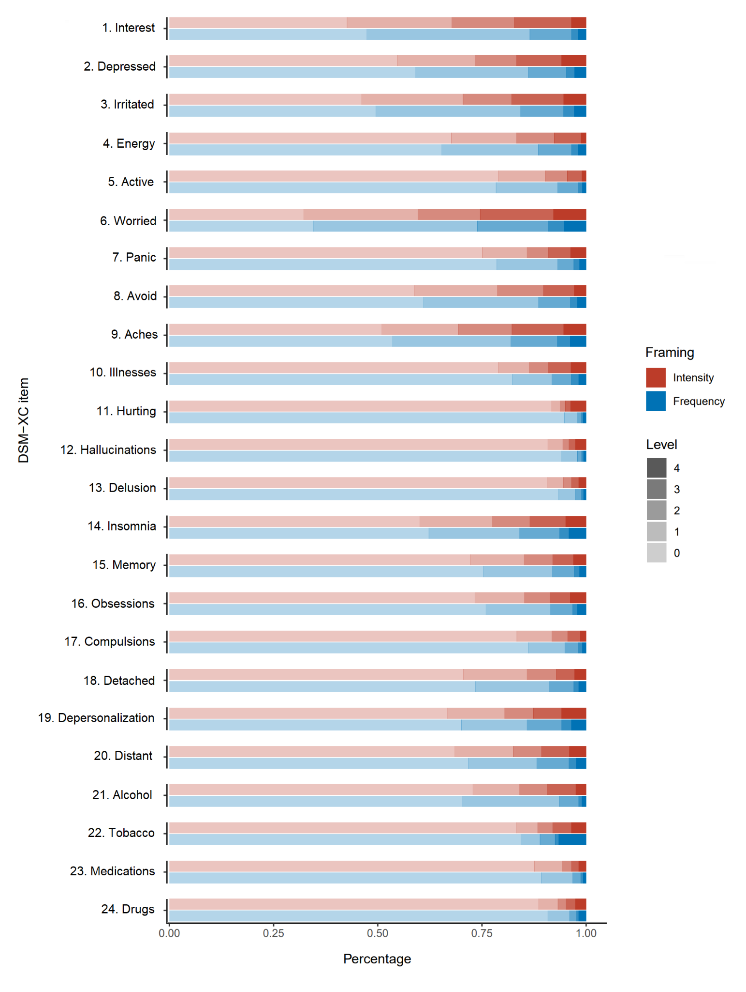
Levels for intensity were 0=none, 1=slight, 2=mild, 3=moderate, and 4=severe. Levels for frequency were 0=not at all, 1=less than a day or two, 2=several days, 3=more than half the days, and 4=nearly every day. DSM-XC, DSM-5-TR Level 1 Cross-Cutting Symptom Measure.
Supplementary figure 2. Sensitivity across DSM-XC domains for psychiatric diagnoses using intensity and frequency framings.

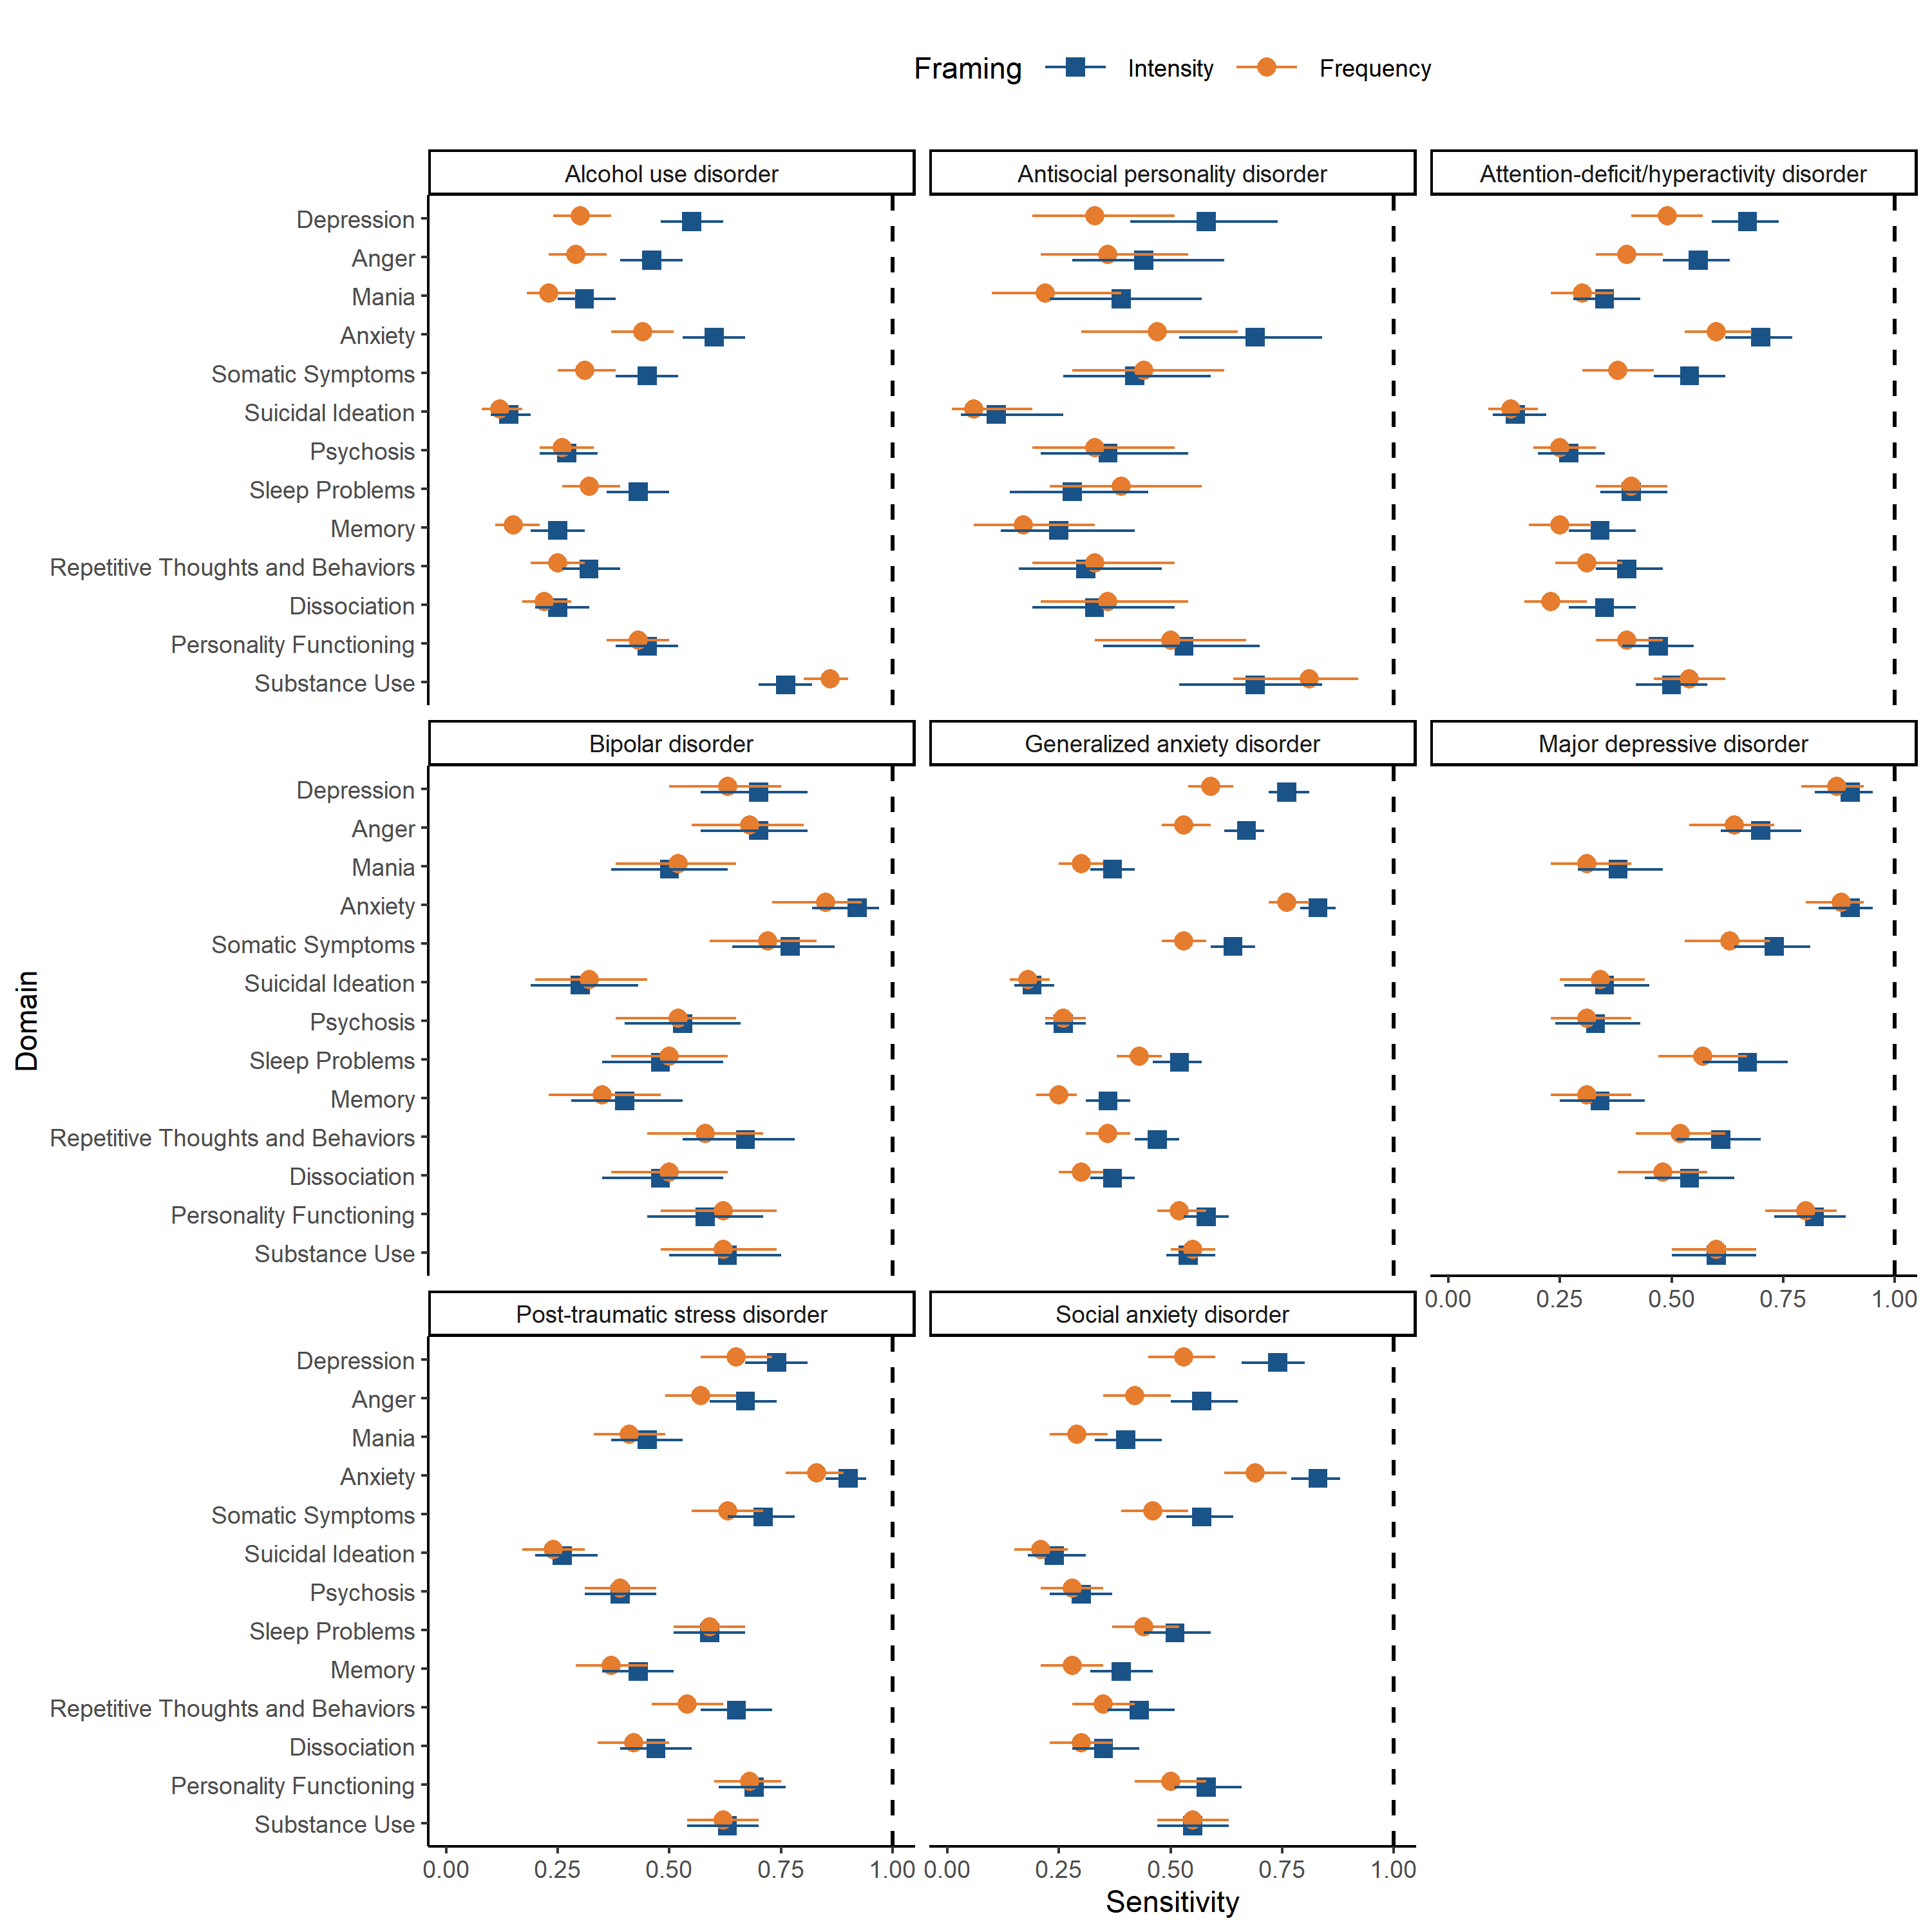

Intensity (in blue) and frequency (in yellow) represent how the instrument would perform if questions were asked with separate frames. DSM-XC, DSM-5-TR Level 1 Cross-Cutting Symptom Measure.

Supplementary figure 3. Specificity across DSM-XC domains for psychiatric diagnoses using intensity and frequency framings.

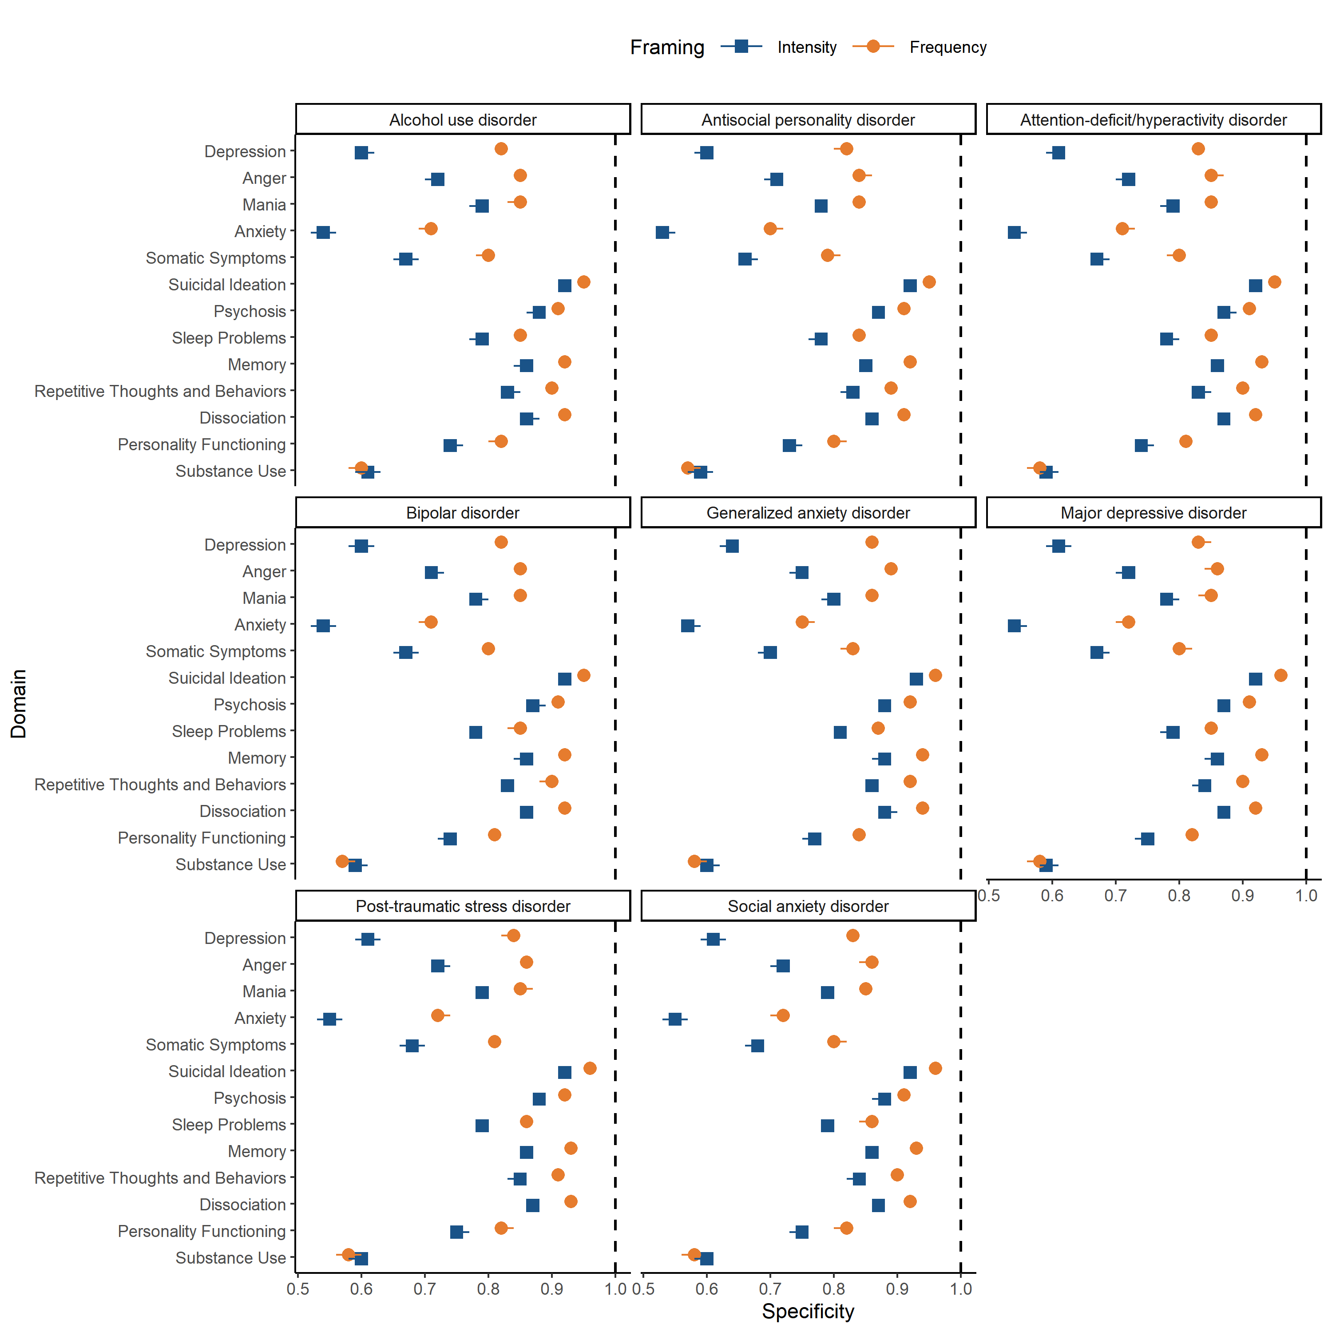
Intensity (in blue) and frequency (in yellow) represent how the instrument would perform if questions were asked with separate frames. DSM-XC, DSM-5-TR Level 1 Cross-Cutting Symptom Measure.

Supplementary Figure 4. Sensitivity across DSM-XC domains for psychiatric diagnoses using intensity and frequency framings, after removing the clinical impairment criteria.

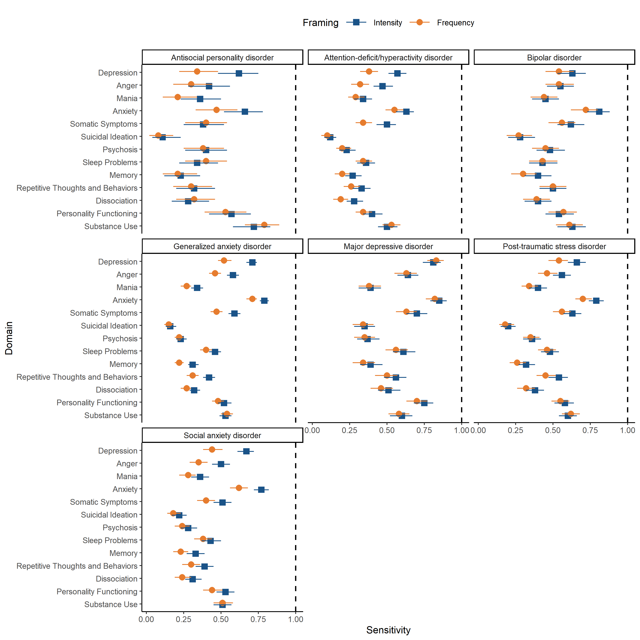

Intensity (in blue) and frequency (in yellow) represent how the instrument would perform if questions were asked with separate frames. DSM-XC, DSM-5-TR Level 1 Cross-Cutting Symptom Measure.

Supplementary Figure 5. Specificity across DSM-XC domains for psychiatric diagnoses using intensity and frequency framings, after removing the clinical impairment criteria.

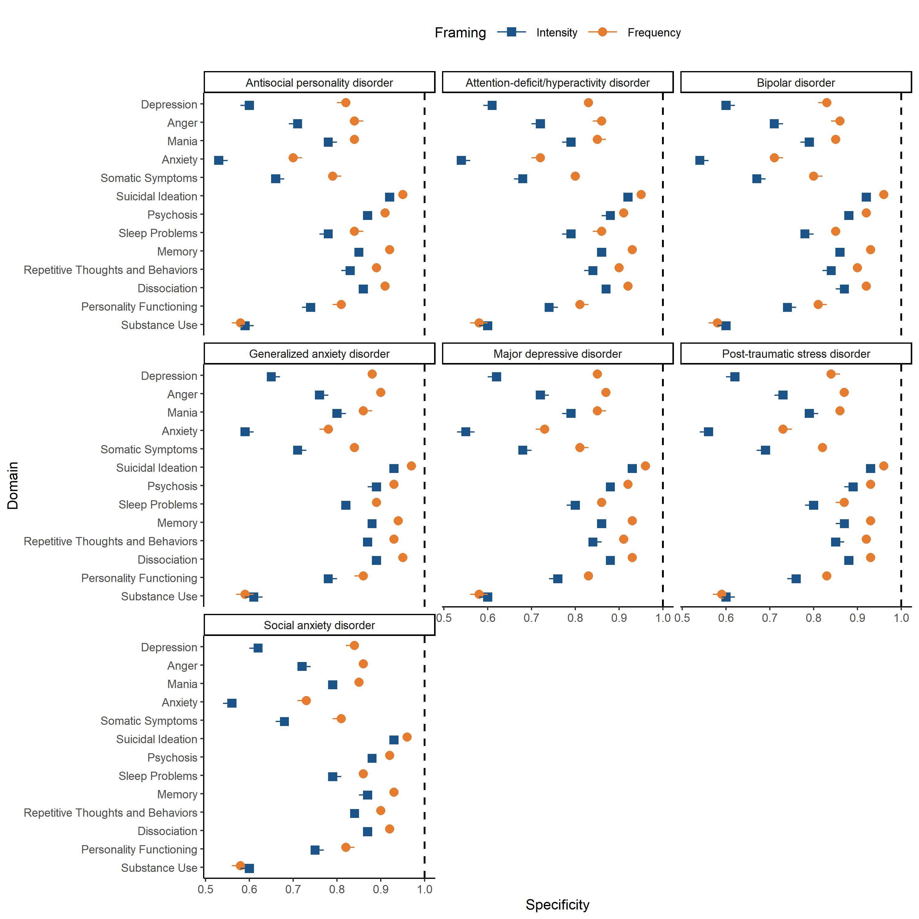

Intensity (in blue) and frequency (in yellow) represent how the instrument would perform if questions were asked with separate frames. DSM-XC, DSM-5-TR Level 1 Cross-Cutting Symptom Measure.

Supplementary Figure 6. Positive likelihood ratio (LR+) across DSM-XC domains for psychiatric diagnoses using intensity and frequency framings, after removing the clinical impairment criteria.

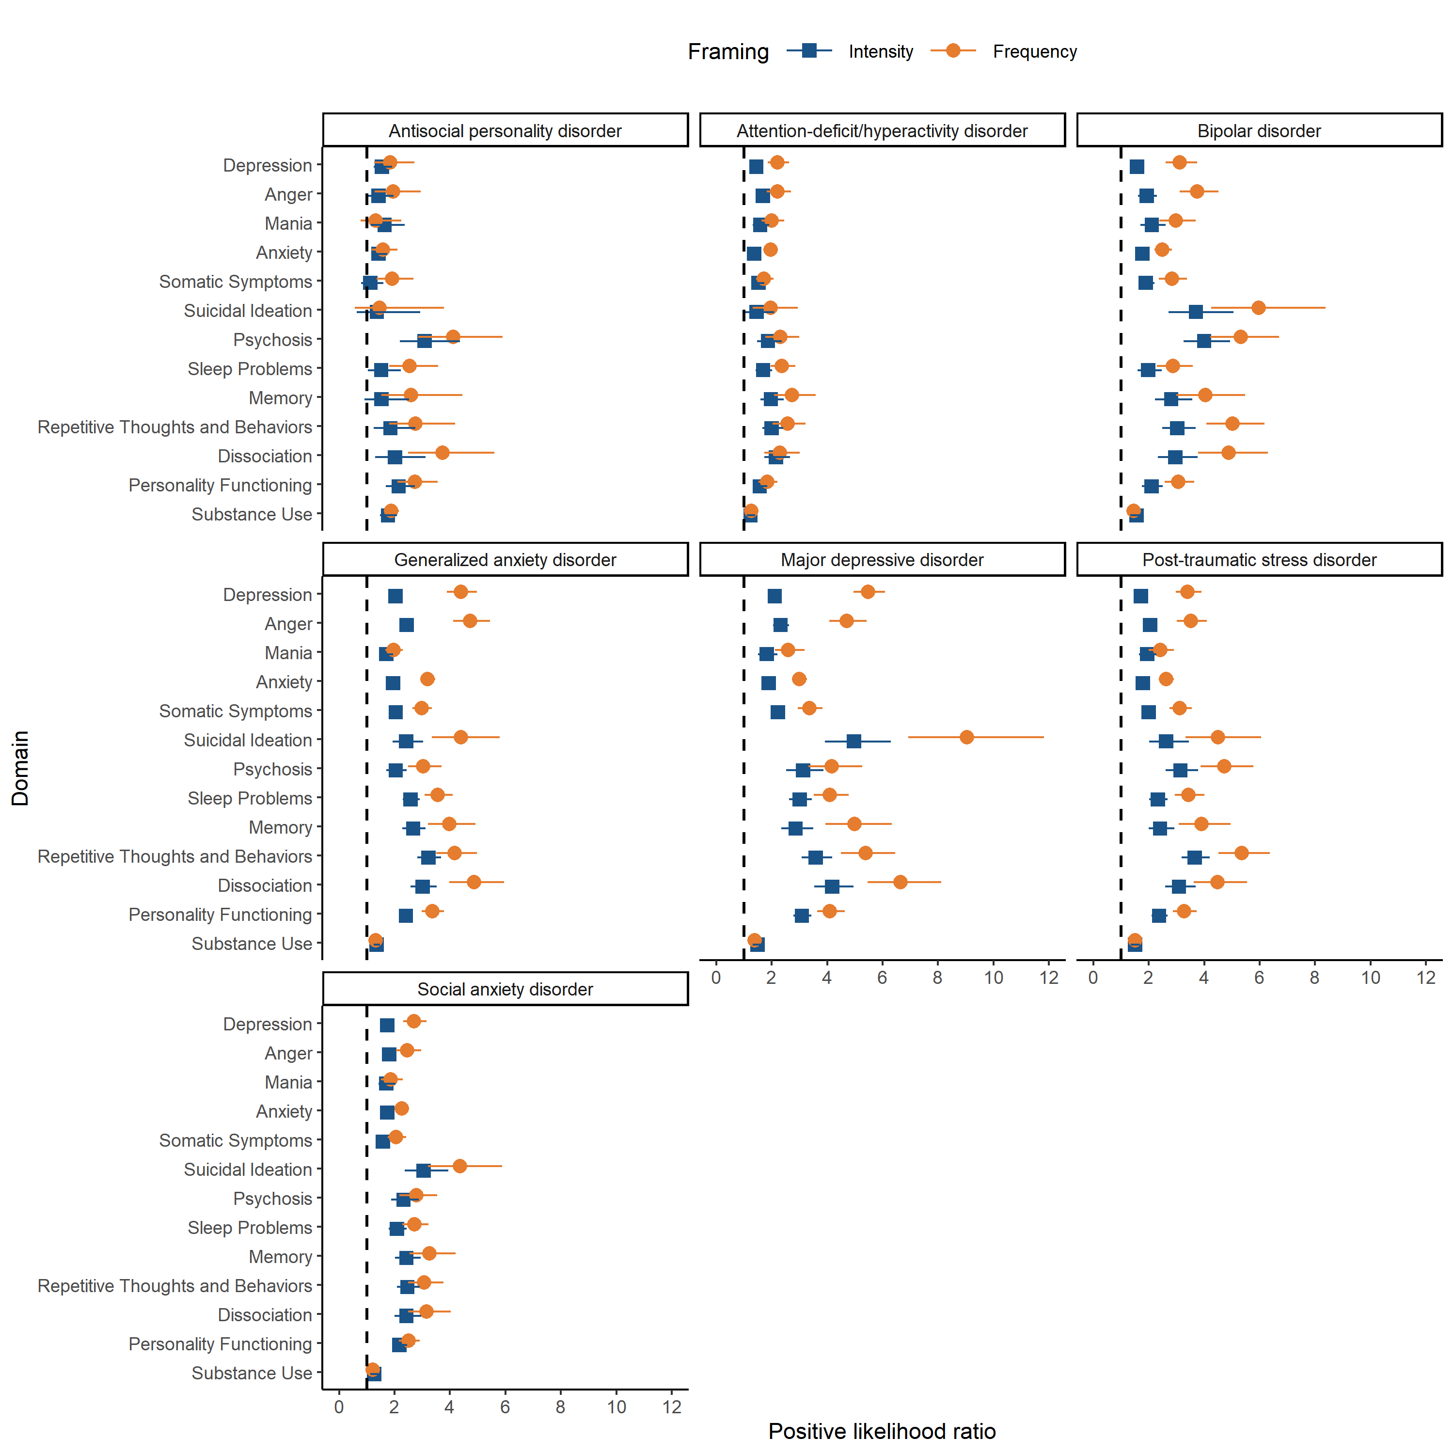

Intensity (in blue) and frequency (in yellow) represent how the instrument would perform if questions were asked with separate frames. DSM-XC, DSM-5-TR Level 1 Cross-Cutting Symptom Measure.

Supplementary Figure 7. Negative likelihood ratio (LR+) across DSM-XC domains for psychiatric diagnoses using intensity and frequency framings, after removing the clinical impairment criteria.

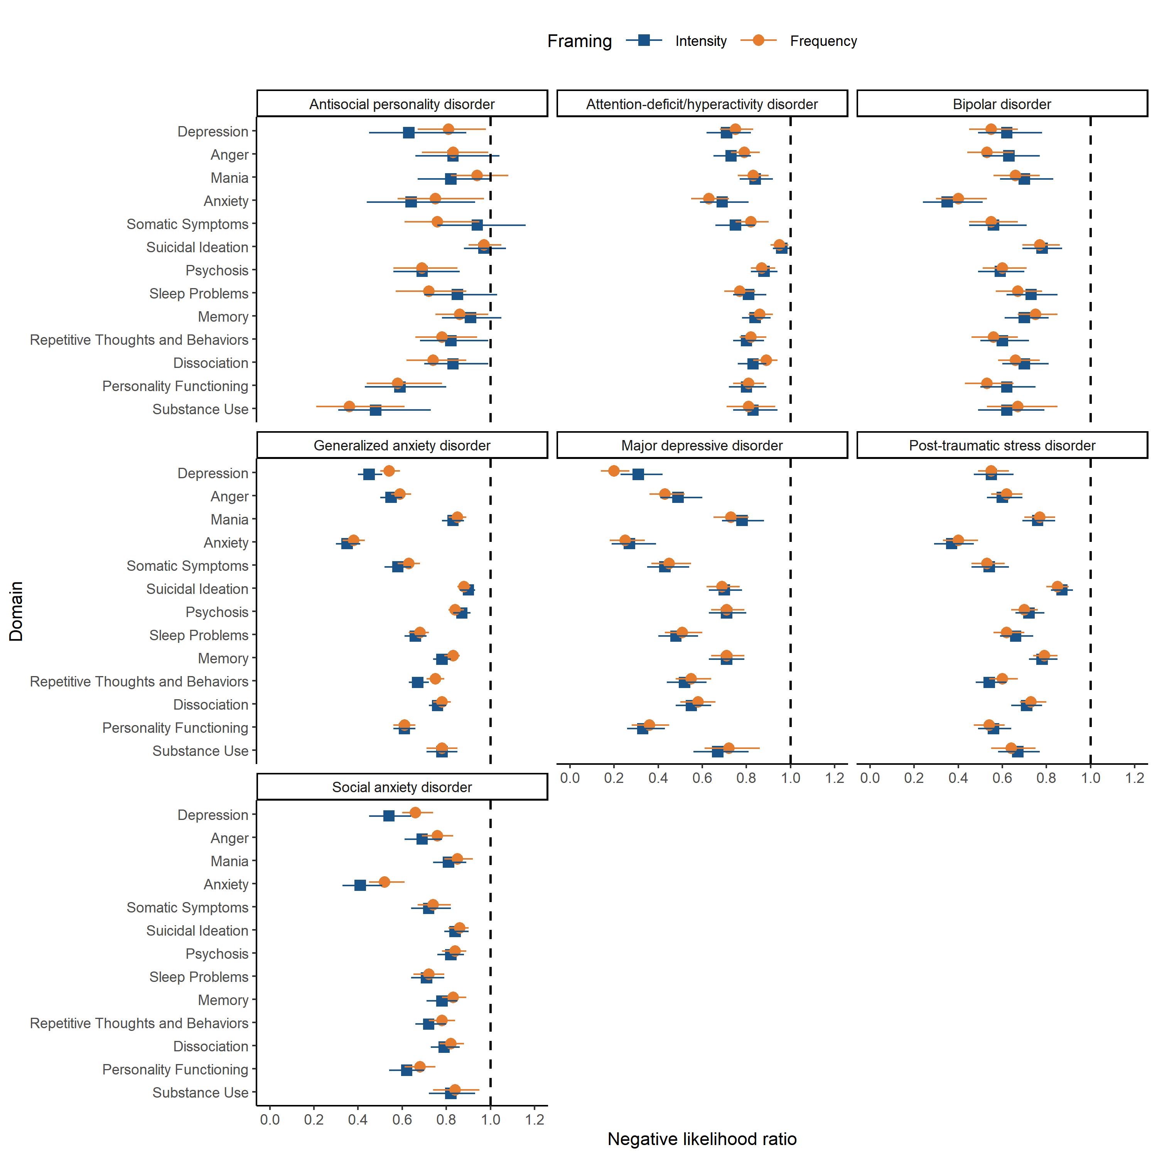

Intensity (in blue) and frequency (in yellow) represent how the instrument would perform if questions were asked with separate frames. DSM-XC, DSM-5-TR Level 1 Cross-Cutting Symptom Measure.

Supplementary table 1. Correlation between intensity and frequency framings from the DSM-XC.

Domain | Item | Polychoric correlationª | Kappa^{b}
I. Depression | 1. Little interest or pleasure in doing things? | 0.80 | 0.47
 | 2. Feeling down, depressed, or hopeless? | 0.86 | 0.56
II. Anger | 3. Feeling more irritated, grouchy, or angry than usual? | 0.85 | 0.56
III. Mania | 4. Sleeping less than usual, but still have a lot of energy? | 0.78 | 0.50
 | 5. Starting lots more projects than usual or doing more risky things than usual? | 0.84 | 0.57
IV. Anxiety | 6. Feeling nervous, anxious, frightened, worried, or on edge? | 0.86 | 0.51
 | 7. Feeling panic or being frightened? | 0.86 | 0.61
 | 8. Avoiding situations that make you anxious? | 0.85 | 0.59
V. Somatic symptoms | 9. Unexplained aches and pains (e.g., head, back, joints, abdomen, legs)? | 0.88 | 0.58
 | 10. Feeling that your illnesses are not being taken seriously enough? | 0.89 | 0.61
VI. Suicidal ideation | 11. Thoughts of actually hurting yourself? | 0.86 | 0.49
VII. Psychosis | 12. Hearing things other people couldn’t hear, such as voices even when no one was around? | 0.85 | 0.54
 | 13. Feeling that someone could hear your thoughts, or that you could hear what another person was thinking? | 0.83 | 0.52
VIII. Sleep problems | 14. Problems with sleep that affected your sleep quality over all? | 0.90 | 0.66
IX. Memory | 15. Problems with memory (e.g., learning new information) or with location (e.g., finding your way home)? | 0.88 | 0.64
X. Repetitive thoughts and behaviors | 16. Unpleasant thoughts, urges, or images that repeatedly enter your mind? | 0.89 | 0.66
 | 17. Feeling driven to perform certain behaviors or mental acts over and over again? | 0.87 | 0.62
XI. Dissociation | 18. Feeling detached or distant from yourself, your body, your physical surroundings, or your memories? | 0.89 | 0.68
XII. Personality functioning | 19. Not knowing who you really are or what you want out of life? | 0.89 | 0.64
 | 20. Not feeling close to other people or enjoying your relationships with them? | 0.87 | 0.64
XIII. Substance use | 21. Drinking at least 4 drinks of any kind of alcohol in a single day? | 0.77 | 0.48
 | 22. Smoking any cigarettes, a cigar, or pipe, or using snuff or chewing tobacco? | 0.86 | 0.52
 | 23. Using any of the following medicines ON YOUR OWN, that is, without a doctor’s prescription, in greater amounts or longer than prescribed [e.g., painkillers (like Vicodin), stimulants (like Ritalin or Adderall), sedatives or tranquilizers (like sleeping pills or Valium)?* | 0.82 | 0.60
 | 24. Using drugs like marijuana, cocaine or crack, club drugs (like ecstasy), hallucinogens (like LSD), heroin, inhalants or solvents (like glue), or methamphetamine (like speed)]?* | 0.78 | 0.50
ªPolychoric correlation measures the strength and direction of the relationship between framings. ^{b}Kappa coefficient measures the beyond chance agreement between two framings. *The last item of the original DSM-XC was split into two (items 23 and 24 in the present instrument), to allow for the exploration of substance use and self-prescription/misuse separately. DSM-XC, DSM-5-TR Level 1 Cross-Cutting Symptom Measure.

Supplementary table 2. Standards for Reporting of Diagnostic Accuracy Studies (STARD) 2015
Checklist.

 | Section & Topic | No | Item | Reported on page #
 | TITLE OR ABSTRACT
 |  | 1 | Identification as a study of diagnostic accuracy using at least one measure of accuracy (such as sensitivity, specificity, predictive values, or AUC) | 1
 | ABSTRACT
 |  | 2 | Structured summary of study design, methods, results, and conclusions (for specific guidance, see STARD for Abstracts) | 3
 | INTRODUCTION
 |  | 3 | Scientific and clinical background, including the intended use and clinical role of the index test | 4
 |  | 4 | Study objectives and hypotheses | 5
 | METHODS
 | Study design | 5 | Whether data collection was planned before the index test and reference standard  were performed (prospective study) or after (retrospective study) | 5
 | Participants | 6 | Eligibility criteria | 5
 |  | 7 | On what basis potentially eligible participants were identified (such as symptoms, results from previous tests, inclusion in registry) | 5
 |  | 8 | Where and when potentially eligible participants were identified (setting, location and dates) | 5
 |  | 9 | Whether participants formed a consecutive, random or convenience series | 5
 | Test methods | 10a | Index test, in sufficient detail to allow replication | 5-6
 |  | 10b | Reference standard, in sufficient detail to allow replication | 6
 |  | 11 | Rationale for choosing the reference standard (if alternatives exist) | NA
 |  | 12a | Definition of and rationale for test positivity cut-offs or result categories  of the index test, distinguishing pre-specified from exploratory | 5
 |  | 12b | Definition of and rationale for test positivity cut-offs or result categories of the reference standard, distinguishing pre-specified from exploratory | 5
 |  | 13a | Whether clinical information and reference standard results were available to the performers/readers of the index test | 6
 |  | 13b | Whether clinical information and index test results were available to the assessors of the reference standard | 6
 | Analysis | 14 | Methods for estimating or comparing measures of diagnostic accuracy | 7
 |  | 15 | How indeterminate index test or reference standard results were handled | NA
 |  | 16 | How missing data on the index test and reference standard were handled | 5
 |  | 17 | Any analyses of variability in diagnostic accuracy, distinguishing pre-specified from exploratory | 7
 |  | 18 | Intended sample size and how it was determined | NA
 | RESULTS
 | Participants | 19 | Flow of participants, using a diagram | NA
 |  | 20 | Baseline demographic and clinical characteristics of participants | Table 1
 |  | 21a | Distribution of severity of disease in those with the target condition | NA
 |  | 21b | Distribution of alternative diagnoses in those without the target condition | NA
 |  | 22 | Time interval and any clinical interventions between index test and reference standard | NA
 | Test results | 23 | Cross tabulation of the index test results (or their distribution) by the results of the reference standard | Due to the large number of index and reference tests, cross tabulation was described in tables instead of diagram (Supplementary Tables 4 to 19)
 |  | 24 | Estimates of diagnostic accuracy and their precision (such as 95% confidence intervals) | Tables 2 and 3
 |  | 25 | Any adverse events from performing the index test or the reference standard | NA
 | DISCUSSION
 |  | 26 | Study limitations, including sources of potential bias, statistical uncertainty, and generalisability | 12
 |  | 27 | Implications for practice, including the intended use and clinical role of the index test | 12
 | OTHER INFORMATION
 |  | 28 | Registration number and name of registry | 5
 |  | 29 | Where the full study protocol can be accessed | NA
 |  | 30 | Sources of funding and other support; role of funders | 1

Supplementary table 3. Number and proportion of positive screens and according to DSM-XC scoring rules for each domain.

Domain | OR rule |  | Intensity |  | Frequency
 | n | Proportion (95% CI) | n | Proportion (95% CI) | n | Proportion (95% CI)
01. Depression | 1524 | 0.43 (0.41-0.44) | 1452 | 0.41 (0.39-0.42) | 665 | 0.19 (0.17-0.20)
02. Anger | 1143 | 0.32 (0.30-0.34) | 1056 | 0.30 (0.28-0.31) | 564 | 0.16 (0.15-0.17)
03. Mania | 1007 | 0.28 (0.27-0.30) | 789 | 0.22 (0.21-0.23) | 564 | 0.16 (0.15-0.17)
04. Anxiety | 1798 | 0.50 (0.49-0.52) | 1677 | 0.47 (0.45-0.49) | 1076 | 0.30 (0.29-0.32)
05. Somatic symptoms | 1290 | 0.36 (0.34-0.38) | 1206 | 0.34 (0.32-0.35) | 751 | 0.21 (0.20-0.22)
06. Suicidal ideation | 318 | 0.09 (0.08-0.10) | 299 | 0.08 (0.07-0.09) | 186 | 0.05 (0.04-0.06)
07. Psychosis | 499 | 0.14 (0.13-0.15) | 474 | 0.13 (0.12-0.14) | 344 | 0.10 (0.09-0.11)
08. Sleep problems | 886 | 0.25 (0.23-0.26) | 805 | 0.22 (0.21-0.24) | 570 | 0.16 (0.15-0.17)
09. Memory | 594 | 0.17 (0.15-0.18) | 534 | 0.15 (0.14-0.16) | 293 | 0.08 (0.07-0.09)
10. Repetitive thoughts and behaviors | 701 | 0.20 (0.18-0.21) | 629 | 0.18 (0.16-0.19) | 403 | 0.11 (0.10-0.12)
11. Dissociation | 572 | 0.16 (0.15-0.17) | 510 | 0.14 (0.13-0.15) | 320 | 0.09 (0.08-0.10)
12. Personality functioning | 1069 | 0.30 (0.28-0.31) | 958 | 0.27 (0.25-0.28) | 709 | 0.20 (0.19-0.21)
13. Substance use | 1696 | 0.47 (0.46-0.49) | 1474 | 0.41 (0.40-0.43) | 1537 | 0.43 (0.41-0.45)
n = number of positive screens. DSM-XC stipulates a positive screen as rating mild (i.e., 2) or greater on any item within a domain (depression, anger, mania, anxiety, somatic symptoms, sleep problems, memory, repetitive thoughts and behaviors, dissociation, personality functioning, except for substance use, suicidal ideation, and psychosis). For substance use, suicidal ideation, and psychosis, rating slight (i.e., 1) or greater on any item within the domain was considered a positive screen. “OR” rule represents original DSM-XC scoring instructions. Intensity and frequency represent how the instrument would perform if questions were asked with separate frames. DSM-XC, DSM-5-TR Level 1 Cross-Cutting Symptom Measure.
Supplementary table 4. Diagnostic and test results of DSM-XC domains using the original “OR” rule for alcohol use disorder.
Domain | Test + /  Diagnosis + | Test - /  Diagnosis + | Test + /  Diagnosis - | Test - /  Diagnosis -
I. Depression | 123 | 85 | 1401 | 1969
II. Anger | 103 | 105 | 1040 | 2330
III. Mania | 84 | 124 | 923 | 2447
IV. Anxiety | 132 | 76 | 1666 | 1704
V. Somatic symptoms | 102 | 106 | 1188 | 2182
VI. Suicidal ideation | 31 | 177 | 287 | 3083
VII. Psychosis | 61 | 147 | 438 | 2932
VIII. Sleep problems | 99 | 109 | 787 | 2583
IX. Memory | 59 | 149 | 535 | 2835
X. Repetitive thoughts and behaviors | 78 | 130 | 623 | 2747
XI. Dissociation | 63 | 145 | 509 | 2861
XII. Personality functioning | 110 | 98 | 959 | 2411
XIII. Substance use | 180 | 28 | 1516 | 1854
DSM-XC, DSM-5-TR Level 1 Cross-Cutting Symptom Measure.

Supplementary table 5. Diagnostic and test results of DSM-XC domains using the original “OR” rule for antisocial personality disorder.
Domain | Test + /  Diagnosis + | Test - /  Diagnosis + | Test + /  Diagnosis - | Test - /  Diagnosis -
I. Depression | 21 | 15 | 1503 | 2039
II. Anger | 16 | 20 | 1127 | 2415
III. Mania | 15 | 21 | 992 | 2550
IV. Anxiety | 25 | 11 | 1773 | 1769
V. Somatic symptoms | 18 | 18 | 1272 | 2270
VI. Suicidal ideation | 4 | 32 | 314 | 3228
VII. Psychosis | 14 | 22 | 485 | 3057
VIII. Sleep problems | 14 | 22 | 872 | 2670
IX. Memory | 9 | 27 | 585 | 2957
X. Repetitive thoughts and behaviors | 15 | 21 | 686 | 2856
XI. Dissociation | 15 | 21 | 557 | 2985
XII. Personality functioning | 22 | 14 | 1047 | 2495
XIII. Substance use | 29 | 7 | 1667 | 1875
DSM-XC, DSM-5-TR Level 1 Cross-Cutting Symptom Measure.

Supplementary table 6. Diagnostic and test results of DSM-XC domains using the original “OR” rule for attention-deficit/hyperactivity disorder.
Domain | Test + /  Diagnosis + | Test - /  Diagnosis + | Test + /  Diagnosis - | Test - /  Diagnosis -
I. Depression | 112 | 50 | 1412 | 2004
II. Anger | 96 | 66 | 1047 | 2369
III. Mania | 70 | 92 | 937 | 2479
IV. Anxiety | 121 | 41 | 1677 | 1739
V. Somatic symptoms | 88 | 74 | 1202 | 2214
VI. Suicidal ideation | 30 | 132 | 288 | 3128
VII. Psychosis | 47 | 115 | 452 | 2964
VIII. Sleep problems | 76 | 86 | 810 | 2606
IX. Memory | 60 | 102 | 534 | 2882
X. Repetitive thoughts and behaviors | 68 | 94 | 633 | 2783
XI. Dissociation | 59 | 103 | 513 | 2903
XII. Personality functioning | 84 | 78 | 985 | 2431
XIII. Substance use | 94 | 68 | 1602 | 1814
DSM-XC, DSM-5-TR Level 1 Cross-Cutting Symptom Measure.

Supplementary table 7. Diagnostic and test results of DSM-XC domains using the original “OR” rule for bipolar disorder.
Domain | Test + /  Diagnosis + | Test - /  Diagnosis + | Test + /  Diagnosis - | Test - /  Diagnosis -
I. Depression | 46 | 14 | 1478 | 2040
II. Anger | 45 | 15 | 1098 | 2420
III. Mania | 39 | 21 | 968 | 2550
IV. Anxiety | 57 | 3 | 1741 | 1777
V. Somatic symptoms | 47 | 13 | 1243 | 2275
VI. Suicidal ideation | 20 | 40 | 298 | 3220
VII. Psychosis | 32 | 28 | 467 | 3051
VIII. Sleep problems | 34 | 26 | 852 | 2666
IX. Memory | 29 | 31 | 565 | 2953
X. Repetitive thoughts and behaviors | 41 | 19 | 660 | 2858
XI. Dissociation | 36 | 24 | 536 | 2982
XII. Personality functioning | 43 | 17 | 1026 | 2492
XIII. Substance use | 40 | 20 | 1656 | 1862
DSM-XC, DSM-5-TR Level 1 Cross-Cutting Symptom Measure.

Supplementary table 8. Diagnostic and test results of DSM-XC domains using the original “OR” rule for generalized anxiety disorder.
Domain | Test + /  Diagnosis + | Test - /  Diagnosis + | Test + /  Diagnosis - | Test - /  Diagnosis -
I. Depression | 304 | 74 | 1220 | 1980
II. Anger | 264 | 114 | 879 | 2321
III. Mania | 162 | 216 | 845 | 2355
IV. Anxiety | 329 | 49 | 1469 | 1731
V. Somatic symptoms | 252 | 126 | 1038 | 2162
VI. Suicidal ideation | 77 | 301 | 241 | 2959
VII. Psychosis | 104 | 274 | 395 | 2805
VIII. Sleep problems | 204 | 174 | 682 | 2518
IX. Memory | 143 | 235 | 451 | 2749
X. Repetitive thoughts and behaviors | 185 | 193 | 516 | 2684
XI. Dissociation | 152 | 226 | 420 | 2780
XII. Personality functioning | 237 | 141 | 832 | 2368
XIII. Substance use | 223 | 155 | 1473 | 1727
DSM-XC, DSM-5-TR Level 1 Cross-Cutting Symptom Measure.

Supplementary table 9. Diagnostic and test results of DSM-XC domains using the original “OR” rule for major depressive disorder.
Domain | Test + /  Diagnosis + | Test - /  Diagnosis + | Test + /  Diagnosis - | Test - /  Diagnosis -
I. Depression | 100 | 5 | 1424 | 2049
II. Anger | 80 | 25 | 1063 | 2410
III. Mania | 48 | 57 | 959 | 2514
IV. Anxiety | 100 | 5 | 1698 | 1775
V. Somatic symptoms | 79 | 26 | 1211 | 2262
VI. Suicidal ideation | 40 | 65 | 278 | 3195
VII. Psychosis | 36 | 69 | 463 | 3010
VIII. Sleep problems | 72 | 33 | 814 | 2659
IX. Memory | 41 | 64 | 553 | 2920
X. Repetitive thoughts and behaviors | 66 | 39 | 635 | 2838
XI. Dissociation | 61 | 44 | 511 | 2962
XII. Personality functioning | 90 | 15 | 979 | 2494
XIII. Substance use | 66 | 39 | 1630 | 1843
DSM-XC, DSM-5-TR Level 1 Cross-Cutting Symptom Measure.

Supplementary table 10. Diagnostic and test results of DSM-XC domains using the original “OR” rule for post-traumatic stress disorder.
Domain | Test + /  Diagnosis + | Test - /  Diagnosis + | Test + /  Diagnosis - | Test - /  Diagnosis -
I. Depression | 123 | 32 | 1401 | 2022
II. Anger | 111 | 44 | 1032 | 2391
III. Mania | 85 | 70 | 922 | 2501
IV. Anxiety | 145 | 10 | 1653 | 1770
V. Somatic symptoms | 112 | 43 | 1178 | 2245
VI. Suicidal ideation | 42 | 113 | 276 | 3147
VII. Psychosis | 61 | 94 | 438 | 2985
VIII. Sleep problems | 101 | 54 | 785 | 2638
IX. Memory | 72 | 83 | 522 | 2901
X. Repetitive thoughts and behaviors | 106 | 49 | 595 | 2828
XI. Dissociation | 76 | 79 | 496 | 2927
XII. Personality functioning | 117 | 38 | 952 | 2471
XIII. Substance use | 100 | 55 | 1596 | 1827
DSM-XC, DSM-5-TR Level 1 Cross-Cutting Symptom Measure.

Supplementary table 11. Diagnostic and test results of DSM-XC domains using the original “OR” rule for social anxiety disorder.
Domain | Test + /  Diagnosis + | Test - /  Diagnosis + | Test + /  Diagnosis - | Test - /  Diagnosis -
I. Depression | 137 | 41 | 1387 | 2013
II. Anger | 108 | 70 | 1035 | 2365
III. Mania | 81 | 97 | 926 | 2474
IV. Anxiety | 153 | 25 | 1645 | 1755
V. Somatic symptoms | 107 | 71 | 1183 | 2217
VI. Suicidal ideation | 45 | 133 | 273 | 3127
VII. Psychosis | 54 | 124 | 445 | 2955
VIII. Sleep problems | 99 | 79 | 787 | 2613
IX. Memory | 74 | 104 | 520 | 2880
X. Repetitive thoughts and behaviors | 81 | 97 | 620 | 2780
XI. Dissociation | 70 | 108 | 502 | 2898
XII. Personality functioning | 110 | 68 | 959 | 2441
XIII. Substance use | 106 | 72 | 1590 | 1810
DSM-XC, DSM-5-TR Level 1 Cross-Cutting Symptom Measure.

Supplementary table 12. Diagnostic and test results of DSM-XC domains using the intensity and frequency framings for alcohol use disorder.
Domain | Framing | Test + /  Diagnosis + | Test - /  Diagnosis + | Test + /  Diagnosis - | Test - /  Diagnosis -
I. Depression | Intensity | 114 | 94 | 1338 | 2032
 | Frequency | 63 | 145 | 602 | 2768
II. Anger | Intensity | 96 | 112 | 960 | 2410
 | Frequency | 61 | 147 | 503 | 2867
III. Mania | Intensity | 65 | 143 | 724 | 2646
 | Frequency | 48 | 160 | 516 | 2854
IV. Anxiety | Intensity | 125 | 83 | 1552 | 1818
 | Frequency | 91 | 117 | 985 | 2385
V. Somatic symptoms | Intensity | 93 | 115 | 1113 | 2257
 | Frequency | 64 | 144 | 687 | 2683
VI. Suicidal ideation | Intensity | 29 | 179 | 270 | 3100
 | Frequency | 25 | 183 | 161 | 3209
VII. Psychosis | Intensity | 57 | 151 | 417 | 2953
 | Frequency | 55 | 153 | 289 | 3081
VIII. Sleep problems | Intensity | 89 | 119 | 716 | 2654
 | Frequency | 67 | 141 | 503 | 2867
IX. Memory | Intensity | 51 | 157 | 483 | 2887
 | Frequency | 32 | 176 | 261 | 3109
X. Repetitive thoughts and behaviors | Intensity | 67 | 141 | 562 | 2808
 | Frequency | 52 | 156 | 351 | 3019
XI. Dissociation | Intensity | 53 | 155 | 457 | 2913
 | Frequency | 46 | 162 | 274 | 3096
XII. Personality functioning | Intensity | 93 | 115 | 865 | 2505
 | Frequency | 89 | 119 | 620 | 2750
XIII. Substance use | Intensity | 159 | 49 | 1315 | 2055
 | Frequency | 178 | 30 | 1359 | 2011
DSM-XC, DSM-5-TR Level 1 Cross-Cutting Symptom Measure.

Supplementary table 13. Diagnostic and test results of DSM-XC domains using the intensity and frequency framings for antisocial personality disorder.
Domain | Framing | Test + /  Diagnosis + | Test - /  Diagnosis + | Test + /  Diagnosis - | Test - /  Diagnosis -
I. Depression | Intensity | 21 | 15 | 1431 | 2111
 | Frequency | 12 | 24 | 653 | 2889
II. Anger | Intensity | 16 | 20 | 1040 | 2502
 | Frequency | 13 | 23 | 551 | 2991
III. Mania | Intensity | 14 | 22 | 775 | 2767
 | Frequency | 8 | 28 | 556 | 2986
IV. Anxiety | Intensity | 25 | 11 | 1652 | 1890
 | Frequency | 17 | 19 | 1059 | 2483
V. Somatic symptoms | Intensity | 15 | 21 | 1191 | 2351
 | Frequency | 16 | 20 | 735 | 2807
VI. Suicidal ideation | Intensity | 4 | 32 | 295 | 3247
 | Frequency | 2 | 34 | 184 | 3358
VII. Psychosis | Intensity | 13 | 23 | 461 | 3081
 | Frequency | 12 | 24 | 332 | 3210
VIII. Sleep problems | Intensity | 10 | 26 | 795 | 2747
 | Frequency | 14 | 22 | 556 | 2986
IX. Memory | Intensity | 9 | 27 | 525 | 3017
 | Frequency | 6 | 30 | 287 | 3255
X. Repetitive thoughts and behaviors | Intensity | 11 | 25 | 618 | 2924
 | Frequency | 12 | 24 | 391 | 3151
XI. Dissociation | Intensity | 12 | 24 | 498 | 3044
 | Frequency | 13 | 23 | 307 | 3235
XII. Personality functioning | Intensity | 19 | 17 | 939 | 2603
 | Frequency | 18 | 18 | 691 | 2851
XIII. Substance use | Intensity | 25 | 11 | 1449 | 2093
 | Frequency | 29 | 7 | 1508 | 2034
DSM-XC, DSM-5-TR Level 1 Cross-Cutting Symptom Measure.

Supplementary table 14. Diagnostic and test results of DSM-XC domains using the intensity and frequency framings for attention-deficit/hyperactivity disorder.
Domain | Framing | Test + /  Diagnosis + | Test - /  Diagnosis + | Test + /  Diagnosis - | Test - /  Diagnosis -
I. Depression | Intensity | 108 | 54 | 1344 | 2072
 | Frequency | 79 | 83 | 586 | 2830
II. Anger | Intensity | 90 | 72 | 966 | 2450
 | Frequency | 65 | 97 | 499 | 2917
III. Mania | Intensity | 57 | 105 | 732 | 2684
 | Frequency | 48 | 114 | 516 | 2900
IV. Anxiety | Intensity | 113 | 49 | 1564 | 1852
 | Frequency | 98 | 64 | 978 | 2438
V. Somatic symptoms | Intensity | 87 | 75 | 1119 | 2297
 | Frequency | 61 | 101 | 690 | 2726
VI. Suicidal ideation | Intensity | 25 | 137 | 274 | 3142
 | Frequency | 22 | 140 | 164 | 3252
VII. Psychosis | Intensity | 44 | 118 | 430 | 2986
 | Frequency | 41 | 121 | 303 | 3113
VIII. Sleep problems | Intensity | 67 | 95 | 738 | 2678
 | Frequency | 66 | 96 | 504 | 2912
IX. Memory | Intensity | 55 | 107 | 479 | 2937
 | Frequency | 40 | 122 | 253 | 3163
X. Repetitive thoughts and behaviors | Intensity | 65 | 97 | 564 | 2852
 | Frequency | 50 | 112 | 353 | 3063
XI. Dissociation | Intensity | 56 | 106 | 454 | 2962
 | Frequency | 38 | 124 | 282 | 3134
XII. Personality functioning | Intensity | 76 | 86 | 882 | 2534
 | Frequency | 65 | 97 | 644 | 2772
XIII. Substance use | Intensity | 81 | 81 | 1393 | 2023
 | Frequency | 87 | 75 | 1450 | 1966
DSM-XC, DSM-5-TR Level 1 Cross-Cutting Symptom Measure.

Supplementary table 15. Diagnostic and test results of DSM-XC domains using the intensity and frequency framings for bipolar disorder.
Domain | Framing | Test + /  Diagnosis + | Test - /  Diagnosis + | Test + /  Diagnosis - | Test - /  Diagnosis -
I. Depression | Intensity | 42 | 18 | 1410 | 2108
 | Frequency | 38 | 22 | 627 | 2891
II. Anger | Intensity | 42 | 18 | 1014 | 2504
 | Frequency | 41 | 19 | 523 | 2995
III. Mania | Intensity | 30 | 30 | 759 | 2759
 | Frequency | 31 | 29 | 533 | 2985
IV. Anxiety | Intensity | 55 | 5 | 1622 | 1896
 | Frequency | 51 | 9 | 1025 | 2493
V. Somatic symptoms | Intensity | 46 | 14 | 1160 | 2358
 | Frequency | 43 | 17 | 708 | 2810
VI. Suicidal ideation | Intensity | 18 | 42 | 281 | 3237
 | Frequency | 19 | 41 | 167 | 3351
VII. Psychosis | Intensity | 32 | 28 | 442 | 3076
 | Frequency | 31 | 29 | 313 | 3205
VIII. Sleep problems | Intensity | 29 | 31 | 776 | 2742
 | Frequency | 30 | 30 | 540 | 2978
IX. Memory | Intensity | 24 | 36 | 510 | 3008
 | Frequency | 21 | 39 | 272 | 3246
X. Repetitive thoughts and behaviors | Intensity | 40 | 20 | 589 | 2929
 | Frequency | 35 | 25 | 368 | 3150
XI. Dissociation | Intensity | 29 | 31 | 481 | 3037
 | Frequency | 30 | 30 | 290 | 3228
XII. Personality functioning | Intensity | 35 | 25 | 923 | 2595
 | Frequency | 37 | 23 | 672 | 2846
XIII. Substance use | Intensity | 38 | 22 | 1436 | 2082
 | Frequency | 37 | 23 | 1500 | 2018
DSM-XC, DSM-5-TR Level 1 Cross-Cutting Symptom Measure.
Supplementary table 16. Diagnostic and test results of DSM-XC domains using the intensity and frequency framings for generalized anxiety disorder.
Domain | Framing | Test + /  Diagnosis + | Test - /  Diagnosis + | Test + /  Diagnosis - | Test - /  Diagnosis -
I. Depression | Intensity | 289 | 89 | 1163 | 2037
 | Frequency | 224 | 154 | 441 | 2759
II. Anger | Intensity | 252 | 126 | 804 | 2396
 | Frequency | 202 | 176 | 362 | 2838
III. Mania | Intensity | 140 | 238 | 649 | 2551
 | Frequency | 113 | 265 | 451 | 2749
IV. Anxiety | Intensity | 314 | 64 | 1363 | 1837
 | Frequency | 289 | 89 | 787 | 2413
V. Somatic symptoms | Intensity | 243 | 135 | 963 | 2237
 | Frequency | 200 | 178 | 551 | 2649
VI. Suicidal ideation | Intensity | 73 | 305 | 226 | 2974
 | Frequency | 69 | 309 | 117 | 3083
VII. Psychosis | Intensity | 100 | 278 | 374 | 2826
 | Frequency | 98 | 280 | 246 | 2954
VIII. Sleep problems | Intensity | 195 | 183 | 610 | 2590
 | Frequency | 163 | 215 | 407 | 2793
IX. Memory | Intensity | 135 | 243 | 399 | 2801
 | Frequency | 93 | 285 | 200 | 3000
X. Repetitive thoughts and behaviors | Intensity | 178 | 200 | 451 | 2749
 | Frequency | 135 | 243 | 268 | 2932
XI. Dissociation | Intensity | 141 | 237 | 369 | 2831
 | Frequency | 113 | 265 | 207 | 2993
XII. Personality functioning | Intensity | 218 | 160 | 740 | 2460
 | Frequency | 198 | 180 | 511 | 2689
XIII. Substance use | Intensity | 206 | 172 | 1268 | 1932
 | Frequency | 209 | 169 | 1328 | 1872
DSM-XC, DSM-5-TR Level 1 Cross-Cutting Symptom Measure.
Supplementary table 17. Diagnostic and test results of DSM-XC domains using the intensity and frequency framings for major depressive disorder.
Domain | Framing | Test + /  Diagnosis + | Test - /  Diagnosis + | Test + /  Diagnosis - | Test - /  Diagnosis -
I. Depression | Intensity | 94 | 11 | 1358 | 2115
 | Frequency | 91 | 14 | 574 | 2899
II. Anger | Intensity | 74 | 31 | 982 | 2491
 | Frequency | 67 | 38 | 497 | 2976
III. Mania | Intensity | 40 | 65 | 749 | 2724
 | Frequency | 33 | 72 | 531 | 2942
IV. Anxiety | Intensity | 95 | 10 | 1582 | 1891
 | Frequency | 92 | 13 | 984 | 2489
V. Somatic symptoms | Intensity | 77 | 28 | 1129 | 2344
 | Frequency | 66 | 39 | 685 | 2788
VI. Suicidal ideation | Intensity | 37 | 68 | 262 | 3211
 | Frequency | 36 | 69 | 150 | 3323
VII. Psychosis | Intensity | 35 | 70 | 439 | 3034
 | Frequency | 33 | 72 | 311 | 3162
VIII. Sleep problems | Intensity | 70 | 35 | 735 | 2738
 | Frequency | 60 | 45 | 510 | 2963
IX. Memory | Intensity | 36 | 69 | 498 | 2975
 | Frequency | 33 | 72 | 260 | 3213
X. Repetitive thoughts and behaviors | Intensity | 64 | 41 | 565 | 2908
 | Frequency | 55 | 50 | 348 | 3125
XI. Dissociation | Intensity | 57 | 48 | 453 | 3020
 | Frequency | 50 | 55 | 270 | 3203
XII. Personality functioning | Intensity | 86 | 19 | 872 | 2601
 | Frequency | 84 | 21 | 625 | 2848
XIII. Substance use | Intensity | 63 | 42 | 1411 | 2062
 | Frequency | 63 | 42 | 1474 | 1999
DSM-XC, DSM-5-TR Level 1 Cross-Cutting Symptom Measure.
Supplementary table 18. Diagnostic and test results of DSM-XC domains using the intensity and frequency framings for post-traumatic stress disorder.
Domain | Framing | Test + /  Diagnosis + | Test - /  Diagnosis + | Test + /  Diagnosis - | Test - /  Diagnosis -
I. Depression | Intensity | 115 | 40 | 1337 | 2086
 | Frequency | 101 | 54 | 564 | 2859
II. Anger | Intensity | 104 | 51 | 952 | 2471
 | Frequency | 88 | 67 | 476 | 2947
III. Mania | Intensity | 70 | 85 | 719 | 2704
 | Frequency | 64 | 91 | 500 | 2923
IV. Anxiety | Intensity | 140 | 15 | 1537 | 1886
 | Frequency | 129 | 26 | 947 | 2476
V. Somatic symptoms | Intensity | 110 | 45 | 1096 | 2327
 | Frequency | 98 | 57 | 653 | 2770
VI. Suicidal ideation | Intensity | 41 | 114 | 258 | 3165
 | Frequency | 37 | 118 | 149 | 3274
VII. Psychosis | Intensity | 60 | 95 | 414 | 3009
 | Frequency | 60 | 95 | 284 | 3139
VIII. Sleep problems | Intensity | 91 | 64 | 714 | 2709
 | Frequency | 91 | 64 | 479 | 2944
IX. Memory | Intensity | 67 | 88 | 467 | 2956
 | Frequency | 57 | 98 | 236 | 3187
X. Repetitive thoughts and behaviors | Intensity | 101 | 54 | 528 | 2895
 | Frequency | 84 | 71 | 319 | 3104
XI. Dissociation | Intensity | 73 | 82 | 437 | 2986
 | Frequency | 65 | 90 | 255 | 3168
XII. Personality functioning | Intensity | 107 | 48 | 851 | 2572
 | Frequency | 105 | 50 | 604 | 2819
XIII. Substance use | Intensity | 97 | 58 | 1377 | 2046
 | Frequency | 96 | 59 | 1441 | 1982
DSM-XC, DSM-5-TR Level 1 Cross-Cutting Symptom Measure.
Supplementary table 19. Diagnostic and test results of DSM-XC domains using the intensity and frequency framings for social anxiety disorder.
Domain | Framing | Test + /  Diagnosis + | Test - /  Diagnosis + | Test + /  Diagnosis - | Test - /  Diagnosis -
I. Depression | Intensity | 131 | 47 | 1321 | 2079
 | Frequency | 94 | 84 | 571 | 2829
II. Anger | Intensity | 102 | 76 | 954 | 2446
 | Frequency | 75 | 103 | 489 | 2911
III. Mania | Intensity | 72 | 106 | 717 | 2683
 | Frequency | 52 | 126 | 512 | 2888
IV. Anxiety | Intensity | 148 | 30 | 1529 | 1871
 | Frequency | 123 | 55 | 953 | 2447
V. Somatic symptoms | Intensity | 101 | 77 | 1105 | 2295
 | Frequency | 82 | 96 | 669 | 2731
VI. Suicidal ideation | Intensity | 43 | 135 | 256 | 3144
 | Frequency | 37 | 141 | 149 | 3251
VII. Psychosis | Intensity | 53 | 125 | 421 | 2979
 | Frequency | 49 | 129 | 295 | 3105
VIII. Sleep problems | Intensity | 91 | 87 | 714 | 2686
 | Frequency | 79 | 99 | 491 | 2909
IX. Memory | Intensity | 69 | 109 | 465 | 2935
 | Frequency | 49 | 129 | 244 | 3156
X. Repetitive thoughts and behaviors | Intensity | 77 | 101 | 552 | 2848
 | Frequency | 62 | 116 | 341 | 3059
XI. Dissociation | Intensity | 63 | 115 | 447 | 2953
 | Frequency | 53 | 125 | 267 | 3133
XII. Personality functioning | Intensity | 104 | 74 | 854 | 2546
 | Frequency | 89 | 89 | 620 | 2780
XIII. Substance use | Intensity | 98 | 80 | 1376 | 2024
 | Frequency | 98 | 80 | 1439 | 1961
DSM-XC, DSM-5-TR Level 1 Cross-Cutting Symptom Measure.

Supplementary table 20. Sensitivity differences between DSM-XC intensity and frequency question framings.

Diagnosis | Sensitivity difference (median*) | P-value
Alcohol use disorder | 0.08 | 0.01
Antisocial personality disorder | 0.04 | 0.17
Attention-deficit/hyperactivity disorder | 0.09 | 0.01
Bipolar disorder | 0.02 | 0.29
Generalized anxiety disorder | 0.09 | <0.01
Major depressive disorder | 0.05 | <0.01
Post-traumatic stress disorder | 0.06 | <0.01
Social anxiety disorder | 0.09 | <0.01

*Median of the differences between the two groups using paired Wilcoxon tests. Intensity was used as the reference group for the comparisons with frequency. Intensity and frequency represent how the instrument would perform if questions were asked with separate frames. A bold font indicates statistical significance in the comparison between frames or between rules. DSM-XC, DSM-5-TR Level 1 Cross-Cutting Symptom Measure.

Supplementary table 21. Specificity differences between DSM-XC intensity and frequency question framings.

Diagnosis | Specificity difference (median*) | P-value
Alcohol use disorder | -0.07 | <0.01
Antisocial personality disorder | -0.07 | <0.01
Attention-deficit/hyperactivity disorder | -0.07 | <0.01
Bipolar disorder | -0.07 | <0.01
Generalized anxiety disorder | -0.07 | <0.01
Major depressive disorder | -0.07 | <0.01
Post-traumatic stress disorder | -0.07 | <0.01
Social anxiety disorder | -0.07 | <0.01

*Median of the differences between the two groups using paired Wilcoxon tests. Intensity was used as the reference group for the comparisons with frequency. Intensity and frequency represent how the instrument would perform if questions were asked with separate frames. A bold font indicates statistical significance in the comparison between frames or between rules. DSM-XC, DSM-5-TR Level 1 Cross-Cutting Symptom Measure.

Supplementary table 22. LR+ differences between DSM-XC intensity and frequency question framings.

Diagnosis | LR+ difference (median*) | P-value
Alcohol use disorder | -0.38 | <0.01
Antisocial personality disorder | -0.58 | 0.01
Attention-deficit/hyperactivity disorder | -0.58 | <0.01
Bipolar disorder | -1.45 | <0.01
Generalized anxiety disorder | -1.09 | <0.01
Major depressive disorder | -1.37 | <0.01
Post-traumatic stress disorder | -1.47 | <0.01
Social anxiety disorder | -0.76 | <0.01

*Median of the differences between the two groups using paired Wilcoxon tests. Intensity was used as the reference group for the comparisons with frequency. Intensity and frequency represent how the instrument would perform if questions were asked with separate frames. A bold font indicates statistical significance in the comparison between frames or between rules. DSM-XC, DSM-5-TR Level 1 Cross-Cutting Symptom Measure.

Supplementary table 23. LR- differences between DSM-XC intensity and frequency question framings.

Diagnosis | LR- difference (median*) | P-value
Alcohol use disorder | -0.02 | 0.20
Antisocial personality disorder | 0.02 | 0.60
Attention-deficit/hyperactivity disorder | -0.02 | 0.11
Bipolar disorder | 0.04 | 0.31
Generalized anxiety disorder | -0.04 | 0.01
Major depressive disorder | -0.02 | 0.11
Post-traumatic stress disorder | -0.02 | 0.18
Social anxiety disorder | -0.05 | <0.01

*Median of the differences between the two groups using paired Wilcoxon tests. Intensity was used as the reference group for the comparisons with frequency. Intensity and frequency represent how the instrument would perform if questions were asked with separate frames. A bold font indicates statistical significance in the comparison between frames or between rules. DSM-XC, DSM-5-TR Level 1 Cross-Cutting Symptom Measure.

Supplementary table 24. Sensitivity differences between DSM-XC OR rule and intensity/frequency question framings.

Diagnosis | Framing being compared to OR rule | Sensitivity difference (median*) | P-value
Alcohol use disorder | Intensity | 0.05 | <0.01
 | Frequency | 0.13 | <0.01
Antisocial personality disorder | Intensity | 0.08 | 0.01
 | Frequency | 0.10 | <0.01
Attention-deficit/hyperactivity disorder | Intensity | 0.04 | <0.01
 | Frequency | 0.12 | <0.01
Bipolar disorder | Intensity | 0.07 | <0.01
 | Frequency | 0.08 | <0.01
Generalized anxiety disorder | Intensity | 0.03 | <0.01
 | Frequency | 0.12 | <0.01
Major depressive disorder | Intensity | 0.04 | <0.01
 | Frequency | 0.09 | <0.01
Post-traumatic stress disorder | Intensity | 0.04 | <0.01
 | Frequency | 0.09 | <0.01
Social anxiety disorder | Intensity | 0.04 | <0.01
 | Frequency | 0.12 | <0.01

*Median of the differences between the two groups using paired Wilcoxon tests. The OR rule was used as the reference group for the comparisons with intensity and frequency. “OR” rule represents original DSM-XC scoring instructions. Intensity and frequency represent how the instrument would perform if questions were asked with separate frames. A bold font indicates statistical significance in the comparison between frames. DSM-XC, DSM-5-TR Level 1 Cross-Cutting Symptom Measure.

Supplementary table 25. Specificity differences between DSM-XC OR rule and intensity/frequency question framings.

Diagnosis | Framing being compared to OR rule | Specificity difference (median*) | P-value
Alcohol use disorder | Intensity | -0.02 | <0.01
 | Frequency | -0.10 | <0.01
Antisocial personality disorder | Intensity | -0.02 | <0.01
 | Frequency | -0.10 | <0.01
Attention-deficit/hyperactivity disorder | Intensity | -0.03 | <0.01
 | Frequency | -0.10 | <0.01
Bipolar disorder | Intensity | -0.02 | <0.01
 | Frequency | -0.10 | <0.01
Generalized anxiety disorder | Intensity | -0.02 | <0.01
 | Frequency | -0.10 | <0.01
Major depressive disorder | Intensity | -0.03 | <0.01
 | Frequency | -0.10 | <0.01
Post-traumatic stress disorder | Intensity | -0.02 | <0.01
 | Frequency | -0.10 | <0.01
Social anxiety disorder | Intensity | -0.02 | <0.01
 | Frequency | -0.10 | <0.01

*Median of the differences between the two groups using paired Wilcoxon tests. The OR rule was used as the reference group for the comparisons with intensity and frequency. “OR” rule represents original DSM-XC scoring instructions. Intensity and frequency represent how the instrument would perform if questions were asked with separate frames. A bold font indicates statistical significance in the comparison between frames. DSM-XC, DSM-5-TR Level 1 Cross-Cutting Symptom Measure.

Supplementary table 26. LR+ differences between DSM-XC OR rule and intensity/frequency question framings.

Diagnosis | Framing being compared to OR rule | LR+ difference (median*) | P-value
Alcohol use disorder | Intensity | 0.04 | 0.03
 | Frequency | -0.33 | <0.01
Antisocial personality disorder | Intensity | 0.03 | 0.75
 | Frequency | -0.55 | <0.01
Attention-deficit/hyperactivity disorder | Intensity | -0.03 | 0.29
 | Frequency | -0.60 | <0.01
Bipolar disorder | Intensity | 0.04 | 0.55
 | Frequency | -1.48 | <0.01
Generalized anxiety disorder | Intensity | -0.11 | <0.01
 | Frequency | -1.21 | <0.01
Major depressive disorder | Intensity | -0.10 | 0.02
 | Frequency | -1.47 | <0.01
Post-traumatic stress disorder | Intensity | -0.12 | <0.01
 | Frequency | -1.54 | <0.01
Social anxiety disorder | Intensity | -0.08 | <0.01
 | Frequency | -0.83 | <0.01

*Median of the differences between the two groups using paired Wilcoxon tests. The OR rule was used as the reference group for the comparisons with intensity and frequency. “OR” rule represents original DSM-XC scoring instructions. Intensity and frequency represent how the instrument would perform if questions were asked with separate frames. A bold font indicates statistical significance in the comparison between frames. DSM-XC, DSM-5-TR Level 1 Cross-Cutting Symptom Measure.

Supplementary table 27. LR- differences between DSM-XC OR rule and intensity/frequency question framings.

Diagnosis | Framing being compared to OR rule | LR- difference (median*) | P-value
Alcohol use disorder | Intensity | -0.04 | <0.01
 | Frequency | -0.07 | <0.01
Antisocial personality disorder | Intensity | -0.04 | 0.15
 | Frequency | -0.02 | 0.29
Attention-deficit/hyperactivity disorder | Intensity | -0.03 | <0.01
 | Frequency | -0.06 | <0.01
Bipolar disorder | Intensity | -0.07 | 0.01
 | Frequency | -0.05 | 0.01
Generalized anxiety disorder | Intensity | -0.02 | <0.01
 | Frequency | -0.07 | <0.01
Major depressive disorder | Intensity | -0.04 | 0.01
 | Frequency | -0.05 | <0.01
Post-traumatic stress disorder | Intensity | -0.04 | 0.01
 | Frequency | -0.05 | <0.01
Social anxiety disorder | Intensity | -0.02 | 0.01
 | Frequency | -0.07 | <0.01

*Median of the differences between the two groups using paired Wilcoxon tests. The OR rule was used as the reference group for the comparisons with intensity and frequency. “OR” rule represents original DSM-XC scoring instructions. Intensity and frequency represent how the instrument would perform if questions were asked with separate frames. A bold font indicates statistical significance in the comparison between frames. DSM-XC, DSM-5-TR Level 1 Cross-Cutting Symptom Measure.

Supplementary table 28. Odds ratios for different framing combinations of specific DSM-XC domains to detect corresponding disorders.
 | Odds ratio (95% CI)
Domain and disorder | Intensity (-) /  Frequency (-) (reference group) | Intensity (-) /  Frequency (+) | Intensity (+) / Frequency (-) | Intensity (+) /  Frequency (+)
Depression domain to detect MDD | 0.00 (0.00 - 0.01) | 37.25* (11.09 - 125.15) | 4.34* (1.45 - 12.98) | 68.57* (27.68 - 169.84)
Mania domain to detect BD | 0.03 (0.02 - 0.04) | 5.23* (2.36 - 11.56) | 2.23 (0.98 - 5.07) | 8.25* (4.48 - 15.16)
Anxiety domain to detect GAD | 0.01 (0.01 - 0.02) | 5.00* (2.71 - 9.21) | 2.07* (1.35 - 3.18) | 14.21* (10.36 - 19.51)
Anxiety domain to detect SAD | 0.01 (0.00 - 0.01) | 3.03* (1.14 - 8.05) | 3.04* (1.78 - 5.21) | 9.90* (6.38 - 15.36)
Personality functioning domain to detect APD | 0.01 (0.01 - 0.01) | 4.95* (1.40 - 17.48) | 2.00 (0.66 - 6.12) | 4.59* (2.20 - 9.55)
Substance use domain to detect AUD | 0.02 (0.01 - 0.02) | 6.92* (3.86 - 12.41) | 0.84 (0.20 - 3.57) | 8.98* (5.97 - 13.51)
Intensity (+) and (-) represents above- and below- threshold domains, respectively for the intensity framing. Frequency (+) and (-) represents above- and below- threshold domains, respectively for the frequency framing. MDD, major depressive disorder. BD, bipolar disorder. GAD, generalized anxiety disorder. SAD, social anxiety disorder. APD, antisocial personality disorder. AUD, alcohol use disorder. DSM-XC, DSM-5-TR Level 1 Cross-Cutting Symptom Measure. *P-value <0.05 for the comparison with reference group, Intensity (-) /Frequency (-).

Supplementary table 29. Sensitivities and specificities of DSM-XC domains for alcohol use disorder.

Domain | Metric | Intensity | Frequency
I. Depression | Sensitivity | 0.55 (0.48-0.62) | 0.30 (0.24-0.37)
 | Specificity | 0.60 (0.59-0.62) | 0.82 (0.81-0.83)
II. Anger | Sensitivity | 0.46 (0.39-0.53) | 0.29 (0.23-0.36)
 | Specificity | 0.72 (0.70-0.73) | 0.85 (0.84-0.86)
III. Mania | Sensitivity | 0.31 (0.25-0.38) | 0.23 (0.18-0.29)
 | Specificity | 0.79 (0.77-0.80) | 0.85 (0.83-0.86)
IV. Anxiety | Sensitivity | 0.60 (0.53-0.67) | 0.44 (0.37-0.51)
 | Specificity | 0.54 (0.52-0.56) | 0.71 (0.69-0.72)
V. Somatic symptoms | Sensitivity | 0.45 (0.38-0.52) | 0.31 (0.25-0.38)
 | Specificity | 0.67 (0.65-0.69) | 0.80 (0.78-0.81)
VI. Suicidal ideation | Sensitivity | 0.14 (0.10-0.19) | 0.12 (0.08-0.17)
 | Specificity | 0.92 (0.91-0.93) | 0.95 (0.94-0.96)
VII. Psychosis | Sensitivity | 0.27 (0.21-0.34) | 0.26 (0.21-0.33)
 | Specificity | 0.88 (0.86-0.89) | 0.91 (0.90-0.92)
VIII. Sleep problems | Sensitivity | 0.43 (0.36-0.50) | 0.32 (0.26-0.39)
 | Specificity | 0.79 (0.77-0.80) | 0.85 (0.84-0.86)
IX. Memory | Sensitivity | 0.25 (0.19-0.31) | 0.15 (0.11-0.21)
 | Specificity | 0.86 (0.84-0.87) | 0.92 (0.91-0.93)
X. Repetitive thoughts and behaviors | Sensitivity | 0.32 (0.26-0.39) | 0.25 (0.19-0.31)
 | Specificity | 0.83 (0.82-0.85) | 0.90 (0.89-0.91)
XI. Dissociation | Sensitivity | 0.25 (0.20-0.32) | 0.22 (0.17-0.28)
 | Specificity | 0.86 (0.85-0.88) | 0.92 (0.91-0.93)
XII. Personality functioning | Sensitivity | 0.45 (0.38-0.52) | 0.43 (0.36-0.50)
 | Specificity | 0.74 (0.73-0.76) | 0.82 (0.80-0.83)
XIII. Substance use | Sensitivity | 0.76 (0.70-0.82) | 0.86 (0.80-0.90)
 | Specificity | 0.61 (0.59-0.63) | 0.60 (0.58-0.61)
DSM-XC, DSM-5-TR Level 1 Cross-Cutting Symptom Measure.

Supplementary table 30. Sensitivities and specificities of DSM-XC domains for antisocial personality disorder.
Domain | Metric | Intensity | Frequency
I. Depression | Sensitivity | 0.58 (0.41-0.74) | 0.33 (0.19-0.51)
 | Specificity | 0.60 (0.58-0.61) | 0.82 (0.80-0.83)
II. Anger | Sensitivity | 0.44 (0.28-0.62) | 0.36 (0.21-0.54)
 | Specificity | 0.71 (0.69-0.72) | 0.84 (0.83-0.86)
III. Mania | Sensitivity | 0.39 (0.23-0.57) | 0.22 (0.10-0.39)
 | Specificity | 0.78 (0.77-0.79) | 0.84 (0.83-0.85)
IV. Anxiety | Sensitivity | 0.69 (0.52-0.84) | 0.47 (0.30-0.65)
 | Specificity | 0.53 (0.52-0.55) | 0.70 (0.69-0.72)
V. Somatic symptoms | Sensitivity | 0.42 (0.26-0.59) | 0.44 (0.28-0.62)
 | Specificity | 0.66 (0.65-0.68) | 0.79 (0.78-0.81)
VI. Suicidal ideation | Sensitivity | 0.11 (0.03-0.26) | 0.06 (0.01-0.19)
 | Specificity | 0.92 (0.91-0.93) | 0.95 (0.94-0.96)
VII. Psychosis | Sensitivity | 0.36 (0.21-0.54) | 0.33 (0.19-0.51)
 | Specificity | 0.87 (0.86-0.88) | 0.91 (0.90-0.92)
VIII. Sleep problems | Sensitivity | 0.28 (0.14-0.45) | 0.39 (0.23-0.57)
 | Specificity | 0.78 (0.76-0.79) | 0.84 (0.83-0.85)
IX. Memory | Sensitivity | 0.25 (0.12-0.42) | 0.17 (0.06-0.33)
 | Specificity | 0.85 (0.84-0.86) | 0.92 (0.91-0.93)
X. Repetitive thoughts and behaviors | Sensitivity | 0.31 (0.16-0.48) | 0.33 (0.19-0.51)
 | Specificity | 0.83 (0.81-0.84) | 0.89 (0.88-0.90)
XI. Dissociation | Sensitivity | 0.33 (0.19-0.51) | 0.36 (0.21-0.54)
 | Specificity | 0.86 (0.85-0.87) | 0.91 (0.90-0.92)
XII. Personality functioning | Sensitivity | 0.53 (0.35-0.70) | 0.50 (0.33-0.67)
 | Specificity | 0.73 (0.72-0.75) | 0.80 (0.79-0.82)
XIII. Substance use | Sensitivity | 0.69 (0.52-0.84) | 0.81 (0.64-0.92)
 | Specificity | 0.59 (0.57-0.61) | 0.57 (0.56-0.59)
DSM-XC, DSM-5-TR Level 1 Cross-Cutting Symptom Measure.

Supplementary table 31. Sensitivities and specificities of DSM-XC domains for attention-deficit/hyperactivity disorder.
Domain | Metric | Intensity | Frequency
I. Depression | Sensitivity | 0.67 (0.59-0.74) | 0.49 (0.41-0.57)
 | Specificity | 0.61 (0.59-0.62) | 0.83 (0.82-0.84)
II. Anger | Sensitivity | 0.56 (0.48-0.63) | 0.40 (0.33-0.48)
 | Specificity | 0.72 (0.70-0.73) | 0.85 (0.84-0.87)
III. Mania | Sensitivity | 0.35 (0.28-0.43) | 0.30 (0.23-0.37)
 | Specificity | 0.79 (0.77-0.80) | 0.85 (0.84-0.86)
IV. Anxiety | Sensitivity | 0.70 (0.62-0.77) | 0.60 (0.53-0.68)
 | Specificity | 0.54 (0.53-0.56) | 0.71 (0.70-0.73)
V. Somatic symptoms | Sensitivity | 0.54 (0.46-0.62) | 0.38 (0.30-0.46)
 | Specificity | 0.67 (0.66-0.69) | 0.80 (0.78-0.81)
VI. Suicidal ideation | Sensitivity | 0.15 (0.10-0.22) | 0.14 (0.09-0.20)
 | Specificity | 0.92 (0.91-0.93) | 0.95 (0.94-0.96)
VII. Psychosis | Sensitivity | 0.27 (0.20-0.35) | 0.25 (0.19-0.33)
 | Specificity | 0.87 (0.86-0.89) | 0.91 (0.90-0.92)
VIII. Sleep problems | Sensitivity | 0.41 (0.34-0.49) | 0.41 (0.33-0.49)
 | Specificity | 0.78 (0.77-0.80) | 0.85 (0.84-0.86)
IX. Memory | Sensitivity | 0.34 (0.27-0.42) | 0.25 (0.18-0.32)
 | Specificity | 0.86 (0.85-0.87) | 0.93 (0.92-0.93)
X. Repetitive thoughts and behaviors | Sensitivity | 0.40 (0.33-0.48) | 0.31 (0.24-0.39)
 | Specificity | 0.83 (0.82-0.85) | 0.90 (0.89-0.91)
XI. Dissociation | Sensitivity | 0.35 (0.27-0.42) | 0.23 (0.17-0.31)
 | Specificity | 0.87 (0.86-0.88) | 0.92 (0.91-0.93)
XII. Personality functioning | Sensitivity | 0.47 (0.39-0.55) | 0.40 (0.33-0.48)
 | Specificity | 0.74 (0.73-0.76) | 0.81 (0.80-0.82)
XIII. Substance use | Sensitivity | 0.50 (0.42-0.58) | 0.54 (0.46-0.62)
 | Specificity | 0.59 (0.58-0.61) | 0.58 (0.56-0.59)
DSM-XC, DSM-5-TR Level 1 Cross-Cutting Symptom Measure.

Supplementary table 32. Sensitivities and specificities of DSM-XC domains for bipolar disorder.
Domain | Metric | Intensity | Frequency
I. Depression | Sensitivity | 0.70 (0.57-0.81) | 0.63 (0.50-0.75)
 | Specificity | 0.60 (0.58-0.62) | 0.82 (0.81-0.83)
II. Anger | Sensitivity | 0.70 (0.57-0.81) | 0.68 (0.55-0.80)
 | Specificity | 0.71 (0.70-0.73) | 0.85 (0.84-0.86)
III. Mania | Sensitivity | 0.50 (0.37-0.63) | 0.52 (0.38-0.65)
 | Specificity | 0.78 (0.77-0.80) | 0.85 (0.84-0.86)
IV. Anxiety | Sensitivity | 0.92 (0.82-0.97) | 0.85 (0.73-0.93)
 | Specificity | 0.54 (0.52-0.56) | 0.71 (0.69-0.72)
V. Somatic symptoms | Sensitivity | 0.77 (0.64-0.87) | 0.72 (0.59-0.83)
 | Specificity | 0.67 (0.65-0.69) | 0.80 (0.79-0.81)
VI. Suicidal ideation | Sensitivity | 0.30 (0.19-0.43) | 0.32 (0.20-0.45)
 | Specificity | 0.92 (0.91-0.93) | 0.95 (0.94-0.96)
VII. Psychosis | Sensitivity | 0.53 (0.40-0.66) | 0.52 (0.38-0.65)
 | Specificity | 0.87 (0.86-0.89) | 0.91 (0.90-0.92)
VIII. Sleep problems | Sensitivity | 0.48 (0.35-0.62) | 0.50 (0.37-0.63)
 | Specificity | 0.78 (0.77-0.79) | 0.85 (0.83-0.86)
IX. Memory | Sensitivity | 0.40 (0.28-0.53) | 0.35 (0.23-0.48)
 | Specificity | 0.86 (0.84-0.87) | 0.92 (0.91-0.93)
X. Repetitive thoughts and behaviors | Sensitivity | 0.67 (0.53-0.78) | 0.58 (0.45-0.71)
 | Specificity | 0.83 (0.82-0.84) | 0.90 (0.88-0.91)
XI. Dissociation | Sensitivity | 0.48 (0.35-0.62) | 0.50 (0.37-0.63)
 | Specificity | 0.86 (0.85-0.87) | 0.92 (0.91-0.93)
XII. Personality functioning | Sensitivity | 0.58 (0.45-0.71) | 0.62 (0.48-0.74)
 | Specificity | 0.74 (0.72-0.75) | 0.81 (0.80-0.82)
XIII. Substance use | Sensitivity | 0.63 (0.50-0.75) | 0.62 (0.48-0.74)
 | Specificity | 0.59 (0.58-0.61) | 0.57 (0.56-0.59)
DSM-XC, DSM-5-TR Level 1 Cross-Cutting Symptom Measure.

Supplementary table 33. Sensitivities and specificities of DSM-XC domains for generalized anxiety disorder.
Domain | Metric | Intensity | Frequency
I. Depression | Sensitivity | 0.76 (0.72-0.81) | 0.59 (0.54-0.64)
 | Specificity | 0.64 (0.62-0.65) | 0.86 (0.85-0.87)
II. Anger | Sensitivity | 0.67 (0.62-0.71) | 0.53 (0.48-0.59)
 | Specificity | 0.75 (0.73-0.76) | 0.89 (0.88-0.90)
III. Mania | Sensitivity | 0.37 (0.32-0.42) | 0.30 (0.25-0.35)
 | Specificity | 0.80 (0.78-0.81) | 0.86 (0.85-0.87)
IV. Anxiety | Sensitivity | 0.83 (0.79-0.87) | 0.76 (0.72-0.81)
 | Specificity | 0.57 (0.56-0.59) | 0.75 (0.74-0.77)
V. Somatic symptoms | Sensitivity | 0.64 (0.59-0.69) | 0.53 (0.48-0.58)
 | Specificity | 0.70 (0.68-0.71) | 0.83 (0.81-0.84)
VI. Suicidal ideation | Sensitivity | 0.19 (0.15-0.24) | 0.18 (0.14-0.23)
 | Specificity | 0.93 (0.92-0.94) | 0.96 (0.96-0.97)
VII. Psychosis | Sensitivity | 0.26 (0.22-0.31) | 0.26 (0.22-0.31)
 | Specificity | 0.88 (0.87-0.89) | 0.92 (0.91-0.93)
VIII. Sleep problems | Sensitivity | 0.52 (0.46-0.57) | 0.43 (0.38-0.48)
 | Specificity | 0.81 (0.80-0.82) | 0.87 (0.86-0.88)
IX. Memory | Sensitivity | 0.36 (0.31-0.41) | 0.25 (0.20-0.29)
 | Specificity | 0.88 (0.86-0.89) | 0.94 (0.93-0.95)
X. Repetitive thoughts and behaviors | Sensitivity | 0.47 (0.42-0.52) | 0.36 (0.31-0.41)
 | Specificity | 0.86 (0.85-0.87) | 0.92 (0.91-0.93)
XI. Dissociation | Sensitivity | 0.37 (0.32-0.42) | 0.30 (0.25-0.35)
 | Specificity | 0.88 (0.87-0.90) | 0.94 (0.93-0.94)
XII. Personality functioning | Sensitivity | 0.58 (0.53-0.63) | 0.52 (0.47-0.58)
 | Specificity | 0.77 (0.75-0.78) | 0.84 (0.83-0.85)
XIII. Substance use | Sensitivity | 0.54 (0.49-0.60) | 0.55 (0.50-0.60)
 | Specificity | 0.60 (0.59-0.62) | 0.58 (0.57-0.60)
DSM-XC, DSM-5-TR Level 1 Cross-Cutting Symptom Measure.

Supplementary table 34. Sensitivities and specificities of DSM-XC domains for major depressive disorder.
Domain | Metric | Intensity | Frequency
I. Depression | Sensitivity | 0.90 (0.82-0.95) | 0.87 (0.79-0.93)
 | Specificity | 0.61 (0.59-0.63) | 0.83 (0.82-0.85)
II. Anger | Sensitivity | 0.70 (0.61-0.79) | 0.64 (0.54-0.73)
 | Specificity | 0.72 (0.70-0.73) | 0.86 (0.84-0.87)
III. Mania | Sensitivity | 0.38 (0.29-0.48) | 0.31 (0.23-0.41)
 | Specificity | 0.78 (0.77-0.80) | 0.85 (0.83-0.86)
IV. Anxiety | Sensitivity | 0.90 (0.83-0.95) | 0.88 (0.80-0.93)
 | Specificity | 0.54 (0.53-0.56) | 0.72 (0.70-0.73)
V. Somatic symptoms | Sensitivity | 0.73 (0.64-0.81) | 0.63 (0.53-0.72)
 | Specificity | 0.67 (0.66-0.69) | 0.80 (0.79-0.82)
VI. Suicidal ideation | Sensitivity | 0.35 (0.26-0.45) | 0.34 (0.25-0.44)
 | Specificity | 0.92 (0.92-0.93) | 0.96 (0.95-0.96)
VII. Psychosis | Sensitivity | 0.33 (0.24-0.43) | 0.31 (0.23-0.41)
 | Specificity | 0.87 (0.86-0.88) | 0.91 (0.90-0.92)
VIII. Sleep problems | Sensitivity | 0.67 (0.57-0.76) | 0.57 (0.47-0.67)
 | Specificity | 0.79 (0.77-0.80) | 0.85 (0.84-0.86)
IX. Memory | Sensitivity | 0.34 (0.25-0.44) | 0.31 (0.23-0.41)
 | Specificity | 0.86 (0.84-0.87) | 0.93 (0.92-0.93)
X. Repetitive thoughts and behaviors | Sensitivity | 0.61 (0.51-0.70) | 0.52 (0.42-0.62)
 | Specificity | 0.84 (0.82-0.85) | 0.90 (0.89-0.91)
XI. Dissociation | Sensitivity | 0.54 (0.44-0.64) | 0.48 (0.38-0.58)
 | Specificity | 0.87 (0.86-0.88) | 0.92 (0.91-0.93)
XII. Personality functioning | Sensitivity | 0.82 (0.73-0.89) | 0.80 (0.71-0.87)
 | Specificity | 0.75 (0.73-0.76) | 0.82 (0.81-0.83)
XIII. Substance use | Sensitivity | 0.60 (0.50-0.69) | 0.60 (0.05-0.69)
 | Specificity | 0.59 (0.58-0.61) | 0.58 (0.56-0.59)
DSM-XC, DSM-5-TR Level 1 Cross-Cutting Symptom Measure.

Supplementary table 35. Sensitivities and specificities of DSM-XC domains for post-traumatic stress disorder.
Domain | Metric | Intensity | Frequency
I. Depression | Sensitivity | 0.74 (0.67-0.81) | 0.65 (0.57-0.73)
 | Specificity | 0.61 (0.59-0.63) | 0.84 (0.82-0.85)
II. Anger | Sensitivity | 0.67 (0.59-0.74) | 0.57 (0.49-0.65)
 | Specificity | 0.72 (0.71-0.74) | 0.86 (0.85-0.87)
III. Mania | Sensitivity | 0.45 (0.37-0.53) | 0.41 (0.33-0.49)
 | Specificity | 0.79 (0.78-0.80) | 0.85 (0.84-0.87)
IV. Anxiety | Sensitivity | 0.90 (0.85-0.94) | 0.83 (0.76-0.89)
 | Specificity | 0.55 (0.53-0.57) | 0.72 (0.71-0.74)
V. Somatic symptoms | Sensitivity | 0.71 (0.63-0.78) | 0.63 (0.55-0.71)
 | Specificity | 0.68 (0.66-0.70) | 0.81 (0.80-0.82)
VI. Suicidal ideation | Sensitivity | 0.26 (0.20-0.34) | 0.24 (0.17-0.31)
 | Specificity | 0.92 (0.92-0.93) | 0.96 (0.95-0.96)
VII. Psychosis | Sensitivity | 0.39 (0.31-0.47) | 0.39 (0.31-0.47)
 | Specificity | 0.88 (0.87-0.89) | 0.92 (0.91-0.93)
VIII. Sleep problems | Sensitivity | 0.59 (0.51-0.67) | 0.59 (0.51-0.67)
 | Specificity | 0.79 (0.78-0.80) | 0.86 (0.85-0.87)
IX. Memory | Sensitivity | 0.43 (0.35-0.51) | 0.37 (0.29-0.45)
 | Specificity | 0.86 (0.85-0.87) | 0.93 (0.92-0.94)
X. Repetitive thoughts and behaviors | Sensitivity | 0.65 (0.57-0.73) | 0.54 (0.46-0.62)
 | Specificity | 0.85 (0.83-0.86) | 0.91 (0.90-0.92)
XI. Dissociation | Sensitivity | 0.47 (0.39-0.55) | 0.42 (0.34-0.50)
 | Specificity | 0.87 (0.86-0.88) | 0.93 (0.92-0.93)
XII. Personality functioning | Sensitivity | 0.69 (0.61-0.76) | 0.68 (0.60-0.75)
 | Specificity | 0.75 (0.74-0.77) | 0.82 (0.81-0.84)
XIII. Substance use | Sensitivity | 0.63 (0.54-0.70) | 0.62 (0.54-0.70)
 | Specificity | 0.60 (0.58-0.61) | 0.58 (0.56-0.60)
DSM-XC, DSM-5-TR Level 1 Cross-Cutting Symptom Measure.

Supplementary table 36. Sensitivities and specificities of DSM-XC domains for social anxiety disorder.
Domain | Metric | Intensity | Frequency
I. Depression | Sensitivity | 0.74 (0.66-0.80) | 0.53 (0.45-0.60)
 | Specificity | 0.61 (0.59-0.63) | 0.83 (0.82-0.84)
II. Anger | Sensitivity | 0.57 (0.50-0.65) | 0.42 (0.35-0.50)
 | Specificity | 0.72 (0.70-0.73) | 0.86 (0.84-0.87)
III. Mania | Sensitivity | 0.40 (0.33-0.48) | 0.29 (0.23-0.36)
 | Specificity | 0.79 (0.78-0.80) | 0.85 (0.84-0.86)
IV. Anxiety | Sensitivity | 0.83 (0.77-0.88) | 0.69 (0.62-0.76)
 | Specificity | 0.55 (0.53-0.57) | 0.72 (0.70-0.73)
V. Somatic symptoms | Sensitivity | 0.57 (0.49-0.64) | 0.46 (0.39-0.54)
 | Specificity | 0.68 (0.66-0.69) | 0.80 (0.79-0.82)
VI. Suicidal ideation | Sensitivity | 0.24 (0.18-0.31) | 0.21 (0.15-0.27)
 | Specificity | 0.92 (0.92-0.93) | 0.96 (0.95-0.96)
VII. Psychosis | Sensitivity | 0.30 (0.23-0.37) | 0.28 (0.21-0.35)
 | Specificity | 0.88 (0.86-0.89) | 0.91 (0.90-0.92)
VIII. Sleep problems | Sensitivity | 0.51 (0.44-0.59) | 0.44 (0.37-0.52)
 | Specificity | 0.79 (0.78-0.80) | 0.86 (0.84-0.87)
IX. Memory | Sensitivity | 0.39 (0.32-0.46) | 0.28 (0.21-0.35)
 | Specificity | 0.86 (0.85-0.87) | 0.93 (0.92-0.94)
X. Repetitive thoughts and behaviors | Sensitivity | 0.43 (0.36-0.51) | 0.35 (0.28-0.42)
 | Specificity | 0.84 (0.82-0.85) | 0.90 (0.89-0.91)
XI. Dissociation | Sensitivity | 0.35 (0.28-0.43) | 0.30 (0.23-0.37)
 | Specificity | 0.87 (0.86-0.88) | 0.92 (0.91-0.93)
XII. Personality functioning | Sensitivity | 0.58 (0.51-0.66) | 0.50 (0.42-0.58)
 | Specificity | 0.75 (0.73-0.76) | 0.82 (0.80-0.83)
XIII. Substance use | Sensitivity | 0.55 (0.47-0.63) | 0.55 (0.47-0.63)
 | Specificity | 0.60 (0.58-0.61) | 0.58 (0.56-0.59)
DSM-XC, DSM-5-TR Level 1 Cross-Cutting Symptom Measure.

Supplementary table 37. Positive likelihood ratios of DSM-XC domains for alcohol use disorder.
Domain | Intensity | Frequency
I. Depression | 1.38 (1.21-1.57) | 1.70 (1.36-2.11)
II. Anger | 1.62 (1.39-1.89) | 1.96 (1.57-2.46)
III. Mania | 1.45 (1.18-1.80) | 1.51 (1.16-1.96)
IV. Anxiety | 1.30 (1.16-1.47) | 1.50 (1.27-1.76)
V. Somatic symptoms | 1.35 (1.16-1.59) | 1.51 (1.22-1.87)
VI. Suicidal ideation | 1.74 (1.22-2.49) | 2.52 (1.69-3.74)
VII. Psychosis | 2.21 (1.74-2.81) | 3.08 (2.40-3.97)
VIII. Sleep problems | 2.01 (1.70-2.39) | 2.16 (1.74-2.67)
IX. Memory | 1.71 (1.33-2.20) | 1.99 (1.41-2.79)
X. Repetitive thoughts and behaviors | 1.93 (1.56-2.39) | 2.40 (1.86-3.10)
XI. Dissociation | 1.88 (1.47-2.41) | 2.72 (2.06-3.60)
XII. Personality functioning | 1.74 (1.48-2.05) | 2.33 (1.96-2.76)
XIII. Substance use | 1.96 (1.80-2.14) | 2.12 (1.98-2.27)
DSM-XC, DSM-5-TR Level 1 Cross-Cutting Symptom Measure.

Supplementary table 38. Positive likelihood ratios of DSM-XC domains for antisocial personality disorder.
Domain | Intensity | Frequency
I. Depression | 1.44 (1.09-1.91) | 1.81 (1.13-2.88)
II. Anger | 1.51 (1.05-2.19) | 2.32 (1.49-3.61)
III. Mania | 1.78 (1.17-2.69) | 1.42 (0.76-2.62)
IV. Anxiety | 1.49 (1.20-1.85) | 1.58 (1.11-2.24)
V. Somatic symptoms | 1.24 (0.84-1.83) | 2.14 (1.48-3.10)
VI. Suicidal ideation | 1.33 (0.53-3.38) | 1.07 (0.28-4.14)
VII. Psychosis | 2.77 (1.78-4.32) | 3.56 (2.22-5.71)
VIII. Sleep problems | 1.24 (0.73-2.10) | 2.48 (1.63-3.76)
IX. Memory | 1.69 (0.95-2.99) | 2.06 (0.98-4.31)
X. Repetitive thoughts and behaviors | 1.75 (1.06-2.88) | 3.02 (1.88-4.84)
XI. Dissociation | 2.37 (1.48-3.79) | 4.17 (2.66-6.52)
XII. Personality functioning | 1.99 (1.45-2.72) | 2.56 (1.84-3.58)
XIII. Substance use | 1.70 (1.36-2.12) | 1.89 (1.60-2.23)
DSM-XC, DSM-5-TR Level 1 Cross-Cutting Symptom Measure.

Supplementary table 39. Positive likelihood ratios of DSM-XC domains for attention-deficit/hyperactivity disorder.
Domain | Intensity | Frequency
I. Depression | 1.69 (1.51-1.90) | 2.84 (2.39-3.38)
II. Anger | 1.96 (1.69-2.28) | 2.75 (2.24-3.37)
III. Mania | 1.64 (1.32-2.04) | 1.96 (1.53-2.52)
IV. Anxiety | 1.52 (1.37-1.70) | 2.11 (1.85-2.42)
V. Somatic symptoms | 1.64 (1.41-1.91) | 1.86 (1.51-2.30)
VI. Suicidal ideation | 1.92 (1.32-2.81) | 2.83 (1.87-4.29)
VII. Psychosis | 2.16 (1.65-2.82) | 2.85 (2.14-3.80)
VIII. Sleep problems | 1.91 (1.58-2.32) | 2.76 (2.26-3.38)
IX. Memory | 2.42 (1.92-3.05) | 3.33 (2.48-4.47)
X. Repetitive thoughts and behaviors | 2.43 (1.98-2.98) | 2.99 (2.32-3.84)
XI. Dissociation | 2.60 (2.07-3.27) | 2.84 (2.11-3.83)
XII. Personality functioning | 1.82 (1.53-2.16) | 2.13 (1.74-2.60)
XIII. Substance use | 1.23 (1.05-1.44) | 1.27 (1.09-1.47)
DSM-XC, DSM-5-TR Level 1 Cross-Cutting Symptom Measure.

Supplementary table 40. Positive likelihood ratios of DSM-XC domains for bipolar disorder.
Domain | Intensity | Frequency
I. Depression | 1.75 (1.47-2.07) | 3.55 (2.89-4.36)
II. Anger | 2.43 (2.04-2.89) | 4.60 (3.80-5.56)
III. Mania | 2.32 (1.79-3.01) | 3.41 (2.64-4.41)
IV. Anxiety | 1.99 (1.83-2.16) | 2.92 (2.59-3.28)
V. Somatic symptoms | 2.33 (2.01-2.69) | 3.56 (3.00-4.23)
VI. Suicidal ideation | 3.76 (2.51-5.62) | 6.67 (4.47-9.95)
VII. Psychosis | 4.24 (3.30-5.46) | 5.81 (4.45-7.58)
VIII. Sleep problems | 2.19 (1.67-2.87) | 3.26 (2.50-4.24)
IX. Memory | 2.76 (2.00-3.80) | 4.53 (3.15-6.51)
X. Repetitive thoughts and behaviors | 3.98 (3.28-4.83) | 5.58 (4.41-7.05)
XI. Dissociation | 3.54 (2.69-4.65) | 6.07 (4.60-7.99)
XII. Personality functioning | 2.22 (1.78-2.77) | 3.23 (2.61-3.99)
XIII. Substance use | 1.55 (1.27-1.89) | 1.45 (1.18-1.77)
DSM-XC, DSM-5-TR Level 1 Cross-Cutting Symptom Measure.

Supplementary table 41. Positive likelihood ratios of DSM-XC domains for generalized anxiety disorder.
Domain | Intensity | Frequency
I. Depression | 2.10 (1.96-2.26) | 4.30 (3.81-4.85)
II. Anger | 2.65 (2.42-2.91) | 4.72 (4.13-5.41)
III. Mania | 1.83 (1.57-2.12) | 2.12 (1.78-2.53)
IV. Anxiety | 1.95 (1.84-2.07) | 3.11 (2.86-3.38)
V. Somatic symptoms | 2.14 (1.95-2.34) | 3.07 (2.72-3.47)
VI. Suicidal ideation | 2.73 (2.15-3.48) | 4.99 (3.78-6.59)
VII. Psychosis | 2.26 (1.87-2.75) | 3.37 (2.74-4.15)
VIII. Sleep problems | 2.71 (2.40-3.05) | 3.39 (2.93-3.93)
IX. Memory | 2.86 (2.43-3.37) | 3.94 (3.15-4.91)
X. Repetitive thoughts and behaviors | 3.34 (2.91-3.83) | 4.26 (3.57-5.09)
XI. Dissociation | 3.23 (2.75-3.80) | 4.62 (3.77-5.66)
XII. Personality functioning | 2.49 (2.24-2.78) | 3.28 (2.90-3.72)
XIII. Substance use | 1.38 (1.24-1.52) | 1.33 (1.21-1.47)
DSM-XC, DSM-5-TR Level 1 Cross-Cutting Symptom Measure.

Supplementary table 42. Positive likelihood ratios of DSM-XC domains for major depressive disorder.
Domain | Intensity | Frequency
I. Depression | 2.29 (2.12-2.47) | 5.24 (4.72-5.83)
II. Anger | 2.49 (2.18-2.85) | 4.46 (3.78-5.26)
III. Mania | 1.77 (1.37-2.27) | 2.06 (1.53-2.76)
IV. Anxiety | 1.99 (1.85-2.13) | 3.09 (2.83-3.38)
V. Somatic symptoms | 2.26 (1.99-2.56) | 3.19 (2.71-3.75)
VI. Suicidal ideation | 4.67 (3.52-6.21) | 7.94 (5.84-10.8)
VII. Psychosis | 2.64 (1.98-3.50) | 3.51 (2.60-4.75)
VIII. Sleep problems | 3.15 (2.71-3.66) | 3.89 (3.24-4.68)
IX. Memory | 2.39 (1.81-3.15) | 4.20 (3.09-5.70)
X. Repetitive thoughts and behaviors | 3.75 (3.16-4.44) | 5.23 (4.25-6.44)
XI. Dissociation | 4.16 (3.42-5.06) | 6.13 (4.86-7.72)
XII. Personality functioning | 3.26 (2.93-3.63) | 4.45 (3.95-5.01)
XIII. Substance use | 1.48 (1.26-1.74) | 1.41 (1.20-1.66)
DSM-XC, DSM-5-TR Level 1 Cross-Cutting Symptom Measure.

Supplementary table 43. Positive likelihood ratios of DSM-XC domains for post-traumatic stress disorder.
Domain | Intensity | Frequency
I. Depression | 1.90 (1.72-2.10) | 3.95 (3.45-4.54)
II. Anger | 2.41 (2.13-2.73) | 4.08 (3.48-4.79)
III. Mania | 2.15 (1.79-2.59) | 2.83 (2.30-3.47)
IV. Anxiety | 2.01 (1.89-2.14) | 3.01 (2.75-3.29)
V. Somatic symptoms | 2.22 (1.98-2.48) | 3.31 (2.89-3.81)
VI. Suicidal ideation | 3.51 (2.63-4.68) | 5.48 (3.97-7.57)
VII. Psychosis | 3.20 (2.57-3.98) | 4.67 (3.72-5.86)
VIII. Sleep problems | 2.81 (2.43-3.26) | 4.20 (3.59-4.90)
IX. Memory | 3.17 (2.60-3.87) | 5.33 (4.19-6.78)
X. Repetitive thoughts and behaviors | 4.22 (3.68-4.86) | 5.82 (4.86-6.95)
XI. Dissociation | 3.69 (3.06-4.45) | 5.63 (4.52-7.01)
XII. Personality functioning | 2.78 (2.46-3.13) | 3.84 (3.37-4.37)
XIII. Substance use | 1.56 (1.37-1.77) | 1.47 (1.29-1.67)
DSM-XC, DSM-5-TR Level 1 Cross-Cutting Symptom Measure.

Supplementary table 44. Positive likelihood ratios of DSM-XC domains for social anxiety disorder.
Domain | Intensity | Frequency
I. Depression | 1.89 (1.72-2.09) | 3.14 (2.69-3.68)
II. Anger | 2.04 (1.78-2.34) | 2.93 (2.42-3.55)
III. Mania | 1.92 (1.59-2.32) | 1.94 (1.52-2.47)
IV. Anxiety | 1.85 (1.71-1.99) | 2.47 (2.20-2.76)
V. Somatic symptoms | 1.75 (1.52-2.00) | 2.34 (1.97-2.78)
VI. Suicidal ideation | 3.21 (2.41-4.27) | 4.74 (3.42-6.58)
VII. Psychosis | 2.40 (1.89-3.07) | 3.17 (2.44-4.12)
VIII. Sleep problems | 2.43 (2.08-2.85) | 3.07 (2.56-3.69)
IX. Memory | 2.83 (2.31-3.47) | 3.84 (2.94-5.01)
X. Repetitive thoughts and behaviors | 2.66 (2.21-3.21) | 3.47 (2.77-4.35)
XI. Dissociation | 2.69 (2.17-3.34) | 3.79 (2.94-4.88)
XII. Personality functioning | 2.33 (2.03-2.67) | 2.74 (2.33-3.23)
XIII. Substance use | 1.36 (1.18-1.56) | 1.30 (1.13-1.49)
DSM-XC, DSM-5-TR Level 1 Cross-Cutting Symptom Measure.

Supplementary table 45. Negative likelihood ratios of DSM-XC domains for alcohol use disorder.
Domain | Intensity | Frequency
I. Depression | 0.75 (0.64-0.87) | 0.85 (0.77-0.93)
II. Anger | 0.75 (0.66-0.86) | 0.83 (0.76-0.91)
III. Mania | 0.88 (0.80-0.96) | 0.91 (0.84-0.98)
IV. Anxiety | 0.74 (0.62-0.88) | 0.79 (0.70-0.90)
V. Somatic symptoms | 0.83 (0.73-0.93) | 0.87 (0.79-0.95)
VI. Suicidal ideation | 0.94 (0.88-0.99) | 0.92 (0.88-0.97)
VII. Psychosis | 0.83 (0.76-0.90) | 0.80 (0.74-0.87)
VIII. Sleep problems | 0.73 (0.65-0.82) | 0.80 (0.72-0.88)
IX. Memory | 0.88 (0.81-0.95) | 0.92 (0.86-0.97)
X. Repetitive thoughts and behaviors | 0.81 (0.74-0.89) | 0.84 (0.77-0.91)
XI. Dissociation | 0.86 (0.80-0.93) | 0.85 (0.79-0.91)
XII. Personality functioning | 0.74 (0.66-0.84) | 0.70 (0.62-0.79)
XIII. Substance use | 0.39 (0.30-0.49) | 0.24 (0.17-0.34)
DSM-XC, DSM-5-TR Level 1 Cross-Cutting Symptom Measure.

Supplementary table 46. Negative likelihood ratios of DSM-XC domains for antisocial personality disorder.
Domain | Intensity | Frequency
I. Depression | 0.70 (0.47-1.03) | 0.82 (0.65-1.03)
II. Anger | 0.79 (0.59-1.05) | 0.76 (0.59-0.97)
III. Mania | 0.78 (0.60-1.02) | 0.92 (0.77-1.10)
IV. Anxiety | 0.57 (0.35-0.94) | 0.75 (0.55-1.03)
V. Somatic symptoms | 0.88 (0.67-1.16) | 0.70 (0.52-0.94)
VI. Suicidal ideation | 0.97 (0.86-1.09) | 1.00 (0.92-1.08)
VII. Psychosis | 0.73 (0.57-0.94) | 0.74 (0.58-0.93)
VIII. Sleep problems | 0.93 (0.76-1.14) | 0.72 (0.56-0.94)
IX. Memory | 0.88 (0.73-1.06) | 0.91 (0.78-1.05)
X. Repetitive thoughts and behaviors | 0.84 (0.68-1.05) | 0.75 (0.59-0.94)
XI. Dissociation | 0.78 (0.62-0.98) | 0.70 (0.55-0.89)
XII. Personality functioning | 0.64 (0.45-0.91) | 0.62 (0.45-0.86)
XIII. Substance use | 0.52 (0.32-0.85) | 0.34 (0.17-0.66)
DSM-XC, DSM-5-TR Level 1 Cross-Cutting Symptom Measure.

Supplementary table 47. Negative likelihood ratios of DSM-XC domains for attention-deficit/hyperactivity disorder.
Domain | Intensity | Frequency
I. Depression | 0.55 (0.44-0.68) | 0.62 (0.53-0.72)
II. Anger | 0.62 (0.52-0.74) | 0.70 (0.62-0.80)
III. Mania | 0.82 (0.74-0.93) | 0.83 (0.75-0.92)
IV. Anxiety | 0.56 (0.44-0.71) | 0.55 (0.46-0.67)
V. Somatic symptoms | 0.69 (0.58-0.81) | 0.78 (0.69-0.88)
VI. Suicidal ideation | 0.92 (0.86-0.98) | 0.91 (0.85-0.97)
VII. Psychosis | 0.83 (0.76-0.92) | 0.82 (0.75-0.90)
VIII. Sleep problems | 0.75 (0.66-0.85) | 0.70 (0.61-0.79)
IX. Memory | 0.77 (0.69-0.86) | 0.81 (0.74-0.89)
X. Repetitive thoughts and behaviors | 0.72 (0.63-0.81) | 0.77 (0.70-0.86)
XI. Dissociation | 0.75 (0.67-0.84) | 0.83 (0.77-0.91)
XII. Personality functioning | 0.72 (0.62-0.83) | 0.74 (0.65-0.84)
XIII. Substance use | 0.84 (0.72-0.99) | 0.80 (0.68-0.95)
DSM-XC, DSM-5-TR Level 1 Cross-Cutting Symptom Measure.

Supplementary table 48. Negative likelihood ratios of DSM-XC domains for bipolar disorder.
Domain | Intensity | Frequency
I. Depression | 0.50 (0.34-0.74) | 0.45 (0.32-0.62)
II. Anger | 0.42 (0.29-0.62) | 0.37 (0.26-0.54)
III. Mania | 0.64 (0.49-0.82) | 0.57 (0.44-0.74)
IV. Anxiety | 0.15 (0.07-0.36) | 0.21 (0.12-0.39)
V. Somatic symptoms | 0.35 (0.22-0.55) | 0.35 (0.24-0.53)
VI. Suicidal ideation | 0.76 (0.64-0.90) | 0.72 (0.60-0.85)
VII. Psychosis | 0.53 (0.41-0.70) | 0.53 (0.41-0.69)
VIII. Sleep problems | 0.66 (0.52-0.85) | 0.59 (0.46-0.76)
IX. Memory | 0.70 (0.57-0.86) | 0.70 (0.58-0.85)
X. Repetitive thoughts and behaviors | 0.40 (0.28-0.57) | 0.47 (0.34-0.63)
XI. Dissociation | 0.60 (0.47-0.76) | 0.54 (0.42-0.70)
XII. Personality functioning | 0.56 (0.42-0.76) | 0.47 (0.34-0.65)
XIII. Substance use | 0.62 (0.44-0.86) | 0.67 (0.48-0.92)
DSM-XC, DSM-5-TR Level 1 Cross-Cutting Symptom Measure.

Supplementary table 49. Negative likelihood ratios of DSM-XC domains for generalized anxiety disorder.
Domain | Intensity | Frequency
I. Depression | 0.37 (0.31-0.44) | 0.47 (0.42-0.53)
II. Anger | 0.45 (0.39-0.51) | 0.52 (0.47-0.59)
III. Mania | 0.79 (0.73-0.85) | 0.82 (0.76-0.87)
IV. Anxiety | 0.29 (0.24-0.37) | 0.31 (0.26-0.37)
V. Somatic symptoms | 0.51 (0.45-0.59) | 0.57 (0.51-0.63)
VI. Suicidal ideation | 0.87 (0.83-0.91) | 0.85 (0.81-0.89)
VII. Psychosis | 0.83 (0.78-0.89) | 0.80 (0.76-0.85)
VIII. Sleep problems | 0.60 (0.54-0.66) | 0.65 (0.60-0.71)
IX. Memory | 0.73 (0.68-0.79) | 0.80 (0.76-0.85)
X. Repetitive thoughts and behaviors | 0.62 (0.56-0.68) | 0.70 (0.65-0.76)
XI. Dissociation | 0.71 (0.66-0.77) | 0.75 (0.70-0.80)
XII. Personality functioning | 0.55 (0.49-0.62) | 0.57 (0.51-0.63)
XIII. Substance use | 0.75 (0.67-0.84) | 0.76 (0.68-0.86)
DSM-XC, DSM-5-TR Level 1 Cross-Cutting Symptom Measure.

Supplementary table 50. Negative likelihood ratios of DSM-XC domains for major depressive disorder.
Domain | Intensity | Frequency
I. Depression | 0.17 (0.10-0.30) | 0.16 (0.10-0.26)
II. Anger | 0.41 (0.31-0.55) | 0.42 (0.33-0.54)
III. Mania | 0.79 (0.68-0.92) | 0.81 (0.71-0.92)
IV. Anxiety | 0.17 (0.10-0.32) | 0.17 (0.10-0.29)
V. Somatic symptoms | 0.40 (0.29-0.54) | 0.46 (0.36-0.59)
VI. Suicidal ideation | 0.70 (0.61-0.81) | 0.69 (0.60-0.79)
VII. Psychosis | 0.76 (0.67-0.87) | 0.75 (0.66-0.86)
VIII. Sleep problems | 0.42 (0.32-0.55) | 0.50 (0.40-0.63)
IX. Memory | 0.77 (0.67-0.88) | 0.74 (0.65-0.84)
X. Repetitive thoughts and behaviors | 0.47 (0.37-0.59) | 0.53 (0.43-0.65)
XI. Dissociation | 0.53 (0.43-0.65) | 0.57 (0.47-0.68)
XII. Personality functioning | 0.24 (0.16-0.36) | 0.24 (0.17-0.36)
XIII. Substance use | 0.67 (0.53-0.85) | 0.69 (0.55-0.88)
DSM-XC, DSM-5-TR Level 1 Cross-Cutting Symptom Measure.

Supplementary table 51. Negative likelihood ratios of DSM-XC domains for post-traumatic stress disorder.
Domain | Intensity | Frequency
I. Depression | 0.42 (0.32-0.55) | 0.42 (0.34-0.52)
II. Anger | 0.46 (0.36-0.57) | 0.50 (0.42-0.60)
III. Mania | 0.69 (0.60-0.80) | 0.69 (0.60-0.79)
IV. Anxiety | 0.18 (0.11-0.28) | 0.23 (0.16-0.33)
V. Somatic symptoms | 0.43 (0.33-0.55) | 0.45 (0.37-0.56)
VI. Suicidal ideation | 0.80 (0.72-0.87) | 0.80 (0.73-0.87)
VII. Psychosis | 0.70 (0.61-0.79) | 0.67 (0.59-0.76)
VIII. Sleep problems | 0.52 (0.43-0.63) | 0.48 (0.40-0.58)
IX. Memory | 0.66 (0.57-0.75) | 0.68 (0.60-0.77)
X. Repetitive thoughts and behaviors | 0.41 (0.33-0.51) | 0.51 (0.43-0.60)
XI. Dissociation | 0.61 (0.52-0.70) | 0.63 (0.55-0.72)
XII. Personality functioning | 0.41 (0.33-0.52) | 0.39 (0.31-0.49)
XIII. Substance use | 0.63 (0.51-0.77) | 0.66 (0.54-0.81)
DSM-XC, DSM-5-TR Level 1 Cross-Cutting Symptom Measure.

Supplementary table 52. Negative likelihood ratios of DSM-XC domains for social anxiety disorder.
Domain | Intensity | Frequency
I. Depression | 0.43 (0.34-0.55) | 0.57 (0.49-0.66)
II. Anger | 0.59 (0.50-0.70) | 0.68 (0.60-0.77)
III. Mania | 0.75 (0.67-0.85) | 0.83 (0.76-0.92)
IV. Anxiety | 0.31 (0.22-0.43) | 0.43 (0.34-0.54)
V. Somatic symptoms | 0.64 (0.54-0.76) | 0.67 (0.59-0.77)
VI. Suicidal ideation | 0.82 (0.75-0.89) | 0.83 (0.77-0.89)
VII. Psychosis | 0.80 (0.73-0.88) | 0.79 (0.72-0.87)
VIII. Sleep problems | 0.62 (0.53-0.72) | 0.65 (0.57-0.74)
IX. Memory | 0.71 (0.63-0.80) | 0.78 (0.71-0.86)
X. Repetitive thoughts and behaviors | 0.68 (0.60-0.77) | 0.72 (0.65-0.81)
XI. Dissociation | 0.74 (0.67-0.83) | 0.76 (0.69-0.84)
XII. Personality functioning | 0.56 (0.47-0.66) | 0.61 (0.53-0.71)
XIII. Substance use | 0.75 (0.64-0.89) | 0.78 (0.66-0.92)
DSM-XC, DSM-5-TR Level 1 Cross-Cutting Symptom Measure.

Supplementary table 53. Sensitivities and specificities of DSM-XC domains for antisocial personality disorder, after removing the clinical impairment criteria.
Domain | Metric | Intensity | Frequency | “OR”
I. Depression | Sensitivity | 0.62 (0.48-0.75) | 0.34 (0.22-0.48) | 0.64 (0.50-0.77)
 | Specificity | 0.60 (0.58-0.61) | 0.82 (0.80-0.83) | 0.58 (0.56-0.59)
II. Anger | Sensitivity | 0.42 (0.28-0.56) | 0.30 (0.18-0.44) | 0.42 (0.28-0.56)
 | Specificity | 0.71 (0.69-0.72) | 0.84 (0.83-0.86) | 0.68 (0.67-0.70)
III. Mania | Sensitivity | 0.36 (0.23-0.50) | 0.21 (0.11-0.34) | 0.40 (0.26-0.54)
 | Specificity | 0.78 (0.77-0.80) | 0.84 (0.83-0.85) | 0.72 (0.71-0.74)
IV. Anxiety | Sensitivity | 0.66 (0.52-0.78) | 0.47 (0.33-0.61) | 0.68 (0.54-0.80)
 | Specificity | 0.53 (0.52-0.55) | 0.70 (0.69-0.72) | 0.50 (0.48-0.52)
V. Somatic symptoms | Sensitivity | 0.38 (0.25-0.52) | 0.40 (0.26-0.54) | 0.45 (0.32-0.60)
 | Specificity | 0.66 (0.65-0.68) | 0.79 (0.78-0.81) | 0.64 (0.62-0.66)
VI. Suicidal ideation | Sensitivity | 0.11 (0.04-0.23) | 0.08 (0.02-0.18) | 0.11 (0.04-0.23)
 | Specificity | 0.92 (0.91-0.93) | 0.95 (0.94-0.96) | 0.91 (0.90-0.92)
VII. Psychosis | Sensitivity | 0.40 (0.26-0.54) | 0.38 (0.25-0.52) | 0.42 (0.28-0.56)
 | Specificity | 0.87 (0.86-0.88) | 0.91 (0.90-0.92) | 0.86 (0.85-0.88)
VIII. Sleep problems | Sensitivity | 0.34 (0.22-0.48) | 0.40 (0.26-0.54) | 0.42 (0.28-0.56)
 | Specificity | 0.78 (0.76-0.79) | 0.84 (0.83-0.86) | 0.75 (0.74-0.77)
IX. Memory | Sensitivity | 0.23 (0.12-0.36) | 0.21 (0.11-0.34) | 0.28 (0.17-0.42)
 | Specificity | 0.85 (0.84-0.86) | 0.92 (0.91-0.93) | 0.84 (0.82-0.85)
X. Repetitive thoughts and behaviors | Sensitivity | 0.32 (0.20-0.46) | 0.30 (0.18-0.44) | 0.40 (0.26-0.54)
 | Specificity | 0.83 (0.81-0.84) | 0.89 (0.88-0.90) | 0.81 (0.79-0.82)
XI. Dissociation | Sensitivity | 0.28 (0.17-0.42) | 0.32 (0.20-0.46) | 0.36 (0.23-0.50)
 | Specificity | 0.86 (0.85-0.87) | 0.91 (0.90-0.92) | 0.84 (0.83-0.85)
XII. Personality functioning | Sensitivity | 0.57 (0.42-0.70) | 0.53 (0.39-0.67) | 0.64 (0.50-0.77)
 | Specificity | 0.74 (0.72-0.75) | 0.81 (0.79-0.82) | 0.71 (0.69-0.72)
XIII. Substance use | Sensitivity | 0.72 (0.58-0.83) | 0.79 (0.66-0.89) | 0.79 (0.66-0.89)
 | Specificity | 0.59 (0.58-0.61) | 0.58 (0.56-0.59) | 0.53 (0.51-0.55)
DSM-XC, DSM-5-TR Level 1 Cross-Cutting Symptom Measure.

Supplementary table 54. Sensitivities and specificities of DSM-XC domains for attention-deficit/hyperactivity disorder, after removing the clinical impairment criteria.
Domain | Metric | Intensity | Frequency | “OR”
I. Depression | Sensitivity | 0.57 (0.51-0.63) | 0.38 (0.32-0.44) | 0.59 (0.53-0.65)
 | Specificity | 0.61 (0.59-0.62) | 0.83 (0.82-0.84) | 0.59 (0.57-0.60)
II. Anger | Sensitivity | 0.47 (0.41-0.54) | 0.32 (0.26-0.38) | 0.50 (0.44-0.57)
 | Specificity | 0.72 (0.70-0.73) | 0.86 (0.84-0.87) | 0.70 (0.68-0.71)
III. Mania | Sensitivity | 0.34 (0.28-0.40) | 0.29 (0.24-0.35) | 0.43 (0.37-0.49)
 | Specificity | 0.79 (0.77-0.80) | 0.85 (0.84-0.87) | 0.73 (0.71-0.75)
IV. Anxiety | Sensitivity | 0.63 (0.56-0.68) | 0.55 (0.49-0.61) | 0.67 (0.61-0.73)
 | Specificity | 0.54 (0.53-0.56) | 0.72 (0.70-0.73) | 0.51 (0.49-0.53)
V. Somatic symptoms | Sensitivity | 0.50 (0.43-0.56) | 0.34 (0.29-0.40) | 0.51 (0.45-0.57)
 | Specificity | 0.68 (0.66-0.69) | 0.80 (0.79-0.81) | 0.65 (0.63-0.67)
VI. Suicidal ideation | Sensitivity | 0.12 (0.08-0.16) | 0.10 (0.06-0.14) | 0.14 (0.10-0.19)
 | Specificity | 0.92 (0.91-0.93) | 0.95 (0.94-0.96) | 0.92 (0.91-0.92)
VII. Psychosis | Sensitivity | 0.23 (0.18-0.29) | 0.20 (0.16-0.26) | 0.24 (0.19-0.30)
 | Specificity | 0.88 (0.86-0.89) | 0.91 (0.90-0.92) | 0.87 (0.86-0.88)
VIII. Sleep problems | Sensitivity | 0.36 (0.30-0.42) | 0.34 (0.29-0.40) | 0.41 (0.35-0.47)
 | Specificity | 0.79 (0.77-0.80) | 0.86 (0.84-0.87) | 0.77 (0.75-0.78)
IX. Memory | Sensitivity | 0.27 (0.22-0.33) | 0.20 (0.15-0.25) | 0.31 (0.25-0.36)
 | Specificity | 0.86 (0.85-0.87) | 0.93 (0.92-0.94) | 0.84 (0.83-0.86)
X. Repetitive thoughts and behaviors | Sensitivity | 0.33 (0.27-0.39) | 0.26 (0.21-0.32) | 0.35 (0.30-0.42)
 | Specificity | 0.84 (0.82-0.85) | 0.90 (0.89-0.91) | 0.82 (0.80-0.83)
XI. Dissociation | Sensitivity | 0.28 (0.23-0.34) | 0.19 (0.14-0.24) | 0.31 (0.25-0.36)
 | Specificity | 0.87 (0.86-0.88) | 0.92 (0.91-0.93) | 0.85 (0.84-0.86)
XII. Personality functioning | Sensitivity | 0.40 (0.34-0.47) | 0.34 (0.29-0.40) | 0.45 (0.39-0.52)
 | Specificity | 0.74 (0.73-0.76) | 0.81 (0.80-0.83) | 0.71 (0.70-0.73)
XIII. Substance use | Sensitivity | 0.50 (0.44-0.57) | 0.53 (0.47-0.59) | 0.57 (0.51-0.63)
 | Specificity | 0.60 (0.58-0.61) | 0.58 (0.56-0.60) | 0.53 (0.52-0.55)
DSM-XC, DSM-5-TR Level 1 Cross-Cutting Symptom Measure.

Supplementary table 55. Sensitivities and specificities of DSM-XC domains for bipolar disorder, after removing the clinical impairment criteria.
Domain | Metric | Intensity | Frequency | “OR”
I. Depression | Sensitivity | 0.63 (0.53-0.72) | 0.54 (0.45-0.64) | 0.72 (0.63-0.80)
 | Specificity | 0.60 (0.59-0.62) | 0.83 (0.81-0.84) | 0.58 (0.57-0.60)
II. Anger | Sensitivity | 0.55 (0.46-0.64) | 0.54 (0.45-0.64) | 0.63 (0.53-0.72)
 | Specificity | 0.71 (0.70-0.73) | 0.86 (0.84-0.87) | 0.69 (0.68-0.71)
III. Mania | Sensitivity | 0.45 (0.36-0.54) | 0.44 (0.35-0.53) | 0.59 (0.49-0.68)
 | Specificity | 0.79 (0.77-0.80) | 0.85 (0.84-0.86) | 0.73 (0.71-0.74)
IV. Anxiety | Sensitivity | 0.81 (0.73-0.88) | 0.72 (0.62-0.80) | 0.85 (0.78-0.91)
 | Specificity | 0.54 (0.53-0.56) | 0.71 (0.70-0.73) | 0.51 (0.49-0.53)
V. Somatic symptoms | Sensitivity | 0.62 (0.53-0.71) | 0.56 (0.47-0.65) | 0.66 (0.57-0.75)
 | Specificity | 0.67 (0.66-0.69) | 0.80 (0.79-0.82) | 0.65 (0.63-0.67)
VI. Suicidal ideation | Sensitivity | 0.28 (0.20-0.38) | 0.27 (0.19-0.36) | 0.30 (0.22-0.39)
 | Specificity | 0.92 (0.91-0.93) | 0.96 (0.95-0.96) | 0.92 (0.91-0.93)
VII. Psychosis | Sensitivity | 0.48 (0.39-0.58) | 0.45 (0.36-0.54) | 0.48 (0.39-0.58)
 | Specificity | 0.88 (0.87-0.89) | 0.92 (0.91-0.92) | 0.87 (0.86-0.88)
VIII. Sleep problems | Sensitivity | 0.43 (0.34-0.53) | 0.43 (0.34-0.53) | 0.52 (0.42-0.61)
 | Specificity | 0.78 (0.77-0.80) | 0.85 (0.84-0.86) | 0.76 (0.75-0.78)
IX. Memory | Sensitivity | 0.40 (0.31-0.49) | 0.30 (0.22-0.39) | 0.46 (0.36-0.55)
 | Specificity | 0.86 (0.85-0.87) | 0.93 (0.92-0.93) | 0.84 (0.83-0.86)
X. Repetitive thoughts and behaviors | Sensitivity | 0.50 (0.41-0.59) | 0.50 (0.41-0.59) | 0.57 (0.47-0.66)
 | Specificity | 0.84 (0.82-0.85) | 0.90 (0.89-0.91) | 0.82 (0.80-0.83)
XI. Dissociation | Sensitivity | 0.40 (0.31-0.49) | 0.39 (0.30-0.48) | 0.47 (0.38-0.57)
 | Specificity | 0.87 (0.85-0.88) | 0.92 (0.91-0.93) | 0.85 (0.84-0.86)
XII. Personality functioning | Sensitivity | 0.54 (0.45-0.64) | 0.57 (0.47-0.66) | 0.67 (0.58-0.76)
 | Specificity | 0.74 (0.73-0.76) | 0.81 (0.80-0.83) | 0.71 (0.70-0.73)
XIII. Substance use | Sensitivity | 0.63 (0.53-0.72) | 0.61 (0.52-0.70) | 0.67 (0.58-0.76)
 | Specificity | 0.60 (0.58-0.61) | 0.58 (0.56-0.59) | 0.53 (0.52-0.55)
DSM-XC, DSM-5-TR Level 1 Cross-Cutting Symptom Measure.

Supplementary table 56. Sensitivities and specificities of DSM-XC domains for generalized anxiety disorder, after removing the clinical impairment criteria.
Domain | Metric | Intensity | Frequency | “OR”
I. Depression | Sensitivity | 0.71 (0.67-0.74) | 0.52 (0.48-0.57) | 0.75 (0.71-0.78)
 | Specificity | 0.65 (0.64-0.67) | 0.88 (0.87-0.89) | 0.64 (0.62-0.65)
II. Anger | Sensitivity | 0.58 (0.54-0.62) | 0.46 (0.42-0.50) | 0.63 (0.59-0.66)
 | Specificity | 0.76 (0.75-0.78) | 0.90 (0.89-0.91) | 0.74 (0.72-0.76)
III. Mania | Sensitivity | 0.34 (0.30-0.38) | 0.27 (0.23-0.30) | 0.41 (0.37-0.45)
 | Specificity | 0.80 (0.79-0.82) | 0.86 (0.85-0.88) | 0.74 (0.73-0.76)
IV. Anxiety | Sensitivity | 0.79 (0.76-0.82) | 0.71 (0.67-0.74) | 0.83 (0.80-0.86)
 | Specificity | 0.59 (0.58-0.61) | 0.78 (0.76-0.79) | 0.56 (0.54-0.58)
V. Somatic symptoms | Sensitivity | 0.59 (0.55-0.63) | 0.47 (0.43-0.51) | 0.61 (0.57-0.65)
 | Specificity | 0.71 (0.70-0.73) | 0.84 (0.83-0.85) | 0.69 (0.67-0.71)
VI. Suicidal ideation | Sensitivity | 0.16 (0.13-0.20) | 0.15 (0.12-0.18) | 0.17 (0.14-0.21)
 | Specificity | 0.93 (0.92-0.94) | 0.97 (0.96-0.97) | 0.93 (0.92-0.94)
VII. Psychosis | Sensitivity | 0.23 (0.20-0.27) | 0.22 (0.19-0.25) | 0.24 (0.21-0.28)
 | Specificity | 0.89 (0.87-0.90) | 0.93 (0.92-0.94) | 0.88 (0.87-0.89)
VIII. Sleep problems | Sensitivity | 0.46 (0.42-0.50) | 0.40 (0.36-0.44) | 0.50 (0.46-0.54)
 | Specificity | 0.82 (0.81-0.83) | 0.89 (0.88-0.90) | 0.80 (0.79-0.82)
IX. Memory | Sensitivity | 0.31 (0.28-0.35) | 0.22 (0.19-0.25) | 0.34 (0.30-0.38)
 | Specificity | 0.88 (0.87-0.89) | 0.94 (0.94-0.95) | 0.87 (0.86-0.88)
X. Repetitive thoughts and behaviors | Sensitivity | 0.42 (0.38-0.46) | 0.31 (0.27-0.35) | 0.44 (0.40-0.48)
 | Specificity | 0.87 (0.86-0.88) | 0.93 (0.92-0.93) | 0.85 (0.84-0.86)
XI. Dissociation | Sensitivity | 0.32 (0.29-0.36) | 0.27 (0.23-0.30) | 0.36 (0.32-0.40)
 | Specificity | 0.89 (0.88-0.90) | 0.95 (0.94-0.95) | 0.88 (0.87-0.89)
XII. Personality functioning | Sensitivity | 0.52 (0.48-0.57) | 0.48 (0.44-0.52) | 0.58 (0.54-0.62)
 | Specificity | 0.78 (0.77-0.80) | 0.86 (0.84-0.87) | 0.76 (0.74-0.77)
XIII. Substance use | Sensitivity | 0.53 (0.49-0.57) | 0.54 (0.50-0.58) | 0.57 (0.53-0.61)
 | Specificity | 0.61 (0.59-0.63) | 0.59 (0.57-0.61) | 0.55 (0.53-0.56)
DSM-XC, DSM-5-TR Level 1 Cross-Cutting Symptom Measure.

Supplementary table 57. Sensitivities and specificities of DSM-XC domains for major depressive disorder, after removing the clinical impairment criteria.
Domain | Metric | Intensity | Frequency | “OR”
I. Depression | Sensitivity | 0.81 (0.74-0.86) | 0.83 (0.77-0.88) | 0.90 (0.85-0.94)
 | Specificity | 0.62 (0.60-0.63) | 0.85 (0.84-0.86) | 0.60 (0.58-0.62)
II. Anger | Sensitivity | 0.64 (0.57-0.71) | 0.63 (0.55-0.70) | 0.73 (0.65-0.79)
 | Specificity | 0.72 (0.71-0.74) | 0.87 (0.86-0.88) | 0.70 (0.69-0.72)
III. Mania | Sensitivity | 0.39 (0.31-0.46) | 0.38 (0.31-0.46) | 0.49 (0.42-0.57)
 | Specificity | 0.79 (0.77-0.80) | 0.85 (0.84-0.87) | 0.73 (0.71-0.74)
IV. Anxiety | Sensitivity | 0.85 (0.79-0.90) | 0.82 (0.76-0.87) | 0.92 (0.87-0.95)
 | Specificity | 0.55 (0.53-0.57) | 0.73 (0.71-0.74) | 0.52 (0.50-0.54)
V. Somatic symptoms | Sensitivity | 0.70 (0.63-0.77) | 0.63 (0.56-0.70) | 0.74 (0.67-0.81)
 | Specificity | 0.68 (0.67-0.70) | 0.81 (0.80-0.83) | 0.66 (0.64-0.68)
VI. Suicidal ideation | Sensitivity | 0.35 (0.28-0.42) | 0.34 (0.27-0.41) | 0.37 (0.30-0.44)
 | Specificity | 0.93 (0.92-0.94) | 0.96 (0.96-0.97) | 0.93 (0.92-0.93)
VII. Psychosis | Sensitivity | 0.37 (0.30-0.45) | 0.35 (0.28-0.42) | 0.38 (0.31-0.46)
 | Specificity | 0.88 (0.87-0.89) | 0.92 (0.91-0.93) | 0.87 (0.86-0.88)
VIII. Sleep problems | Sensitivity | 0.61 (0.54-0.69) | 0.56 (0.49-0.64) | 0.66 (0.58-0.73)
 | Specificity | 0.80 (0.78-0.81) | 0.86 (0.85-0.87) | 0.77 (0.76-0.79)
IX. Memory | Sensitivity | 0.39 (0.32-0.47) | 0.34 (0.27-0.42) | 0.44 (0.36-0.51)
 | Specificity | 0.86 (0.85-0.87) | 0.93 (0.92-0.94) | 0.85 (0.84-0.86)
X. Repetitive thoughts and behaviors | Sensitivity | 0.56 (0.48-0.63) | 0.50 (0.42-0.57) | 0.59 (0.52-0.66)
 | Specificity | 0.84 (0.83-0.86) | 0.91 (0.90-0.92) | 0.82 (0.81-0.84)
XI. Dissociation | Sensitivity | 0.51 (0.44-0.59) | 0.46 (0.39-0.54) | 0.56 (0.48-0.63)
 | Specificity | 0.88 (0.87-0.89) | 0.93 (0.92-0.94) | 0.86 (0.85-0.87)
XII. Personality functioning | Sensitivity | 0.75 (0.68-0.81) | 0.70 (0.63-0.77) | 0.79 (0.72-0.85)
 | Specificity | 0.76 (0.74-0.77) | 0.83 (0.82-0.84) | 0.73 (0.71-0.74)
XIII. Substance use | Sensitivity | 0.60 (0.52-0.67) | 0.58 (0.51-0.65) | 0.63 (0.55-0.70)
 | Specificity | 0.60 (0.58-0.61) | 0.58 (0.56-0.60) | 0.53 (0.52-0.55)
DSM-XC, DSM-5-TR Level 1 Cross-Cutting Symptom Measure.

Supplementary table 58. Sensitivities and specificities of DSM-XC domains for post-traumatic stress disorder, after removing the clinical impairment criteria.
Domain | Metric | Intensity | Frequency | “OR”
I. Depression | Sensitivity | 0.66 (0.60-0.72) | 0.54 (0.47-0.60) | 0.72 (0.66-0.77)
 | Specificity | 0.62 (0.60-0.63) | 0.84 (0.83-0.86) | 0.60 (0.58-0.61)
II. Anger | Sensitivity | 0.56 (0.50-0.62) | 0.46 (0.40-0.53) | 0.62 (0.56-0.67)
 | Specificity | 0.73 (0.71-0.74) | 0.87 (0.86-0.88) | 0.70 (0.69-0.72)
III. Mania | Sensitivity | 0.40 (0.34-0.46) | 0.34 (0.29-0.40) | 0.50 (0.44-0.56)
 | Specificity | 0.79 (0.78-0.81) | 0.86 (0.85-0.87) | 0.74 (0.72-0.75)
IV. Anxiety | Sensitivity | 0.79 (0.74-0.84) | 0.70 (0.65-0.76) | 0.85 (0.80-0.89)
 | Specificity | 0.56 (0.54-0.57) | 0.73 (0.72-0.75) | 0.53 (0.51-0.54)
V. Somatic symptoms | Sensitivity | 0.63 (0.57-0.69) | 0.56 (0.50-0.62) | 0.66 (0.60-0.72)
 | Specificity | 0.69 (0.67-0.70) | 0.82 (0.81-0.83) | 0.66 (0.65-0.68)
VI. Suicidal ideation | Sensitivity | 0.20 (0.15-0.25) | 0.18 (0.14-0.24) | 0.21 (0.16-0.26)
 | Specificity | 0.93 (0.92-0.93) | 0.96 (0.95-0.97) | 0.92 (0.91-0.93)
VII. Psychosis | Sensitivity | 0.36 (0.30-0.42) | 0.35 (0.30-0.41) | 0.36 (0.30-0.42)
 | Specificity | 0.89 (0.87-0.90) | 0.93 (0.92-0.93) | 0.88 (0.87-0.89)
VIII. Sleep problems | Sensitivity | 0.48 (0.42-0.54) | 0.46 (0.40-0.52) | 0.54 (0.47-0.60)
 | Specificity | 0.80 (0.78-0.81) | 0.87 (0.85-0.88) | 0.78 (0.76-0.79)
IX. Memory | Sensitivity | 0.32 (0.27-0.38) | 0.26 (0.21-0.32) | 0.35 (0.30-0.41)
 | Specificity | 0.87 (0.85-0.88) | 0.93 (0.92-0.94) | 0.85 (0.84-0.86)
X. Repetitive thoughts and behaviors | Sensitivity | 0.54 (0.47-0.60) | 0.45 (0.39-0.52) | 0.58 (0.52-0.64)
 | Specificity | 0.85 (0.84-0.87) | 0.92 (0.91-0.92) | 0.84 (0.82-0.85)
XI. Dissociation | Sensitivity | 0.38 (0.32-0.44) | 0.32 (0.26-0.38) | 0.41 (0.35-0.47)
 | Specificity | 0.88 (0.87-0.89) | 0.93 (0.92-0.94) | 0.86 (0.85-0.87)
XII. Personality functioning | Sensitivity | 0.58 (0.51-0.64) | 0.55 (0.49-0.61) | 0.65 (0.59-0.70)
 | Specificity | 0.76 (0.74-0.77) | 0.83 (0.82-0.84) | 0.73 (0.71-0.74)
XIII. Substance use | Sensitivity | 0.60 (0.54-0.66) | 0.62 (0.56-0.68) | 0.65 (0.59-0.70)
 | Specificity | 0.60 (0.59-0.62) | 0.59 (0.57-0.60) | 0.54 (0.52-0.56)
DSM-XC, DSM-5-TR Level 1 Cross-Cutting Symptom Measure.

Supplementary table 59. Sensitivities and specificities of DSM-XC domains for social anxiety disorder, after removing the clinical impairment criteria.
Domain | Metric | Intensity | Frequency | “OR”
I. Depression | Sensitivity | 0.67 (0.61-0.72) | 0.44 (0.38-0.51) | 0.72 (0.66-0.77)
 | Specificity | 0.62 (0.60-0.63) | 0.84 (0.82-0.85) | 0.60 (0.58-0.61)
II. Anger | Sensitivity | 0.50 (0.44-0.56) | 0.35 (0.29-0.41) | 0.54 (0.48-0.60)
 | Specificity | 0.72 (0.71-0.74) | 0.86 (0.85-0.87) | 0.70 (0.68-0.71)
III. Mania | Sensitivity | 0.36 (0.30-0.42) | 0.28 (0.22-0.33) | 0.42 (0.36-0.48)
 | Specificity | 0.79 (0.78-0.80) | 0.85 (0.84-0.86) | 0.73 (0.71-0.74)
IV. Anxiety | Sensitivity | 0.77 (0.72-0.82) | 0.62 (0.56-0.68) | 0.83 (0.78-0.87)
 | Specificity | 0.56 (0.54-0.57) | 0.73 (0.71-0.74) | 0.52 (0.51-0.54)
V. Somatic symptoms | Sensitivity | 0.51 (0.45-0.57) | 0.40 (0.34-0.46) | 0.55 (0.49-0.61)
 | Specificity | 0.68 (0.66-0.69) | 0.81 (0.79-0.82) | 0.66 (0.64-0.67)
VI. Suicidal ideation | Sensitivity | 0.22 (0.17-0.27) | 0.18 (0.14-0.23) | 0.23 (0.18-0.29)
 | Specificity | 0.93 (0.92-0.94) | 0.96 (0.95-0.97) | 0.92 (0.91-0.93)
VII. Psychosis | Sensitivity | 0.28 (0.23-0.34) | 0.24 (0.19-0.29) | 0.28 (0.23-0.34)
 | Specificity | 0.88 (0.87-0.89) | 0.92 (0.91-0.92) | 0.87 (0.86-0.88)
VIII. Sleep problems | Sensitivity | 0.43 (0.37-0.50) | 0.38 (0.32-0.44) | 0.49 (0.43-0.55)
 | Specificity | 0.79 (0.78-0.81) | 0.86 (0.85-0.87) | 0.77 (0.76-0.79)
IX. Memory | Sensitivity | 0.33 (0.27-0.39) | 0.23 (0.18-0.28) | 0.35 (0.29-0.41)
 | Specificity | 0.87 (0.85-0.88) | 0.93 (0.92-0.94) | 0.85 (0.84-0.86)
X. Repetitive thoughts and behaviors | Sensitivity | 0.39 (0.33-0.45) | 0.30 (0.24-0.36) | 0.42 (0.36-0.48)
 | Specificity | 0.84 (0.83-0.85) | 0.90 (0.89-0.91) | 0.82 (0.81-0.84)
XI. Dissociation | Sensitivity | 0.31 (0.26-0.37) | 0.24 (0.19-0.30) | 0.35 (0.29-0.41)
 | Specificity | 0.87 (0.86-0.88) | 0.92 (0.91-0.93) | 0.86 (0.84-0.87)
XII. Personality functioning | Sensitivity | 0.53 (0.47-0.59) | 0.44 (0.38-0.51) | 0.56 (0.50-0.62)
 | Specificity | 0.75 (0.74-0.77) | 0.82 (0.81-0.84) | 0.72 (0.71-0.74)
XIII. Substance use | Sensitivity | 0.51 (0.45-0.57) | 0.51 (0.45-0.58) | 0.57 (0.50-0.63)
 | Specificity | 0.60 (0.58-0.61) | 0.58 (0.56-0.59) | 0.53 (0.52-0.55)
DSM-XC, DSM-5-TR Level 1 Cross-Cutting Symptom Measure.

Supplementary table 60. Positive likelihood ratios of DSM-XC domains for antisocial personality disorder, after removing the clinical impairment criteria.
Domain | Intensity | Frequency | “OR”
I. Depression | 1.55 (1.25-1.91) | 1.85 (1.26-2.71) | 1.52 (1.24-1.86)
II. Anger | 1.42 (1.02-1.96) | 1.94 (1.28-2.95) | 1.31 (0.94-1.80)
III. Mania | 1.64 (1.14-2.37) | 1.32 (0.78-2.25) | 1.42 (1.01-1.98)
IV. Anxiety | 1.42 (1.17-1.73) | 1.58 (1.18-2.11) | 1.36 (1.13-1.64)
V. Somatic symptoms | 1.12 (0.79-1.59) | 1.91 (1.36-2.68) | 1.26 (0.93-1.70)
VI. Suicidal ideation | 1.36 (0.64-2.92) | 1.46 (0.56-3.79) | 1.28 (0.60-2.74)
VII. Psychosis | 3.08 (2.19-4.35) | 4.11 (2.86-5.89) | 3.07 (2.20-4.27)
VIII. Sleep problems | 1.52 (1.04-2.23) | 2.54 (1.81-3.58) | 1.69 (1.22-2.34)
IX. Memory | 1.53 (0.92-2.53) | 2.59 (1.52-4.44) | 1.72 (1.12-2.66)
X. Repetitive thoughts and behaviors | 1.85 (1.24-2.75) | 2.75 (1.81-4.19) | 2.05 (1.46-2.88)
XI. Dissociation | 2.02 (1.30-3.12) | 3.73 (2.49-5.60) | 2.29 (1.58-3.30)
XII. Personality functioning | 2.15 (1.69-2.74) | 2.73 (2.10-3.56) | 2.18 (1.78-2.69)
XIII. Substance use | 1.76 (1.48-2.09) | 1.87 (1.62-2.16) | 1.69 (1.47-1.95)
DSM-XC, DSM-5-TR Level 1 Cross-Cutting Symptom Measure.

Supplementary table 61. Positive likelihood ratios of DSM-XC domains for attention-deficit/hyperactivity disorder, after removing the clinical impairment criteria.
Domain | Intensity | Frequency | “OR”
I. Depression | 1.45 (1.29-1.62) | 2.21 (1.86-2.63) | 1.43 (1.29-1.60)
II. Anger | 1.68 (1.47-1.93) | 2.21 (1.82-2.69) | 1.65 (1.45-1.88)
III. Mania | 1.59 (1.32-1.91) | 2.00 (1.63-2.46) | 1.60 (1.38-1.86)
IV. Anxiety | 1.37 (1.24-1.52) | 1.96 (1.73-2.21) | 1.37 (1.25-1.50)
V. Somatic symptoms | 1.53 (1.34-1.74) | 1.72 (1.44-2.06) | 1.47 (1.29-1.67)
VI. Suicidal ideation | 1.46 (1.03-2.08) | 1.97 (1.31-2.94) | 1.67 (1.21-2.29)
VII. Psychosis | 1.87 (1.47-2.37) | 2.31 (1.77-3.00) | 1.86 (1.48-2.34)
VIII. Sleep problems | 1.69 (1.42-2.01) | 2.37 (1.97-2.86) | 1.76 (1.50-2.06)
IX. Memory | 1.97 (1.59-2.44) | 2.73 (2.08-3.58) | 1.97 (1.61-2.40)
X. Repetitive thoughts and behaviors | 2.00 (1.66-2.42) | 2.57 (2.04-3.23) | 1.94 (1.62-2.31)
XI. Dissociation | 2.15 (1.74-2.66) | 2.29 (1.73-3.02) | 2.06 (1.68-2.51)
XII. Personality functioning | 1.57 (1.34-1.84) | 1.84 (1.53-2.21) | 1.59 (1.37-1.83)
XIII. Substance use | 1.24 (1.10-1.41) | 1.26 (1.12-1.42) | 1.23 (1.10-1.37)
DSM-XC, DSM-5-TR Level 1 Cross-Cutting Symptom Measure.

Supplementary table 62. Positive likelihood ratios of DSM-XC domains for bipolar disorder, after removing the clinical impairment criteria.
Domain | Intensity | Frequency | “OR”
I. Depression | 1.58 (1.37-1.83) | 3.12 (2.60-3.75) | 1.74 (1.55-1.96)
II. Anger | 1.93 (1.62-2.29) | 3.75 (3.12-4.52) | 2.04 (1.76-2.36)
III. Mania | 2.11 (1.70-2.60) | 2.97 (2.38-3.70) | 2.16 (1.84-2.54)
IV. Anxiety | 1.77 (1.61-1.95) | 2.49 (2.20-2.83) | 1.74 (1.60-1.89)
V. Somatic symptoms | 1.89 (1.63-2.20) | 2.83 (2.37-3.37) | 1.89 (1.65-2.17)
VI. Suicidal ideation | 3.70 (2.71-5.05) | 5.97 (4.26-8.37) | 3.69 (2.74-4.97)
VII. Psychosis | 4.00 (3.25-4.93) | 5.31 (4.22-6.69) | 3.77 (3.07-4.64)
VIII. Sleep problems | 1.98 (1.59-2.46) | 2.87 (2.29-3.59) | 2.17 (1.80-2.61)
IX. Memory | 2.81 (2.22-3.57) | 4.05 (3.00-5.47) | 2.92 (2.36-3.62)
X. Repetitive thoughts and behaviors | 3.03 (2.49-3.69) | 5.02 (4.08-6.18) | 3.10 (2.61-3.69)
XI. Dissociation | 2.96 (2.33-3.76) | 4.88 (3.78-6.30) | 3.17 (2.58-3.91)
XII. Personality functioning | 2.10 (1.76-2.51) | 3.06 (2.58-3.64) | 2.35 (2.05-2.70)
XIII. Substance use | 1.56 (1.34-1.80) | 1.45 (1.24-1.68) | 1.44 (1.26-1.64)
DSM-XC, DSM-5-TR Level 1 Cross-Cutting Symptom Measure.

Supplementary table 63. Positive likelihood ratios of DSM-XC domains for generalized anxiety disorder, after removing the clinical impairment criteria.
Domain | Intensity | Frequency | “OR”
I. Depression | 2.03 (1.89-2.18) | 4.39 (3.88-4.97) | 2.05 (1.92-2.19)
II. Anger | 2.44 (2.22-2.68) | 4.73 (4.12-5.44) | 2.41 (2.21-2.63)
III. Mania | 1.70 (1.49-1.95) | 1.96 (1.66-2.30) | 1.57 (1.40-1.77)
IV. Anxiety | 1.95 (1.84-2.07) | 3.19 (2.93-3.47) | 1.90 (1.80-2.01)
V. Somatic symptoms | 2.04 (1.87-2.23) | 2.97 (2.64-3.35) | 1.97 (1.81-2.14)
VI. Suicidal ideation | 2.42 (1.93-3.03) | 4.40 (3.34-5.79) | 2.38 (1.91-2.96)
VII. Psychosis | 2.04 (1.70-2.44) | 3.03 (2.48-3.70) | 2.02 (1.69-2.40)
VIII. Sleep problems | 2.58 (2.30-2.90) | 3.56 (3.09-4.10) | 2.52 (2.26-2.80)
IX. Memory | 2.67 (2.28-3.12) | 3.97 (3.21-4.91) | 2.56 (2.21-2.96)
X. Repetitive thoughts and behaviors | 3.22 (2.82-3.68) | 4.17 (3.50-4.97) | 2.96 (2.61-3.36)
XI. Dissociation | 3.01 (2.58-3.52) | 4.87 (3.98-5.95) | 2.95 (2.55-3.41)
XII. Personality functioning | 2.41 (2.18-2.67) | 3.36 (2.97-3.79) | 2.38 (2.16-2.61)
XIII. Substance use | 1.35 (1.24-1.48) | 1.32 (1.21-1.44) | 1.26 (1.16-1.36)
DSM-XC, DSM-5-TR Level 1 Cross-Cutting Symptom Measure.

Supplementary table 64. Positive likelihood ratios of DSM-XC domains for major depressive disorder, after removing the clinical impairment criteria.
Domain | Intensity | Frequency | “OR”
I. Depression | 2.11 (1.94-2.29) | 5.48 (4.95-6.08) | 2.24 (2.10-2.39)
II. Anger | 2.32 (2.05-2.62) | 4.71 (4.08-5.42) | 2.44 (2.20-2.70)
III. Mania | 1.82 (1.50-2.21) | 2.60 (2.12-3.19) | 1.82 (1.55-2.13)
IV. Anxiety | 1.89 (1.76-2.03) | 3.00 (2.75-3.28) | 1.91 (1.80-2.02)
V. Somatic symptoms | 2.22 (1.99-2.47) | 3.36 (2.95-3.84) | 2.18 (1.98-2.41)
VI. Suicidal ideation | 4.97 (3.92-6.29) | 9.04 (6.92-11.82) | 4.97 (3.97-6.23)
VII. Psychosis | 3.13 (2.53-3.86) | 4.17 (3.32-5.26) | 3.00 (2.44-3.68)
VIII. Sleep problems | 3.01 (2.63-3.44) | 4.09 (3.51-4.77) | 2.92 (2.58-3.30)
IX. Memory | 2.86 (2.34-3.50) | 4.99 (3.93-6.34) | 2.87 (2.39-3.45)
X. Repetitive thoughts and behaviors | 3.59 (3.08-4.18) | 5.38 (4.49-6.45) | 3.38 (2.94-3.90)
XI. Dissociation | 4.18 (3.53-4.95) | 6.65 (5.45-8.12) | 4.02 (3.45-4.70)
XII. Personality functioning | 3.09 (2.78-3.43) | 4.10 (3.64-4.63) | 2.89 (2.63-3.17)
XIII. Substance use | 1.49 (1.31-1.69) | 1.38 (1.21-1.57) | 1.34 (1.19-1.51)
DSM-XC, DSM-5-TR Level 1 Cross-Cutting Symptom Measure.

Supplementary table 65. Positive likelihood ratios of DSM-XC domains for post-traumatic stress disorder, after removing the clinical impairment criteria.
Domain | Intensity | Frequency | “OR”
I. Depression | 1.72 (1.56-1.89) | 3.40 (2.97-3.90) | 1.79 (1.64-1.95)
II. Anger | 2.05 (1.82-2.31) | 3.51 (3.01-4.10) | 2.09 (1.87-2.33)
III. Mania | 1.94 (1.65-2.27) | 2.41 (2.00-2.90) | 1.89 (1.65-2.16)
IV. Anxiety | 1.79 (1.67-1.93) | 2.63 (2.39-2.90) | 1.78 (1.67-1.90)
V. Somatic symptoms | 2.00 (1.80-2.22) | 3.12 (2.75-3.55) | 1.97 (1.78-2.17)
VI. Suicidal ideation | 2.63 (2.01-3.44) | 4.49 (3.33-6.05) | 2.61 (2.01-3.38)
VII. Psychosis | 3.14 (2.61-3.78) | 4.72 (3.87-5.77) | 2.98 (2.48-3.58)
VIII. Sleep problems | 2.33 (2.02-2.68) | 3.43 (2.94-4.00) | 2.39 (2.10-2.71)
IX. Memory | 2.41 (1.99-2.92) | 3.90 (3.08-4.95) | 2.35 (1.96-2.82)
X. Repetitive thoughts and behaviors | 3.66 (3.18-4.20) | 5.36 (4.51-6.37) | 3.55 (3.13-4.03)
XI. Dissociation | 3.09 (2.59-3.69) | 4.48 (3.62-5.55) | 2.94 (2.49-3.47)
XII. Personality functioning | 2.37 (2.11-2.67) | 3.27 (2.87-3.73) | 2.39 (2.15-2.65)
XIII. Substance use | 1.51 (1.35-1.68) | 1.51 (1.36-1.67) | 1.40 (1.28-1.54)
DSM-XC, DSM-5-TR Level 1 Cross-Cutting Symptom Measure.

Supplementary table 66. Positive likelihood ratios of DSM-XC domains for social anxiety disorder, after removing the clinical impairment criteria.
Domain | Intensity | Frequency | “OR”
I. Depression | 1.74 (1.59-1.91) | 2.70 (2.32-3.15) | 1.78 (1.64-1.94)
II. Anger | 1.81 (1.59-2.06) | 2.46 (2.05-2.96) | 1.81 (1.60-2.04)
III. Mania | 1.70 (1.43-2.03) | 1.86 (1.51-2.30) | 1.55 (1.33-1.80)
IV. Anxiety | 1.74 (1.61-1.88) | 2.26 (2.03-2.52) | 1.74 (1.63-1.86)
V. Somatic symptoms | 1.58 (1.40-1.80) | 2.06 (1.76-2.42) | 1.60 (1.42-1.80)
VI. Suicidal ideation | 3.05 (2.37-3.94) | 4.35 (3.21-5.88) | 3.00 (2.35-3.84)
VII. Psychosis | 2.32 (1.88-2.87) | 2.78 (2.18-3.54) | 2.22 (1.80-2.73)
VIII. Sleep problems | 2.09 (1.79-2.43) | 2.71 (2.28-3.22) | 2.17 (1.89-2.48)
IX. Memory | 2.43 (2.01-2.94) | 3.26 (2.54-4.20) | 2.31 (1.93-2.77)
X. Repetitive thoughts and behaviors | 2.46 (2.08-2.91) | 3.06 (2.48-3.77) | 2.36 (2.02-2.76)
XI. Dissociation | 2.43 (2.00-2.96) | 3.16 (2.48-4.02) | 2.39 (1.99-2.87)
XII. Personality functioning | 2.17 (1.91-2.46) | 2.50 (2.15-2.91) | 2.01 (1.79-2.27)
XIII. Substance use | 1.27 (1.12-1.43) | 1.22 (1.08-1.38) | 1.21 (1.09-1.36)
DSM-XC, DSM-5-TR Level 1 Cross-Cutting Symptom Measure.

Supplementary table 67. Negative likelihood ratios of DSM-XC domains for antisocial personality disorder, after removing the clinical impairment criteria.
Domain | Intensity | Frequency | “OR”
I. Depression | 0.63 (0.45-0.89) | 0.81 (0.67-0.98) | 0.62 (0.43-0.89)
II. Anger | 0.83 (0.66-1.04) | 0.83 (0.69-0.99) | 0.86 (0.68-1.08)
III. Mania | 0.82 (0.67-1.00) | 0.94 (0.82-1.08) | 0.84 (0.67-1.04)
IV. Anxiety | 0.64 (0.44-0.93) | 0.75 (0.58-0.97) | 0.64 (0.43-0.95)
V. Somatic symptoms | 0.94 (0.76-1.16) | 0.76 (0.61-0.95) | 0.85 (0.67-1.09)
VI. Suicidal ideation | 0.97 (0.88-1.07) | 0.97 (0.90-1.05) | 0.97 (0.88-1.07)
VII. Psychosis | 0.69 (0.56-0.86) | 0.69 (0.56-0.85) | 0.68 (0.54-0.85)
VIII. Sleep problems | 0.85 (0.70-1.03) | 0.72 (0.57-0.89) | 0.77 (0.62-0.97)
IX. Memory | 0.91 (0.78-1.05) | 0.86 (0.75-0.99) | 0.86 (0.72-1.02)
X. Repetitive thoughts and behaviors | 0.82 (0.68-0.99) | 0.78 (0.66-0.94) | 0.75 (0.60-0.93)
XI. Dissociation | 0.83 (0.70-0.99) | 0.74 (0.62-0.89) | 0.76 (0.62-0.93)
XII. Personality functioning | 0.59 (0.43-0.80) | 0.58 (0.44-0.78) | 0.51 (0.35-0.73)
XIII. Substance use | 0.48 (0.31-0.73) | 0.36 (0.21-0.61) | 0.39 (0.23-0.66)
DSM-XC, DSM-5-TR Level 1 Cross-Cutting Symptom Measure.

Supplementary table 68. Negative likelihood ratios of DSM-XC domains for attention-deficit/hyperactivity disorder, after removing the clinical impairment criteria.
Domain | Intensity | Frequency | “OR”
I. Depression | 0.71 (0.62-0.82) | 0.75 (0.68-0.83) | 0.70 (0.60-0.81)
II. Anger | 0.73 (0.65-0.82) | 0.79 (0.73-0.86) | 0.71 (0.63-0.81)
III. Mania | 0.84 (0.77-0.92) | 0.83 (0.76-0.90) | 0.78 (0.70-0.87)
IV. Anxiety | 0.69 (0.59-0.81) | 0.63 (0.55-0.72) | 0.64 (0.54-0.77)
V. Somatic symptoms | 0.75 (0.66-0.84) | 0.82 (0.75-0.90) | 0.75 (0.66-0.85)
VI. Suicidal ideation | 0.96 (0.92-1.00) | 0.95 (0.91-0.99) | 0.94 (0.89-0.99)
VII. Psychosis | 0.88 (0.82-0.94) | 0.87 (0.82-0.93) | 0.87 (0.81-0.93)
VIII. Sleep problems | 0.81 (0.74-0.89) | 0.77 (0.70-0.84) | 0.77 (0.69-0.85)
IX. Memory | 0.84 (0.78-0.91) | 0.86 (0.81-0.92) | 0.82 (0.76-0.89)
X. Repetitive thoughts and behaviors | 0.80 (0.74-0.88) | 0.82 (0.77-0.89) | 0.79 (0.72-0.87)
XI. Dissociation | 0.83 (0.76-0.89) | 0.89 (0.83-0.94) | 0.82 (0.75-0.88)
XII. Personality functioning | 0.80 (0.72-0.89) | 0.81 (0.74-0.88) | 0.76 (0.68-0.86)
XIII. Substance use | 0.83 (0.74-0.94) | 0.81 (0.71-0.93) | 0.80 (0.69-0.92)
DSM-XC, DSM-5-TR Level 1 Cross-Cutting Symptom Measure.

Supplementary table 69. Negative likelihood ratios of DSM-XC domains for bipolar disorder, after removing the clinical impairment criteria.
Domain | Intensity | Frequency | “OR”
I. Depression | 0.62 (0.49-0.78) | 0.55 (0.45-0.67) | 0.47 (0.35-0.64)
II. Anger | 0.63 (0.51-0.77) | 0.53 (0.44-0.65) | 0.54 (0.42-0.68)
III. Mania | 0.70 (0.59-0.83) | 0.66 (0.56-0.77) | 0.57 (0.46-0.71)
IV. Anxiety | 0.35 (0.24-0.51) | 0.40 (0.30-0.53) | 0.29 (0.19-0.45)
V. Somatic symptoms | 0.56 (0.45-0.71) | 0.55 (0.45-0.67) | 0.52 (0.40-0.67)
VI. Suicidal ideation | 0.78 (0.69-0.87) | 0.77 (0.69-0.86) | 0.76 (0.67-0.86)
VII. Psychosis | 0.59 (0.49-0.70) | 0.60 (0.51-0.71) | 0.59 (0.50-0.71)
VIII. Sleep problems | 0.73 (0.62-0.85) | 0.67 (0.57-0.78) | 0.63 (0.52-0.77)
IX. Memory | 0.70 (0.61-0.81) | 0.75 (0.67-0.85) | 0.64 (0.54-0.76)
X. Repetitive thoughts and behaviors | 0.60 (0.50-0.72) | 0.56 (0.46-0.67) | 0.53 (0.43-0.65)
XI. Dissociation | 0.70 (0.60-0.81) | 0.66 (0.58-0.77) | 0.62 (0.52-0.74)
XII. Personality functioning | 0.62 (0.50-0.75) | 0.53 (0.43-0.65) | 0.46 (0.35-0.60)
XIII. Substance use | 0.62 (0.49-0.79) | 0.67 (0.53-0.85) | 0.62 (0.47-0.80)
DSM-XC, DSM-5-TR Level 1 Cross-Cutting Symptom Measure.

Supplementary table 70. Negative likelihood ratios of DSM-XC domains for generalized anxiety disorder, after removing the clinical impairment criteria.
Domain | Intensity | Frequency | “OR”
I. Depression | 0.45 (0.40-0.51) | 0.54 (0.50-0.59) | 0.40 (0.35-0.46)
II. Anger | 0.55 (0.50-0.60) | 0.59 (0.55-0.64) | 0.51 (0.45-0.56)
III. Mania | 0.83 (0.78-0.88) | 0.85 (0.81-0.89) | 0.80 (0.75-0.86)
IV. Anxiety | 0.35 (0.30-0.41) | 0.38 (0.33-0.43) | 0.30 (0.25-0.36)
V. Somatic symptoms | 0.58 (0.52-0.64) | 0.63 (0.58-0.68) | 0.56 (0.50-0.62)
VI. Suicidal ideation | 0.90 (0.86-0.93) | 0.88 (0.85-0.91) | 0.89 (0.86-0.93)
VII. Psychosis | 0.87 (0.83-0.91) | 0.84 (0.81-0.88) | 0.86 (0.82-0.90)
VIII. Sleep problems | 0.66 (0.61-0.71) | 0.68 (0.63-0.72) | 0.62 (0.58-0.68)
IX. Memory | 0.78 (0.74-0.82) | 0.83 (0.79-0.86) | 0.76 (0.72-0.81)
X. Repetitive thoughts and behaviors | 0.67 (0.63-0.72) | 0.75 (0.71-0.79) | 0.66 (0.61-0.71)
XI. Dissociation | 0.76 (0.72-0.80) | 0.78 (0.74-0.82) | 0.73 (0.69-0.78)
XII. Personality functioning | 0.61 (0.56-0.66) | 0.61 (0.56-0.66) | 0.56 (0.50-0.61)
XIII. Substance use | 0.78 (0.71-0.85) | 0.78 (0.71-0.85) | 0.78 (0.71-0.87)
DSM-XC, DSM-5-TR Level 1 Cross-Cutting Symptom Measure.

Supplementary table 71. Negative likelihood ratios of DSM-XC domains for major depressive disorder, after removing the clinical impairment criteria.
Domain | Intensity | Frequency | “OR”
I. Depression | 0.31 (0.23-0.42) | 0.20 (0.14-0.27) | 0.17 (0.11-0.26)
II. Anger | 0.49 (0.41-0.60) | 0.43 (0.36-0.52) | 0.39 (0.31-0.50)
III. Mania | 0.78 (0.69-0.88) | 0.73 (0.65-0.81) | 0.70 (0.60-0.81)
IV. Anxiety | 0.27 (0.19-0.39) | 0.25 (0.18-0.34) | 0.16 (0.10-0.26)
V. Somatic symptoms | 0.43 (0.35-0.54) | 0.45 (0.37-0.55) | 0.39 (0.30-0.50)
VI. Suicidal ideation | 0.70 (0.63-0.78) | 0.69 (0.62-0.77) | 0.68 (0.61-0.76)
VII. Psychosis | 0.71 (0.63-0.80) | 0.71 (0.64-0.79) | 0.71 (0.63-0.80)
VIII. Sleep problems | 0.48 (0.40-0.58) | 0.51 (0.43-0.60) | 0.44 (0.36-0.54)
IX. Memory | 0.71 (0.63-0.79) | 0.71 (0.64-0.79) | 0.67 (0.58-0.76)
X. Repetitive thoughts and behaviors | 0.52 (0.44-0.62) | 0.55 (0.48-0.64) | 0.49 (0.41-0.59)
XI. Dissociation | 0.55 (0.48-0.64) | 0.58 (0.50-0.66) | 0.51 (0.43-0.60)
XII. Personality functioning | 0.33 (0.26-0.43) | 0.36 (0.28-0.45) | 0.29 (0.22-0.39)
XIII. Substance use | 0.67 (0.56-0.81) | 0.72 (0.61-0.86) | 0.70 (0.58-0.85)
DSM-XC, DSM-5-TR Level 1 Cross-Cutting Symptom Measure.

Supplementary table 72. Negative likelihood ratios of DSM-XC domains for post-traumatic stress disorder, after removing the clinical impairment criteria.
Domain | Intensity | Frequency | “OR”
I. Depression | 0.55 (0.47-0.65) | 0.55 (0.49-0.63) | 0.47 (0.39-0.57)
II. Anger | 0.60 (0.53-0.69) | 0.62 (0.55-0.69) | 0.54 (0.47-0.63)
III. Mania | 0.76 (0.69-0.84) | 0.77 (0.70-0.84) | 0.68 (0.60-0.77)
IV. Anxiety | 0.37 (0.29-0.47) | 0.40 (0.33-0.49) | 0.29 (0.22-0.39)
V. Somatic symptoms | 0.54 (0.46-0.63) | 0.53 (0.46-0.61) | 0.51 (0.43-0.60)
VI. Suicidal ideation | 0.87 (0.82-0.92) | 0.85 (0.80-0.90) | 0.86 (0.81-0.92)
VII. Psychosis | 0.72 (0.66-0.79) | 0.70 (0.64-0.76) | 0.73 (0.66-0.80)
VIII. Sleep problems | 0.66 (0.59-0.74) | 0.62 (0.56-0.70) | 0.60 (0.53-0.68)
IX. Memory | 0.78 (0.72-0.85) | 0.79 (0.74-0.85) | 0.76 (0.70-0.83)
X. Repetitive thoughts and behaviors | 0.54 (0.48-0.62) | 0.60 (0.54-0.67) | 0.50 (0.43-0.57)
XI. Dissociation | 0.71 (0.64-0.78) | 0.73 (0.68-0.80) | 0.69 (0.62-0.76)
XII. Personality functioning | 0.56 (0.49-0.64) | 0.54 (0.47-0.61) | 0.49 (0.41-0.57)
XIII. Substance use | 0.67 (0.58-0.77) | 0.64 (0.55-0.75) | 0.66 (0.56-0.77)
DSM-XC, DSM-5-TR Level 1 Cross-Cutting Symptom Measure.

Supplementary table 73. Negative likelihood ratios of DSM-XC domains for social anxiety disorder, after removing the clinical impairment criteria.
Domain | Intensity | Frequency | “OR”
I. Depression | 0.54 (0.45-0.64) | 0.66 (0.60-0.74) | 0.47 (0.39-0.57)
II. Anger | 0.69 (0.61-0.78) | 0.76 (0.69-0.83) | 0.65 (0.57-0.74)
III. Mania | 0.81 (0.74-0.89) | 0.85 (0.79-0.92) | 0.80 (0.72-0.88)
IV. Anxiety | 0.41 (0.33-0.51) | 0.52 (0.45-0.61) | 0.33 (0.25-0.43)
V. Somatic symptoms | 0.72 (0.64-0.82) | 0.74 (0.67-0.82) | 0.68 (0.60-0.78)
VI. Suicidal ideation | 0.84 (0.79-0.90) | 0.86 (0.81-0.90) | 0.83 (0.78-0.89)
VII. Psychosis | 0.82 (0.76-0.88) | 0.84 (0.78-0.89) | 0.82 (0.76-0.89)
VIII. Sleep problems | 0.71 (0.64-0.79) | 0.72 (0.65-0.79) | 0.66 (0.58-0.74)
IX. Memory | 0.78 (0.71-0.85) | 0.83 (0.78-0.89) | 0.77 (0.70-0.84)
X. Repetitive thoughts and behaviors | 0.72 (0.66-0.80) | 0.78 (0.72-0.84) | 0.71 (0.64-0.78)
XI. Dissociation | 0.79 (0.73-0.86) | 0.82 (0.77-0.88) | 0.77 (0.70-0.83)
XII. Personality functioning | 0.62 (0.54-0.70) | 0.68 (0.61-0.75) | 0.61 (0.53-0.70)
XIII. Substance use | 0.82 (0.72-0.93) | 0.84 (0.74-0.95) | 0.81 (0.71-0.93)
DSM-XC, DSM-5-TR Level 1 Cross-Cutting Symptom Measure.

Supplementary table 74. Sensitivity differences between DSM-XC question framings (intensity and frequency), after removing the clinical impairment criteria.

Diagnosis | Sensitivity difference (median*) | P-value
Antisocial personality disorder | 0.03 | 0.20
Attention-deficit/hyperactivity disorder | 0.07 | <0.01
Bipolar disorder | 0.03 | 0.02
Generalized anxiety disorder | 0.07 | <0.01
Major depressive disorder | 0.03 | <0.01
Post-traumatic stress disorder | 0.06 | <0.01
Social anxiety disorder | 0.09 | <0.01

*Median of the differences between the two groups using paired Wilcoxon tests. Intensity was used as the reference group for the comparisons with frequency. Intensity and frequency represent how the instrument would perform if questions were asked with separate frames. A bold font indicates statistical significance in the comparison between frames or between rules. DSM-XC, DSM-5-TR Level 1 Cross-Cutting Symptom Measure.

Supplementary table 75. Specificity differences between DSM-XC question framings (intensity and frequency), after removing the clinical impairment criteria.

Diagnosis | Specificity difference (median*) | P-value
Antisocial personality disorder | -0.07 | <0.01
Attention-deficit/hyperactivity disorder | -0.07 | <0.01
Bipolar disorder | -0.07 | <0.01
Generalized anxiety disorder | -0.08 | <0.01
Major depressive disorder | -0.07 | <0.01
Post-traumatic stress disorder | -0.07 | <0.01
Social anxiety disorder | -0.07 | <0.01

*Median of the differences between the two groups using paired Wilcoxon tests. Intensity was used as the reference group for the comparisons with frequency. Intensity and frequency represent how the instrument would perform if questions were asked with separate frames. A bold font indicates statistical significance in the comparison between frames or between rules. DSM-XC, DSM-5-TR Level 1 Cross-Cutting Symptom Measure.

Supplementary table 76. Diagnostic accuracy differences between DSM-XC question framings (intensity and frequency), after removing the clinical impairment criteria.

Diagnosis | Diagnostic accuracy difference (median*) | P-value
Antisocial personality disorder | -0.07 | <0.01
Attention-deficit/hyperactivity disorder | -0.06 | <0.01
Bipolar disorder | -0.07 | <0.01
Generalized anxiety disorder | -0.05 | <0.01
Major depressive disorder | -0.06 | <0.01
Post-traumatic stress disorder | -0.07 | <0.01
Social anxiety disorder | -0.06 | <0.01

*Median of the differences between the two groups using paired Wilcoxon tests. Intensity was used as the reference group for the comparisons with frequency. Intensity and frequency represent how the instrument would perform if questions were asked with separate frames. A bold font indicates statistical significance in the comparison between frames or between rules. DSM-XC, DSM-5-TR Level 1 Cross-Cutting Symptom Measure.

Supplementary table 77. LR+ differences between DSM-XC question framings (intensity and frequency), after removing the clinical impairment criteria.

Diagnosis | LR+ difference (median*) | P-value
Antisocial personality disorder | -0.58 | <0.01
Attention-deficit/hyperactivity disorder | -0.47 | <0.01
Bipolar disorder | -1.27 | <0.01
Generalized anxiety disorder | -1.14 | <0.01
Major depressive disorder | -1.63 | <0.01
Post-traumatic stress disorder | -1.30 | <0.01
Social anxiety disorder | -0.58 | <0.01

*Median of the differences between the two groups using paired Wilcoxon tests. Intensity was used as the reference group for the comparisons with frequency. Intensity and frequency represent how the instrument would perform if questions were asked with separate frames. A bold font indicates statistical significance in the comparison between frames or between rules. DSM-XC, DSM-5-TR Level 1 Cross-Cutting Symptom Measure.

Supplementary table 78. LR- differences between DSM-XC question framings (intensity and frequency), after removing the clinical impairment criteria.

Diagnosis | LR- difference (median*) | P-value
Antisocial personality disorder | 0.03 | 0.57
Attention-deficit/hyperactivity disorder | -0.01 | 0.34
Bipolar disorder | 0.02 | 0.18
Generalized anxiety disorder | -0.03 | 0.03
Major depressive disorder | -0.00 | 1.00
Post-traumatic stress disorder | 0.00 | 0.94
Social anxiety disorder | -0.04 | <0.01

*Median of the differences between the two groups using paired Wilcoxon tests. Intensity was used as the reference group for the comparisons with frequency. Intensity and frequency represent how the instrument would perform if questions were asked with separate frames. A bold font indicates statistical significance in the comparison between frames or between rules. DSM-XC, DSM-5-TR Level 1 Cross-Cutting Symptom Measure.

