Table S1
Breakdown by group of baseline scores on variables included in network analysis

 | Non-Responder | Responder | Wait-list
 | (N=77) | (N=49) | (N=155) | P-value
Restraint | 3.08 (1.40) | 2.87 (1.56) | 3.06 (1.67) | .720
Eating Concerns | 3.46 (1.35) | 3.71 (1.26) | 3.63 (1.17) | .523
Overvaluation | 4.82 (1.44) | 4.86 (1.60) | 4.96 (1.31) | .741
Dissatisfaction | 5.01 (1.27) | 4.95 (1.44) | 5.14 (1.15) | .605
Preoccupation | 3.75 (2.06) | 3.84 (2.18) | 3.80 (2.05) | .975
Fear Weight Gain | 5.10 (1.61) | 5.16 (1.82) | 5.26 (1.51) | .754
Depression | 2.81 (1.97) | 2.71 (1.83) | 2.74 (1.82) | .957
Binge | 12.9 (7.61)^{R} | 21.9 (18.9)^{NR} | 17.2 (16.8) | <.001
Notes. Superscript specifies groups that a specific group significantly differs from using Tukey’s HSD post-hoc comparison approach (p < .05). R = responder group, nr = non-responder group.

Table S2
Levene’s test for equal variances on baseline variables included in network analysis

 | Non-Responder | Responder | Wait-list
 | (N=77) | (N=49) | (N=155) | P-value
Restraint | 1.96 | 2.43 | 2.79 | .069
Eating Concerns | 1.82 | 1.59 | 1.37 | .097
Overvaluation | 2.07 | 2.56 | 1.72 | .093
Dissatisfaction | 1.61 | 2.07 | 1.32 | .349
Preoccupation | 4.24 | 4.75 | 4.20 | .446
Fear Weight Gain | 2.59 | 3.31 | 2.28 | .261
Depression | 3.88 | 3.35 | 3.31 | .502
Binge | 57.91 | 357.21 | 282.24 | .026
Notes. Variances are reported in columns per group.

Table S3
Levene’s test for equal variances on post-intervention variables included in network analysis

 | Non-Responder | Responder | Wait-list
 | (N=77) | (N=49) | (N=155) | P-value
Restraint | 2.04 | 2.43 | 2.37 | .813
Eating Concerns | 2.19 | 1.49 | 1.56 | .237
Overvaluation | 2.66 | 3.38 | 1.90 | .003
Dissatisfaction | 2.02 | 2.43 | 1.51 | .003
Preoccupation | 4.08 | 3.92 | 4.20 | .701
Fear Weight Gain | 3.38 | 4.88 | 2.31 | <.001
Depression | 4.24 | 2.96 | 3.24 | .011
Binge | 43.16 | 28.62 | 262.44 | <.001
Notes. Variances are reported in columns per group.

Table S4
Change in correlations among modelled variables at baseline vs follow-up for the intervention group combined
 | Rest | EatCon | Overval | Dissat | Preocc | FearWG | Dep
Restraint
Eating Concerns | 0.01
Overvaluation | -0.01 | 0.02
Dissatisfaction | -0.01 | 0.07 | 0.04
Preoccupation | 0.12 | 0.04 | 0.01 | -0.05
Fear Weight Gain | 0.06 | 0.02 | -0.10 | 0.03 | -0.02
Depression | 0.12 | 0.00 | 0.21* | 0.27** | -0.08 | 0.08
Binge | -0.12 | 0.09 | 0.12 | 0.07 | 0.07 | 0.17† | -0.08
Notes.
Rest = dietary restraint, EatCon = eating concerns, Overval = overvaluation of weight and shape, Dissat = appearance-related dissatisfaction, Preocc = preoccupation with weight and shape, FearWG = fear of weight gain, and Dep = depressive symptoms.
Positive values indicate correlation became increasingly positive over time.
*p < .05, ** p <.01, ***p < .001, †p < .10
Changes in correlation greater than |.2| may be deemed practically significant.

Table S5
Correlations among modelled variables at baseline and follow-up for responder group
Baseline | Rest | EatCon | Overval | Dissat | Preocc | FearWG | Dep
Restraint
Eating Concerns | .49
Overvaluation | .42 | .68
Dissatisfaction | .32 | .60 | .86
Preoccupation | .36 | .65 | .64 | .57
Fear Weight Gain | .39 | .72 | .56 | .54 | .55
Depression | .30 | .06 | .25 | .12 | .23 | .07
Binge | .13 | .23 | .20 | .12 | .17 | .09 | .27

Follow-up | Rest | EatCon | Overval | Dissat | Preocc | FearWG | Dep
Restraint
Eating Concerns | .43
Overvaluation | .38 | .58
Dissatisfaction | .16 | .56 | .74
Preoccupation | .39 | .66 | .52 | .27
Fear Weight Gain | .37 | .70 | .61 | .61 | .40
Depression | .57 | .27 | .51 | .34 | .19 | .31
Binge | -.23 | .30 | .13 | .12 | .17 | .13 | -.01
Notes. Rest = dietary restraint, EatCon = eating concerns, Overval = overvaluation of weight and shape, Dissat = appearance-related dissatisfaction, Preocc = preoccupation with weight and shape, FearWG = fear of weight gain, and Dep = depressive symptoms.

Table S6
Correlations among modelled variables at baseline and follow-up for non-responder group
Baseline | Rest | EatCon | Overval | Dissat | Preocc | FearWG | Dep
Restraint
Eating Concerns | .38
Overvaluation | .24 | .56
Dissatisfaction | .06 | .36 | .63
Preoccupation | .26 | .67 | .40 | .21
Fear Weight Gain | .21 | .52 | .69 | .38 | .37
Depression | .11 | .39 | .34 | .20 | .41 | .35
Binge | -.01 | .24 | -.01 | .05 | .13 | -.05 | .10

Follow-up | Rest | EatCon | Overval | Dissat | Preocc | FearWG | Dep
Restraint
Eating Concerns | .41
Overvaluation | .22 | .62
Dissatisfaction | .16 | .48 | .79
Preoccupation | .43 | .71 | .47 | .32
Fear Weight Gain | .31 | .53 | .42 | .35 | .42
Depression | .15 | .21 | .49 | .48 | .26 | .30
Binge | .12 | .43 | .34 | .14 | .27 | .16 | .10
Notes. Rest = dietary restraint, EatCon = eating concerns, Overval = overvaluation of weight and shape, Dissat = appearance-related dissatisfaction, Preocc = preoccupation with weight and shape, FearWG = fear of weight gain, and Dep = depressive symptoms.

Table S7
Correlations among modelled variables at baseline and follow-up for intervention group combined
Baseline | Rest | EatCon | Overval | Dissat | Preocc | FearWG | Dep
Restraint
Eating Concerns | .41
Overvaluation | .31 | .60
Dissatisfaction | .18 | .45 | .73
Preoccupation | .30 | .66 | .50 | .37
Fear Weight Gain | .29 | .59 | .63 | .45 | .45
Depression | .19 | .27 | .30 | .17 | .34 | .24
Binge | .04 | .25 | .10 | .08 | .15 | .02 | .16

Follow-up | Rest | EatCon | Overval | Dissat | Preocc | FearWG | Dep
Restraint
Eating Concerns | .42
Overvaluation | .30 | .62
Dissatisfaction | .17 | .52 | .77
Preoccupation | .42 | .70 | .51 | .32
Fear Weight Gain | .35 | .61 | .53 | .49 | .43
Depression | .31 | .27 | .51 | .44 | .26 | .32
Binge | -.07 | .34 | .21 | .15 | .21 | .20 | .08
Notes. Rest = dietary restraint, EatCon = eating concerns, Overval = overvaluation of weight and shape, Dissat = appearance-related dissatisfaction, Preocc = preoccupation with weight and shape, FearWG = fear of weight gain, and Dep = depressive symptoms.

Table S8
Correlations among modelled variables at baseline and follow-up for wait-list control group
Baseline | Rest | EatCon | Overval | Dissat | Preocc | FearWG | Dep
Restraint
Eating Concerns | .43
Overvaluation | .10 | .36
Dissatisfaction | -.04 | .28 | .41
Preoccupation | .44 | .57 | .41 | .21
Fear Weight Gain | .46 | .49 | .26 | .18 | .36
Depression | .23 | .28 | .21 | .09 | .40 | .18
Binge | .16 | .36 | .16 | .10 | .16 | .22 | .14

Follow-up | Rest | EatCon | Overval | Dissat | Preocc | FearWG | Dep
Restraint
Eating Concerns | .46
Overvaluation | .20 | .43
Dissatisfaction | -.01 | .42 | .52
Preoccupation | .43 | .74 | .38 | .28
Fear Weight Gain | .30 | .50 | .30 | .37 | .41
Depression | .22 | .30 | .29 | .25 | .29 | .24
Binge | .19 | .47 | .25 | .28 | .33 | .17 | .13
Notes. Rest = dietary restraint, EatCon = eating concerns, Overval = overvaluation of weight and shape, Dissat = appearance-related dissatisfaction, Preocc = preoccupation with weight and shape, FearWG = fear of weight gain, and Dep = depressive symptoms.

Table S9
Statistically comparing networks
Comparison | Corr_adj | Corr_strength | Global invar | Structural invar
R_{T0} v NR_{T0} | .22 | .68 | .060 | .019
R_{T0} v WL_{T0} | .34 | .36 | .441 | .030
INT_{T0} v WL_{T0} | .51 | .60 | .212 | .125
R_{T1} v NR_{T1} | .60 | .67 | .124 | .053
R_{T1} v WL_{T1} | .44 | .32 | .226 | .105
INT_{T1} v WL_{T1} | .46 | .63 | .593 | .492
R_{T0} v R_{T1} | .35 | .77 | .623 | .656
NR_{T0} v NR_{T1} | .63 | .94 | .492 | .020
INT_{T0} v INT_{T1} | .46 | .96 | .555 | .376
WL_{T0} v WL_{T1} | .31 | .61 | .964 | .402
Notes. R = responders, NR = non-responders, WL = wait-list, INT = intervention group combined (responders + non-responders), T0 = baseline, T1 = post-intervention, corr_adj = correlation between adjacency matrices, corr_strength = correlation between strength matrices, invar = invariance test p-value

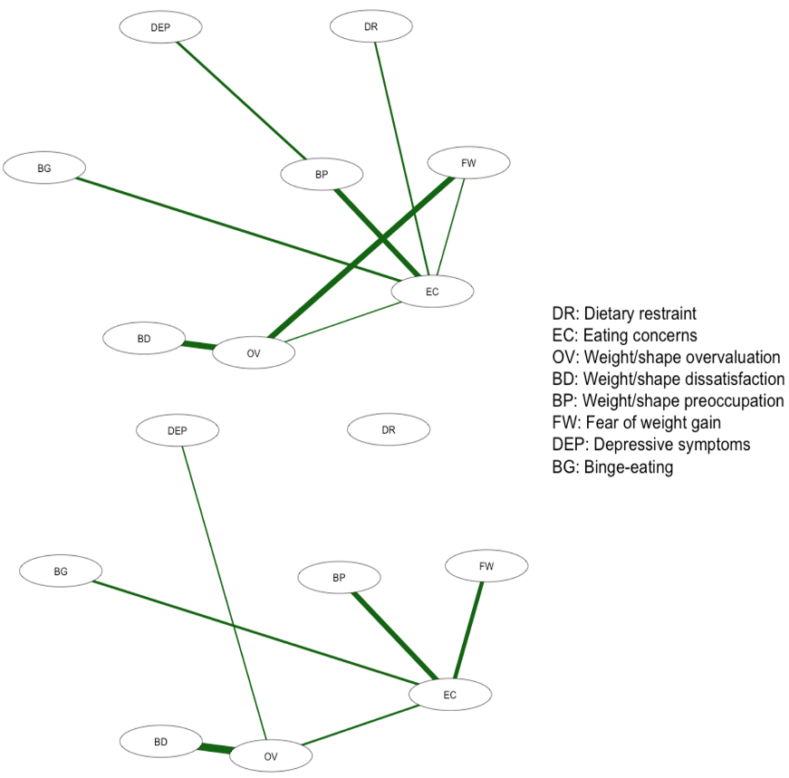
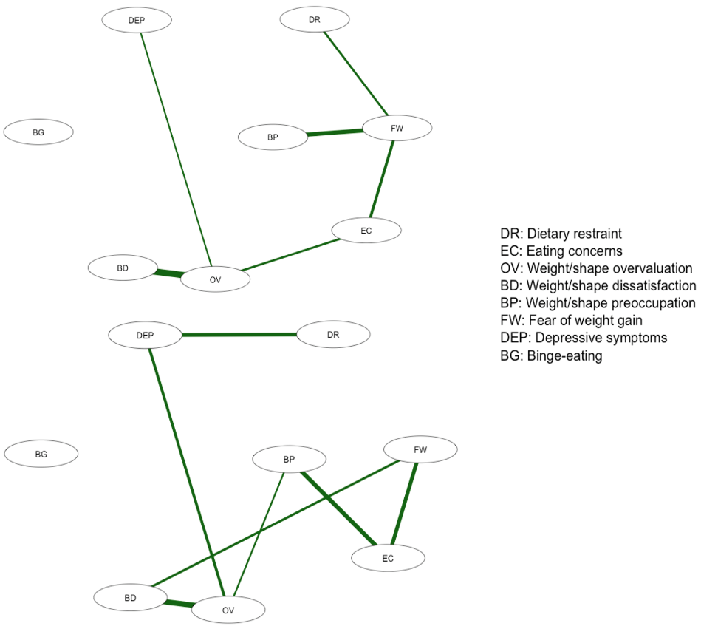
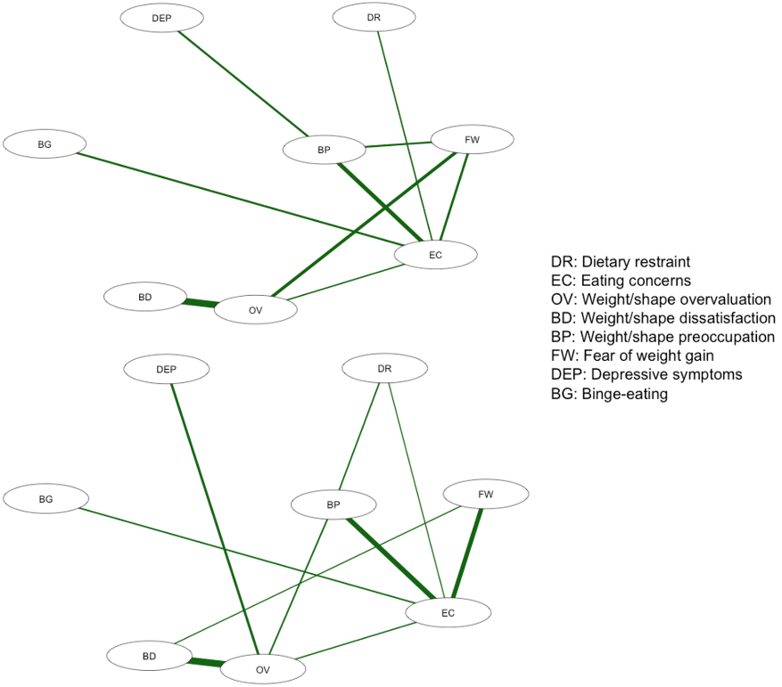

Figure S1. Network structures baseline (top) and post-intervention (bottom). Top left panel networks are for non-responders, top right for responders, and bottom left pan is for the waitlist group.

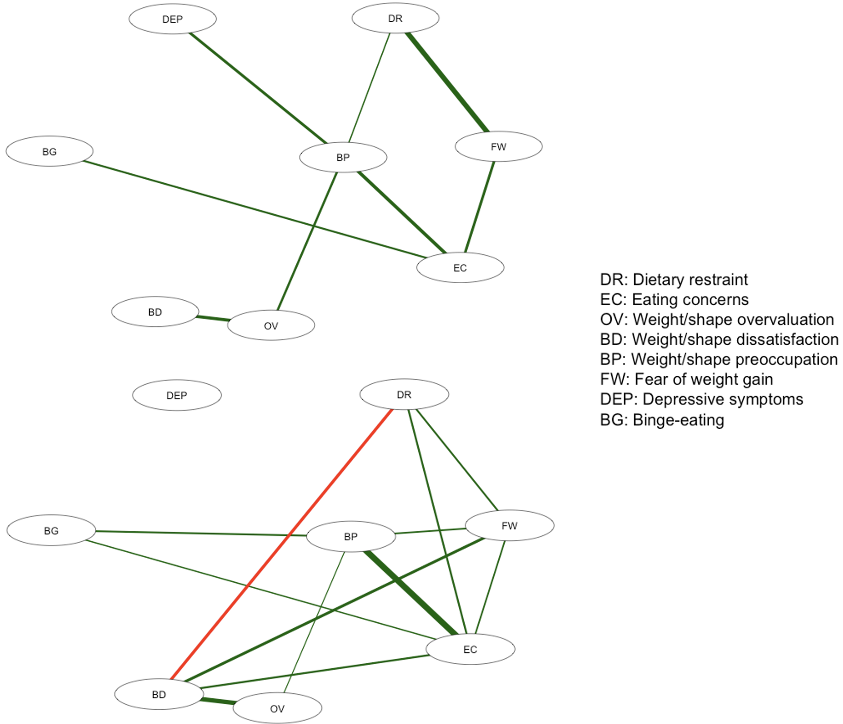
Figure S2. Network structures for wait-list at baseline (top) and post-intervention (bottom)

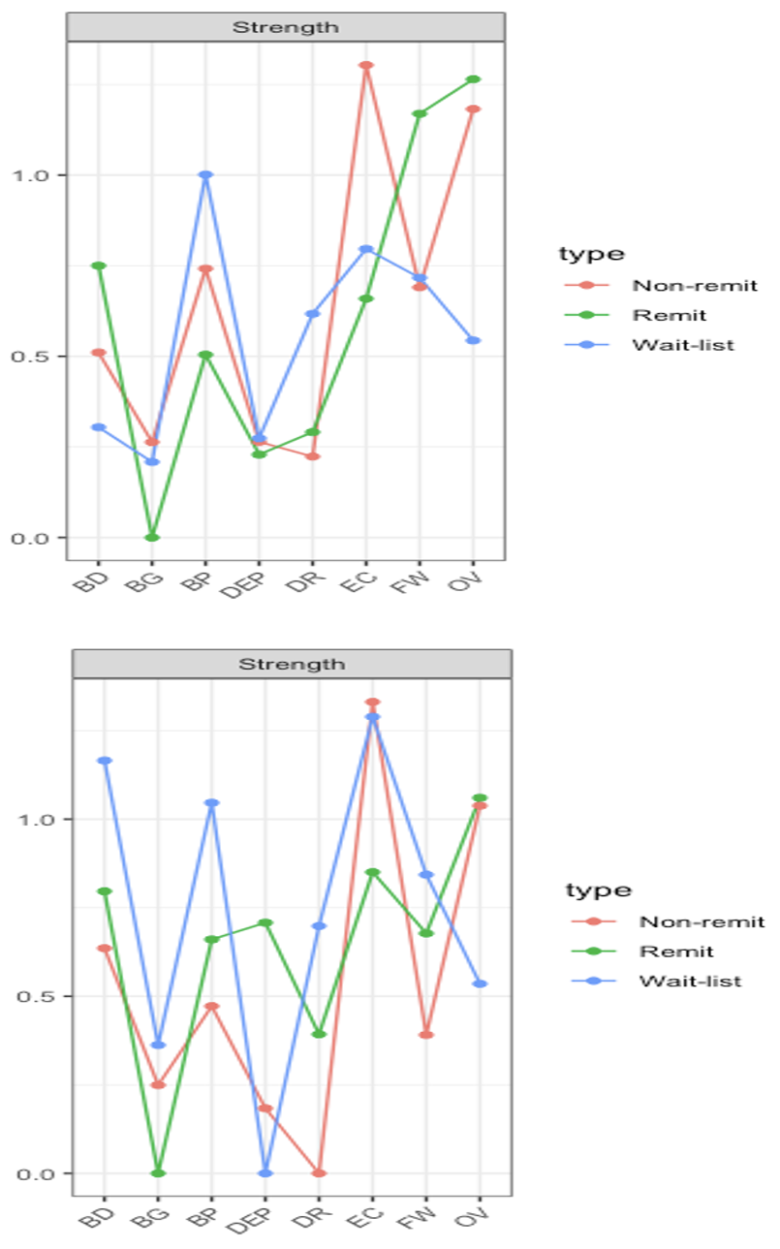
Figure S3. Node strength at baseline (top panel) and post-intervention (bottom panel) for non-responders, responders, and wait-list control groups. BD = appearance-related dissatisfaction, BG = binge eating, BP = preoccupation with weight and shape, DEP = depressive symptoms, DR = dietary restraint, EC = eating concerns, FW = fear of weight gain, OV = overvaluation of weight and shape.
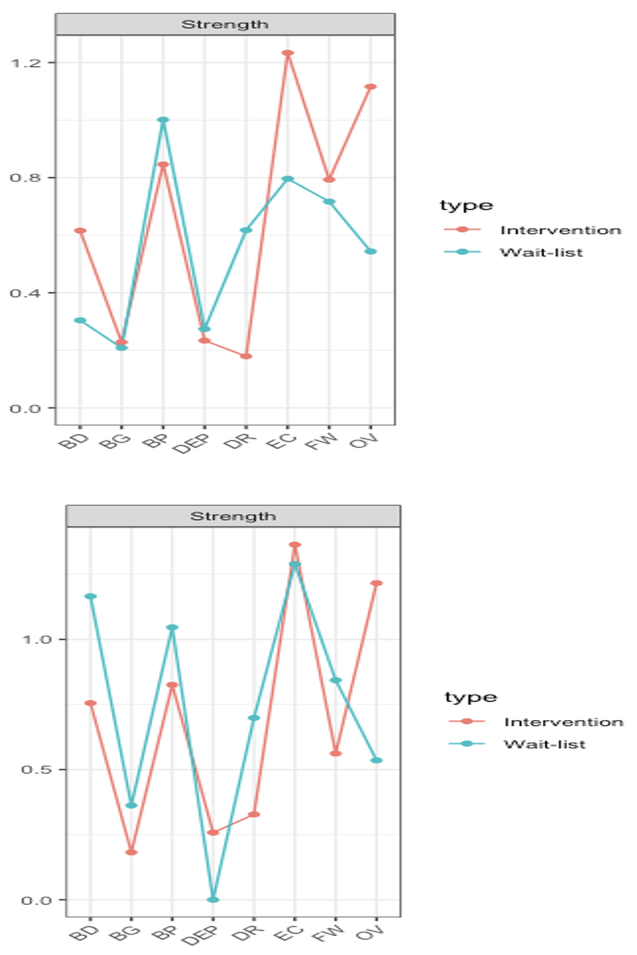
Figure S4. Node strength at baseline (top panel) and post-intervention (bottom panel) for intervention group combined (non-responders and responders) and wait-list control groups. BD = appearance-related dissatisfaction, BG = binge eating, BP = preoccupation with weight and shape, DEP = depressive symptoms, DR = dietary restraint, EC = eating concerns, FW = fear of weight gain, OV = overvaluation of weight and shape.

