Neuroimaging and epigenetic analysis reveal novel epigenetic loci in
major depressive disorder

Supplementary Materials

Supplementary Methods
Extraction of DNA
To estimate the DNA methylation level for each participant, DNA was isolated from the peripheral blood. Quantification of genomic DNA was measured using a NanoDrop® ND-1000 UV–Vis Spectrophotometer (NanoDrop Technologies, Wilmington, DE, USA). By using Quant-iT Picogreen quantitation (Invitrogen, Carlsbad, CA, USA), pure DNA sample was dissolved to 50 ng/μL concentration. Bisulfite treatment was conducted on 500 ng of diluted genomic DNA following the manufacturer's instructions of the Zymo EZ DNA methylation kit (Zymo Research, Irvine, CA, USA). The bisulfite-converted DNA fragments were amplified and purified according to the guidelines of manufacturer prior to hybridization on the EPIC Beadchip. The Illumina iScan platform scanned the hybridized arrays after washing.

White blood cell count estimation
To correct cell type heterogeneity, estimateCellCounts2 function in FlowSorted.Blood.EPIC R package was used to estimate the composition of white blood cells of each patient based on reference (Houseman et al., 2012; lucassalas, 2018). Six type of white blood cell were estimated in this method (CD4 T-cells, CD8 T-cells, natural killer (NK) cells, B-cells, monocytes, and neutrophils). Cell type composition was corrected using the linear regression model before differential methylation analysis.

Co-methylation analysis and visualization
Co-methylation analysis and visualization were performed on eight CpG sites from the methylation–neuroimaging correlation results using the coMET R package (Martin, Yet, Tsai, & Bell, 2015). A 10kb genomic window centered on each CpG site and Spearman correlation coefficient were applied to identify significant co-methylation (rho > |0.5|) (rho > |0.5|) (Hao et al., 2017). Two of the eight CpG sites are not shown in Fig.S4 due to the absence of adjacent CpGs within the 10kb genomic region (cg09705759 and cg14706523).

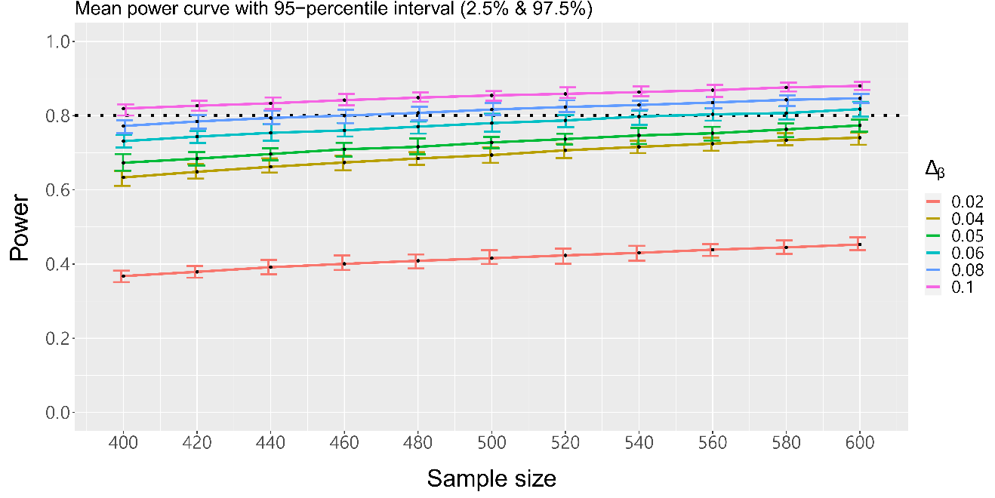
Figure S1. Statistical power curve for EWAS. The x-axis represents the total sample size and the y-axis represents the EWAS power. The horizontal dashed line indicates a statistical power of 80%. Plot was generated using pwrEWAS R package (Graw et al., 2019). MDD, major depressive disorder; HC, healthy control; Δβ (delta-beta), the average beta value of MDD patients minus the average beta value of HCs

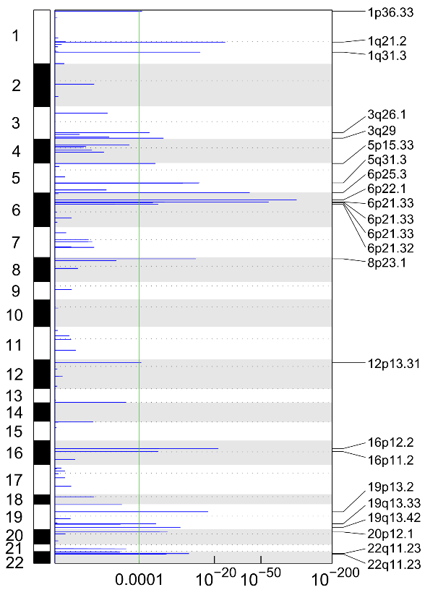
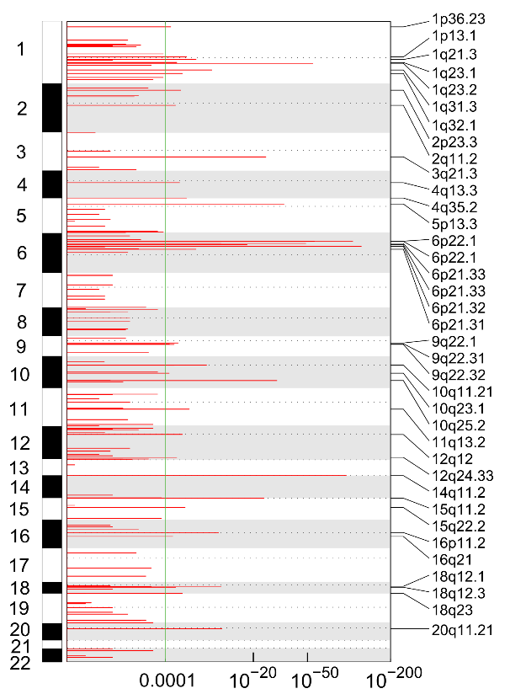
(b)
(a)

Figure S2. Recurrent CNAs in MDD patients. GISTIC2.0 analysis of 350 MDD patients identified recurrent focal (a) 37 gain regions and (b) 23 loss regions. Chromosomes are shown on the left-side, and the labeled cytobands which are shown on the right-side were related to the peak of significance. Green line indicates FDR threshold of 1.0E-04. MDD, major depressive disorder; HC, healthy control

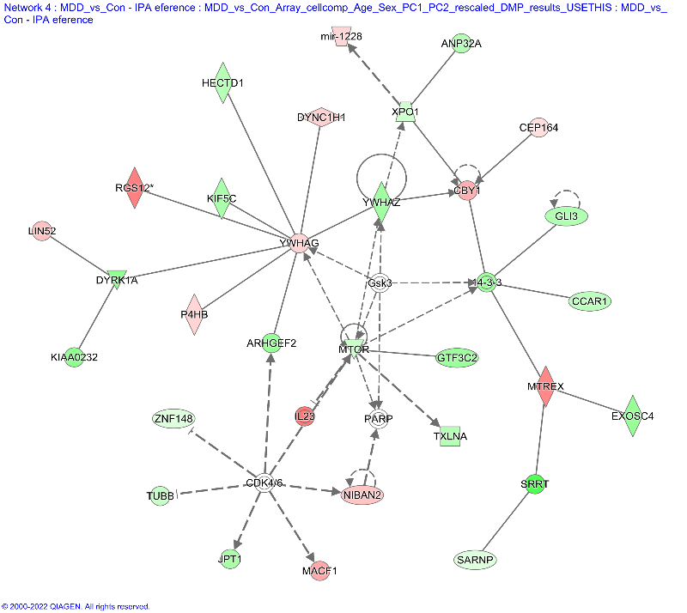
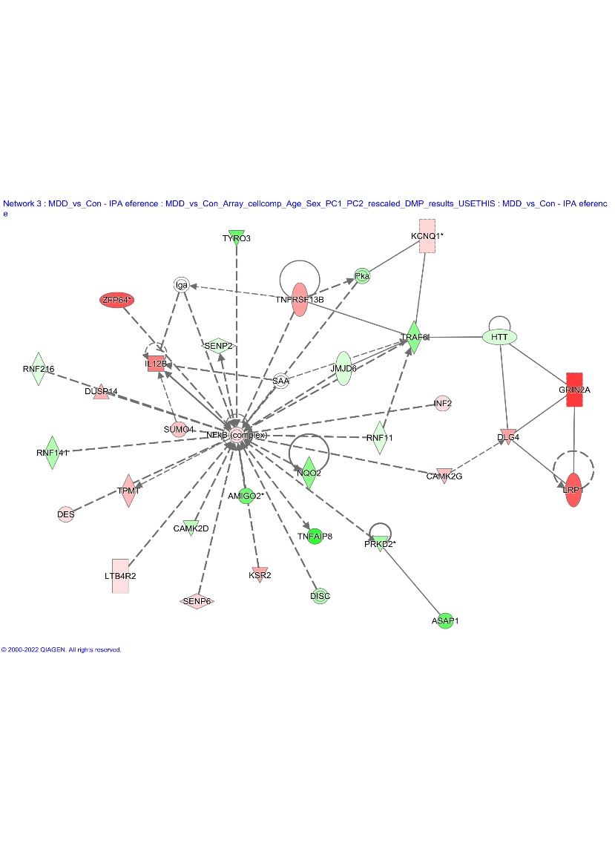
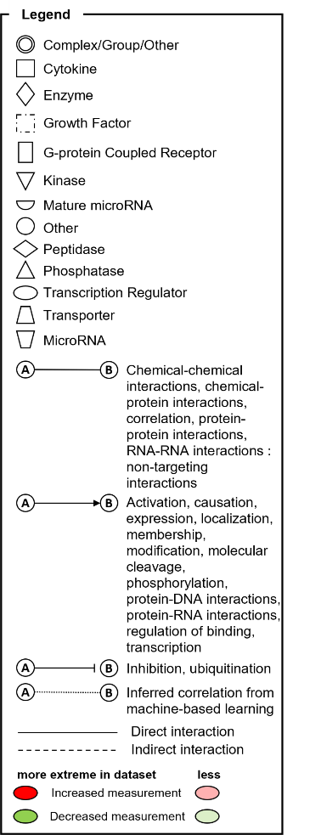
Figure S3. Gene networks using 1,474 unique genes associated with 2,018 significant DMPs between MDD and HC groups. The analysis indicated (a) gene network of “nervous system development and function, organ morphology, tissue morphology” with a score of 29, and (b) gene network of “developmental disorder, hereditary disorder, neurological disease” with a score of 29. The biological interactions between two molecules are represented as lines, and the molecules are represented as nodes. Red-colored nodes indicate hypermethylated genes in the MDD patients, and green-colored nodes indicate hypomethylated genes. Direct interactions are represented by solid lines, whereas dashed lines represent indirect interactions. The Ingenuity Pathways Knowledge Base's canonical data or at least one citation from the literature are used to substantiate each line.
(b)
(a)
DMP, differentially methylated probe; MDD, major depressive disorder; HC, healthy control

- cg09705759
- cg01490772

Figure S4. Correlation scatter plots derived from correlation analysis between DNA methylation levels and HDRS scores. (a) Correlation between methylation levels of cg09705759 and HDRS scores in the MDD (left) and HC (right) groups. (b) Correlation between the methylation levels of cg01490772 and HDRS scores in the MDD (left) and HC (right) groups. The x-axis represents the methylation level of the CpG site and the y-axis represents the HDRS scores. The blue line indicates the regression line. Spearman’s correlation coefficients (R) and nominal P-value (p) are represented at the top right of each plot. MDD, major depressive disorder; HC, healthy controls”

- cg02593636 (b) cg26929161
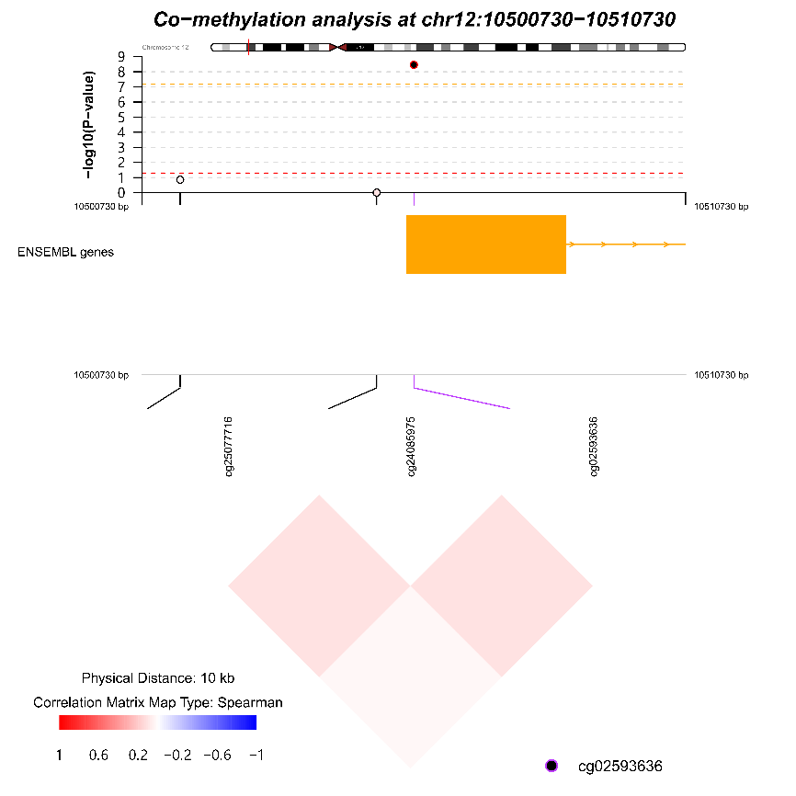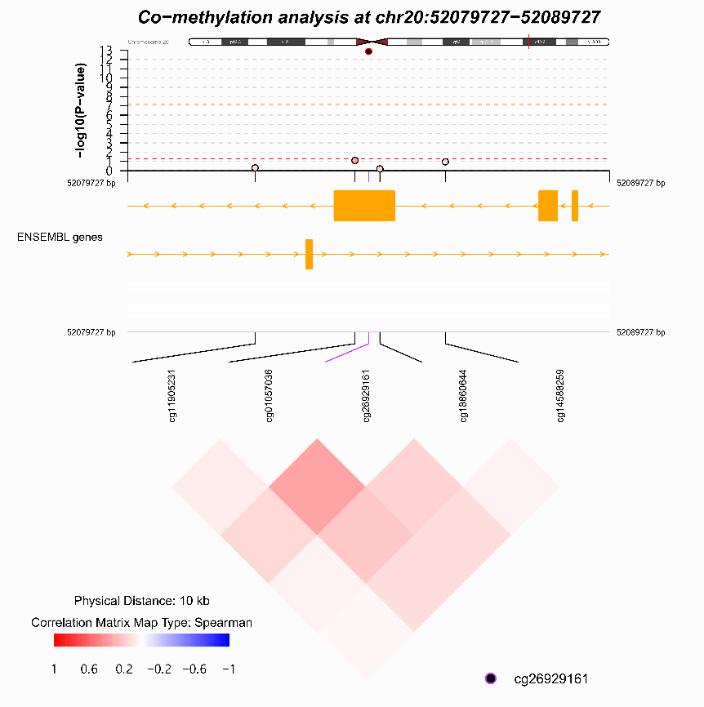

(c) cg01490772 (d) cg23644045
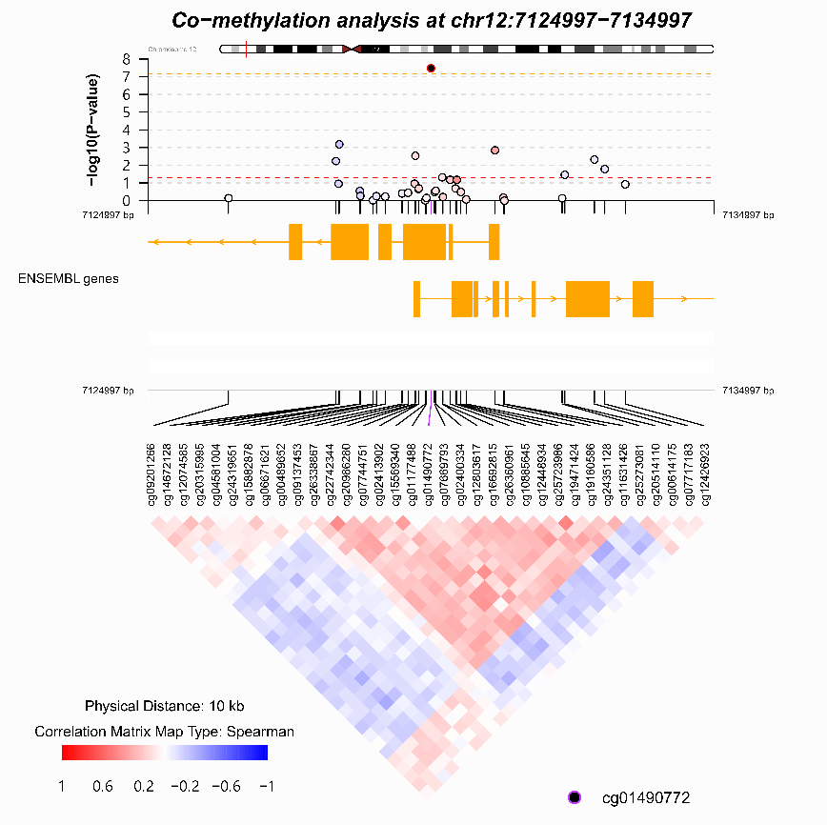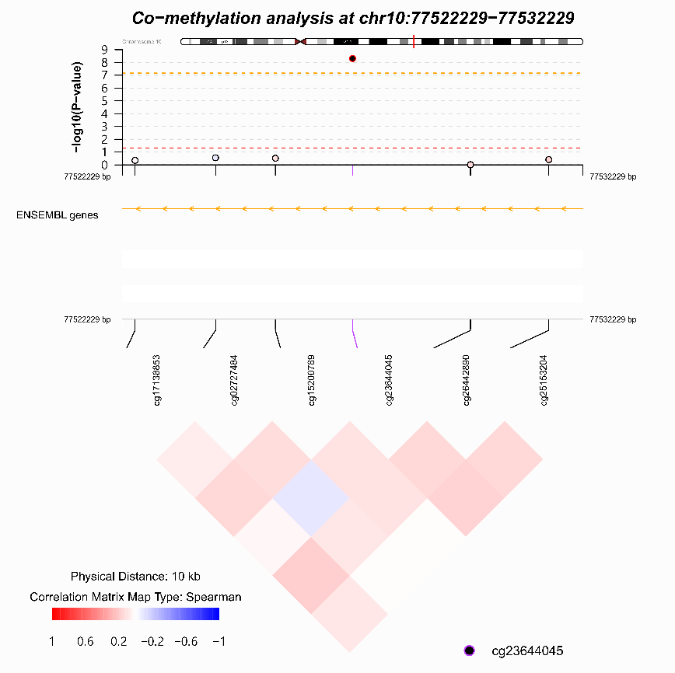

(e) cg24300703 (f) cg04227758
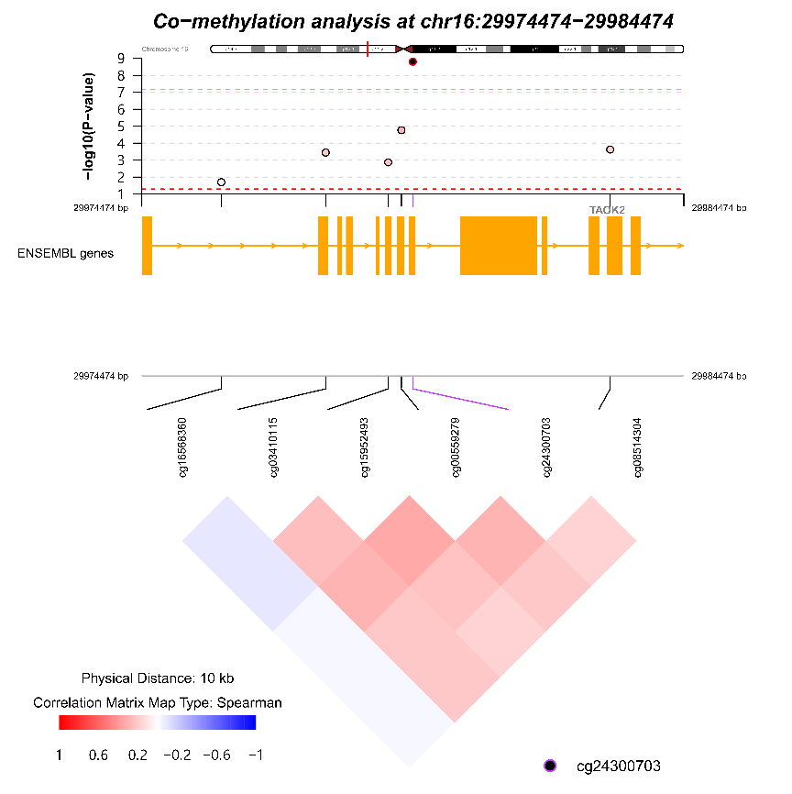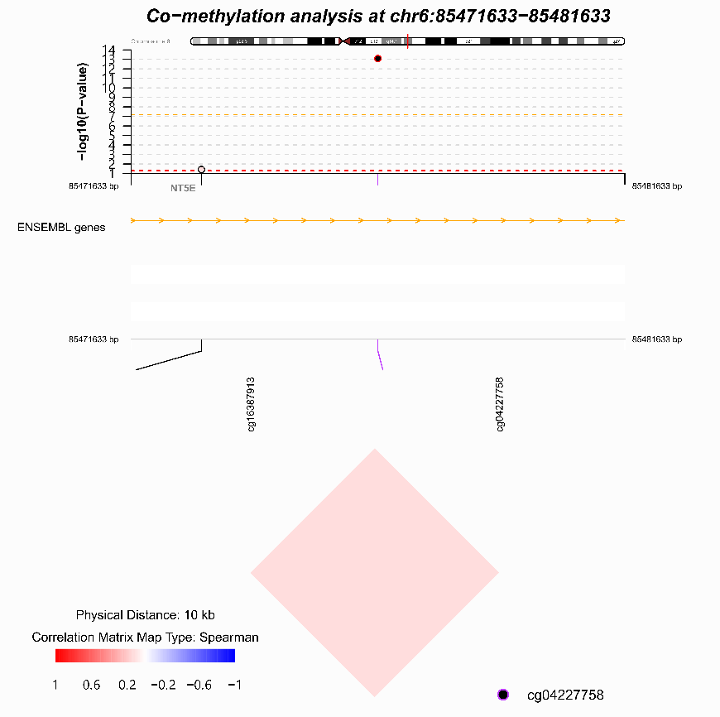

Figure S5. Regional association plots of six CpG sites from neuroimaging–methylation analysis. (a) cg02593636, (b) cg26929161, (c) cg01490772, (d) cg23644045, (e) cg24300703, and (f) cg04227758. In the MDD-methylation association profiles (top panel), CpG sites are represented by dots. The x-axis indicates genomic position, and the y-axis indicates log10(P-value). The red horizontal dashed line represents the nominal P-value cutoff (P-value < 0.05), and the orange horizontal dashed line represents the Bonferroni-corrected P-value cutoff (P-value < 6.80×10⁻⁰⁸). Functional annotation of the region is shown in the middle (middle panel), and the co-methylation pattern is shown at the bottom (bottom panel).

Reference
Graw, S., Henn, R., Thompson, J. A., & Koestler, D. C. (2019). pwrEWAS: A user-friendly tool for comprehensive power estimation for epigenome wide association studies (EWAS). BMC Bioinformatics, 20(1), 218. doi: 10.1186/s12859-019-2804-7
Hao, X., Luo, H., Krawczyk, M., Wei, W., Wang, W., Wang, J., … Zhang, K. (2017). DNA methylation markers for diagnosis and prognosis of common cancers. Proceedings of the National Academy of Sciences, 114(28), 7414–7419. doi: 10.1073/pnas.1703577114
Houseman, E. A., Accomando, W. P., Koestler, D. C., Christensen, B. C., Marsit, C. J., Nelson, H. H., … Kelsey, K. T. (2012). DNA methylation arrays as surrogate measures of cell mixture distribution. BMC Bioinformatics, 13(1), 86. doi: 10.1186/1471-2105-13-86
lucassalas. (2018). immunomethylomics/FlowSorted.Blood.EPIC: FlowSorted.Blood.EPIC v.0.99.36. Zenodo. doi: 10.5281/zenodo.1241200
Martin, T. C., Yet, I., Tsai, P.-C., & Bell, J. T. (2015). coMET: Visualisation of regional epigenome-wide association scan results and DNA co-methylation patterns. BMC Bioinformatics, 16(1), 131. doi: 10.1186/s12859-015-0568-2

