Appendix 1
Table S1. Full search strategy.
CLINICAL TRIALS
PubMed (from inception to 2023)
1 (probiotic OR symbiotic OR prebiotic OR Lactobacillus OR Lactobacillus* OR Bifidobacterium OR Bifidobacterium* OR Enterococcus spp. OR Enterococcus* OR Streptococci OR Streptococci* OR Bacillus OR Bacillus* OR Clostridium OR Clostridium* OR saccharomycete OR saccharomycete*)
2 (depress* OR anxi* OR anxiety OR mental health OR mental illness OR affective disorder OR affective illness OR stress OR psychological stress OR mental stress OR mood disorder)
3 (Randomized Controlled Trial OR controlled clinical trial OR random allocation OR double-blind OR singled-blind OR Placebo OR Randomly OR randomized OR clinical trial* OR RCT OR Random*)
Strategy of search | Results
1 AND 2 AND 3 | 1842
Web of Science (from inception to 2023)
1 TS= (probiotic OR symbiotic OR prebiotic OR Lactobacillus OR Lactobacillus* OR Bifidobacterium OR Bifidobacterium* OR Enterococcus spp. OR Enterococcus* OR Streptococci OR Streptococci* OR Bacillus OR Bacillus* OR Clostridium OR Clostridium* OR saccharomycete OR saccharomycete*)
2 TS= (depress* OR anxi* OR anxiety OR mental health OR mental illness OR affective disorder OR affective illness OR stress OR psychological stress OR mental stress OR mood disorder)

3 TS= (Randomized Controlled Trial OR controlled clinical trial OR random allocation OR double-blind OR singled-blind OR Placebo OR Randomly OR randomized OR clinical trial* OR RCT OR Random*)
Strategy of search | Results
1 AND 2 AND 3 | 4153
Embase (from inception to 2023)
1 (probiotic OR symbiotic OR prebiotic OR Lactobacillus OR Lactobacillus* OR Bifidobacterium OR Bifidobacterium* OR Enterococcus spp. OR Enterococcus* OR Streptococci OR Streptococci* OR Bacillus OR Bacillus* OR Clostridium OR Clostridium* OR saccharomycete OR saccharomycete*)
2 (depress* OR anxi* OR anxiety OR mental health OR mental illness OR affective disorder OR affective illness OR stress OR psychological stress OR mental stress OR mood disorder)
3 (Randomized Controlled Trial OR controlled clinical trial OR random allocation OR double-blind OR singled-blind OR Placebo OR Randomly OR randomized OR clinical trial* OR RCT OR Random*)
Strategy of search | Results
1 AND 2 AND 3 | 3753
Cochrane (from inception to 2023)
1 (probiotic OR symbiotic OR prebiotic OR Lactobacillus OR Lactobacillus* OR Bifidobacterium OR Bifidobacterium* OR Enterococcus spp. OR Enterococcus* OR Streptococci OR Streptococci* OR Bacillus OR Bacillus* OR Clostridium OR Clostridium* OR saccharomycete OR saccharomycete*)
2 (depress* OR anxi* OR anxiety OR mental health OR mental illness OR affective disorder OR affective illness OR stress OR psychological stress OR mental stress OR mood disorder)
3 (Randomized Controlled Trial OR controlled clinical trial OR random allocation OR double-blind OR singled-blind OR Placebo OR Randomly OR randomized OR clinical trial* OR RCT OR Random*)
Strategy of search | Results
1 AND 2 AND 3 | 1198

Figure S1. (a) review authors' judgements about each risk of bias item presented as percentages across all included studies. (b) review authors' judgements about each risk of bias item for each included study.
(a)
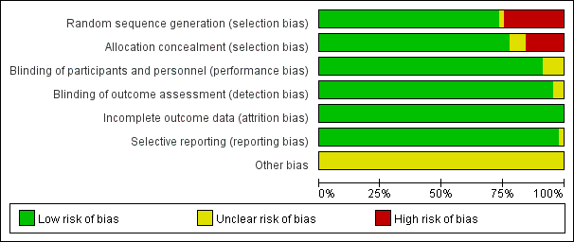
(b)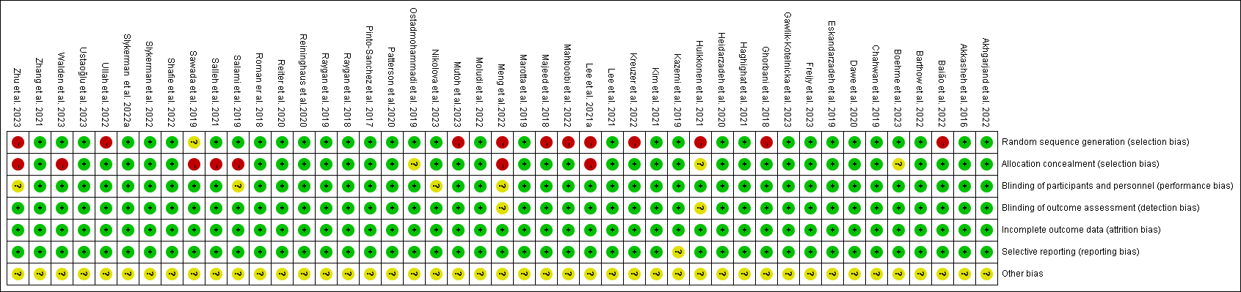

Table S2. GRADE evidence rating scale.
Outcomes | No of Participants  (studies)  Follow up | Quality of the evidence  (GRADE) | Relative effect  (95% CI) | Anticipated absolute effects
 |  |  |  | Risk with Control | Risk difference with Depression (95% CI)
Depression | 2311  (36 studies) | ⊕⊕⊕⊝  MODERATE¹  due to inconsistency |  |  | The mean depression in the intervention groups was  0.33 lower  (0.51 to 0.16 lower)
Anxiety | 2938  (30 studies) | ⊕⊕⊕⊕  HIGH |  |  | The mean anxiety (copy) in the intervention groups was  0.34 lower  (0.48 to 0.20 lower)
Stress | 1549  (12 studies) | ⊕⊕⊕⊝  MODERATE¹  due to inconsistency |  |  | The mean stress (copy) in the intervention groups was  0.13 lower  (0.23 to 0.03 lower)
*The basis for the assumed risk (e.g. the median control group risk across studies) is provided in footnotes. The corresponding risk (and its 95% confidence interval) is based on the assumed risk in the comparison group and the relative effect of the intervention (and its 95% CI).
CI: Confidence interval;
GRADE Working Group grades of evidence
High quality: Further research is very unlikely to change our confidence in the estimate of effect.
Moderate quality: Further research is likely to have an important impact on our confidence in the estimate of effect and may change the estimate.
Low quality: Further research is very likely to have an important impact on our confidence in the estimate of effect and is likely to change the estimate.
Very low quality: We are very uncertain about the estimate.
¹ Point estimates varied considerably between studies

Appendix 2
Figure S1. Forest plot and the global inconsistency test result (anxiety). (chi² = 51.69, P < 0.01)
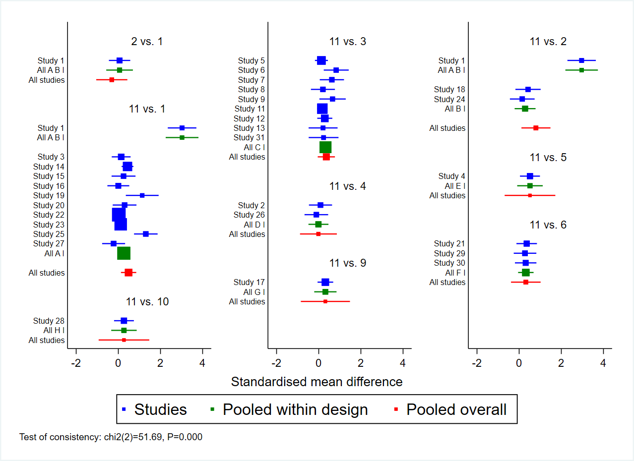
Label: A= 1 = Lactobacillus B= 2 = Bifidobacterium C= 3 = Lactobacillus + Bifidobacterium D= 4 = Bacillus + Bifidobacterium + Lactobacillus + Streptococcus E= 5 = Biﬁdobacterium + Lactobacillus + Lactococcus F= 6 = Lactobacillus + Biﬁdobacterium + Streptococcus G= 9 = Lacticaseibacillus H= 10 = Limosilactobacillus + Lacticaseibacillus + Lactiplantibacillus + Bifidobacterium I= 11 = Placebo
Table S1. Local inconsistency test (anxiety).
Side | Direct |  | Indirect |  | Difference |  |  | tau
 | Coef. | Std. Err. | Coef. | Std. Err. | Coef. | Std. Err. | P>z
A B | 0.05 | 0.63 | -0.52 | 0.48 | 0.57 | 0.79 | 0.47 | 0.57
A I | 0.53 | 0.18 | -2.02 | 1.37 | 2.56 | 1.39 | 0.07 | 0.54
B I | 1.13 | 0.32 | -2.16 | 1.00 | 3.28 | 1.06 | 0.00 | 0.46
C I | 0.36 | 0.21 | 0.96 | 210.50 | -0.60 | 210.50 | 1.00 | 0.56
D I | -0.01 | 0.45 | 0.98 | 448.00 | -0.99 | 448.00 | 1.00 | 0.56
E I | 0.51 | 0.61 | 1.00 | 634.99 | -0.48 | 634.99 | 1.00 | 0.56
F I | 0.32 | 0.36 | 0.97 | 362.56 | -0.66 | 362.56 | 1.00 | 0.56
G I | 0.32 | 0.59 | 0.98 | 632.97 | -0.67 | 632.97 | 1.00 | 0.56
H I | 0.27 | 0.61 | 0.98 | 631.78 | -0.71 | 631.78 | 1.00 | 0.56
Label: A= Lactobacillus B= Bifidobacterium C= Lactobacillus + Bifidobacterium D= Bacillus + Bifidobacterium + Lactobacillus + Streptococcus E= Biﬁdobacterium + Lactobacillus + Lactococcus F= Lactobacillus + Biﬁdobacterium + Streptococcus G= Lacticaseibacillus H= Limosilactobacillus + Lacticaseibacillus + Lactiplantibacillus + Bifidobacterium I= Placebo
Table S2. SUCRA analysis: Mean Rank table (anxiety).
Treat~t | SUCRA | PrBest | Mean Rank
A | 63.80 | 3.90 | 3.90
B | 82.10 | 36.90 | 2.40
C | 53.20 | 2.00 | 4.70
D | 27.60 | 2.30 | 6.80
E | 59.70 | 23.20 | 4.20
F | 48.50 | 5.10 | 5.10
G | 49.60 | 14.00 | 5.00
H | 45.70 | 12.60 | 5.30
I | 19.80 | 0.00 | 7.40
Label: A= Lactobacillus B= Bifidobacterium C= Lactobacillus + Bifidobacterium D= Bacillus + Bifidobacterium + Lactobacillus + Streptococcus E= Biﬁdobacterium + Lactobacillus + Lactococcus F= Lactobacillus + Biﬁdobacterium + Streptococcus G= Lacticaseibacillus H= Limosilactobacillus + Lacticaseibacillus + Lactiplantibacillus + Bifidobacterium I= Placebo

Figure S2. Assessment of loop inconsistency in networks (anxiety).
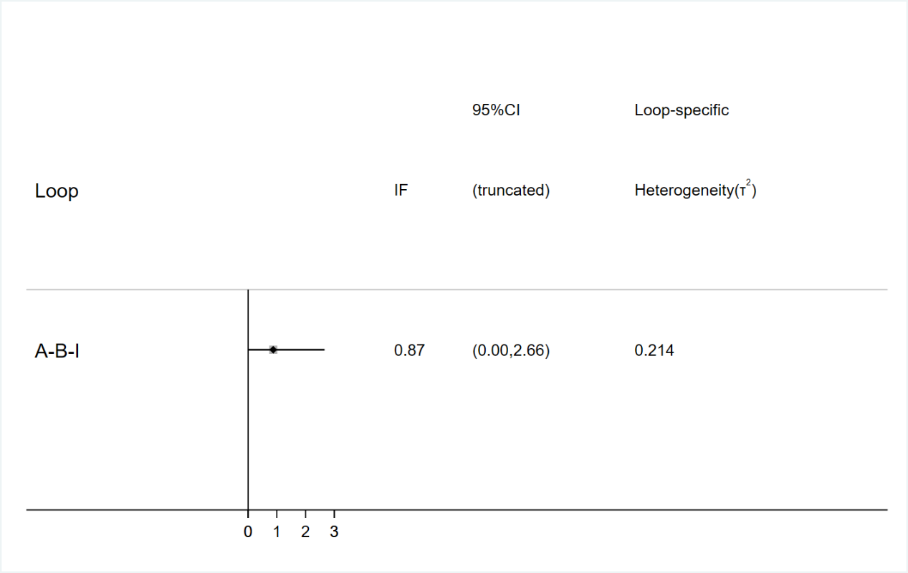
Label: A= Lactobacillus B= Bifidobacterium I= Placebo
Figure S3. SUCRA ranking curve for anxiety.
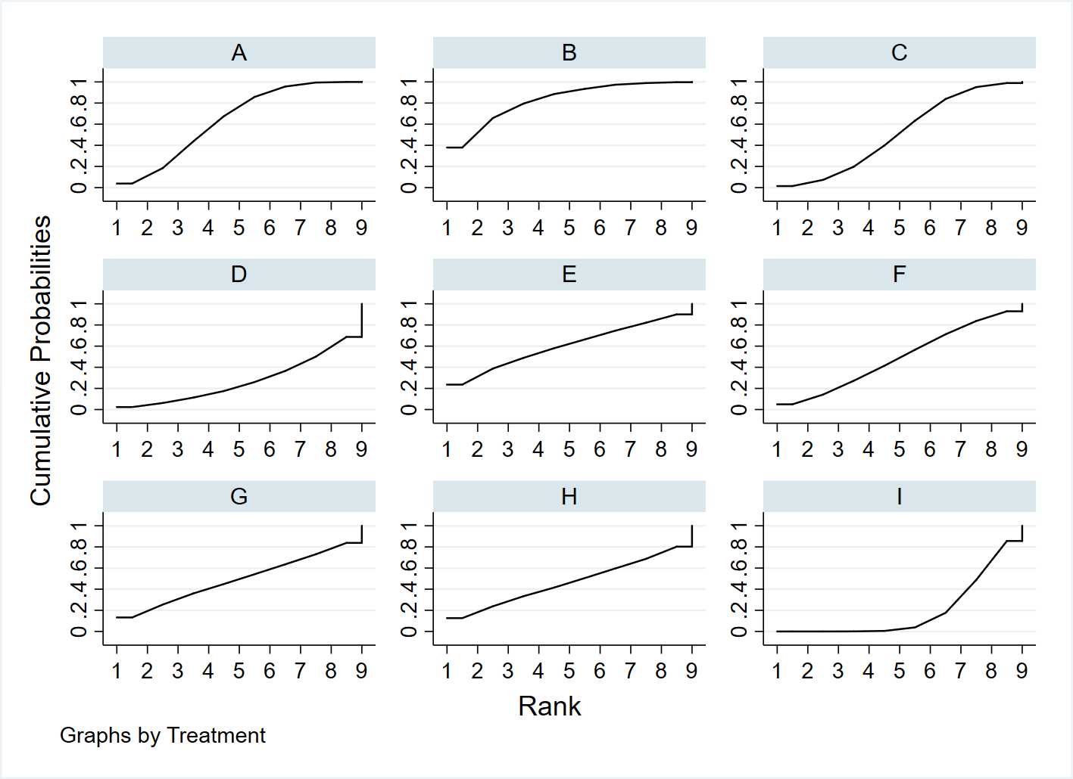
Label: A= Lactobacillus B= Bifidobacterium C= Lactobacillus + Bifidobacterium D= Bacillus + Bifidobacterium + Lactobacillus + Streptococcus E= Biﬁdobacterium + Lactobacillus + Lactococcus F= Lactobacillus + Biﬁdobacterium + Streptococcus G= Lacticaseibacillus H= Limosilactobacillus + Lacticaseibacillus + Lactiplantibacillus + Bifidobacterium I= Placebo
Figure S4. Comparison-adjusted funnel plot for the network of anxiety in all comparisons.
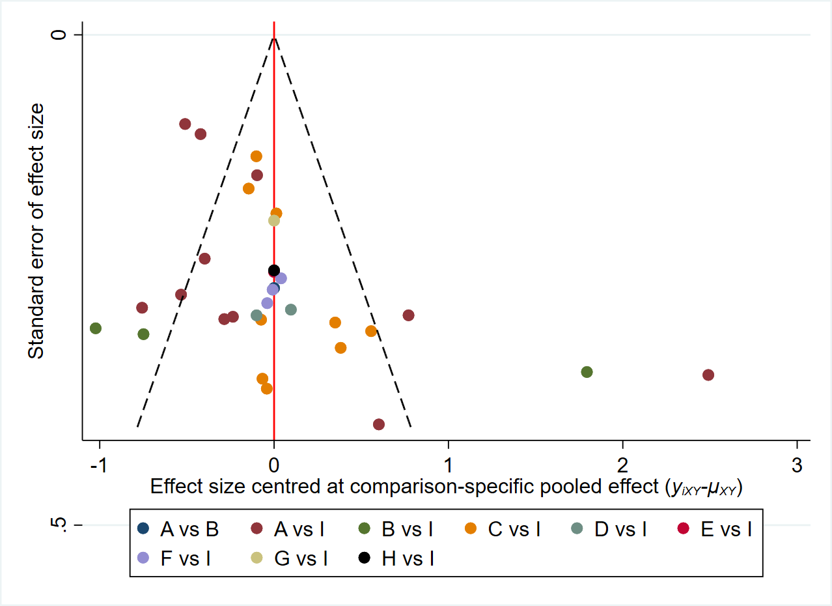
Label: A= Lactobacillus B= Bifidobacterium C= Lactobacillus + Bifidobacterium D= Bacillus + Bifidobacterium + Lactobacillus + Streptococcus E= Biﬁdobacterium + Lactobacillus + Lactococcus F= Lactobacillus + Biﬁdobacterium + Streptococcus G= Lacticaseibacillus H= Limosilactobacillus + Lacticaseibacillus + Lactiplantibacillus + Bifidobacterium I= Placebo

Figure S5. Forest plot and the global inconsistency test result (depression).
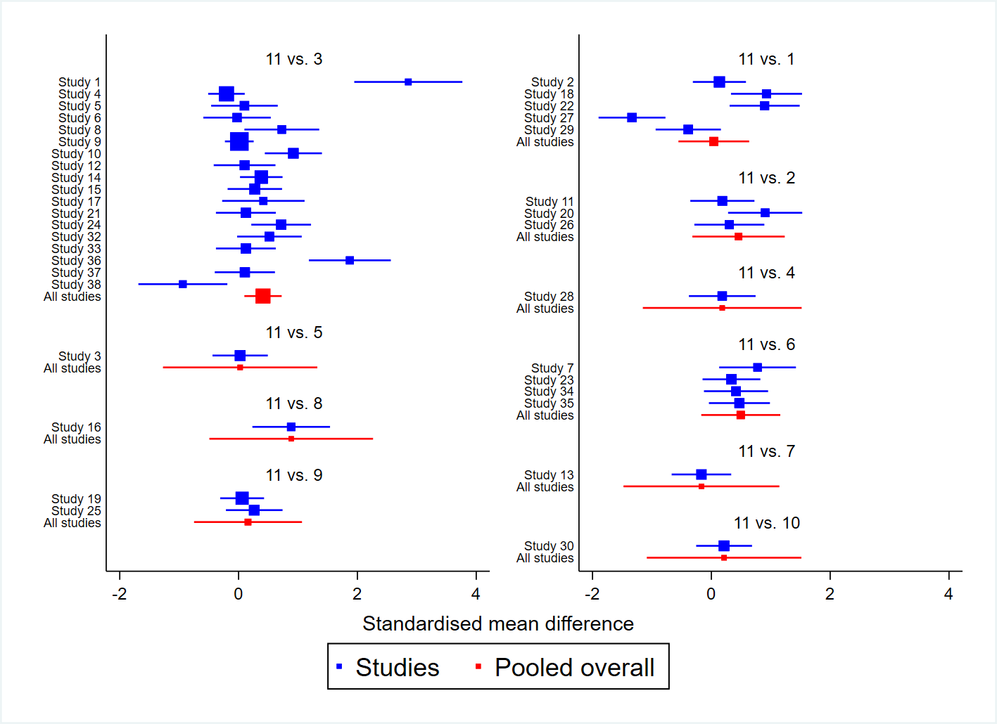
Label: 1= Lactobacillus 2= Bifidobacterium 3= Lactobacillus + Bifidobacterium 4= Bacillus + Bifidobacterium + Lactobacillus + Streptococcus 5= Biﬁdobacterium + Lactobacillus + Lactococcus 6= Lactobacillus + Biﬁdobacterium + Streptococcus 7= Weissella 8= Bacillus 9= Lacticaseibacillus 10= Limosilactobacillus + Lacticaseibacillus + Lactiplantibacillus + Bifidobacterium 11= Placebo
Table S3. Local inconsistency test (depression).
Side | Direct |  | Indirect |  | Difference |  |  | tau
 | Coef. | Std. Err. | Coef. | Std. Err. | Coef. | Std. Err. | P>z
A K | 0.04 | 0.30 | 0.19 | 55.98 | -0.15 | 55.98 | 1.00 | 0.62
B K | 0.46 | 0.40 | 0.07 | 365.68 | 0.38 | 365.68 | 1.00 | 0.62
C K | 0.41 | 0.16 | 0.07 | 149.34 | 0.34 | 149.34 | 1.00 | 0.62
D K | 0.18 | 0.68 | 0.09 | 633.41 | 0.10 | 633.42 | 1.00 | 0.62
E K | 0.03 | 0.66 | 0.08 | 632.55 | -0.06 | 632.55 | 1.00 | 0.62
F K | 0.49 | 0.34 | 0.08 | 316.23 | 0.41 | 316.23 | 1.00 | 0.62
G K | -0.17 | 0.67 | 0.10 | 633.78 | -0.27 | 633.78 | 1.00 | 0.62
H K | 0.89 | 0.70 | 0.08 | 632.92 | 0.80 | 632.92 | 1.00 | 0.62
I K | 0.16 | 0.46 | 0.07 | 446.08 | 0.09 | 446.08 | 1.00 | 0.62
J K | 0.21 | 0.66 | 0.08 | 632.79 | 0.13 | 632.79 | 1.00 | 0.62

Label: A= Lactobacillus B= Bifidobacterium C= Lactobacillus + Bifidobacterium D= Bacillus + Bifidobacterium + Lactobacillus + Streptococcus E= Biﬁdobacterium + Lactobacillus + Lactococcus F= Lactobacillus + Biﬁdobacterium + Streptococcus G= Weissella H= Bacillus I= Lacticaseibacillus J= Limosilactobacillus + Lacticaseibacillus + Lactiplantibacillus + Bifidobacterium K = Placebo
Table S4. SUCRA analysis: Mean Rank table (depression).
Treat~t | SUCRA | PrBest | Mean Rank
A | 36.00 | 0.50 | 7.40
B | 64.10 | 9.60 | 4.60
C | 64.10 | 1.80 | 4.60
D | 46.70 | 10.10 | 6.30
E | 38.90 | 6.20 | 7.10
F | 67.80 | 8.90 | 4.20
G | 30.20 | 3.60 | 8.00
H | 79.10 | 45.20 | 3.10
I | 45.30 | 4.10 | 6.50
J | 48.30 | 10.10 | 6.20
K | 29.50 | 0.00 | 8.00
Label: A= Lactobacillus B= Bifidobacterium C= Lactobacillus + Bifidobacterium D= Bacillus + Bifidobacterium + Lactobacillus + Streptococcus E= Biﬁdobacterium + Lactobacillus + Lactococcus F= Lactobacillus + Biﬁdobacterium + Streptococcus G= Weissella H= Bacillus I= Lacticaseibacillus J= Limosilactobacillus + Lacticaseibacillus + Lactiplantibacillus + Bifidobacterium K = Placebo

Figure S6. SUCRA ranking curve for depression.
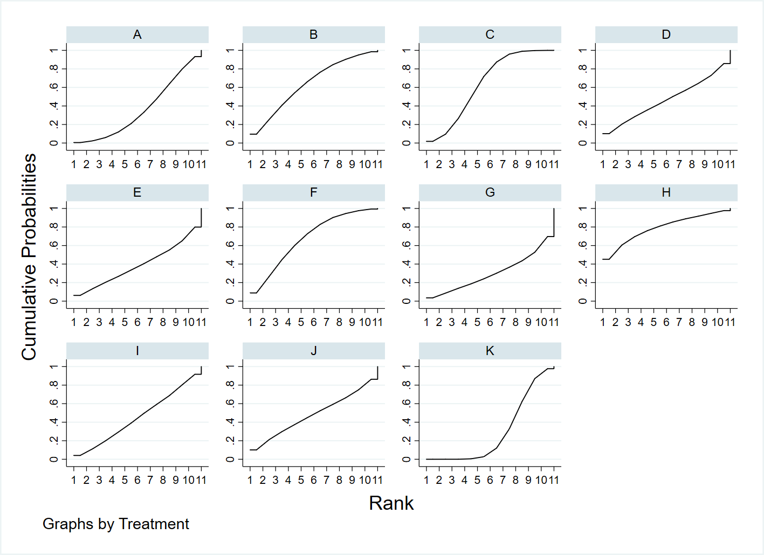
Label: A= Lactobacillus B= Bifidobacterium C= Lactobacillus + Bifidobacterium D= Bacillus + Bifidobacterium + Lactobacillus + Streptococcus E= Biﬁdobacterium + Lactobacillus + Lactococcus F= Lactobacillus + Biﬁdobacterium + Streptococcus G= Weissella H= Bacillus I= Lacticaseibacillus J= Limosilactobacillus + Lacticaseibacillus + Lactiplantibacillus + Bifidobacterium K = Placebo

Figure S7. Comparison-adjusted funnel plot for the network of depression in all comparisons.
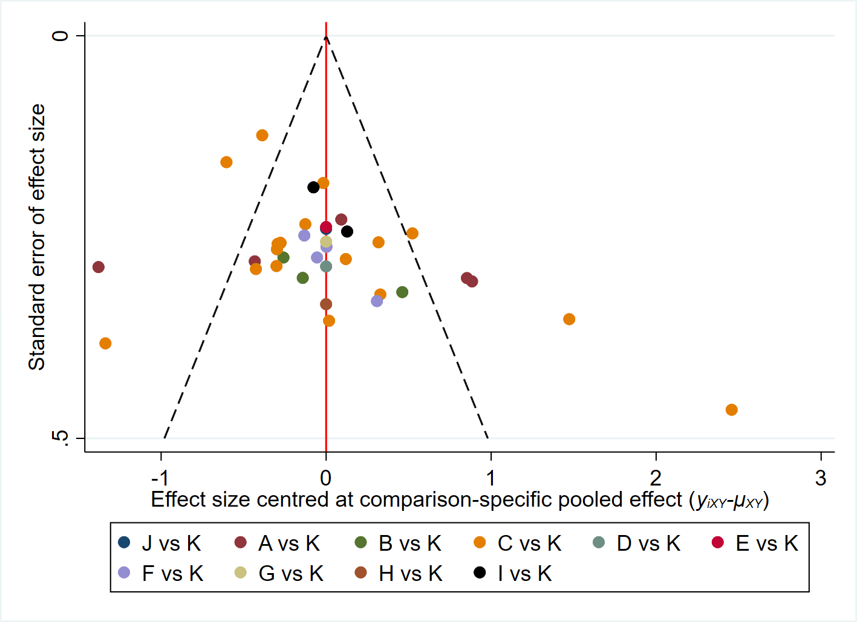
Label: A= Lactobacillus B= Bifidobacterium C= Lactobacillus + Bifidobacterium D= Bacillus + Bifidobacterium + Lactobacillus + Streptococcus E= Biﬁdobacterium + Lactobacillus + Lactococcus F= Lactobacillus + Biﬁdobacterium + Streptococcus G= Weissella H= Bacillus I= Lacticaseibacillus J= Limosilactobacillus + Lacticaseibacillus + Lactiplantibacillus + Bifidobacterium K = Placebo

Figure S8. Forest plot and the global inconsistency test result (stress).
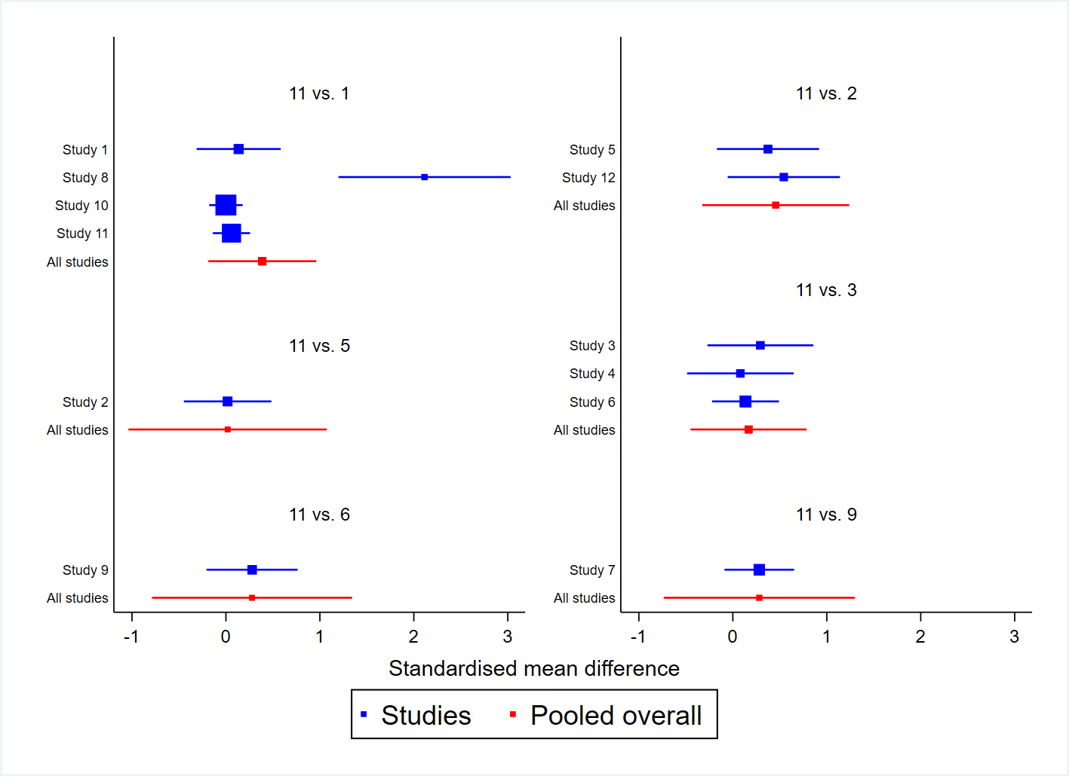
Label: 1= Lactobacillus 2= Bifidobacterium 3= Lactobacillus + Bifidobacterium 5= Biﬁdobacterium + Lactobacillus + Lactococcus 6= Lactobacillus + Biﬁdobacterium + Streptococcus 9= Lacticaseibacillus 11= Placebo
Table S5. Local inconsistency test (stress).
Side | Direct |  | Indirect |  | Difference |  |  | tau
 | Coef. | Std. Err. | Coef. | Std. Err. | Coef. | Std. Err. | P>z
A G | 0.39 | 0.29 | 0.13 | 111.57 | 0.26 | 111.57 | 1.00 | 0.48
B G | 0.46 | 0.40 | 0.75 | 446.53 | -0.30 | 446.53 | 1.00 | 0.48
C G | 0.17 | 0.32 | 0.77 | 365.62 | -0.60 | 365.62 | 1.00 | 0.48
D G | 0.02 | 0.54 | 0.77 | 631.61 | -0.76 | 631.61 | 1.00 | 0.48
E G | 0.28 | 0.54 | 0.77 | 634.35 | -0.50 | 634.35 | 1.00 | 0.48
F G | 0.28 | 0.52 | 0.78 | 632.73 | -0.50 | 632.73 | 1.00 | 0.48
Label: A= Lactobacillus B= Bifidobacterium C= Lactobacillus + Bifidobacterium D= Biﬁdobacterium + Lactobacillus + Lactococcus E= Lactobacillus + Biﬁdobacterium + Streptococcus F= Lacticaseibacillus G = Placebo

Table S6. SUCRA analysis: Mean Rank table (stress).
Treat~t | SUCRA | PrBest | Mean Rank
A | 65.20 | 16.50 | 3.10
B | 68.60 | 27.80 | 2.90
C | 45.50 | 5.60 | 4.30
D | 36.20 | 9.80 | 4.80
E | 53.50 | 20.60 | 3.80
F | 54.30 | 19.60 | 3.70
G | 26.70 | 0.00 | 5.40
Label: A= Lactobacillus B= Bifidobacterium C= Lactobacillus + Bifidobacterium D= Biﬁdobacterium + Lactobacillus + Lactococcus E= Lactobacillus + Biﬁdobacterium + Streptococcus F= Lacticaseibacillus G= Placebo
Figure S9. SUCRA ranking curve for stress.
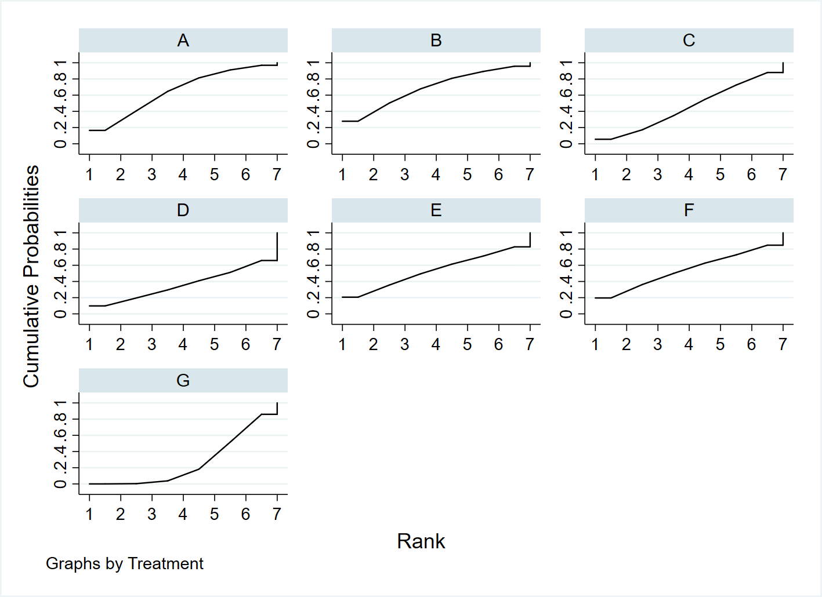
Label: A= Lactobacillus B= Bifidobacterium C= Lactobacillus + Bifidobacterium D= Biﬁdobacterium + Lactobacillus + Lactococcus E= Lactobacillus + Biﬁdobacterium + Streptococcus F= Lacticaseibacillus G= Placebo

Figure S10. Comparison-adjusted funnel plot for the network of stress in all comparisons.
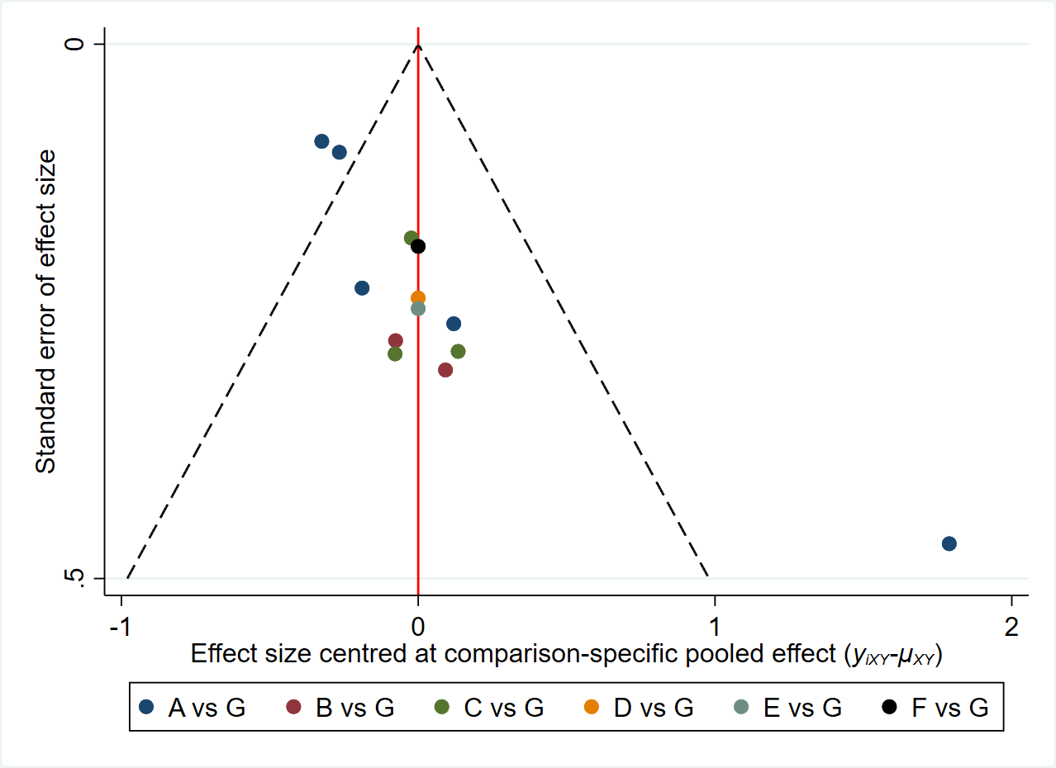
Label: A= Lactobacillus B= Bifidobacterium C= Lactobacillus + Bifidobacterium D= Biﬁdobacterium + Lactobacillus + Lactococcus E= Lactobacillus + Biﬁdobacterium + Streptococcus F= Lacticaseibacillus G= Placebo

Figure S11. Pooled effect size (ES) and confidence interval (CI) for stress by network meta-analysis and traditional meta-analysis.
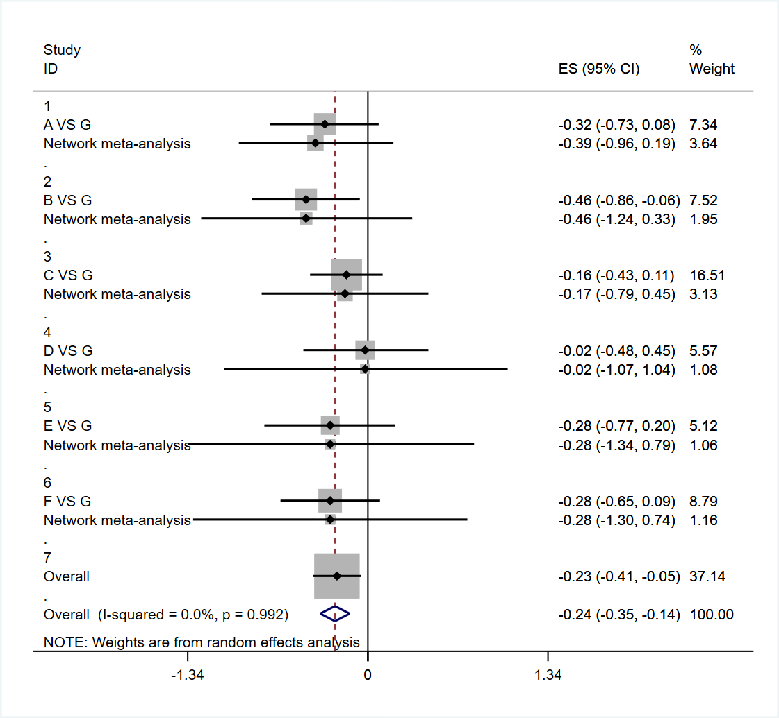
Label: A= Lactobacillus B= Bifidobacterium C= Lactobacillus + Bifidobacterium D= Biﬁdobacterium + Lactobacillus + Lactococcus E= Lactobacillus + Biﬁdobacterium + Streptococcus F= Lacticaseibacillus G= Placebo

Appendix 3
Subgroup analysis
Table S1. The standardized mean difference (95% confidence interval) and the rank order (SUCRA ranks) of the intervention time compared to placebo (Anxiety).
Intervention | Anxiety
 | SMD (95%CI) | SUCRA rank
1 (12w) | -0.88 (-1.68, -0.08) | 2
2 (12w) | -1.82 (-3.29, -0.34) | 1
1 (24w) | -0.14 (-1.72, 1.45) | 11
3 (22w) | -0.13 (-1.68, 1.43) | 12
3 (8w) | -0.43 (-1.16, 0.29) | 5
3 (12w) | -0.66 (-2.30, 0.99) | 4
3 (48w) | -0.17 (-1.71, 1.37) | 10
3 (9w) | -0.21 (-1.88, 1.46) | 9
1 (8w) | -0.25 (-1.87, 1.38) | 8
1 (6w) | -0.27 (-1.22, 0.68) | 7
2 (6w) | -0.28 (-1.44, 0.87) | 6
1 (10w) | -0.11 (-1.65, 1.42) | 1
1 (3 w) | -1.30 (-2.93, 0.32) | 3
PLA | reference | reference
1 = Lactobacillus 2 = Bifidobacterium 3 = Lactobacillus + Bifidobacterium PLA = placebo
Table S2. The standardized mean difference (95% confidence interval) and the rank order (SUCRA ranks) of the intervention time compared to placebo (Depression).
Intervention | Depression
 | SMD (95%CI) | SUCRA rank
3 (8w) | -0.51 (-1.10, 0.08) | 5
1 (24w) | -0.14 (-1.64, 1.37) | 10
3 (22w) | 0.20 (-1.27, 1.68) | 13
3 (12w) | -0.41 (-1.50, 0.69) | 6
3 (48w) | -0.35 (-1.41, 0.71) | 7
2 (12w) | -0.19 (-1.72, 1.35) | 9
3 (4w) | -0.10 (-1.63, 1.43) | 12
3 (9w) | -0.34 (-1.44, 0.76) | 8
1 (8w) | -0.93 (-2.49, 0.63) | 2
2 (6w) | -0.91 (-2.48, 0.66) | 3
3 (4w) | -0.12 (-1.20, 0.96) | 11
1 (12w) | -0.60 (-1.70, 0.50) | 4
1 (3w) | 1.34 (-0.21, 2.88) | 15
1 (6w) | 0.39 (-1.15, 1.93) | 14
3 (16w) | -1.87 (-3.47, -0.27) | 1
PLA | reference | reference
1 = Lactobacillus 2 = Bifidobacterium 3 = Lactobacillus + Bifidobacterium PLA = placebo
Table S3. The standardized mean difference (95% confidence interval) and the rank order (SUCRA ranks) of the intervention dosage compared to placebo (Anxiety).
Intervention | Anxiety
 | SMD (95%CI) | SUCRA rank
1 (≥10¹¹) | -3.02 (-3.79, -2.26) | 1
2 (≥10¹¹) | -2.96 (-3.72, -2.21) | 2
1 (10⁹~10¹⁰) | -0.09 (-0.31, 0.13) | 9
3 (10⁹~10¹⁰) | -0.20 (-0.48, 0.08) | 8
3 (10¹⁰~10¹¹) | -0.41 (-0.76, -0.06) | 5
3 (10⁸~10⁹) | -0.66 (-1.37, 0.06) | 3
1 (10¹⁰~10¹¹) | -0.51 (-0.79, -0.24) | 4
2 (10¹⁰~10¹¹) | -0.28 (-0.77, 0.20) | 6
3 (< 10⁸) | -0.23 (-1.02, 0.56) | 7
PLA | reference | reference
1 = Lactobacillus 2 = Bifidobacterium 3 = Lactobacillus + Bifidobacterium PLA = placebo

Appendix 4
Included reference list:
Akhgarjand, C., Vahabi, Z., Shab-Bidar, S., Etesam, F., & Djafarian, K. (2022). Effects of probiotic supplements on cognition, anxiety, and physical activity in subjects with mild and moderate Alzheimer's disease: A randomized, double-blind, and placebo-controlled study. Frontiers in Aging Neuroscience, 14, 1032494. doi:10.3389/fnagi.2022.1032494
Akkasheh, G., Kashani-Poor, Z., Tajabadi-Ebrahimi, M., Jafari, P., Akbari, H., Taghizadeh, M., . . . Esmaillzadeh, A. (2016). Clinical and metabolic response to probiotic administration in patients with major depressive disorder: A randomized, double-blind, placebo-controlled trial. Nutrition, 32(3), 315-320. doi:10.1016/j.nut.2015.09.003
Baião, R., Capitão, L. P., Higgins, C., Browning, M., Harmer, C. J., & Burnet, P. W. J. (2023). Multispecies probiotic administration reduces emotional salience and improves mood in subjects with moderate depression: a randomised, double-blind, placebo-controlled study. Psychological Medicine, 53(8), 3437-3447. doi:10.1017/s003329172100550x
Barthow, C., Hood, F., Crane, J., Huthwaite, M., Weatherall, M., Parry-Strong, A., & Krebs, J. (2022). A randomised controlled trial of a probiotic and a prebiotic examining metabolic and mental health outcomes in adults with pre-diabetes. BMJ Open, 12(3), e055214. doi:10.1136/bmjopen-2021-055214
Boehme, M., Rémond-Derbez, N., Lerond, C., Lavalle, L., Keddani, S., Steinmann, M., . . . et al. (2023). Bifidobacterium longum subsp. longum Reduces Perceived Psychological Stress in Healthy Adults: an Exploratory Clinical Trial. Nutrients, 15(14), 3122. doi:10.3390/nu15143122
Chahwan, B., Kwan, S., Isik, A., van Hemert, S., Burke, C., & Roberts, L. (2019). Gut feelings: A randomised, triple-blind, placebo-controlled trial of probiotics for depressive symptoms. Journal of Affective Disorders, 253, 317-326. doi:10.1016/j.jad.2019.04.097
Dawe, J. P., McCowan, L. M. E., Wilson, J., Okesene-Gafa, K. A. M., & Serlachius, A. S. (2020). Probiotics and Maternal Mental Health: A Randomised Controlled Trial among Pregnant Women with Obesity. Scientific Reports, 10(1), 1291. doi:10.1038/s41598-020-58129-w
Eskandarzadeh, S., Effatpanah, M., Khosravi-Darani, K., Askari, R., Hosseini, A. F., Reisian, M., & Jazayeri, S. (2021). Efficacy of a multispecies probiotic as adjunctive therapy in generalized anxiety disorder: a double blind, randomized, placebo-controlled trial. Nutritional Neuroscience, 24(2), 102-108. doi:10.1080/1028415x.2019.1598669
Freijy, T. M., Cribb, L., Oliver, G., Metri, N. J., Opie, R. S., Jacka, F. N., . . . Sarris, J. (2022). Effects of a high-prebiotic diet versus probiotic supplements versus synbiotics on adult mental health: The "Gut Feelings" randomised controlled trial. Frontiers in Neuroscience, 16, 1097278. doi:10.3389/fnins.2022.1097278
Gawlik-Kotelnicka, O., Margulska, A., Skowrońska, A., & Strzelecki, D. (2023). PRO-DEMET Randomized Controlled Trial on Probiotics in Depression-Pilot Study Results. Nutrients, 15(6), 1400. doi:10.3390/nu15061400
Ghorbani, Z., Nazari, S., Etesam, F., Nourimajd, S., Ahmadpanah, M., & Jahromi, S. R. (2018). The effect of synbiotic as an adjuvant therapy to fluoxetine in moderate depression: a randomized multicenter trial. Archives of Neuroscience, 5(2). Retrieved from: https://so.cljtscd.com/scholar?hl=zh-CN&as_sdt=0%2C5&q=The+effect+of+synbiotic+as+an+adjuvant+therapy+to+fluoxetine+in+moderate+depression%3A+a+randomized+multicenter+trial.&btnG=
Haghighat, N., Rajabi, S., & Mohammadshahi, M. (2021). Effect of synbiotic and probiotic supplementation on serum brain-derived neurotrophic factor level, depression and anxiety symptoms in hemodialysis patients: a randomized, double-blinded, clinical trial. Nutritional Neuroscience, 24(6), 490-499. doi:10.1080/1028415x.2019.1646975
Heidarzadeh-Rad, N., Gökmen-Özel, H., Kazemi, A., Almasi, N., & Djafarian, K. (2020). Effects of a Psychobiotic Supplement on Serum Brain-derived Neurotrophic Factor Levels in Depressive Patients: A Post Hoc Analysis of a Randomized Clinical Trial. Journal of Neurogastroenterology And Motility, 26(4), 486-495. doi:10.5056/jnm20079
Hulkkonen, P., Kataja, E. L., Vahlberg, T., Koivuniemi, E., Houttu, N., Pellonperä, O., . . . Laitinen, K. (2021). The efficacy of probiotics and/or n-3 long-chain polyunsaturated fatty acids intervention on maternal prenatal and postnatal depressive and anxiety symptoms among overweight and obese women. Journal of Affective Disorders, 289, 21-30. doi:10.1016/j.jad.2021.04.006
Kazemi, A., Noorbala, A. A., Azam, K., Eskandari, M. H., & Djafarian, K. (2019). Effect of probiotic and prebiotic vs placebo on psychological outcomes in patients with major depressive disorder: A randomized clinical trial. Clinical Nutrition, 38(2), 522-528. doi:10.1016/j.clnu.2018.04.010
Kim, C. S., Cha, L., Sim, M., Jung, S., Chun, W. Y., Baik, H. W., & Shin, D. M. (2021). Probiotic Supplementation Improves Cognitive Function and Mood with Changes in Gut Microbiota in Community-Dwelling Older Adults: A Randomized, Double-Blind, Placebo-Controlled, Multicenter Trial. Journals of Gerontology Series A-biological Sciences And Medical Sciences, 76(1), 32-40. doi:10.1093/gerona/glaa090
Kreuzer, K., Reiter, A., Birkl-Töglhofer, A. M., Dalkner, N., Mörkl, S., Mairinger, M., . . . Bengesser, S. (2022). The PROVIT Study-Effects of Multispecies Probiotic Add-on Treatment on Metabolomics in Major Depressive Disorder-A Randomized, Placebo-Controlled Trial. Metabolites, 12(8), 770. doi:10.3390/metabo12080770
Lee, D. S., Kim, M., Nam, S. H., Kang, M. S., & Lee, S. A. (2021). Effects of Oral Probiotics on Subjective Halitosis, Oral Health, and Psychosocial Health of College Students: A Randomized, Double-Blind, Placebo-Controlled Study. International Journal of Environmental Research And Public Health, 18(3), 1143. doi:10.3390/ijerph18031143
Lee, H. J., Hong, J. K., Kim, J. K., Kim, D. H., Jang, S. W., Han, S. W., & Yoon, I. Y. (2021). Effects of Probiotic NVP-1704 on Mental Health and Sleep in Healthy Adults: An 8-Week Randomized, Double-Blind, Placebo-Controlled Trial. Nutrients, 13(8), 2660. doi:10.3390/nu13082660
Mahboobi, S., Ghasvarian, M., Ghaem, H., Alipour, H., Alipour, S., & Eftekhari, M. H. (2022). Effects of probiotic and magnesium co-supplementation on mood, cognition, intestinal barrier function and inflammation in individuals with obesity and depressed mood: A randomized, double-blind placebo-controlled clinical trial. Frontiers in Nutrition, 9, 1018357. doi:10.3389/fnut.2022.1018357
Majeed, M., Nagabhushanam, K., Arumugam, S., Majeed, S., & Ali, F. (2018). Bacillus coagulans MTCC 5856 for the management of major depression with irritable bowel syndrome: a randomised, double-blind, placebo controlled, multi-centre, pilot clinical study. Food & Nutrition Research, 62. doi:10.29219/fnr.v62.1218
Marotta, A., Sarno, E., Del Casale, A., Pane, M., Mogna, L., Amoruso, A., . . . Fiorio, M. (2019). Effects of Probiotics on Cognitive Reactivity, Mood, and Sleep Quality. Frontiers in Psychiatry, 10, 164. doi:10.3389/fpsyt.2019.00164
Meng, X., Gao, Y., Qi, H., Ding, Y., & Sun, Y. (2022). Clinical Application Value of Lactobacillus Plantarum PS128 in Patients with Anxiety Disorders. Clinical Psychopharmacology And Neuroscience, 20(3), 560-566. doi:10.9758/cpn.2022.20.3.560
Moludi, J., Khedmatgozar, H., Nachvak, S. M., Abdollahzad, H., Moradinazar, M., & Sadeghpour Tabaei, A. (2022). The effects of co-administration of probiotics and prebiotics on chronic inflammation, and depression symptoms in patients with coronary artery diseases: a randomized clinical trial. Nutritional Neuroscience, 25(8), 1659-1668. doi:10.1080/1028415x.2021.1889451
Mutoh, N., Kakiuchi, I., Hiraku, A., Iwabuchi, N., Kiyosawa, K., Igarashi, K., . . . Miyasaka, M. (2023). Heat-killed Lactobacillus helveticus improves mood states: a randomised, double-blind, placebo-controlled study. Benef Microbes, 14(2), 109-117. doi:10.3920/bm2022.0048
Nikolova, V. L., Cleare, A. J., Young, A. H., & Stone, J. M. (2023). Acceptability, Tolerability, and Estimates of Putative Treatment Effects of Probiotics as Adjunctive Treatment in Patients with Depression: A Randomized Clinical Trial. JAMA Psychiatry, 80(8), 842-847. doi:10.1001/jamapsychiatry.2023.1817
Ostadmohammadi, V., Jamilian, M., Bahmani, F., & Asemi, Z. (2019). Vitamin D and probiotic co-supplementation affects mental health, hormonal, inflammatory and oxidative stress parameters in women with polycystic ovary syndrome. Journal of Ovarian Research, 12(1), 5. doi:10.1186/s13048-019-0480-x
Patterson, E., Griffin, S. M., Ibarra, A., Ellsiepen, E., & Hellhammer, J. (2020). Lacticaseibacillus paracasei Lpc-37® improves psychological and physiological markers of stress and anxiety in healthy adults: a randomized, double-blind, placebo-controlled and parallel clinical trial (the Sisu study). Neurobiology of Stress, 13, 100277. doi:10.1016/j.ynstr.2020.100277
Pinto-Sanchez, M. I., Hall, G. B., Ghajar, K., Nardelli, A., Bolino, C., Lau, J. T., . . . Bercik, P. (2017). Probiotic Bifidobacterium longum NCC3001 Reduces Depression Scores and Alters Brain Activity: A Pilot Study in Patients With Irritable Bowel Syndrome. Gastroenterology, 153(2), 448-459. doi:10.1053/j.gastro.2017.05.003
Raygan, F., Ostadmohammadi, V., & Asemi, Z. (2019). The effects of probiotic and selenium co-supplementation on mental health parameters and metabolic profiles in type 2 diabetic patients with coronary heart disease: A randomized, double-blind, placebo-controlled trial. Clinical Nutrition, 38(4), 1594-1598. doi:10.1016/j.clnu.2018.07.017
Raygan, F., Ostadmohammadi, V., Bahmani, F., & Asemi, Z. (2018). The effects of vitamin D and probiotic co-supplementation on mental health parameters and metabolic status in type 2 diabetic patients with coronary heart disease: A randomized, double-blind, placebo-controlled trial. Progress in Neuro-psychopharmacology & Biological Psychiatry, 84(Pt A), 50-55. doi:10.1016/j.pnpbp.2018.02.007
Reininghaus, E. Z., Platzer, M., Kohlhammer-Dohr, A., Hamm, C., Mörkl, S., Bengesser, S. A., . . . Dalkner, N. (2020). PROVIT: Supplementary Probiotic Treatment and Vitamin B7 in Depression-A Randomized Controlled Trial. Nutrients, 12(11), 3422. doi:10.3390/nu12113422
Reiter, A., Bengesser, S. A., Hauschild, A. C., Birkl-Töglhofer, A. M., Fellendorf, F. T., Platzer, M., . . . Reininghaus, E. (2020). Interleukin-6 Gene Expression Changes after a 4-Week Intake of a Multispecies Probiotic in Major Depressive Disorder-Preliminary Results of the PROVIT Study. Nutrients, 12(9), 2575. doi:10.3390/nu12092575
Roman, P., Estévez, A. F., Miras, A., Sánchez-Labraca, N., Cañadas, F., Vivas, A. B., & Cardona, D. (2018). A Pilot Randomized Controlled Trial to Explore Cognitive and Emotional Effects of Probiotics in Fibromyalgia. Scientific Reports, 8(1), 10965. doi:10.1038/s41598-018-29388-5
Salami, M., Kouchaki, E., Asemi, Z., & Tamtaji, O. R. J. J. o. F. F. (2019). How probiotic bacteria influence the motor and mental behaviors as well as immunological and oxidative biomarkers in multiple sclerosis? A double blind clinical trial. Journal of Functional Foods, 52, 8-13. doi: 10.1016/j.jff.2018.10.023
Salleh, R. M., Kuan, G., Aziz, M. N. A., Rahim, M. R. A., Rahayu, T., Sulaiman, S., . . . Appukutty, M. (2021). Effects of Probiotics on Anxiety, Stress, Mood and Fitness of Badminton Players. Nutrients, 13(6), 1783. doi:10.3390/nu13061783
Sawada, D., Kuwano, Y., Tanaka, H., Hara, S., Uchiyama, Y., Sugawara, T., . . . Nishida, K. (2019). Daily intake of Lactobacillus gasseri CP2305 relieves fatigue and stress-related symptoms in male university Ekiden runners: A double-blind, randomized, and placebo-controlled clinical trial. Journal of Functional Foods, 57, 465-476. doi: 10.1016/j.jff.2019.04.022
Shafie, M., Homayouni Rad, A., Mohammad-Alizadeh-Charandabi, S., & Mirghafourvand, M. (2022). The effect of probiotics on mood and sleep quality in postmenopausal women: A triple-blind randomized controlled trial. Clinical Nutrition Espen, 50, 15-23. doi:10.1016/j.clnesp.2022.06.005
Slykerman, R. F., & Li, E. (2022). A randomized trial of probiotic supplementation in nurses to reduce stress and viral illness. Scientific Reports, 12(1), 14742. doi:10.1038/s41598-022-19104-9
Slykerman, R. F., Li, E., & Mitchell, E. A. (2022). Probiotics for Reduction of Examination Stress in Students (PRESS) study: A randomized, double-blind, placebo-controlled trial of the probiotic Lacticaseibacillus rhamnosus HN001. PLoS One, 17(6), e0267778. doi:10.1371/journal.pone.0267778
Ullah, H., Di Minno, A., Esposito, C., El-Seedi, H. R., Khalifa, S. A. M., Baldi, A., . . . Daglia, M. (2022). Efficacy of a food supplement based on S-adenosyl methionine and probiotic strains in subjects with subthreshold depression and mild-to-moderate depression: A monocentric, randomized, cross-over, double-blind, placebo-controlled clinical trial. Biomedicine & Pharmacotherapy, 156, 113930. doi:10.1016/j.biopha.2022.113930
Ustaoğlu, T., Tek, N. A., & Yıldırım, A. E. (2023). Evaluation of the effects of the FODMAP diet and probiotics on irritable bowel syndrome (IBS) symptoms, quality of life and depression in women with IBS. Journal of Human Nutrition And Dietetics, 37(1), 5-17. doi:10.1111/jhn.13194
Walden, K. E., Moon, J. M., Hagele, A. M., Allen, L. E., Gaige, C. J., Krieger, J. M., . . . Kerksick, C. M. (2023). A randomized controlled trial to examine the impact of a multi-strain probiotic on self-reported indicators of depression, anxiety, mood, and associated biomarkers. Frontiers in Nutrition, 10, 1219313. doi:10.3389/fnut.2023.1219313
Zhang, X., Chen, S., Zhang, M., Ren, F., Ren, Y., Li, Y., . . . Wang, R. (2021). Effects of Fermented Milk Containing Lacticaseibacillus paracasei Strain Shirota on Constipation in Patients with Depression: A Randomized, Double-Blind, Placebo-Controlled Trial. Nutrients, 13(7), 2238. doi:10.3390/nu13072238
Zhu, R., Fang, Y., Li, H., Liu, Y., Wei, J., Zhang, S., . . . et al. (2023). Psychobiotic Lactobacillus plantarum JYLP-326 relieves anxiety, depression, and insomnia symptoms in test anxious college via modulating the gut microbiota and its metabolism. Frontiers in Immunology, 14, 1158137. doi:10.3389/fimmu.2023.1158137

