Supplementary material

Dynamic aberrances of substantia nigra-relevant coactivation patterns in first-episode treatment-naïve patients with schizophrenia

Lihong Deng^{1,2,3,4,5*}, Wei Wei^{1,2,3,4*}, Chunxia Qiao⁵, Yubing Yin⁵, Xiaojing Li^{1,2,3,4}, Hua Yu^{1,2,3,4}, Lingqi Jian⁵, Xiaohong Ma⁵, Liansheng Zhao⁵, Qiang Wang⁵, Wei Deng^{1,2,3,4}, Wanjun Guo^{1,2,3,4}, Tao Li^{1,2,3,4}

Supplementary Methods
Participants
Schizophrenic patients were assessed using the Structured Clinical Interview for DSM-IV-Text Revision Axis-I Disorders-Patient Edition (SCID-I/P), and they were followed for 6 months or longer to confirm the diagnosis. Treatment-naïve patients with DSM-IV-diagnosed schizophrenia (SZ) were included. Healthy controls (HCs) were enrolled from the local community and screened using the Structured Clinical Interview for DSM-IV-Non-Patient Edition (SCID-NP) to rule out the presence of psychiatric disorders, both at the time of enrollment and in the past. All participants were Han Chinese and right-handed. Handedness was assessed with the Annett Handedness Scale (Annett, 1970, 2004). The exclusion criteria for all subjects were as follows: 1) diagnoses of other major psychiatric disorders; 2) a history of neurological diseases or severe physical diseases; 3) IQ less than 70; 4) current pregnancy; and 5) any contraindications for MRI scanning.
MRI data acquisition
All scanning was performed on a Philips 3.0 T MR scanner (Achieva, TX, best, Amsterdam, the Netherlands) with an eight-channel phased-array head coil. We instructed the participants to keep their heads as still as possible and used foam padding to minimize head movement. Earplugs were used to minimize the scanner noise. The participants were explicitly instructed to stay awake with their eyes closed and not to think about any particular things, as confirmed after scanning.
Resting-state functional MRI (rs-fMRI) images were collected by using a gradient-echo echo-planar imaging (EPI) sequence with the following parameters: repetition time (TR) 2000 ms, echo time (TE) 30 ms, flip angle=90°, slice thickness 4.0 mm with no slice gap, matrix size 64×64, field of view (FOV) 240×240 mm², reconstructed voxel size 3.75×3.75×4 mm³ and 38 slices. Each functional run contained 240 volumes and lasted for 8 min and 6 s.
In addition, high-resolution three-dimensional T1-weighted images were acquired using a magnetization-prepared rapid gradient-echo sequence with the following parameters: TR 8.1 ms, TE 3.7 ms, flip angle 7°, slice thickness 1 mm (no slice gap), 188 contiguous axial slices, matrix size 256 × 256, FOV 256 × 256 mm², and voxel size 1 × 1 × 1 mm³.
One experienced neuroradiologist checked the images after each scan and repeated the scan if any artifact was identified. Subjects with head motion greater than 1 mm/1° were excluded. Before preprocessing, we reassessed the T1-weighted images according to the quality control standard operating procedure of Human Connectome Project (HCP) and retained images with ‘excellent’ or ‘good’ quality.
Imaging preprocessing
Data preprocessing was conducted with the Data Processing Assistant for Resting-State fMRI (DPARSF) software suite (http://rfmri.org/DPARSF)(Yan & Zang, 2010), which is based on Statistical Parametric Mapping (SPM, http://www.fil.ion.ucl.ac.uk/spm) and the toolbox for Data Processing & Analysis of Brain Imaging (http://rfmri.org/DPABI)(Yan, Wang, Zuo, & Zang, 2016). Standard preprocessing was performed, including the following steps: 1) removing the first 10 time points; 2) slice timing correction; 3) volume realignments; 4) brain extraction; 5) the preprocessing steps included co-registration of the T1 image to the mean functional image; 6) T1 segmentation using the Diffeomorphic Anatomical Registration Through Exponentiated Lie algebra (DARTEL) tool (Ashburner, 2007); 7) normalization of both anatomical and functional images to the MNI152 standard space using DARTEL; 8) nuisance regression, including head motion (using the Friston 24-parameter Model)(Friston, Williams, Howard, Frackowiak, & Turner, 1996; Satterthwaite et al., 2013; Yan et al., 2013), mean white matter and mean cerebrospinal fluid signal to control for nonneural noise, with global signal regression (GSR) (GSR was performed to better reveal the interactions between brain areas, and it would not affect the temporal features of CAPs according to previous evidence)(Li et al., 2021; Liu & Duyn, 2013; Liu, Zhang, Chang, & Duyn, 2018; Yang et al., 2021); 9) constant and linear detrending; 10) bandpass filtering (0.01~0.1 Hz); 11) spatial smoothing with a 6 mm FWHM Gaussian kernel.
Atlas for constructing parcellation
A parcellation of the whole brain containing 416 regions of interest (ROIs) was constructed by combining the Schaefer2018 atlas with 400 cortical parcellations (matched to Kong2022 17 network order, https://github.com/ThomasYeoLab/CBIG/tree/master/stable_projects/brain_parcellation/Schaefer2018_LocalGlobal) (Kong et al., 2021; Schaefer et al., 2018; Yeo et al., 2011) and the Harvard-Oxford 16 subcortical structural atlas (https://neurovault.org/images/1707/) (Desikan et al., 2006).
Schaefer2018 parcellations are derived from resting state fMRI data of 1489 subjects and are available at multiple resolution, ranging from 100 to 1000 parcels (Schaefer et al., 2018). We chose the 400-parcel cortical parcellation to balance high spatial resolution with region interpretability (Craddock, James, Holtzheimer, Hu, & Mayberg, 2012). VERSION 3 of the Schaefer2018 atlas, which we used, maintains the same ROIs as other versions but differs in ROI orderings (Kong et al., 2021). In this version, the Schaefer ROIs were matched with individual-specific 17-network parcellations from HCP subjects. This include the default mode network (DMN) A, B, and C, language network (LAN), control network (CON) A, B, and C, salience/ventral attention network (VAN) A and B, dorsal attention network (DAN) A and B, auditory network (AUD), somatomotor network (SMN) A and B, and visual network (VIS) A, B and C. Kong et al. aggregated the network assignments across all subjects, assigning each ROI to the network with the majority subjects (Kong et al., 2021).
The Harvard-Oxford subcortical atlas includes the bilateral brain stem, thalamus, caudate, putamen, pallidum, hippocampus, amygdala, and accumbens (Desikan et al., 2006).
Consensus clustering analysis
Consensus clustering was performed for the time points coupled with SN-activation and with SN-deactivation respectively, using the R package ‘cola’ (Gu, Schlesner, & Hübschmann, 2021). The spherical k-means clustering (skmeans) algorithm was employed for its high computational efficiency and good solution quality (Hornik, Feinerer, Kober, & Buchta, 2012). The distance between time points (i.e., frames) was measured using cosine dissimilarity, based on the angle between the vectors. For each k from 2 to 10 with a step length of 1, we randomly sampled 80% time points to run clustering and repeated this process 50 times, with a maximum of 100 iterations for each run. To assess the quality of the clustering results, the silhouette score and the proportion of ambiguously clustered pairs (PAC) were computed. The silhouette score was calculated according to Rousseeuw (Rousseeuw, 1987), which evaluates the clustering validity. The silhouette score ranges from ﹣1 to 1. A silhouette score ranging from 0.71 to 1.00 indicates an appropriate clustering configuration and a strong structure (Kaufman & Rousseeuw, 1990). While a higher 1－PAC value indicates more stable clustering across runs, highlighting a more robust k (Șenbabaoğlu, Michailidis, & Li, 2014). The 1－PAC value usually exhibits an exponential increase as the k value increases; for this reason, an appropriate k should be determined as a local stability optimum (Bolton et al., 2020). The choice of cluster number k should be considered carefully since the clustering validity will influence the derived spatial patterns. To reach a balance between clustering validity and stability and to better capture the brain dynamic variability (Chen, Chang, Greicius, & Glover, 2015; Gu et al., 2021; Liu & Duyn, 2013), the optimal k was determined according to the following rules: 1) for all k with mean silhouette score ≥0.71, k in the local maxima of the 1－PAC curve was taken as the optimal k; or 2) for all k with mean silhouette score ≥0.71, the maximal k was adopted as the optimal k. Therefore, for both SN activation-related and SN deactivation-related time points, clustering results of k = 6 was chosen according to the above rules (see Fig. S1).
Supplementary Results
Table S1. Spatial patterns of CAPs
CAP | Cortical Activation | Cortical Deactivation | Subcortical Activation | Subcortical Deactivation
A1 | - VAN (insula, frontal operculum, parietal operculum, inferior parietal lobule, lateral prefrontal cortex, and anterior cingulate)  - SMN (motor cortex, somatomotor cortex, and supplementary motor area)  - AUD (superior temporal gyrus, adjacent insula, and temporal pole)  - DAN (superior parietal lobule, inferior parietal lobule, intraparietal sulcus, ventral and dorsal premotor cortices) | / | - Putamen  - Thalamus  - Pallidum  - Amygdala  - Brainstem | /
A2 | - CON (intraparietal sulcus, inferior parietal lobule, posterior cingulate, dorsal and medial prefrontal cortices) | - VIS (striate, extra-striate, inferior and superior extra-striate cortices)  - SMN (motor and somatomotor cortices) | - Caudate  - Thalamus  - Putamen  - Pallidum  - Brainstem | /
A3 | - VIS (striate, extra-striate, inferior and superior extra-striate cortices)  - SMN (motor and somatomotor cortices)  - DMN (middle temporal gyrus, superior temporal sulcus, parahippocampal cortex, retrosplenial cortex, ventral and dorsal prefrontal cortices) | / | - Hippocampus  - Amygdala  - Brainstem  - Thalamus | /
A4 | - DMN (posterior extent of the inferior parietal lobule, precuneus/posterior cingulate cortex, medial prefrontal cortex, ventral and dorsal prefrontal cortices, parahippocampal cortex, middle temporal gyrus, superior temporal sulcus, temporal pole, and retrosplenial cortex)  - CON (intraparietal sulcus, precuneus, posterior cingulate, mid-cingulate, temporal cortex, medial posterior prefrontal cortex, dorsal and lateral prefrontal cortices) | / | - Hippocampus  - Brainstem  - Thalamus  - Amygdala | /
A5 | - DAN (superior parietal lobule, inferior parietal lobule, dorsal and ventral premotor cortices)  - CON (intraparietal sulcus, inferior parietal lobule, orbitofrontal cortex, and temporal cortex) | - DMN (parahippocampal cortex, retrosplenial cortex, posterior cingulate cortex, middle temporal gyrus, superior temporal sulcus, medial prefrontal cortex, the posterior extent of the inferior parietal lobule, and dorsal prefrontal cortex)  - LAN (temporal cortex and temporal pole) | / | /
A6 | - DMN (retrosplenial cortex, posterior cingulate cortex, middle temporal gyrus, ventral prefrontal cortex, superior temporal sulcus, medial prefrontal cortex, dorsal prefrontal cortex, frontal pole, inferior parietal lobule, parahippocampal cortex, and temporal pole)  - LAN (inferior frontal gyrus, temporal pole, and temporal cortex)  - CON (dorsal and medial prefrontal cortices) | / | - Hippocampus  - Amygdala  - Caudate  - Accumbens  - Thalamus  - Brainstem  - Pallidum  - Putamen | /
D1 | / | - DMN (precuneus, posterior cingulate cortex, inferior parietal lobule, retrosplenial cortex, parahippocampal cortex, dorsal and medial prefrontal cortices)  - LAN (temporal pole and temporal cortex)  - CON (intraparietal sulcus, insula, inferior parietal lobule, dorsal and lateral prefrontal cortices) | / | - Hippocampus  - Amygdala  - Brainstem  - Thalamus  - Caudate  - Accumbens
D2 | - DMN (precuneus, posterior cingulate cortex, inferior parietal lobule, retrosplenial cortex, parahippocampal cortex, dorsal and medial prefrontal cortices)  - LAN (temporal pole and temporal cortex)  - CON (intraparietal sulcus, insula, inferior parietal lobule, dorsal and lateral prefrontal cortices) | / | / | /
D3 | - VIS (striate, extra-striate, inferior and superior extra-striate cortices)  - DAN (superior parietal lobule, inferior parietal lobule, dorsal and ventral premotor cortices) | / | / | /
D4 | - CON (intraparietal sulcus, precuneus, posterior cingulate, mid-cingulate, temporal cortex, medial posterior prefrontal cortex, dorsal and lateral prefrontal cortices)  - DMN (inferior parietal lobule, retrosplenial cortex, frontal pole, temporal pole, posterior cingulate cortex, medial and dorsal prefrontal cortices)  - DAN (intraparietal sulcus, dorsal prefrontal cortex, and parietal operculum) | / | / | /
D5 | / | - VIS (striate, extra-striate, inferior and superior extra-striate cortices)  - DAN (superior parietal lobule, inferior parietal lobule, dorsal and ventral premotor cortices)  - DMN (retrosplenial cortex, parahippocampal cortex, inferior parietal lobule, posterior cingulate cortex, medial, ventral, and dorsal prefrontal cortices)  - CON (intraparietal sulcus, orbitofrontal cortex, posterior cingulate, lateral prefrontal cortex, and temporal cortex) | / | - Hippocampus  - Brainstem  - Thalamus  - Amygdala
D6 | / | - DMN (inferior parietal lobule, retrosplenial cortex, frontal pole, temporal pole, posterior cingulate cortex, medial and dorsal prefrontal cortices)  - CON (intraparietal sulcus, precuneus, posterior cingulate, mid-cingulate, temporal cortex, medial posterior prefrontal cortex, dorsal and lateral prefrontal cortices)  - VAN (including the insula, inferior parietal lobule, and lateral prefrontal cortex) | / | - Thalamus  - Caudate  - Brainstem  - Accumbens  - Pallidum  - Putamen  - Hippocampus  - Amygdala
Note: the networks and brain regions are arranged according to their relative activation or deactivation level within the given CAP. Abbreviations: CAP, coactivtiaon patterm; DMN, default mode network; LAN, language network; CON, control network; VAN, salience/ventral attention network; DAN, dorsal attention network; AUD, auditory network; SMN, somatomotor network; VIS, visual network.
Table S2. Comparison of temporal dynamic features between the FES and HCs
Temporal metrics | CAP | FES (n = 84) | HC (n = 94) | df | F-valueª | FDR-corrected p value | Partial η²
Occurrence | A1 | 8.02 (3.39) | 8.15 (4.09) | 177 | 0.029 | 0.864 | ＜0.001
 | A2 | 9.08 (5.05) | 7.99 (5.17) | 177 | 2.294 | 0.259 | 0.013
 | A3 | 5.52 (2.93) | 6.57 (3.28) | 177 | 7.14 | 0.030* | 0.040
 | A4 | 7.42 (3.13) | 8.64 (3.92) | 177 | 5.489 | 0.052 | 0.031
 | A5 | 6.40 (3.40) | 6.86 (3.58) | 177 | 0.538 | 0.597 | 0.003
 | A6 | 9.23 (4.32) | 7.32 (3.52) | 177 | 8.539 | 0.030* | 0.047
 | D1 | 8.85 (4.37) | 8.61 (4.04) | 177 | 0.194 | 0.754 | 0.001
 | D2 | 8.19 (4.22) | 8.70 (4.01) | 177 | 0.676 | 0.571 | 0.004
 | D3 | 8.46 (4.33) | 6.76 (3.65) | 177 | 8.092 | 0.030* | 0.045
 | D4 | 6.70 (3.30) | 6.83 (3.47) | 177 | 0.182 | 0.754 | 0.001
 | D5 | 5.11 (3.56) | 6.68 (3.70) | 177 | 6.577 | 0.034* | 0.037
 | D6 | 8.32 (5.78) | 8.04 (4.66) | 177 | 0.136 | 0.754 | 0.001
Balance Ratio | A3-A2 | -0.19 (0.39) | -0.04 (0.48) | 177 | 7.48 | 0.030* | 0.041
 | A4-A1 | -0.04 (0.34) | 0.03 (0.39) | 177 | 2.157 | 0.259 | 0.012
 | A6-A5 | 0.17 (0.38) | 0.03 (0.42) | 177 | 4.101 | 0.100 | 0.023
 | D2-D1 | -0.04 (0.37) | 0.01 (0.36) | 177 | 0.955 | 0.495 | 0.005
 | D5-D3 | -0.25 (0.41) | -0.02 (0.41) | 177 | 12.195 | 0.011* | 0.066
 | D6-D4 | 0.03 (0.47) | 0.04 (0.46) | 177 | 1.202 | 0.449 | 0.007
Values are presented as mean (standard deviation). Note: ªAdjusted for age, sex, and years of education; *p < 0.05, p values were FDR-corrected. Abbreviations: FES, first-episode treatment-naïve patients with schizophrenia; HC, healthy control; CAP, coactivation pattern; FDR, false discovery rate.

Table S3. Comparison of temporal dynamic features between the FES and HCs, adjusted for IQ
Temporal metrics | CAP | FES (n = 84) | HC (n = 94) | df | F-valueª | FDR-corrected p value | Partial η²
Occurrence | A1 | 7.88 (3.33) | 8.27 (4.08) | 166 | 0.013 | 0.911 | ＜0.001
 | A2 | 9.23 (5.12) | 8.06 (5.17) | 166 | 2.157 | 0.259 | 0.013
 | A3 | 5.70 (2.97) | 6.57 (3.20) | 166 | 7.506 | 0.038* | 0.045
 | A4 | 7.26 (3.07) | 8.59 (3.79) | 166 | 3.272 | 0.163 | 0.020
 | A5 | 6.34 (3.44) | 6.82 (3.44) | 166 | 0.761 | 0.563 | 0.005
 | A6 | 9.26 (4.28) | 7.26 (3.51) | 166 | 6.715 | 0.038* | 0.040
 | D1 | 8.87 (4.43) | 8.43 (3.97) | 166 | 0.119 | 0.773 | 0.001
 | D2 | 8.25 (4.23) | 8.77 (3.93) | 166 | 0.435 | 0.618 | 0.003
 | D3 | 8.36 (4.19) | 6.83 (3.65) | 166 | 6.852 | 0.038* | 0.041
 | D4 | 6.57 (3.32) | 6.84 (3.46) | 166 | 0.359 | 0.618 | 0.002
 | D5 | 5.19 (3.63) | 6.64 (3.69) | 166 | 4.896 | 0.085 | 0.030
 | D6 | 8.38 (5.87) | 8.09 (4.68) | 166 | 0.374 | 0.618 | 0.002
Balance Ratio | A3-A2 | -0.18 (0.40) | -0.04 (0.47) | 166 | 7.992 | 0.038* | 0.047
 | A4-A1 | -0.04 (0.35) | 0.03 (0.39) | 166 | 1.15 | 0.467 | 0.007
 | A6-A5 | 0.18 (0.39) | 0.03 (0.41) | 166 | 4.282 | 0.103 | 0.026
 | D2-D1 | -0.04 (0.37) | 0.02 (0.35) | 166 | 0.693 | 0.563 | 0.004
 | D5-D3 | -0.24 (0.42) | -0.03 (0.40) | 166 | 8.658 | 0.038* | 0.051
 | D6-D4 | 0.05 (0.48) | 0.04 (0.46) | 166 | 2.633 | 0.213 | 0.016
Values are presented as mean (standard deviation). Note: ªAdjusted for age, sex, years of education, and IQ; *p < 0.05, p values were FDR-corrected. Abbreviations: FES, first-episode treatment-naïve patients with schizophrenia; HC, healthy control; CAP, coactivation pattern; FDR, false discovery rate.

Fig. S1. Cluster validation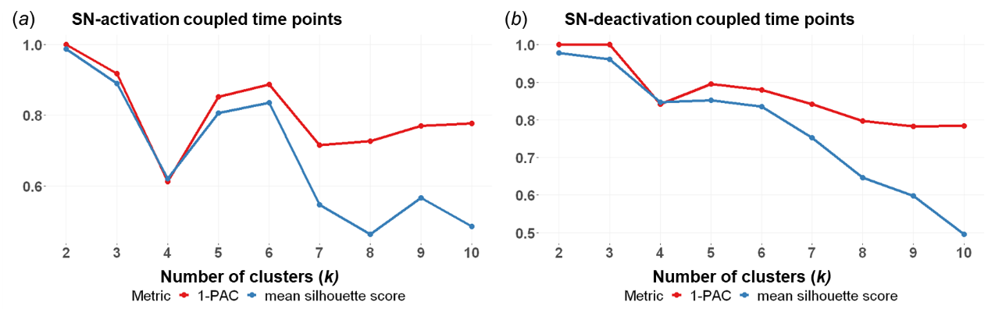
(a) Cluster validation for consensus clustering results of SN-activation coupled time points. (b) Cluster validation for consensus clustering results of SN-activation coupled time points. The X-axis represents the number of clusters. The Y-axis represents the value of metric 1-PAC and the mean silhouette score. To achieve clustering validity and stability as well as focus on dynamic variability, the results of 6 clusters were used in this study. Abbreviations: SN, substantia nigra; PAC, the proportion of ambiguously clustered pairs.

Fig. S2. Spatial similarity of SN-relevant CAPs 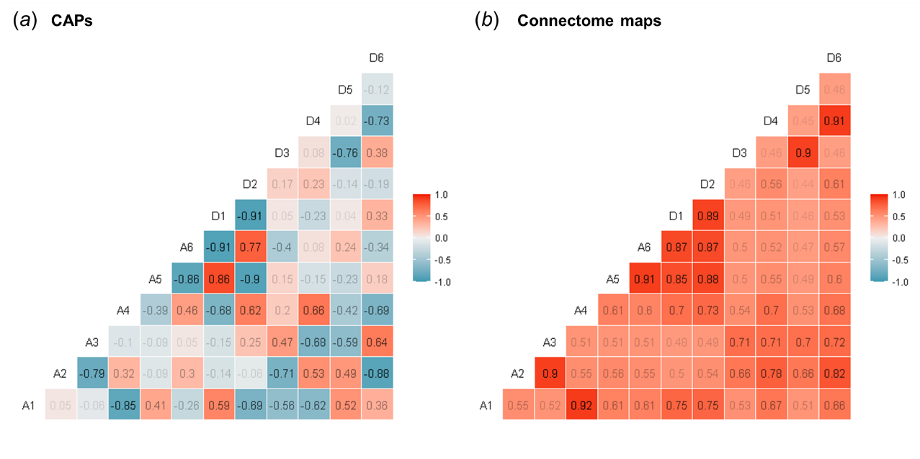
Spatial similarities among CAPs (a) and their corresponding connectome patterns (b) were measured using Spearman’s correlation coefficients. Abbreviations: SN, substantia nigra; CAP, coactivation pattern; Corr, Spearman’s correlation coefficient.

Fig. S3. Spatial comparison between FES and HCs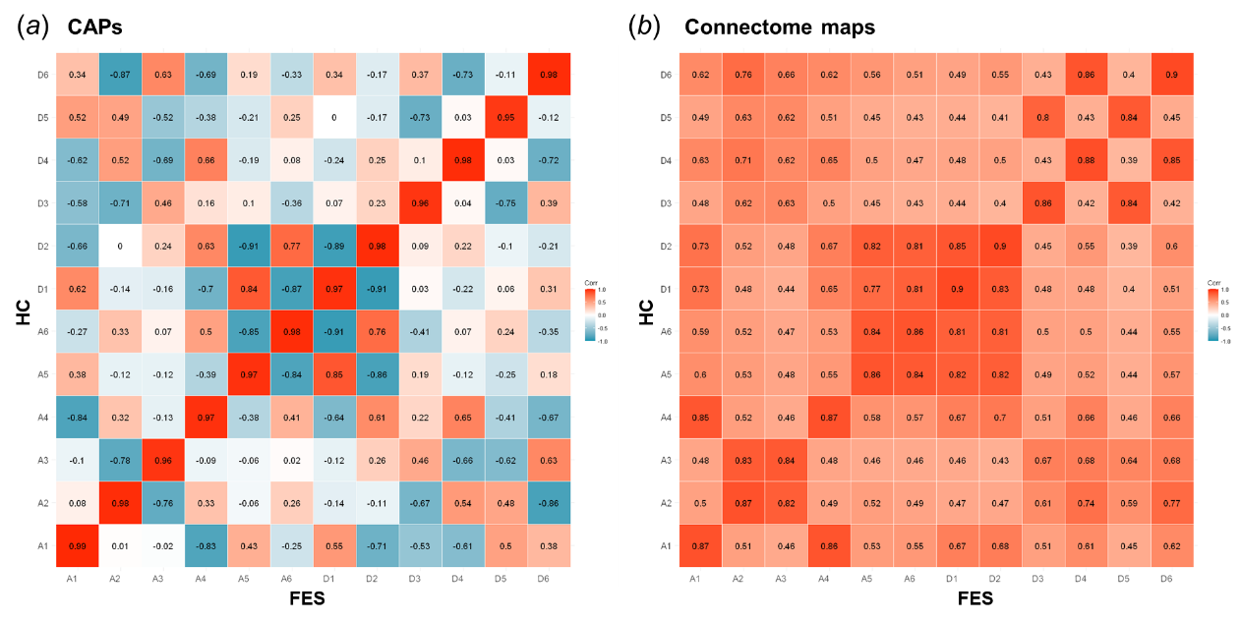
Spearman’s correlation coefficients among CAPs (a) and their corresponding connectome patterns (b) between the FES and HC groups. Abbreviations: FES, first-episode treatment-naïve patients with schizophrenia; HC, healthy control; CAP, coactivation pattern; Corr, Spearman’s correlation coefficient.

References
Annett, M. (1970). A classification of hand preference by association analysis. British Journal of Psychology, 61(3), 303-321. doi:10.1111/j.2044-8295.1970.tb01248.x
Annett, M. (2004). Hand preference observed in large healthy samples: classification, norms and interpretations of increased non-right-handedness by the right shift theory. British Journal of Psychology, 95(Pt 3), 339-353. doi:10.1348/0007126041528130
Ashburner, J. (2007). A fast diffeomorphic image registration algorithm. Neuroimage, 38(1), 95-113. doi:10.1016/j.neuroimage.2007.07.007
Bolton, T. A. W., Tuleasca, C., Wotruba, D., Rey, G., Dhanis, H., Gauthier, B., . . . Van De Ville, D. (2020). TbCAPs: A toolbox for co-activation pattern analysis. Neuroimage, 211, 116621. doi:10.1016/j.neuroimage.2020.116621
Chen, J. E., Chang, C., Greicius, M. D., & Glover, G. H. (2015). Introducing co-activation pattern metrics to quantify spontaneous brain network dynamics. Neuroimage, 111, 476-488. doi:10.1016/j.neuroimage.2015.01.057
Craddock, R. C., James, G. A., Holtzheimer, P. E., Hu, X. P., & Mayberg, H. S. (2012). A whole brain fMRI atlas generated via spatially constrained spectral clustering. Human Brain Mapping, 33(8), 1914-1928. doi:10.1002/hbm.21333
Desikan, R. S., Ségonne, F., Fischl, B., Quinn, B. T., Dickerson, B. C., Blacker, D., . . . Killiany, R. J. (2006). An automated labeling system for subdividing the human cerebral cortex on MRI scans into gyral based regions of interest. Neuroimage, 31(3), 968-980. doi:10.1016/j.neuroimage.2006.01.021
Friston, K. J., Williams, S., Howard, R., Frackowiak, R. S. J., & Turner, R. (1996). Movement‐Related effects in fMRI time‐series. Magnetic Resonance in Medicine, 35(3), 346-355. doi:10.1002/mrm.1910350312
Gu, Z., Schlesner, M., & Hübschmann, D. (2021). cola: an R/Bioconductor package for consensus partitioning through a general framework. Nucleic Acids Research, 49(3), e15-e15. doi:10.1093/nar/gkaa1146
Hornik, K., Feinerer, I., Kober, M., & Buchta, C. (2012). Spherical k-Means Clustering. Journal of Statistical Software, 50(10), 1 - 22. doi:10.18637/jss.v050.i10
Kaufman, L., & Rousseeuw, P. J. (1990). Finding Groups in Data. Hoboken, NJ: Wiley-Interscience.
Kong, R., Yang, Q., Gordon, E., Xue, A., Yan, X., Orban, C., . . . Yeo, B. T. T. (2021). Individual-Specific Areal-Level Parcellations Improve Functional Connectivity Prediction of Behavior. Cerebral Cortex, 31(10), 4477-4500. doi:10.1093/cercor/bhab101
Li, M., Dahmani, L., Wang, D., Ren, J., Stocklein, S., Lin, Y., . . . Liu, H. (2021). Co-activation patterns across multiple tasks reveal robust anti-correlated functional networks. Neuroimage, 227, 117680. doi:10.1016/j.neuroimage.2020.117680
Liu, X., & Duyn, J. H. (2013). Time-varying functional network information extracted from brief instances of spontaneous brain activity. Proceedings of the National Academy of Sciences, 110(11), 4392-4397. doi:10.1073/pnas.1216856110
Liu, X., Zhang, N., Chang, C., & Duyn, J. H. (2018). Co-activation patterns in resting-state fMRI signals. Neuroimage, 180(Pt B), 485-494. doi:10.1016/j.neuroimage.2018.01.041
Rousseeuw, P. J. (1987). Silhouettes: A graphical aid to the interpretation and validation of cluster analysis. Journal of Computational and Applied Mathematics, 20, 53-65. doi:10.1016/0377-0427(87)90125-7
Satterthwaite, T. D., Elliott, M. A., Gerraty, R. T., Ruparel, K., Loughead, J., Calkins, M. E., . . . Wolf, D. H. (2013). An improved framework for confound regression and filtering for control of motion artifact in the preprocessing of resting-state functional connectivity data. Neuroimage, 64, 240-256. doi:10.1016/j.neuroimage.2012.08.052
Schaefer, A., Kong, R., Gordon, E. M., Laumann, T. O., Zuo, X.-N., Holmes, A. J., . . . Yeo, B. T. T. (2018). Local-Global Parcellation of the Human Cerebral Cortex from Intrinsic Functional Connectivity MRI. Cerebral Cortex, 28(9), 3095-3114. doi:10.1093/cercor/bhx179
Șenbabaoğlu, Y., Michailidis, G., & Li, J. Z. (2014). Critical limitations of consensus clustering in class discovery. Scientific Reports, 4(1), 6207. doi:10.1038/srep06207
Yan, C.-G., Cheung, B., Kelly, C., Colcombe, S., Craddock, R. C., Di Martino, A., . . . Milham, M. P. (2013). A comprehensive assessment of regional variation in the impact of head micromovements on functional connectomics. Neuroimage, 76, 183-201. doi:10.1016/j.neuroimage.2013.03.004
Yan, C.-G., Wang, X.-D., Zuo, X.-N., & Zang, Y.-F. (2016). DPABI: Data Processing & Analysis for (Resting-State) Brain Imaging. Neuroinformatics, 14(3), 339-351. doi:10.1007/s12021-016-9299-4
Yan, C.-G., & Zang, Y.-F. (2010). DPARSF: a MATLAB toolbox for “pipeline” data analysis of resting-state fMRI. Frontiers in System Neuroscience, 4, 13. doi:10.3389/fnsys.2010.00013
Yang, H., Zhang, H., Di, X., Wang, S., Meng, C., Tian, L., & Biswal, B. (2021). Reproducible coactivation patterns of functional brain networks reveal the aberrant dynamic state transition in schizophrenia. Neuroimage, 237, 118193. doi:10.1016/j.neuroimage.2021.118193
Yeo, T. B. T., Krienen, F. M., Sepulcre, J., Sabuncu, M. R., Lashkari, D., Hollinshead, M., . . . Buckner, R. L. (2011). The organization of the human cerebral cortex estimated by intrinsic functional connectivity. Journal of Neurophysiology, 106(3), 1125-1165. doi:10.1152/jn.00338.2011

