Supplemental material
Table S1. Description of classes of upsetting events
Category | Event
Change in family environment | Separation from mother/ father, acquired new mother/ father, new bother/ sister, changed caretaker
Health issues/ adversity | Admitted to hospital, had shock/ fright, abused by someone, taken into care
Loss/ bereavement | Loss of family member/ best friend/ pet
Change in social environment | Started new school/ kinder garden, moved home

Table S2a. Fit model statistics for trajectories of emotional problems
SDQ-E model | Free Parameters | H0a | BIC(Sample Adj)a | Entropyb | Lo-Mendell-Rubin test§ | Bootstrapped likelihood ratio test§ | Smallest class size
1 CLASS – LINEAR | 9 | -91648.759 | 183,350.12 | NA | NA | NA | NA
2 CLASS – LINEAR | 12 | -85221.068 | 170,512.27 | 0.892 | 0 | 0 | 1640
3 CLASS – LINEAR | 15 | -83857.997 | 167,803.66 | 0.841 | 0 | 1 | 525
4 CLASS – LINEAR | 18 | -83230.555 | 166,566.31 | 0.837 | 0.0025 | 1 | 400
5 CLASS – LINEAR | 21 | 82771.933 | 165,666.60 | 0.813 | 0.1546 | 1 | 220
1 CLASS – QUADRATIC | 10 | -91646.152 | 183,350.75 | NA | NA | NA | NA
2 CLASS – QUADRATIC | 14 | -84982.609 | 170,047.04 | 0.894 | 0 | 0 | 1660
3 CLASS – QUADRATIC | 18 | -83507.931 | 167,121.06 | 0.844 | 0 | 1 | 560
4 CLASS – QUADRATIC | 22 | -82903.858 | 165,936.30 | 0.835 | 0.0212 | 1 | 461
5 CLASS - QUADRATIC | 26 | -82725.339 | 165,902.64 | 0.812 | 0.0012 | 1 | 242
1 CLASS – CUBIC | 11 | -91625.967 | 183,316.22 | NA | NA | NA | NA
2 CLASS – CUBIC | 16 | -84923.314 | 169,940.14 | 0.894 | 0 | 0 | 1668
3 CLASS – CUBIC | 21 | -83439.15 | 167,001.03 | 0.845 | 0 | 1 | 559
4 CLASS – CUBIC | 26 | -82654.545 | 165,461.05 | 0.844 | 0 | 1 | 469
5 CLASS - CUBIC | 31 | -82147.862 | 164,476.90 | 0.824 | 0 | 1 | 235
Notes: a lowest value indicates better fit; §indicates addition of this class significantly improves fit; b value closest to 1 indicates high certainty in classification

Although the bootstrapped likelihood ratio test suggests that the addition of a third or fourth class does not improve the model fit for the linear, quadratic or cubic models for the total subscale score (suggest a 2-class solution), the Lo-Mendell-Rubin test did indicate improvement in fit. We have decided that on the basis of the other model fit indices and what is known from the literature on the development of emotional problems, adding additional classes led to the characterisation of a more theory-informed model that can depict the variations of different symptom trajectories. The cubic model was selected over the linear and quadratic as it performed better in all the model fit indices.

Table S3. Mean SDQ-E item score by age
 | Somatic complaints | Worry | Low mood | Nervous/ clingy | Fears
Age 4 | 1.21 | 1.14 | 1.15 | 1.6 | 1.33
Age 7 | 1.33 | 1.29 | 1.17 | 1.43 | 1.27
Age 8 | 1.35 | 1.35 | 1.21 | 1.43 | 1.31
Age 9 | 1.42 | 1.29 | 1.17 | 1.35 | 1.24
Age 12 | 1.41 | 1.32 | 1.17 | 1.31 | 1.22
Age 13 | 1.48 | 1.34 | 1.2 | 1.34 | 1.25
Age 17 | 1.48 | 1.52 | 1.24 | 1.33 | 1.3

Figure S1a. Mean SDQ-E item score by age. Data show mean item score at each timepoint
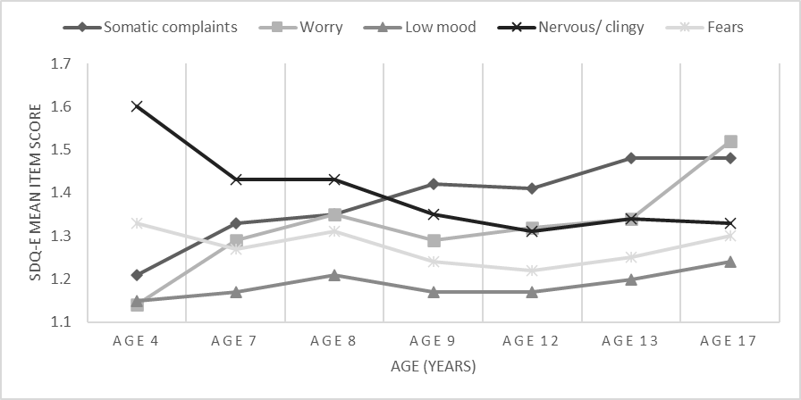
a Item scores range from 0 to 2

Figure S1b. Mean SDQ-E item score among males. Data show mean item score at each timepoint
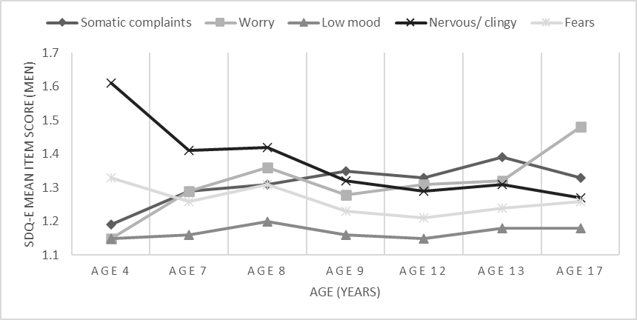
a Item scores range from 0 to 2

Figure S1c. Mean SDQ-E item score among females. Data show mean item score at each timepoint
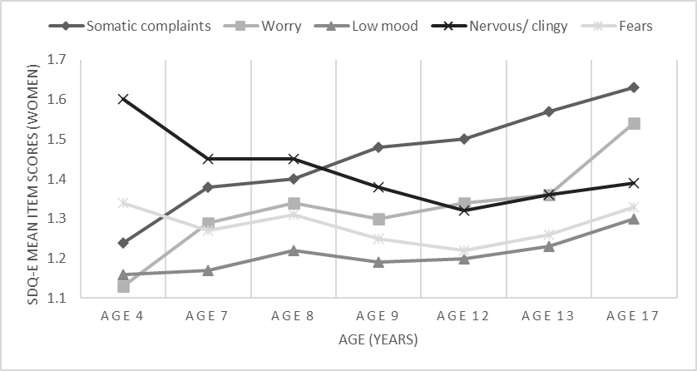
a Item scores range from 0 to 2

Table S4. Proportion of missing data in key factors in the cohort before the imputation
Child factors | % Missing
Female, % ª | 0%
Temperament intensity (6m), mean (s.d.)^{b} | 9.9%
Behavioural inhibition (3y), mean (s.d.)^{b} | 6.5%
Irritability (4y), % ª | 6.6%
Sleep problems (6y), % ª | 10.8%
High ADHD or ASD traits (7y), % ª | 12.6%
Conduct problems (7y), % ª | 10.9%
Low IQ (8y), % ª | 25.3%
Genetic risk
PGS (MDD), mean (s.d.)^{b} | 25.2%
PGS (anxiety), mean (s.d.)^{b} | 25.2%
PGS (ADHD), mean (s.d.)^{b} | 25.2%
Wider family factors
Maternal depression, % ª | 8.4%
Maternal anxiety, % ª | 8.7%
Adverse experiences (7y), % ª | 15.4%
Family poverty (11y), % ª | 28.7%
Emotional problem score
Age 4 | 8.2%
Age 7 | 12.9%
Age 8 | 15.9%
Age 9 | 14.2%
Age 12 | 21.9%
Age 13 | 21.8%
Age 17 | 36.5%
Mental health outcomes
MDD (CISR;24y) ª | 60.8%
GAD (CISR;24y) ª | 60.9%
Self-harm (24y) ª | 51.5%
Functional outcomes
Attainment | 64.6%
NEET (22y) ª | 62.5%
Social functioning (25y) ª | 59.3%
a Binary variable b standardised variable

Multiple imputation
In our imputation script for childhood correlates, we included the modal class assignment along with auxiliary data to make our missing at random assumption more tenable. These included birthweight, child ethnicity, mother age at birth, mother and partner education status, along with physical illness and financial difficulties in childhood.
Our cohort included those with at least two time-points of SDQ (one in childhood and one in adolescence). As our max missingness was ~ 40% among key early life correlates¹⁻² we chose to implement 40 imputations, which seems to be approximately correct for the levels of missingness of the data.²

Table S5a. Sociodemographic characteristics and classes of emotional problems in non-imputed sample. Data represent numbers (percentages) and mean (standard deviation).
 | Low emotional problems | Decreasing emotional problems | Increasing emotional problems | Persistent emotional problems
Child factors
Female, % ª | 2,586 (46.6) | 800 (52.5) | 462 (62.2) | 260 (55.4)
Temperament intensity (6m), mean (s.d.)^{b} | -.01 (1.01) | .04 (.99) | .04 (1.01) | .02 (1.02)
Behavioural inhibition (3y), mean (s.d.) ^{b} | -.12 (.95) | .34 (1.02) | -.01 (.98) | .45 (1.11)
Irritability (4y), % ª | 1,834 (35.3) | 741 (52.4) | 337 (48.8) | 296 (67.1)
Sleep problems (6y), % ª | 137 (2.8) | 103 (7.6) | 44 (6.6) | 76 (18.5)
High ADHD or ASD traits (7y), % ª | 204 (4.2) | 161 (12.2) | 78 (12.2) | 106 (26.5)
Conduct problems (7y), % ª | 845 (17.1) | 459 (34.0) | 237 (35.8) | 211 (51.1)
Low IQ (8y), % ª | 377 (9.1) | 128 (11.2) | 94 (16.8) | 65 (19.6)
Genetic risk
PGS (MDD), mean (s.d.)^{b} | -.08 (.99) | .02 (1.01) | .07 (.99) | .05 (1.05)
PGS (anxiety), mean (s.d.)^{b} | -.06 (1.00) | .02 (1.03) | .02 (1.00) | .07 (0.99)
PGS (ADHD), mean (s.d.)^{b} | -.06 (.99) | -.06 (1.01) | .01 (1.04) | .01 (1.08)
Wider family factors
Maternal depression (8m), % ª | 968 (18.8) | 397 (28.6) | 201 (29.8) | 177 (40.8)
Maternal anxiety (8m), % ª | 713 (14.0) | 327 (23.8) | 186 (27.5) | 134 (31.7)
Adverse experiences (7y), % ª | 418 (10.6) | 159 (14.3) | 80 (14.7) | 63 (19.9)
Family poverty (11y), % ª | 433 (9.2) | 175 (13.6) | 88 (14.0) | 72 (18.6)
a Binary variable b standardised variable
Table S5b. Univariable multinomial logistic regressions of the association of early life factors with trajectory classes of emotional problem in non-imputed dataset. Data show Relative Risk Ratios and 95% Confidence Intervals
 | Low emotional problems | Decreasing emotional problems | Increasing emotional problems | Persistent emotional problems
Child factors
Female^{1 a} | 1 (ref) | 1.27 (1.13-1.42) | 1.88 (1.61-2.21) | 1.43 (1.18-1.72)
Temperament intensity (6m)^{2 b} | 1 (ref) | 1.05 (0.99-1.12) | 1.05 (0.97-1.14) | 1.04 (0.94-1.15)
Behavioural inhibition (3y) ^{2 b} | 1 (ref) | 1.59 (1.50-1.69) | 1.12 (1.04-1.22) | 1.75 (1.59-1.93)
Irritability (4y)^{2 a} | 1 (ref) | 2.02 (1.79-2.27) | 1.75 (1.49-2.06) | 3.74 (3.05-4.61)
Sleep problems (6y)^{2 a} | 1 (ref) | 2.93 (2.25-3.81) | 2.56 (1.80-3.64) | 8.16 (6.03-11.05)
High ADHD or ASD traits (7y)^{2 a} | 1 (ref) | 3.38 (2.72-4.21) | 3.76 (2.84-4.98) | 9.30 (7.11-12.17)
Conduct problems (7y)^{2 a} | 1 (ref) | 2.55 (2.23-2.92) | 2.84 (2.38-3.38) | 5.27 (4.28-6.48)
Low IQ (8y)^{2 a} | 1 (ref) | 1.29 (1.04-1.60) | 2.11 (1.65-2.71) | 2.50 (1.87-3.35)
Genetic risk
PGS (MDD)^{2 b} | 1 (ref) | 1.04 (0.98-1.11) | 1.13 (1.04-1.24) | 1.18 (1.05-1.32)
PGS (anxiety)^{2 b} | 1 (ref) | 1.08 (1.01-1.16) | 1.08 (0.99-1.18) | 1.14 (1.02-1.28)
PGS (ADHD) ^{2 b} | 1 (ref) | 1.00 (0.93-2.06) | 1.07 (0.98-1.17) | 1.07 (0.96-1.20)
Wider family factors
Maternal depression (8m)^{2 a} | 1 (ref) | 1.75 (1.53-2.01) | 1.86 (1.56-2.23) | 3.01 (2.45-3.69)
Maternal anxiety (8m)^{2 a} | 1 (ref) | 1.92 (1.66-2.23) | 2.36 (1.96-2.85) | 2.87 (2.31-3.58)
Adverse experiences (7y)^{2 a} | 1 (ref) | 1.54 (1.28-1.86) | 1.60 (1.25-2.05) | 2.24 (1.70-2.95)
Family poverty (11y)^{2 a} | 1 (ref) | 1.40 (1.15-1.70) | 1.45 (1.12-1.87) | 2.09 (1.56-2.81)
¹ :Unadjusted, ² :Adjusted for sex, a Binary variable, b standardised variable
Table S5c. Univariable logistic regressions of differences in the association of early life factors between the decreasing and persistent trajectory classes of emotional problems. Data show Relative Risk Ratios and 95% Confidence Intervals
 | Decreasing emotional problems | Persistent emotional problems
Child factors
Female^{1 a} | 1 (ref) | 1.13 (0.91-2.39)
Temperament intensity (6m)^{2 b} | 1 (ref) | 0.99 (0.88-1.10)
Behavioural inhibition (3y) ^{2 b} | 1 (ref) | 1.10 (0.99-1.21)
Irritability (4y)^{2 a} | 1 (ref) | 1.86 (1.49-2.32)
Sleep problems (6y)^{2 a} | 1 (ref) | 2.60 (1.90-3.58)
High ADHD or ASD traits (7y)^{2 a} | 1 (ref) | 2.23 (1.64-3.09)
Conduct problems (7y)^{2 a} | 1 (ref) | 2.03 (1.63-2.55)
Low IQ (8y)^{2 a} | 1 (ref) | 1.51 (0.98-2.33)
Genetic risk
PGS (MDD)^{2 b} | 1 (ref) | 1.00 (0.88-1.12)
PGS (anxiety)^{2 b} | 1 (ref) | 1.04 (0.92-1.17)
PGS (ADHD) ^{2 b} | 1 (ref) | 1.07 (0.95-1.22)
Wider family factors
Maternal depression (8m)^{2 a} | 1 (ref) | 1.72 (1.37-2.16)
Maternal anxiety (8m)^{2 a} | 1 (ref) | 1.52 (1.20-1.93)
Adverse experiences (7y)^{2 a} | 1 (ref) | 1.46 (1.09-1.97)
Family poverty (11y)^{2 a} | 1 (ref) | 1.39 (0.96-1.99)
a Binary variable, b standardised variable
Table S6. Mental health and functional outcomes stratified by emotional problems trajectory class, imputed sample
 | Low emotional problems | Decreasing emotional problems | Increasing emotional problems | Persistent emotional problems
Mental health outcomes
MDD (CISR;24y) ^{1 a} | 9.2 | 9.9 | 15.0 | 19.4
GAD (CISR;24y) ^{1 a} | 7.8 | 10.6 | 14.4 | 18.2
Self-harm (24y)^{1 a} | 7.4 | 9.7 | 17.8 | 13.9
Functional outcomes
Attainment (no GCSEs) ¹ | 2.5 | 4.1 | 8.5 | 7.1
NEET (22y)^{1 a} | 1.2 | 1.7 | 1.9 | 3.2
Social functioning (25)^{1 a} | 7.0 | 7.4 | 10.4 | 11.4
¹ :Adjusted for sex, a Binary variable

Table S7. Fit model statistics for trajectories of emotional problems for those with data three points with at one timepoint in childhood and one timepoint in adolescence
SDQ-E model | Free Parameters | H0a | BIC(Sample Adj)a | Entropyb | Lo-Mendell-Rubin test§ | Bootstrapped likelihood ratio test§ | Smallest class size
1 CLASS – LINEAR | 9 | -91371.749 | 182,796.03 | NA | NA | NA | NA
2 CLASS – LINEAR | 12 | -84957.908 | 169,985.85 | 0.893 | 0 | 0 | 1630
3 CLASS – LINEAR | 15 | -83600.335 | 167,288.22 | 0.841 | 0 | 1 | 523
4 CLASS – LINEAR | 18 | -82975.569 | 166,056.20 | 0.838 | 0.0027 | 1 | 398
5 CLASS – LINEAR | 21 | -82516.565 | 165,155.70 | 0.815 | 0.1528 | 1 | 213
1 CLASS – QUADRATIC | 10 | -91369.278 | 182,796.92 | NA | NA | NA | NA
2 CLASS – QUADRATIC | 14 | -84720.495 | 169,522.70 | 0.895 | 0 | 0 | 1,648
3 CLASS – QUADRATIC | 18 | -83252.148 | 166,609.35 | 0.845 | 0 | 1 | 556
4 CLASS – QUADRATIC | 22 | -82650.678 | 165,429.76 | 0.836 | 0.0212 | 1 | 455
1 CLASS – CUBIC | 11 | -91349.448 | 182,763.10 | NA | NA | NA | NA
2 CLASS – CUBIC | 16 | -84661.931 | 169,417.25 | 0.897 | 0 | 0 | 1,654
3 CLASS – CUBIC | 21 | -83184.092 | 166,490.75 | 0.845 | 0 | 1 | 558
4 CLASS – CUBIC | 26 | -82401.669 | 164,455.09 | 0.845 | 0 | 1 | 464
Notes: a lowest value indicates better fit; §indicates addition of this class significantly improves fit; b value closest to 1 indicates high certainty in classification

As with our chosen model, the 4-class cubic appeared to be the best model fit, so we plotted it below.

Figure S2. Cubic 4-class trajectory of emotional problems (4-17 years) in those with data ≥3 timepoints

a SDQ-E clinical cut-off point ≥5

Table S8. Fit model statistics for trajectories of emotional problems by sex
Male
SDQ-E model | Free Parameters | H0a | BIC(Sample Adj)a | Entropyb | Lo-Mendell-Rubin test§ | Bootstrapped likelihood ratio test§ | Smallest class size
1 CLASS – LINEAR | 9 | -45110.094 | 90266.629 | NA | NA | NA | NA
2 CLASS – LINEAR | 12 | -41910.118 | 83882.157 | 0.904 | 0 | 0 | 749
3 CLASS – LINEAR | 15 | -41229.114 | 82535.627 | 0.85 | 0 | 1 | 272
4 CLASS – LINEAR | 18 | -40880.743 | 81854.366 | 0.853 | 0.128 | 1 | 194
1 CLASS - QUADRATIC | 10 | -45100.27 | 90252.139 | NA | NA | NA | NA
2 CLASS - QUADRATIC | 14 | -41709.125 | 83490.489 | 0.908 | 0 | 0 | 776
3 CLASS - QUADRATIC | 18 | -40971.446 | 82035.772 | 0.864 | 0.005 | 1 | 259
4 CLASS - QUADRATIC | 22 | -40625.834 | 81365.189 | 0.858 | 0.005 | 1 | 222
1 CLASS – CUBIC | 11 | -45094.005 | 90244.77 | NA | NA | NA | NA
2 CLASS – CUBIC | 16 | -41685.057 | 83,452.67 | 0.909 | 0 | 0 | 773
3 CLASS – CUBIC | 21 | -40944.398 | 81,997.16 | 0.864 | 0.218 | 1 | 254
4 CLASS – CUBIC | 26 | -40536.345 | 81,206.85 | 0.861 | 0.022 | 1 | 216
Female
SDQ-E model | Free Parameters | H0a | BIC(Sample Adj)a | Entropyb | Lo-Mendell-Rubin test§ | Bootstrapped likelihood ratio test§ | Smallest class size
1 CLASS – LINEAR | 9 | -46204.746 | 92,455.78 | NA | NA | NA | NA
2 CLASS – LINEAR | 12 | -43060.524 | 86,182.77 | 0.877 | 0 | 0 | 883
3 CLASS – LINEAR | 15 | -42391.227 | 84,859.60 | 0.822 | 0 | 1 | 284
4 CLASS – LINEAR | 18 | -42092.481 | 84,277.54 | 0.821 | 0.007 | 1 | 217
1 CLASS - QUADRATIC | 10 | -46204.601 | 92,460.63 | NA | NA | NA | NA
2 CLASS - QUADRATIC | 14 | -42973.609 | 86,019.22 | 0.88 | 0 | 0 | 873
3 CLASS - QUADRATIC | 18 | -42251.985 | 84,596.55 | 0.822 | 0 | 1 | 306
4 CLASS - QUADRATIC | 22 | -41955.931 | 84,025.01 | 0.822 | 0.004 | 1 | 244
1 CLASS – CUBIC | 11 | -46190.819 | 92,438.21 | NA | NA | NA | NA
2 CLASS – CUBIC | 16 | -42939.73 | 85,961.75 | 0.88 | 0 | 0 | 885
3 CLASS – CUBIC | 21 | -42210.931 | 84,529.87 | 0.823 | 0 | 1 | 308
4 CLASS – CUBIC | 26 | -41837.793 | 83,809.31 | 0.824 | 0.0001 | 1 | 256
Notes: a lowest value indicates better fit; §indicates addition of this class significantly improves fit; b value closest to 1 indicates high certainty in classification

Across both sexes, it appears that the 4-class cubic model is the best fit model. So, we plotted the 4-class cubic model for male and female separately.

Among men, there is a class with low emotional problems (69.7%), one with increasing levels of emotional problems (7.5%), one with decreasing levels of emotional problems (17.6%) and one with persistent high levels of emotional problems throughout childhood/adolescence (5.2%).

Figure S3a. Cubic 4-class trajectory of emotional problems from 4-17 years in male
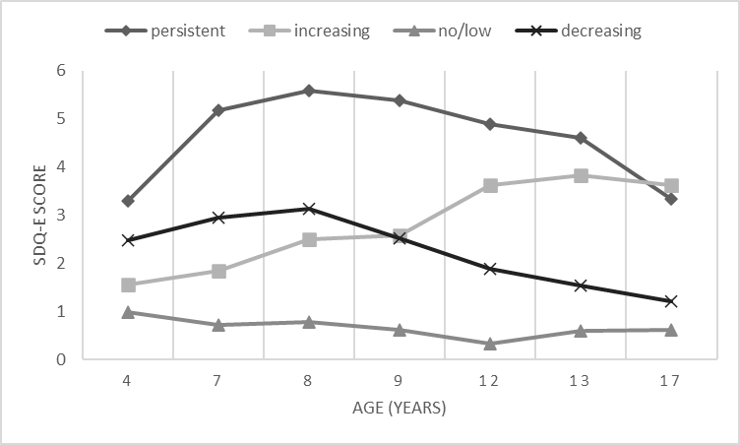
a SDQ-E clinical cut-off point ≥5

Among women, there is a class with low emotional problems (63.9%), one with increasing levels of emotional problems (10.4%), one with decreasing levels of emotional problems (19.5%) and one with persistent high levels of emotional problems throughout childhood/adolescence (6.2%).

Figure S3b. Cubic 4-class trajectory of emotional problems from 4-17 years in female
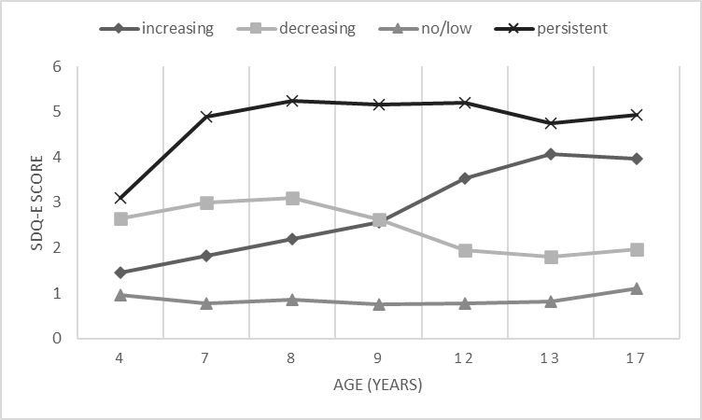
a SDQ-E clinical cut-off point ≥5

Table S9. Fit model statistics for anxiety trajectories
BINARY MODEL | Free Parameters | H0a | BIC(Sample Adj)a | Entropyb | Lo-Mendell-Rubin test§ | Bootstrapped likelihood ratio test§ | Smallest class size
1 CLASS – LINEAR | 3 | -31624.777 | 63267.087 | NA | NA | NA | NA
2 CLASS – LINEAR | 6 | -28712.422 | 57459.907 | 0.719 | 0 | 0 | 2,444
3 CLASS – LINEAR | 9 | -28516.072 | 57084.739 | 0.581 | 0 | 0 | 997
4 CLASS – LINEAR | 12 | -28460.311 | 56990.749 | 0.611 | 0.226 | 0 | 248
5 CLASS – LINEAR | 15 | -28412.379 | 56912.416 | 0.633 | 0.046 | 0 | 149
1 CLASS – QUADRATIC | 4 | -31542.525 | 63108.425 | NA | NA | NA | NA
2 CLASS – QUADRATIC | 8 | -28520.041 | 57086.832 | 0.729 | 0 | 0 | 2,404
3 CLASS – QUADRATIC | 12 | -28303.902 | 56677.931 | 0.682 | 0 | 0 | 643
4 CLASS – QUADRATIC | 16 | -28121.099 | 56335.701 | 0.589 | 0 | 0 | 894
1 CLASS – CUBIC | 5 | -31376.009 | 62781.238 | NA | NA | NA | NA
2 CLASS – CUBIC | 10 | -28329.201 | 56716.841 | 0.731 | 0 | 0 | 2,396
3 CLASS – CUBIC | 15 | -28112.220 | 56312.098 | 0.617 | 0 | 0 | 835
4 CLASS – CUBIC | 20 | -27978.877 | 56074.633 | 0.617 | 0 | 0 | 759

Notes: a lowest value indicates better fit; §indicates addition of this class significantly improves fit; b value closest to 1 indicates high certainty in classification

Figure S4. Cubic 4-class anxiety trajectory memberships from 4-17 years
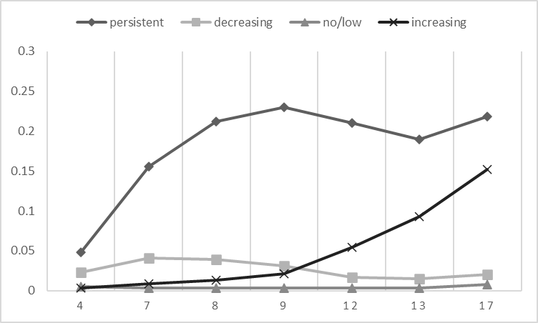
The best solution was the 4-class cubic model which is very similar with the 4-class model for the emotional trajectories suggesting the presence of low worry, high in childhood and stable low in adolescence, adolescence increasing and persistent high worry. It performed better in terms of best model fit criteria including log likelihood, sample size adjusted BIC and had similar entropy indicating a better model fit.

Table S10a. Univariable multinomial logistic regressions of the association of early life factors with anxiety trajectory classes. Data show Relative Risk Ratios and 95% Confidence Intervals
 | Low worry | Decreasing worry | Increasing worry | Persistent worry
Child factors
Female^{1 a} | 1 (ref) | 0.93 (0.83-1.03) | 1.72 (1.47-2.01) | 1.15 (1.00-1.33)
Temperament intensity (6m)^{2 b} | 1 (ref) | 1.08 (1.02-1.15) | 1.08 (1.00-1.17) | 1.14 (1.06-1.23)
Behavioural inhibition (3y) ^{2 b} | 1 (ref) | 1.17 (1.11-1.24) | 0.98 (0.91-1.06) | 1.32 (1.23-1.42)
Irritability (4y)^{2 a} | 1 (ref) | 1.60 (1.43-1.80) | 1.67 (1.42-1.96) | 2.53 (2.17-2.94)
Sleep problems (6y)^{2 a} | 1 (ref) | 2.32 (1.78-3.04) | 2.13 (1.48-3.08) | 4.70 (3.55-6.21)
High ADHD or ASD traits (7y)^{2 a} | 1 (ref) | 2.46 (1.97-3.07) | 2.69 (2.00-3.63) | 5.48 (4.32-6.93)
Conduct problems (7y)^{2 a} | 1 (ref) | 1.73 (1.52-1.99) | 1.88 (1.56-2.26) | 3.22 (2.74-3.79)
Low IQ (8y)^{2 a} | 1 (ref) | 1.04 (0.84-1.28) | 1.54 (1.19-2.00) | 1.25 (0.96-1.61)
Genetic risk
PGS (MDD)^{2 b} | 1 (ref) | 0.96 (0.90-1.02) | 0.97 (0.89-1.06) | 1.23 (1.13-1.34)
PGS (anxiety)^{2 b} | 1 (ref) | 1.09 (1.02-1.16) | 1.05 (0.96-1.14) | 1.16 (1.07-1.27)
PGS (ADHD) ^{2 b} | 1 (ref) | 1.00 (0.93-1.06) | 1.01 (0.92-1.10) | 1.01 (0.93-1.10)
Wider family factors
Maternal depression^{2 a} | 1 (ref) | 1.51 (1.32-1.73) | 1.53 (1.27-1.84) | 2.26 (1.92-2.66)
Maternal anxiety^{2 a} | 1 (ref) | 1.41 (1.21-1.64) | 1.85 (1.52-2.24) | 2.56 (2.15-3.04)
Adverse experiences (7y)^{2 a} | 1 (ref) | 1.44 (1.20-1.74) | 1.22 (0.94-1.59) | 2.02 (1.62-2.52)
Family poverty (11y)^{2 a} | 1 (ref) | 1.11 (0.91-1.36) | 1.16 (0.89-1.52) | 1.49 (1.18-1.89)
¹ :Unadjusted, ² :Adjusted for sex, a Binary variable, b standardised variable

Table S10b. Univariable multinomial logistic regressions of adult functional and mental health outcomes across anxiety trajectory classes. Data show Relative Risk Ratios and 95% Confidence Intervals
 | Low worry | Decreasing worry | Increasing worry | Persistent worry
Mental health outcomes
MDD (CISR;24y) ^{1 a} | 1 (ref) | 1.31 (0.98-1.76) | 2.01 (1.45-2.79) | 1.92 (1.14-2.70)
GAD (CISR;24y) ^{1 a} | 1 (ref) | 1.23 (0.90-1.68) | 1.97 (1.40-2.77) | 2.09 (1.48-2.96)
Self-harm (24y)^{1 a} | 1 (ref) | 1.19 (0.97-1.59) | 2.41 (1.93-3.01) | 2.45 (1.97-3.04)
Functional outcomes | 1 (ref)
Attainment (no GCSEs) ¹ | 1 (ref) | 0.93 (0.74-1.15) | 1.23 (0.93-1.63) | 1.01 (0.76-1.33)
NEET (22y)^{1 a} | 1 (ref) | 1.07 (0.95-1.21) | 1.07 (0.91-1.27) | 1.02 (0.87-1.19)
Social functioning (25)^{1 a} | 1 (ref) | 1.20 (0.86-1.66) | 1.34 (0.89-2.02) | 1.93 (1.33-2.80)
¹ :Adjusted for sex, a Binary variable

1. Bodner, T. E. 2008. “What Improves with Increased Missing Data Imputations?” Structural Equation Modeling 15 (4): 651–75. and
2. Graham, J. W., A. E. Olchowski, and T. D. Gilreath. 2007. “How Many Imputations Are Really Needed? Some Practical Clarifications of Multiple Imputation Theory.” Preventive Science 8 (3): 206–13.

