Online Supplement to:
Thielecke, J., Kuper, P., Lehr, D., Schuurmans, L., Harrer, M., Ebert, D. D., Behrendt, D., Brückner, H., Horvath, H., Riper, H., Cuijpers, P., & Buntrock, C. (in preparation). Who benefits from indirect prevention and treatment of depression using an online intervention for insomnia? Results from an individual-participant data meta-analysis

Content:
Supplement 1: PRISMA- IPD Checklist
Supplement 2: Methodological Changes to the preregistration
Supplement 3: Imputation models
Supplement 4: Participants’ characteristics
Supplement 5: Sensitivity analysis (complete cases)
Supplement 6: Sensitivity analysis (without CES-D sleep item)
Supplement 7: Results from the univariate moderation analysis
Supplement 8: Results from random-forest-analysis (variable importance)

Supplement 1: PRISMA-IPD Checklist of items to include when reporting a systematic review and meta-analysis of individual participant data (IPD)
PRISMA-IPD  Section/topic | Item No | Checklist item | Reported on page
Title
Title | 1 | Identify the report as a systematic review and meta-analysis of individual participant data. | p. 1
Abstract
Structured summary | 2 | Provide a structured summary including as applicable: | p. 4
 |  | Background: state research question and main objectives, with information on participants, interventions, comparators and outcomes.
 |  | Methods: report eligibility criteria; data sources including dates of last bibliographic search or elicitation, noting that IPD were sought; methods of assessing risk of bias.
 |  | Results: provide number and type of studies and participants identified and number (%) obtained; summary effect estimates for main outcomes (benefits and harms) with confidence intervals and measures of statistical heterogeneity. Describe the direction and size of summary effects in terms meaningful to those who would put findings into practice.
 |  | Discussion: state main strengths and limitations of the evidence, general interpretation of the results and any important implications.
 |  | Other: report primary funding source, registration number and registry name for the systematic review and IPD meta-analysis.
Introduction
Rationale | 3 | Describe the rationale for the review in the context of what is already known. | p. 5-6
Objectives | 4 | Provide an explicit statement of the questions being addressed with reference, as applicable, to participants, interventions, comparisons, outcomes and study design (PICOS). Include any hypotheses that relate to particular types of participant-level subgroups. | p. 6
Methods
Protocol and registration | 5 | Indicate if a protocol exists and where it can be accessed. If available, provide registration information including registration number and registry name. Provide publication details, if applicable. | p. 7
Eligibility criteria | 6 | Specify inclusion and exclusion criteria including those relating to participants, interventions, comparisons, outcomes, study design and characteristics (e.g. years when conducted, required minimum follow-up). Note whether these were applied at the study or individual level i.e. whether eligible participants were included (and ineligible participants excluded) from a study that included a wider population than specified by the review inclusion criteria. The rationale for criteria should be stated. | p. 7
Identifying studies - information sources | 7 | Describe all methods of identifying published and unpublished studies including, as applicable: which bibliographic databases were searched with dates of coverage; details of any hand searching including of conference proceedings; use of study registers and agency or company databases; contact with the original research team and experts in the field; open adverts and surveys. Give the date of last search or elicitation. | p. 7
Identifying studies - search | 8 | Present the full electronic search strategy for at least one database, including any limits used, such that it could be repeated. | Not applicable
Study selection processes | 9 | State the process for determining which studies were eligible for inclusion.
Data collection processes | 10 | Describe how IPD were requested, collected and managed, including any processes for querying and confirming data with investigators. If IPD were not sought from any eligible study, the reason for this should be stated (for each such study). | p. 10-11
 |  | If applicable, describe how any studies for which IPD were not available were dealt with. This should include whether, how and what aggregate data were sought or extracted from study reports and publications (such as extracting data independently in duplicate) and any processes for obtaining and confirming these data with investigators.
Data items | 11 | Describe how the information and variables to be collected were chosen. List and define all study level and participant level data that were sought, including baseline and follow-up information. If applicable, describe methods of standardising or translating variables within the IPD datasets to ensure common scales or measurements across studies. | p. 7-8
IPD integrity | A1 | Describe what aspects of IPD were subject to data checking (such as sequence generation, data consistency and completeness, baseline imbalance) and how this was done. | p.11
Risk of bias assessment in individual studies. | 12 | Describe methods used to assess risk of bias in the individual studies and whether this was applied separately for each outcome. If applicable, describe how findings of IPD checking were used to inform the assessment. Report if and how risk of bias assessment was used in any data synthesis. | p. 7
Specification of outcomes and effect measures | 13 | State all treatment comparisons of interests. State all outcomes addressed and define them in detail. State whether they were pre-specified for the review and, if applicable, whether they were primary/main or secondary/additional outcomes. Give the principal measures of effect (such as risk ratio, hazard ratio, difference in means) used for each outcome. | p. 7-8
Synthesis methods | 14 | Describe the meta-analysis methods used to synthesise IPD. Specify any statistical methods and models used. Issues should include (but are not restricted to):  - Use of a one-stage or two-stage approach.  - How effect estimates were generated separately within each study and combined across studies (where applicable).  - Specification of one-stage models (where applicable) including how clustering of patients within studies was accounted for.  - Use of fixed or random effects models and any other model assumptions, such as proportional hazards.  - How (summary) survival curves were generated (where applicable).  - Methods for quantifying statistical heterogeneity (such as I² and τ²).  - How studies providing IPD and not providing IPD were analysed together (where applicable).  - How missing data within the IPD were dealt with (where applicable). | p. 8-10
Exploration of variation in effects | A2 | If applicable, describe any methods used to explore variation in effects by study or participant level characteristics (such as estimation of interactions between effect and covariates). State all participant-level characteristics that were analysed as potential effect modifiers, and whether these were pre-specified. | p. 9-10
Risk of bias across studies | 15 | Specify any assessment of risk of bias relating to the accumulated body of evidence, including any pertaining to not obtaining IPD for particular studies, outcomes or other variables.
Additional analyses | 16 | Describe methods of any additional analyses, including sensitivity analyses. State which of these were pre-specified. | p. 10
Results
Study selection and IPD obtained | 17 | Give numbers of studies screened, assessed for eligibility, and included in the systematic review with reasons for exclusions at each stage. Indicate the number of studies and participants for which IPD were sought and for which IPD were obtained. For those studies where IPD were not available, give the numbers of studies and participants for which aggregate data were available. Report reasons for non-availability of IPD. Include a flow diagram. | p. 10-11
Study characteristics | 18 | For each study, present information on key study and participant characteristics (such as description of interventions, numbers of participants, demographic data, unavailability of outcomes, funding source, and if applicable duration of follow-up). Provide (main) citations for each study. Where applicable, also report similar study characteristics for any studies not providing IPD. | Table 1
IPD integrity | A3 | Report any important issues identified in checking IPD or state that there were none. | p. 11
Risk of bias within studies | 19 | Present data on risk of bias assessments. If applicable, describe whether data checking led to the up-weighting or down-weighting of these assessments. Consider how any potential bias impacts on the robustness of meta-analysis conclusions. | Table 1, p. 11
Results of individual studies | 20 | For each comparison and for each main outcome (benefit or harm), for each individual study report the number of eligible participants for which data were obtained and show simple summary data for each intervention group (including, where applicable, the number of events), effect estimates and confidence intervals. These may be tabulated or included on a forest plot. | Figure 2
Results of syntheses | 21 | Present summary effects for each meta-analysis undertaken, including confidence intervals and measures of statistical heterogeneity. State whether the analysis was pre-specified, and report the numbers of studies and participants and, where applicable, the number of events on which it is based. | Figure 2  Supplement 7 & 8,  Figure 3  p. 19
 |  | When exploring variation in effects due to patient or study characteristics, present summary interaction estimates for each characteristic examined, including confidence intervals and measures of statistical heterogeneity. State whether the analysis was pre-specified. State whether any interaction is consistent across trials.
 |  | Provide a description of the direction and size of effect in terms meaningful to those who would put findings into practice.
Risk of bias across studies | 22 | Present results of any assessment of risk of bias relating to the accumulated body of evidence, including any pertaining to the availability and representativeness of available studies, outcomes or other variables. | p. 22
Additional analyses | 23 | Give results of any additional analyses (e.g. sensitivity analyses). If applicable, this should also include any analyses that incorporate aggregate data for studies that do not have IPD. If applicable, summarise the main meta-analysis results following the inclusion or exclusion of studies for which IPD were not available. | 11
Discussion
Summary of evidence | 24 | Summarise the main findings, including the strength of evidence for each main outcome. | 19
Strengths and limitations | 25 | Discuss any important strengths and limitations of the evidence including the benefits of access to IPD and any limitations arising from IPD that were not available. | 22
Conclusions | 26 | Provide a general interpretation of the findings in the context of other evidence. | 23
Implications | A4 | Consider relevance to key groups (such as policy makers, service providers and service users). Consider implications for future research. | 20-21
Funding
Funding | 27 | Describe sources of funding and other support (such as supply of IPD), and the role in the systematic review of those providing such support. | 1

A1 – A3 denote new items that are additional to standard PRISMA items. A4 has been created as a result of re-arranging content of the standard PRISMA statement to suit the way that systematic review IPD meta-analyses are reported.
© Reproduced with permission of the PRISMA IPD Group, which encourages sharing and reuse for non-commercial purposes

Supplement 2: Methodological Changes to the preregistration
Table 1
Methodological Changes to the preregistration, the rational for the changes and the expected consequences
Change | Rational & Consequence
Exclusion of two additional studies, originally promising their IPD | The preregistration was written with the studies in mind that promised their IPD at time of writing. Unfortunately, no formal data sharing agreement could be reached for two of the studies which let to their exclusion. However, the excluded studies by Spanhel et al (2021, 2022) would have contributed a lot to the heterogeneity between studies, given that the interventions had crucial adaptations in content, duration and language due to the different target groups (international students and refugees). Due to the low number of participants in these pilot trials we deemed a combined approach of IPD and aggregated data not sensible. This led to two major changes in the methodology:  - We excluded level two (study level) variables as potential moderators, because the remaining studies were too similar in their characteristics, which limits our results to a work-focused online CBT-I intervention.  - We reconsidered the potential variables to seek from the original study authors, because the sample now consisted of solely working participants, which had not been studied as an individual group before. The addition of engagement and effort-reward-ration as potential moderators allows us better consider differential effects of the intervention in the working population. Ethnicity and employment were excluded as potential moderators due to a lack of variance.
Use of CES-D scores instead of common metrics as the main outcome | Because all included studies assessed the CES-D there was no need to harmonize the outcome by using common metrics. We decided to stay with the original measure in order to not introduce unnecessary insecurity through the score transformation and remain an easier interpretation of the results.
Separate imputation models for post- and follow-up assessment | In the preregistration we did not consider that one of the potential studies had no follow-up assessment in the control group, making it impossible to estimate a treatment effect. Therefore, that study was excluded form the follow-up analysis. In order to avoid imputation of data for the not-assessed follow-up data, separate imputation models had to be built for the two time points including only the studies which assessed the time point.  Consequently, analysis at post-treatment were done with the full sample of N= 563 from four studies and analysis at follow-up included N=433 individuals from three studies.

Table 1 (continued)
Methodological Changes to the preregistration, the rational for the changes and the expected consequences
Change | Rational & Consequence
Imputation method changed from 2l.pan to 2l.pmm | We inspected our imputed data using stripplots, densityplots and traceplots following the diagnostic procedure described by van Buren (2018). Using 2l.pan as the imputation method the densityplots showed that density estimates for the marginal distributions imputed data did not fit the observed data very well. Switching the imputation model to 2l.pmm increased the fit while still accounting for the data being nested within studies.
Additional sensitivity analysis without the sleep item in CES-D | Inspired by studies we read in preparation of the manuscript, we decided to run an additional sensitivity analysis in which we excluded the sleep-item from the CES-D total to confirm the robustness of our results and conclude that changes in depression symptom severity does not solely derive from changes in the sleep item.
R² reported | We did not pre-specify to report R² but thought it was helpful to interpret the overall model fit, so we included that information in addition to the pre-specified effect estimates and model parameters.
Note to research question 3 | Research question 3 (mechanisms and mediators of the treatment approach) was planned as a separate analysis from the beginning with a Bayesian methodology and thus was considered beyond the scope of this article.

Supplement 3: Imputation models
Figure 1
Predictor matrix of the imputation model for post-treatment data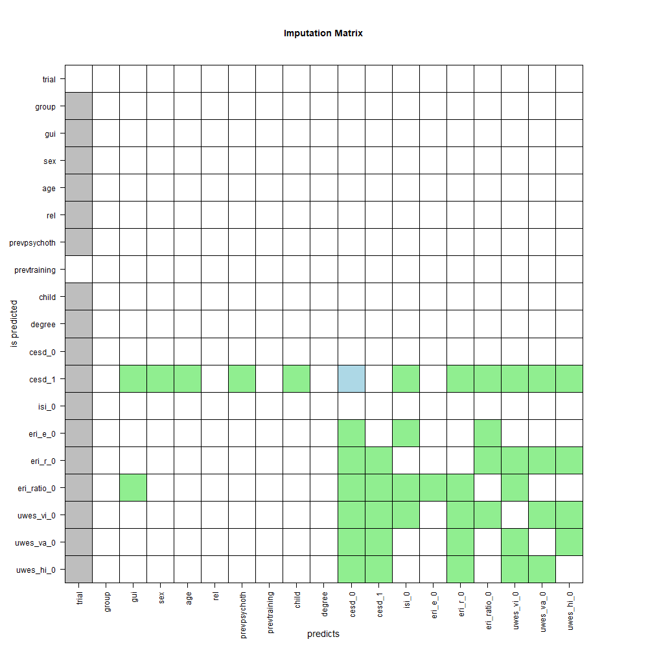
Note. Variables were not used as predictors if their correlation with the imputed variables was lower than r = 0.05.

Figure 2
Predictor matrix of the imputation model for follow-up data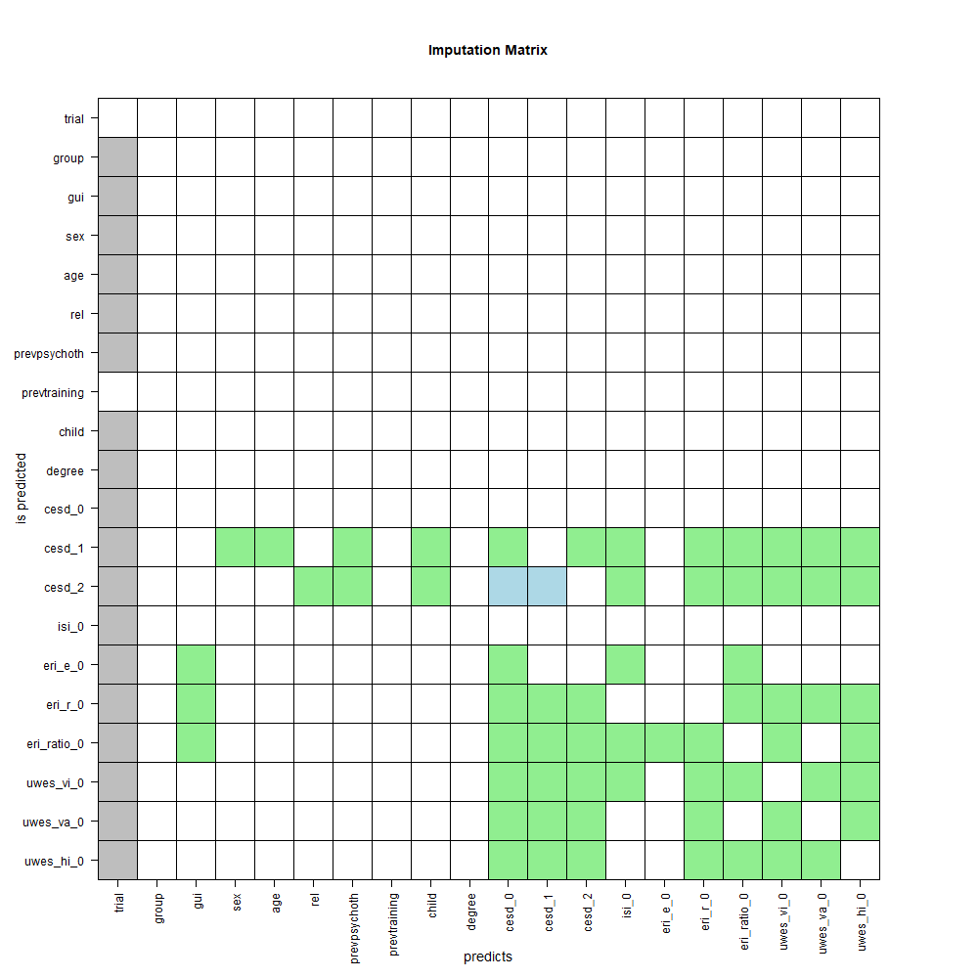
Note. Variables were not used as predictors if their correlation with the imputed variables was lower than r = 0.05.

Supplement 4: Participants’ characteristics
Table 2
Baseline descriptive of sociodemographic, clinical and work-related characteristics
variable | total (N=561) |  |  | intervention (N=280) |  |  | control (N=281)
 | n | % |  | n | % |  | n | %
sociodemographic variables
age (M, SD) | 47.15 | 9.73 |  | 47.82 | 9.52 |  | 46.47 | 9.91
sex
female | 381 | 67.91 |  | 186 | 66.43 |  | 195 | 69.4
male | 179 | 31.91 |  | 94 | 33.57 |  | 85 | 30.25
relationship status
single | 122 | 21.75 |  | 57 | 20.36 |  | 65 | 23.13
married/in a relationship | 395 | 70.41 |  | 201 | 71.79 |  | 194 | 69.04
divorced/separated | 42 | 7.49 |  | 21 | 7.5 |  | 21 | 7.47
widowed | 2 | 0.36 |  | 1 | 0.36 |  | 1 | 0.36
employment | 558 | 99.47 |  | 280 | 100 |  | 278 | 98.93
children | 345 | 61.5 |  | 172 | 61.43 |  | 173 | 61.57
education
education up to high school only  (7-9 years) | 24 | 4.28 |  | 15 | 5.36 |  | 9 | 3.2
high school education (12-13 years) | 77 | 13.73 |  | 40 | 14.29 |  | 37 | 13.17
education after high school | 429 | 76.47 |  | 209 | 74.64 |  | 220 | 78.29
post graduate education (>17 years) | 31 | 5.53 |  | 16 | 5.71 |  | 15 | 5.34
clinical variables
CES-D (M, SD) | 22.13 | 7.99 |  | 22.24 | 8.05 |  | 22.02 | 7.94
clinically relevant depression (CESD >=16) | 440 | 78.43 |  | 224 | 80 |  | 216 | 76.87
ISI (M,SD) | 16.81 | 3.65 |  | 16.87 | 3.65 |  | 16.75 | 3.66
clinically relevant insomnia (ISI >=15) | 425 | 75.76 |  | 211 | 75.36 |  | 214 | 76.16
close-to-symptom-free (CES-D <16) | 121 | 21.57 |  | 56 | 20 |  | 65 | 23.13
previous experience
psychotherapy | 216 | 38.5 |  | 98 | 35 |  | 118 | 41.99
health training | 76 | 13.55 |  | 34 | 12.14 |  | 42 | 14.95
work related variables
Effort-Reward-Ratio (ERI-S)
effort (M, SD) | 9.93 | 1.74 |  | 9.95 | 1.74 |  | 9.91 | 1.74
reward (M, SD) | 17.09 | 3.27 |  | 17.1 | 3.32 |  | 17.09 | 3.23
effort-reward-Ratio (M, SD) | 1.41 | 0.40 |  | 1.41 | 0.41 |  | 1.41 | 0.39
Work engagement (UWES)
vigor (M, SD) | 3.02 | 1.26 |  | 3.02 | 1.29 |  | 3.02 | 1.23
absorption (M, SD) | 3.07 | 1.49 |  | 3.04 | 1.54 |  | 3.09 | 1.44
dedication (M, SD) | 3.38 | 1.36 |  | 3.37 | 1.37 |  | 3.4 | 1.34
Abbreviations. CES-D: Center for Epidemiological Studies Depression Scale (total score range 0-60), ISI: Insomnia Severity Index (total score range 0-28), ERI-S: Effort-Reward Imbalance Scale – Short form (range effort: 3-15, range reward: 7-35), UWES: Utrecht Work Engagement Scale (scale range 0-6)

Supplement 5: Sensitivity analysis (complete cases)

Table 3
Overview over all depressive outcomes at post-treatment (8 weeks post-randomization) and follow-up (24 weeks post-randomization) based on complete cases
variable | group | n _{T0} | M | SD | ß | [95%-CI] | p_{adjusted} | d | [95%-CI] | τ_{intercept} | τ_{group} | marginal R²
depression symptom severity (CES-D)
baseline | IG | 216 | 22.03 | 8.00
 | CG | 239 | 21.75 | 7.95
post | IG | 216 | 13.75 | 8.02 | -6.11 | [ -7.79, -4.43] | <0.001 | -0.70 | [-0.51, -0.89] | 0.67 | 1.26 | 0.41
 | CG | 239 | 19.65 | 8.82
follow-up | IG | 149 | 14.08 | 7.98 | -6.97 | [ -9.21, -4.73] | <0.001 | -0.80 | [-0.58, -1.03] | 0.67 | 1.26 | 0.34
 | CG | 178 | 21.05 | 9.26
variable | group | n_{T0} | n_{event} | % | OR | [95%-CI] | p_{adjusted} | NNT | [95%-CI] | τ_{intercept} | τ_{group} | marginal R²
clinical relevant depression (MDD onset)ª
post | IG | 46 | 7 | 15.2 | 1.97 | [0.70, 5.58] | 1.0 | 9.8 | [-3.9, 20.0] | 0.04 | 0.04 | 0.11
 | CG | 59 | 15 | 25.4
follow-up | IG | 33 | 8 | 24.2 | 1.76 | [0.62, 5.03] | 1.0 | 8.5 | [-3.2, 12.5] | 0.03 | 0.04 | 0.13
 | CG | 50 | 18 | 36.0
Close-to-symptom-free status^{b}
post | IG | 170 | 106 | 62.4 | 0.14 | [0.08, 0.24] | <0.001 | 2.5 | [3.3, 2.0] | 0.02 | 0.04 | 0.34
 | CG | 180 | 40 | 22.2
follow-up | IG | 116 | 71 | 61.2 | 0.12 | [0.06, 0.23] | <0.001 | 2.2 | [3.0, 1.8] | 0.03 | 0.06 | 0.31
 | CG | 128 | 21 | 16.4
RCI improvement
post | IG | 280 | 123 | 43.9 | 0.17 | [0.11, 0.27] | <0.001 | 3.9 | [5.4, 3.0] | 0.02 | 0.03 | 0.30
 | CG | 281 | 51 | 18.1
follow-up | IG | 280 | 80 | 28.6 | 0.1 | [0.05, 0.19] | <0.001 | 5.2 | [7.7, 3.9] | 0.05 | 0.05 | 0.45
 | CG | 281 | 26 | 9.3

Table 3 (continued)
Overview over all depressive outcomes at post-treatment (8 weeks post-randomization) and follow-up (24 weeks post-randomization) based on complete cases
variable | group | n_{T0} | n_{event} | % | OR | [95%-CI] | p_{adjusted} | NNT | [95%-CI] | τ_{intercept} | τ_{group} | marginal R²
RCI deterioration
post | IG | 280 | 7 | 2.5 | 2.93 | [1.18, 7.30] | 0.25 | 20.1 | [-11.7, -71.6] | 0.04 | 0.05 | 0.12
 | CG | 281 | 21 | 7.5
follow-up | IG | 280 | 7 | 2.5 | 2.87 | [1.14, 7.23] | 0.30 | 18.8 | [-11.2, -59.0] | 0.05 | 0.05 | 0.12
 | CG | 281 | 22 | 7.8
anchor-based clinically relevant change
post | IG | 280 | 135 | 48.2 | 0.15 | [0.10, 0.24] | <0.001 | 3.2 | [4.3, 2.6] | 0.02 | 0.03 | 0.22
 | CG | 281 | 49 | 17.4
follow-up | IG | 280 | 90 | 32.1 | 0.11 | [0.06, 0.20] | <0.001 | 4.4 | [6.1, 3.4] | 0.03 | 0.05 | 0.28
 | CG | 281 | 26 | 9.3

Note. Numbers are estimated based on complete cases analysis. ªanalyzed in subgroup considered close-to-symptom-free at baseline (CES-D <16), ^{b}analyzed in subgroup exceeding the cut-offs for clinically relevant cases at baseline (CES-D≥16). Abbreviations. CES-D: Center for Epidemiological Studies Depression Scale, MDD: Major depressive disorder, RCI: Reliable Change Index, IG: intervention group, CG: control group, NNT: Numbers Needed to treat, n_{T0}: case number at baseline assessment, n_{T0}: cases number with outcome at post-treatment or follow-up, τ_{intercept}: intercept variance, τ_{group}: slope variance for the treatment effect.

Supplement 6: Sensitivity analysis (without CES-D sleep item)

Table 4
Overview over all depressive outcomes at post-treatment (8 weeks post-randomization) and follow-up (24 weeks post-randomization) based on CES-D scores excluding the sleep item
variable | group | n_{T0} | M | SD | β | [95%-CI] | p_{adjusted} | d | [95%-CI] | τ_{intercept} | τ_{group} | marginal R²
Depression symptom severity (CES-D)
baseline | IG | 280 | 19.97 | 7.89
 | CG | 281 | 19.81 | 7.82
post | IG | 280 | 12.68 | 6.87 | -5.28 | [-6.96, -3.59] | < .0001 | -0.65 | [-0.44, -0.86] | 0.69 | 1.07 | 0.35
 | G | 281 | 17.81 | 7.89
follow-up | IG | 280 | 12.98 | 6.48 | -6.46 | [-8.59, -4.33] | < .0001 | -0.78 | [-0.52, -1.03] | 1.89 | 1.27 | 0.32
 | CG | 281 | 19.08 | 8.28
variable | group | n_{T0} | n_{event} | % | OR | [95%-CI] | p_{adjusted} | NNT | [95%-CI] | τ_{intercept} | τ_{group} | marginal R²
clinical relevant depression (MDD onset)ª
post | IG | 84 | 5 | 6 | 5.34 | [16.15, 1.76] | 1.00 | -4.3 | [-3.0, -8.0] | 0.04 | 0.07 | 0.17
 | CG | 93 | 27 | 29
follow-up | IG | 64 | 10 | 15.6 | 3.06 | [8.19, 1.14] | 1.00 | -3.3 | [-2.2, -6.2] | 0.03 | 0.05 | 0.13
 | CG | 76 | 35 | 46.1
Close-to-symptom-free status^{b}
post | IG | 196 | 140 | 71.4 | 0.17 | [0.31, 0.10] | <0.001 | 2.1 | [1.8, 2.5 ] | 0.03 | 0.03 | 0.24
 | CG | 188 | 44 | 23.4
follow-up | IG | 152 | 110 | 72.4 | 0.12 | [0.25, 0.06] | <0.001 | 1.8 | [1.6, 2.2] | 0.05 | 0.03 | 0.28
 | CG | 141 | 25 | 17.7
RCI improvement
post | IG | 280 | 142 | 50.7 | 0.21 | [0.33, 0.13] | <0.001 | 3.2 | [2.6, 4.2] | 0.01 | 0.01 | 0.22
 | CG | 281 | 54 | 19.2
follow-up | IG | 280 | 113 | 40.4 | 0.13 | [0.27, 0.07] | <0.001 | 3.4 | [2.8, 4.4] | 0.05 | 0.04 | 0.3
 | CG | 281 | 31 | 11

Table 4 (continued)
Overview over all depressive outcomes at post-treatment (8 weeks post-randomization) and follow-up (24 weeks post-randomization) based on CES-D scores excluding the sleep item
variable | group | n_{T0} | n_{event} | % | OR | [95%-CI] | p_{adjusted} | NNT | [95%-CI] | τ_{intercept} | τ_{group} | marginal R²
RCI deterioration
post | IG | 280 | 8 | 2.9 | 2.31 | [5.64, 0.95] | 0.28 | -23.5 | [-12.7, -147.9] | 0.03 | 0.05 | 0.03
 | CG | 281 | 20 | 7.1
follow-up | IG | 280 | 7 | 2.5 | 2.61 | [6.75, 1.01] | 0.3 | -20.1 | [-11.7, -71.6] | 0.06 | 0.04 | 0.04
 | CG | 281 | 21 | 7.5
anchor-based clinical change
post | IG | 280 | 177 | 63.2 | 0.21 | [0.33, 0.13] | <0.001 | 2.4 | [2.0, 2.9] | 0.04 | 0.04 | 0.15
 | CG | 281 | 60 | 21.4
follow-up | IG | 280 | 138 | 49.3 | 0.12 | [0.23, 0.07] | <0.001 | 2.6 | [2.2, 3.1] | 0.03 | 0.07 | 0.24
 | CG | 281 | 29 | 10.3
Note. Numbers are estimated based on imputed data. ªanalyzed in subgroup considered close-to-symptom-free at baseline (CES-D <16), ^{b}analyzed in subgroup exceeding the cut-offs for clinically relevant cases at baseline (CES-D≥16). Abbreviations. CES-D: Center for Epidemiological Studies Depression Scale (excluding the sleep item), MDD: Major depressive disorder, RCI: Reliable Change Index, IG: intervention group, CG: control group, NNT: Numbers Needed to treat, n_{T0}: case number at baseline assessment, n_{T0}: cases number with outcome at post-treatment or follow-up, τ_{intercept}: intercept variance, τ_{group}: slope variance for the treatment effect.

Supplement 7: Results from the univariate moderation analysis

Table 5
Univariable moderation analyses of sociodemographic, clinical, and work-related variables post-treatment (8 weeks post-randomization) and at follow-up (24 weeks post-randomization)
Variable | Interaction: trial mean-centered baseline characteristic × treatment group
 | Post-treatment (N=563) |  |  |  |  |  |  |  |  | Follow-up (N=433)
 | Estimate [95%-CI] |  | SE | T | df | p | τ²_{int} | τ²_{group} |  | Estimate [95%-CI] |  | SE | T | df | p | τ²_{int} | τ²_{group}
Sociodemographic variables
Sex | 2.20 | [−0.73, 5.12] | 1.49 | 1.48 | 1071.1 | 0.140 | 1.37 | 1.1 |  | 2.09 | [−1.61, 5.79] | 1.88 | 1.11 | 1.35 | 0.266 | 1.2 | 1.35
Age | 0.01 | [−0.17, 0.19] | 0.09 | 0.12 | 188.0 | 0.906 | 1.55 | 1.12 |  | 0.13 | [−0.04, 0.30] | 0.09 | 1.49 | 1.32 | 0.137 | 1.84 | 1.32
Relationship statusª
Single | −2.04 | [−5.70, 1.61] | 1.85 | −1.10 | 368.4 | 0.271 | 1.63 | 1.1 |  | −3.26 | [−7.30, 0.79] | 2.05 | −1.59 | 1.33 | 0.113 | 3.08 | 1.33
Married/in a relationship | 1.39 | [−1.91, 4.69] | 1.67 | 0.83 | 392.3 | 0.407 | 1.54 | 1.04 |  | 1.75 | [−1.87, 5.38] | 1.84 | 0.95 | 1.34 | 0.340 | 3.56 | 1.34
Divorced/seperated | 0.74 | [−4.61, 6.10] | 2.72 | 0.27 | 739.7 | 0.785 | 1.54 | 1.07 |  | 2.12 | [−3.57, 7.80] | 2.89 | 0.73 | 1.34 | 0.463 | 1.35 | 1.34
Widowed | 5.02 | [−22.50, 32.54] | 13.91 | 0.36 | 235.1 | 0.718 | 1.17 | 1.13 |  | 3.29 | [−26.86, 33.44] | 15.22 | 0.22 | 1.48 | 0.829 | 3.83 | 1.48
Educationª
Up to high school only | 0.01 | [−7.46, 7.48] | 3.80 | 0.00 | 929.5 | 0.999 | 0.91 | 1.11 |  | 2.89 | [−5.21, 11.00] | 4.11 | 0.70 | 1.53 | 0.482 | 1.54 | 1.53
High school | 2.64 | [−1.60, 6.89] | 2.16 | 1.22 | 978.8 | 0.221 | 1.57 | 1.1 |  | 0.18 | [−4.57, 4.94] | 2.41 | 0.08 | 1.31 | 0.939 | 2.02 | 1.31
After high school | −0.60 | [−4.62, 3.41] | 2.04 | −0.30 | 740.3 | 0.767 | 1.38 | 1.1 |  | −0.94 | [−5.26, 3.38] | 2.19 | −0.43 | 1.35 | 0.668 | 1.18 | 1.35
Postgraduate | −3.79 | [−9.63, 2.05] | 2.97 | −1.27 | 2461.1 | 0.203 | 1.35 | 1.1 |  | 0.46 | [−6.08, 7.00] | 3.32 | 0.14 | 1.38 | 0.889 | 1.13 | 1.38
Clinical variables
Baseline depression (CES-D) | −0.15 | [−0.36, 0.06] | 0.10 | −1.44 | 229.7 | 0.151 | 0.67 | 1.13 |  | −0.30 | [−0.56, −0.03] | 0.13 | −2.25 | 1.55 | 0.026 | 2.40 | 1.55
Baseline insomnia (ISI) | −0.40 | [−0.81, 0.00] | 0.21 | −1.95 | 637.1 | 0.052 | 1.45 | 1.09 |  | −0.43 | [−0.96, 0.09] | 0.26 | −1.65 | 1.34 | 0.100 | 1.32 | 1.34
Previous psychotherapy | −1.54 | [−4.45, 1.37] | 1.48 | −1.04 | 702.9 | 0.297 | 0.75 | 1.07 |  | 0.14 | [−3.56, 3.84] | 1.87 | 0.08 | 1.51 | 0.940 | 2.62 | 1.51
Previous health training | −0.94 | [−5.01, 3.14] | 2.07 | −0.45 | 827.8 | 0.651 | 1.17 | 1.13 |  | −2.10 | [−6.94, 2.74] | 2.46 | −0.85 | 1.4 | 0.393 | 3.89 | 1.4

Table 5 (continued)
Univariable moderation analyses of sociodemographic, clinical, and work-related variables post-treatment (8 weeks post-randomization) and at follow-up (24 weeks post-randomization)
Variable | Interaction: trial mean-centered baseline characteristic × treatment group
 | Post-treatment (N=563) |  |  |  |  |  |  |  |  | Follow-up (N=433)
 | Estimate [95%-CI] |  | SE | T | df | p | τ²_{int} | τ²_{group} |  | Estimate [95%-CI] |  | SE | T | df | p | τ²_{int} | τ²_{group}
Work-related variables
Effort-reward-ratio (ERI-S)
Effort | −0.38 | [−1.14, 0.38] | 0.39 | −0.99 | 1679.8 | 0.324 | 0.70 | 1.18 |  | −0.11 | [−1.06, 0.84] | 0.48 | −0.22 | 1.52 | 0.822 | 3.67 | 1.52
Reward | 0.31 | [−0.17, 0.79] | 0.25 | 1.27 | 365.6 | 0.207 | 1.25 | 1.03 |  | −0.07 | [−0.63, 0.49] | 0.28 | −0.25 | 1.55 | 0.806 | 2.40 | 1.55
Effort-reward ratio | −3.37 | [−7.13, 0.38] | 1.90 | −1.77 | 449.1 | 0.077 | 1.00 | 1.09 |  | −0.33 | [−4.92, 4.26] | 2.32 | −0.14 | 1.55 | 0.887 | 2.81 | 1.55
work engagement (UWES)
Vigor | 0.21 | [−0.87, 1.29] | 0.55 | 0.38 | 1115.2 | 0.702 | 1.54 | 1.02 |  | −0.01 | [−1.42, 1.39] | 0.71 | −0.02 | 1.31 | 0.987 | 2.14 | 1.31
Absorption | 0.27 | [−0.64, 1.18] | 0.46 | 0.58 | 1199.6 | 0.559 | 1.60 | 1.06 |  | −0.64 | [−1.85, 0.58] | 0.61 | −1.03 | 1.31 | 0.302 | 3.27 | 1.31
Dedication | 0.59 | [−0.40, 1.59] | 0.51 | 1.18 | 1219.1 | 0.240 | 1.52 | 1.02 |  | 0.41 | [−0.89, 1.71] | 0.66 | 0.62 | 1.25 | 0.533 | 2.40 | 1.25
Note. Significant interactions are printed bold. ª Variable levels were tested individually against all other levels. Abbreviations. CES-D: Center for Epidemiological Studies Depression Scale, ISI: Insomnia Severity Index, ERI-S: Effort-Reward Imbalance Scale – Short form, UWES: Utrecht Work Engagement Scale, τ²_{int}: intercept variance, τ²_{group}: slope variance of the treatment effect.

Supplement 8: Results from random-forest-analysis (variable importance)
Figure 4
Variable importance of potential moderators for the treatment effect at post-treatment in random-forest models with 300 bootstrap samples (N= 561) 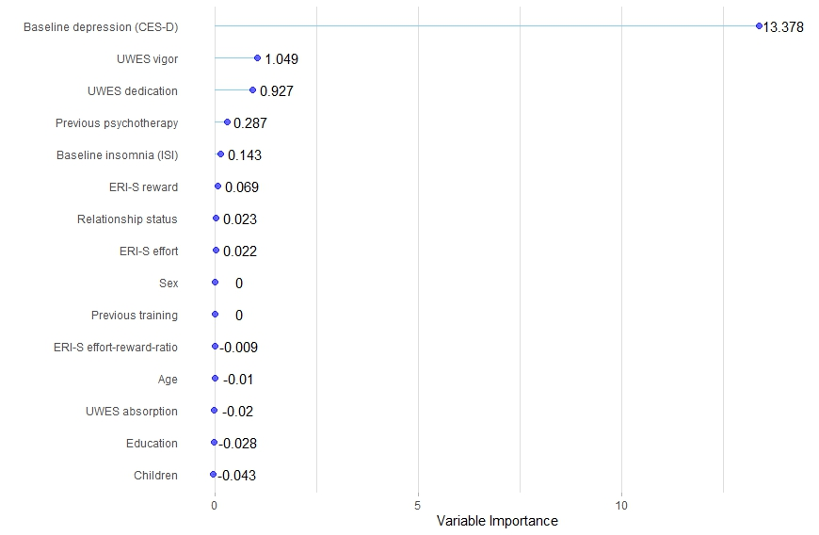

Figure 5
Variable importance of potential moderators for the treatment effect at follow-up in random-forest models with 300 bootstrap samples (N= 433) 