Supplementary materials

Content:
Supplementary Table 1 Distribution of antipsychotic medication types
Supplementary Tables 2-3 Associations between T1w/T2w ratio values and antipsychotic medication use, separate analyses in the SCZ and BPD groups
Supplementary Table 4 Association between T1w/T2w ratio values and PANSS scores
Supplementary Tables 5-6 Association between T1w/T2w ratio values and PANSS scores, separate analyses in the SCZ and BPD groups
Supplementary Figure 1 Age slopes in all significant clusters

Supplementary Table 1: Distribution of antipsychotic medication types used.

 | SCZ (n=56) | BPD (n=31) | All patients (n=87)
SGA
Olanzapine (N05AH03) | 26 (46%) | 4 (13%) | 31 (35%)
Aripiprazole (N05AX12) | 17 30%) | 11 (35%) | 28 (32%)
Quetiapine (N05AH04) | 5 (9%) | 13 (42%) | 18 (20%)
Risperidone (N05AX08) | 9 (16%) | 2 (6%) | 11 (13%)
Paliperidone (N05AX13) | 8 (14%) | 1 (3%) | 9 (10%)
Ziprazidone (N05AE04) | 3 (5%) | 0 (0%) | 3 (3%)
Clozapine (N05AH02) | 2 (3%) | 0 (0%) | 2 (2%)
FGA
Zuclopenthixol (N05AF05) | 2 (3%) | 0 (0%) | 2 (2%)
Haloperidol (N05AD01) | 1 (2%) | 0 (0%) | 1 (1%)
Chlorprothixene (N05AF03) | 0 (0%) | 1 (3%) | 1 (1%)

Anatomical Therapeutic Chemical (ATC) classification codes are provided in the parentheses.

Abbreviations: SCZ: Schizophrenia. BPD: Bipolar disorder. SGA: Second generation antipsychotic agent. FGA: First generation antipsychotic agent.

Supplementary table 2: Analysis of cluster-wise T1w/T2w values, antipsychotic medication use and interaction with age in patients with schizophrenia (SCZ).

Region | AP |  | AP × age |  | CPZ |  | CPZ × age
 | β | p | β | p | β | p | β | p
Left hemisphere
Superior frontal | .06 | .72 | .83 | .49 | −.03 | .82 | .42 | .02
Pars opercularis | .15 | .40 | 1.41 | .24 | −.13 | .32 | .32 | .10
Caudal anterior cingulate | .02 | .91 | −.60 | .62 | −.03 | .82 | .19 | .34
Precuneus | .04 | .83 | .03 | .98 | −.01 | .95 | .37 | .06
Insula | .11 | .56 | 1.53 | .22 | .05 | .71 | .29 | .14
Middle temporal | .14 | .42 | 1.88 | .12 | −.06 | .64 | .19 | .32
Precentral | .02 | .90 | 1.89 | .08 | .11 | .35 | .35 | .04
Superior temporal | .22 | .23 | 2.55 | .04 | −.09 | .51 | .26 | .18
Fusiform gyrus | .11 | .53 | 1.16 | .34 | −.15 | .27 | .32 | .09
Supramarginal | .19 | .30 | 1.98 | .11 | −.05 | .73 | .36 | .06
Lateral occipital | .22 | .20 | 2.43 | .04 | −.13 | .31 | .34 | .06
Banks of the superior temporal sulcus | .01 | .95 | 1.37 | .26 | −.17 | .20 | .39 | .04
Right hemisphere
Rostral middle frontal | .12 | .52 | 1.44 | .25 | .05 | .71 | .36 | .06
Superior parietal | .08 | .65 | 1.09 | .38 | .03 | .79 | .49 | .01
Insula (1) | −.01 | .97 | .50 | .69 | −.02 | .88 | .33 | .09
Superior temporal | .10 | .58 | 1.64 | .17 | −.05 | .68 | .32 | .08
Superior frontal (1) | .13 | .46 | 1.97 | .10 | −.12 | .38 | .27 | .15
Precuneus (1) | .05 | .78 | .82 | .50 | .08 | .55 | .36 | .06
Precuneus (2) | .17 | .35 | 1.62 | .18 | −.11 | .42 | .38 | .05
Insula (2) | .17 | .36 | 1.01 | .41 | .05 | .71 | .30 | .13
Superior frontal (2) | .11 | .46 | 1.37 | .19 | .14 | .22 | .34 | .03
Postcentral | .38 | .04 | 1.94 | .10 | .00 | .99 | .35 | .07

Linear regression models (AP and AP x age: n=63, CPZ and CPZ x age: n=55) adjusted for age and sex. The age and CPZ variables were centered prior to analysis. P-values below 0.05 (not corrected for multiple testing) are marked in bold. Abbreviations: AP = Antipsychotic medication status. CPZ = Chlorpromazine-equivalent dose.

Supplementary table 3: Analysis of cluster-wise T1w/T2w values, antipsychotic medication use and interaction with age in patients with bipolar disorder (BD).

Region | AP |  | AP × age |  | CPZ |  | CPZ × age
 | β | p | β | p | β | p | β | p
Left hemisphere
Superior frontal | .00 | .97 | .05 | .72 | −.02 | .92 | .07 | .73
Pars opercularis | −.03 | .78 | .09 | .52 | .00 | .99 | .11 | .58
Caudal anterior cingulate | .02 | .87 | .05 | .73 | .12 | .50 | .30 | .10
Precuneus | .05 | .60 | .17 | .19 | −.16 | .43 | .09 | .66
Insula | −.05 | .62 | .11 | .39 | .01 | .94 | .21 | .26
Middle temporal | .06 | .59 | .06 | .64 | −.11 | .56 | .19 | .34
Precentral | .02 | .85 | .08 | .55 | .03 | .90 | .22 | .28
Superior temporal | .07 | .51 | .00 | .99 | −.17 | .36 | .23 | .21
Fusiform gyrus | −.06 | .57 | .01 | .96 | −.33 | .08 | .13 | .50
Supramarginal | .00 | .97 | .07 | .61 | −.12 | .54 | .24 | .21
Lateral occipital | −.05 | .62 | .04 | .76 | −.36 | .06 | .15 | .44
Banks of the superior temporal sulcus | .08 | .41 | .17 | .20 | −.08 | .68 | .16 | .41
Right hemisphere
Rostral middle frontal | −.05 | .60 | .07 | .60 | −.14 | .44 | .01 | .97
Superior parietal | −.03 | .77 | −.04 | .75 | −.15 | .43 | .15 | .44
Insula (1) | −.10 | .36 | .13 | .34 | −.05 | .81 | .11 | .58
Superior temporal | −.01 | .96 | .04 | .76 | −.06 | .77 | .19 | .33
Superior frontal (1) | −.02 | .88 | .14 | .28 | −.08 | .70 | .13 | .52
Precuneus (1) | .09 | .39 | .22 | .10 | −.12 | .56 | .23 | .26
Precuneus (2) | .04 | .73 | .15 | .25 | −.18 | .35 | .22 | .26
Insula (2) | −.05 | .65 | .22 | .10 | −.01 | .94 | .12 | .53
Superior frontal (2) | −.02 | .83 | .26 | .05 | −.19 | .28 | −.03 | .88
Postcentral | .08 | .48 | .16 | .25 | −.30 | .12 | .04 | .84

Linear regression models (AP and AP x age: n=91, CPZ and CPZ x age: n=31) adjusted for age and sex. The age and CPZ variables were centered prior to analysis. P-values below 0.05 (not corrected for multiple testing) are marked in bold. Abbreviations: AP = Antipsychotic medication status. CPZ = Chlorpromazine-equivalent dose.

Supplementary Table 4 – Associations between cluster-wise T1w/T2w values and PANSS total scores and symptom factors.

Region | PANSS total score¹ |  |  | Positive factor |  |  | Negative factor |  |  | Disorganized factor |  |  | Excited factor |  |  | Depressive factor
 | β | p | p_{corr} | β | p | p_{corr} | β | p | p_{corr} | β | p | p_{corr} | β | p | p_{corr} | β | p | p_{corr}
Left hemisphere
Superior frontal | .04 | .68 | .96 | .10 | .32 | .94 | .01 | .91 | .98 | .08 | .36 | .94 | .14 | .09 | .76 | -.07 | .37 | .94
Pars opercularis | .03 | .76 | .96 | .05 | .51 | .96 | -.03 | .72 | .96 | .10 | .24 | .83 | .14 | .07 | .76 | -.03 | .70 | .96
Caudal anterior cingulate | .04 | .68 | .96 | .07 | .45 | .96 | .02 | .81 | .97 | .05 | .55 | .96 | .13 | .10 | .76 | -.07 | .41 | .94
Precuneus | .05 | .61 | .96 | .14 | .14 | .76 | -.04 | .67 | .96 | .05 | .55 | .96 | .14 | .09 | .76 | -.04 | .65 | .96
Insula | .02 | .81 | .97 | .12 | .20 | .76 | -.03 | .79 | .97 | .17 | .04 | .76 | .11 | .17 | .76 | -.11 | .18 | .76
Middle temporal | .07 | .45 | .96 | .10 | .32 | .94 | .00 | .99 | .99 | .14 | .10 | .76 | .16 | .05 | .76 | -.01 | .89 | .98
Precentral | .00 | .99 | .99 | .05 | .63 | .96 | -.01 | .91 | .98 | .07 | .42 | .94 | .08 | .30 | .94 | -.03 | .70 | .96
Superior temporal | .05 | .47 | .96 | .09 | .32 | .94 | -.04 | .68 | .96 | .12 | .17 | .76 | .11 | .17 | .76 | -.03 | .70 | .96
Fusiform gyrus | -.03 | .76 | .96 | .09 | .35 | .94 | -.01 | .89 | .98 | -.03 | .71 | .96 | .07 | .40 | .94 | -.05 | .55 | .96
Supramarginal | -.05 | .62 | .96 | .03 | .73 | .96 | -.12 | .20 | .76 | .08 | .36 | .94 | .11 | .20 | .76 | -.03 | .72 | .96
Lateral occipital | .05 | .59 | .96 | .14 | .14 | .76 | -.04 | .64 | .96 | .04 | .67 | .96 | .13 | .10 | .76 | .02 | .78 | .96
Banks of the superior temporal sulcus | -.01 | .92 | .98 | .10 | .31 | .94 | -.04 | .68 | .96 | .03 | .76 | .96 | .13 | .11 | .76 | -.08 | .31 | .94
Right hemisphere
Rostral middle frontal | .09 | .36 | .94 | .17 | .08 | .76 | -.06 | .55 | .96 | .13 | .13 | .76 | .21 | .01 | .52 | -.01 | .94 | .98
Superior parietal | .04 | .65 | .96 | .03 | .78 | .96 | -.02 | .85 | .98 | .08 | .38 | .94 | .10 | .22 | .79 | .04 | .66 | .96
Insula (1) | .17 | .08 | .76 | .21 | .03 | .75 | .03 | .78 | .96 | .23 | .009 | .52 | .20 | .01 | .52 | -.01 | .91 | .98
Superior temporal | .08 | .39 | .94 | .13 | .17 | .76 | .02 | .85 | .98 | .11 | .20 | .76 | .12 | .13 | .76 | -.01 | .86 | .98
Superior frontal (1) | .05 | .60 | .96 | .05 | .57 | .96 | -.05 | .56 | .96 | .16 | .06 | .76 | .11 | .17 | .76 | .07 | .40 | .94
Precuneus (1) | .06 | .55 | .96 | .09 | .35 | .94 | .01 | .92 | .98 | .05 | .55 | .96 | .13 | .12 | .76 | -.09 | .93 | .98
Precuneus (2) | -.02 | .86 | .98 | .05 | .63 | .96 | .06 | .50 | .96 | .05 | .58 | .96 | .07 | .42 | .94 | .00 | .97 | .99
Insula (2) | .12 | .20 | .76 | .13 | .17 | .76 | .04 | .65 | .96 | .16 | .07 | .76 | .18 | .02 | .75 | -.04 | .62 | .96
Superior frontal (2) | .03 | .74 | .96 | -.02 | .85 | .98 | .01 | .88 | .98 | .03 | .71 | .96 | .07 | .35 | .94 | .10 | .22 | .8
Postcentral | -.07 | .51 | .96 | -.09 | .33 | .94 | -.02 | .83 | .98 | .00 | .99 | .99 | .00 | .99 | .99 | .00 | .99 | .99

Linear regression models (n=155) adjusted for age, sex, and diagnosis.

¹For PANSS total score and negative symptom factor n=154 due to missing data in one participant.

Supplementary Table 5 – Associations with PANSS total scores and symptom factors in patients with schizophrenia (SCZ).

Region | PANSS total score |  | Positive factor |  | Negative factor |  | Disorganized factor |  | Excited factor |  | Depressive factor
 | β | p | β | p | β | p | β | p | β | p | β | p
Left hemisphere
Superior frontal | −.01 | .92 | .13 | .30 | −.06 | .62 | .02 | .87 | .06 | .63 | −.09 | .47
Pars opercularis | −.03 | .81 | .09 | .46 | −.10 | .42 | .04 | .75 | .05 | .69 | −.02 | .87
Caudal anterior cingulate | .07 | .61 | .16 | .19 | −.02 | .88 | .06 | .64 | .11 | .36 | −.06 | .64
Precuneus | .01 | .95 | .20 | .11 | −.13 | .31 | −.01 | .93 | .09 | .47 | −.01 | .95
Insula | .00 | .99 | .14 | .26 | −.09 | .51 | .17 | .21 | .06 | .65 | −.05 | .71
Middle temporal | .02 | .89 | .14 | .25 | −.10 | .42 | .09 | .50 | .12 | .33 | .09 | .46
Precentral | .00 | .98 | .11 | .32 | −.06 | .59 | .06 | .62 | .10 | .40 | −.02 | .85
Superior temporal | .02 | .88 | .13 | .29 | −.12 | .34 | .06 | .64 | .10 | .41 | .03 | .79
Fusiform gyrus | −.13 | .32 | .10 | .41 | −.14 | .28 | −.16 | .20 | −.04 | .75 | −.02 | .88
Supramarginal | −.06 | .63 | .11 | .38 | −.16 | .21 | .05 | .71 | .06 | .64 | .00 | .99
Lateral occipital | −.02 | .89 | .17 | .16 | −.14 | .26 | −.08 | .54 | .13 | .28 | .05 | .70
Banks of the superior temporal sulcus | −.04 | .78 | .15 | .23 | −.14 | .26 | −.01 | .95 | .11 | .39 | −.04 | .75
Right hemisphere
Rostral middle frontal | .07 | .61 | .20 | .12 | −.08 | .56 | .10 | .45 | .18 | .14 | .06 | .66
Superior parietal | −.03 | .80 | .06 | .66 | −.08 | .53 | −.02 | .88 | .01 | .95 | .07 | .59
Insula (1) | .13 | .33 | .27 | .03 | −.09 | .49 | .22 | .09 | .23 | .07 | −.01 | .93
Superior temporal | .10 | .43 | .16 | .18 | −.01 | .93 | .06 | .65 | .17 | .17 | .05 | .66
Superior frontal (1) | −.05 | .68 | .02 | .90 | −.16 | .19 | .04 | .78 | .08 | .53 | .10 | .43
Precuneus (1) | −.03 | .81 | .14 | .24 | −.08 | .52 | −.07 | .61 | .04 | .75 | −.04 | .75
Precuneus (2) | −.12 | .36 | .03 | .83 | −.14 | .28 | −.06 | .66 | −.03 | .81 | −.05 | .70
Insula (2) | .11 | .40 | .18 | .14 | −.05 | .68 | .15 | .23 | .19 | .13 | .00 | .99
Superior frontal (2) | −.02 | .82 | .01 | .96 | −.01 | .92 | −.03 | .80 | −.01 | .96 | .11 | .30
Postcentral | −.12 | .33 | -.13 | .30 | −.04 | .74 | −.05 | .70 | −.09 | .46 | .05 | .67

Linear regression models (n=64) adjusted for age, sex, and diagnosis. P-values below 0.05 (not corrected for multiple testing) are marked in bold.
Abbreviations: PANSS: Positive and negative syndrome scales.

Supplementary Table 6 – Associations with PANSS total scores and symptom factors in patients with bipolar disorders (BD).

Region | PANSS total score¹ |  | Positive factor |  | Negative factor |  | Disorganized factor |  | Excited factor |  | Depressive factor
 | β | p | β | p | β | p | β | p | β | p | β | p
Left hemisphere
Superior frontal | .13 | .21 | .02 | .86 | .17 | .11 | .12 | .26 | .21 | .04 | −.04 | .71
Pars opercularis | .13 | .23 | −.05 | .67 | .12 | .26 | .13 | .20 | .24 | .02 | −.03 | .77
Caudal anterior cingulate | .05 | .65 | −.09 | .38 | .15 | .14 | .02 | .82 | .15 | .15 | −.05 | .68
Precuneus | .13 | .22 | −.02 | .81 | .17 | .11 | .09 | .36 | .18 | .08 | −.05 | .66
Insula | .08 | .45 | .06 | .56 | .11 | .28 | .15 | .13 | .16 | .12 | −.15 | .16
Middle temporal | .13 | .20 | −.01 | .95 | .18 | .09 | .14 | .17 | .18 | .08 | −.10 | .35
Precentral | .01 | .89 | −.08 | .46 | .11 | .31 | .02 | .86 | .05 | .61 | −.03 | .80
Superior temporal | .09 | .38 | −.02 | .88 | .14 | .19 | .15 | .15 | .11 | .28 | −.07 | .50
Fusiform gyrus | .15 | .17 | .04 | .68 | .21 | .04 | .12 | .27 | .18 | .10 | −.06 | .59
Supramarginal | .02 | .84 | −.11 | .28 | .03 | .79 | .09 | .38 | .14 | .15 | −.03 | .78
Lateral occipital | .15 | .18 | .05 | .65 | .13 | .22 | .14 | .20 | .12 | .25 | .01 | .92
Banks of the superior temporal sulcus | .05 | .65 | −.01 | .93 | .16 | .13 | .02 | .84 | .14 | .18 | −.11 | .32
Right hemisphere
Rostral middle frontal | .11 | .28 | .08 | .41 | .03 | .74 | .10 | .31 | .21 | .03 | −.05 | .62
Superior parietal | .16 | .12 | −.03 | .77 | .13 | .22 | .16 | .12 | .20 | .06 | .02 | .86
Insula (1) | .20 | .06 | .07 | .54 | .20 | .05 | .19 | .07 | .17 | .10 | .00 | .97
Superior temporal | .06 | .58 | .05 | .67 | .11 | .29 | .13 | .22 | .06 | .55 | −.06 | .60
Superior frontal (1) | .20 | .05 | .12 | .26 | .16 | .13 | .27 | .01 | .14 | .19 | .07 | .54
Precuneus (1) | .19 | .08 | −.04 | .72 | .18 | .09 | .17 | .10 | .22 | .04 | .04 | .75
Precuneus (2) | .13 | .20 | .08 | .46 | .09 | .38 | .12 | .24 | .15 | .14 | .06 | .57
Insula (2) | .11 | .31 | .03 | .75 | .16 | .13 | .11 | .30 | .17 | .10 | −.07 | .50
Superior frontal (2) | .09 | .41 | −.04 | .71 | .07 | .51 | .02 | .88 | .14 | .19 | .09 | .43
Postcentral | .01 | .89 | −.03 | .81 | .03 | .76 | .00 | .96 | .06 | .56 | −.03 | .78

Linear regression models (n=91) adjusted for age, sex, and diagnosis. P-values below 0.05 (not corrected for multiple testing) are marked in bold.
Abbreviations: PANSS: Positive and negative syndrome scales.

¹For PANSS total score and negative symptom factor n=90 due to missing data in one participant

Supplementary Figure 1 – Age slopes in all significant clusters
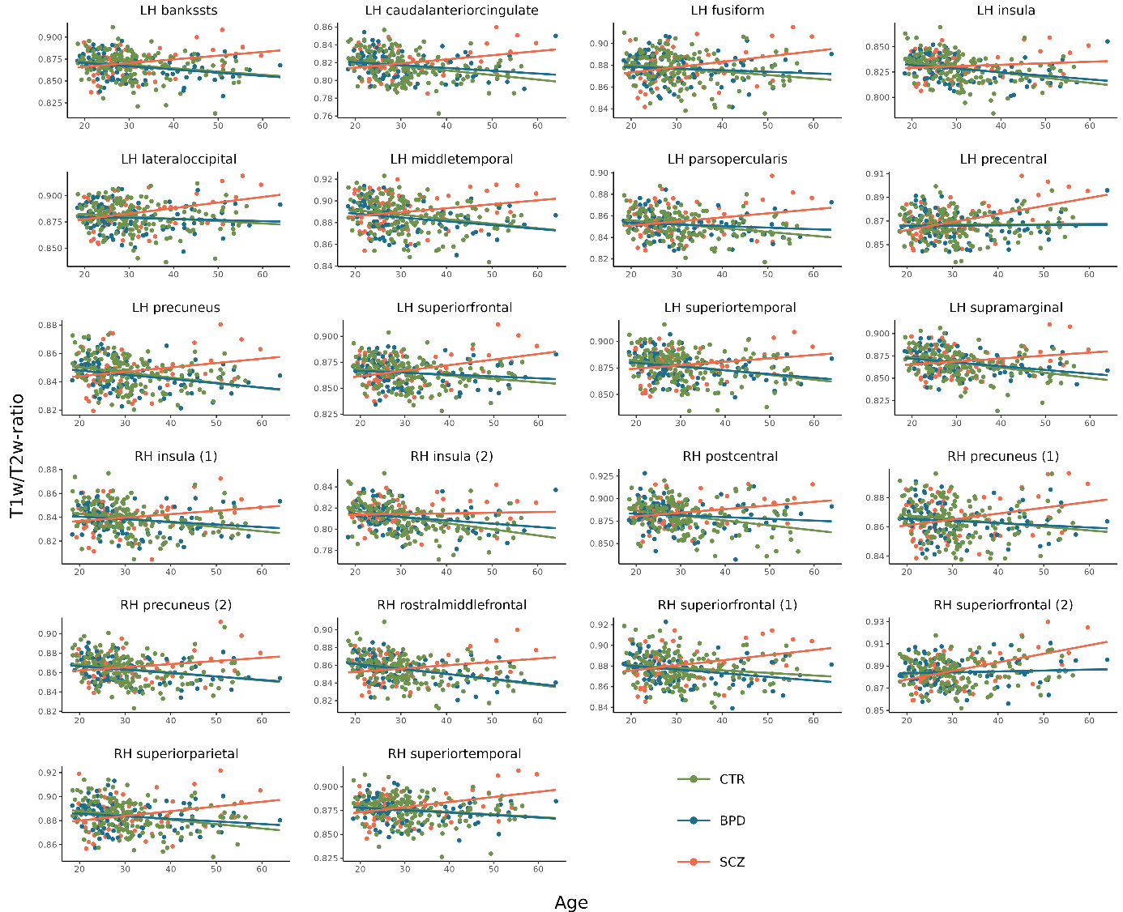

Scatterplots showing the associations with age for each significant cluster from the surface analyses for SCZ (red line), BPD (blue line) and CTR (green line). The x-axes represent age, and the y-axes represent mean T1w/T2-ratio values within the cluster.

