Supplemental Table S1. Comparison of Baseline Characteristics for Participants with and without Missing Data
 | Participants with no missing data | Participants with missing data | Pª
Sample size N | 11,133 | 40
Age (median [IQR]) | 9.92 [9.33, 10.50] | 9.75 [9.29, 10.08] | 0.123
Male(%) | 5,828 (52.3) | 23 (57.5) | 0.622
Race |  |  | 0.791
White (%) | 7,115 (63.9) | 26 (65.0)
Black (%) | 1,689 (15.2) | 7 (17.5)
Asian (%) | 261 (2.3) | 2 (5.0)
Native American/ Pacific Islander (%) | 73 (0.7) | 0 (0.0)
Other (%) | 610 (5.5) | 2 (5.0)
Multi-race (%) | 1,385 (12.4) | 3 (7.5)
Hispanic/Latino (%) | 2,253 (20.2) | 13 (32.5) | 0.084
Parents with high school diploma (%) | 9,544 (85.7) | 29 (72.5) | 0.031
Born in the US (%) | 10,785 (96.9) | 39 (97.5) | 1.000
Family history of psychosis (%) | 930 (8.4) | 4 (10.0) | 0.929
Percentage of families below the poverty level (median [IQR]) | 7.15 [3.19, 15.81] | 10.72 [4.18, 23.56] | 0.045
Neighborhood-level Population Density (median [IQR]) | 1,669.99 [806.15, 2,812.42] | 1,842.86 [967.20, 3,617.17] | 0.165
Neighborhood-level Social Fragmentation
Percentage of single parents (median [IQR]) | 14.38 [8.92, 23.47] | 20.43 [10.99, 29.13] | 0.052
Percentage of house owner (median [IQR]) | 69.96 [50.27, 83.50] | 58.45 [40.55, 80.27] | 0.050
PQBC Distress Score (median [IQR]) | 1.00 [0.00, 6.00] | 5.00 [1.00, 18.75] | 0.001
Friends (median [IQR]) | 14.00 [8.00, 24.00] | 16.50 [13.25, 28.00] | 0.408
Close friends (median [IQR]) | 4.00 [3.00, 7.00] | 4.00 [2.75, 5.25] | 0.613
- X² tests were used for categorical variables and Kruskal–Wallis tests were used for non-normal continuous variables.

Supplemental Table S2. Testing for Potential Moderators of the Association Between Neighborhood Social Fragmentation and Distressing Psychotic-like Experiences

Potential Moderator Terms | β | SE | 95% CI | p
Age | -0.01 | 0.01 | 0.01 to -0.03 | 0.525
Male Sex | <0.01 | 0.02 | 0.04 to -0.04 | 0.972
Greater Parental Education | <0.01 | 0.05 | 0.09 to -0.09 | 0.951
White non-Hispanic | 0.04 | 0.02 | 0.09 to -0.01 | 0.097
Born in the US | -0.01 | 0.06 | 0.12 to -0.13 | 0.894

Note: Four generalized linear mixed models with sites and family groups as random intercepts were used to test for four interaction terms to predict distressing psychotic-like experiences (log-transformed). Each potential moderator term represents the term-by-neighborhood social fragmentation independent variable.

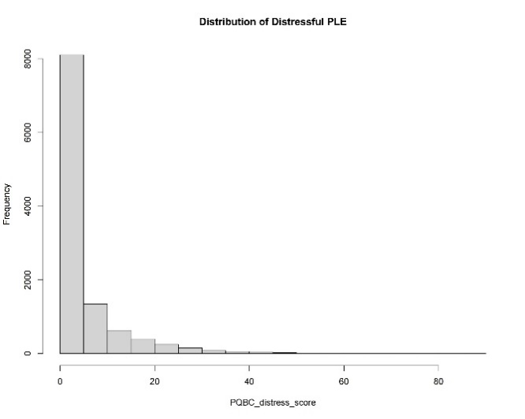
Supplemental Figure S1.
Figure S1a. Distribution of Distressing PLE Before Log-Transformation (Skewness: 3.03)
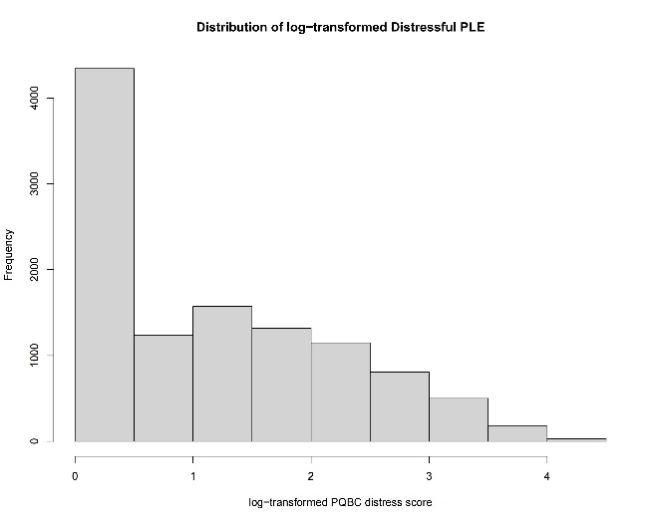
Figure S1b. Distribution of Distressing PLE After Log-Transformation (Skewness: 0.58)

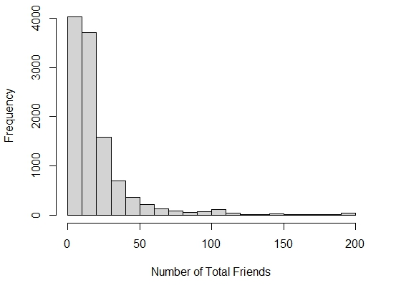
Supplemental Figure S2.
Figure S2a. Distribution of Number of Friends
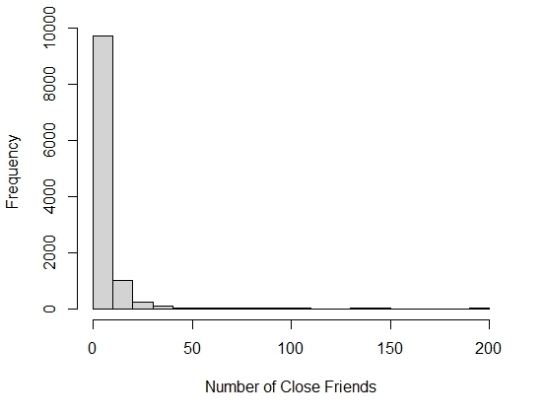
Figure S2b. Distribution of Number of Close Friends
Note: The median number of total and close friends is 14 and 4, respectively. The Pearson Correlation between total and close friends is 0.51.

