Supplementary Material
Fig S1. COI site (230 time points). Altered GS_{sd} in patients with MDD. A). The violin figure shows the distribution of GS_{sd} in HC and MDD groups, respectively. B). The Pearson correlation between GS_{sd} and BDI-Ⅱ scores.
Fig S2. COI site (110 time points). Altered GS_{sd} in patients with MDD. A). The violin figure shows the distribution of GS_{sd} in HC and MDD groups, respectively. B). The Pearson correlation between GS_{sd} and BDI-Ⅱ scores.
Fig S3. HKH site. Altered GS_{sd} in patients with MDD. A). The violin figure shows the distribution of GS_{sd} in HC and MDD groups, respectively. B). The Pearson correlation between GS_{sd} and BDI-Ⅱ scores.
Fig S4. HRC site. Altered GS_{sd} in patients with MDD. A). The violin figure shows the distribution of GS_{sd} in HC and MDD groups, respectively. B). The Pearson correlation between GS_{sd} and BDI-Ⅱ scores.
Fig S5. HUH site. Altered GS_{sd} in patients with MDD. A). The violin figure shows the distribution of GS_{sd} in HC and MDD groups, respectively. B). The Pearson correlation between GS_{sd} and BDI-Ⅱ scores.

Fig S6. COI site (230 time points) Altered GS_{power} in patients with MDD. A). Distribution and differences of GS_{power} at the full frequency range. Red and blue shadows represent standard errors. B). The Pearson’s correlation between GS_{power} and BDI-Ⅱ scores in the MDD and HC groups. FDR correction, q < 0.05.
Fig S7. COI site (110 time points). Altered GS_{power} in patients with MDD. A). Distribution and differences of GS_{power} at the full frequency range. Red and blue shadows represent standard errors. B). The Pearson’s correlation between GS_{power} and BDI-Ⅱ scores in the MDD and HC groups. FDR correction, q < 0.05.
Fig S8. HKH site. Altered GS_{power} in patients with MDD. A). Distribution and differences of GS_{power} at the full frequency range. Red and blue shadows represent standard errors. B). The Pearson’s correlation between GS_{power} and BDI-Ⅱ scores in the MDD and HC groups. FDR correction, q < 0.05.
Fig S9. HRC site. Altered GS_{power} in patients with MDD. A). Distribution and differences of GS_{power} at the full frequency range. Red and blue shadows represent standard errors. B). The Pearson’s correlation between GS_{power} and BDI-Ⅱ scores in the MDD and HC groups. FDR correction, q < 0.05.
Fig S10. HUH site. Altered GS_{power} in patients with MDD. A). Distribution and differences of GS_{power} at the full frequency range. Red and blue shadows represent standard errors. B). The Pearson’s correlation between GS_{power} and BDI-Ⅱ scores in the MDD and HC groups. FDR correction, q < 0.05.

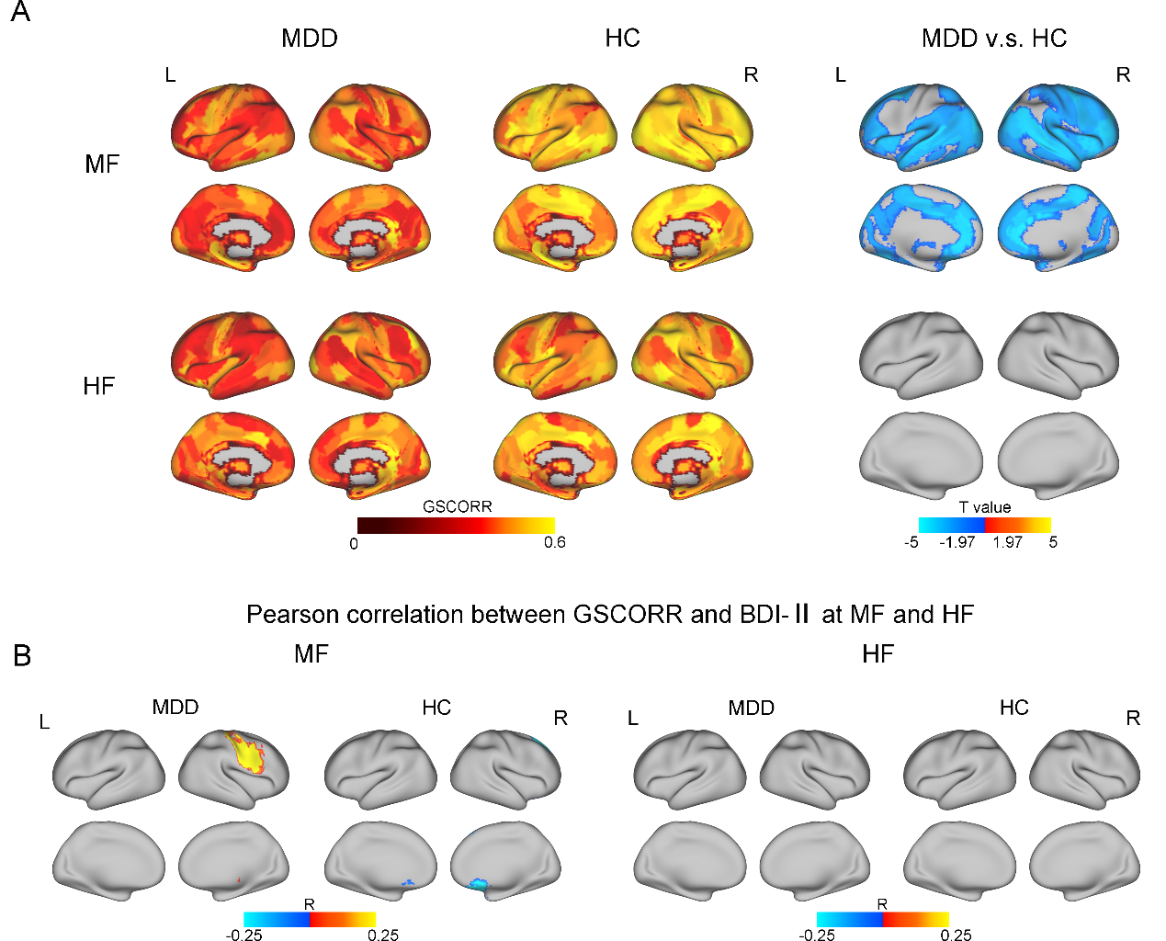Fig S11. COI site (230 time points). A). Distribution and differences of GSCORR at the MF and HF bands, respectively. B). The Pearson’s correlation between GSCORR and BDI-Ⅱ scores in the MDD and HC groups at the MF and HF bands, respectively. MF: medium frequency; HF: high frequency. FDR correction, q < 0.05.
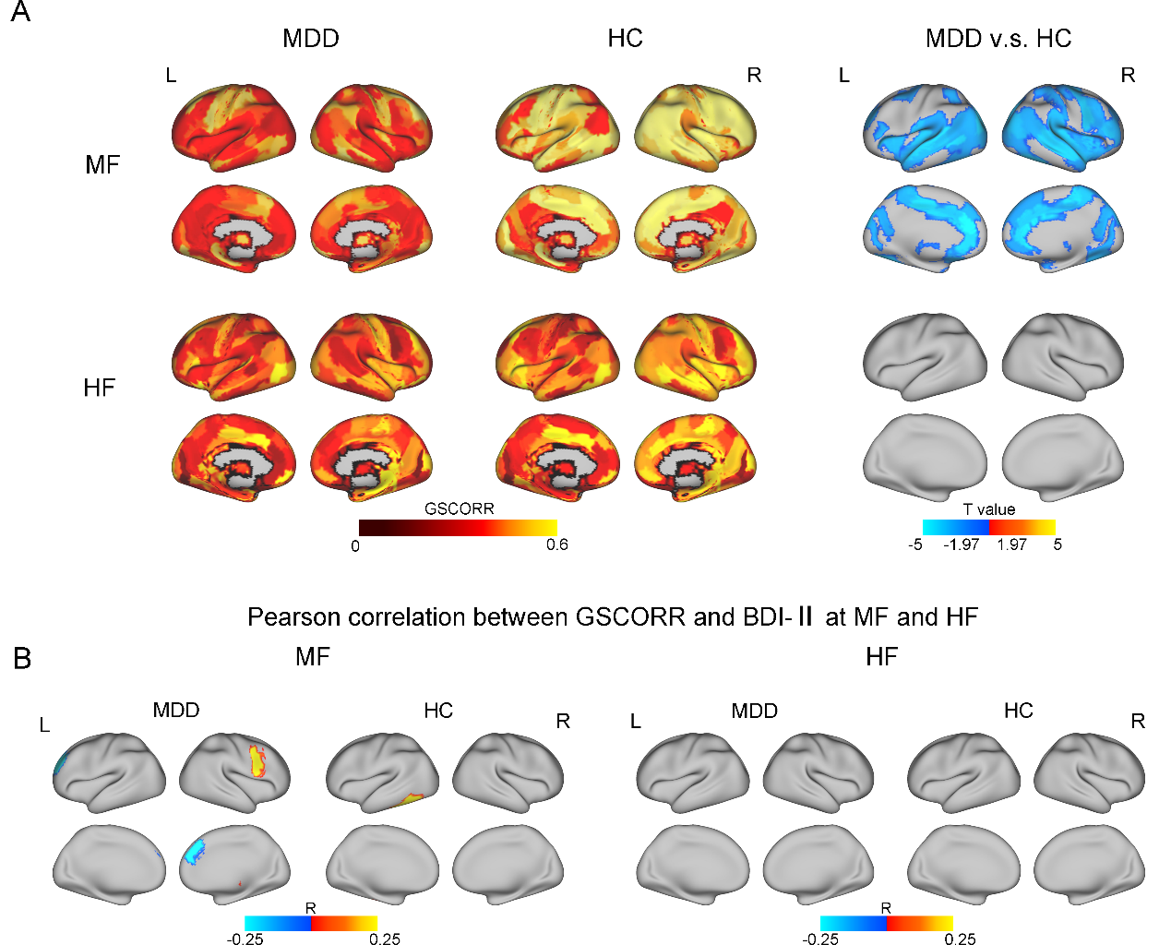Fig S12. COI site (110 time points). A). Distribution and differences of GSCORR at the MF and HF bands, respectively. FDR correction, q < 0.05. B). The Pearson’s correlation between GSCORR and BDI-Ⅱ scores in the MDD and HC groups at the MF and HF bands, respectively. MF: medium frequency; HF: high frequency.
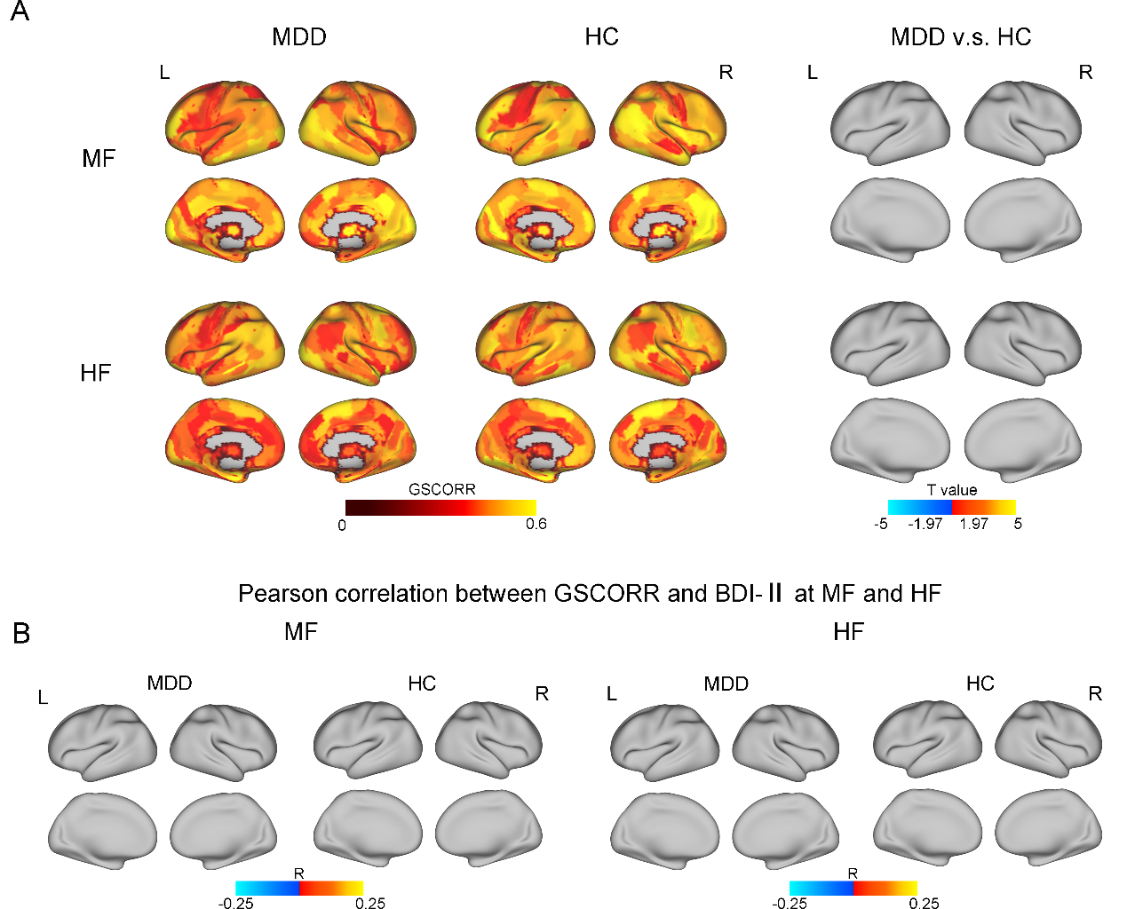Fig S13. HKH site. A). Distribution and differences of GSCORR at the MF and HF bands, respectively. FDR correction, q < 0.05. B). The Pearson’s correlation between GSCORR and BDI-Ⅱ scores in the MDD and HC groups at the MF and HF bands, respectively. MF: medium frequency; HF: high frequency.
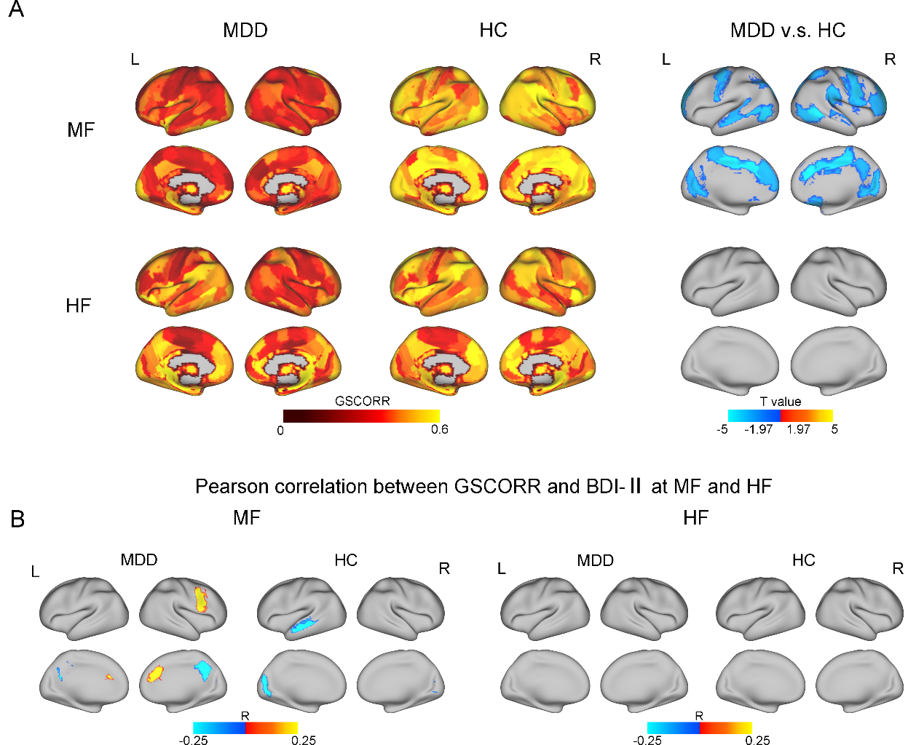Fig S14. HRC site. A). Distribution and differences of GSCORR at the MF and HF bands, respectively. FDR correction, q < 0.05. B). The Pearson’s correlation between GSCORR and BDI-Ⅱ scores in the MDD and HC groups at the MF and HF bands, respectively. MF: medium frequency; HF: high frequency.
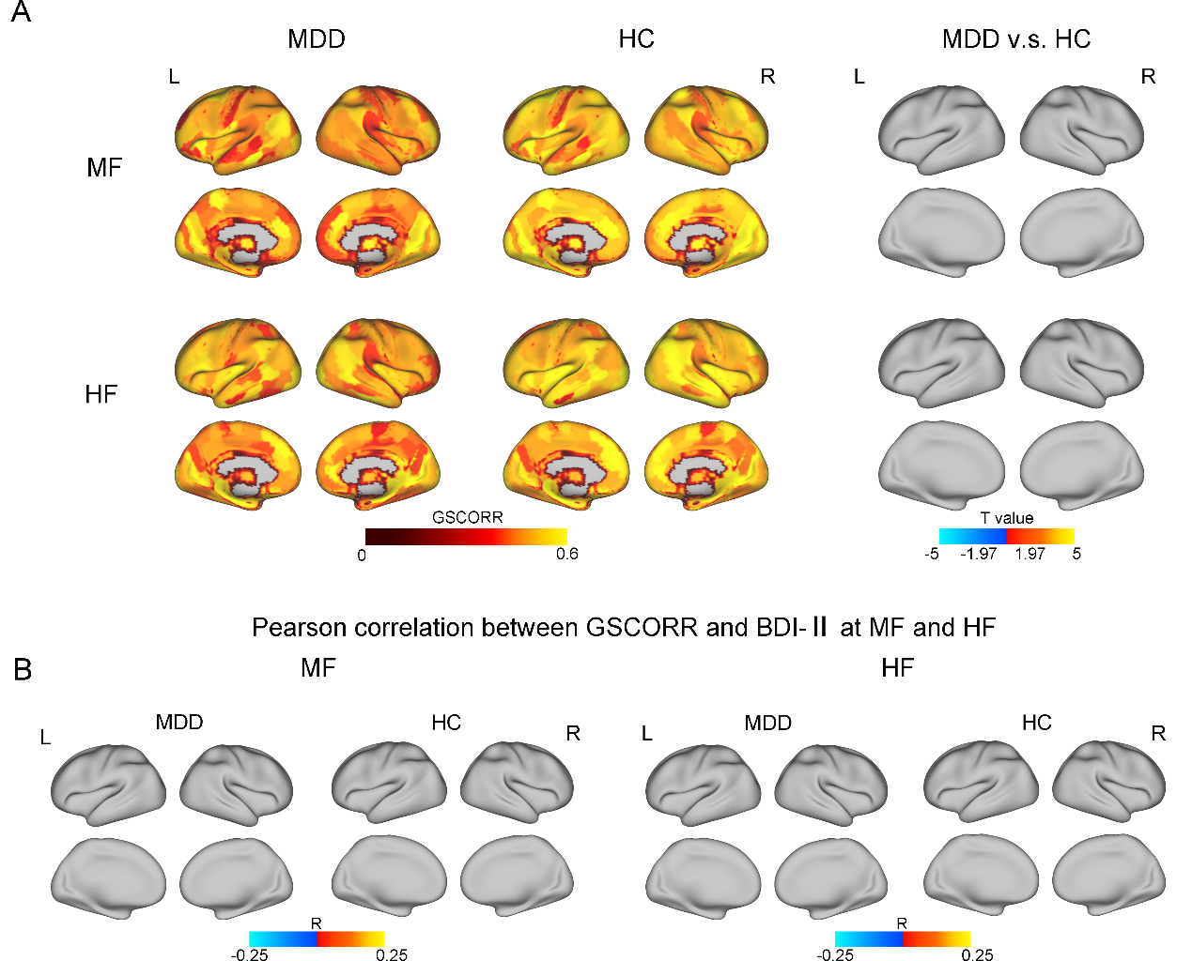Fig S15. HUH site. A). Distribution and differences of GSCORR at the MF and HF bands, respectively. FDR correction, q < 0.05. B). The Pearson’s correlation between GSCORR and BDI-Ⅱ scores in the MDD and HC groups at the MF and HF bands, respectively. MF: medium frequency; HF: high frequency.

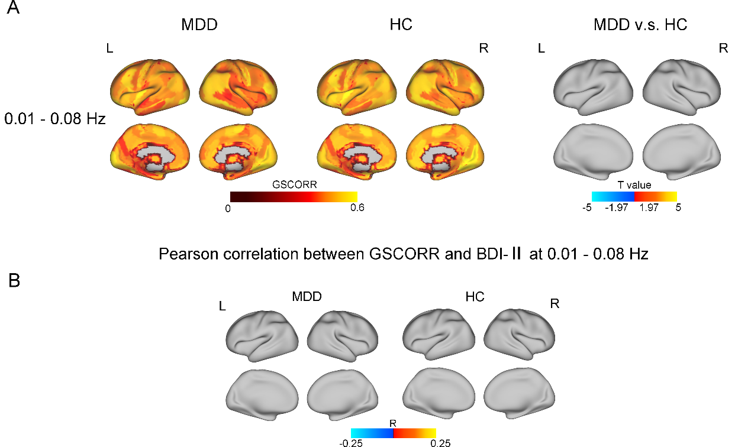
Fig S16. 0.01 - 0.08 Filtering. A). Distribution and differences of GSCORR at 0.01 – 0.08 Hz. B). The Pearson’s correlation between GSCORR and BDI-Ⅱ scores in the MDD and HC groups at 0.01 – 0.08 Hz. FDR correction, q < 0.05.

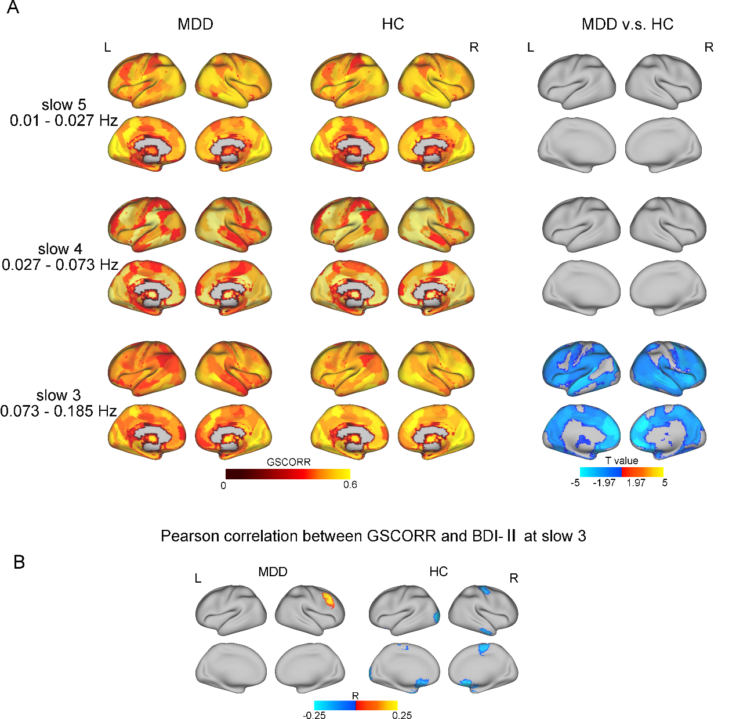
Fig S17. Slow 5 – slow 3 Filtering. A). Distribution and differences of GSCORR at slow 5 – slow 3, respectively. B). The Pearson’s correlation between GSCORR and BDI-Ⅱ scores in the MDD and HC groups at slow 3 (0.073 – 0.185 Hz). FDR correction, q < 0.05.

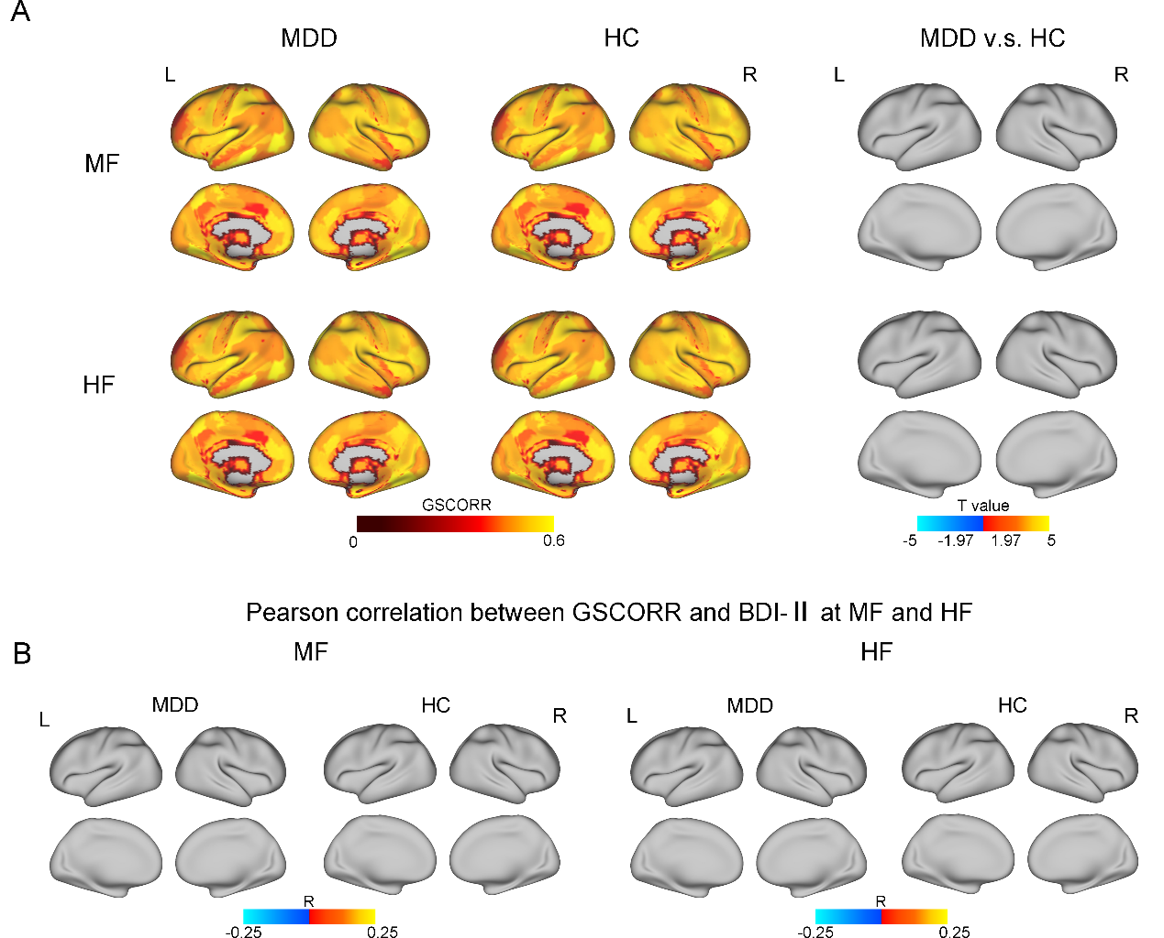
Fig S18. A). Frequency-dependent alteration of GSCORR in the MDD and HC groups disappeared after GS regression. B). The Pearson’s correlation between GSCORR and BDI-Ⅱ scores in the MDD and HC groups at the MF and HF bands, respectively. MF: medium frequency; HF: high frequency.

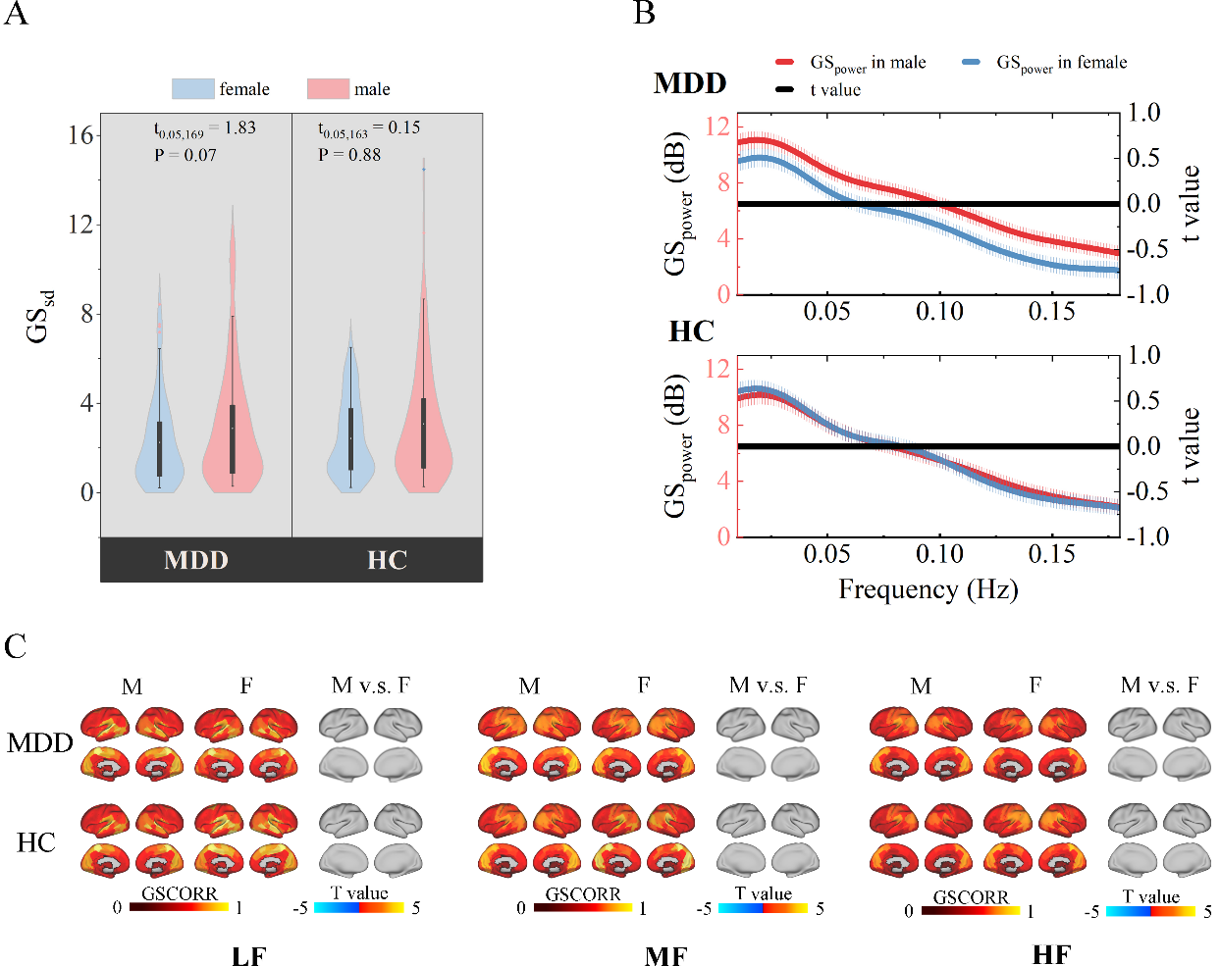
Fig S19. A) Violin plots show the distribution and differences of GS_{sd} between male and female in the MDD and HC groups, respectively. B) Distribution and differences of GS_{power} between male and female in the MDD and HC groups in the full frequency range. C) Distribution and differences of GSCORR between male and female in the MDD and HC groups at LF, MF, and HF bands, respectively. FDR correction, q < 0.05. M: male; F: female. LF: low frequency; MF: medium frequency; HF: high frequency.

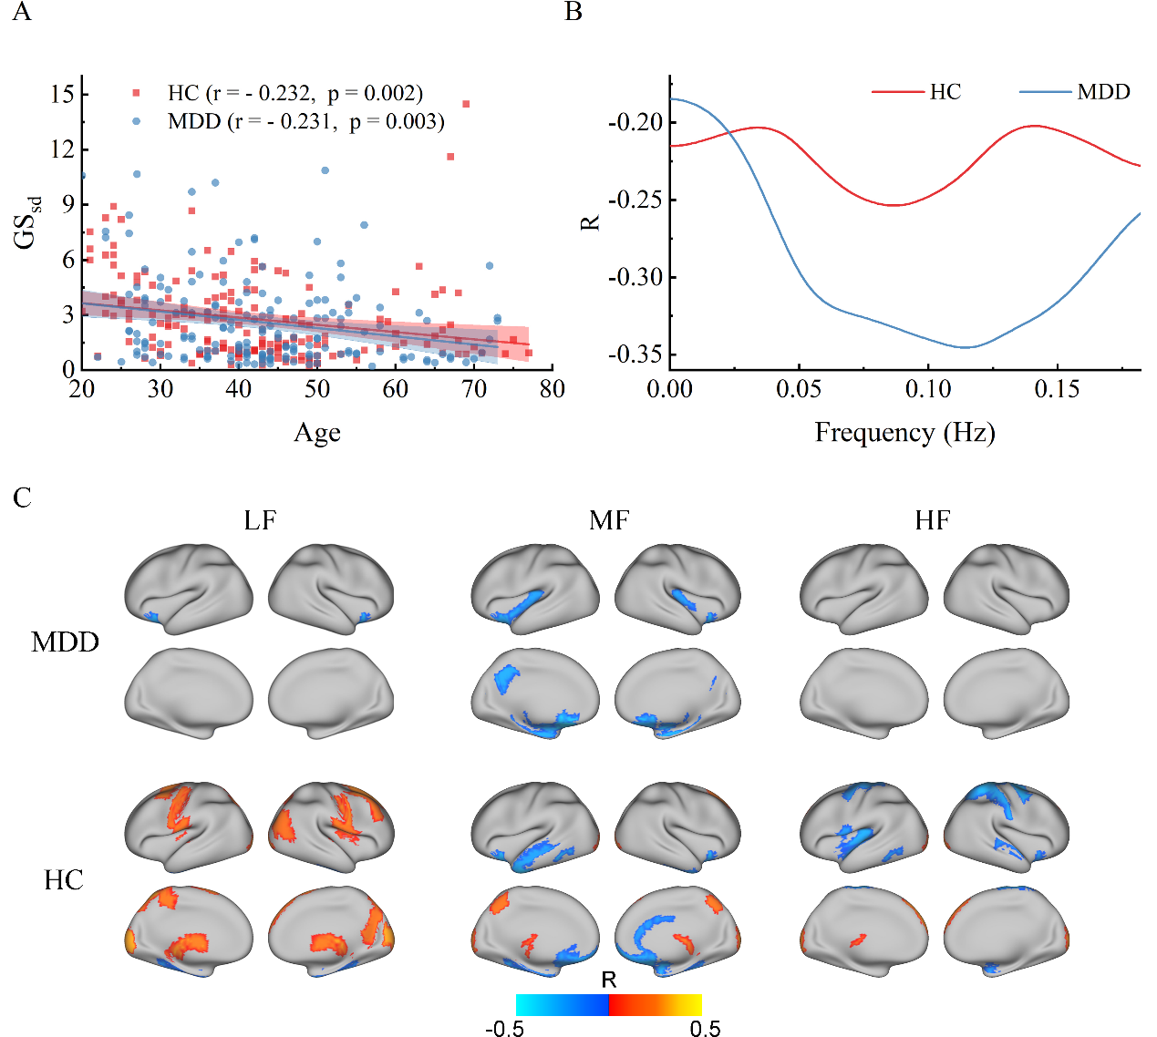
Fig S20. A) and B) show the Pearson's correlation coefficients between age and GS_{sd} / GS_{power} in the MDD and HC groups, respectively. C) The Pearson's correlation coefficients between age and GSCORR at LF, MF, and HF bands in the MDD and HC groups, respectively. LF: low frequency; MF: medium frequency; HF: high frequency.

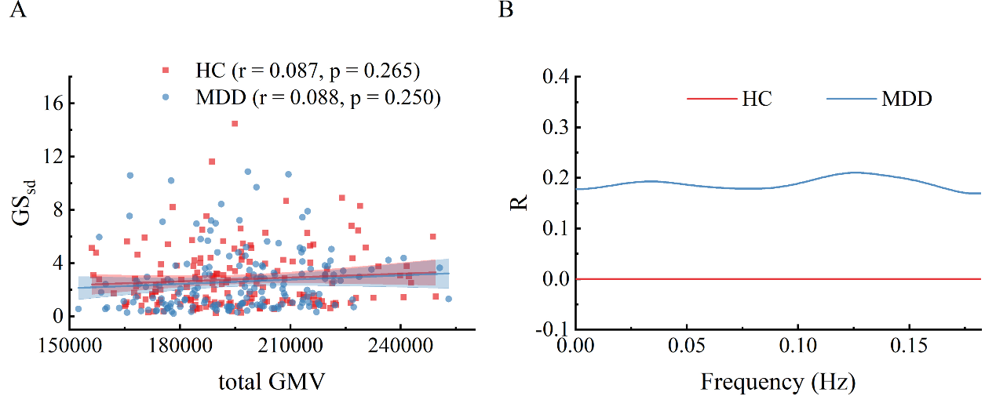
Fig S21. A) and B) show the Pearson's correlation coefficients between total GMV and GS_{sd} / GS_{power} in the MDD and HC groups, respectively. GMV: gray matter valume.

