Included | Excluded
Design
Case note analyses (longitudinal) | Qualitative only studies
Case control  Retrospective cohort | Systematic review or meta-analysis (categorise in separate folder)
Prospective cohort | Narrative review
 | Non-English/Spanish language (if translation can’t be found)
 | Commentaries
 | Case studies
 | Small N samples (<20 eligible participants)
 | Conference abstracts
 | Books
Population
Psychiatric diagnosis | Non-psychiatric inpatients OR mixed samples that were not segregated for analysis
Current adult inpatients (voluntary or involuntary)  Consent to treatment decisions (broadly defined) | Majority focus on organic disorders (e.g. delirium, dementia or intellectual disability)  Child or older adult sample  Non-treatment decisions only
Data/Outcomes
Association between psychopathology and capacity (measured as either a binary clinical judgment or using a validated capacity scale) | No association between capacity and psychopathology investigated OR no reliability statistic reported
Inter-rater reliability (broadly defined)

Table 1. A full list of inclusion/exclusion criteria

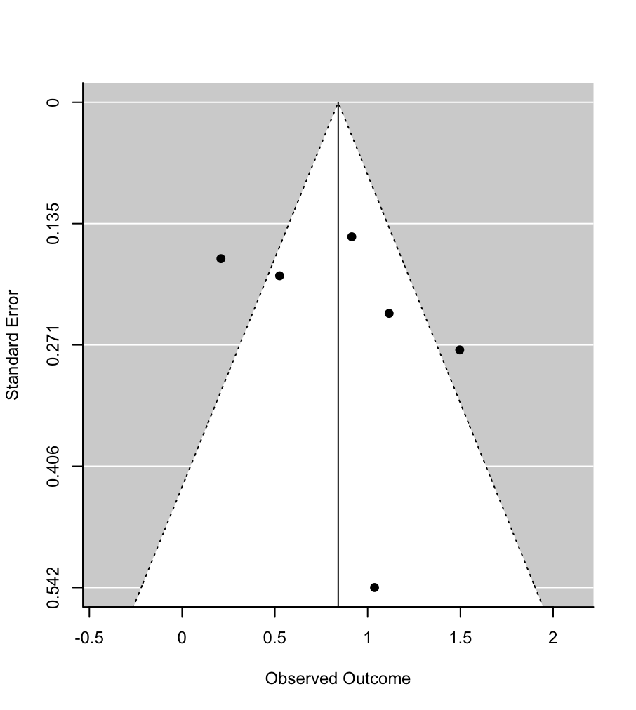
Figure 1. Forest plot for the meta-analysis of BPRS scores
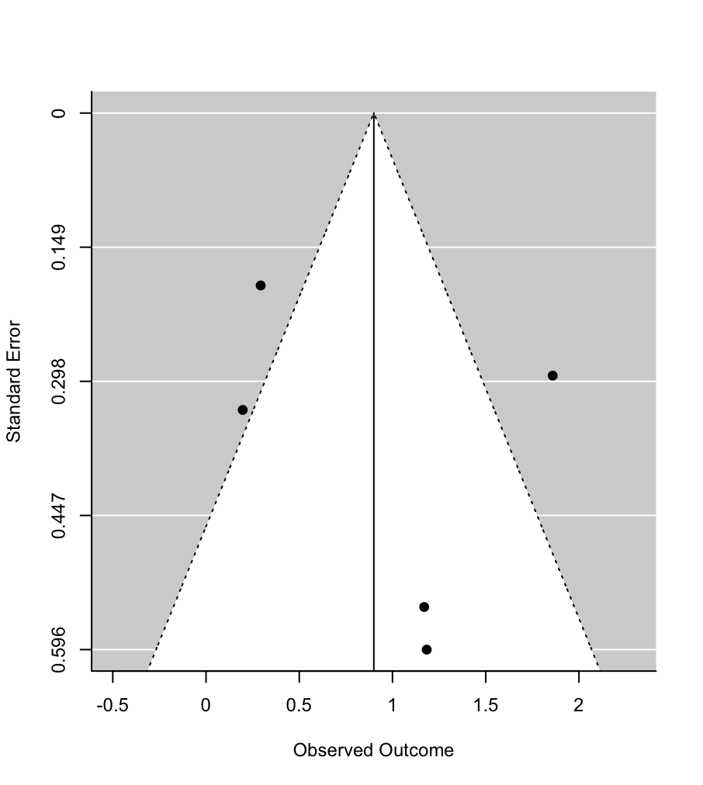
Figure 2. Forest plot for the meta-analysis of MMSE scores

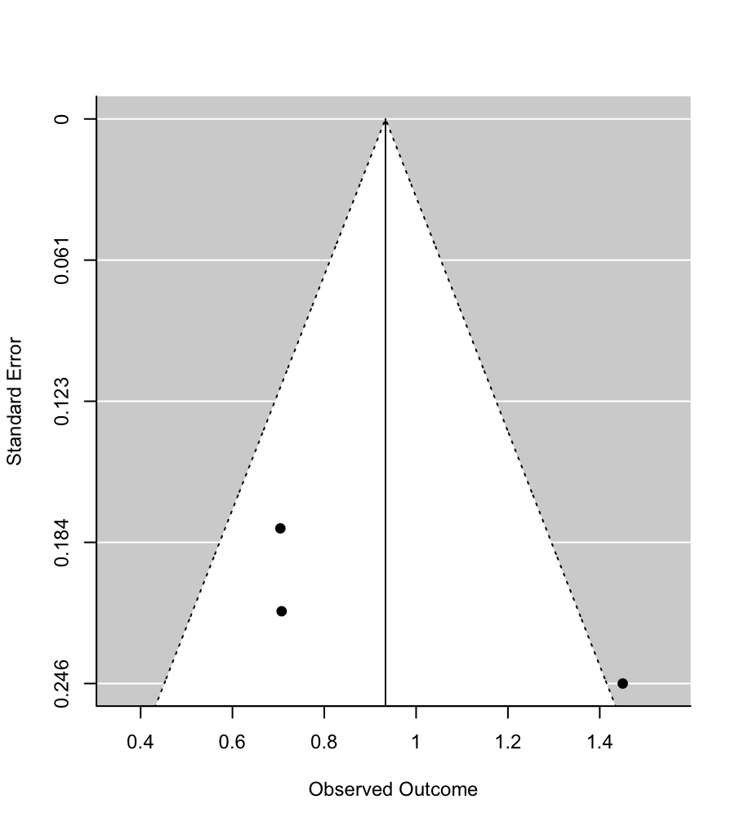
Figure 3. Forest plot for the meta-analysis of GAF scores

