Online supplement 3 Additional methodological detail

Selection of model
We chose the polynomial regression fitting process (LOESS) due to its advantages in terms of computational efficiency, automatic parameter learning, and the mitigation of issues related to local optima and overfitting.
We also tried another model based on a different article (Zabihi et al., 2019), which is a Gaussian process regression model. By comparing different models, we chose the LOESS due to the following reasons:
- The LOESS algorithm is a flexible and robust method to deal with heteroskedasticity and non-constant variance in the data, which are common features of neuroimaging data. In contrast, Gaussian process regression modeling requires the assumption that the data obey a Gaussian distribution, which may not be true of the data.
- The LOESS algorithm can handle outliers and missing values in the data, which are also common challenges in neuroimaging studies. In contrast, Gaussian process regression models are sensitive to outliers and missing values, which may lead to unstable or inaccurate models.
- The LOESS algorithm produces smooth and continuous curves that are easy to interpret and visualize. Gaussian process regression models (see figure 1), on the other hand, produce curves that can be more Rigid and difficult to understand (see figure 2).

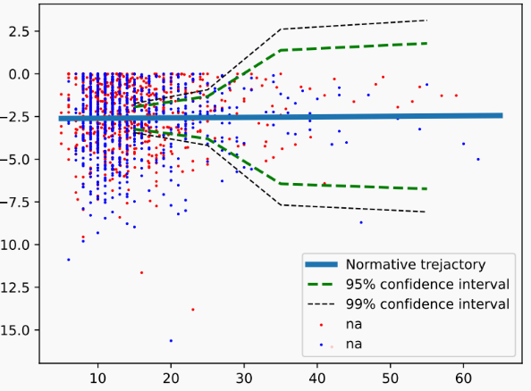
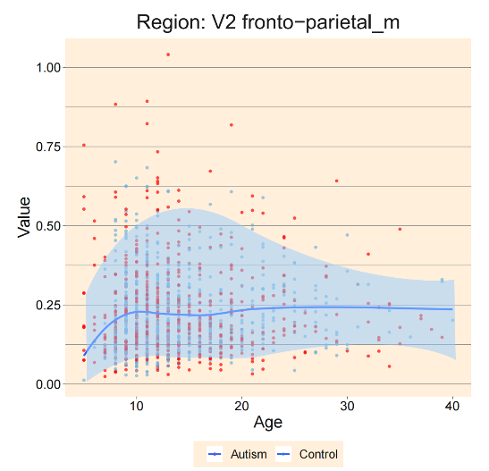
Fig.1 The plot was generated using LOESS smoothing. Fig.2 The plot was generated using Gaussian process regression models, demonstrating the distribution of extreme negative z-scores for all subjects as well as the FC developmental trajectory after normative modeling. The developmental trajectory were just as confusing as the normative probability map.

