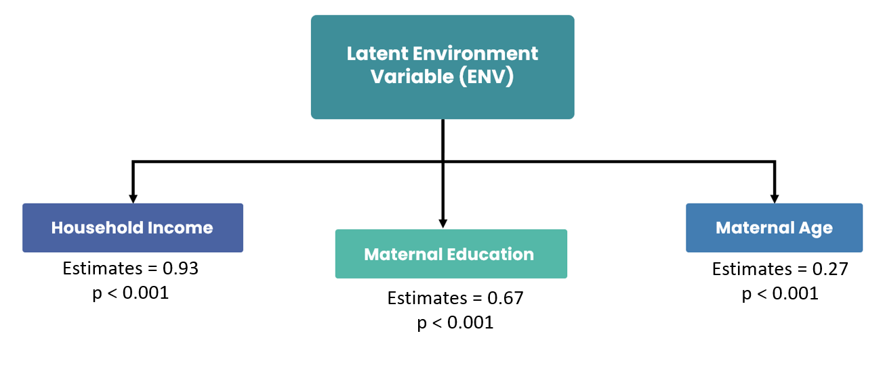
Supplementary Figure 1: Construction of latent environment variable (ENV) from three observed variables: (1) household income, (2) maternal education, and (3) maternal age at recruitment. All three variables significantly contributed to the latent variable (all p<0∙001), with standardized estimates as shown.

Outcome Measure | Predictor | Estimate | Std Error | t-stat | p-value
BRIEF-2 ERI Score | Screen Time Utilization | 0.589 | 0.445 | 1.325 | 0.186
SEARS Total Score | Screen Time Utilization | -0.643 | 1.022 | -0.630 | 0.529

Supplementary Table 1: Linear regression analysis of screen time measures on BRIEF-2 ERI and SEARS Total scores. Note: BRIEF-2: Behavior Rating Inventory for Executive Function-Version 2, ERI: Emotional Regulation Index, SEARS: Social Emotional Assets and Resilience Scales

BRIEF
Measure | Estimate | Lower CI | Upper CI
Association between Screen Time and CCxEP integration | 0.509 | 0.218 | 0.8
Association between Reading Time and CCxEP integration | -0.069 | -0.47 | 0.252
Interaction of Screen and Reading Time on CCxEP integration | -0.429 | -0.791 | -0.06
Association between CCxEP integration and BRIEF ERI | 0.319 | -0.175 | 0.814
Association between Screen Time and BRIEF ERI | -0.205 | -1.218 | 0.883
Mediating Effect of CCxEP integration | 0.162 | -0.051 | 0.523
Moderating Effect of Reading Time on Mediation Model | -0.137 | -0.532 | 0.032

SEARS
Measure | Estimate | Lower CI | Upper CI
Association between Screen Time and CCxEP integration | 0.492 | 0.2 | 0.776
Association between Reading Time and CCxEP integration | -0.079 | -0.466 | 0.229
Interaction of Screen and Reading Time on CCxEP integration | -0.425 | -0.761 | -0.053
Association between CCxEP integration and SEARS | -1.587 | -3.008 | -0.143
Association between Screen Time and SEARS | 1.075 | -1.048 | 3.604
Mediating Effect of CCxEP integration | -0.781 | -1.96 | -0.12
Moderating Effect of Reading Time on Mediation Model | 0.674 | 0.062 | 1.923
Mediating Effect of CCxEP integration at low Reading Time | -0.781 | -1.96 | -0.12
Mediating Effect of CCxEP integration at mean Reading Time | -0.309 | -0.992 | 0.009
Mediating Effect of CCxEP integration at high Reading Time | 0.163 | -0.331 | 1.056

Supplementary Table 2: Full moderated mediation model for BRIEF and SEARS. For BRIEF, the interaction term remained significant, indicating that reading time exhibited a moderating effect on the association between screen time and brain network topology. However, we failed to find a significant mediation effect nor moderated mediation effect for BRIEF ERI.
For SEARS, we found a significant interaction effect, mediation effect and overall moderating effect of reading time on the mediation model. These results show that the brain network topology significantly mediates the link between screen time and SEARS total score, and this mediation effect is significantly moderated by reading time. Post-hoc analysis using simple slopes showed only at low levels of reading time, brain network topology had a significant mediating effect on the relation between screen time and SEARS total score. This is in line with our main findings where higher levels of reading exhibit a buffering effect on the association between screen time and brain network changes.

