Supplemental Figures

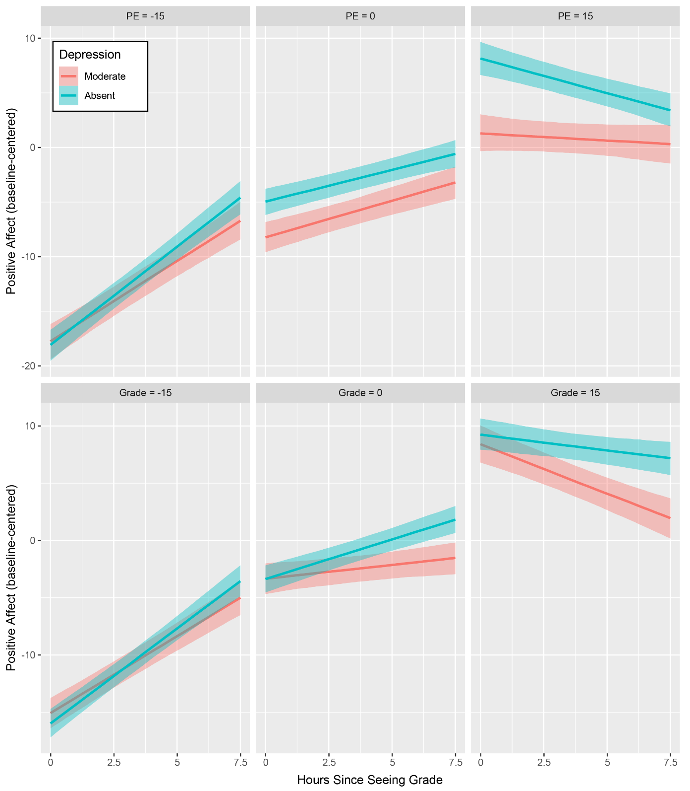
Figure S1. Depression impacts positive affective responses to prediction errors. A) Top row: Individuals with moderate depression (red line; PHQ = 11.25) display blunted emotional responses to positive prediction errors, compared to individuals without depression (teal line; PHQ = 0). Bottom row: Individuals with moderate depression show no differences in emotional responses to different grade (outcome value) levels. These are conditional plots of specific, selected levels of depression and PE / grade from the statistical in which these variables are continuous. Bands are the 95% credible intervals from the model.
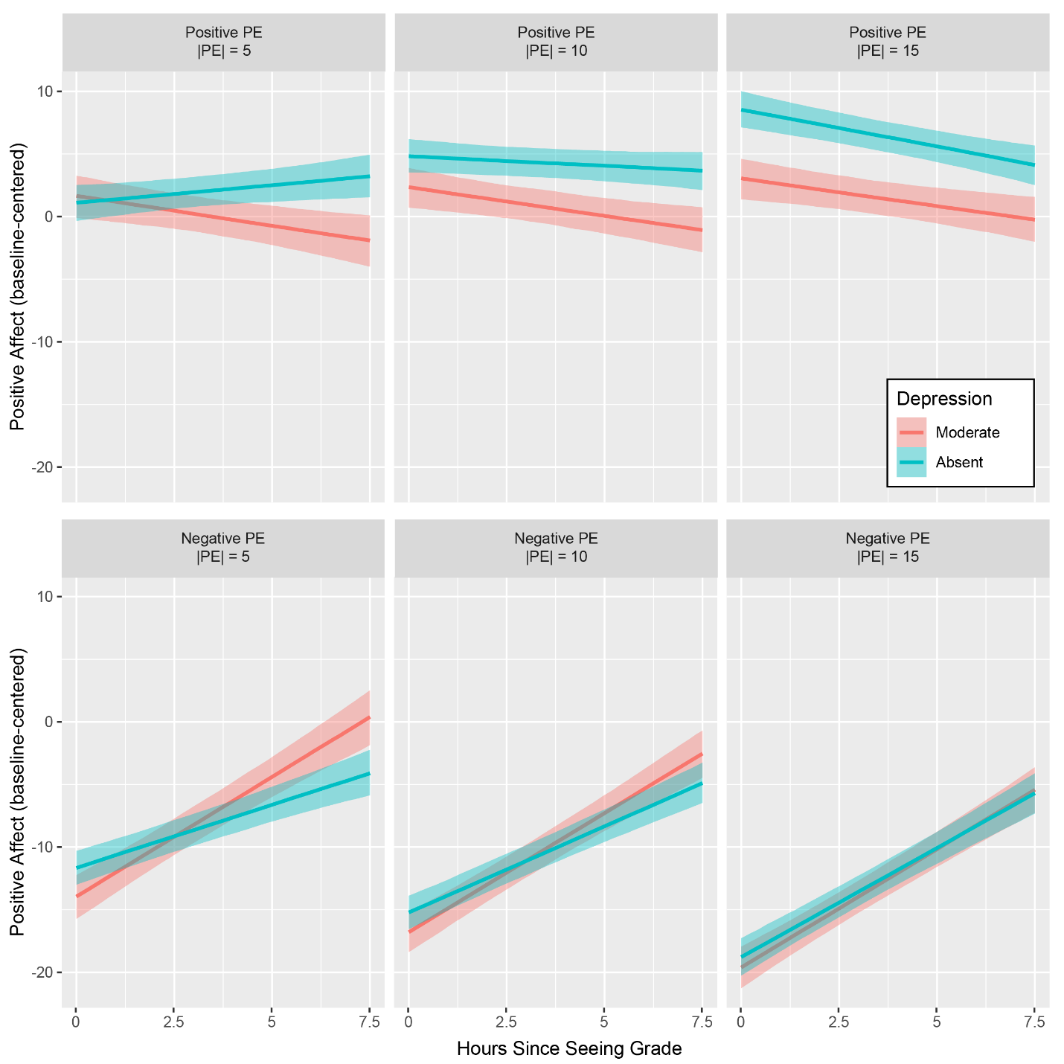
Figure S2. Depression impacts emotional responses to positive, and not negative prediction errors. Conditional plots are from a model in which positive affect was regressed on time since seeing grade (x-axis), depression, PE sign (positive or negative), and PE magnitude. This model revealed a significant four-way interaction indicating that the differential impact of PE on emotion by depression severity was specific to positive PEs which can be observed in the top right corner below. Levels of depression are identical to Figure 2.

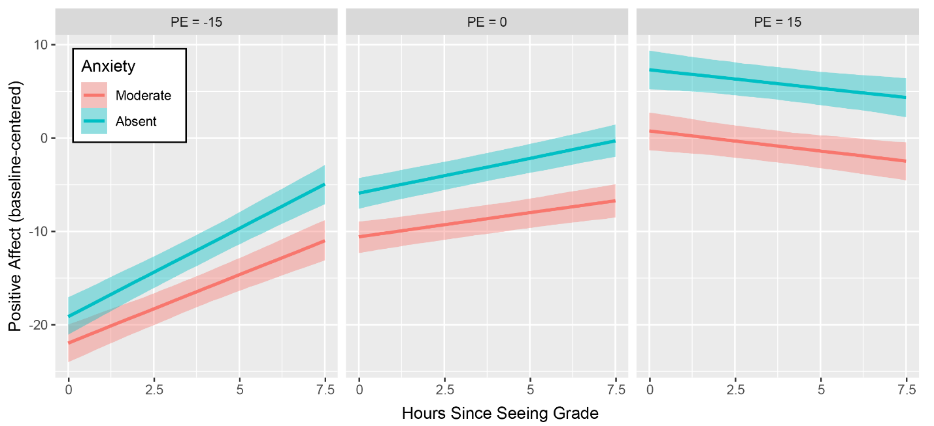
Figure S3. Anxiety is not associated with blunted emotional responses to prediction errors. Anxiety was not linked to differential affective responses to PEs.
Supplemental Tables
Bayesian Regression Results: Positive Affect
Parameter | Effect | 95% CI
Intercept | -67.87024 (EE = 2.11315) | [-71.89156, -63.70754]
Time | 2.72856 (EE = 0.25231) | [2.22476, 3.21519]
Exam Grade | 0.85991 (EE = 0.02823) | [0.80495, 0.91538]
Depression Score | 1.45286 (EE = 0.72675) | [-0.02235, 2.78035]
Exam Number 2 vs. Exam Number 1 | -0.70518 (EE = 0.32296) | [-1.35355, -0.06361]
Exam Number 3 vs. Exam Number 1 | -0.09789 (EE = 0.34532) | [-0.77221, 0.56432]
Exam Number 4 vs. Exam Number 1 | 2.63777 (EE = 0.38646) | [1.89492, 3.3791]
Time * Exam Grade | -0.03076 (EE = 0.00331) | [-0.03709, -0.02399]
Time * Depression Score | 0.03759 (EE = 0.09262) | [-0.13986, 0.2254]
Exam Grade * Depression Score | -0.01925 (EE = 0.01005) | [-0.03798, 0.00101]
Time * Exam Grade * Depression Score | -0.0015 (EE = 0.00125) | [-0.00406, 0.00093]
Table S1. Parameter estimates from a Bayesian regression model in which scaled PA scores are predicted by the three-way interaction between time, exam grade, and depression score. A factor representing exam number was included as a covariate. Results suggest that differences in the processing of outcome values (i.e., exam grades) do not drive altered PA responses in depressed individuals.

Parameter | Effect | 95% CI
Intercept | -7.0872 (EE = 1.15472) | [-9.31425, -4.82194]
Time | 0.10641 (EE = 0.1297) | [-0.14164, 0.35919]
PE Magnitude | -0.76016 (EE = 0.078) | [-0.91628, -0.60878]
PE Valence | 3.27253 (EE = 0.81566) | [1.68473, 4.87962]
Depression Score | -1.01259 (EE = 0.44172) | [-1.89686, -0.13205]
Exam Number 2 vs. Exam Number 1 | 1.04272 (EE = 0.32401) | [0.42095, 1.68449]
Exam Number 3 vs. Exam Number 1 | -2.2268 (EE = 0.36563) | [-2.94903, -1.51989]
Exam Number 4 vs. Exam Number 1 | 4.79213 (EE = 0.40639) | [3.99574, 5.57979]
Time * PE Magnitude | 0.04934 (EE = 0.00902) | [0.0318, 0.06712]
Time * PE Valence | 0.45208 (EE = 0.14495) | [0.17215, 0.72804]
PE Magnitude * PE Valence | 1.70817 (EE = 0.0918) | [1.52001, 1.881]
Time * Depression Score | 0.21365 (EE = 0.05231) | [0.10926, 0.31351]
PE Magnitude * Depression Score | 0.04869 (EE = 0.03023) | [-0.01, 0.10799]
PE Valence * Depression Score | 2.2052 (EE = 0.38619) | [1.43188, 2.9567]
Time * PE Magnitude * PE Valence | -0.10811 (EE = 0.01101) | [-0.12956, -0.08663]
Time * PE Magnitude * Depression Score | -0.01259 (EE = 0.00344) | [-0.01932, -0.00582]
Time * PE Valence * Depression Score | -0.41506 (EE = 0.06221) | [-0.53527, -0.29109]
PE Magnitude * PE Valence * Depression Score | -0.25126 (EE = 0.03585) | [-0.32043, -0.17983]
Time * PE Magnitude * PE Valence * Depression Score | 0.02779 (EE = 0.00424) | [0.0199, 0.0362]
Table S2. Parameter estimates from a Bayesian regression model assessing whether depression moderates PA responses to exam grade PEs of specific valence or magnitude. A four-way interaction was constructed in which time and depression scores interact with variables representing PE valence (i.e., positive or negative) and PE magnitude (i.e., absolute value of PE). A factor representing exam number was included as a covariate. Results suggest that depression is uniquely associated with altered PA responses to positive PEs.
Parameter | Effect | 95% CI
Intercept | -4.32016 (EE = 1.07498) | [-6.41973, -2.30838]
Time | 0.41024 (EE = 0.07682) | [0.25933, 0.55289]
Exam Grade PE | 0.92096 (EE = 0.05547) | [0.81095, 1.03263]
Anxiety Score | -1.57183 (EE = 0.33202) | [-2.18947, -0.90374]
Exam Number 2 vs. Exam Number 1 | 2.69476 (EE = 0.46171) | [1.81031, 3.60395]
Exam Number 3 vs. Exam Number 1 | -0.96787 (EE = 0.47056) | [-1.8733, -0.05493]
Exam Number 4 vs. Exam Number 1 | 5.7198 (EE = 0.49121) | [4.79805, 6.68132]
Time * Exam Grade PE | -0.04005 (EE = 0.00569) | [-0.05114, -0.02973]
Time * Anxiety Score | -0.03774 (EE = 0.02949) | [-0.09498, 0.02095]
Exam Grade PE * Anxiety Score | -0.04111 (EE = 0.02049) | [-0.0823, -0.00118]
Time * Exam Grade PE * Anxiety Score | 0.00212 (EE = 0.0021) | [-0.00182, 0.0063]
Table S3. Parameter estimates from a Bayesian regression model in which scaled PA scores are predicted by the three-way interaction between time, exam grade PE, and anxiety scores. A factor representing exam number was included as a covariate. Results suggest that anxiety does not moderate the time course of PA responses to exam grade PEs.

Bayesian Regression Results: Negative Affect

Parameter | Effect | 95% CI
Intercept | 11.11624 (EE = 0.90209) | [9.32617, 12.84984]
Time | -0.30303 (EE = 0.06806) | [-0.43603, -0.17]
Exam Grade PE | -0.87033 (EE = 0.04341) | [-0.95328, -0.78747]
Depression Score | 0.92229 (EE = 0.29819) | [0.34713, 1.51503]
Exam 2 vs Exam 1 | -2.7926 (EE = 0.33809) | [-3.43258, -2.11465]
Exam 3 vs Exam 1 | -0.04639 (EE = 0.37123) | [-0.77147, 0.67163]
Exam 4 vs Exam 1 | -7.44416 (EE = 0.40975) | [-8.23053, -6.63916]
Time * Exam Grade PE | 0.03981 (EE = 0.00461) | [0.03063, 0.04882]
Time * Depression Score | 0.01358 (EE = 0.02663) | [-0.03922, 0.06527]
Exam Grade PE * Depression Score | 0.05107 (EE = 0.01655) | [0.01903, 0.0831]
Time * Exam Grade PE * Depression Score | -0.00368 (EE = 0.00174) | [-0.00715, -0.00029]
Table S4. Parameter estimates from a Bayesian regression model in which scaled NA scores are predicted by the three-way interaction between time, exam grade PE, and depression score. A factor representing exam number was included as a covariate.

Parameter | Effect | 95% CI
Intercept | 73.55288 (EE = 2.15743) | [69.36223, 77.82886]
Time | -2.56002 (EE = 0.25462) | [-3.06749, -2.06503]
Exam Grade | -0.8447 (EE = 0.02852) | [-0.90258, -0.78972]
Depression Score | -1.58789 (EE = 0.73137) | [-3.09204, -0.16366]
Exam 2 vs Exam 1 | -0.77125 (EE = 0.31779) | [-1.38398, -0.15495]
Exam 3 vs Exam 1 | -1.67497 (EE = 0.35256) | [-2.36599, -0.99688]
Exam 4 vs Exam 1 | -4.89125 (EE = 0.39753) | [-5.69516, -4.11979]
Time * Exam Grade | 0.02837 (EE = 0.00335) | [0.02172, 0.03493]
Time * Depression Score | 0.0242 (EE = 0.09382) | [-0.15236, 0.21063]
Exam Grade * Depression Score | 0.02097 (EE = 0.01007) | [0.00149, 0.0418]
Time * Exam Grade * Depression Score | 0.00092 (EE = 0.00128) | [-0.00158, 0.00339]
Table S5. Parameter estimates from a Bayesian regression model in which scaled NA scores are predicted by the three-way interaction between time, exam grade, and depression score. A factor representing exam number was included as a covariate.

Parameter | Effect | 95% CI
Intercept | 13.42189 (EE = 1.20482) | [11.08109, 15.77175]
Time | -0.13402 (EE = 0.13328) | [-0.39157, 0.12228]
PE Magnitude | 0.75693 (EE = 0.07857) | [0.60842, 0.91221]
PE Valence | -3.07794 (EE = 0.85479) | [-4.74923, -1.3576]
Depression Score | 0.58683 (EE = 0.43289) | [-0.26787, 1.40944]
Exam 2 vs Exam 1 | -2.48443 (EE = 0.34263) | [-3.14012, -1.79393]
Exam 3 vs Exam 1 | 0.40516 (EE = 0.3762) | [-0.32761, 1.19064]
Exam 4 vs Exam 1 | -7.11607 (EE = 0.40866) | [-7.94232, -6.34585]
Time * PE Magnitude | -0.04921 (EE = 0.00921) | [-0.06734, -0.03079]
Time * PE Valence | -0.19107 (EE = 0.14819) | [-0.48278, 0.11707]
PE Magnitude * PE Valence | -1.56483 (EE = 0.09542) | [-1.75271, -1.37807]
Time * Depression Score | -0.11291 (EE = 0.0541) | [-0.22108, -0.01029]
PE Magnitude * Depression Score | -0.01994 (EE = 0.0308) | [-0.08389, 0.03513]
PE Valence * Depression Score | -1.18367 (EE = 0.41836) | [-1.98145, -0.32845]
Time * PE Magnitude * PE Valence | 0.08581 (EE = 0.01166) | [0.06257, 0.10808]
Time * PE Magnitude * Depression Score | 0.01015 (EE = 0.00362) | [0.00325, 0.0171]
Time * PE Valence * Depression Score | 0.1888 (EE = 0.0632) | [0.06958, 0.31277]
PE Magnitude * PE Valence * Depression Score | 0.1501 (EE = 0.03774) | [0.07868, 0.22364]
Time * PE Magnitude * PE Valence * Depression Score | -0.0155 (EE = 0.00456) | [-0.02431, -0.00646]
Table S6. Parameter estimates from a Bayesian regression model assessing whether depression moderates NA responses to exam grade PEs of specific valence or magnitude. A four-way interaction was constructed in which time and depression scores interact with variables representing PE valence (i.e., positive or negative) and PE magnitude (i.e., absolute value of PE). A factor representing exam number was included as a covariate.
Parameter | Effect | 95% CI
Intercept | 11.42065 (EE = 1.1015) | [9.22622, 13.59736]
Time | -0.45575 (EE = 0.07892) | [-0.61022, -0.30279]
Exam Grade PE | -0.80459 (EE = 0.05839) | [-0.91958, -0.69217]
Anxiety Score | 1.4389 (EE = 0.34841) | [0.75632, 2.10559]
Exam 2 vs Exam 1 | -3.65658 (EE = 0.45285) | [-4.57001, -2.77868]
Exam 3 vs Exam 1 | -0.15099 (EE = 0.4599) | [-1.07399, 0.70802]
Exam 4 vs Exam 1 | -7.50687 (EE = 0.50636) | [-8.51425, -6.49678]
Time * Exam Grade PE | 0.03324 (EE = 0.00583) | [0.02255, 0.04426]
Time * Anxiety Score | 0.06874 (EE = 0.03038) | [0.00733, 0.12881]
Exam Grade PE * Anxiety Score | 0.00515 (EE = 0.0214) | [-0.03578, 0.04757]
Time * Exam Grade PE * Anxiety Score | -0.00128 (EE = 0.00214) | [-0.00537, 0.00279]
Table S7. Parameter estimates from a Bayesian regression model in which scaled NA scores are predicted by the three-way interaction between time, exam grade PE, and anxiety scores. A factor representing exam number was included as a covariate.

