Supplemental information for:
“Longitudinal study of peer victimization, social support,
and mental health during early adolescence”

Matías Martínez, MS; Katherine S. Damme, PhD; Teresa Vargas, MS;
Beiming Yang, MS; D.J. Rompilla, MS; Jacquelyn Stephens, PhD;
Yang Qu, PhD; Vijay A. Mittal, PhD; Claudia M. Haase, PhD
January 2024

Contents

Supplemental section 1: KSADS DSM-5, HiTOP, and ABCD data 1
Supplemental section 2: Exploring data missingness 4
Supplemental section 3: Variance inflation factor 7
Supplemental section 4: Sensitivity to different specifications 9
Supplemental section 5: Correlations of error terms 15
Supplemental section 6: Risk factors for peer victimization 16
Supplemental section 7: Pairwise correlations between main variables in the study 20
Supplemental section 8: Coefficients for all regressors in main specification 21
Supplemental section 9: Coefficients for all regressors in specifications including interactions 23
Supplemental section 10: Moderators for the link between peer victimization and mental health symptoms 27
References 29

Supplemental section 1: KSADS DSM-5, HiTOP, and ABCD data

Over the last decades, several systems have been developed to define mental health syndromes (i.e., a constellation of observable indicators – or signs – and subjective indicators – or symptoms) and disorders (i.e., syndromes that other conditions cannot explain) by specific groupings of symptoms.(Lilienfeld & Landfield, 2008) The first significant effort to organize symptoms systematically is known as the Diagnostic and Statistical Manual of Mental Disorders (DSM), which began in the US in the early 1950s, mainly in response to the need for a common language for communication across clinicians and researchers that would help clinicians to reduce subjectivity in diagnoses, and researchers to compare the validity of alternative theoretical models (Hyman, 2010; Widiger & Clark, 2000).
There are five editions of the DSM (1952, 1968, 1980, revised in 1987, 1994, and 2013) containing the descriptions and diagnostic criteria for more than 350 syndromes and disorders. One assessment tool supporting the diagnosis of psychopathology that draws from the DSM system is the Kiddie Schedule for Affective Disorders and Schizophrenia for DSM-5 (KSADS DSM-5), developed in 2016. This system is followed to collect data on mental health symptoms in the ABCD study. It is based on the classification of syndromes and disorders into five distinguishable categories: (1) Affective disorders, (2) psychotic disorders, (3) anxiety disorders, (4) behavioral disorders, and (5) substance abuse and other disorders.
While the DSM system facilitated the transmission of information between clinicians, patients, and researchers, increased the probability that different psychiatrists would reach common diagnoses at the given time point (i.e., inter-rater reliability), allowed the study of diagnoses etiology and pathophysiology (i.e., validity), and promoted mental health research, it also has multiple limitations and weaknesses (Lilienfeld & Treadway, 2016). First, there is large symptom heterogeneity for a given diagnosis, leading to low symptom specificity, difficulty in etiology identification, and concerns about the meaning and validity of labels and diagnoses, which could contribute to misdiagnoses (Monroe & Anderson, 2015; Regier et al., 2013). Second, empirical evidence demonstrates high levels of co-occurrence of two or more diagnostic categories (Kessler et al., 2011). Third, some researchers argue that over-specifying criteria and algorithms to diagnose an individual with a specific disorder can almost certainly exclude others experiencing the same dysfunction and barely miss the diagnostic thresholds (Lilienfeld & Treadway, 2016). Lastly, some single factors have been linked to the development of multiple and distinct disorders (i.e., multi-finality), leading to low specificity after common etiologies and casting doubts on the validity of the classification system (Cecil, Viding, Fearon, Glaser, & McCrory, 2017; Leeb, Lewis, & Zolotor, 2011).
In response to these shortcomings, other conceptualizations of mental health have been proposed recently. The Hierarchical Taxonomy Of Psychopathology (HiTOP) model emerged in the late 2010s and proposed a dimensional model of mental health problems characterized by a four-level hierarchical organization. Towards the top, the constructs are more general and heterogeneous, and toward the bottom, they are more specific, homogeneous, and narrower (Conway et al., 2019; Kotov et al., 2017). At the lowest level, syndromes are constructed based on the observed covariation of symptoms, which aims to reduce heterogeneity and symptom overlap. Next, in the second lowest level, known as subfactors, co-occurring syndromes are combined to address comorbidity. In the second highest level, called spectra, co-occurring syndromes and subfactors are combined to further reduce comorbidity, boundary problems across DSM categories, and diagnostic instability. At the highest level, a general factor of psychopathology, or p-factor, unites all disorders and represents a common cause or outcome of mental health problems.(Caspi & Moffitt, 2018; Michelini, Palumbo, DeYoung, Latzman, & Kotov, 2021)
Leveraging from the DSM and HiTOP classification systems, we identified four mental health problems for which symptoms data are available in the ABCD to use as our outcomes (see eTable 1). Specifically, we sought to maximize the range of distinguishable mental health symptoms according to the HiTOP at the subfactor and spectra level. We focused on MDD as a problem of distress at the subfactor level within internalizing problems at the spectra level, on SA as a fear disorder at the subfactor level within the same spectra as MDD, on PP as a thought disorder at the spectra level, and ADHD as an antisocial behavior within externalizing problems at the spectra level.

eTable 1: KSADS and HiTOP classification, and ABCD data availability
 | HiTOP spectra/subfactors | Youth’s reports |  |  |  | Caregiver’s reports
 |  | Baseline |  | Two-year follow-up |  | Baseline |  | Two-year follow-up
KSADS DSM-5, Supplement # 1: Affective disorders
Depression | Internalizing, distress | Yes |  | Yes |  | Yes |  | Yes
Dysthymia | Internalizing, distress | Yes |  | Yes |  | Yes |  | Yes
Mania / Hypomania | Internalizing, mania | Yes |  | Yes |  | Yes |  | Yes
DMD | Internalizing, distress | No |  | No |  | Yes |  | Yes
KSADS DSM-5, Supplement # 2: Psychotic disorders
Hallucinations | Thought disorder | No |  | No |  | Yes |  | Yes
Delusions | Thought disorder | No |  | No |  | Yes |  | Yes
Other psychotic symptoms | Thought disorder | No |  | No |  | Yes |  | Yes
Diagnostic Tree: Psychosis | Thought disorder | No |  | No |  | Yes |  | Yes
KSADS DSM-5, Supplement # 3: Anxiety disorders
Panic | Internalizing, fear | No |  | No |  | Yes |  | Yes
Agoraphobia | Internalizing, fear | No |  | No |  | No |  | Yes
Separation anxiety | Internalizing, fear | No |  | No |  | Yes |  | Yes
Social anxiety | Internalizing, fear | No |  | No |  | Yes |  | Yes
Specific Phobias | Internalizing, fear | No |  | No |  | Yes |  | Yes
Generalized anxiety | Internalizing, distress | No |  | No |  | Yes |  | Yes
OCD | Internalizing, fear | No |  | No |  | Yes |  | Yes
PTSD | Internalizing, distress | No |  | No |  | Yes |  | Yes
(Continues on next page)
KSADS DSM-5, Supplement # 4: Behavioral disorders
ADHD | Externalizing, antisocial behavior | No |  | No |  | Yes |  | Yes
ODD | Externalizing, antisocial behavior | No |  | No |  | Yes |  | Yes
Conduct disorder | Externalizing, antisocial behavior | No |  | Yes |  | Yes |  | Yes
Tic disorders | Not classified | Yes |  | Yes |  | No |  | No
Autism spectrum | Not classified | No |  | No |  | Yes |  | Yes
KSADS DSM-5, Supplement # 5: Substance abuse and other disorders
Eating disorders | Internalizing, eating problems | No |  | Yes |  | Yes |  | Yes
Alcohol use | Externalizing, substance abuse | No |  | No |  | No |  | No
Substance use | Externalizing, substance abuse | No |  | No |  | No |  | No
DMD: Disruptive mood dysregulation; OCD: Obsessive compulsive disorder; PTSD: Post-traumatic stress disorder; ADHD: Attention deficit hyperactivity disorder; ODD: Oppositional defiant disorder
Notes: HiTOP spectra and subfactor correspondence were retrieved following the HiTOP consortium working model described in Conway et al. (2019)

Supplemental section 2: Exploring data missingness

In this section, we explored data missingness patterns by conducting two analyses. Firstly, we use linear probability models to estimate the average difference between the complete-case observations and the remaining observations separately for each variable used in our analysis. We began by creating a binary indicator equal to one if an observation was not part of the complete-case data (3,459 observations) and zero otherwise (8,385 observations). Next, we used this binary variable as the outcome in a linear probability model that independently regresses each of the variables on this dependent variable. eTable 2 presents the results for the 29 variables used in our analysis. Overall, it appears that white children from higher-income families who had caregivers with higher levels of education were less likely to have incomplete data. These results also suggest that participants excluded from the complete-case analysis were more exposed to peer victimization and experienced more mental health symptoms in all four categories at baseline. However, the magnitude of these differences is relatively small.
Secondly, based on the same dependent variable and linear probability models, we estimated the differences by complete-case status for peer victimization and the four mental health symptoms used as outcomes in our main analysis. Specifically, we separately regressed peer victimization and each of the four outcomes measured at baseline and the two-year follow-up on the binary exclusion indicator from the complete-case analysis. These results show small differences indicating higher MDD and PP symptoms at the two-year follow-up in the excluded group. There are no statistically significant differences by complete-case status (P < 0.05) for peer victimization and other mental health symptoms at baseline or at the two-year follow-up (see eTable 3).

eTable 2: Assessment of data missingness, by variable
 | Observations | Missing values (=1)
 |  | Point estimate | Standard error
 | (1) | (2) | (3)
Outcomes at two-year follow-up
MDD (DSM5) | 10,295 | 0.010*** | (0.004)
SA (DSM5) | 10,198 | 0.006 | (0.004)
PP (DSM5) | 10,369 | 0.013*** | (0.004)
ADHD (DSM5) | 10,198 | -0.003 | (0.004)
Outcomes at baseline
MDD (DSM5) | 11,772 | 0.012*** | (0.004)
SA (DSM5) | 11,714 | 0.017*** | (0.004)
PP (DSM5) | 11,833 | 0.019*** | (0.004)
ADHD (DSM5) | 11,714 | 0.007* | (0.004)
Variable of interest
Peer victimization | 11,837 | 0.010** | (0.004)
Moderators
Parental warmth | 11,816 | -0.001 | (0.004)
Prosocial school | 11,820 | 0.006* | (0.004)
Potential confounders
Internalizing (CBCL) | 11,836 | 0.005 | (0.004)
Thought problems (CBCL) | 11,836 | 0.002 | (0.004)
Attention problems (CBCL) | 11,836 | 0.010** | (0.004)
Externalizing (CBCL) | 11,836 | 0.016*** | (0.004)
Depression (ASR) | 11,739 | 0.003 | (0.004)
Anxiety (ASR) | 11,739 | 0.008* | (0.004)
Thought problems (ASR) | 11,739 | 0.012*** | (0.004)
ADHD (ASR) | 11,739 | 0.008* | (0.004)
Family conflict | 11,820 | 0.013*** | (0.004)
Neighborhood deprivation | 10,967 | 0.052*** | (0.006)
Has a sibling in the study | 11,844 | 0.013 | (0.012)
Sex assigned at birth is female | 11,844 | 0.006 | (0.008)
Race is white | 11,844 | -0.142*** | (0.010)
Age in months | 11,844 | -0.001** | (0.000)
Puberty index | 11,781 | 0.003 | (0.007)
Family income per capita | 10,635 | -0.002*** | (0.000)
Primary caregiver’s education (reference category: High school or less)
Some College | 11,827 | -0.132*** | (0.015)
Associate degree | 11,827 | -0.167*** | (0.016)
College | 11,827 | -0.231*** | (0.014)
Masters or more | 11,827 | -0.249*** | (0.014)
MDD: Major depressive disorder; SA: Social anxiety; PP: Prodromal psychosis; ADHD: Attention-deficit/hyperactivity disorder; CBCL: Child Behavior Checklist Scores Aseba; DSM5: Diagnostic and Statistical Manual of Mental Disorders, fifth edition; ASR: Adult Self Report Aseba. ∗ p < 0.1; ∗∗ p < 0.05; ∗∗∗ p < 0.01.
eTable 3: Assessment of data missingness, by groups of variables
 | Dependent variable: Missing values (=1)
 | (1) | (2) | (3) | (4)
Peer victimization | 0.005 | 0.004 | 0.006 | 0.006
 | (0.004) | (0.004) | (0.004) | (0.004)
MDD at the two-year follow-up | 0.009**
 | (0.004)
MDD at baseline | 0.005
 | (0.004)
SA at the two-year follow-up |  | 0.005
 |  | (0.004)
SA at baseline |  | 0.008*
 |  | (0.004)
PP at the two-year follow-up |  |  | 0.010***
 |  |  | (0.004)
PP at baseline |  |  | 0.007*
 |  |  | (0.004)
ADHD at the two-year follow-up |  |  |  | -0.004
 |  |  |  | (0.004)
ADHD at baseline |  |  |  | 0.002
 |  |  |  | (0.004)
Number of observations | 10,234 | 10,089 | 10,358 | 10,089
MDD: Major depressive disorder; SA: Social anxiety; PP: Prodromal psychosis; ADHD: Attention-deficit/hyperactivity disorder. ∗ p < 0.1; ∗∗ p < 0.05; ∗∗∗ p < 0.01.

Supplemental section 3: Variance inflation factor

A high degree of collinearity among any pair of independent variables can lead to unstable coefficients whose magnitude can change significantly after small changes in the model. Moreover, their standard errors are larger compared to the case when the independent variables are uncorrelated. Larger standard errors imply higher values for p-values for statistical tests assessing the relationship between variables of interest and the dependent variable, resulting in a lower rejection of the null hypothesis of no relationship. In other words, fewer coefficients of interest will end up being statistically significant compared to a scenario with a lower degree of collinearity.

One method to diagnose whether the estimates suffer from high levels of collinearity is to compute the variance inflation factor (VIF) for each independent variable and compare it with a benchmark of ten. A rule of thumb commonly used by researchers is that if the VIF for any variable is greater than ten, then some of the coefficients are affected by high levels of collinearity. The VIF represents the component of the coefficient variance that is explained by the correlation between a single independent variable and all the other independent variables. The VIF can be computed by the ratio between the variance of the estimate of interest including all the covariates and the variance estimated in a specification using the single regressor of interest. The VIF is equal to one when the variable of interest is orthogonal to the remaining covariates.

The four specifications used to estimate the longitudinal associations between peer victimization and mental health symptoms do not seem to suffer from high levels of collinearity and do not represent a serious threat to the statistical inference conducted throughout the study (eTable 4).

eTable 4: Variance inflation factor

 | MDD symptoms | SA symptoms | PP symptoms | ADHD symptoms
 | (1) | (2) | (3) | (4)
Peer victimization | 1.546 | 1.541 | 1.546 | 1.540
Parental warmth | 1.231 | 1.230 | 1.230 | 1.229
Protective school | 1.170 | 1.169 | 1.171 | 1.170
Family conflict | 1.187 | 1.169 | 1.189 | 1.171
Outcome symptoms at baseline | 1.074 | 1.045 | 1.099 | 1.733
Internalizing problems (CBCL) | 2.008 | 2.015 | 1.937 | 1.973
Thought problems (CBCL) | 2.175 | 2.182 | 2.203 | 2.184
Attention problems (CBCL) | 2.037 | 2.033 | 2.041 | 2.687
Externalizing problems (CBCL) | 2.203 | 2.196 | 2.199 | 2.200
Outcome symptoms caregiver at baseline | 1.302 | 1.214 | 1.238 | 1.248
Neighborhood deprivation | 1.338 | 1.336 | 1.340 | 1.338
Siblings | 1.046 | 1.046 | 1.046 | 1.046
Sex | 1.056 | 1.055 | 1.057 | 1.055
White | 1.157 | 1.154 | 1.156 | 1.156
Age | 1.028 | 1.029 | 1.033 | 1.029
Puberty index | 1.049 | 1.043 | 1.059 | 1.044
Family income per capita | 1.711 | 1.711 | 1.706 | 1.706
Caregiver’s education
Some college | 1.950 | 1.950 | 1.947 | 1.950
Associate degree | 1.829 | 1.829 | 1.828 | 1.831
College | 2.876 | 2.876 | 2.880 | 2.878
Masters or more | 3.061 | 3.061 | 3.069 | 3.063
Average VIF | 1.621 | 1.613 | 1.618 | 1.678
MDD: Major depressive disorder; SA: Social anxiety; PP: Prodromal psychosis; ADHD: Attention-deficit/hyperactivity disorder; CBCL: Child Behavior Checklist Scores Aseba; DSM5: Diagnostic and Statistical Manual of Mental Disorders, fifth edition; ASR: Adult Self Report Aseba.

Supplemental section 4: Sensitivity to different specifications

This section presents the results of six additional exercises to assess the robustness of the results to variations in the potential confounders included in the regressions and in the estimation strategy.

Specification 1: Corresponds to the main specification described in the main text. These results are shown as reference.

Specification 2: Simplest specification that does not control for potential confounders. It regresses the peer victimization, parental warmth, and prosocial school environments (or their interaction when studying moderation effects) on each of the four outcomes measured at the two-year follow-up.

Specification 3: It differs from specification 1 in the covariates included to control for confounders. Specifically, the specification excludes the CBCL variables and instead of controlling for the mental health outcome measured at baseline, all five DSM5 symptoms at baseline are included.

Specification 4: It includes the same set of covariates as specification 3 except for family income per capita, which has relatively more missing values.

Specification 5: It includes fewer covariates in comparison to the specifications 3 and 4. In terms of the children’s mental health, it only includes the corresponding mental health outcome symptoms at baseline. In addition, instead of including child externalizing symptoms from the CBCL, it includes the child’s aggressive behavior measured by four CBCL items: Cruelty, bullying, or meanness to others; teases a lot; threatens people; physically attacks people; (α₀=.71). Finally, it also includes the same demographic variables as in specification 1 except for family income per capita.

Specification 6: It is equivalent to the main specification 1 described in the main text, but changing the covariate sex at birth by a binary variable capturing differences in gender expression at baseline (1 = dressing or acting like the sex not assigned at birth during play; 0 = otherwise), and the binary indicator of white race by a categorical variable (1 = White; 2 = Black; 3 = Hispanic; 4 = Asian; 5 = Other). We opted to use gender expression instead of alternative measures of gender identity (e.g., transgender) and sexual orientation (e.g., gay or bisexual) available at baseline (ages 9-11) because the ABCD study workgroup of Gender Identity and Sexual Health (Potter et al., 2022) has reported that these constructs are not developmentally appropriate. The gender identity question was not understood by 40% of youth, and the sexual identity question was not understood by 25% of youth.

Specification 7: Corresponds to a variation from the original specification 1 presented in the main body of the paper. This specification presents results from multiple imputation based on combining the results from ten “completed” datasets. In simple terms, multiple imputation can be divided into three stages. First, each missing value is replaced by plausible values to create a complete dataset. Each missing value is filled by drawing from a conditional distribution of the missing observation given the observed data. The assumed distribution is a multivariate normal distribution. Following this method, ten completed data sets are created. Second, the ten data sets are analyzed following specification 1. Finally, the results from the ten analyses are combined into a single inference by applying Rubin’s rules for multiple imputation, which depend on the number of imputations, the between imputation variance, and the within imputation variance.

The results across specifications indicate that peer victimization is consistently associated with longitudinal increases in MDD, SA, and ADHD; caregivers’ warmth with longitudinal decrease in MDD; and prosocial school environments with a reduction in PP. In terms of moderating effects, parental warmth appears to buffer the link between peer victimization and ADHD (and MDD to a lesser extent). A prosocial school environment seems to act as a buffer between peer victimization and MDD, and by exacerbating the link between peer victimization and SA and ADHD.

eTable 5: Robustness of longitudinal association between peer victimization and mental health outcomes to different specifications

 | MDD symptoms | SA  symptoms | PP  symptoms | ADHD symptoms
 | (1) | (2) | (3) | (4)
Specification 1 | 0.038*** | 0.031** | 0.019 | 0.030***
Nf=7,101; Ny=8,385 | (0.013) | (0.013) | (0.013) | (0.011)
Specification 2 | 0.093*** | 0.086*** | 0.103*** | 0.235***
Nf=8,531; Ny=10,273 | (0.010) | (0.010) | (0.010) | (0.010)
Specification 3 | 0.049*** | 0.064*** | 0.039*** | 0.080***
Nf=7,205; Ny=8,514 | (0.011) | (0.011) | (0.011) | (0.010)
Specification 4 | 0.052*** | 0.077*** | 0.041*** | 0.071***
Nf=7,896; Ny=9,314 | (0.011) | (0.011) | (0.011) | (0.010)
Specification 5 | 0.069*** | 0.068*** | 0.051*** | 0.070***
Nf=7,955; Ny=9,391 | (0.011) | (0.012) | (0.011) | (0.010)
Specification 6 | 0.038*** | 0.031** | 0.020 | 0.031***
Nf=7,251; Ny=8,574 | (0.013) | (0.013) | (0.013) | (0.011)
Specification 7 | 0.035*** | 0.032*** | 0.017 | 0.025**
Nf=9,829; Ny=11,844 | (0.012) | (0.012) | (0.011) | (0.010)
Nf = Number of families; Ny = Number of youths; MDD: Major depressive disorder; SA: Social anxiety; PP: Prodromal psychosis; ADHD: Attention-deficit/hyperactivity disorder.
∗ p < 0.1; ∗∗ p < 0.05; ∗∗∗ p < 0.01.

eTable 6: Robustness of longitudinal association between parental warmth and mental health outcomes to different specifications

 | MDD symptoms | SA  symptoms | PP  symptoms | ADHD symptoms
 | (1) | (2) | (3) | (4)
Specification 1 | -0.041*** | 0.001 | -0.016 | -0.010
Nf=7,101; Ny=8,385 | (0.011) | (0.011) | (0.011) | (0.010)
Specification 2 | -0.067*** | 0.004 | -0.055*** | -0.037***
Nf=8,531; Ny=10,273 | (0.010) | (0.010) | (0.010) | (0.010)
Specification 3 | -0.042*** | 0.000 | -0.017 | -0.019*
Nf=7,205; Ny=8,514 | (0.011) | (0.011) | (0.011) | (0.010)
Specification 4 | -0.042*** | 0.005 | -0.019* | -0.021**
Nf=7,896; Ny=9,314 | (0.011) | (0.012) | (0.011) | (0.010)
Specification 5 | -0.042*** | 0.005 | -0.019* | -0.021**
Nf=7,955; Ny=9,391 | (0.011) | (0.011) | (0.011) | (0.010)
Specification 6 | -0.041*** | 0.000 | -0.017 | -0.011
Nf=7,251; Ny=8,574 | (0.011) | (0.011) | (0.011) | (0.010)
Specification 7 | -0.044*** | 0.008 | -0.015 | -0.013
Nf=9,829; Ny=11,844 | (0.011) | (0.011) | (0.011) | (0.009)
Nf = Number of families; Ny = Number of youths; MDD: Major depressive disorder; SA: Social anxiety; PP: Prodromal psychosis; ADHD: Attention-deficit/hyperactivity disorder.
∗ p < 0.1; ∗∗ p < 0.05; ∗∗∗ p < 0.01.

eTable 7: Robustness of longitudinal association between school prosocial environment and mental health outcomes to different specifications

 | MDD symptoms | SA  symptoms | PP  symptoms | ADHD symptoms
 | (1) | (2) | (3) | (4)
Specification 1 | -0.024** | -0.001 | -0.044*** | 0.005
Nf=7,101; Ny=8,385 | (0.011) | (0.011) | (0.011) | (0.010)
Specification 2 | -0.016 | -0.004 | -0.038*** | -0.025**
Nf=8,531; Ny=10,273 | (0.011) | (0.010) | (0.010) | (0.010)
Specification 3 | -0.022** | -0.002 | -0.040*** | 0.008
Nf=7,205; Ny=8,514 | (0.011) | (0.011) | (0.011) | (0.010)
Specification 4 | -0.019* | -0.002 | -0.037*** | 0.008
Nf=7,896; Ny=9,314 | (0.011) | (0.011) | (0.010) | (0.009)
Specification 5 | -0.021* | -0.002 | -0.037*** | 0.006
Nf=7,955; Ny=9,391 | (0.011) | (0.011) | (0.010) | (0.009)
Specification 6 | -0.025** | -0.002 | -0.045*** | 0.005
Nf=7,251; Ny=8,574 | (0.011) | (0.011) | (0.011) | (0.010)
Specification 7 | -0.015 | -0.002 | -0.04*** | 0.000
Nf=9,829; Ny=11,844 | (0.011) | (0.011) | (0.01) | (0.009)
Nf = Number of families; Ny = Number of youths; MDD: Major depressive disorder; SA: Social anxiety; PP: Prodromal psychosis; ADHD: Attention-deficit/hyperactivity disorder.
∗ p < 0.1; ∗∗ p < 0.05; ∗∗∗ p < 0.01.

eTable 8: Robustness of parental warmth moderation of longitudinal link between peer victimization and mental health outcomes to different specifications

 | MDD symptoms | SA  symptoms | PP  symptoms | ADHD symptoms
 | (1) | (2) | (3) | (4)
Specification 1 | -0.020** | 0.009 | 0.000 | -0.020**
Nf=7,101; Ny=8,385 | (0.009) | (0.010) | (0.009) | (0.008)
Specification 2 | -0.011 | 0.017* | 0.014 | -0.025***
Nf=8,531; Ny=10,273 | (0.009) | (0.009) | (0.009) | (0.009)
Specification 3 | -0.021** | 0.009 | 0.001 | -0.017**
Nf=7,205; Ny=8,514 | (0.009) | (0.009) | (0.009) | (0.009)
Specification 4 | -0.020** | 0.018* | 0.003 | -0.016*
Nf=7,896; Ny=9,314 | (0.009) | (0.010) | (0.009) | (0.008)
Specification 5 | -0.015 | 0.018* | 0.002 | -0.016*
Nf=7,955; Ny=9,391 | (0.009) | (0.010) | (0.009) | (0.008)
Specification 6 | -0.021** | 0.009 | 0.001 | -0.021**
Nf=7,251; Ny=8,574 | (0.010) | (0.010) | (0.009) | (0.008)
Specification 7 | -0.009 | 0.014 | 0.001 | -0.016**
Nf=9,829; Ny=11,844 | (0.009) | (0.009) | (0.008) | (0.007)
Nf = Number of families; Ny = Number of youths; MDD: Major depressive disorder; SA: Social anxiety; PP: Prodromal psychosis; ADHD: Attention-deficit/hyperactivity disorder.
∗ p < 0.1; ∗∗ p < 0.05; ∗∗∗ p < 0.01.

eTable 9: Robustness of school prosociality moderation of longitudinal link between peer victimization and mental health outcomes to different specifications

 | MDD symptoms | SA  symptoms | PP  symptoms | ADHD symptoms
 | (1) | (2) | (3) | (4)
Specification 1 | 0.030*** | 0.012 | 0.020*** | -0.025***
Nf=7,101; Ny=8,385 | (0.009) | (0.008) | (0.007) | (0.008)
Specification 2 | 0.024*** | 0.011 | 0.011 | -0.017**
Nf=8,531; Ny=10,273 | (0.008) | (0.008) | (0.008) | (0.008)
Specification 3 | 0.031*** | 0.014* | 0.023*** | -0.025***
Nf=7,205; Ny=8,514 | (0.008) | (0.008) | (0.008) | (0.008)
Specification 4 | 0.027*** | 0.011 | 0.015** | -0.021**
Nf=7,896; Ny=9,314 | (0.009) | (0.008) | (0.007) | (0.008)
Specification 5 | 0.027*** | 0.010 | 0.015** | -0.020**
Nf=7,955; Ny=9,391 | (0.009) | (0.008) | (0.007) | (0.008)
Specification 6 | 0.030*** | 0.012 | 0.020*** | -0.025***
Nf=7,251; Ny=8,574 | (0.009) | (0.008) | (0.007) | (0.008)
Specification 7 | 0.022*** | 0.005 | 0.004 | -0.014*
Nf=9,829; Ny=11,844 | (0.008) | (0.008) | (0.007) | (0.008)
Nf = Number of families; Ny = Number of youths; MDD: Major depressive disorder; SA: Social anxiety; PP: Prodromal psychosis; ADHD: Attention-deficit/hyperactivity disorder.
∗ p < 0.1; ∗∗ p < 0.05; ∗∗∗ p < 0.01.

Supplemental section 5: Correlations of error terms

For each of the four outcomes analyzed, three different models were estimated. First, the focus was on the longitudinal associations between peer victimization and mental health symptoms and no moderation effects were tested. Second, the center of analysis was on the buffering role of parental warmth. Consequently, an interaction term between peer victimization and parental warmth was included in the specification estimating longitudinal associations. Finally, attention was paid to the moderating role of prosocial school environments. In this latter case, an interaction term between peer victimization and prosocial school environment was included in the first specification estimating longitudinal associations.

After fitting the four models for each of the three analyses of interest, the error term was estimated to get a sense of the degree of correlation between the four mental health outcomes we examined. In all cases, the correlation was below 0.2. Furthermore, 15 out of 18 correlations were below 0.1 (eTable 10).

eTable 10: Correlations between error terms

 | 1 | 2 | 3 | 4
Main effects (corresponds to Panel A regressions in Figure 1)
1. Error term MDD | 1.00
2. Error term SA | 0.05 | 1.00
3. Error term PP | 0.20 | 0.06 | 1.00
4. Error term ADHD | 0.03 | 0.06 | 0.02 | 1.00
Parental warmth as moderator (Panel B in Figure 1)
1. Error term MDD | 1.00
2. Error term SA | 0.05 | 1.00
3. Error term PP | 0.20 | 0.06 | 1.00
4. Error term ADHD | 0.03 | 0.06 | 0.02 | 1.00
Prosocial school as moderator (Panel B in Figure 1)
1. Error term MDD | 1.00
2. Error term SA | 0.05 | 1.00
3. Error term PP | 0.20 | 0.06 | 1.00
4. Error term ADHD | 0.03 | 0.06 | 0.02 | 1.00
MDD: Major depressive disorder; SA: Social anxiety; PP: Prodromal psychosis; ADHD: Attention-deficit/hyperactivity disorder

Supplemental section 6: Risk factors for peer victimization

Table 1 in the main text reports the sample characteristics and shows the results from independent t-tests assessing average differences between victims and non-victims of peer victimization. An alternative approach to examine these differences is to analyze all variables simultaneously. This could be more informative because it reduces potential biases from confounding variables. This section presents the results from two sets of exercises that follow the latter approach by employing logistic regressions and computing the odds ratio associated with each covariate. First, three logit regressions that vary in the covariates added were estimated to calculate the odds ratio of being a victim of peer victimization (columns (1) to (3) in eTable 11). In these specifications, the dependent variable is binary and equal to one if the child experiences at least sometimes any of the three experiences used to calculate the peer victimization scale (i.e., gets teased a lot; not liked by other kids; and does not get along with others), and zero if the child never experienced any of them.

Second, three ordered logit regressions varying on the added covariates were fit to calculate the odds ratio of increasing one level in a peer victimization intensity scale ranging from zero to six, where zero represents children that have not experienced any of the three types of victimization, and six is for children who often experienced all three types of victimization (columns (4) to (6) in eTable 11). In this latter case, the odds ratios are interpreted as how each covariate is associated with moving from a rating of six rather than a five, or five rather than a four, and so on until zero.

The results are similar to those under the bivariate approach in the main body of the text. At baseline, children victimized by their peers were more likely to be boys, older, attend less prosocial schools, live in more deprived neighborhoods, and have higher mental health symptoms.

eTable 11: Risk factors for peer victimization

 | Logit model |  |  |  | Ordered logit model
 | Victim vs. non-victim | Victim vs. non-victim | Victim vs. non-victim |  | PV category | PV category | PV category
 | (1) | (2) | (3) |  | (4) | (5) | (6)
Prosocial school environment | 0.875*** | 0.878*** | 0.868*** |  | 0.874*** | 0.866*** | 0.861***
 | (0.030) | (0.027) | (0.029) |  | (0.027) | (0.026) | (0.026)
Parental warmth | 1.049 | 0.997 | 1.041 |  | 1.042 | 1.004 | 1.038
 | (0.036) | (0.032) | (0.036) |  | (0.033) | (0.031) | (0.033)
Family conflict | 1.034 | 1.109*** | 1.074** |  | 1.017 | 1.091*** | 1.063**
 | (0.035) | (0.034) | (0.036) |  | (0.032) | (0.032) | (0.033)
Youth IP (CBCL) | 1.628*** | - | - |  | 1.604*** | - | -
 | (0.068) | - | - |  | (0.057) | - | -
Youth TP (CBCL) | 1.043 | - | - |  | 1.031 | - | -
 | (0.045) | - | - |  | (0.039) | - | -
Youth AP (CBCL) | 1.444*** | - | - |  | 1.493*** | - | -
 | (0.068) | - | - |  | (0.064) | - | -
Youth EP (CBCL) | 1.870*** | - | - |  | 1.771*** | - | -
 | (0.082) | - | - |  | (0.063) | - | -
CBCL average | - | - | 4.128*** |  | - | - | 3.938***
 | - | - | (0.209) |  | - | - | (0.161)
Youth MDD (DSM5) | 1.112*** | 1.127*** | - |  | 1.101*** | 1.129*** | -
 | (0.033) | (0.030) | - |  | (0.029) | (0.028) | -
Youth SA (DSM5) | 1.006 | 1.089** | - |  | 0.986 | 1.062** | -
 | (0.038) | (0.038) | - |  | (0.030) | (0.030) | -
Youth PP (DSM5) | 1.212*** | 1.228*** | - |  | 1.217*** | 1.225*** | -
 | (0.040) | (0.037) | - |  | (0.038) | (0.036) | -
Youth ADHD (DSM5) | 0.994 | 1.532*** | - |  | 0.985 | 1.562*** | -
 | (0.036) | (0.040) | - |  | (0.031) | (0.038) | -
DSM5 average | - | - | 1.384*** |  | - | - | 1.317***
 | - | - | (0.084) |  | - | - | (0.069)
(Table continues on next page)
Caregiver DS (ASR) | 1.052 | 1.236*** | - |  | 1.033 | 1.228*** | -
 | (0.046) | (0.049) | - |  | (0.042) | (0.046) | -
Caregiver ANX (ASR) | 0.944 | 1.070* | - |  | 0.958 | 1.076** | -
 | (0.037) | (0.038) | - |  | (0.034) | (0.036) | -
Caregiver TP (ASR) | 0.971 | 1.102*** | - |  | 0.965 | 1.107*** | -
 | (0.039) | (0.039) | - |  | (0.035) | (0.037) | -
Caregiver ADHD (ASR) | 1.054 | 1.156*** | - |  | 1.072* | 1.159*** | -
 | (0.042) | (0.041) | - |  | (0.038) | (0.039) | -
ASR average | - | - | 1.038 |  | - | - | 1.036
 | - | - | (0.043) |  | - | - | (0.038)
Neighborhood deprivation | 1.005** | 1.006*** | 1.005** |  | 1.005** | 1.006*** | 1.004**
 | (0.002) | (0.002) | (0.002) |  | (0.002) | (0.002) | (0.002)
Siblings | 1.031 | 0.918 | 1.077 |  | 1.050 | 0.923 | 1.093
 | (0.073) | (0.059) | (0.075) |  | (0.069) | (0.057) | (0.071)
Sex | 0.850** | 0.784*** | 0.894* |  | 0.835*** | 0.776*** | 0.875**
 | (0.057) | (0.047) | (0.058) |  | (0.052) | (0.046) | (0.054)
White | 0.836** | 0.948 | 0.835** |  | 0.835** | 0.948 | 0.840**
 | (0.070) | (0.072) | (0.068) |  | (0.064) | (0.069) | (0.064)
Age | 1.010** | 1.010*** | 1.009** |  | 1.010** | 1.012*** | 1.010**
 | (0.004) | (0.004) | (0.004) |  | (0.004) | (0.004) | (0.004)
Puberty index | 1.021 | 1.050 | 1.052 |  | 1.041 | 1.046 | 1.079
 | (0.063) | (0.059) | (0.064) |  | (0.060) | (0.057) | (0.061)
Family income per capita | 0.994** | 0.993*** | 0.994** |  | 0.996 | 0.993*** | 0.995**
 | (0.002) | (0.002) | (0.002) |  | (0.002) | (0.002) | (0.002)
(Table continues on next page)
Caregiver’s education
Some college | 0.915 | 0.923 | 0.903 |  | 0.957 | 0.910 | 0.942
 | (0.105) | (0.096) | (0.102) |  | (0.101) | (0.091) | (0.099)
Associate degree | 1.009 | 0.966 | 0.984 |  | 1.077 | 0.973 | 1.066
 | (0.121) | (0.105) | (0.116) |  | (0.119) | (0.102) | (0.116)
College | 0.827* | 0.794** | 0.777** |  | 0.882 | 0.797** | 0.834*
 | (0.095) | (0.082) | (0.088) |  | (0.095) | (0.080) | (0.089)
Masters or more | 0.841 | 0.781** | 0.797* |  | 0.880 | 0.775** | 0.838
 | (0.104) | (0.088) | (0.097) |  | (0.103) | (0.085) | (0.097)
Cut 1 | - | - | - |  | 2.991*** | 3.018*** | 2.980***
 | - | - | - |  | (0.542) | (0.512) | (0.536)
Cut 2 | - | - | - |  | 4.325*** | 4.137*** | 4.289***
 | - | - | - |  | (0.544) | (0.514) | (0.538)
Cut 3 | - | - | - |  | 5.436*** | 5.043*** | 5.378***
 | - | - | - |  | (0.547) | (0.516) | (0.541)
Cut 4 | - | - | - |  | 7.124*** | 6.440*** | 7.060***
 | - | - | - |  | (0.557) | (0.524) | (0.551)
Cut 5 | - | - | - |  | 8.398*** | 7.568*** | 8.349***
 | - | - | - |  | (0.577) | (0.543) | (0.571)
Cut 6 | - | - | - |  | 9.867*** | 8.833*** | 9.808***
 | - | - | - |  | (0.647) | (0.605) | (0.641)
Number of research sites | 21 | 21 | 21 |  | 21 | 21 | 21
Number of families | 7,101 | 7,101 | 7,101 |  | 7,101 | 7,101 | 7,101
Number of students | 8,385 | 8,385 | 8,385 |  | 8,385 | 8,385 | 8,385
CBCL: Child Behavior Checklist Scores Aseba; DSM5: Diagnostic and Statistical Manual of Mental Disorders, fifth edition; ASR: Adult Self Report Aseba; IP: Internalizing problems; DS: Depressive symptoms; ANX: Anxiety symptoms; TP: Thought problems; EP: Externalizing problems; MDD: Major depressive disorder; SA: Social anxiety; PP: Prodromal psychosis; ADHD: Attention-deficit/hyperactivity disorder.
Notes: Coefficients correspond to the odd ratios. Prosocial school environment, parental warmth, family conflict, and mental health variables related to the youth and caregivers were standardized, so their mean is zero, and the standard deviation is one. ∗ p < 0.1; ∗∗ p < 0.05; ∗∗∗ p < 0.01.

Supplemental section 7: Pairwise correlations between main variables in the study

eTable 12: Pairwise correlations between main variables

 | 1 | 2 | 3 | 4 | 5 | 6 | 7 | 8 | 9 | 10 | 11
1. MDD at two-year follow-up | 1.00
2. SA at two-year follow-up | 0.06 | 1.00
3. PP at two-year follow-up | 0.27 | 0.07 | 1.00
4. ADHD at two-year follow-up | 0.07 | 0.08 | 0.06 | 1.00
5. MDD at baseline | 0.17 | 0.05 | 0.16 | 0.06 | 1.00
6. SA at baseline | 0.03 | 0.07 | 0.04 | 0.08 | 0.07 | 1.00
7. PP at baseline | 0.13 | 0.02 | 0.31 | 0.06 | 0.26 | 0.05 | 1.00
8. ADHD at baseline | 0.06 | 0.03 | 0.07 | 0.55 | 0.08 | 0.13 | 0.08 | 1.00
9. Peer victimization | 0.11 | 0.09 | 0.11 | 0.25 | 0.14 | 0.12 | 0.13 | 0.31 | 1.00
10. Parental warmth | -0.08 | -0.01 | -0.09 | -0.06 | -0.12 | 0.00 | -0.11 | -0.06 | -0.06 | 1.00
11. Prosocial school | -0.05 | -0.01 | -0.08 | -0.06 | -0.09 | -0.03 | -0.09 | -0.08 | -0.10 | 0.35 | 1.00
MDD: Major depressive disorder; SA: Social anxiety; PP: Prodromal psychosis; ADHD: Attention-deficit/hyperactivity disorder

Supplemental section 8: Coefficients for all regressors in main specification

eTable 13: Extended Table showing all estimates in the main specification of the study
 | MDD symptoms | SA symptoms | PP symptoms | ADHD symptoms
 | (1) | (2) | (3) | (4)
Peer victimization | 0.038*** | 0.031** | 0.019 | 0.030***
 | (0.013) | (0.013) | (0.013) | (0.011)
Parental warmth | -0.041*** | 0.001 | -0.016 | -0.010
 | (0.011) | (0.011) | (0.011) | (0.010)
Prosocial school environment | -0.024** | -0.001 | -0.044*** | 0.005
 | (0.011) | (0.011) | (0.011) | (0.010)
Family conflict | 0.028** | -0.002 | 0.061*** | 0.003
 | (0.011) | (0.011) | (0.011) | (0.010)
Outcome symptoms at baseline | 0.130*** | 0.056*** | 0.243*** | 0.393***
 | (0.011) | (0.013) | (0.011) | (0.012)
Internalizing problems (CBCL) | 0.027* | 0.050*** | 0.037** | -0.038***
 | (0.015) | (0.015) | (0.014) | (0.013)
Thought problems (CBCL) | 0.008 | 0.036** | 0.021 | 0.034**
 | (0.015) | (0.015) | (0.015) | (0.013)
Attention problems (CBCL) | 0.017 | -0.030** | 0.025* | 0.243***
 | (0.015) | (0.015) | (0.015) | (0.015)
Externalizing problems (CBCL) | 0.004 | 0.033** | 0.009 | -0.015
 | (0.016) | (0.016) | (0.015) | (0.014)
Outcome symptoms caregiver at baseline | 0.041*** | -0.005 | 0.004 | 0.028***
 | (0.012) | (0.012) | (0.012) | (0.010)
Neighborhood deprivation | 0.018 | 0.005 | 0.036*** | -0.008
 | (0.014) | (0.012) | (0.014) | (0.011)
Siblings | -0.097*** | -0.031 | -0.060** | -0.051**
 | (0.026) | (0.024) | (0.024) | (0.021)
Sex | 0.175*** | -0.008 | 0.142*** | -0.033*
 | (0.021) | (0.021) | (0.021) | (0.019)
White | -0.065** | -0.001 | -0.161*** | 0.075***
 | (0.028) | (0.028) | (0.027) | (0.024)
Age | 0.001 | 0.000 | -0.003** | 0.000
 | (0.001) | (0.001) | (0.001) | (0.001)
(Table continues on next page)
Puberty index | 0.081*** | 0.007 | 0.079*** | -0.009
 | (0.020) | (0.020) | (0.020) | (0.018)
Family income per capita | 0.000 | -0.001 | 0.000 | 0.001
 | (0.001) | (0.001) | (0.001) | (0.001)
Caregiver’s education
Some college | -0.003 | -0.039 | -0.009 | 0.044
 | (0.041) | (0.040) | (0.039) | (0.035)
Associate degree | 0.057 | 0.003 | -0.035 | 0.022
 | (0.043) | (0.042) | (0.041) | (0.037)
College | -0.064 | -0.048 | -0.110*** | 0.064*
 | (0.039) | (0.039) | (0.038) | (0.034)
Masters or more | -0.076* | -0.044 | -0.121*** | 0.073**
 | (0.042) | (0.041) | (0.040) | (0.036)
Number of research sites | 21 | 21 | 21 | 21
Number of families | 7,101 | 7,101 | 7,101 | 7,101
Number of students | 8,385 | 8,385 | 8,385 | 8,385
MDD: Major depressive disorder; SA: Social anxiety; PP: Prodromal psychosis; ADHD: Attention-deficit/hyperactivity disorder.
∗ p < 0.1; ∗∗ p < 0.05; ∗∗∗ p < 0.01.

Supplemental section 9: Coefficients for all regressors in specifications including interactions

eTable 14: Extended Table showing all estimates in specification including interactions between peer victimization and parental warmth
 | MDD symptoms | SA symptoms | PP symptoms | ADHD symptoms
 | (1) | (2) | (3) | (4)
Peer victimization | 0.035*** | 0.032** | 0.019 | 0.027**
 | (0.013) | (0.013) | (0.013) | (0.011)
Parental warmth | -0.039*** | -0.000 | -0.016 | -0.008
 | (0.011) | (0.011) | (0.011) | (0.010)
Peer victimization x Parental warmth | -0.020** | 0.009 | 0.000 | -0.020**
 | (0.009) | (0.010) | (0.009) | (0.008)
Prosocial school environment | -0.024** | -0.001 | -0.044*** | 0.005
 | (0.011) | (0.011) | (0.011) | (0.010)
Family conflict | 0.029*** | -0.002 | 0.061*** | 0.003
 | (0.011) | (0.011) | (0.011) | (0.010)
Outcome symptoms at baseline | 0.129*** | 0.056*** | 0.243*** | 0.393***
 | (0.011) | (0.013) | (0.011) | (0.012)
Internalizing problems (CBCL) | 0.027* | 0.050*** | 0.037** | -0.038***
 | (0.015) | (0.015) | (0.014) | (0.013)
Thought problems (CBCL) | 0.008 | 0.036** | 0.021 | 0.034**
 | (0.015) | (0.015) | (0.015) | (0.013)
Attention problems (CBCL) | 0.018 | -0.030** | 0.025* | 0.244***
 | (0.015) | (0.015) | (0.015) | (0.015)
Externalizing problems (CBCL) | 0.004 | 0.033** | 0.009 | -0.015
 | (0.016) | (0.016) | (0.015) | (0.014)
Outcome symptoms caregiver at baseline | 0.042*** | -0.005 | 0.004 | 0.027***
 | (0.012) | (0.012) | (0.012) | (0.010)
Neighborhood deprivation | 0.018 | 0.005 | 0.036*** | -0.008
 | (0.014) | (0.012) | (0.014) | (0.011)
Siblings | -0.096*** | -0.032 | -0.060** | -0.050**
 | (0.026) | (0.024) | (0.024) | (0.021)
Sex | 0.176*** | -0.008 | 0.142*** | -0.033*
 | (0.021) | (0.021) | (0.021) | (0.019)
(Table continues on next page)
White | -0.065** | -0.000 | -0.161*** | 0.075***
 | (0.028) | (0.028) | (0.027) | (0.024)
Age | 0.001 | 0.000 | -0.003** | 0.000
 | (0.001) | (0.001) | (0.001) | (0.001)
Puberty index | 0.081*** | 0.007 | 0.079*** | -0.008
 | (0.020) | (0.020) | (0.020) | (0.018)
Family income per capita | 0.000 | -0.001 | 0.000 | 0.001
 | (0.001) | (0.001) | (0.001) | (0.001)
Caregiver’s education
Some college | -0.004 | -0.039 | -0.009 | 0.044
 | (0.041) | (0.040) | (0.039) | (0.035)
Associate degree | 0.057 | 0.003 | -0.035 | 0.022
 | (0.043) | (0.042) | (0.041) | (0.037)
College | -0.065* | -0.048 | -0.110*** | 0.063*
 | (0.039) | (0.039) | (0.038) | (0.034)
Masters or more | -0.077* | -0.043 | -0.121*** | 0.072**
 | (0.042) | (0.041) | (0.040) | (0.036)
Number of research sites | 21 | 21 | 21 | 21
Number of families | 7,101 | 7,101 | 7,101 | 7,101
Number of students | 8,385 | 8,385 | 8,385 | 8,385
MDD: Major depressive disorder; SA: Social anxiety; PP: Prodromal psychosis; ADHD: Attention-deficit/hyperactivity disorder.
∗ p < 0.1; ∗∗ p < 0.05; ∗∗∗ p < 0.01.

eTable 15: Extended Table showing all estimates in specification including interactions between peer victimization and prosocial school environment
 | MDD symptoms | SA symptoms | PP symptoms | ADHD symptoms
 | (1) | (2) | (3) | (4)
Peer victimization | 0.031** | 0.039*** | 0.022* | 0.035***
 | (0.013) | (0.013) | (0.013) | (0.012)
Prosocial school environment | -0.020* | -0.007 | -0.047*** | 0.002
 | (0.011) | (0.011) | (0.011) | (0.010)
Peer victimization x Prosocial school environment | -0.025*** | 0.030*** | 0.012 | 0.020***
 | (0.008) | (0.009) | (0.008) | (0.007)
Parental warmth | -0.041*** | 0.001 | -0.016 | -0.010
 | (0.011) | (0.011) | (0.011) | (0.010)
Family conflict | 0.029*** | -0.002 | 0.060*** | 0.003
 | (0.011) | (0.011) | (0.011) | (0.010)
Outcome symptoms at baseline | 0.130*** | 0.058*** | 0.242*** | 0.394***
 | (0.011) | (0.013) | (0.011) | (0.012)
Internalizing problems (CBCL) | 0.027* | 0.051*** | 0.037** | -0.038***
 | (0.015) | (0.015) | (0.014) | (0.013)
Thought problems (CBCL) | 0.009 | 0.034** | 0.021 | 0.033**
 | (0.015) | (0.015) | (0.015) | (0.013)
Attention problems (CBCL) | 0.018 | -0.030** | 0.025* | 0.242***
 | (0.015) | (0.015) | (0.015) | (0.015)
Externalizing problems (CBCL) | 0.003 | 0.034** | 0.010 | -0.015
 | (0.016) | (0.016) | (0.015) | (0.014)
Outcome symptoms caregiver at baseline | 0.042*** | -0.005 | 0.004 | 0.027***
 | (0.012) | (0.012) | (0.012) | (0.010)
Neighborhood deprivation | 0.018 | 0.004 | 0.036*** | -0.008
 | (0.014) | (0.012) | (0.014) | (0.011)
Siblings | -0.097*** | -0.032 | -0.061** | -0.051**
 | (0.026) | (0.024) | (0.024) | (0.021)
Sex | 0.173*** | -0.006 | 0.142*** | -0.032*
 | (0.021) | (0.021) | (0.021) | (0.019)
White | -0.064** | -0.001 | -0.161*** | 0.075***
 | (0.028) | (0.028) | (0.027) | (0.024)
(Table continues on next page)
Age | 0.001 | 0.000 | -0.003** | 0.000
 | (0.001) | (0.001) | (0.001) | (0.001)
Puberty index | 0.081*** | 0.007 | 0.080*** | -0.008
 | (0.020) | (0.020) | (0.020) | (0.018)
Family income per capita | 0.000 | -0.001 | 0.000 | 0.001
 | (0.001) | (0.001) | (0.001) | (0.001)
Caregiver’s education
Some college | -0.006 | -0.036 | -0.008 | 0.046
 | (0.041) | (0.040) | (0.039) | (0.035)
Associate degree | 0.055 | 0.006 | -0.035 | 0.023
 | (0.043) | (0.042) | (0.041) | (0.037)
College | -0.065* | -0.047 | -0.109*** | 0.064*
 | (0.039) | (0.039) | (0.038) | (0.034)
Masters or more | -0.077* | -0.042 | -0.121*** | 0.074**
 | (0.042) | (0.041) | (0.040) | (0.036)
Number of research sites | 21 | 21 | 21 | 21
Number of families | 7,101 | 7,101 | 7,101 | 7,101
Number of students | 8,385 | 8,385 | 8,385 | 8,385
MDD: Major depressive disorder; SA: Social anxiety; PP: Prodromal psychosis; ADHD: Attention-deficit/hyperactivity disorder.
∗ p < 0.1; ∗∗ p < 0.05; ∗∗∗ p < 0.01.

Supplemental section 10: Moderators for the link between peer victimization and mental health symptoms

eFigure 1: Moderators for the link between peer victimization and mental health symptoms
Left Panels: Parental warmth as moderator | Right Panels: Prosocial school as moderator
- MDD symptoms  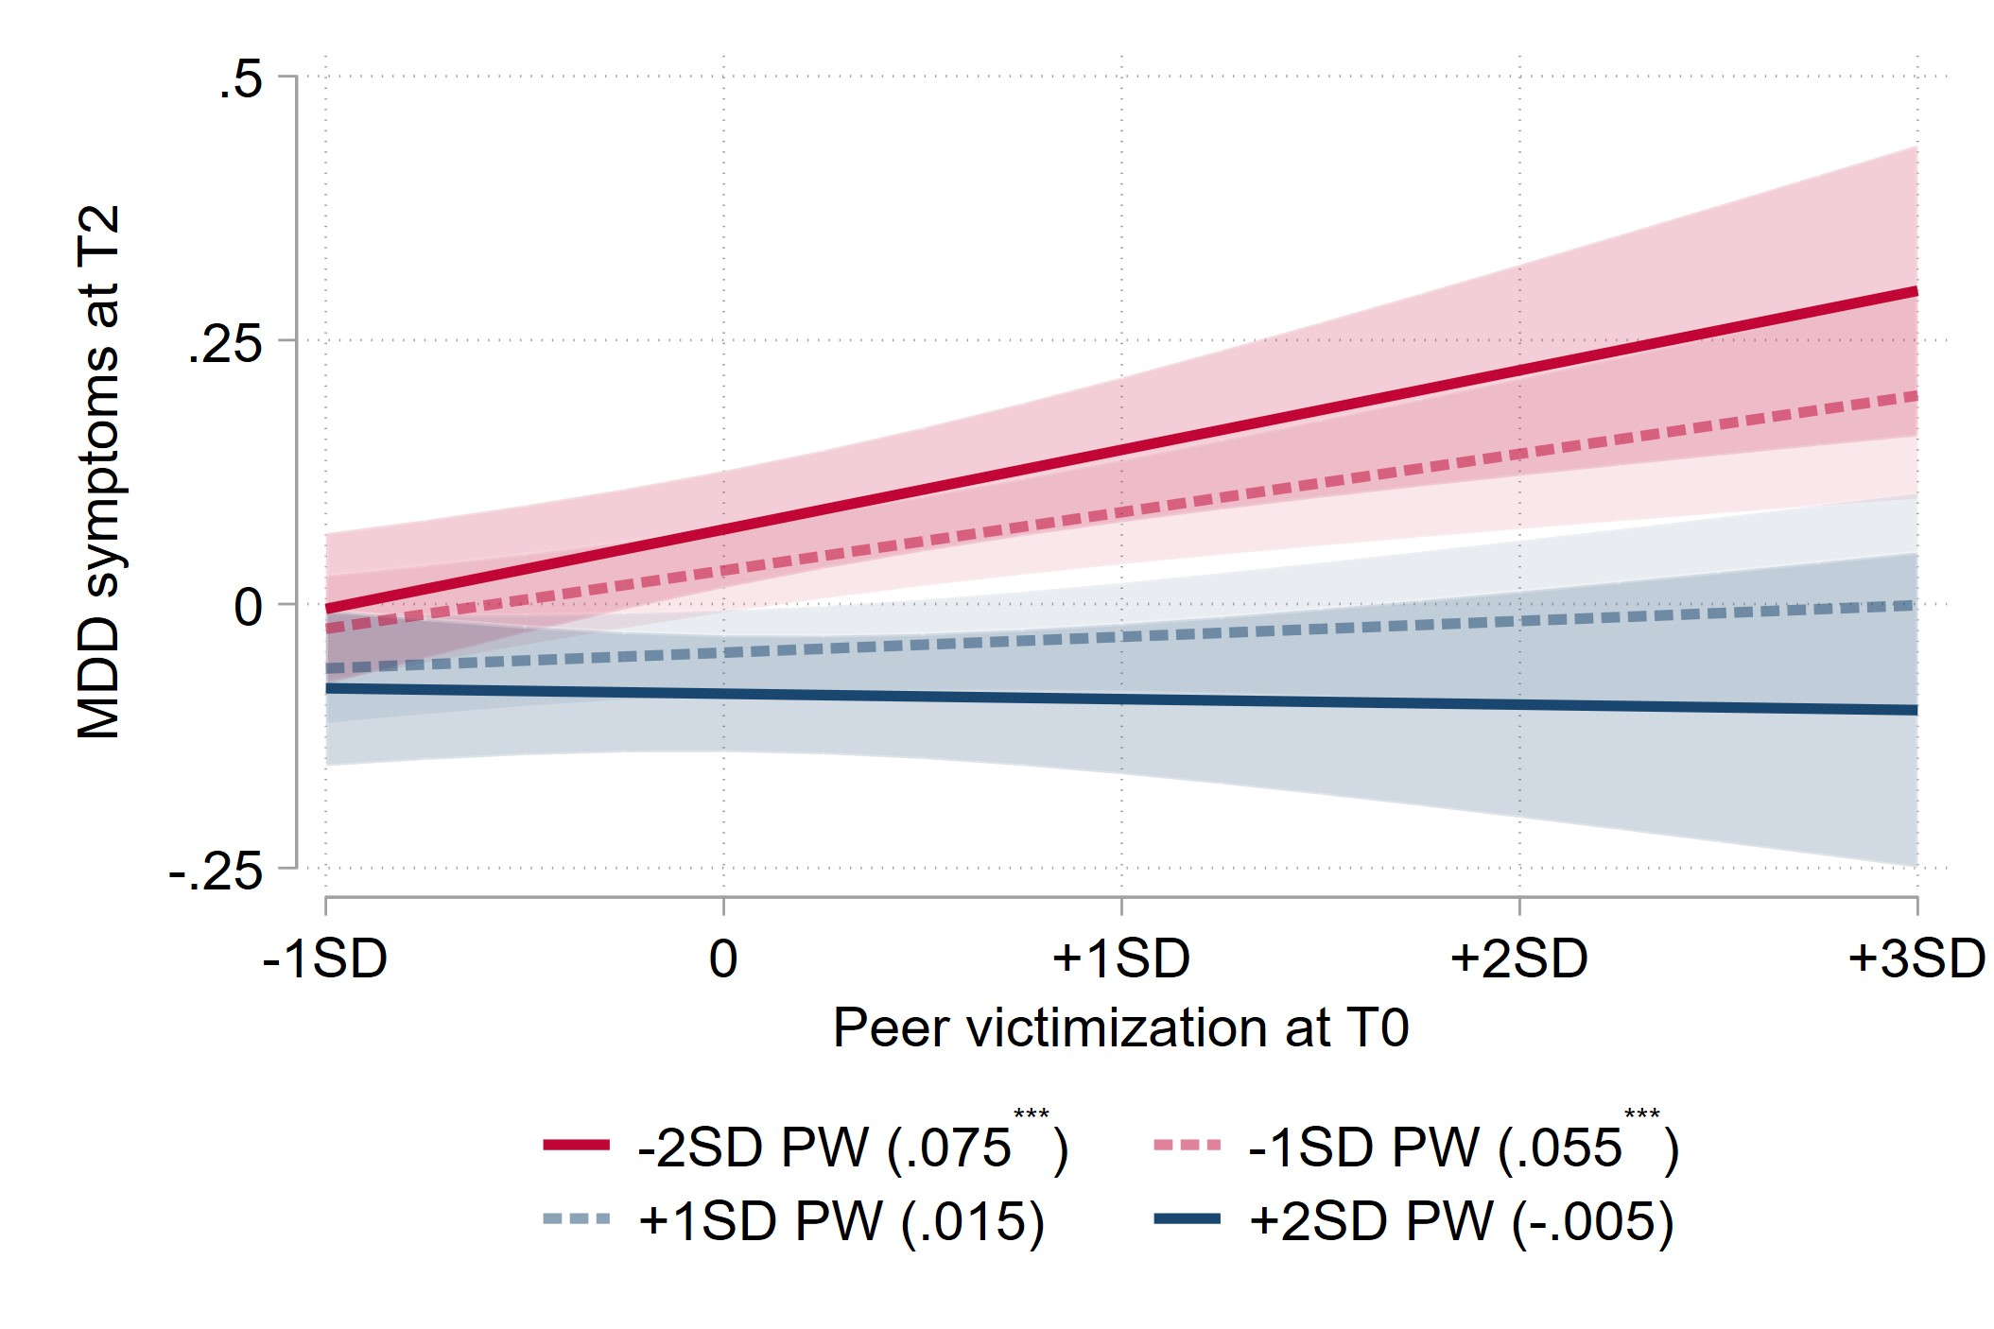 | - MDD symptoms  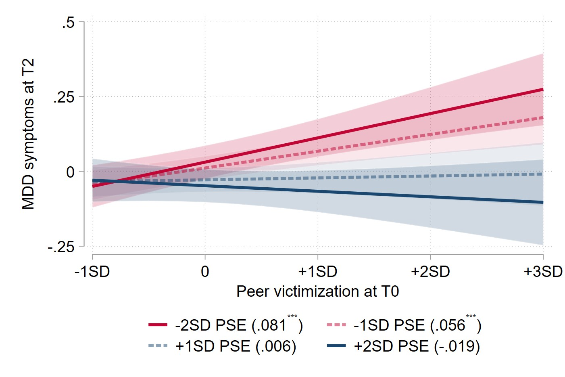
- SA symptoms  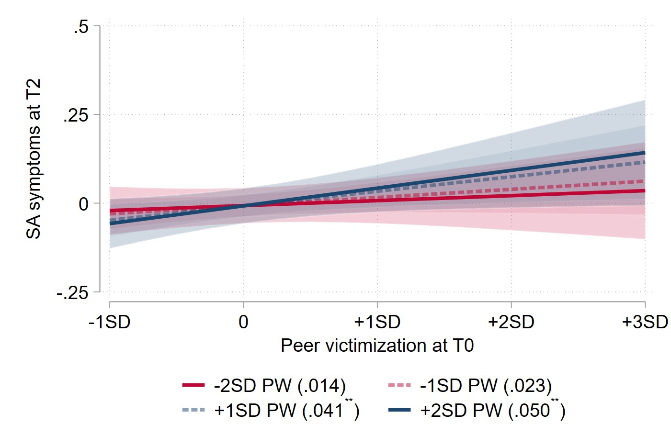 | - SA symptoms  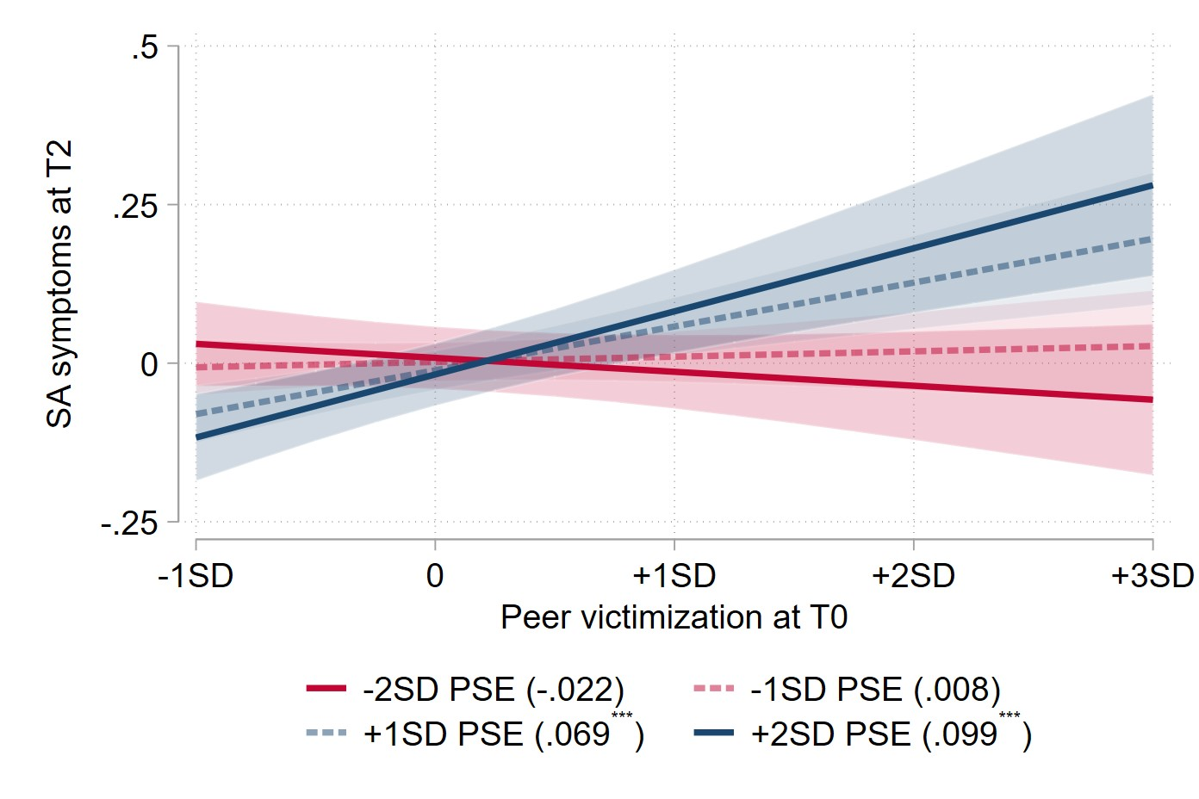
- PP symptoms  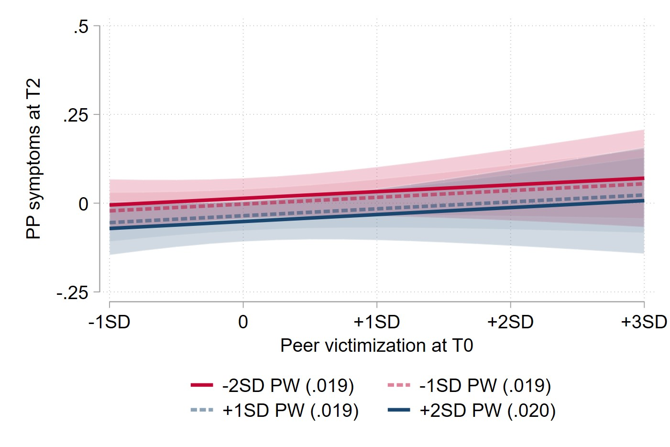 | - PP symptoms  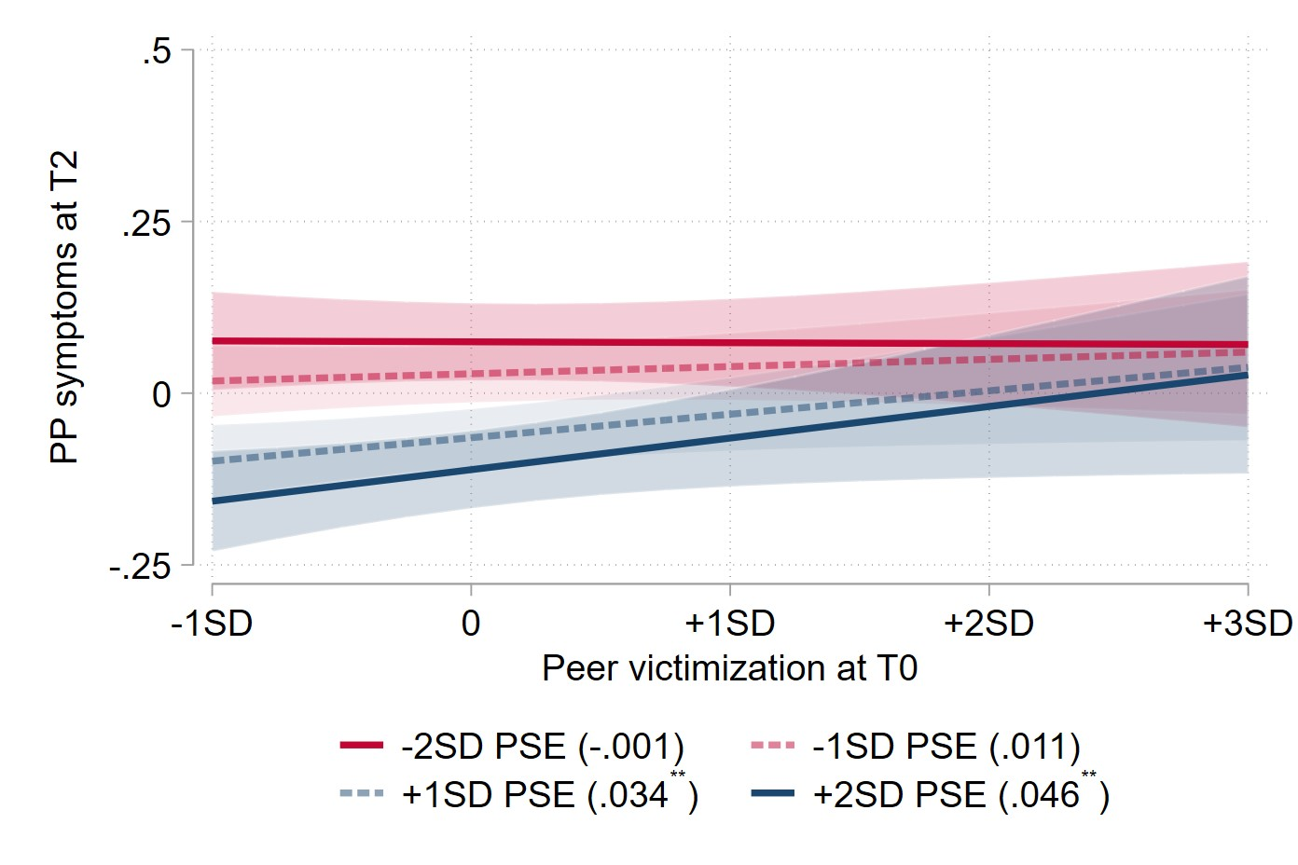
- ADHD symptoms  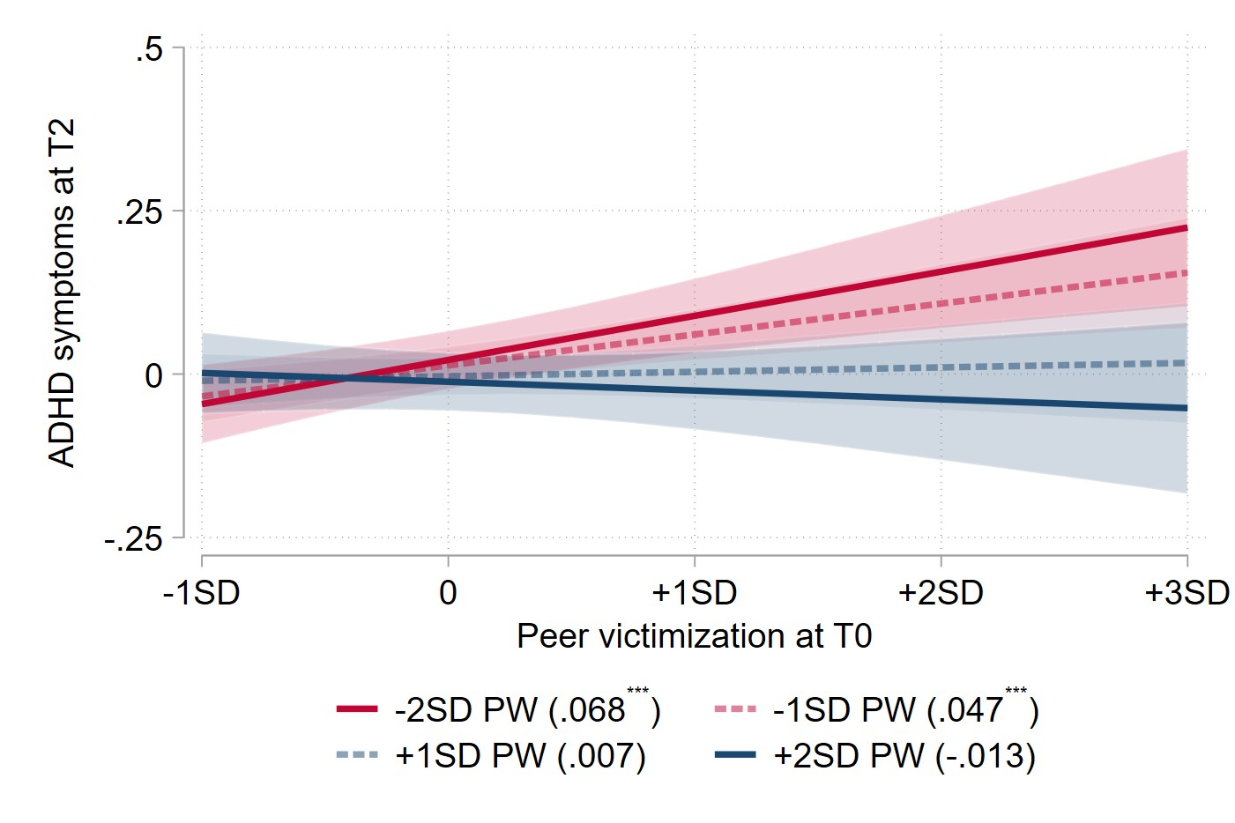 | - ADHD symptoms  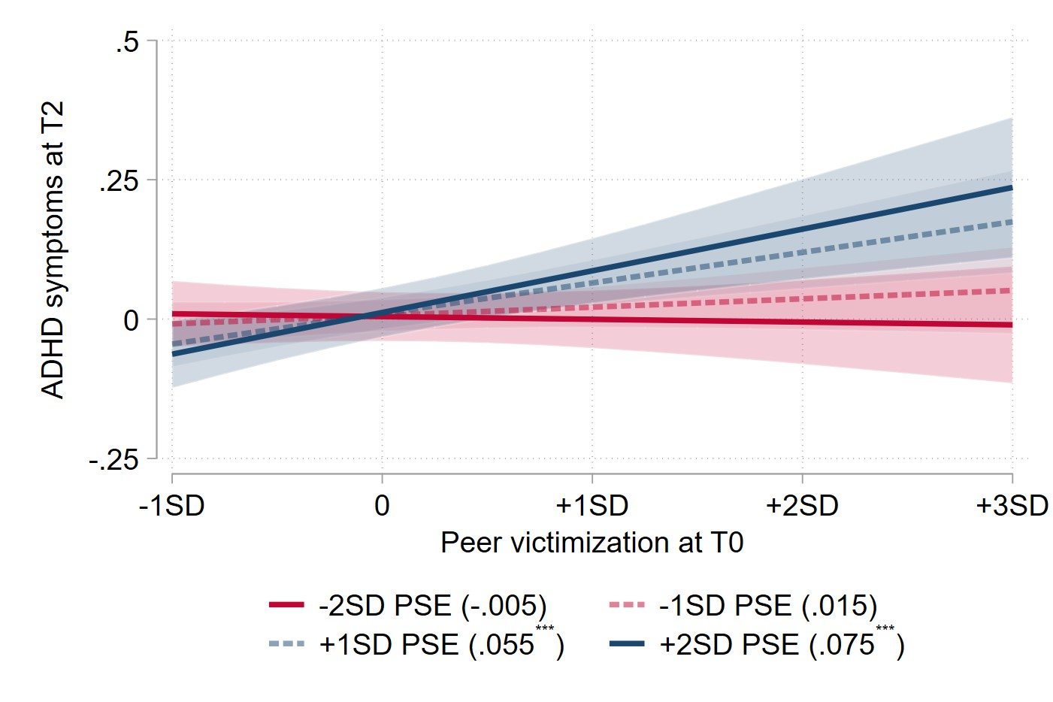
MDD: Major depressive disorder; SA: Separation anxiety; PP: Prodromal psychosis; ADHD: Attention-deficit/hyperactivity disorder;
PW: Parental warmth; PSE: Prosocial school environment.

References

Caspi, A., & Moffitt, T. E. (2018). All for one and one for all: Mental disorders in one dimension. American journal of psychiatry, 175(9), 831-844.
Cecil, C. A., Viding, E., Fearon, P., Glaser, D., & McCrory, E. J. (2017). Disentangling the mental health impact of childhood abuse and neglect. Child abuse & neglect, 63, 106-119.
Conway, C. C., Forbes, M. K., Forbush, K. T., Fried, E. I., Hallquist, M. N., Kotov, R., . . . South, S. C. (2019). A hierarchical taxonomy of psychopathology can transform mental health research. Perspectives on Psychological Science, 14(3), 419-436.
Hyman, S. E. (2010). The diagnosis of mental disorders: the problem of reification. Annual review of clinical psychology, 6, 155-179.
Kessler, R. C., Cox, B. J., Green, J. G., Ormel, J., McLaughlin, K. A., Merikangas, K. R., . . . Swendsen, J. (2011). The effects of latent variables in the development of comorbidity among common mental disorders. Depression and Anxiety, 28(1), 29-39.
Kotov, R., Krueger, R. F., Watson, D., Achenbach, T. M., Althoff, R. R., Bagby, R. M., . . . Clark, L. A. (2017). The Hierarchical Taxonomy of Psychopathology (HiTOP): A dimensional alternative to traditional nosologies. Journal of abnormal psychology, 126(4), 454.
Leeb, R. T., Lewis, T., & Zolotor, A. J. (2011). A review of physical and mental health consequences of child abuse and neglect and implications for practice. American Journal of Lifestyle Medicine, 5(5), 454-468.
Lilienfeld, S. O., & Landfield, K. (2008). Issues in diagnosis: Categorical vs. dimensional In W. E. Craighead, D. J. Miklowitz, & L. W. Craighead (Eds.), Psychopathology: History, diagnosis, and empirical foundations (pp. 1–33): John Wiley & Sons, Inc.
Lilienfeld, S. O., & Treadway, M. T. (2016). Clashing diagnostic approaches: DSM-ICD versus RDoC. Annual review of clinical psychology, 12, 435.
Michelini, G., Palumbo, I. M., DeYoung, C. G., Latzman, R. D., & Kotov, R. (2021). Linking RDoC and HiTOP: A new interface for advancing psychiatric nosology and neuroscience. Clinical Psychology Review, 86, 102025.
Monroe, S. M., & Anderson, S. F. (2015). Depression: The shroud of heterogeneity. Current directions in psychological science, 24(3), 227-231.
Potter, A. S., Dube, S. L., Barrios, L. C., Bookheimer, S., Espinoza, A., Ewing, S. W. F., . . . Jefferys, H. (2022). Measurement of gender and sexuality in the Adolescent Brain Cognitive Development (ABCD) study. Developmental cognitive neuroscience, 53, 101057.
Regier, D. A., Narrow, W. E., Clarke, D. E., Kraemer, H. C., Kuramoto, S. J., Kuhl, E. A., & Kupfer, D. J. (2013). DSM-5 field trials in the United States and Canada, Part II: test-retest reliability of selected categorical diagnoses. American journal of psychiatry, 170(1), 59-70.
Widiger, T. A., & Clark, L. A. (2000). Toward DSM—V and the classification of psychopathology. Psychological bulletin, 126(6), 946.

