Supplementary Materials

Limited evidence of autocorrelation signaling upcoming affective episodes: a 12-month e-diary study in patients with bipolar disorder

Ludwig, V.M.^{1*}, Reinhard, I.², Mühlbauer, E.¹, Hill, H.^{1,4}, Severus, W.E.^{1,3}, Bauer, M.¹, Ritter, P.¹ & Ebner-Priemer, U.W.^{4,5}

1) Department of Psychiatry and Psychotherapy, University Hospital Carl Gustav Carus, Technical University Dresden, Dresden, Germany.
2) Department of Biostatistics, Central Institute of Mental Health, University of Heidelberg, Medical Faculty Mannheim, Mannheim, Germany.
3) Asklepios Klinik Nord-Ochsenzoll, Hamburg, Germany.
4) Mental mHealth Lab, Institute of Sport and Sport Sciences, Karlsruhe Institute of Technology, Karlsruhe, Germany.
5) Department of Psychiatry and Psychotherapy, Central Institute of Mental Health, University of Heidelberg, Medical Faculty Mannheim, Mannheim, Germany.

*Corresponding author.
E-mail: Vera.Ludwig@ukdd.de
Department of Psychiatry and Psychotherapy, University Hospital Carl Gustav Carus,
Fetscherstr. 74
01307 Dresden, Germany

 |  | Baseline |  |  |  |  |  |  |  |  |  |  |  |  | Visit 1 |  |  |  |  |  |  |  |  |  |  |  |  |  |  |  | Visit 2 |  |  |  |  | Visit 26
 |  | YMRS |  |  |  |  |  |  |  |  |  |  |  |  | YMRS |  |  |  |  |  |  |  |  |  |  |  |  |  |  |  | YMRS |  |  |  |  | YMRS
 |  | BRMRS |  |  |  |  |  |  |  |  |  |  |  |  | BRMRS |  |  |  |  |  |  |  |  |  |  |  |  |  |  |  | BRMRS |  |  |  |  | BRMRS
 |  | MADRS |  |  |  |  |  |  |  |  |  |  |  |  | MADRS |  |  |  |  |  |  |  |  |  |  |  |  |  |  |  | MADRS |  |  |  |  | MADRS
 |  | DSM-5 |  |  |  |  |  |  |  |  |  |  |  |  | DSM-5 |  |  |  |  |  |  |  |  |  |  |  |  |  |  |  | DSM-5 |  |  |  | … | DSM-5
Smartphone usage
Actigraphy
E-Diary |  |  |  |  | ・ | ・ | ・ | ・ | ・ | ・ | ・ | ・ | ・ | ・ | ・ | ・ | ・ | ・ | ・ | ・ |  | ・ |  | ・ | ・ | ・ | ・ | ・ | ・ | ・ | ・ | ・ | ・ | ・ | ・ | ・
Day | -2 |  | -1 | 0 | 1 | 2 | 3 | 4 | 5 | 6 | 7 | 8 | 9 | 10 | 11 | 12 | 13 | 14 | 15 | 16 |  | 17 |  | 18 | 19 | 20 | 21 | 22 | 23 | 24 | 25 | 26 | 27 | 28 | … | 365

Supplementary Figure 1. Overview of the BipoSense study design. In-person visits assessed the following instruments: Young Mania Rating Scale (YMRS), Bech-Rafaelsen Mania Rating Scale (BRMRS), Montgomery Asberg Depression Rating Scale (MADRS), and the SCID-I section A for affective episodes according to DSM-5. The former three questionnaires referring to the previous three days, while the SCID-I assessed the mood in the past 14 days. Ratings were performed bi-weekly by a trained clinical psychologist. Every other visit could be conducted over the phone, if preferred by the patient. Over the study period of one year, a total of 26 visits took place. After the baseline assessment, the study app on the patient‘s smartphones continually recorded certain parameters of the smartphone usage and actigraphy (frequency and length of incoming and outgoing phone calls and text messages, number of different call and text contacts, frequency and duration of times the display was on/off, rates of transmitted and received data, travel distances in kilometers, frequency and duration of different activity classes and the velocity of movement and number of steps). Moreover, the app prompted the end-of-day diary questions, which were to be filled out between 8 pm and midnight each evening.
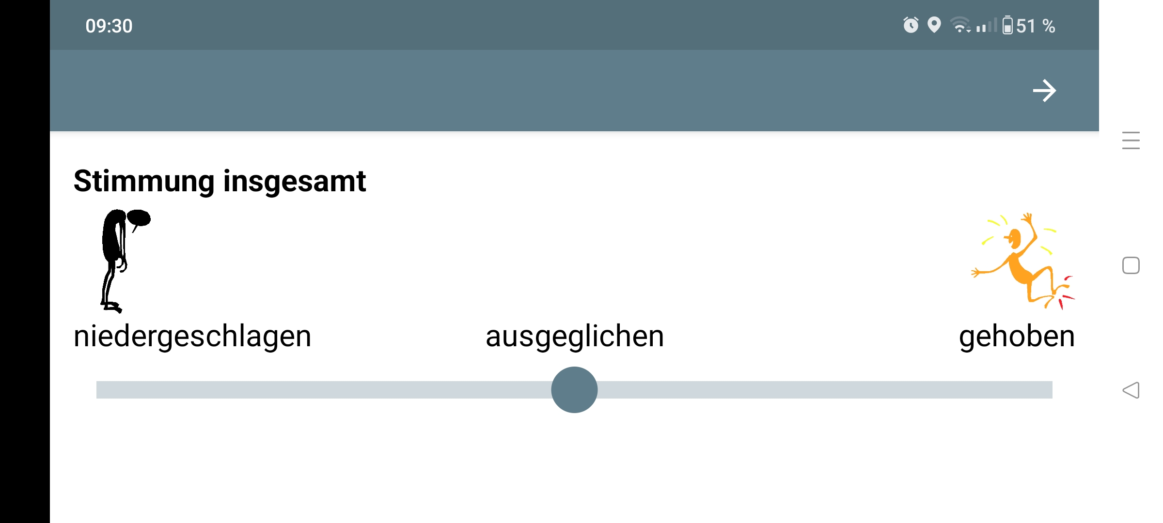

Supplementary Figure 2. Screenshot of the end-of-day e-diary question ‘self-reported mood’, adapted from ChronoRecord. Patients rated their current overall mood by dragging the dot anywhere on the continuum between depressed (niedergeschlagen) on the left, even-tempered (ausgeglichen) in the middle and elevated (gehoben) on the right.

To test the increase of AR before affective episodes and make our results more comparable to previous results, we followed the example by Smit et al. (2022) and calculated Mann-Kendall Tau’s. To make these new additional results fully comparable to our original findings, we used the same data preparation and data analyses steps, just replacing daily AR values with daily Mann-Kendall Tau’s of AR, indicating rising AR over the same time frame (14 days). We ran two kinds of models, imitating our previous analyses: a) using Mann-Kendall Tau´s as statistical predictors for a binary outcome of disorder status (comparing euthymic days to early-/late-prodromal days, weeks of depressive or (hypo)manic episodes), and b) reversing models using disorder status (early-/late-prodromal days, weeks of depressive or (hypo)manic episodes) as statistical predictor and the Mann-Kendall Tau´s as outcome.

Multilevel logit models revealed no significant effect of increases in AR (as operationalized by the Mann-Kendall Tau of AR) as a predictor for early-prodromal days of depression vs. euthymic days (p=.613). However, Mann-Kendall Tau of AR significantly predicted late-prodromal days vs. euthymic days: p=.006). There were no effects of Mann-Kendall Tau of AR on the 1st week, the 2nd week and ongoing depressive weeks (P=.222, p=709, and p=.155 respectively) compared to euthymic days. For (hypo)manic episodes, there was no significant effect of the predictor Mann-Kendall Tau of AR on early-prodromal days vs. euthymic days (p=.177), or late-prodromal days vs. euthymic days (p=.351). However, Mann-Kendall Tau significantly predicted for the 1st – or 2nd week of (hypo)mania vs. euthymic days (p=.030, p<.0001).

Supplementary Table 1. Multilevel logit models using Mann-Kendall Tau of autocorrelation as a predictor for a binary outcome of each expert-rated disorder status (Early-/late prodromal, 1st-week/2nd-week, ongoing weeks) vs. euthymic

Disorder status |  | p value of F-tests for predictor Mann-Kendall Tau  (Disorder status k vs. euthymic)
Depressive episodes | Early prodromal | .613
 | Late prodromal | .006
 | 1st week depressive episode | .228
 | 2nd week depressive episode | .709
 | Ongoing depressive weeks | .155
(Hypo)manic episodes | Early prodromal | .172
 | Late prodromal | .351
 | 1st week (hypo)manic episode | .030
 | 2nd week (hypo)manic episode | <.0001
Early prodromal= days 14–8 before episode onset; late prodromal= days 7–1 before episode onset. Significant p values are presented in bold.

In sum, the increases in AR were only able to differentiate between late prodromal depressive days and euthymic days, and 1st- and 2nd week of (hypo)mania vs. euthymic days.

Reversing the order of predictor and outcome helped to understand the direction and sizes of the effects. As can be seen in Supplementary Table 2, the effect for the comparison between the late prodromal phase before a depressive episode was negative, which implies that the AR is significantly decreased in the week before a depressive episode. The Mann-Kendall Tau estimates for the 1st and 2nd week of a (hypo)manic episode were positive, denoting an increasing AR during manic episodes.

In sum, the new analyses did not reveal any positive evidence for critical slowing down as a “short-term” predictor of upcoming affective episodes.

Supplementary Table 2. Linear mixed models with differences in Mann-Kendall Tau of autocorrelation between levels of expert-rated disorder status
Disorder status |  | Estimates of mean Mann-Kendall Tau of AR | Standard Error | Post-hoc tests  vs. euthymic,  p value
 | Euthymic days | -.02 | .01
Depressive episodes | Early prodromal | -.004 | .04 | .789
 | Late prodromal | -.15 | .04 | .002
 | 1st week depressive episode | -.08 | .04 | .151
 | 2nd week depressive episode | -.02 | .05 | .968
 | Ongoing depressive weeks | .01 | .04 | .521
(Hypo)manic episodes | Early prodromal | .06 | .05 | .142
 | Late prodromal | -.05 | .05 | .461
 | 1st week (hypo)manic episode | .10 | .05 | .030
 | 2nd week (hypo)manic episode | .18 | .05 | <.001
Results for linear mixed models with factor disorder status and outcome Mann-Kendall Tau of autocorrelation (AR). Early prodromal= days 14–8 before episode onset; late prodromal= days 7–1 before episode onset. Post-hoc tests were conducted between each disorder state and euthymic days without α-error correction. Significant p values are presented in bold.

Bibliography

Smit, A. C., Helmich, M. A., Bringmann, L. F., Oldehinkel, A. J., Wichers, M., & Snippe, E. (2022). Critical slowing down in momentary affect as early warning signal of impending transitions in depression. PsyArXiv Preprints.

