Supplementary File 03
Analyses of missingness
Table 03.1. Baseline characteristics between those available in ITT analysis and those with no post-randomisation data.
 |  | Available for analysis | No post-randomisation data | p-value
 |  | N=168 | N=26
Age (M, SD) |  | 42.0 (13.2) | 34.2 (11.1) | 0.005
Female (N, %) |  | 130 (77.4%) | 23 (92.0%) | 0.092
White ethnicity (N, %) |  | 155 (92.3%) | 25 (96.2%) | 0.48
Long-term condition (N, %) | Psoriasis | 11 ( 6.5%) | 3 (11.5%) | 0.82
 | IBD | 83 (49.4%) | 13 (50.0%)
 | CKD | 44 (26.2%) | 6 (23.1%)
 | MS | 30 (17.9%) | 4 (15.4%)
Number of comorbidities (M, SD) |  | 1.4 (1.6) | 2.0 (1.7) | 0.052
Employment status (N, %)* | Employed | 104 (61.9%) | 15 (57.7%) | 0.40
 | Unemployed | 27 (16.1%) | 5 (19.2%)
 | Retired | 12 ( 7.1%) | 0 ( 0.0%)
 | Other | 25 (14.9%) | 6 (23.1%)
Education (N, %)* | GCSE/O-level or none | 1 ( 0.6%) | 0 ( 0.0%) | 0.034
 | A-level | 45 (27.1%) | 14 (56.0%)
 | Degree | 101 (60.8%) | 10 (40.0%)
 | Other | 19 (11.4%) | 1 ( 4.0%)
Marital status (N, %)* | Single | 42 (25.0%) | 10 (38.5%) | 0.14
 | Married/cohabiting | 106 (63.1%) | 14 (53.8%)
 | Separated/divorced | 19 (11.3%) | 1 ( 3.8%)
 | Widowed | 1 ( 0.6%) | 1 ( 3.8%)
Living arrangements (N, %) | Live with others | 144 (85.7%) | 24 (92.3%) | 0.36
 | Live alone | 24 (14.3%) | 2 ( 7.7%)
Use of psychotropic medication (N, %)* | Prescribed and taking | 39 (23.2%) | 17 (65.4%) | <0.001
 | Prescribed but not taking | 7 ( 4.2%) | 1 ( 3.8%)
 | Not prescribed | 120 (71.4%) | 8 (30.8%)
 | Not sure | 2 ( 1.2%) | 0 ( 0.0%)
Receipt of sickpay (N, %)* | Yes | 5 ( 3.0%) | 0 ( 0.0%) | 0.19
 | No | 161 (95.8%) | 25 (96.2%)
 | Unsure | 2 ( 1.2%) | 0 ( 0.0%)
 | Prefer not to say | 0 ( 0.0%) | 1 ( 3.8%)
IMD decile (Median, IQR) |  | 6.0 (4.0-8.0) | 7.0 (4.0-9.0) | 0.54
PHQ-ADS (M, SD) |  | 22.1 (9.6) | 26.7 (6.7) | 0.019
PHQ-9 (M, SD) |  | 11.6 (5.7) | 14.1 (4.4) | 0.034
GAD-7 (M, SD) |  | 10.5 (4.7) | 12.6 (3.7) | 0.028
WSAS (M, SD) |  | 21.5 (8.5) | 22.1 (6.6) | 0.72
IRD (M, SD) |  | 2.9 (1.8) | 3.5 (1.6) | 0.12
IPQ (M, SD) |  | 22.6 (4.8) | 23.3 (4.1) | 0.47
PAM (M, SD) |  | 37.9 (5.4) | 37.5 (6.3) | 0.73
EQ-5D-5L (M, SD) |  | 0.7 (0.2) | 0.6 (0.2) | 0.41
PGIS (Median, IQR) |  | 3.0 (2.0-3.0) | 3.0 (3.0-3.0) | 0.52
Note. *Fischer’s exact alternative where expected cell count below 5 in more than 20% of cells.

Table 03.2. Baseline characteristics between those who completed 12-weeks post-randomisation assessment and those who did not.
 |  | 12-weeks post-randomisation assessment completed | 12-weeks post-randomisation assessment not completed | p-value
 |  | N=162 | N=32
Age (M, SD) |  | 42.2 (13.2) | 34.3 (11.0) | 0.002
Female (N, %) |  | 124 (76.5%) | 29 (93.5%) | 0.032
White ethnicity (N, %) |  | 149 (92.0%) | 31 (96.9%) | 0.33
Long-term condition (N, %) | Psoriasis | 10 ( 6.2%) | 4 (12.5%) | 0.37
 | IBD | 78 (48.1%) | 18 (56.3%)
 | CKD | 44 (27.2%) | 6 (18.8%)
 | MS | 30 (18.5%) | 4 (12.5%)
Number of comorbidities (M, SD) |  | 1.4 (1.6) | 1.8 (1.7) | 0.18
Employment status (N, %) | Employed | 99 (61.1%) | 20 (62.5%) | 0.44
 | Unemployed | 26 (16.0%) | 6 (18.8%)
 | Retired | 12 ( 7.4%) | 0 ( 0.0%)
 | Other | 25 (15.4%) | 6 (18.8%)
Education (N, %)* | GCSE/O-level or none | 1 ( 0.6%) | 0 ( 0.0%) | 0.054
 | A-level | 43 (26.9%) | 16 (51.6%)
 | Degree | 98 (61.3%) | 13 (41.9%)
 | Other | 18 (11.3%) | 2 ( 6.5%)
Marital status (N, %)* | Single | 38 (23.5%) | 14 (43.8%) | 0.031
 | Married/cohabiting | 104 (64.2%) | 16 (50.0%)
 | Separated/divorced | 19 (11.7%) | 1 ( 3.1%)
 | Widowed | 1 ( 0.6%) | 1 ( 3.1%)
Living arrangements (N, %) | Live with others | 139 (85.8%) | 29 (90.6%) | 0.46
 | Live alone | 23 (14.2%) | 3 ( 9.4%)
Use of psychotropic medication (N, %)* | Prescribed and taking | 38 (23.5%) | 18 (56.3%) | 0.003
 | Prescribed but not taking | 7 ( 4.3%) | 1 ( 3.1%)
 | Not prescribed | 115 (71.0%) | 13 (40.6%)
 | Not sure | 2 ( 1.2%) | 0 ( 0.0%)
Receipt of sickpay (N, %)* | Yes | 5 ( 3.1%) | 0 ( 0.0%) | 0.25
 | No | 155 (95.7%) | 31 (96.9%)
 | Unsure | 2 ( 1.2%) | 0 ( 0.0%)
 | Prefer not to say | 0 ( 0.0%) | 1 ( 3.1%)
IMD decile (Median, IQR) |  | 6.0 (4.0-8.0) | 6.5 (4.0-9.0) | 0.85
PHQ-ADS (M, SD) |  | 22.3 (9.6) | 25.0 (7.9) | 0.14
PHQ-9 (M, SD) |  | 11.8 (5.6) | 12.8 (5.2) | 0.33
GAD-7 (M, SD) |  | 10.5 (4.7) | 12.2 (4.0) | 0.064
WSAS (M, SD) |  | 21.8 (8.5) | 20.5 (7.1) | 0.41
IRD (M, SD) |  | 3.0 (1.8) | 3.2 (1.8) | 0.57
IPQ (M, SD) |  | 22.5 (4.8) | 23.5 (4.0) | 0.31
PAM (M, SD) |  | 37.7 (5.4) | 38.3 (6.1) | 0.61
EQ-5D-5L (M, SD) |  | 0.7 (0.2) | 0.6 (0.2) | 0.72
PGIS (Median, IQR) |  | 3.0 (2.0-3.0) | 3.0 (2.0-3.0) | 0.85
Note. *Fischer’s exact alternative where expected cell count below 5 in more than 20% of cells.

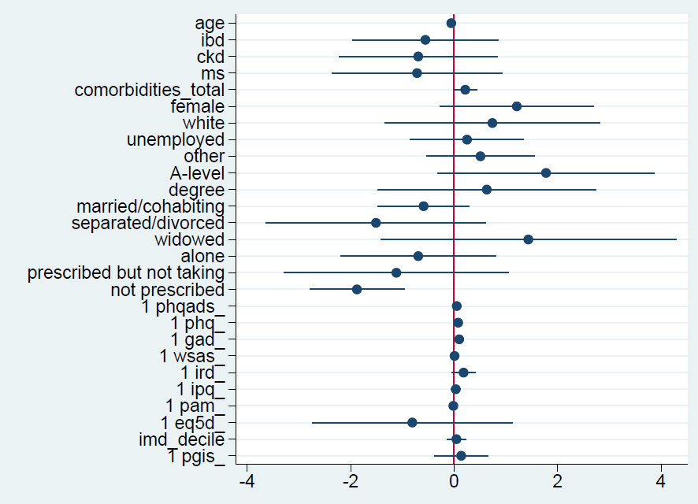
Figure 03.1. Coefficients and 95% CIs of univariate associations between baseline variables and missingness post-randomisation.
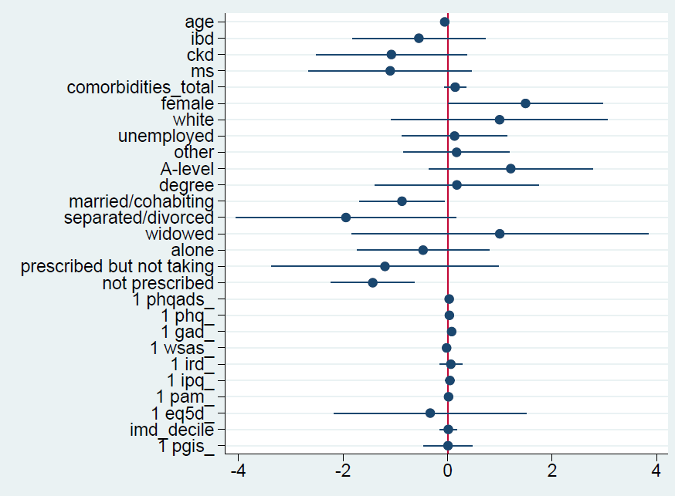
Figure 03.2. Coefficients and 95% CIs of univariate associations between baseline variables and missingness at 12-weeks post-randomisation.
Table 03.3. Univariate logistic regressions of baseline predictors of missingness (no post-randomisation data and no 12-week assessment data).
 |  | No post-randomisation data | 12-weeks post-randomisation assessment not completed
 |  | OR (p-value) | OR (p-value)
Age |  | 0.95 (0.007) | 0.95 (0.003)
Female | Male | 1 | 1
 | Female | 3.36 (0.111) | 4.44 (0.048)
White ethnicity | BAME | 1 | 1
 | White | 2.10 (0.485) | 2.70 (0.346)
Long-term condition | Psoriasis | 1 | 1
 | IBD | 0.57 (0.439) | 0.58 (0.395)
 | CKD | 0.50 (0.376) | 0.34 (0.143)
 | MS | 0.49 (0.395) | 0.33 (0.167)
Number of comorbidities |  | 1.24 (0.057) | 1.16 (0.181)
Employment status | Employed | 1 | 1
 | Unemployed | 1.28 (0.655) | 1.14 (0.796)
 | Retired | 1 | 1
 | Other | 1.66 (0.338) | 1.19 (0.739)
Education | GCSE/O-level or none | 1 | 1
 | A-level | 5.91 (0.097) | 3.34 (0.131)
 | Degree | 1.88 (0.558) | 1.19 (0.825)
 | Other | 1 | 1
Marital status | Single | 1 | 1
 | Married/cohabiting | 0.55 (0.193) | 0.42 (0.034)
 | Separated/divorced | 0.22 (0.164) | 0.14 (0.070)
 | Widowed | 4.20 (0.325) | 2.71 (0.491)
Living arrangements | Live with others | 1 | 1
 | Live alone | 0.50 (0.367) | 0.63 (0.468)
Use of psychotropic medication | Prescribed and taking | 1 | 1
 | Prescribed but not taking | 0.33 (0.314) | 0.30 (0.279)
 | Not prescribed | 0.15 (<0.001) | 0.24 (<0.001)
 | Not sure | 1 | 1
Receipt of sickpay | Yes | 1 | 1
 | No | 1 | 1
 | Unsure | 1 | 1
 | Prefer not to say | 1 | 1
IMD decile |  | 1.05 (0.620) | 1.01 (0.870)
PHQ-ADS |  | 1.05 (0.021) | 1.03 (0.138)
PHQ-9 |  | 1.08 (0.037) | 1.03 (0.330)
GAD-7 |  | 1.10 (0.031) | 1.08 (0.066)
WSAS |  | 1.01 (0.717) | 0.98 (0.409)
IRD |  | 1.20 (0.121) | 1.06 (0.573)
IPQ |  | 1.03 (0.473) | 1.05 (0.307)
PAM |  | 0.99 (0.725) | 1.02 (0.612)
EQ-5D-5L |  | 0.45 (0.413) | 0.72 (0.722)
PGIS |  | 1.15 (0.605) | 1.01 (0.974)

